**Overview of the dataset:**

|  |
| --- |
| **Daily Public Transport Passenger Boardings by Ticket Type** |

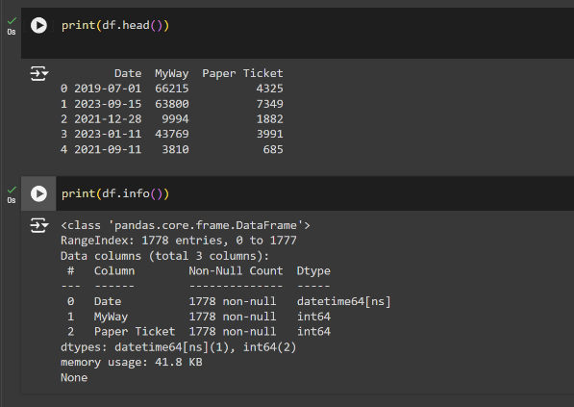

**TASK 1:**

* To filter a last one year data from the given dataset.

**Filtered the data by 1 Year (2023-04-01 to 2024-04-01):**

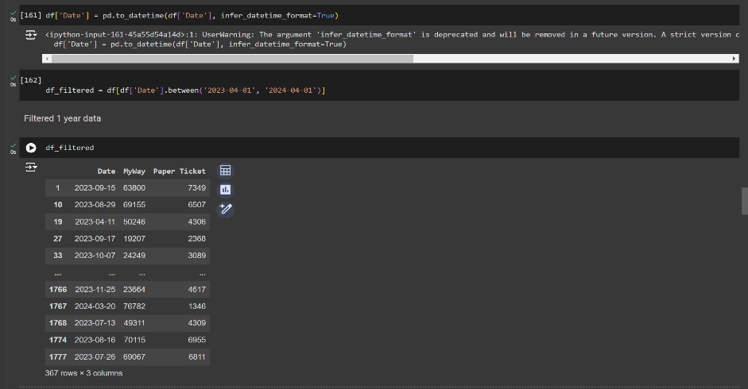

**EDA Techniques:**

* Undertake Exploratory Data Analysis
* Undertake any preliminary data analysis as required.

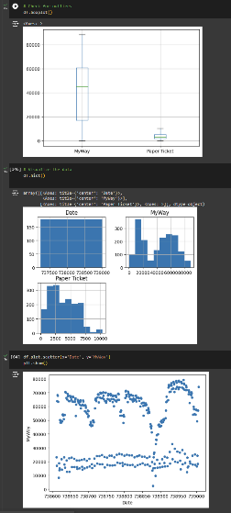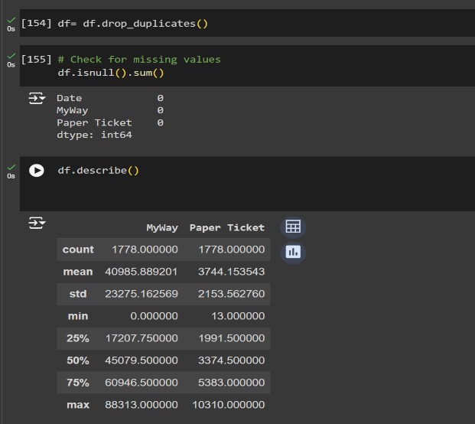 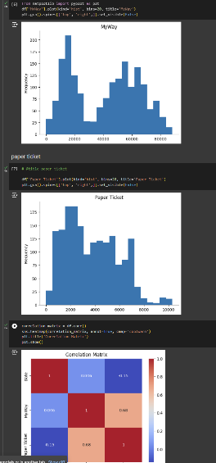

**INFERENCES:**

Data of my usage from last 1 year:

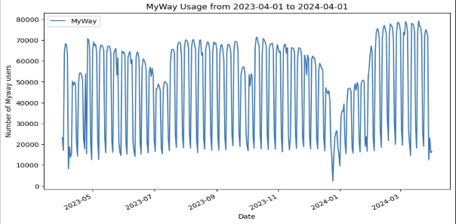

HISTOGRAM:

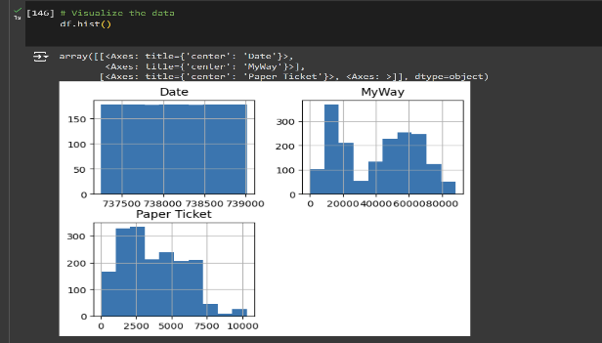

* The distribution of passenger boardings is skewed to the right, with a long tail on the right side. This indicates that there are a few days with very high passenger boardings, while most days have relatively low passenger boardings.
* The most frequent passenger boardings is around 50,000, which occurs on about 10 days.

**TASK 2:**

Use only MyWay column to predict patronage for next 7 days (1st May 2024 – 7th May 2024)

**Predicted output:**

\