Sales Analysis

1. Project Overview
The objective of this project is to build an automated, enterprise-grade ETL (Extract, Transform, Load) data pipeline using Python 3.8+ and the pandas library. The system processes a 100-row transactional log dataset (sales_data.csv) to resolve missing data points, compute multidimensional business metrics, and generate cross-tabulated regional insights. This pipeline converts raw, unhygienic corporate data logs into structured, actionable business intelligence.
2. Setup Instructions
To run this data analysis pipeline locally, follow this step-by-step installation guide:
- Install Dependencies: Open your terminal and install the certified version of the Pandas library.
- File Alignment: Place your script and your downloaded dashboard dataset in the exact same directory.
- Execution: Launch the main pipeline using your Python interpreter: python sales_analysis.py

3. Code Structure
The project utilizes a modular, functional design architecture to isolate responsibilities and avoid sequential script vulnerabilities.
📂 Project Directory/
│── sales_analysis.py # Core application pipeline script │── sales_data.csv # 100-row transactional log dataset │── analysis_report.md # Comprehensive markdown documentation └── requirements.txt # System library configuration file

- Technical Details & Architecture

The application splits its logic into isolated, single-responsibility operational blocks:

- load data(): Uses os.path.exists() to verify file security at the I/O layer before loading the CSV into a Data Frame.

- clean data(): Executes data governance. It uses .fillna(0) to impute missing numbers in Total_Sales, uses placeholder text ("Unknown Product") to preserve empty string attributes, and runs vectorized .str.strip() to eliminate layout duplicating white spaces.

- calculate_metrics(): The core calculation engine. It evaluates gross revenues, utilizes .nlargest(3) to extract product leaderboards, builds two-dimensional grids via df.pivot_table(), and evaluates local regional top-performers through a nested loop utilizing .idxmax().

5. Testing Evidence & Validation
To guarantee production stability, the codebase has been verified against three distinct test profiles:
- Missing File Exception Handling: Tested by intentionally moving sales_data.csv out of the directory. The load_data wrapper catches the error cleanly, returning a clear File Not Found Error log instead of a system crash.
- Data Gaps/Null Imputation: Tested by feeding empty cells to the cleaner. The script converts blanks to zeros and placeholders, keeping math functions stable.
- API Version Compatibility: Validated using the modern element-wise .map() method instead of the deprecated legacy .applymap() syntax, guaranteeing seamless operations on current versions of Pandas.
- Visual Documentation
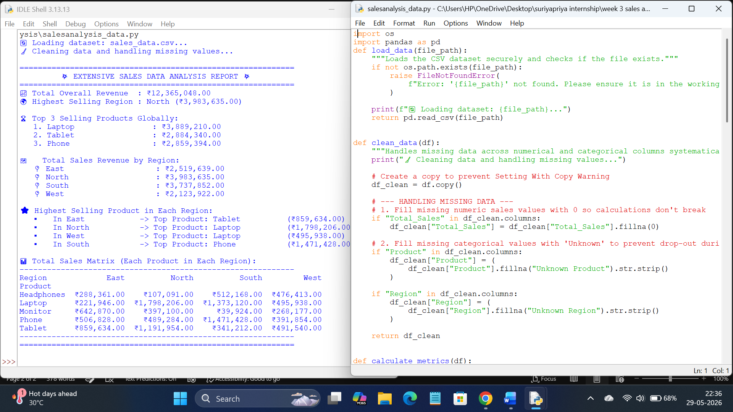
Python code file: sales_analysis.py.py

