INTERCEPTED AUDIO ANALYSIS REPORT
## Personal Details
Name: Surja Sekhar Sengupta
Degree: BTech CSE – Sister Nivedita University – 8.68 CGPA - 2026
Challenge: Intercepted audio analysis (denoising and transcription)
File: war-intercept.wav
Platform: Kali Linux
Date: 1 October 2026
## Executive summary
An intercepted audio file, war-intercept.wav, was analysed on Kali Linux to find out what was being said. The file was inspected and noise reduction was tried. The original file was then transcribed with Whisper and the speech was recovered. Audacity was used to filter noise, and Whisper used again to get a cleaner transcript. The transcript will be pasted below.
## tools used
- sha256sum: hash of the file
- ffprobe: file information
- sox: spectrogram
- ffmpeg: mono conversion and noise filtering
- Python and faster-whisper: speech-to-text
- audacity: noise cleaning and exporting
## Methodology
### analysis
I checked the file details and made a spectrogram. It showed loud high-frequency noise and drum beats, with the speech underneath. I converted the audio to mono 16 kHz and tried noise reduction with ffmpeg. I then tried to transcribe both the cleaned file and the original file with Whisper.
### finding
- The noise reduction removed the faint speech along with the noise, so the cleaned file gave no transcript.
- Whisper handled the noisy original file well and gave a readable transcript.
- Audacity was used to further filter out noise and a more coherent transcript was retrieved, which is as follows:
- Transcript: (Terminal Screenshots attached in steps)
Language: en
[0.0-18.0] I'm not supposed to tell you where I've been, I think even the hardest part is to let a guy know about Christmas Day as I enjoy the other gifts.
[18.0-21.0] I have to start off with Christmas Eve.
[21.0-28.0] It was then I opened the warehouse just to stop some of the fellow war rats standing around helping them.
[28.0-32.0] They lay off, look at that. It's a Mike Christie, Alexia.
[32.0-38.0] Say, Charlie, your mother's a slob fraud, or tell them this one Charlie, a slob, but they can't help it.
[41.0-43.0] So we look at that.
[44.0-46.0] Oh, that's that.
[46.0-48.0] Isn't that swear?
[48.0-52.0] No, I don't care whether I get new razor blades or not.
[52.0-55.0] You're going to hang out with that father, I'll be swiping.
[55.0-58.0] You can have anything but my flesh, Charlie, when I hang on it.
[58.0-60.0] Come in.
[74.0-77.0] I'm going to have dinner with the Queen.
[77.0-79.0] We've been out in the sun for a while.
[79.0-81.0] That's what the notes say.
[81.0-84.0] We're going to set a price on each of them.
[84.0-90.0] And I have been chosen as the two American officers to have true fortune in between there.
[90.0-91.0] Wow.
[96.0-98.0] It wasn't you who were in that.
[98.0-100.0] We really were invited.
[100.0-103.0] What are you?
[106.0-108.0] What are you?
[116.0-118.0] What are you?
[121.0-123.0] What are you?
Old Transcript: (First iteration, ONLY KEPT to show methodology)
Language: en
[30.0-32.0] That is my cookie, Alex.
[32.0-34.5] Hey, Charlie, your mother's a slob fraud.
[34.5-36.0] Tell them this one, Charlie.
[36.0-37.0] A slob of the kid.
[37.0-38.0] No way.
[38.0-39.0] No way.
[39.0-40.0] No way.
[40.0-41.0] No way.
[41.0-42.0] See, look at that.
[42.0-44.0] This is sort of a narrowing hole.
[44.0-45.0] No way.
[45.0-46.0] No way.
[46.0-47.0] Oh, that's not fair.
[47.0-49.0] Isn't this where my father's in there?
[49.0-50.0] No way.
[50.0-51.0] No way.
[51.0-52.0] No way.
[52.0-53.0] No way.
[53.0-54.0] No way.
[54.0-55.0] No way.
[55.0-56.0] No way.
[56.0-57.0] No way.
[57.0-58.0] No way.
[58.0-59.0] No way.
[59.0-60.0] No way.
[60.0-61.0] No way.
[61.0-62.0] No way.
[62.0-63.0] No way.
[63.0-64.0] No way.
[64.0-65.0] No way.
[65.0-66.0] No way.
[66.0-67.0] No way.
[67.0-68.0] No way.
[68.0-69.0] No way.
[69.0-70.0] No way.
[70.0-71.0] No way.
[71.0-72.0] No way.
[72.0-73.0] No way.
[73.0-74.0] No way.
[74.0-75.0] No way.
[75.0-76.0] No way.
[76.0-77.0] No way.
[77.0-78.0] No way.
[78.0-79.0] No way.
[79.0-80.0] No way.
[80.0-81.0] No way.
[81.0-82.0] No way.
[82.0-83.0] No way.
[83.0-84.0] No way.
[84.0-85.0] No way.
[85.0-86.0] No way.
[86.0-87.0] No way.
[87.0-88.0] No way.
[118.0-124.0] to look in the closet, a box where the perfection faces the city of glory.
[124.0-129.0] Carve some of the thoughts that you wouldn't want to break.
[129.0-130.0] Who would have thought that?
[130.0-135.0] You might just be a captain of God's family, a captain of heaven,
[135.0-139.0] a new captain of grace, a new captain of grace,
[139.0-147.0] a stewardess, a queen, a queen, a queen, a queen, a queen, a queen, a queen, a queen, a queen, a queen, a queen,
[177.0-207.0] a queen, a queen, a queen, a queen, a queen, a queen, a queen, a queen, a queen, a queen, a queen, a queen, a queen, a queen, a queen, a queen, a queen, a queen, a queen, a queen, a queen, a queen, a queen, a queen, a queen, a queen, a queen, a queen, a queen, a queen, a queen, a queen, a queen, a queen, a queen, a queen, a queen, a queen, a queen, a queen, a queen, a queen, a queen, a queen, a queen, a queen, a queen, a queen, a queen, a queen, a queen, a queen, a queen, a queen, a queen, a queen, a queen, a queen, a queen, a queen, a queen, a queen, a queen, a queen, a queen, a queen, a queen, a queen, a queen, a queen, a queen, a queen, a queen, a queen, a
[267.0-269.0] We're all friends.
[269.0-271.0] We're friends.
[271.0-273.0] Let's close now.
[273.0-275.0] We're all friends.
[275.0-277.0] We're all friends.
[277.0-279.0] We're all friends.
### outcome
The speech was successfully recovered by transcribing the original file with faster-whisper (small model). Cleaning the audio through audacity gave more coherent words. Transcription was slow on the CPU, but it finished.
## Step by step process along with screenshots
Step 1: Open the file location and get its hash
cd ~/Downloads/Challenges
sha256sum war-intercept.wav
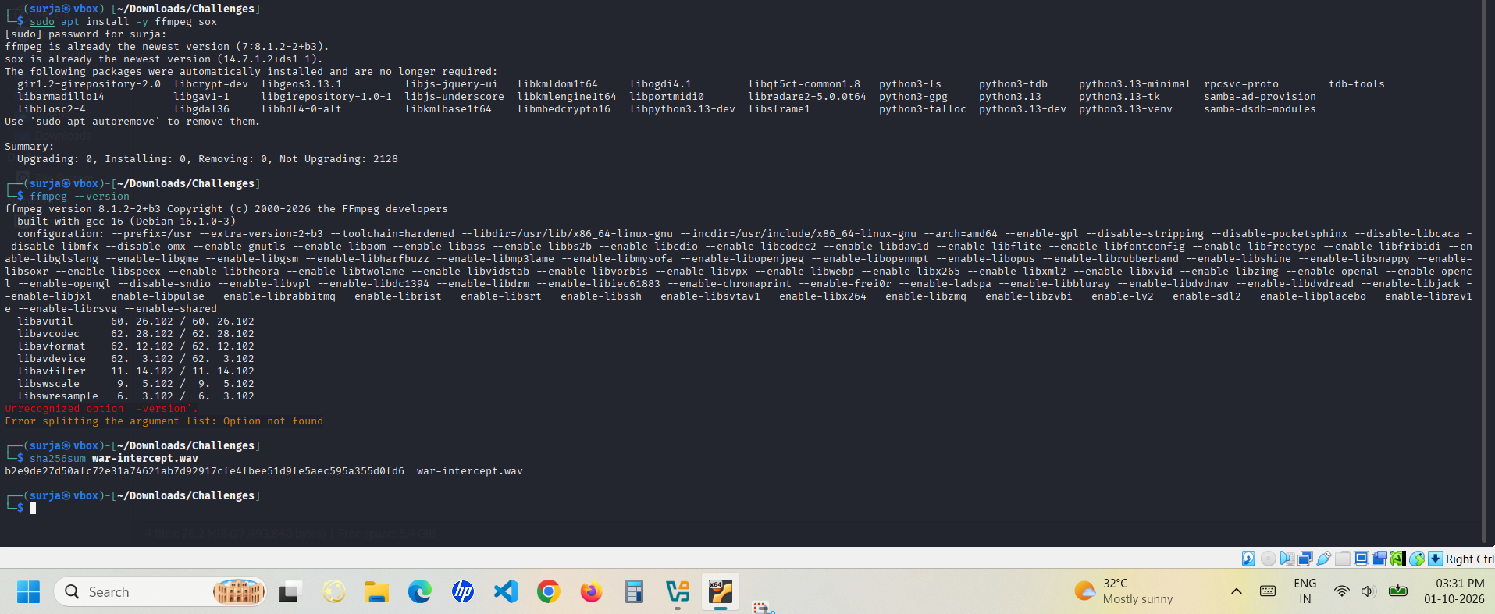
Step 2: Check the file info
ffprobe war-intercept.wav
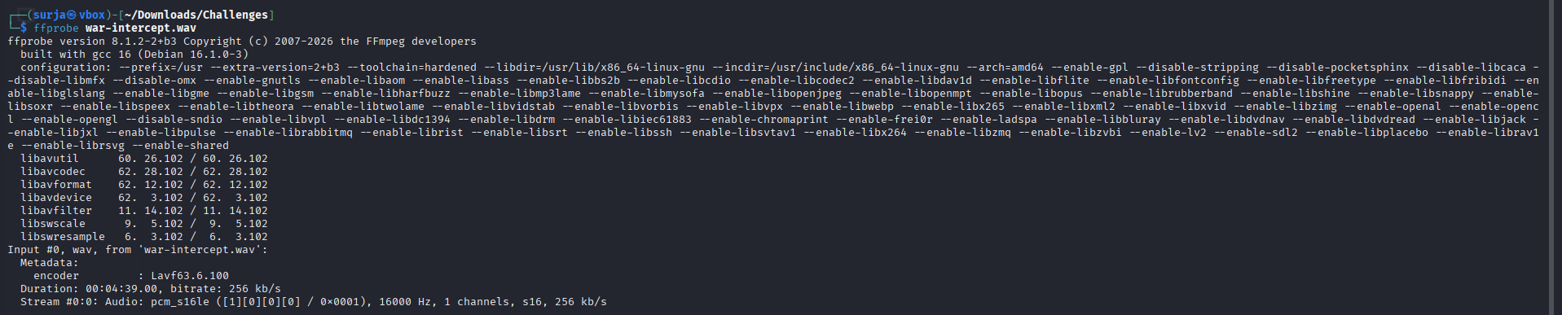
Step 3: Make a spectrogram
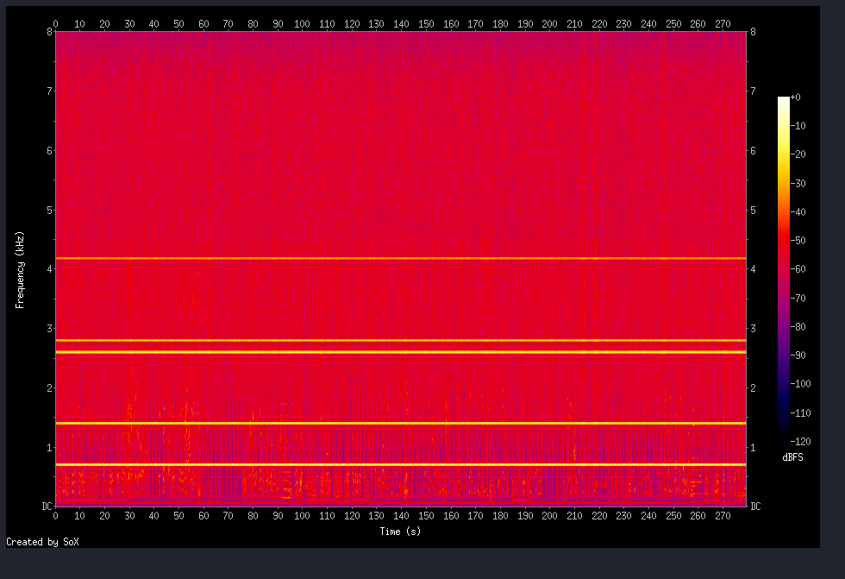
Step 4: Convert to mono 16 kHz
ffmpeg -i war-intercept.wav -ac 1 -ar 16000 mono.wav
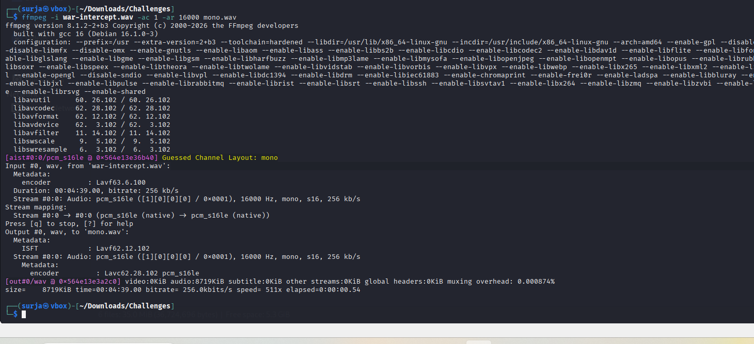

Step 5: Try noise reduction

ffmpeg -i mono.wav -af "highpass=f=100,lowpass=f=7500,afftdn=nf=-25,loudnorm" clean.wav
sox clean.wav -n spectrogram -o spec_after.png
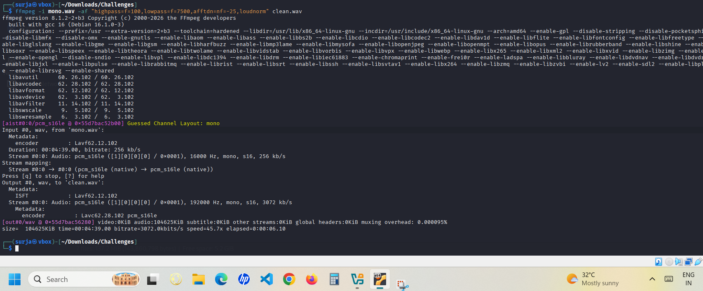
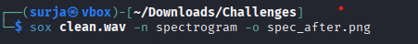
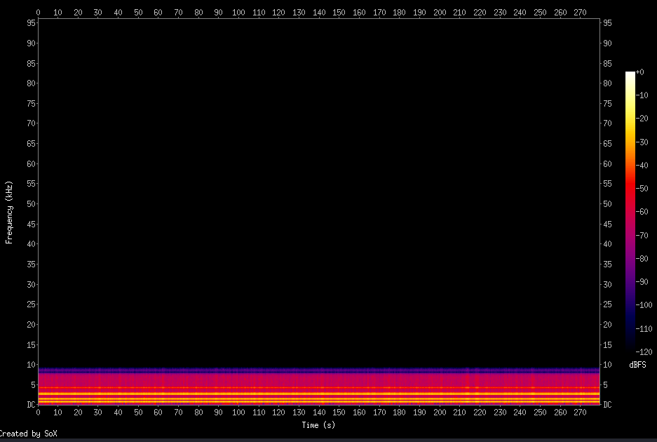
Step 6: Set up Whisper
python3 -m venvvenv
source venv/bin/activate
pip install faster-whisper soundfile
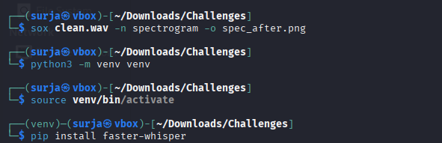
Step 7: Transcribe the cleaned file
python transcribe.py clean.wav
import sys
import soundfile as sf
from faster_whisper import WhisperModel
audio, sr = sf.read(sys.argv[1], dtype="float32")
model = WhisperModel("small", compute_type="int8")
segments, info = model.transcribe(audio, vad_filter=False, beam_size=5)
print("Language:", info.language)
for s in segments:
print(f"[{s.start:.1f}-{s.end:.1f}] {s.text}")

It detected English but printed no text, because the speech was barely audible after cleaning.
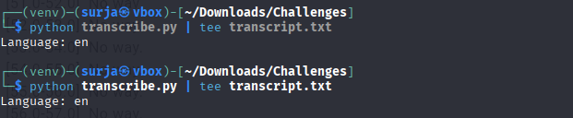
Step 8: Transcribe the original file

python transcribe.py war-intercept.wav | tee transcript_raw.txt

It ran slowly on the CPU but finished and printed the transcript.

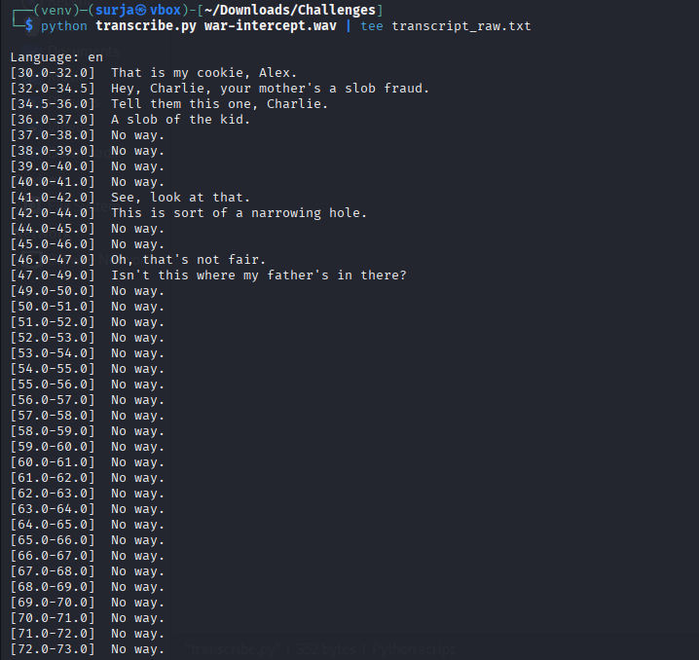
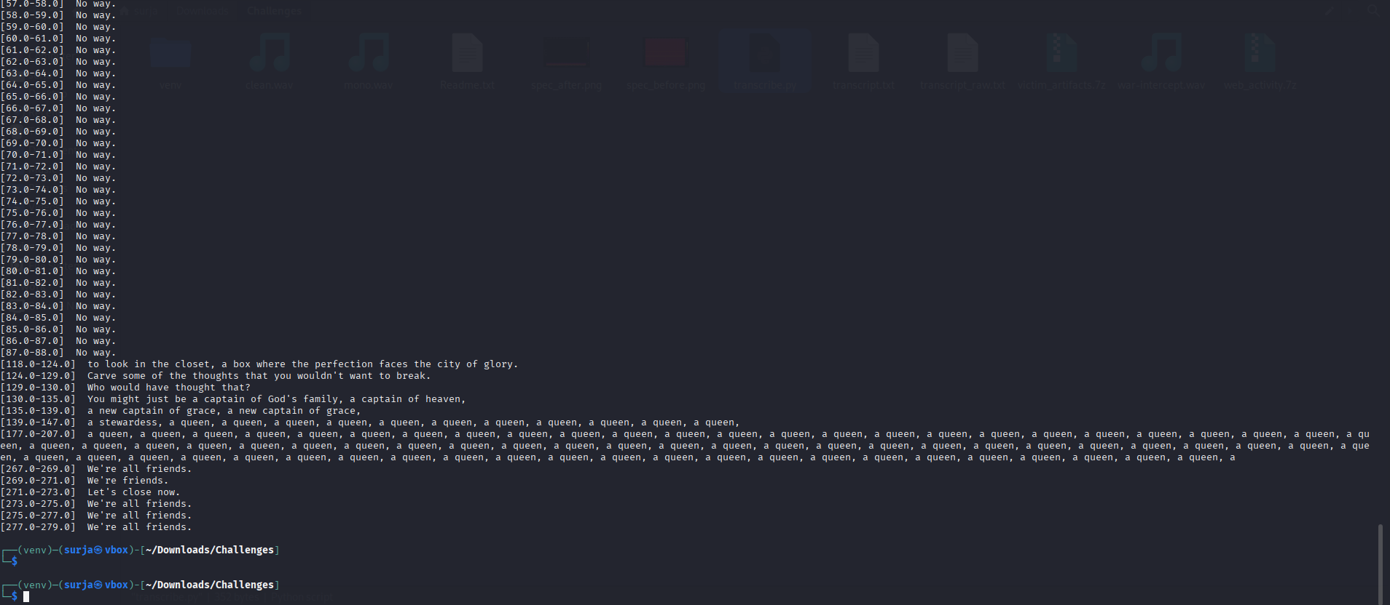
Step 9: Clean the audio in Audacity (filters, gentle noise reduction, normalise) and export war-intercept_audacity.wav.
To improve clarity and remove residual artifacts, Audacity was used to further refine the transcript.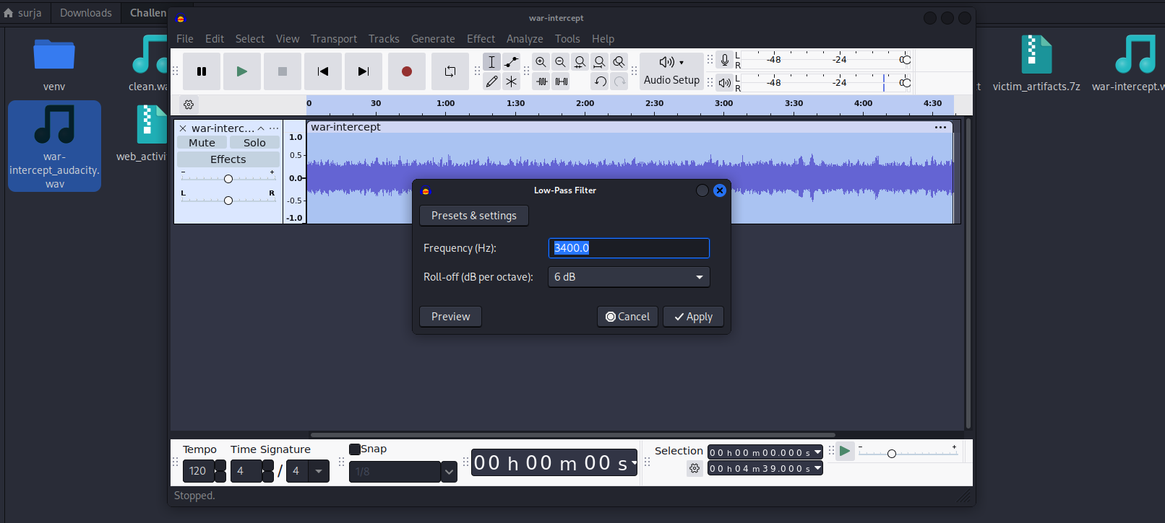

Step 10: Transcribe war-intercept_audacity.wav with the same script.
