ENDPOINT LOG ANALYSIS REPORT

Personal Details
Name: Surja Sekhar Sengupta
Degree: BTech CSE – Sister Nivedita University – 8.68 CGPA - 2026
Challenge: Endpoint compromise investigation (web activity, endpoint security and USB logs)
Files: web_activity.csv, endpoint_security.csv, usb_events.csv
Platform: Kali Linux
Date: 3 October 2026

Executive summary
Three log files from 248 endpoints were analysed on Kali Linux to find out which systems are compromised and how. The files were hash-checked, loaded into a DuckDB database and searched for malware detections, blocked websites, rare websites, USB activity and remote-access tools. Three endpoints stood out. EPSES7ZK (host-4c8d) is infected with a browser hijacker. EPGSQVEB (host-9a4f) shows signs of unauthorised remote access through AnyDesk after a malicious zip file. EPD24DBC (host-7394) had a suspicious USB device plugged in. Most of the other alerts looked like false positives or normal browsing noise. Remedial measures are given below.

Tools used
- sha256sum: check file integrity of the logs
- Python (venv), DuckDB and pandas: load the CSV logs and run queries
- curl, grep and awk: download public threat lists and compare them with the logs
- URLhaus, Feodo Tracker and Tor exit list: known bad hosts and IPs
- whois: installed to check domain details
- less: read the saved reports

Methodology

Analysis
I first checked that the three files were not changed using their SHA256 values and made them read-only. The times in the files are in DD-MM-YYYY format, so I converted them before loading the data into DuckDB. The web log covers 10 to 21 September 2026 (about 2.8 million rows), while the security and USB logs run from 1 to 25 September. I then checked the antivirus and quarantine records, blocked sites, rare websites, USB events and compared the domains with public threat lists. For each suspicious endpoint I built a timeline of what happened and when.

Assumptions
- A website seen on only one or two endpoints in the whole company is treated as rare and worth checking.
- Hostnames and endpoint IDs are taken as correct, even though the usernames in the logs look anonymised.
- The clocks of the endpoints are not perfectly in sync, so timings between two different hosts are only approximate.

Findings
- The logs contain 20,004 quarantine records, 2,622 antivirus scan records and 914 blocked-website records.
- The scanner's detections are written as “Quarantined and deleted”, not “FOUND”, so my first search for “FOUND” returned nothing. After checking the real message format, I found detections on 13 endpoints.
- 33 endpoints have files marked Malicious (51 different files). Most of these are not real attacks: recently-used.xbel (a normal GNOME recent-files list) appears on 9 endpoints with the same hash, and printer driver files (HP, Canon, Brother) look like detections on unsigned installers.
- EPSES7ZK contacts search-hijacker and adware domains every day from 10 September, which shows the browser was already hijacked when the web log starts. It also contacts cdn.frompdftodoc-cdn.com, which suggests a “PDF to DOC” browser extension as the likely source. Five copies of an HP printer installer were deleted on 21 September, which points to a download from an unofficial driver site.
- EPGSQVEB had Final_Documents.zip quarantined on 10 September (found in two folders). From 13 September it connects to AnyDesk relay servers, with the first contact each day at about 11:05 to 11:07 on 13, 14 and 15 September, and a long busy period on 19 September between about 12:17 and 15:35. This looks like remote-access sessions. AnyDesk could be approved software, so this needs to be confirmed with IT.
- The USB log has only two devices. A Logitech mouse on EP7FZ2XY is normal. EPD24DBC had a “General UDisk” mass-storage device with ID abcd:1234, which is a placeholder-style ID often seen on cheap or fake devices.
- The blocked-website list is mostly Facebook, Instagram, LinkedIn and googleapis (normal blocked categories). Four endpoints (EPIXXNDT, EPNXD2NI, EPMDU6L5, EPTX4FCZ) had repeated blocked requests to api.ipify.org, a site used to look up a public IP. I checked their timelines and found no other bad signs, so I rated them low risk and put them on a watch list.
- No domains or IPs from the logs matched the URLhaus, Feodo Tracker or Tor exit lists, and no regular beaconing pattern was found.
- EP4YIFHV (Lima) had 18 JavaScript files quarantined, but it has very little web traffic and no rare websites. The file names look like a payment checkout SDK cache, so it is probably a false positive. Their hashes should still be checked on VirusTotal.

Affected endpoints
Endpoint ID | Host / Unit | What was found | Confidence
EPSES7ZK | host-4c8d / unit-papa | Browser hijacker / adware infection. Contacts freshysearch.com, search.freshy.com, searchtabnew.com, freshysearch-cdn.com and frompdftodoc-cdn.com from 10 Sep. Five copies of hp_LJ1020_Full_Solution...exe were also deleted by the scanner on 21 Sep. | High
EPGSQVEB | host-9a4f / unit-bravo | Suspected unauthorised remote access. Final_Documents.zip was flagged malicious on 10 Sep, then AnyDesk relay connections appear on 13, 14, 15, 16 and 19 Sep. | Medium
EPD24DBC | host-7394 / unit-foxtrot | Suspicious USB storage device (ID abcd:1234, a placeholder ID) plugged in on 22 Sep at 18:23. No logs after that, so the result is unknown. | Low to Medium

Based on the evidence above, I identified EPSES7ZK as the infected system, with EPGSQVEB as the second most serious system, and EPD24DBC as needing further checking.

Limitations
- The web log starts on 10 September, so activity before that cannot be checked.
- Some rows are duplicated in the logs, so counts may be about double the real number.
- 122 endpoints show events being received before they happened, which points to clock problems. This makes exact timelines less reliable.
- No file contents were available, so the malicious files were judged only by name, location and hash.

Recommended remedial measures
- Contain: isolate EPSES7ZK, EPGSQVEB and EPD24DBC from the network until they are checked.
- EPSES7ZK: remove the browser extension, reset the browser settings, run a full scan, and reimage the machine if the hijacker comes back. Change the passwords saved in the browser.
- EPGSQVEB: check with IT whether AnyDesk is approved. If not, uninstall it, review recent activity, and reset the user's passwords. Check the user's email for the source of Final_Documents.zip.
- EPD24DBC: find and scan the USB device, and check what files were copied to or from it.
- Block bad domains: add freshysearch.com, search.freshy.com, searchtabnew.com, freshysearch-cdn.com and frompdftodoc-cdn.com to the web filter.
- Remote tools: allow only approved remote-access software and raise an alert when a new one appears.
- Downloads: do not allow driver downloads from unofficial sites. Keep printer drivers on an internal share.
- Email: scan zip, docx and xlsx attachments from outside and disable macros from the internet.
- USB: use device control to allow only approved USB devices, and block unknown mass-storage devices.
- Logging and antivirus: fix the time sync (NTP), remove duplicate log rows, use the same antivirus signature version everywhere, and tune the rules that flag recently-used.xbel and vendor installers.

Outcome
The endpoint logs were analysed and the suspicious systems were identified. EPSES7ZK was found to be infected with a browser hijacker and adware, most likely from a browser extension and an unofficial driver download. EPGSQVEB shows a likely unauthorised remote-access case through AnyDesk after a malicious zip file. EPD24DBC had a suspicious USB device. The other alerts were mostly false positives or normal browsing noise.
Key indicators found: freshysearch.com, search.freshy.com, searchtabnew.com, freshysearch-cdn.com, cdn.frompdftodoc-cdn.com, Final_Documents.zip (SHA256 404ee575...), hp_LJ1020_Full_Solution...exe (SHA256 f0c48557...), AnyDesk relay servers (148.113.x.x), USB ID abcd:1234.

Step by step process along with screenshots
Step 1: Install the required packages
sudo apt install -y python3-venv python3-pip whois
All packages were already installed, and whois was upgraded.
Step 2: Create the case folder and Python environment
mkdir -p ~/case && cd ~/case
python3 -m venv venv
source venv/bin/activate
pip install duckdb pandas
Step 3: Check the integrity of the log files and make them read-only
sha256sum -c SHA256SUMS --ignore-missing
chmod a-w data/*.csv
All three CSV files showed OK, so they were not changed.
Step 4: Preview the three log files
head -3 data/web_activity.csv
head -3 data/endpoint_security.csv
head -10 data/usb_events.csv
Each file has the columns endpoint_id, endpoint_name, mac, unit, log_type, event_time, received_time and message.
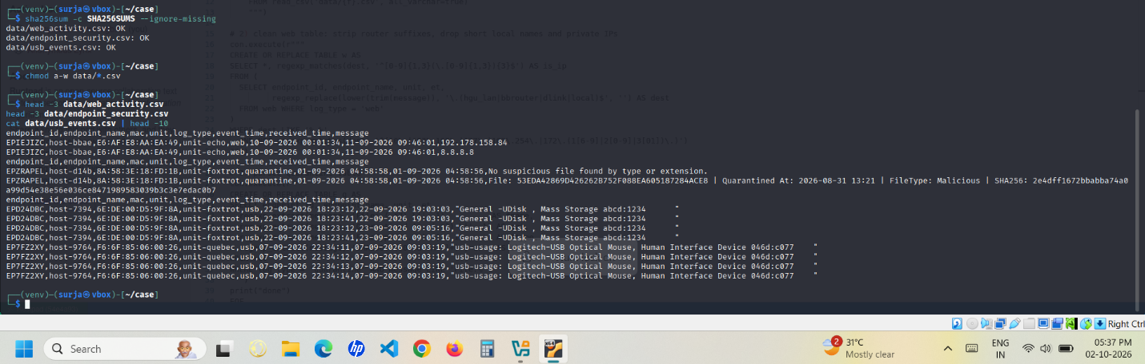Step 5: Load the logs into a DuckDB database
python3 load.py
The script converts the DD-MM-YYYY times, cleans the website names (removes router suffixes and private IPs) and splits the quarantine messages into file name, type and SHA256.
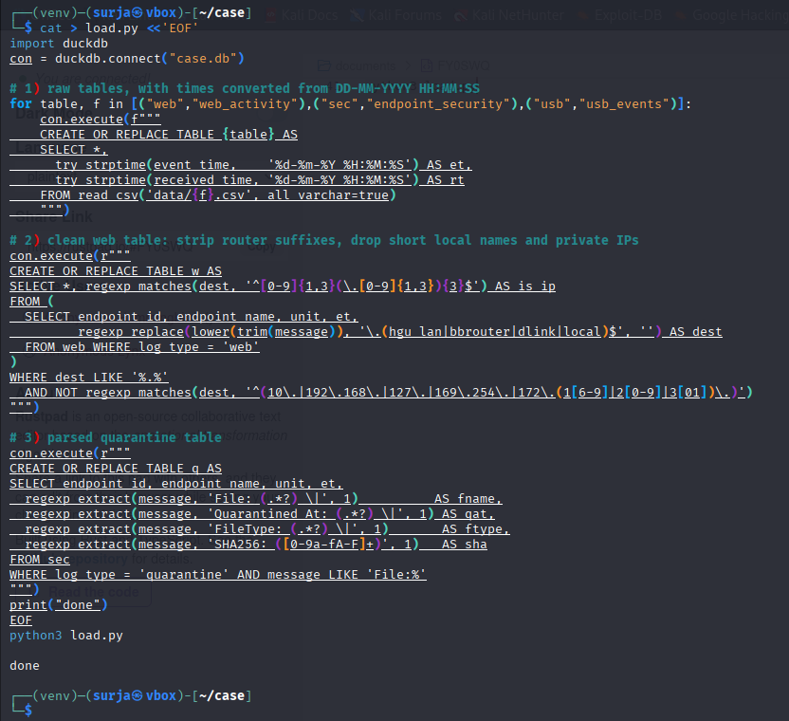
Step 6: Basic counts and date range
There are 248 endpoints in the web log (10 Sep to 21 Sep, 2,812,118 rows). The security log has 20,004 quarantine, 2,622 av_scan and 914 web_block rows. No rows had bad times.
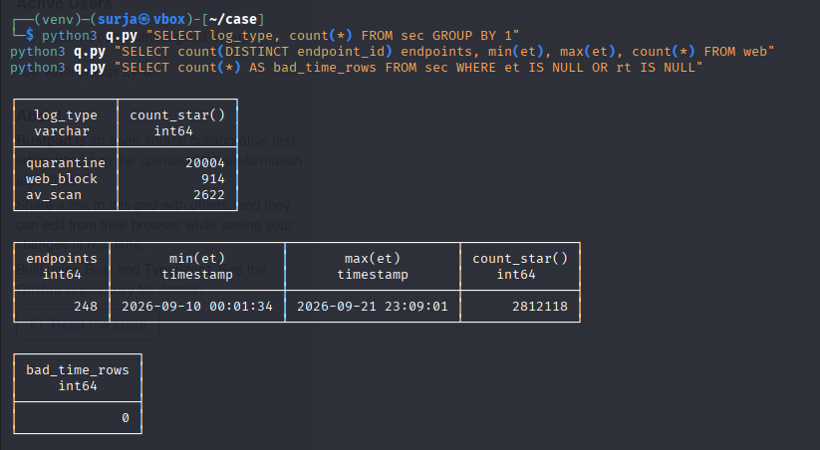
Step 7: Check the time difference between event time and received time
python3 q.py "SELECT endpoint_id, endpoint_name, unit, round(min(date_diff('second', et, rt))/3600.0,1) AS min_lag_hours, round(max(date_diff('second', et, rt))/3600.0,1) AS max_lag_hours FROM web GROUP BY ALL HAVING min(date_diff('second', et, rt)) < 0 OR max(date_diff('second', et, rt)) > 7*86400 ORDER BY 4"
122 endpoints had events received before they happened, which means their clocks are not in sync.
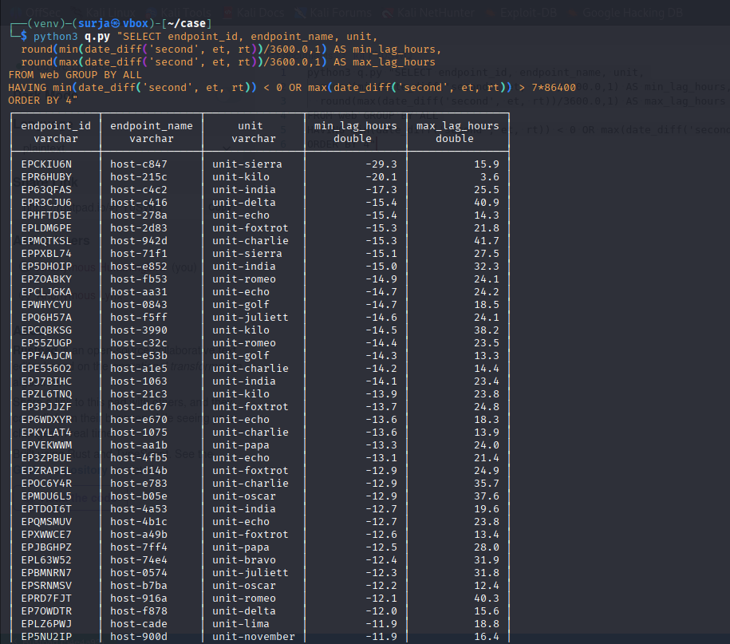
Step 8: Check the antivirus scan logs
python3 q.py "SELECT endpoint_id, endpoint_name, unit, count(*) AS n, min(et) AS first_seen, max(et) AS last_seen FROM sec WHERE log_type='av_scan' AND message LIKE '%Beginning quarantine%' GROUP BY ALL ORDER BY n DESC"
python3 q.py "SELECT endpoint_id, endpoint_name, unit, regexp_extract(message,'Quarantined and deleted: (.*?) to ',1) AS path, count(*) AS n, min(et) AS first_seen FROM sec WHERE log_type='av_scan' AND message LIKE '%Quarantined and deleted%' GROUP BY ALL ORDER BY first_seen"
My first search for “FOUND” gave 0 rows because the scanner writes “Quarantined and deleted” instead. With the correct search, 13 endpoints had detections. The deleted files include Final_Documents.zip (EPGSQVEB) and five HP installer copies (EPSES7ZK).
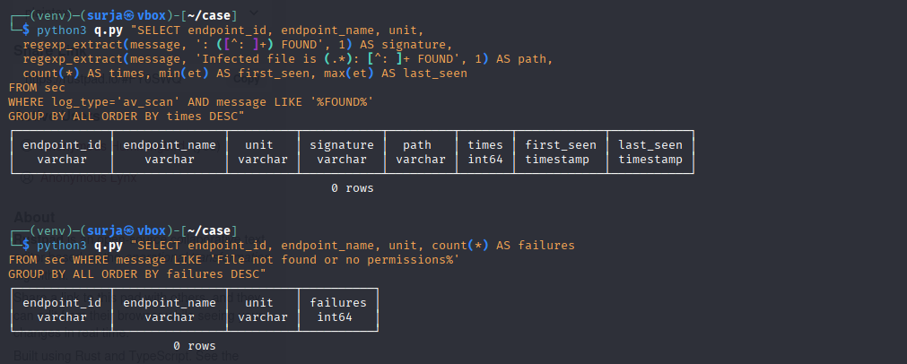
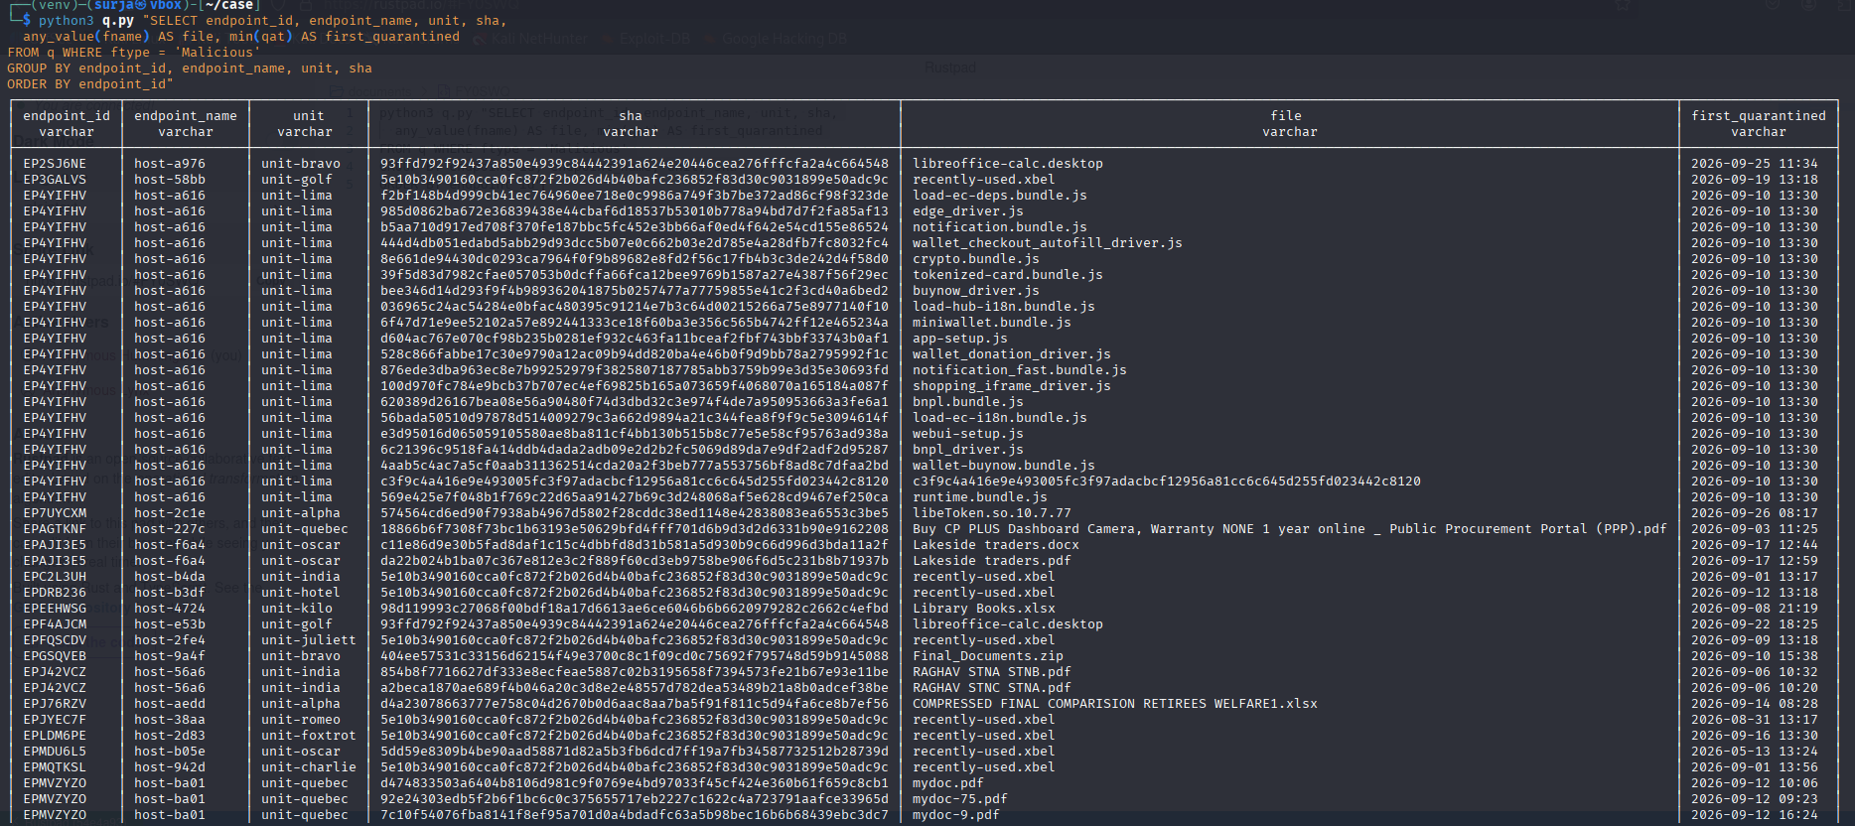

Step 9: List the files marked Malicious
python3 q.py "SELECT sha, any_value(fname) AS file, count(DISTINCT endpoint_id) AS endpoints FROM q WHERE ftype='Malicious' GROUP BY sha ORDER BY endpoints DESC"
python3 q.py "SELECT ftype, count(DISTINCT endpoint_id) AS endpoints, count(DISTINCT sha) AS files FROM q GROUP BY ftype ORDER BY files DESC"
33 endpoints and 51 files are marked Malicious. The file recently-used.xbel (same hash) appears on 9 endpoints, which is normal, and printer drivers were also flagged. These were treated as likely false positives.
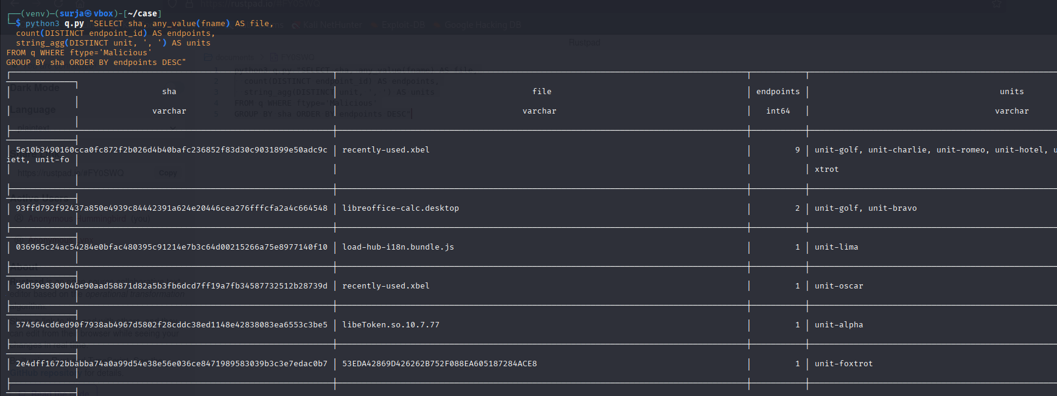Step 10: Look for rare websites and IPs
python3 rebuild_w.py
python3 q.py "SELECT dest, is_ip, count(DISTINCT endpoint_id) AS endpoints, count(*) AS hits, min(et) AS first_seen, max(et) AS last_seen, string_agg(DISTINCT unit, ',') AS units FROM w GROUP BY dest, is_ip HAVING count(DISTINCT endpoint_id) <= 3 ORDER BY endpoints, hits DESC LIMIT 100"
The website table was rebuilt to remove router names. Most rare websites were normal sites (news, mail, banking, travel).
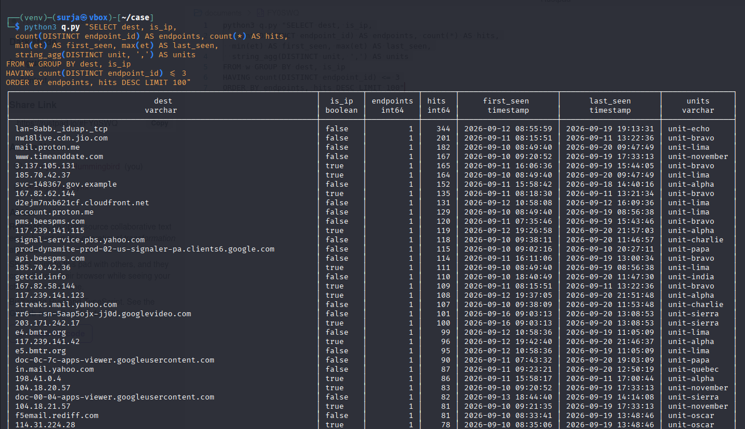
Step 11: Check for beaconing (regular call-backs)
python3 beacon.py
No endpoint showed a regular repeating connection to a rare destination.
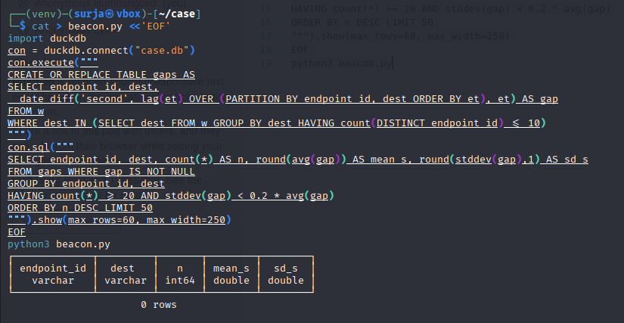
Step 12: Check blocked websites
python3 q.py "SELECT message AS blocked_dest, count(DISTINCT endpoint_id) AS endpoints, count(*) AS blocks FROM sec WHERE log_type='web_block' GROUP BY 1 ORDER BY endpoints DESC, blocks DESC LIMIT 50"
python3 q.py "SELECT endpoint_id, endpoint_name, unit, message AS blocked, count(*) AS n, min(et) AS first_seen, max(et) AS last_seen FROM sec WHERE log_type='web_block' AND message IN ('api.ipify.org','ip-api.com','yandex.ru','-','github.com','www.dropbox.com','archive.org') GROUP BY ALL ORDER BY n DESC"
Most blocks are Facebook, googleapis, LinkedIn and Instagram. Repeated api.ipify.org blocks were seen on EPIXXNDT, EPNXD2NI, EPMDU6L5 and EPTX4FCZ, so these were added to the watch list.
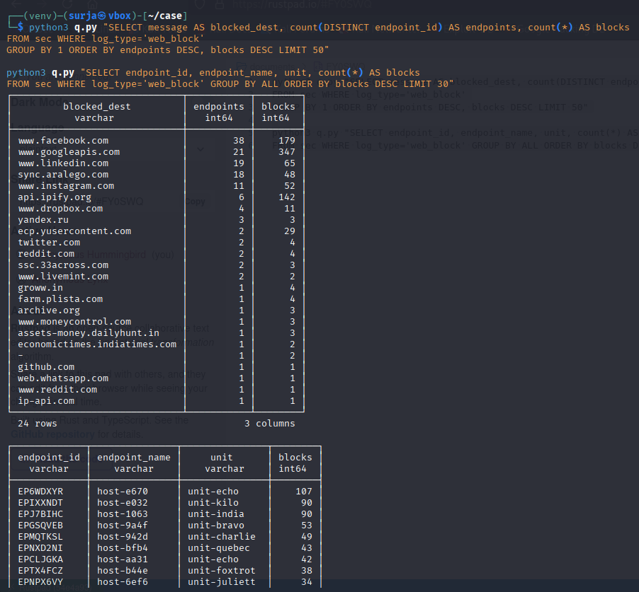
Step 13: Check USB events
python3 q.py "SELECT endpoint_id, endpoint_name, unit, et, message FROM usb ORDER BY endpoint_id, et"
Only two devices appear: a Logitech mouse on EP7FZ2XY (normal) and a General UDisk mass-storage device with ID abcd:1234 on EPD24DBC at 22 Sep 18:23.
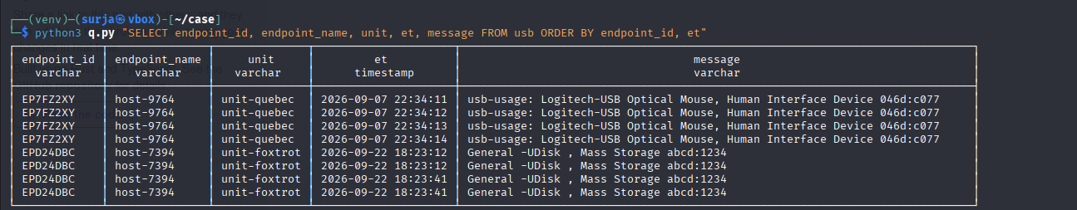
Step 14: Compare with public threat lists
cd intel
curl -sLo urlhaus.txt https://urlhaus.abuse.ch/downloads/hostfile/
curl -sLo feodo.txt https://feodotracker.abuse.ch/downloads/ipblocklist.txt
curl -sLo tor.txt https://check.torproject.org/torbulkexitlist
cd ..
grep -Fxf intel/all.txt candidates.txt
No website or IP from the logs matched these lists.
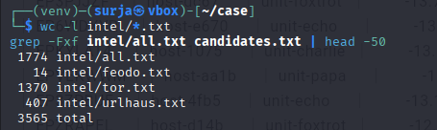

Step 15: Look for adware, odd domains and remote-access tools
python3 q.py "SELECT endpoint_id, endpoint_name, unit, dest, count(*) AS hits, min(et) AS first_seen, max(et) AS last_seen FROM w WHERE dest LIKE '%freshy%' OR dest LIKE '%searchtabnew%' OR dest LIKE '%getcid%' OR dest LIKE '%anydesk%' GROUP BY ALL ORDER BY hits DESC LIMIT 40"
python3 q.py "SELECT endpoint_id, unit, dest, count(*) AS hits FROM w WHERE dest LIKE '%66yahoo.com' OR dest LIKE '%06yahoo.com' GROUP BY ALL ORDER BY 1 LIMIT 40"
freshysearch.com, search.freshy.com and searchtabnew.com were seen on EPSES7ZK from 10 Sep. AnyDesk relay servers were seen on EPGSQVEB from 13 Sep. The yahoo look-alike names (wc.66yahoo.com, wc.06yahoo.com) only appeared on two hosts that use Yahoo Mail, so they were not treated as malicious without further proof.
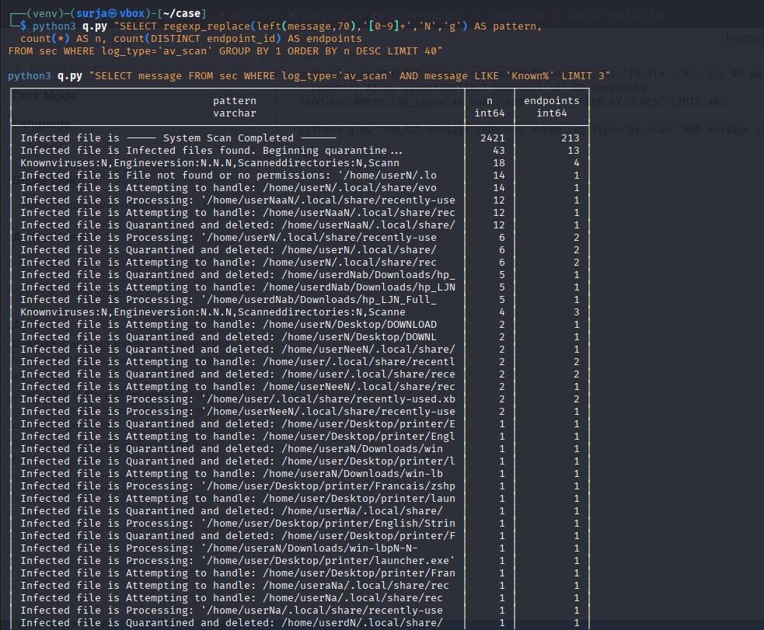
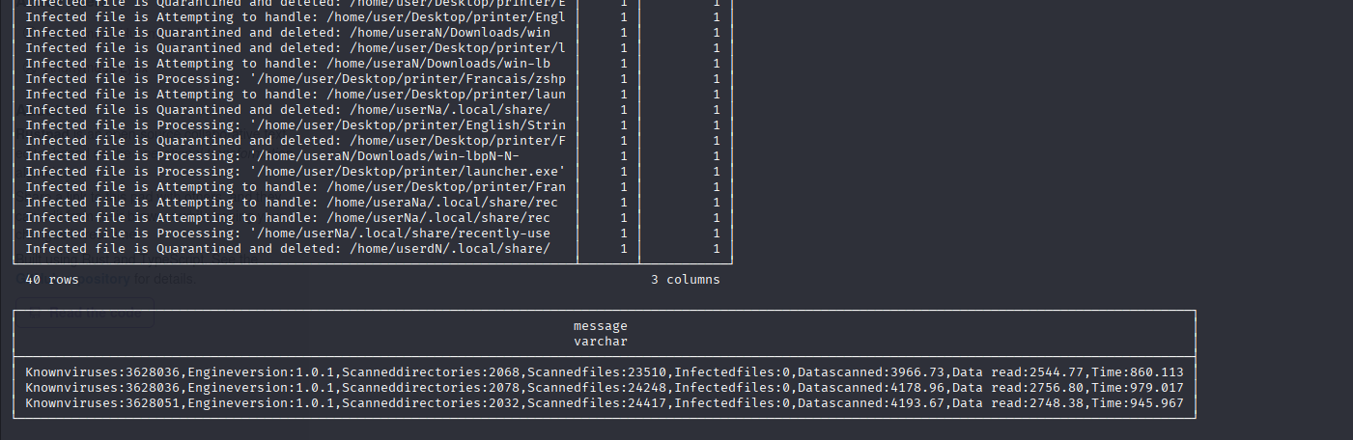

Step 16: Build a timeline for each suspect endpoint
python3 timeline.py EPSES7ZK
python3 timeline.py EPGSQVEB
python3 timeline.py EPMDU6L5
python3 timeline.py EPIXXNDT
python3 timeline.py EPNXD2NI
python3 timeline.py EPTX4FCZ
for e in EPSES7ZK EPGSQVEB EPMDU6L5 EPIXXNDT EPNXD2NI EPTX4FCZ; do python3 timeline.py $e; done > report.txt
The timeline shows security events, rare websites and daily activity for each endpoint. EPSES7ZK and EPGSQVEB showed the clearest suspicious activity, while the other four had no further bad signs.
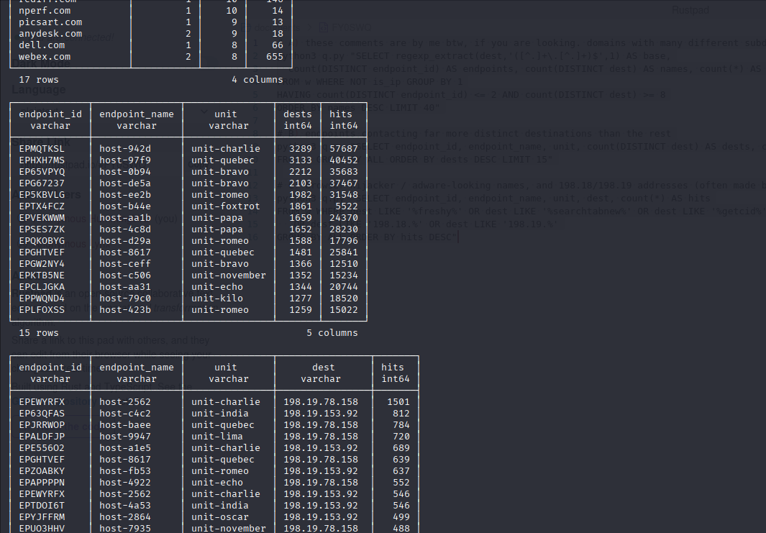
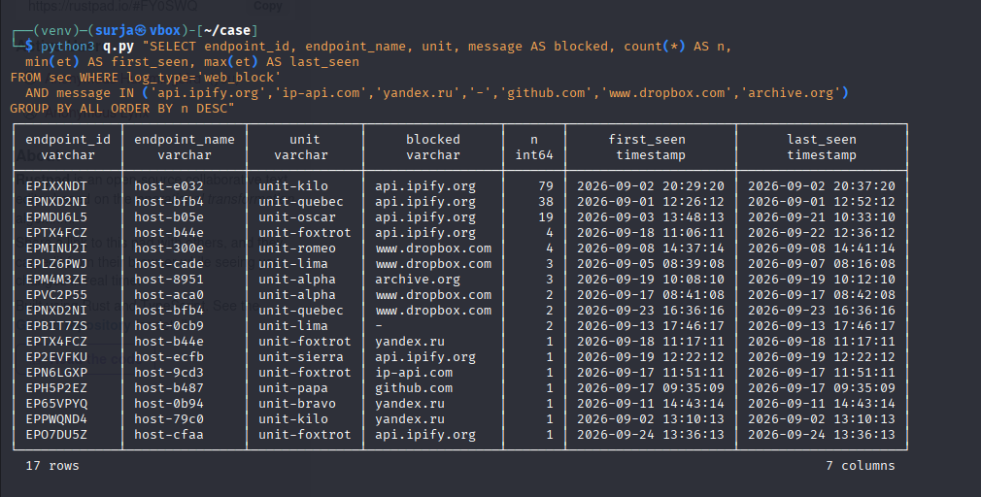

Step 17: Check the Lima endpoint (EP4YIFHV)
python3 timeline.py EP4YIFHV
python3 q.py "SELECT dest, count(*) AS hits FROM w WHERE endpoint_id='EP4YIFHV' GROUP BY 1 ORDER BY 2 DESC LIMIT 30"
It has very little traffic and no rare websites, so the 18 quarantined JavaScript files are probably a false positive.
