1. **Introduction of OS.**

An operating system acts as an intermediary between the user of a computer and computer hardware. In short its an interface between computer hardware and user. The purpose of an operating system is to provide an environment in which a user can execute programs conveniently and efficiently.

An operating system is software that manages computer hardware. The hardware must provide appropriate mechanisms to ensure the correct operation of the computer system and to prevent user programs from interfering with the proper operation of the system.

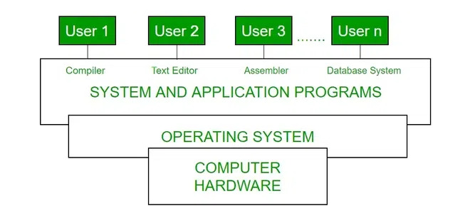

Operating System

**2. Service of OS.**

* **Process Execution**: It is the Operating System that manages how a program is going to be executed. It loads the program into the memory after which it is executed.
* **Communication Between Processes:** The Operating system manages the communication between processes. Communication between processes includes data transfer among them.
* **File Management**:The operating system helps in managing files also. If a program needs access to a file, it is the operating system that grants access.
* **Memory Management**: Allocates and de-allocates memory to processes, manages virtual memory, and ensures efficient memory utilization.
* **Security and Access Control** - Protects data and system resources through user authentication, encryption, and access permissions.

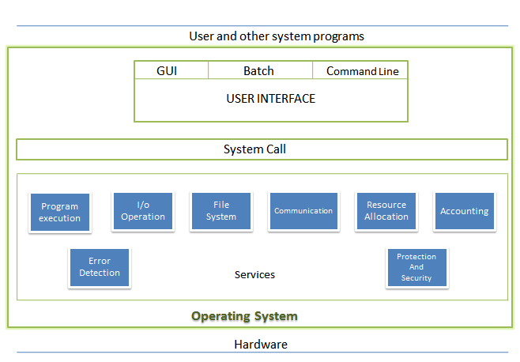

Operating System Services

**3. Need of OS.**

* **Security and Access Control:** Protects data and system resources through user authentication, encryption, and access permissions.
* **Multitasking:** The operating system manages memory and allows multiple programs to run in their own space and even communicate with each other through shared memory.
* **Managing Input-Output unit:** The operating system also allows the computer to manage its own resources such as memory, monitor, keyboard, printer, etc.
* **A platform for other software applications:** Different application programs are needed by users to carry out particular system tasks. These applications are managed and controlled by the OS to ensure their effectiveness.

**4. What is Linux?**

Linux is an open-source, Unix-like operating system kernel that serves as the foundation for various distributions (like Ubuntu, Fedora, and Debian). It's known for being stable, secure, and customizable, often used in servers, desktops, and embedded systems. Linux supports multitasking, multi-user operations, and is popular in programming, system administration, and cloud environments due to its flexibility and powerful command-line interface.

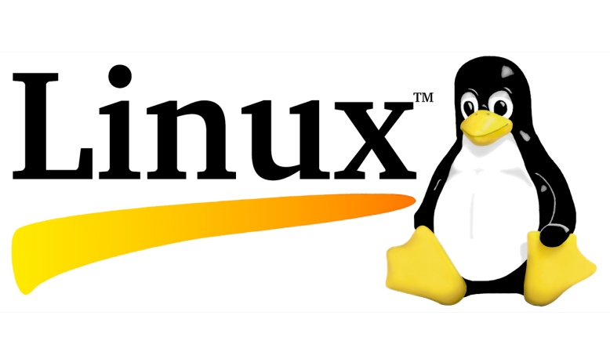

Linux OS

**5. Need for Linux.**

* **Open source:** At the core of Linux’s significance lies its open-source philosophy. Unlike proprietary operating systems, Linux is developed collaboratively by a community of passionate programmers and developers from around the globe.
* **Customizability and Flexibility:** Linux OS provides an unparalleled level of customizability and flexibility. Users have the freedom to choose from a variety of “distributions” or “distros,” each tailored to specific use cases and preferences.
* **Stability and security:** A major advantage of the Linux operating system is considered to be its stability and security. Thanks to its modular architecture and robust design, Linux is known for its ability to run for extended periods without requiring a restart, making it ideal for critical applications and servers.

**6. Linux Distributions.**

* **Ubuntu:** It came into existence in 2004 by Canonical and quickly became popular. Canonical wants Ubuntu to be used as easy graphical Linux desktop without the use of command line. It is the most well known Linux distribution. Ubuntu is a next version of Debian and easy to use for newbies. It comes with a lots of pre-installed apps and easy to use repositories libraries.
* **Debian:** Debian has its existence since 1993 and releases its versions much slowly then Ubuntu and mint. This makes it one of the most stable Linux distributor. Ubuntu is based on Debian and was founded to improve the core bits of Debian more quickly and make it more user friendly.
* **Red Hat Enterprise/Cent OS:** Red hat is a commercial Linux distributor. There products are red hat enterprise Linux (RHEL) and Fedora which are freely available. RHEL is well tested before release and supported till seven years after the release, whereas, fedora provides faster update and without any support.
* **Kali Linux:** Kali Linux is a **Debian-based Linux distribution** that comes with a number of pre-installed tools such as **Nmap, Aircrack-ng**, and **Wireshark** to help with information security tasks such as **ethical hacking.** If we are a security enthusiast or a beginner ethical hacker.
* **Fedora:** Fedora, also known as Fedora Linux, is a popular Open Source Linux-based operating system(OS) .Designed as a secure, general-purpose OS, Fedora is developed on a six-month to eight-month  release cycle under the Fedora Project. Both the OS and the Fedora Project are financially sponsored and supported by Red Hat.

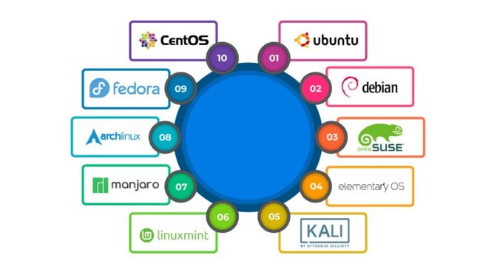

Linux Distributions

**7. Services of Linux.**

* **File and Directory Management**: Linux offers comprehensive file system management, supporting multiple file systems like ext4, XFS, and Btrfs. It allows users to create, delete, modify, and organize files and directories efficiently.
* **User Management**: Linux provides robust user and group management tools, allowing administrators to control access rights and permissions. It ensures secure multi-user environments with features like user creation, password management, and access control lists.
* **Network Services**: Linux supports various network services, including web servers (Apache, Nginx), DNS (Bind), DHCP, FTP, and SSH, enabling seamless communication and remote access over the network.
* **Process Management**: Linux provides tools to monitor and manage system processes, including task scheduling, resource allocation, and process prioritization. Commands like ps, top, and kill are essential for handling processes.
* **Security Services**: Linux offers security features such as firewalls (iptables, nftables), SELinux for access control, and encryption tools for securing data and protecting the system from unauthorized access and attacks.
* **Software Package Management**: Linux distributions use package managers (like apt, yum, or dnf) to install, update, and remove software. This ensures efficient software distribution and system maintenance.