**LINUX ARCHITECTURE**

**Linux Architecture:**

The architecture of a Linux System consists of the following layers −

* **Hardware layer** − Hardware consists of all peripheral devices (RAM/ HDD/ CPU etc).
* **Kernel** − It is the core component of Operating System, interacts directly with hardware, provides low level services to upper layer components.
* **Shell** − An interface to kernel, hiding complexity of kernel's functions from users. The shell takes commands from the user and executes kernel's functions.
* **Utilities** − Utility programs that provide the user most of the functionalities of an operating systems.

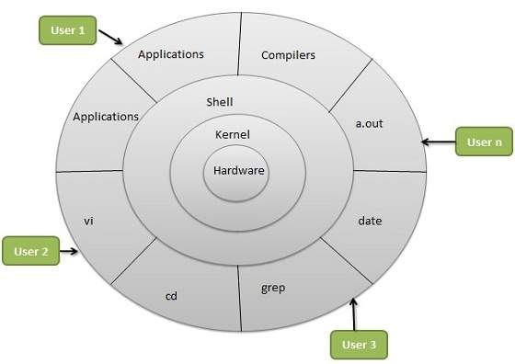

Linux Architecture

**Kernel:**

Kernel is the main core component if Linux, it controls the activity of other hardware components. It visualizes the common hardware resources and provide each process with necessary virtual resources. It makes the process to wait in the ready queue and execute in consequently to avoid any kind of conflict.

**Types of Kernel:**

There are some of the important kernel types which are as follows:

* Monolithic Kernel
* Micro Kernels
* Exo Kernels
* Hybrid Kernels

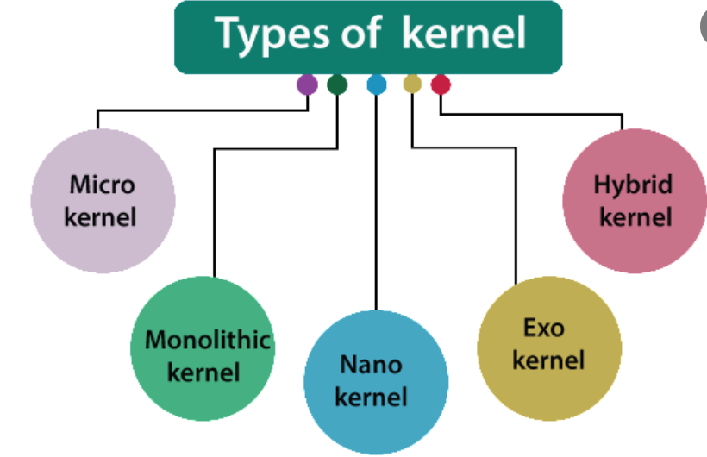

Types of kernel

1. **Monolithic Kernels:** Monolithic kernels are larger than microkernels because they house both kernel and user services in the same address space. Monolithic kernels use a faster system call communication protocol than microkernels to execute processes between the hardware and software. They're less flexible than microkernels and require more work; admins must reconstruct the entire kernel to support a new service.
2. **Micro kernels:** Microkernels have all their services in separate address spaces from the kernel. Microkernels use message passing for their communication protocol, which sends data packets, signals and functions to the correct processes. Microkernels also provide greater flexibility than monolithic kernels; to add a new service, admins modify the user address space for a microkernel.
3. **Exo kernels:** Exokernels are unique in that they expose hardware resources directly to applications. Instead of abstracting hardware functionality like other kernel types, exokernels enable applications to implement their own abstractions and management policies. This means that application developers can make the most efficient use of resources for each program. Exokernels also come with library OSes, which can export different APIs.
4. **Hybrid kernels:** Apple developed the XNU OS kernel in 1996 as a hybrid of the Mach and Berkeley Software Distribution (BSD) kernels and paired it with an Objective-C application programming interface (API). Because it's a combination of the monolithic kernel and microkernel, it has increased modularity, and parts of the OS gain memory protection.

**Shell:**

In general computing, a shell is a program that acts as an interface between the user and the operating system. It forms the connection between the operating system and human users by taking user-written commands and converting them into instructions that the OS can understand and execute.

Essentially, a shell is an interpreter program that parses user input commands and sends them to the OS. Earlier, we only had command-line interfaces (CLI), but now there are multiple graphical user interfaces (GUI)/ graphical shells available out there.

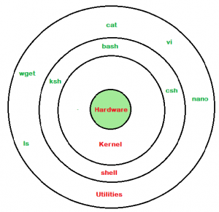

Shell

**Types of Shell:**

1. **The C Shell:** The C Shell is a Unix shell with C-like syntax and interactive command-line editing features. While it is less commonly used than shells like Bash or Zsh, it still has a presence in Unix-like operating systems, including Linux. It includes features such as command line editing, error status, fatal errors, history, and job control.

Command full-path name is /bin/csh,

Non-root user default prompt is hostname %,

Root user default prompt is hostname #.

1. **The Bourne Shell:** The **Bourne shell** was the first default shell on Unix systems, released in 1979.

Command full-path name is /bin/sh and /sbin/sh,

Non-root user default prompt is $,

Root user default prompt is #.

1. **The Korn Shell:** The **KornShell (ksh**) is a Unix shell and language based on the Bourne shell (sh) developed in the early 1980s.

Command full-path name is /bin/ksh,Non-root user default prompt is $,

Root user default prompt is #.

1. **GNU Bourne-Again Shell:** It is compatible to the Bourne shell. It includes features from Korn and Bourne shell.

Command full-path name is /bin/bash,

Default prompt for a non-root user is bash-g.gg$

(g.ggindicates the shell version number like bash-3.50$),

Root user default prompt is bash-g.gg#.