**Linux Lab -02**

# 1. man command ->

**Syntax: man [command]**

**Example: man man**

**2. whatis command ->**

**Syntax: whatis [command]**

# Example: whatis pwd

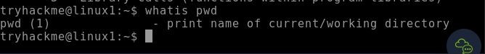

# 3. date command ->

**Syntax: date [option]...[+format]**

**Example: date -d “2000-11-20 09:10:15”**

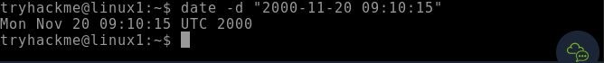

**4. ls command ->**

**Syntax: ls [option] [file/directory]**

# Example: ls -l

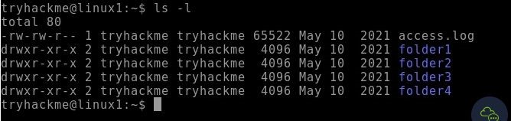

# 5. mkdir command ->

**Syntax: mkdir [directory]**

**Example: mkdir newdocuments**



# 6. cd command ->

**Syntax: cd [directory]**

**Example: cd newdocuments**



**7. pwd command ->**

**Syntax: pwd [directory]**

# Example: pwd

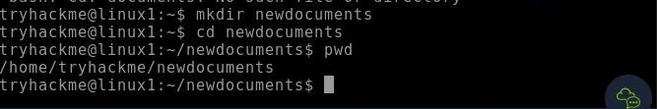

# 8. rmdir command ->

**Syntax: rmdir [directory]**

**Example: rmdir newdocuments**

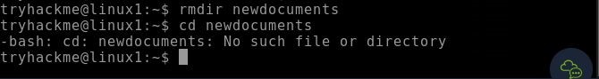

# 9. cat command ->

**Syntax: cat [option] [File]**

**Example: cat dsa.txt**



# 10. find command ->

**Syntax: find [path] [option] [expression]**

**Example: find ~ -name “dsa.txt”**



**11. cal command ->**

**Syntax: cal [month] [year]**

# Example: cal 02 2024

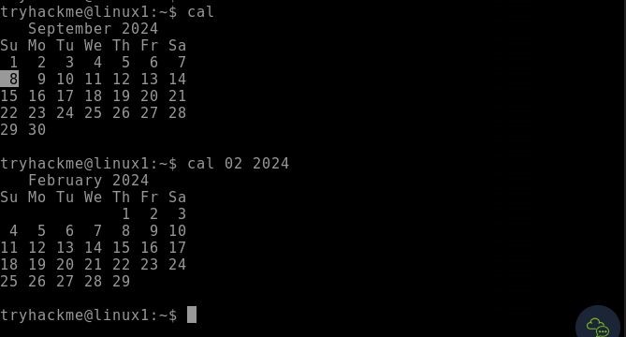

# 12. grep command ->

**Syntax: grep [options] pattern [files]**

**Example: grep -l “unix” \***

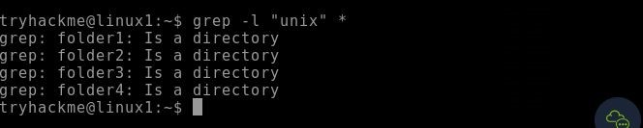

# 13. echo command ->

**Syntax: echo “text”**

**Example: echo “Hello World”**

