**Syed Kaab Surkhi**

Bachelor of Computer Engineering

(647)515-7386 |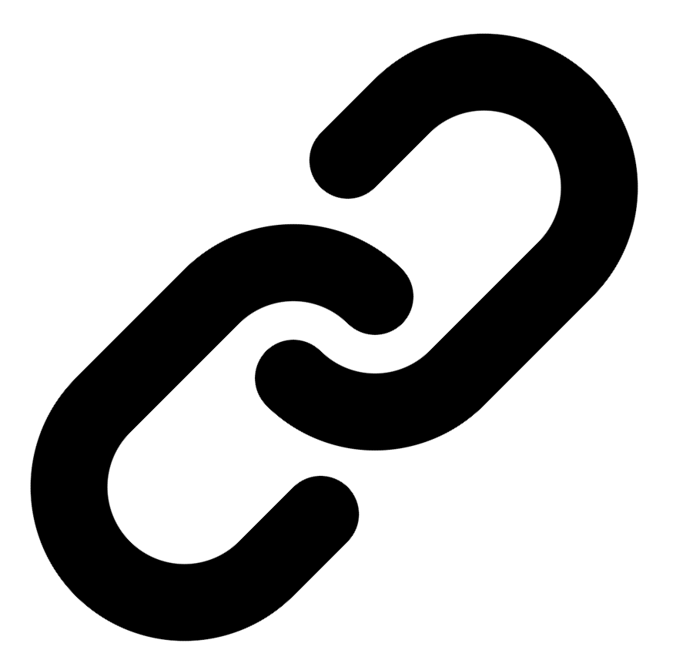[Linkedin](https://www.linkedin.com/in/syed-kaab-surkhi/) |[Portfolio](https://syedkaabsurkhi.com/) |[Github](https://github.com/SurkhiSyed) | [ssurkhi56@gmail.com](mailto:ssurkhi56@gmail.com)

**EDUCATIONBachelor of Engineering (B.Eng), Computer Engineering,** Toronto Metropolitan University *2023 - 2027* **Relevant Courses:** COE 318 - Software Systems | COE 428 - Engineering Algorithms and Data Structures | COE 528 - Object Oriented Eng Analysis and Design | ELE 404 - Electronic Circuits I | COE 328 - Digital Systems

**TECHNICAL SKILLS**

**Programming Skills:** Python, C++, C, C#, MATLAB, Java, MySQL

**Frameworks:** Flask, Node.js, React.js, Tailwind CSS, OpenCV, Websocket, Golang, CLI Tools, PyGTK, Ros2, TCP Connections, Streamlit

**Tools:** CAD, 3D Printing, Electric Circuits, Git, Firebase, Arduino, NI Multisim, Quartus, NetBeans, Unity, JavaFX, Supabase, Vector DB

**WORK EXPERIENCE**