**Syed Kaab Surkhi**

Bachelor of Computer Engineering

(647)515-7386 |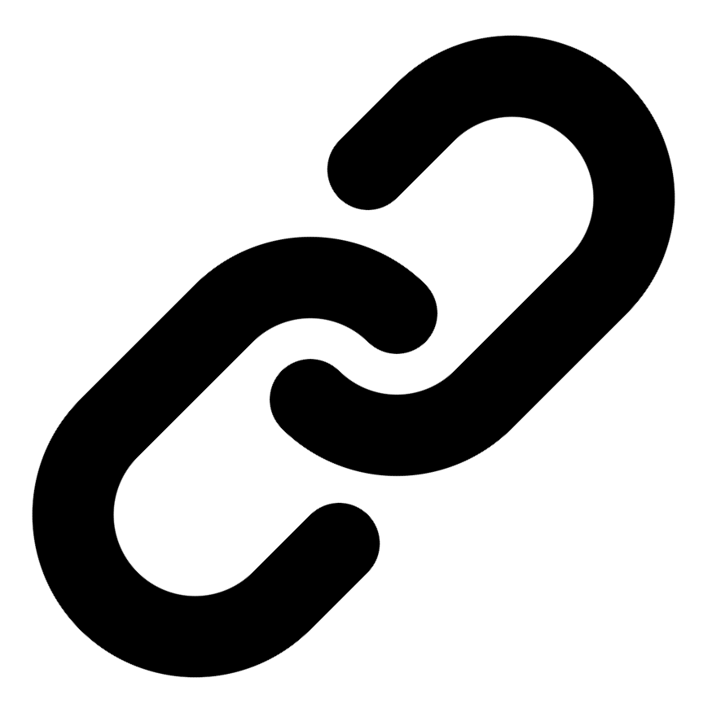[Linkedin](https://www.linkedin.com/in/syed-kaab-surkhi/) |[Portfolio](https://syedkaabsurkhi.com/) |[Github](https://github.com/SurkhiSyed) | [ssurkhi56@gmail.com](mailto:ssurkhi56@gmail.com)

**EDUCATIONBachelor of Engineering (B.Eng), Computer Engineering,** Toronto Metropolitan University *2023 - 2027* **Relevant Courses:** COE 318 - Software Systems | COE 428 - Engineering Algorithms and Data Structures | COE 528 - Object Oriented Eng Analysis and Design | ELE 404 - Electronic Circuits I | COE 328 - Digital Systems

**TECHNICAL SKILLS**

**Programming Skills:** Python, C++, C, C#, MATLAB, Java, MySQL

**Frameworks:** Flask, Node.js, React.js, Tailwind CSS, OpenCV, Websocket, Golang, CLI Tools, PyGTK, Ros2, TCP Connections, Streamlit

**Tools:** CAD, 3D Printing, Electric Circuits, Git, Firebase, Arduino, NI Multisim, Quartus, NetBeans, Unity, JavaFX, Supabase, Vector DB

**WORK EXPERIENCE**

**Full Stack Developer, Momentum AI** — May 2025 – Ongoing

• Developed a full-stack AI-powered study application featuring flashcards, study planners, exam generators, and a RAG-trained study assistant.

• Implemented complete application functionalities, including backend APIs using Flask, frontend using React.js, and database integrations.

• Collaborated with a team of developers in a fast-paced startup environment to deliver a production-ready application.

**Software Developer, Toronto MetRobotics** — Oct 2024 – Ongoing

• Implemented a control program for a robotics rover, enabling simultaneous component management via a game controller and data transmission using PySocket and WebSockets.

• Developed a GUI for a multi-camera system using PyGST and TCP connections, incorporating CLI tools for testing.

• Incorporated dual production pipelines with varying methods to optimize for speed and smooth streaming.

**Network Programming Controls and Web Developer, Metropolitan Hyperloop** — Sep 2024 – Ongoing

• Collaborated with marketing teams to develop a promotional website using React.js and Tailwind CSS, including a multi-tier sponsorship benefit system.

• Built a GUI to display critical pod operational data, connecting a central Raspberry Pi to the backend via TCP connections for data transmission.

• Successfully integrated data visualization and user interfaces to streamline operational monitoring.

**TECHNICAL PROJECTS**

**Vireel - News Aggregation App** *| React.js, Tailwind CSS, Python, Flask, Firebase, API Integration, Gemini API, News API, JavaScript*

• Engineered a news aggregation application integrating four APIs (Gemini, News API, etc.) to deliver personalized news summaries.

• Developed a full-stack application using React.js/Tailwind CSS (frontend) and Python/Flask (backend) for a user-friendly experience.

• Implemented features including user profiles, messaging, liked articles, and genre customization to enhance user engagement.

**BetEd - Tech Collaboration Platform** *| Streamlit, Python, Retrieval-Augmented-Generation (RAG), Snowflake, Mistral LLM, Cortex Search, JavaScript, Full Stack*

• Developed a full-stack platform using Streamlit, Python, and JavaScript for tech collaboration and training.

• Implemented Retrieval Augmented Generation (RAG) using Snowflake, Mistral LLM, and Cortex Search to power an AI tutoring model.

• Enabled collaborative problem-solving through a competitive environment with professional feedback mechanisms.

**Inclusee - Accessibility Addon for Adobe Express** *| Adobe API, JavaScript, React, Accessibility, UX/UI*

• Developed a browser extension that analyzes design elements in Adobe Express to provide accessibility feedback.

• Implemented real-time suggestions for improving color contrast, font choices, and layout for users with visual impairments.

• Improved the accessibility of designs by providing actionable insights to designers based on WCAG guidelines.