**Syed Kaab Surkhi**

Bachelor of Computer Engineering

(647)515-7386 |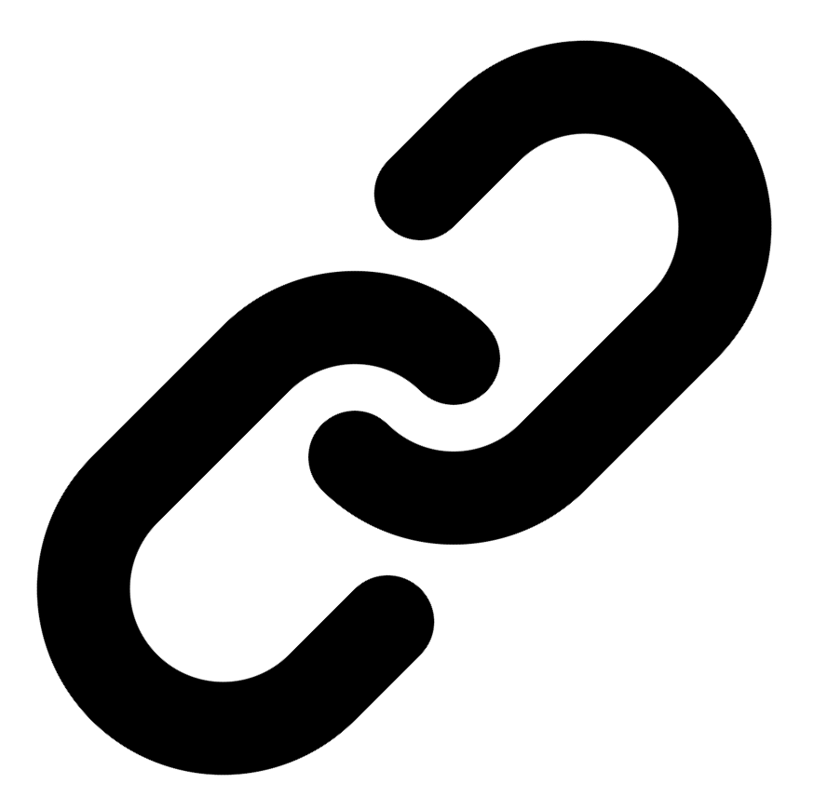[Linkedin](https://www.linkedin.com/in/syed-kaab-surkhi/) |[Portfolio](https://syedkaabsurkhi.com/) |[Github](https://github.com/SurkhiSyed) | [ssurkhi56@gmail.com](mailto:ssurkhi56@gmail.com)

**EDUCATIONBachelor of Engineering (B.Eng), Computer Engineering,** Toronto Metropolitan University *2023 - 2027* **Relevant Courses:** COE 318 - Software Systems | COE 428 - Engineering Algorithms and Data Structures | COE 528 - Object Oriented Eng Analysis and Design | ELE 404 - Electronic Circuits I | COE 328 - Digital Systems

**TECHNICAL SKILLS**

**Programming Skills:** Python, C++, C, C#, MATLAB, Java, MySQL

**Frameworks:** Flask, Node.js, React.js, Tailwind CSS, OpenCV, Websocket, Golang, CLI Tools, PyGTK, Ros2, TCP Connections, Streamlit

**Tools:** CAD, 3D Printing, Electric Circuits, Git, Firebase, Arduino, NI Multisim, Quartus, NetBeans, Unity, JavaFX, Supabase, Vector DB

**WORK EXPERIENCE**

**Software Developer, Toronto MetRobotics** — Oct 2024 – Ongoing

• Implemented a control program for a Robotics Rover, enabling simultaneous component management via a game controller and data transmission using PySocket and WebSocket libraries.

• Developed a GUI for a multi-camera system using PyGST, leveraging TCP connections and CLI tools for testing; improved data visualization and system monitoring.

**Full Stack Developer, Momentum AI** — May 2025 – Ongoing

• Developed a full-stack AI study application featuring flashcards, study planner, exam generator, and a RAG-trained study assistant; integrated various functionalities within a Flask backend and minimal React.js frontend.

• Designed and implemented database schema for efficient data management and retrieval within the study application, optimizing for scalability and performance.

**Network Programming Controls and Web Developer, Metropolitan Hyperloop** — Sep 2024 – Ongoing

• Developed a promotional website using React.js and Tailwind CSS, collaborating with marketing teams to design a multi-tier sponsorship benefit system; improved brand visibility and sponsor engagement.

• Built a GUI to display real-time pod data, connecting a central Raspberry Pi to the backend via TCP for efficient data transmission; enhanced real-time monitoring and operational efficiency.

**TECHNICAL PROJECTS**

**Vireel** *| React.js, Tailwind CSS, Python, Flask, Firebase, API Integration, Gemini API, News API*

• Engineered a full-stack news aggregation application integrating four APIs (Gemini, News API, etc.) to deliver personalized news summaries.

• Developed the frontend using React.js and Tailwind CSS, and the backend using Python Flask and Firebase, enabling personalized news feeds and user engagement features.

**BookCartFX** *| Java, JavaFX, FXML, UML, Design Patterns, Object-Oriented Programming*

• Developed a JavaFX bookstore application with secure user authentication and real-time book management, utilizing FXML for UI design.

• Collaborated on system architecture design using UML modeling and design patterns, ensuring application scalability and maintainability.

**BetEd** *| Python, Streamlit, Snowflake, Mistral LLM, Cortex Search, Retrieval-Augmented Generation*

• Implemented Retrieval Augmented Generation (RAG) for an AI model using Snowflake database, Mistral LLM, and Cortex Search, improving model accuracy and efficiency.

• Developed a Streamlit frontend for a networking platform connecting tech seekers with mentors and challenges, facilitating collaboration and skill development.