**Syed Kaab Surkhi**

Bachelor of Computer Engineering

(647)515-7386 |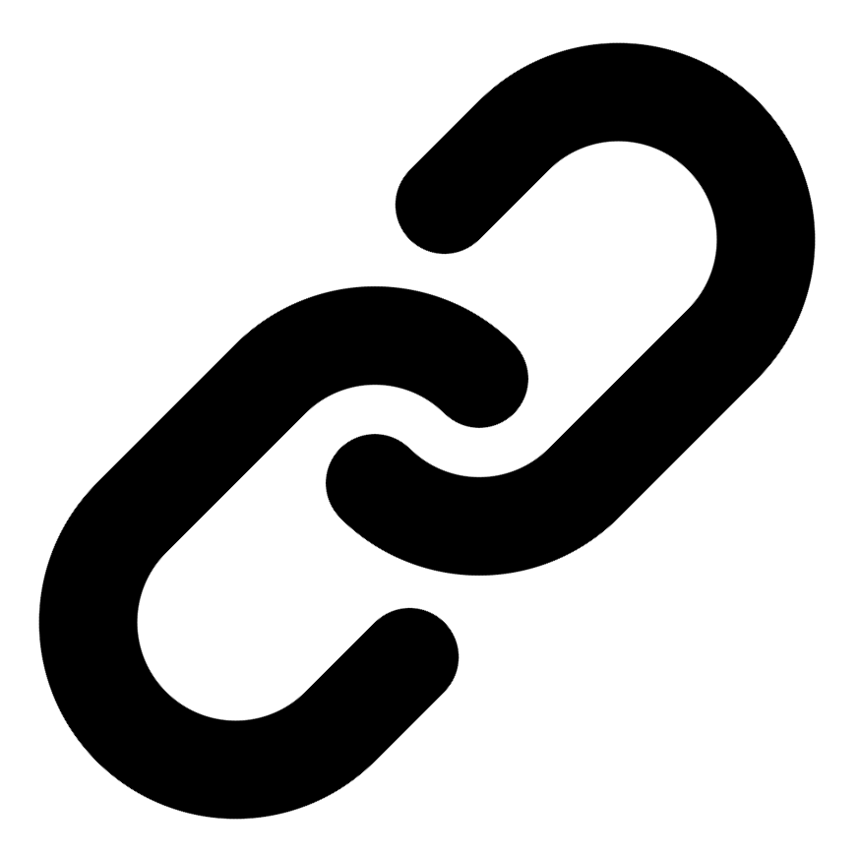[Linkedin](https://www.linkedin.com/in/syed-kaab-surkhi/) |[Portfolio](https://syedkaabsurkhi.com/) |[Github](https://github.com/SurkhiSyed) | [ssurkhi56@gmail.com](mailto:ssurkhi56@gmail.com)

**EDUCATIONBachelor of Engineering (B.Eng), Computer Engineering,** Toronto Metropolitan University *2023 - 2027* **Relevant Courses:** COE 318 - Software Systems | COE 428 - Engineering Algorithms and Data Structures | COE 528 - Object Oriented Eng Analysis and Design | ELE 404 - Electronic Circuits I | COE 328 - Digital Systems

**TECHNICAL SKILLS**

**Programming Skills:** Python, C++, C, C#, MATLAB, Java, MySQL

**Frameworks:** Flask, Node.js, React.js, Tailwind CSS, OpenCV, Websocket, Golang, CLI Tools, PyGTK, Ros2, TCP Connections, Streamlit

**Tools:** CAD, 3D Printing, Electric Circuits, Git, Firebase, Arduino, NI Multisim, Quartus, NetBeans, Unity, JavaFX, Supabase, Vector DB

**WORK EXPERIENCE**

**Research Practicum Assistant,** Toronto Metropolitan University, May 2024 - May 2025

* **Evaluated** 3 international research papers and **benchmarked** curriculum outlines from over thirteen Canadian universities; **pinpointed** key textbooks, culminating in comprehensive recommendations for a redesigned Linear Algebra course structure.
* **Collaborated** with a professor and a team of 3 assistants to **design** an impactful teaching plan for a first-year Linear Algebra course.
* **Partnering** with organizations to **develop** an open-source textbook in PreText, **transitioning** concepts from pre-calculus to advanced university-level mathematics.

**Network Programming Controls and Web Developer,** [Metropolitan Hyperloop](https://methyperloop.netlify.app/)**,** Sep 2024 – Ongoing

* **Collaborated** with various operation-teams such as marketing to develop a promotional website, **utilizing** React.js and Tailwind CSS and **designing** a multi-tier sponsorship benefit system.
* **Built** a **GUI** to display significant readout data when running the pod and connected a central **RaspberryPi** to the backend of the GUI via **TCP Connection** for successful transmission of the data.

**Software Developer,** Toronto MetRobotics Oct 2024 – Ongoing

* **Implemented** a control program for a Robotics Rover, **enabling** simultaneous component management through a game controller, and **transmitting** data with the **Pysocket and Websocket libraries**.
* **Developed** a **GUI** for a multi-camera system on the rover with **PyGST** with the use of **TCP Connections** and **CLI tools** for testing.
* **Incorporated** dual production **pipelines** with different methods to efficiently target needs such as faster or smooth streaming.

**Full Stack Developer,** Momentum AI May 2025 – Ongoing

* **Worked** with a group of developers in a **startup** to **create** an **AI** **full stack** study application with various tools such as **flashcards generator, study planner, exam generator**, and **RAG** trained studying assistant.
* **Implemented** the complete **functionalities** in a **Flask** backend connected with a minimal **React.js** frontend along with databases.

**Term Project Leader,** Toronto Metropolitan University Sep 2023 – Nov 2023

* **Facilitated** a 10-member team in **redesigning** the 3D printing process, integrating environmental and efficiency improvements while **consulting** with the team advisor and group advisors weekly in various team meetings for areas of revisions**.**
* Researched safer alternatives and programmed the fill process in **Java** leading to development of 3 iterations of the process redesign.

**TECHNICAL PROJECTS** [**Inclusee,**Hackthe6ix](https://devpost.com/software/inclusee) | *ReactJS, Adobe-Add-On-SDK, css3, JavaScript* July 2024

* **Programmed** an Adobe Express Add-On within 36 hours, **enhancing** design accessibility for users with low vision, dyslexia, and other impairments; currently **undergoing** review for the official Adobe Add-On marketplace.
* **Incorporating** real-time feedback by analyzing colors, fonts, and layouts used with **React.js, Javascript, and CSS.**

[**Vireel,**Google Gemini API Developer Competition | Startup](https://github.com/SurkhiSyed/Vireel) | *Flask, Python, ReactJS, TailwindCSS, GeminiAPI, JavaScript* August 2024

* **Engineered** a news aggregation app, integrating four APIs including **Gemini** and **News API** to **curate** personalized, concise news for users in the Google Gemini API Developer Competition.
* **Leveraged** the **React.js** framework and **Tailwind CSS** for the frontend, with **Python Flask** for the backend, to build a comprehensive full-stack social media app, featuring messaging, liked articles, and genre customization.

[**BetEd,** Snowflake Rag ‘n’ Roll Competition](https://devpost.com/software/project-hk1nfi?ref_content=my-projects-tab&ref_feature=my_projects) | *Streamlit, Python, WebScraping, JavaScript, RAG, TailwindCSS, Firebase, Snowflake* January 2025

* **Developed** a networking platform for inexperienced tech seekers to **collaborate** on challenging competitions while being tutored by a **trained learning model** and receiving feedback from professionals at the Snowflake RAG competition.
* **Implemented** **Retrieval Augmented Generation (RAG)** for training an AI model with the use of **Snowflake** database for storing documentation, **Mistral LLM** for generation, **Cortex Search** for retrieval, and **Streamlit** for the frontend display.

[**BookCartFX**](https://github.com/SurkhiSyed/BookCartFX)[**,**](https://devpost.com/software/project-hk1nfi?ref_content=my-projects-tab&ref_feature=my_projects) | *Java, JavaFX, SceneBuilder, FXML, UML Modeling, Design Patterns, Java GUI*  March 2025

* **Developed** a Bookstore application in **JavaFX**, implementing secure user authentication, encrypted data storage, and real-time book management functionalities.
* Collaborated in a team to design and implement system architecture using UML modeling and design patterns, ensuring scalability.

[**Embedded Vision Controlled Car**](https://github.com/SurkhiSyed/Programmable-RadioControlled-Car)

* Built an Arduino car using various **components** including motor controllers, motors, ESP32 CAM, Arduino Uno, and Servo Motors.
* Made with **C++** and further developing it to perform tasks such as image recognition and target locking with **OpenCV.**

[**Simple Central Processing Unit (CPU)**](https://github.com/SurkhiSyed/Simple-Central-Processing-Unit)

* **Created** a multi-functional CPU in a **VHDL** environment developed on an FPGA board that uses two 8 bit inputs, clock inputs, enable inputs, and resets to provide hexadecimal output effectively. **Programmed** using **VHDL** code on **Altera Quartus**.
* **Implemented** different functionalities using an **FSM state machine**, **latches**, a **decoder**, **7 segment converters**, and **arithmetic and logic units (ALU cores)**. Used block schematics and logic waveforms to simulate CPU before implementation on the board.

[**ExploreWorld Unity**](https://github.com/SurkhiSyed/Final-ExploreWorld)

* Created a solo exploration game with a task objective of exploring the physics concepts and principles such as gravity, acceleration, mass, and forces on various in-game objects with **C#** in **Unity**. Includes the control of over two vehicles with different physics principles.
* Integrates components such as terrain and over six skyboxes, utilizing Unity's **physics engine** to create a challenging simulation game.

**DinoNFT, HawkHacks**

* Made a **web3** video game similar to that of the google offline game using **Javascript** and **p5.js** in a competitive event within 48 hours and secured 3rd place win in the web3 category
* Incorporate a reward system for the player by connecting their blockchain wallet to the game, and transfer tokens based on their scores

[**Land Average Temperatures Analyzer,**](https://github.com/SurkhiSyed/LandAverageTemperatures)

* **Developed** a **C** program that studies different average land temperatures over 3 centuries using **CSV files** and outputs different averages.
* Used **GNU Plots** to create different plots in respect to the outputted data to evaluate trends and report conclusions.

# Tailored Experience Highlights

**Software Developer, Toronto MetRobotics**

Implemented a robotics rover control program using PySocket and Websocket libraries for data transmission.

Developed a multi-camera GUI using PyGST, TCP connections, and CLI tools for testing and efficient streaming.

# Tailored Project Highlights

**BetEd:**

Developed a networking platform using Snowflake, Mistral LLM, and Cortex Search.

Implemented Retrieval Augmented Generation (RAG) for AI model training.