**Syed Kaab Surkhi**

Bachelor of Computer Engineering

(647)515-7386 |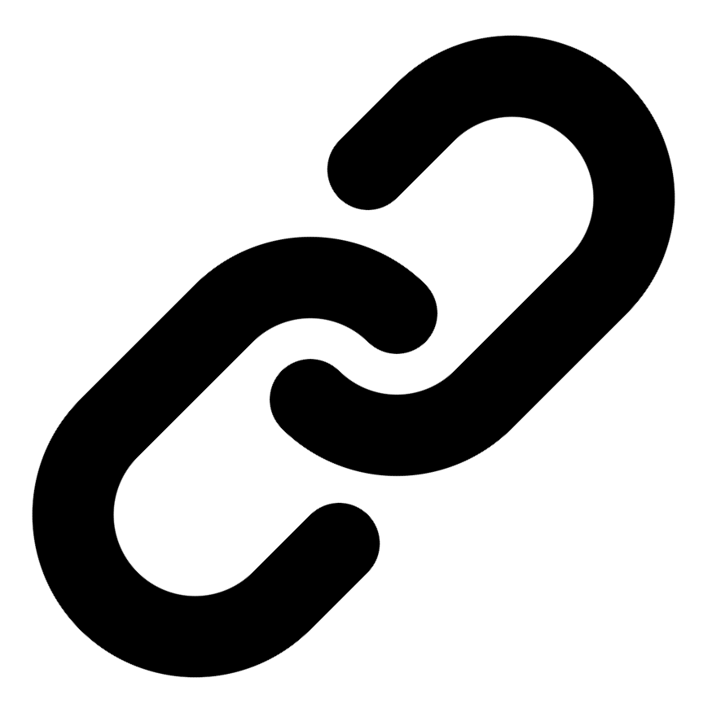[Linkedin](https://www.linkedin.com/in/syed-kaab-surkhi/) |[Portfolio](https://syedkaabsurkhi.com/) |[Github](https://github.com/SurkhiSyed) | [ssurkhi56@gmail.com](mailto:ssurkhi56@gmail.com)

**EDUCATIONBachelor of Engineering (B.Eng), Computer Engineering,** Toronto Metropolitan University *2023 - 2027* **Relevant Courses:** COE 318 - Software Systems | COE 428 - Engineering Algorithms and Data Structures | COE 528 - Object Oriented Eng Analysis and Design | ELE 404 - Electronic Circuits I | COE 328 - Digital Systems

**TECHNICAL SKILLS**

**Programming Skills:** Python, C++, C, C#, MATLAB, Java, MySQL

**Frameworks:** Flask, Node.js, React.js, Tailwind CSS, OpenCV, Websocket, Golang, CLI Tools, PyGTK, Ros2, TCP Connections, Streamlit

**Tools:** CAD, 3D Printing, Electric Circuits, Git, Firebase, Arduino, NI Multisim, Quartus, NetBeans, Unity, JavaFX, Supabase, Vector DB

**WORK EXPERIENCE**

TECHNICAL PROJECTS

## BookCartFX

• Developed a JavaFX bookstore application with secure user authentication.

• Implemented real-time book management functionalities for efficient operations.

• Collaborated on system architecture design using UML and design patterns for scalability.

## BetEd

• Implemented Retrieval Augmented Generation (RAG) for AI model training.

• Utilized Snowflake database, Mistral LLM, and Cortex Search for efficient data management and retrieval.

• Developed a networking platform to support collaborative learning and professional feedback.

## Vireel

• Developed a news aggregator application delivering concise news summaries.

• Enabled user features including saving, sharing, and commenting for engagement.

• Implemented integration with multiple APIs for diverse and user-tailored content.

## Software Developer, Toronto MetRobotics

• Implemented a control program for a Robotics Rover, enabling simultaneous component management.

• Developed a GUI for a multi-camera system using PyGST, TCP Connections, and CLI tools.

• Incorporated dual production pipelines for efficient streaming and faster data transmission.

## Full Stack Developer, Momentum AI

• Developed a full-stack AI study application with features such as flashcards and exam generators.

• Implemented application functionalities using a Flask backend, React.js frontend, and databases.

• Collaborated with developers in a startup environment to deliver a complete application.

## Network Programming Controls and Web Developer, Metropolitan Hyperloop

• Developed a promotional website using React.js and Tailwind CSS for marketing and sponsorship.

• Built a GUI to display data from a RaspberryPi via TCP connection for data transmission.

• Collaborated with operation teams to design a multi-tier sponsorship benefit system.