**Syed Kaab Surkhi**

Bachelor of Computer Engineering

(647)515-7386 |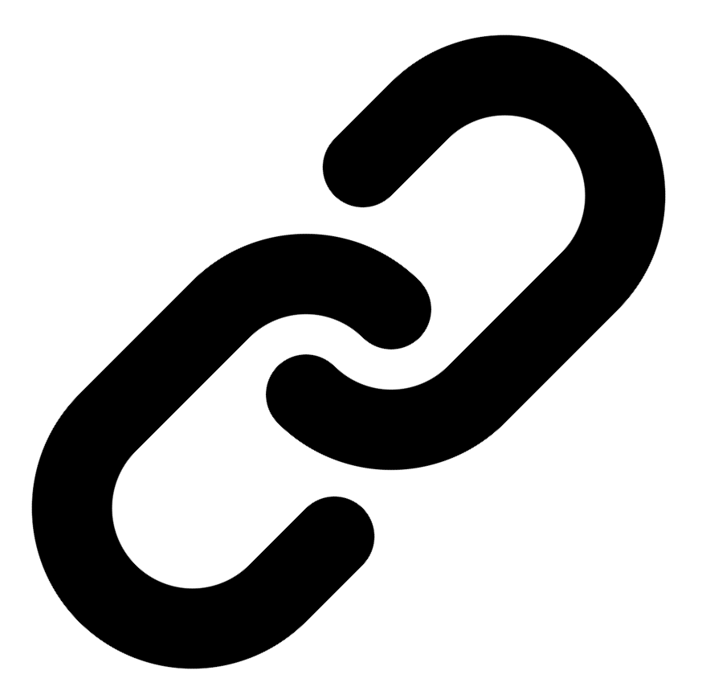[Linkedin](https://www.linkedin.com/in/syed-kaab-surkhi/) |[Portfolio](https://syedkaabsurkhi.com/) |[Github](https://github.com/SurkhiSyed) | [ssurkhi56@gmail.com](mailto:ssurkhi56@gmail.com)

**EDUCATIONBachelor of Engineering (B.Eng), Computer Engineering,** Toronto Metropolitan University *2023 - 2027* **Relevant Courses:** COE 318 - Software Systems | COE 428 - Engineering Algorithms and Data Structures | COE 528 - Object Oriented Eng Analysis and Design | ELE 404 - Electronic Circuits I | COE 328 - Digital Systems

**TECHNICAL SKILLS**

**Programming Skills:** Python, C++, C, C#, MATLAB, Java, MySQL

**Frameworks:** Flask, Node.js, React.js, Tailwind CSS, OpenCV, Websocket, Golang, CLI Tools, PyGTK, Ros2, TCP Connections, Streamlit

**Tools:** CAD, 3D Printing, Electric Circuits, Git, Firebase, Arduino, NI Multisim, Quartus, NetBeans, Unity, JavaFX, Supabase, Vector DB

**WORK EXPERIENCE**

**TECHNICAL PROJECTS**

**BetEd** *| Retrieval-Augmented-Generation, Snowflake, Mistral LLM, Cortex Search, Streamlit, Python, TailWind CSS, Firebase, JavaScript, Full Stack*

• Implemented Retrieval Augmented Generation (RAG) pipeline using Snowflake for data storage, Mistral LLM for text generation, and Cortex Search for efficient retrieval, resulting in a highly accurate and responsive AI tutor.

• Developed a full-stack networking platform using Streamlit for the frontend, integrating user authentication and collaborative features to facilitate learning and knowledge sharing among tech enthusiasts.

**Vireel - Startup** *| Full Stack, React, Node.js, API Integration, JavaScript, Tailwind CSS, Flask, Firebase, Python, Gemini API*

• Engineered a news aggregation platform integrating four APIs (including Gemini and News API) to deliver personalized news summaries, improving user engagement and information consumption efficiency.

• Developed a full-stack social media application using React.js, Tailwind CSS, and Python Flask, incorporating user authentication, messaging, and content personalization features.

**Inclusee** *| Adobe API, JavaScript, Accessibility, UX/UI, React, API Integration*

• Developed a React-based accessibility add-on for Adobe Express, providing real-time feedback on design elements (colors, fonts, layouts) to improve accessibility for users with visual impairments.

• Integrated with the Adobe API to analyze design files and offer actionable suggestions, enhancing the user experience and promoting inclusive design practices.