**Syed Kaab Surkhi**

Bachelor of Computer Engineering

(647)515-7386 |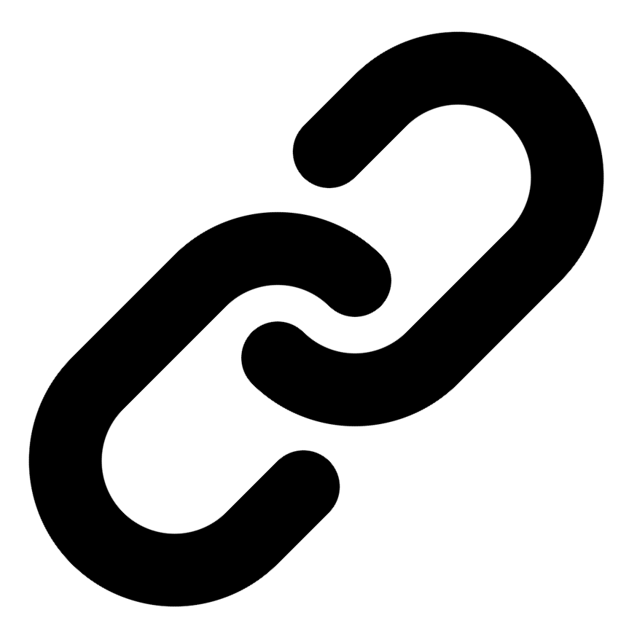[Linkedin](https://www.linkedin.com/in/syed-kaab-surkhi/) |[Portfolio](https://syedkaabsurkhi.com/) |[Github](https://github.com/SurkhiSyed) | [ssurkhi56@gmail.com](mailto:ssurkhi56@gmail.com)

**EDUCATIONBachelor of Engineering (B.Eng), Computer Engineering,** Toronto Metropolitan University *2023 - 2027* **Relevant Courses:** COE 318 - Software Systems | COE 428 - Engineering Algorithms and Data Structures | COE 528 - Object Oriented Eng Analysis and Design | ELE 404 - Electronic Circuits I | COE 328 - Digital Systems

**TECHNICAL SKILLS**

**Programming Skills:** Python, C++, C, C#, MATLAB, Java, MySQL

**Frameworks:** Flask, Node.js, React.js, Tailwind CSS, OpenCV, Websocket, Golang, CLI Tools, PyGTK, Ros2, TCP Connections, Streamlit

**Tools:** CAD, 3D Printing, Electric Circuits, Git, Firebase, Arduino, NI Multisim, Quartus, NetBeans, Unity, JavaFX, Supabase, Vector DB

**WORK EXPERIENCE**

**Research Practicum Assistant,** Toronto Metropolitan University, May 2024 - May 2025

* **Evaluated** 3 international research papers and **benchmarked** curriculum outlines from over thirteen Canadian universities; **pinpointed** key textbooks, culminating in comprehensive recommendations for a redesigned Linear Algebra course structure.
* **Collaborated** with a professor and a team of 3 assistants to **design** an impactful teaching plan for a first-year Linear Algebra course.
* **Partnering** with organizations to **develop** an open-source textbook in PreText, **transitioning** concepts from pre-calculus to advanced university-level mathematics.

**Network Programming Controls and Web Developer,** [Metropolitan Hyperloop](https://methyperloop.netlify.app/)**,** Sep 2024 – Ongoing

* **Collaborated** with various operation-teams such as marketing to develop a promotional website, **utilizing** React.js and Tailwind CSS and **designing** a multi-tier sponsorship benefit system.
* **Built** a **GUI** to display significant readout data when running the pod and connected a central **RaspberryPi** to the backend of the GUI via **TCP Connection** for successful transmission of the data.

**Software Developer,** Toronto MetRobotics Oct 2024 – Ongoing

* **Implemented** a control program for a Robotics Rover, **enabling** simultaneous component management through a game controller, and **transmitting** data with the **Pysocket and Websocket libraries**.
* **Developed** a **GUI** for a multi-camera system on the rover with **PyGST** with the use of **TCP Connections** and **CLI tools** for testing.
* **Incorporated** dual production **pipelines** with different methods to efficiently target needs such as faster or smooth streaming.

**Full Stack Developer,** Momentum AI May 2025 – Ongoing

* **Worked** with a group of developers in a **startup** to **create** an **AI** **full stack** study application with various tools such as **flashcards generator, study planner, exam generator**, and **RAG** trained studying assistant.
* **Implemented** the complete **functionalities** in a **Flask** backend connected with a minimal **React.js** frontend along with databases.

**Term Project Leader,** Toronto Metropolitan University Sep 2023 – Nov 2023

* **Facilitated** a 10-member team in **redesigning** the 3D printing process, integrating environmental and efficiency improvements while **consulting** with the team advisor and group advisors weekly in various team meetings for areas of revisions**.**
* Researched safer alternatives and programmed the fill process in **Java** leading to development of 3 iterations of the process redesign.

**TECHNICAL PROJECTS** [**Inclusee,**Hackthe6ix](https://devpost.com/software/inclusee) | *ReactJS, Adobe-Add-On-SDK, css3, JavaScript* July 2024

* **Programmed** an Adobe Express Add-On within 36 hours, **enhancing** design accessibility for users with low vision, dyslexia, and other impairments; currently **undergoing** review for the official Adobe Add-On marketplace.
* **Incorporating** real-time feedback by analyzing colors, fonts, and layouts used with **React.js, Javascript, and CSS.**

[**Vireel,**Google Gemini API Developer Competition | Startup](https://github.com/SurkhiSyed/Vireel) | *Flask, Python, ReactJS, TailwindCSS, GeminiAPI, JavaScript* August 2024

* **Engineered** a news aggregation app, integrating four APIs including **Gemini** and **News API** to **curate** personalized, concise news for users in the Google Gemini API Developer Competition.
* **Leveraged** the **React.js** framework and **Tailwind CSS** for the frontend, with **Python Flask** for the backend, to build a comprehensive full-stack social media app, featuring messaging, liked articles, and genre customization.

[**BetEd,** Snowflake Rag ‘n’ Roll Competition](https://devpost.com/software/project-hk1nfi?ref_content=my-projects-tab&ref_feature=my_projects) | *Streamlit, Python, WebScraping, JavaScript, RAG, TailwindCSS, Firebase, Snowflake* January 2025

* **Developed** a networking platform for inexperienced tech seekers to **collaborate** on challenging competitions while being tutored by a **trained learning model** and receiving feedback from professionals at the Snowflake RAG competition.
* **Implemented** **Retrieval Augmented Generation (RAG)** for training an AI model with the use of **Snowflake** database for storing documentation, **Mistral LLM** for generation, **Cortex Search** for retrieval, and **Streamlit** for the frontend display.

[**BookCartFX**](https://github.com/SurkhiSyed/BookCartFX)[**,**](https://devpost.com/software/project-hk1nfi?ref_content=my-projects-tab&ref_feature=my_projects) | *Java, JavaFX, SceneBuilder, FXML, UML Modeling, Design Patterns, Java GUI*  March 2025

* **Developed** a Bookstore application in **JavaFX**, implementing secure user authentication, encrypted data storage, and real-time book management functionalities.
* Collaborated in a team to design and implement system architecture using UML modeling and design patterns, ensuring scalability.

[**Embedded Vision Controlled Car**](https://github.com/SurkhiSyed/Programmable-RadioControlled-Car)

* Built an Arduino car using various **components** including motor controllers, motors, ESP32 CAM, Arduino Uno, and Servo Motors.
* Made with **C++** and further developing it to perform tasks such as image recognition and target locking with **OpenCV.**

[**Simple Central Processing Unit (CPU)**](https://github.com/SurkhiSyed/Simple-Central-Processing-Unit)

* **Created** a multi-functional CPU in a **VHDL** environment developed on an FPGA board that uses two 8 bit inputs, clock inputs, enable inputs, and resets to provide hexadecimal output effectively. **Programmed** using **VHDL** code on **Altera Quartus**.
* **Implemented** different functionalities using an **FSM state machine**, **latches**, a **decoder**, **7 segment converters**, and **arithmetic and logic units (ALU cores)**. Used block schematics and logic waveforms to simulate CPU before implementation on the board.

[**ExploreWorld Unity**](https://github.com/SurkhiSyed/Final-ExploreWorld)

* Created a solo exploration game with a task objective of exploring the physics concepts and principles such as gravity, acceleration, mass, and forces on various in-game objects with **C#** in **Unity**. Includes the control of over two vehicles with different physics principles.
* Integrates components such as terrain and over six skyboxes, utilizing Unity's **physics engine** to create a challenging simulation game.

**DinoNFT, HawkHacks**

* Made a **web3** video game similar to that of the google offline game using **Javascript** and **p5.js** in a competitive event within 48 hours and secured 3rd place win in the web3 category
* Incorporate a reward system for the player by connecting their blockchain wallet to the game, and transfer tokens based on their scores

[**Land Average Temperatures Analyzer,**](https://github.com/SurkhiSyed/LandAverageTemperatures)

* **Developed** a **C** program that studies different average land temperatures over 3 centuries using **CSV files** and outputs different averages.
* Used **GNU Plots** to create different plots in respect to the outputted data to evaluate trends and report conclusions.

# Tailored Experience Highlights

Developed full-stack AI study application using Flask, React.js, and RAG, incorporating various study tools.

Implemented robotic rover control program using Python libraries, enabling simultaneous component management and data transmission.

Designed and implemented multi-camera GUI for robotic rover using PyGST and TCP connections.

# Tailored Project Highlights

Developed JavaFX bookstore application with secure user authentication and real-time book management.

Designed and trained large language models for AI-generated content detection using PyTorch.

Built scalable ML training and inference systems for efficient AI agent development.