**Syed Kaab Surkhi**

Bachelor of Computer Engineering

(647)515-7386 |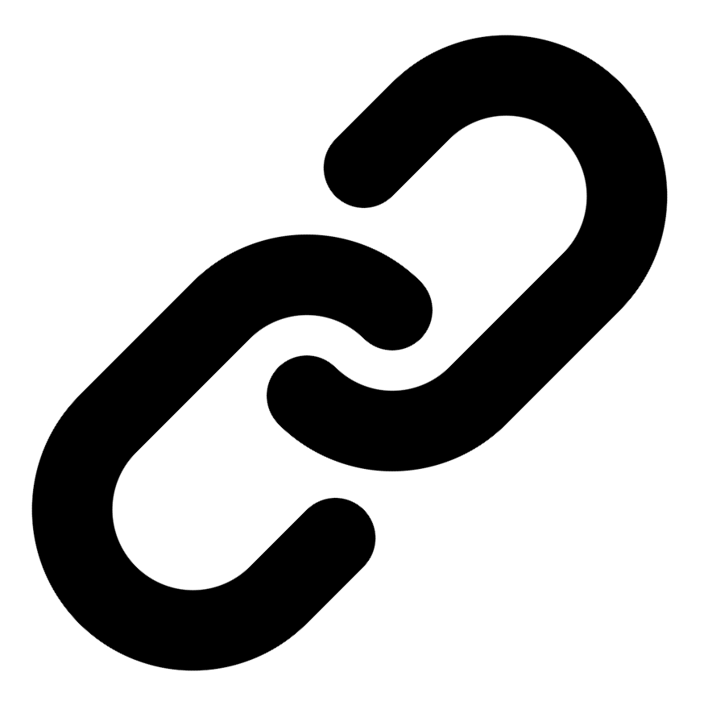[Linkedin](https://www.linkedin.com/in/syed-kaab-surkhi/) |[Portfolio](https://syedkaabsurkhi.com/) |[Github](https://github.com/SurkhiSyed) | [ssurkhi56@gmail.com](mailto:ssurkhi56@gmail.com)

**EDUCATIONBachelor of Engineering (B.Eng), Computer Engineering,** Toronto Metropolitan University *2023 - 2027* **Relevant Courses:** COE 318 - Software Systems | COE 428 - Engineering Algorithms and Data Structures | COE 528 - Object Oriented Eng Analysis and Design | ELE 404 - Electronic Circuits I | COE 328 - Digital Systems

**TECHNICAL SKILLS**

**Programming Skills:** Python, C++, C, C#, MATLAB, Java, MySQL

**Frameworks:** Flask, Node.js, React.js, Tailwind CSS, OpenCV, Websocket, Golang, CLI Tools, PyGTK, Ros2, TCP Connections, Streamlit

**Tools:** CAD, 3D Printing, Electric Circuits, Git, Firebase, Arduino, NI Multisim, Quartus, NetBeans, Unity, JavaFX, Supabase, Vector DB

**WORK EXPERIENCE**

**Research Practicum Assistant,** Toronto Metropolitan University, May 2024 - May 2025

* Evaluated 3 international research papers and benchmarked curriculum outlines from over thirteen Canadian universities; pinpointed key textbooks, culminating in comprehensive recommendations for a redesigned…
* **Collaborated** with a professor and a team of 3 assistants to **design** an impactful teaching plan for a first-year Linear Algebra course.
* **Partnering** with organizations to **develop** an open-source textbook in PreText, **transitioning** concepts from pre-calculus to advanced university-level mathematics.

**Network Programming Controls and Web Developer,** [Metropolitan Hyperloop](https://methyperloop.netlify.app/)**,** Sep 2024 – Ongoing

* **Collaborated** with various operation-teams such as marketing to develop a promotional website, **utilizing** React.js and Tailwind CSS and **designing** a multi-tier sponsorship benefit system.
* Built a GUI to display significant readout data when running the pod and connected a central RaspberryPi to the backend of the GUI via…

**Software Developer,** Toronto MetRobotics Oct 2024 – Ongoing

* Implemented a control program for a Robotics Rover, enabling simultaneous component management through a game controller, and transmitting data with the Pysocket and Websocket…
* Developed a GUI for a multi-camera system on the rover with PyGST with the use of TCP Connections and CLI tools for testing using…
* **Incorporated** dual production **pipelines** with different methods to efficiently target needs such as faster or smooth streaming.

**Full Stack Developer,** Momentum AI May 2025 – Ongoing

* Worked with a group of developers in a startup to create an AI full stack study application with various tools such as flashcards generator,…
* Implemented the complete functionalities in a Flask backend connected with a minimal React.js frontend along with databases using research, software.

**Term Project Leader,** Toronto Metropolitan University Sep 2023 – Nov 2023

* Facilitated a 10-member team in redesigning the 3D printing process, integrating environmental and efficiency improvements while consulting with the team advisor and group advisors…
* Researched safer alternatives and programmed the fill process in **Java** leading to development of 3 iterations of the process redesign.

**TECHNICAL PROJECTS** [**Inclusee,**Hackthe6ix](https://devpost.com/software/inclusee) | *ReactJS, Adobe-Add-On-SDK, css3, JavaScript* July 2024

* Programmed an Adobe Express Add-On within 36 hours, enhancing design accessibility for users with low vision, dyslexia, and other impairments; currently undergoing review for…
* **Incorporating** real-time feedback by analyzing colors, fonts, and layouts used with **React.js, Javascript, and CSS.**

[**Vireel,**Google Gemini API Developer Competition | Startup](https://github.com/SurkhiSyed/Vireel) | *Flask, Python, ReactJS, TailwindCSS, GeminiAPI, JavaScript* August 2024

* Engineered a news aggregation app, integrating four APIs including Gemini and News API to curate personalized, concise news for users in the Google Gemini…
* Leveraged the React.js framework and Tailwind CSS for the frontend, with Python Flask for the backend, to build a comprehensive full-stack social media app,…

[**BetEd,** Snowflake Rag ‘n’ Roll Competition](https://devpost.com/software/project-hk1nfi?ref_content=my-projects-tab&ref_feature=my_projects) | *Streamlit, Python, WebScraping, JavaScript, RAG, TailwindCSS, Firebase, Snowflake* January 2025

* Developed a networking platform for inexperienced tech seekers to collaborate on challenging competitions while being tutored by a trained learning model and receiving feedback…
* Implemented Retrieval Augmented Generation (RAG) for training an AI model with the use of Snowflake database for storing documentation, Mistral LLM for generation, Cortex…

[**BookCartFX**](https://github.com/SurkhiSyed/BookCartFX)[**,**](https://devpost.com/software/project-hk1nfi?ref_content=my-projects-tab&ref_feature=my_projects) | *Java, JavaFX, SceneBuilder, FXML, UML Modeling, Design Patterns, Java GUI*  March 2025

[**Embedded Vision Controlled Car**](https://github.com/SurkhiSyed/Programmable-RadioControlled-Car)

[**Simple Central Processing Unit (CPU)**](https://github.com/SurkhiSyed/Simple-Central-Processing-Unit)

[**ExploreWorld Unity**](https://github.com/SurkhiSyed/Final-ExploreWorld)

**DinoNFT, HawkHacks**

[**Land Average Temperatures Analyzer,**](https://github.com/SurkhiSyed/LandAverageTemperatures)