**Syed Kaab Surkhi**

Bachelor of Computer Engineering

(647)515-7386 |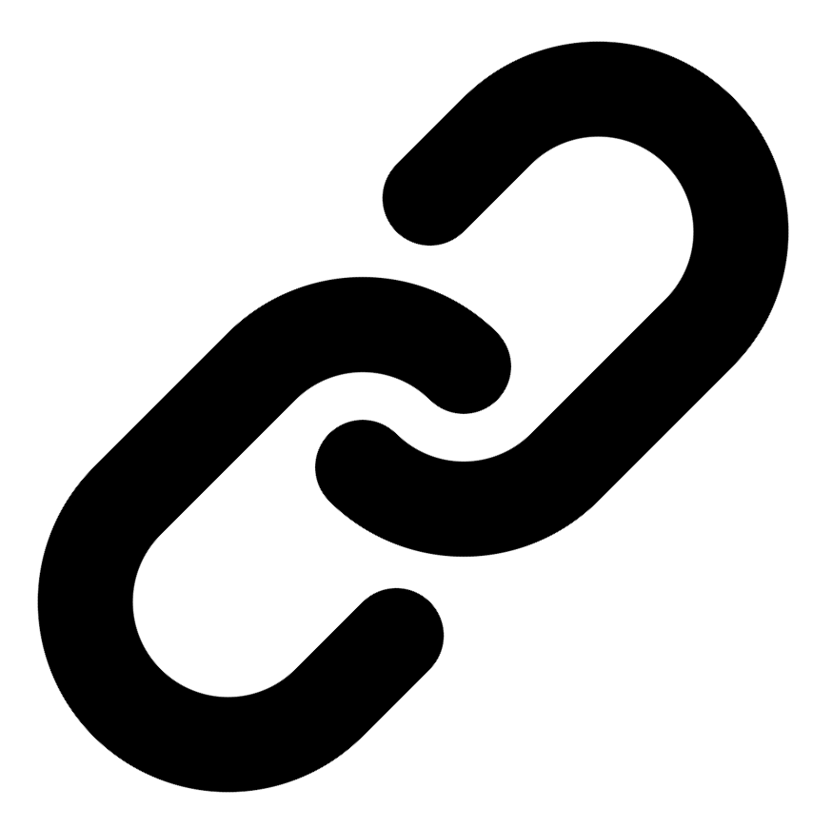[Linkedin](https://www.linkedin.com/in/syed-kaab-surkhi/) |[Portfolio](https://syedkaabsurkhi.com/) |[Github](https://github.com/SurkhiSyed) | [ssurkhi56@gmail.com](mailto:ssurkhi56@gmail.com)

**EDUCATIONBachelor of Engineering (B.Eng), Computer Engineering,** Toronto Metropolitan University *2023 - 2027* **Relevant Courses:** COE 318 - Software Systems | COE 428 - Engineering Algorithms and Data Structures | COE 528 - Object Oriented Eng Analysis and Design | ELE 404 - Electronic Circuits I | COE 328 - Digital Systems

**TECHNICAL SKILLS**

**Programming Skills:** Python, C++, C, C#, MATLAB, Java, MySQL

**Frameworks:** Flask, Node.js, React.js, Tailwind CSS, OpenCV, Websocket, Golang, CLI Tools, PyGTK, Ros2, TCP Connections, Streamlit

**Tools:** CAD, 3D Printing, Electric Circuits, Git, Firebase, Arduino, NI Multisim, Quartus, NetBeans, Unity, JavaFX, Supabase, Vector DB

**WORK EXPERIENCE**

**Software Developer, Toronto MetRobotics** — Oct 2024 – Ongoing

• Implemented a control program for a Robotics Rover, enabling simultaneous component management via a game controller and data transmission using Pysocket and Websocket libraries.

• Developed a GUI for a multi-camera system using PyGST, leveraging TCP connections and CLI tools for testing; ensured efficient data visualization and streamlined system operation.

**Network Programming Controls and Web Developer, Metropolitan Hyperloop** — Sep 2024 – Ongoing

• Collaborated with marketing to develop a promotional website using React.js and Tailwind CSS; designed a multi-tier sponsorship benefit system, enhancing brand promotion and user engagement.

• Built a GUI to display real-time pod data, connecting a central Raspberry Pi to the backend via TCP connection, ensuring reliable data transmission and monitoring.

**TECHNICAL PROJECTS**

**Vireel** *| React.js, Node.js, Python, Flask, Tailwind CSS, API Integration, Firebase, Gemini API, News API*

• Engineered a news aggregation app integrating four APIs (Gemini, News API, etc.) to deliver personalized news summaries, leveraging React.js, Node.js, and Flask.

• Developed a full-stack social media experience featuring user messaging, article liking, and genre customization, enhancing user engagement.

**BetEd** *| Python, Streamlit, Snowflake, Mistral LLM, Cortex Search, Retrieval-Augmented Generation (RAG), Tailwind CSS, Firebase, JavaScript*

• Implemented Retrieval Augmented Generation (RAG) for an AI model, utilizing Snowflake for data storage, Mistral LLM for generation, and Cortex Search for retrieval.

• Developed a networking platform connecting tech learners with collaborative challenges, incorporating AI tutoring and professional feedback.

**Inclusee** *| JavaScript, React, Adobe API, Accessibility, UX/UI*

• Developed an accessibility add-on for Adobe Express, providing real-time feedback on design elements (colors, fonts, layouts) to improve accessibility for users with visual impairments.

• Improved the user experience for designers by integrating real-time feedback and suggestions, ensuring designs meet accessibility standards.