**Syed Kaab Surkhi**

Bachelor of Computer Engineering

(647)515-7386 |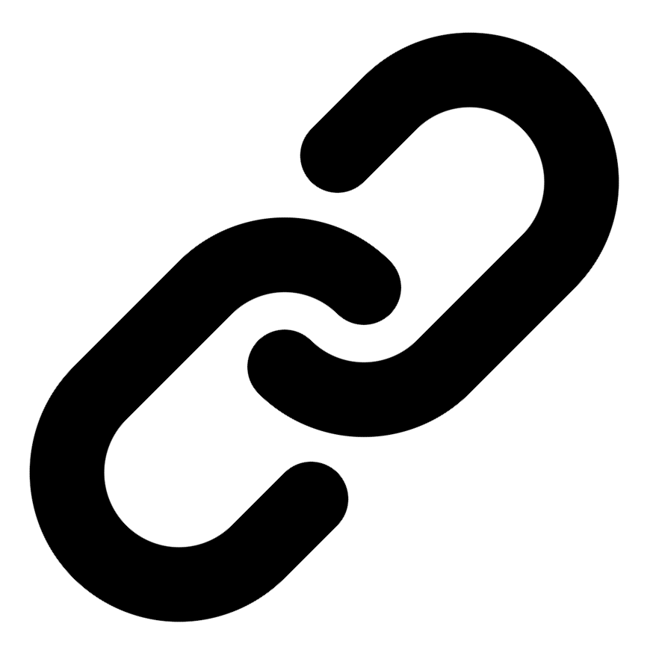[Linkedin](https://www.linkedin.com/in/syed-kaab-surkhi/) |[Portfolio](https://syedkaabsurkhi.com/) |[Github](https://github.com/SurkhiSyed) | [ssurkhi56@gmail.com](mailto:ssurkhi56@gmail.com)

**EDUCATIONBachelor of Engineering (B.Eng), Computer Engineering,** Toronto Metropolitan University *2023 - 2027* **Relevant Courses:** COE 318 - Software Systems | COE 428 - Engineering Algorithms and Data Structures | COE 528 - Object Oriented Eng Analysis and Design | ELE 404 - Electronic Circuits I | COE 328 - Digital Systems

**TECHNICAL SKILLS**

**Programming Skills:** Python, C++, C, C#, MATLAB, Java, MySQL

**Frameworks:** Flask, Node.js, React.js, Tailwind CSS, OpenCV, Websocket, Golang, CLI Tools, PyGTK, Ros2, TCP Connections, Streamlit

**Tools:** CAD, 3D Printing, Electric Circuits, Git, Firebase, Arduino, NI Multisim, Quartus, NetBeans, Unity, JavaFX, Supabase, Vector DB

**WORK EXPERIENCE**

**TECHNICAL PROJECTS**

**BetEd** *| Retrieval-Augmented-Generation, Snowflake, Mistral LLM, Cortex Search, Streamlit, Python, TailWind CSS, Firebase, JavaScript, Full Stack*

• Implemented a Retrieval Augmented Generation (RAG) system using Snowflake, Mistral LLM, and Cortex Search to train an AI model for a tech education platform.

• Developed a full-stack networking platform using Streamlit, Python, and JavaScript, enabling collaboration and feedback for tech learners.

• Designed and implemented the frontend user interface using Streamlit and Tailwind CSS, enhancing user experience and engagement.

**Vireel - Startup** *| Full Stack, React, Node.js, API Integration, JavaScript, Tailwind CSS, Flask, Firebase, Python, Gemini API*

• Engineered a full-stack news aggregation application integrating four APIs (including Gemini and News API) to deliver personalized news summaries.

• Developed the frontend using React.js and Tailwind CSS, and the backend using Python Flask and Firebase, ensuring scalability and maintainability.

• Implemented user features such as personalized feeds, saving articles, commenting, and genre customization, enhancing user engagement.

**Inclusee** *| Adobe API, JavaScript, Accessibility, UX/UI, React, Color Analysis, Font Analysis, Layout Analysis*

• Developed a React-based accessibility addon for Adobe Express, providing real-time feedback on design elements for improved inclusivity.

• Implemented algorithms to analyze colors, fonts, and layouts, offering suggestions to enhance accessibility for users with visual impairments.

• Designed and implemented a user-friendly interface to integrate seamlessly with Adobe Express, improving user experience and accessibility.