**Syed Kaab Surkhi**

Bachelor of Computer Engineering

(647)515-7386 |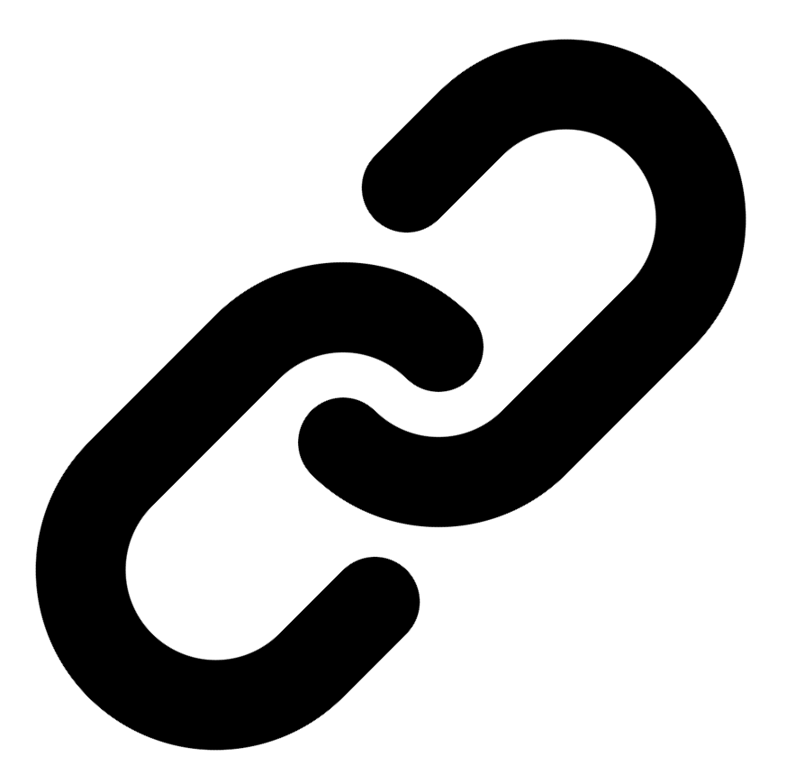[Linkedin](https://www.linkedin.com/in/syed-kaab-surkhi/) |[Portfolio](https://syedkaabsurkhi.com/) |[Github](https://github.com/SurkhiSyed) | [ssurkhi56@gmail.com](mailto:ssurkhi56@gmail.com)

**EDUCATIONBachelor of Engineering (B.Eng), Computer Engineering,** Toronto Metropolitan University *2023 - 2027* **Relevant Courses:** COE 318 - Software Systems | COE 428 - Engineering Algorithms and Data Structures | COE 528 - Object Oriented Eng Analysis and Design | ELE 404 - Electronic Circuits I | COE 328 - Digital Systems

**TECHNICAL SKILLS**

**Programming Skills:** Python, C++, C, C#, MATLAB, Java, MySQL

**Frameworks:** Flask, Node.js, React.js, Tailwind CSS, OpenCV, Websocket, Golang, CLI Tools, PyGTK, Ros2, TCP Connections, Streamlit

**Tools:** CAD, 3D Printing, Electric Circuits, Git, Firebase, Arduino, NI Multisim, Quartus, NetBeans, Unity, JavaFX, Supabase, Vector DB

**WORK EXPERIENCE**

**Software Developer, Toronto MetRobotics**

• Implemented a control program for a Robotics Rover, enabling simultaneous component management via a game controller and data transmission using…

• Developed a GUI for a multi-camera rover system using PyGST, incorporating TCP connections and CLI tools for testing.

• Incorporated dual production pipelines with different methods to efficiently target needs such as faster or smooth streaming.

**Full Stack Developer, Momentum AI**

• Built a full-stack AI study application with features including a flashcard generator, study planner, exam generator, and a RAG-trained studying…

• Implemented complete application functionalities using a Flask backend, minimal React.js frontend, and integrated databases.

• Collaborated with a team of developers in a startup environment to deliver the application.

**Network Programming Controls and Web Developer, Metropolitan Hyperloop**

• Collaborated with marketing teams to develop a promotional website using React.js and Tailwind CSS, and designed a multi-tier sponsorship benefit…

• Built a GUI to display significant readout data during pod operation, connecting a central Raspberry Pi to the backend via…

• Successfully integrated the GUI and backend systems for real-time data display.

**TECHNICAL PROJECTS**

**Vireel** *| React.js, Tailwind CSS, Python, Flask, API Integration, Firebase, Gemini API, News API*

• Engineered a news aggregation app integrating four APIs (Gemini, News API, etc.) to deliver personalized news summaries.

• Built a full-stack social media app using React.js, Tailwind CSS, and Python Flask, featuring user messaging and article sharing.

• Developed a user-friendly interface allowing users to save articles, share comments, and engage in discussions.

**BetEd** *| Streamlit, Python, Retrieval-Augmented-Generation (RAG), Snowflake, Mistral LLM, Cortex Search, Tailwind CSS, Firebase*

• Implemented Retrieval Augmented Generation (RAG) for an AI model using Snowflake, Mistral LLM, and Cortex Search.

• Developed a networking platform for tech learners to collaborate on competitions and receive professional feedback.

• Built a Streamlit frontend for the platform, facilitating interaction and display of generated content.

**Inclusee** *| Adobe API, JavaScript, Accessibility, UX/UI, React*

• Developed an accessibility add-on for Adobe Express analyzing color, font, and layout for accessibility issues.

• Implemented real-time feedback and suggestions to improve designs for users with visual impairments.

• Improved the user experience for designers by providing tools to create more accessible designs.