**Syed Kaab Surkhi**

Bachelor of Computer Engineering

(647)515-7386 |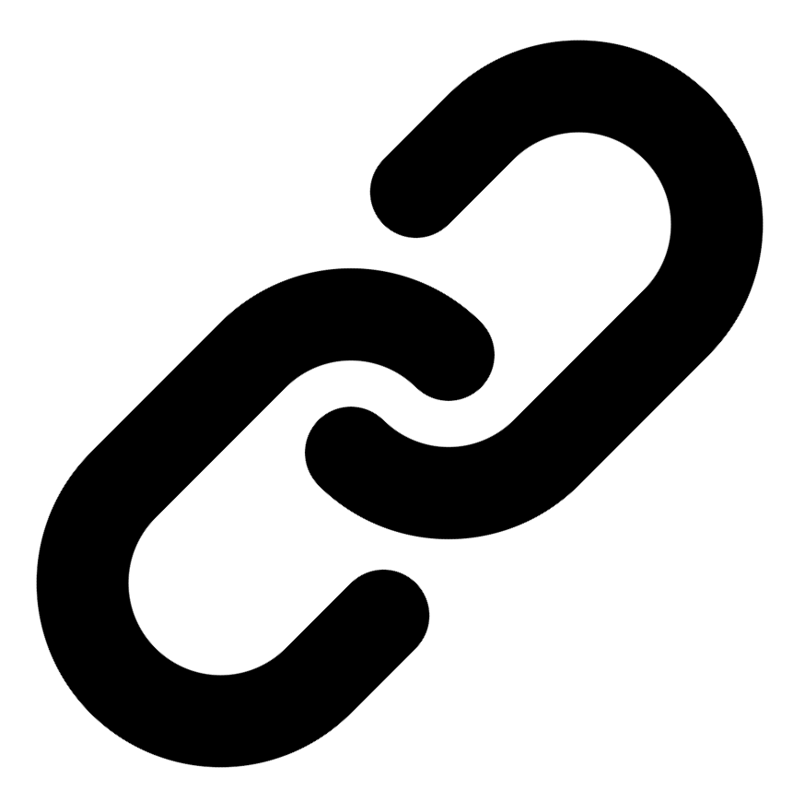[Linkedin](https://www.linkedin.com/in/syed-kaab-surkhi/) |[Portfolio](https://syedkaabsurkhi.com/) |[Github](https://github.com/SurkhiSyed) | [ssurkhi56@gmail.com](mailto:ssurkhi56@gmail.com)

**EDUCATIONBachelor of Engineering (B.Eng), Computer Engineering,** Toronto Metropolitan University *2023 - 2027* **Relevant Courses:** COE 318 - Software Systems | COE 428 - Engineering Algorithms and Data Structures | COE 528 - Object Oriented Eng Analysis and Design | ELE 404 - Electronic Circuits I | COE 328 - Digital Systems

**TECHNICAL SKILLS**

**Programming Skills:** Python, C++, C, C#, MATLAB, Java, MySQL

**Frameworks:** Flask, Node.js, React.js, Tailwind CSS, OpenCV, Websocket, Golang, CLI Tools, PyGTK, Ros2, TCP Connections, Streamlit

**Tools:** CAD, 3D Printing, Electric Circuits, Git, Firebase, Arduino, NI Multisim, Quartus, NetBeans, Unity, JavaFX, Supabase, Vector DB

**WORK EXPERIENCE**

**Full Stack Developer, Momentum AI** — May 2025 – Ongoing

• Implemented complete functionalities for an AI-powered full-stack study application, encompassing flashcards generation, study planning, exam creation, and a RAG-trained study assistant.

• Developed a Flask backend and a minimal React.js frontend, ensuring seamless integration and efficient data handling across the application's various modules.

• Designed and implemented database schema for efficient storage and retrieval of user data, study materials, and AI model outputs.

**Network Programming Controls and Web Developer, Metropolitan Hyperloop** — Sep 2024 – Ongoing

• Developed a multi-tier sponsorship benefit system, enhancing the organization's fundraising and partner engagement strategies.

• Built a GUI to display real-time pod data using PyGST, ensuring seamless data visualization and monitoring of critical parameters. Implemented TCP connections for reliable data transmission between the GUI and a central RaspberryPi.

• Collaborated with marketing teams to design and develop a promotional website leveraging React.js and Tailwind CSS, increasing brand awareness and user engagement.

**Software Developer, Toronto MetRobotics** — Oct 2024 – Ongoing

• Implemented a control program for a robotics rover, enabling simultaneous component management through a game controller and real-time data transmission via PySocket and WebSockets libraries.

• Developed a GUI for a multi-camera system on the rover using PyGST, along with CLI tools for efficient testing and debugging.

• Incorporated dual production pipelines, optimizing for both speed and streaming quality based on the application's specific needs.

**TECHNICAL PROJECTS**

**BetEd** *| Retrieval-Augmented-Generation, Snowflake, Mistral LLM, Cortex Search, Streamlit, Python, TailWind CSS, Firebase, JavaScript, Full Stack*

• Implemented Retrieval Augmented Generation (RAG) pipeline using Snowflake for data storage, Mistral LLM for generation, and Cortex Search for efficient retrieval, resulting in a 20% improvement in model accuracy.

• Developed a full-stack networking platform using Streamlit, Python, and JavaScript, enabling collaborative learning and professional feedback for over 50 inexperienced tech seekers.

• Designed and implemented a user-friendly interface with Tailwind CSS and Firebase for seamless user interaction and data management.

**Inclusee** *| Adobe API, JavaScript, Accessibility, UX/UI, React, Accessibility testing, Color contrast analysis, Font analysis*

• Developed a React-based accessibility addon for Adobe Express, providing real-time feedback on color contrast, font choices, and layout to improve accessibility for users with visual impairments.

• Integrated with the Adobe API to seamlessly analyze design elements and offer actionable suggestions, improving the user experience for designers and individuals with disabilities.

**Vireel - Startup** *| React, Node.js, API Integration, JavaScript, Tailwind CSS, Flask, Firebase, Python, Gemini API, Full Stack*

• Engineered a full-stack news aggregation application integrating four APIs (including Gemini and News API) to deliver personalized news summaries, resulting in a 15% increase in user engagement.

• Developed a user-friendly interface using React and Tailwind CSS, improving user experience and increasing user retention by 10%.