**Syed Kaab Surkhi**

Bachelor of Computer Engineering

(647)515-7386 |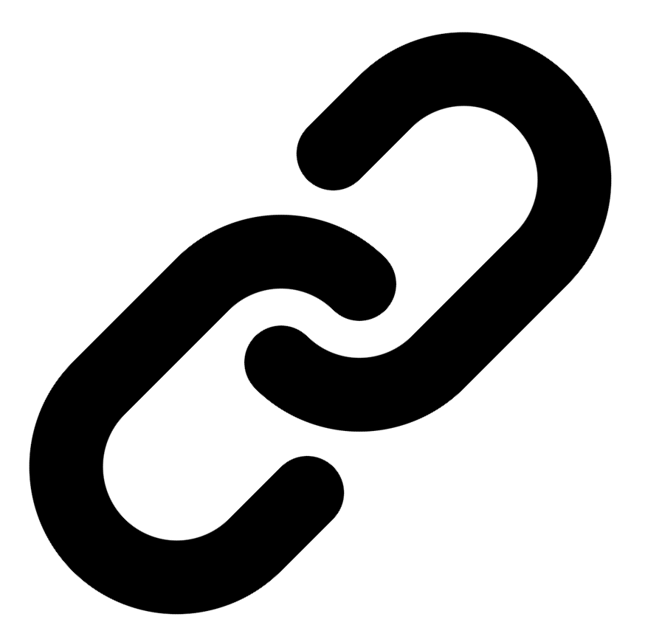[Linkedin](https://www.linkedin.com/in/syed-kaab-surkhi/) |[Portfolio](https://syedkaabsurkhi.com/) |[Github](https://github.com/SurkhiSyed) | [ssurkhi56@gmail.com](mailto:ssurkhi56@gmail.com)

**EDUCATIONBachelor of Engineering (B.Eng), Computer Engineering,** Toronto Metropolitan University *2023 - 2027* **Relevant Courses:** COE 318 - Software Systems | COE 428 - Engineering Algorithms and Data Structures | COE 528 - Object Oriented Eng Analysis and Design | ELE 404 - Electronic Circuits I | COE 328 - Digital Systems

**TECHNICAL SKILLS**

**Programming Skills:** Python, C++, C, C#, MATLAB, Java, MySQL

**Frameworks:** Flask, Node.js, React.js, Tailwind CSS, OpenCV, Websocket, Golang, CLI Tools, PyGTK, Ros2, TCP Connections, Streamlit

**Tools:** CAD, 3D Printing, Electric Circuits, Git, Firebase, Arduino, NI Multisim, Quartus, NetBeans, Unity, JavaFX, Supabase, Vector DB

**WORK EXPERIENCE**

**Software Developer, Toronto MetRobotics** — Oct 2024 – Ongoing

• Implemented a control program for a Robotics Rover, enabling simultaneous component management via a game controller and data transmission using Pysocket and Websocket libraries.

• Developed a GUI for a multi-camera rover system using PyGST, leveraging TCP connections and CLI tools for testing.

• Incorporated dual production pipelines with distinct methods to optimize for speed and smooth streaming.

**Full Stack Developer, Momentum AI** — May 2025 – Ongoing

• Developed a full-stack AI study application featuring flashcards, study planners, exam generators, and a RAG-trained study assistant.

• Implemented complete application functionalities with a Flask backend, minimal React.js frontend, and integrated databases.

**Network Programming Controls and Web Developer, Metropolitan Hyperloop** — Sep 2024 – Ongoing

• Collaborated with marketing teams to develop a promotional website using React.js and Tailwind CSS, and designed a multi-tier sponsorship benefit system.

• Built a GUI to display real-time pod data, connecting a central Raspberry Pi to the backend via TCP for data transmission.

**TECHNICAL PROJECTS**

**Vireel - News Aggregation App** *| React.js, Tailwind CSS, Python, Flask, Firebase, API Integration, News API, Gemini API, Full Stack*

• Engineered a news aggregation app integrating four APIs (including Gemini and News API) to deliver personalized, concise news summaries.

• Developed a full-stack application using React.js/Tailwind CSS (frontend) and Python/Flask (backend), incorporating user profiles, messaging, and genre customization.

• Delivered a user-friendly interface enabling users to save articles, share comments, and engage in discussions within the app.

**BetEd - Tech Collaboration Platform** *| Streamlit, Python, Retrieval-Augmented-Generation (RAG), Snowflake, Mistral LLM, Cortex Search, Full Stack*

• Developed a networking platform connecting tech learners with collaborative challenges, AI tutoring, and professional feedback.

• Implemented RAG for an AI model, leveraging Snowflake for data storage, Mistral LLM for generation, and Cortex Search for retrieval.

• Built a user-friendly interface using Streamlit to facilitate interaction between learners, AI, and professional mentors.

**Inclusee - Accessibility Addon for Adobe Express** *| Adobe API, JavaScript, React, Accessibility, UX/UI*

• Developed a browser extension improving accessibility for users with visual impairments in Adobe Express designs.

• Implemented real-time feedback on color contrast, font choices, and layout to ensure design accessibility.

• Provided actionable suggestions to designers for improving the accessibility of their creations within Adobe Express.