**Syed Kaab Surkhi**

Bachelor of Computer Engineering

(647)515-7386 |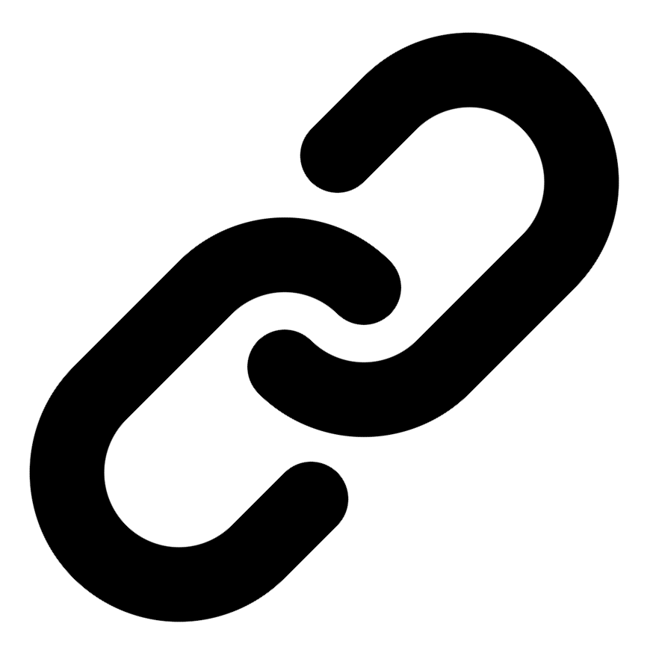[Linkedin](https://www.linkedin.com/in/syed-kaab-surkhi/) |[Portfolio](https://syedkaabsurkhi.com/) |[Github](https://github.com/SurkhiSyed) | [ssurkhi56@gmail.com](mailto:ssurkhi56@gmail.com)

**EDUCATIONBachelor of Engineering (B.Eng), Computer Engineering,** Toronto Metropolitan University *2023 - 2027* **Relevant Courses:** COE 318 - Software Systems | COE 428 - Engineering Algorithms and Data Structures | COE 528 - Object Oriented Eng Analysis and Design | ELE 404 - Electronic Circuits I | COE 328 - Digital Systems

**TECHNICAL SKILLS**

**Programming Skills:** Python, C++, C, C#, MATLAB, Java, MySQL

**Frameworks:** Flask, Node.js, React.js, Tailwind CSS, OpenCV, Websocket, Golang, CLI Tools, PyGTK, Ros2, TCP Connections, Streamlit

**Tools:** CAD, 3D Printing, Electric Circuits, Git, Firebase, Arduino, NI Multisim, Quartus, NetBeans, Unity, JavaFX, Supabase, Vector DB

**WORK EXPERIENCE**

**Software Developer, Toronto MetRobotics**

• Implemented a robotics rover control program enabling simultaneous component management via game controller and data transmission using Pysocket and Websocket…

• Developed a multi-camera system GUI using PyGST, incorporating TCP connections and CLI tools for testing.

• Incorporated dual production pipelines with different methods to optimize for faster or smoother streaming.

**Full Stack Developer, Momentum AI**

• Built a full-stack AI study application including features like flashcards, study planner, exam generator, and a RAG-trained assistant.

• Implemented complete application functionality with a Flask backend, minimal React.js frontend, and integrated databases.

• Developed REST APIs connecting the frontend and backend components.

**Network Programming Controls and Web Developer, Metropolitan Hyperloop**

• Collaborated with marketing to develop a promotional website using React.js and Tailwind CSS, and designed a multi-tier sponsorship system.

• Built a GUI to display pod readout data, connecting a central Raspberry Pi to the backend via TCP for data…

• Designed and implemented responsive UI for seamless user experience across different screen sizes.

**TECHNICAL PROJECTS**

**Vireel News App** *| React, APIs, JavaScript, User Authentication, Mobile Development*

• Designed and implemented a news aggregation application using multiple APIs to deliver concise news summaries.

• Developed user features including saving favorites, sharing, and commenting to enhance user engagement.

• Built a user-friendly interface for easy navigation and consumption of news content.

**BookCartFX Bookstore Application** *| JavaFX, UML, Design Patterns, User Authentication, Database*

• Developed a bookstore application with secure user authentication and real-time book management.

• Collaborated on system architecture design using UML modeling and design patterns to ensure scalability.

• Implemented features for managing books, users, and transactions within the application.

**Average Land Temperatures Analyzer** *| C Programming, Data Analysis, CSV File Processing, GNU Plot*

• Developed a C program to analyze average land temperatures from CSV files over three centuries.

• Generated plots using GNU Plot to visualize temperature trends and support data analysis.

• Outputted various averages and produced a report detailing conclusions based on the data analysis.