**Syed Kaab Surkhi**

Bachelor of Computer Engineering

(647)515-7386 |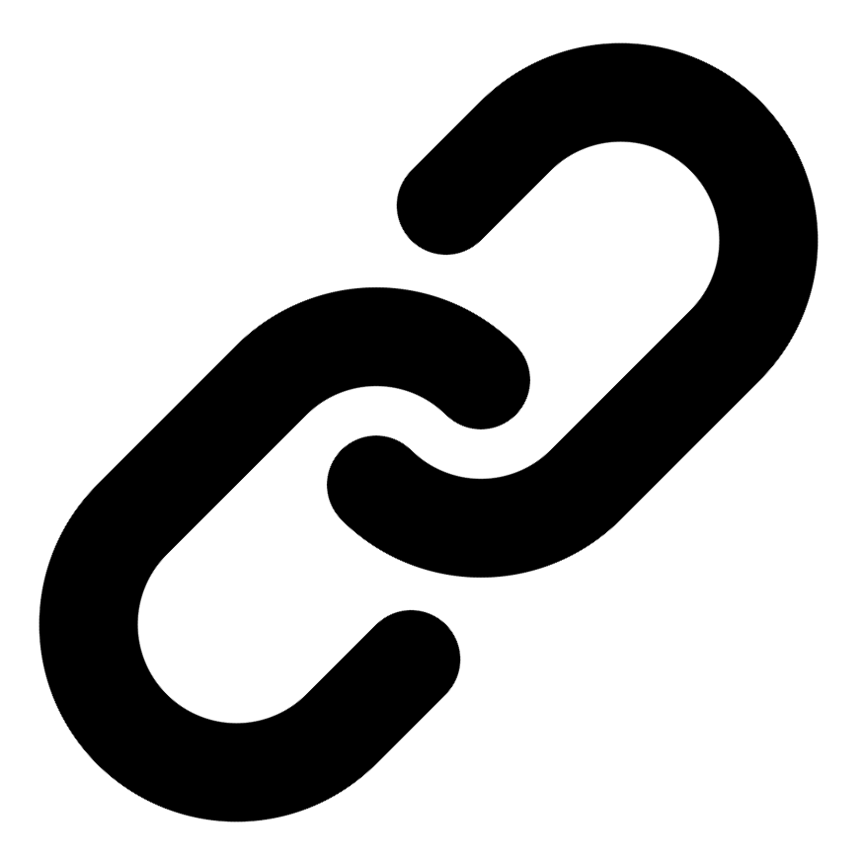[Linkedin](https://www.linkedin.com/in/syed-kaab-surkhi/) |[Portfolio](https://syedkaabsurkhi.com/) |[Github](https://github.com/SurkhiSyed) | [ssurkhi56@gmail.com](mailto:ssurkhi56@gmail.com)

**EDUCATIONBachelor of Engineering (B.Eng), Computer Engineering,** Toronto Metropolitan University *2023 - 2027* **Relevant Courses:** COE 318 - Software Systems | COE 428 - Engineering Algorithms and Data Structures | COE 528 - Object Oriented Eng Analysis and Design | ELE 404 - Electronic Circuits I | COE 328 - Digital Systems

**TECHNICAL SKILLS**

**Programming Skills:** Python, C++, C, C#, MATLAB, Java, MySQL

**Frameworks:** Flask, Node.js, React.js, Tailwind CSS, OpenCV, Websocket, Golang, CLI Tools, PyGTK, Ros2, TCP Connections, Streamlit

**Tools:** CAD, 3D Printing, Electric Circuits, Git, Firebase, Arduino, NI Multisim, Quartus, NetBeans, Unity, JavaFX, Supabase, Vector DB

**WORK EXPERIENCE**

**Software Developer, Toronto MetRobotics** — Oct 2024 – Ongoing

• Implemented a control program for a robotics rover, enabling simultaneous component management via a game controller and transmitting data using Pysocket and Websocket libraries.

• Developed a GUI for a multi-camera system on the rover using PyGST, leveraging TCP connections and CLI tools for testing.

• Incorporated dual production pipelines with distinct methods to efficiently optimize for speed and smoothness of streaming.

**Full Stack Developer, Momentum AI** — May 2025 – Ongoing

• Developed a full-stack AI study application featuring flashcards, study planner, exam generator, and a RAG-trained study assistant.

• Implemented complete application functionality with a Flask backend, minimal React.js frontend, and integrated databases.

• Designed and implemented REST APIs for seamless data exchange between frontend and backend components.

**Network Programming Controls and Web Developer, Metropolitan Hyperloop** — Sep 2024 – Ongoing

• Collaborated with marketing teams to develop a promotional website using React.js and Tailwind CSS, designing a multi-tier sponsorship benefit system.

• Built a GUI to display critical data during pod operation, connecting a central Raspberry Pi to the backend via TCP for data transmission.

• Optimized data visualization within the GUI for improved readability and comprehension of real-time pod performance metrics.

**TECHNICAL PROJECTS**

**Vireel - News Aggregation App** *| React.js, Tailwind CSS, Python, Flask, Firebase, API Integration, Gemini API, News API, Full Stack Development*

• Engineered a full-stack news aggregation application integrating four APIs to deliver personalized news summaries.

• Developed React.js frontend with Tailwind CSS for styling and a Python Flask backend to manage user accounts and preferences.

• Implemented features for saving articles, commenting, and genre customization, enhancing user engagement.

**BetEd - Tech Skills Networking Platform** *| Streamlit, Python, Retrieval-Augmented Generation (RAG), Snowflake, Mistral LLM, Cortex Search, Full Stack Development*

• Implemented Retrieval Augmented Generation (RAG) leveraging Snowflake, Mistral LLM, and Cortex Search to train an AI tutor.

• Developed a Streamlit frontend for the platform, enabling collaboration and feedback from professionals.

• Designed and built the platform to facilitate networking and skill development for aspiring tech professionals.

**Inclusee - Accessibility Addon for Adobe Express** *| Adobe API, JavaScript, React, Accessibility, UX/UI*

• Developed a React-based accessibility addon for Adobe Express, providing real-time feedback on design elements.

• Implemented algorithms to analyze colors, fonts, and layouts, ensuring accessibility for users with visual impairments.

• Integrated the addon with the Adobe Express API to seamlessly enhance the design process.