

PRAYAS

*Experiencing the humane*

**SUBMITED TO** : DR DURGANSH SIR

**SUBMITTED BY :** THE SOULED

**GROUP MEMBERS** :

1.ARUSHI SHAH 11

2.VATASLYA TEGWAL 78

3. SURMAI ADHIKARI 80

*REMEMBERING AGILE MANIFESTO:*

1. **Individuals and interactions over processes and tools**
2. **Working software over comprehensive documentation**
3. **Customer collaboration over contract negotiation**
4. **Responding to change over following a plan.**

**ABSTRACT :** The objective of this report is undergo deep into the agile based project and to prepare a proper documentation before deep digging into the user interface.

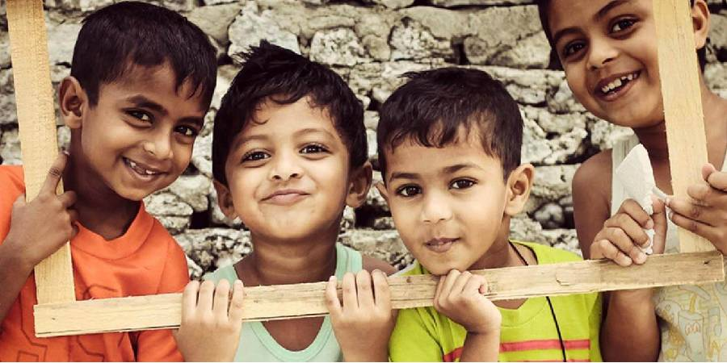

**INTRODUCTION**

As seen there are many platforms available already in the market for eg. Amazon.com is a vast Internet-based enterprise that sells books, music, movies, house wares, electronics, toys, and many other goods, either directly or as the middleman between other retailers and Amazon’s million customers. Its web services business includes renting data storage and computing resources, so-called “cloud computing,” over the Internet. Or we can see **Facebook**, American company offering online social networking services. Facebook was founded in 2004 by Mark Zuckerberg, Eduardo Saverin, Dustin Moskovitz, and Chris Hughes, all of whom were students at Harvard University. Facebook became the largest social network in the world. And many more, such we want to introduce the system *PRAYAS* which is an open platform where we are eligible to donate our secondary or unused things to needy peoples with our choice of NGO’s. With a secured network and certified database of different NGO’s. Basically, PRAYAS is developing an open source system which comes under the agenda of helping and showing concerned with the humanities. PRAYAS is developing a system which is child centered and compassionate that revolves around civilized concern. An open platform where million or billion of users can help the needy ones on just a click away with a secured network ID where all other networks lack due to the interface they provide. *Prayas* can be a widely connected networking platform due to the connections it will form with **NGO's** and **OLD AGE HOMES**. In addition to theories of unemployment, the effects of unemployment within the economic system. *Prayas* provides employment too! The delivery executives or the employees which will act as a carrier in processing the donations to the desired locations and also sending the acknowledgments to the users who have provided the donations. Also, with secured network, *Prayas* will provide the payment gateways to the people with easy transactions. People will be able to donate money as well as to the NGO’S. With high-tech full security like any other money transaction apps PRAYAS will be a lot more than that it offers. It will be a non-selfish fund-raising software and will allow the users to check the growth of PRAYAS on day to day basis by checking the statistics. A statistic will be monitored daily and maintained according to the transactions which will be happening every now and then. It will also help in determining the progress made so far. And due to this very transparency people will be more interested to give their inputs by relying on this initiative that provides with an open platform to billion people to help in a friendly manner.

**AIM**

To develop an open system for social awareness.

**OBJECTIVES**

* Give resources to the child who are not able to buy for themselves.
* Provide shelters.
* Reduce Unemployment.
* To provide the interface between the donor and the receiver.
* Open platform donation website.
* Helping people on a larger platform.
* Creating an Interactive user-friendly environment.
* Rehabilitation measures in the social problem issues like delinquency, child pornography.
* Social and economic development
* Reduce child labours
* Transparency over a network
* Security to the users

**SCOPE**

* Organize events on behalf of “PRAYAS”.
* Increase the effectiveness.
* Can be converted into an app for users who wants to access it on their smart phones.
* Further unit distribution of system can give rise to many other small projects.
* Implement it as website for ease of access to end user and the user who doesn’t have smart phones.
* The main thing that we provide is to give platform to thousand of NGO‟S and Old age homes, so that people can easily get information about them.

***SOFTWARE REQUIREMENT SPECIFICATION***

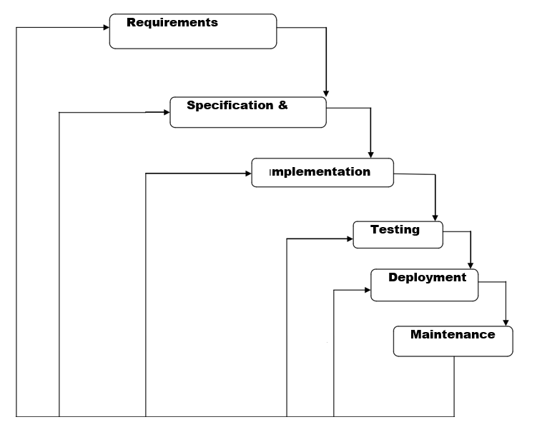

**METHODLOGY**

*WATER FALL MODEL-*

*REQUIRMENTS:*

* Database of different NGO’s - we will be collecting information of different Ngo”s near by the user ., eg.owner,associative head.also our website will map the Google database with user so it becomes easy for the user to choose the place where they want to donate.
* Open working platform - open platform will be build by the software so the website becomes user friendly. Such that multiple users can access through it .{AM.1}
* Security : As the website contains different users so each user will be having unique identification such that they can safely login and donate the things. The user passward and login can be changed on the user prefrences .
* Users - Users are required to make the website working as they will be the main entity in the project to contribute towards donations.{AG:3}
* Donor and Donations - website will accept different forms donations for eg. Books,cloths,blankets,stationary,cash.
* Delivery Executives/employees – To transfer the Donations from one place to another.hence which increase the employment.

*SYSTEM DESIGN:*

A working website will be made by using the output of the requirements. Where user can securely login into their account by the unique id and password and once this is done, a map will pop up with the information of different NGO’s in there surrounding or in their respective diameter. Prayas contains easy money transactions similar to other online payments sites along with the tight security, that it provides.

At each cash donations or the other donations **(old age help)** users will be getting the bonus points for their continuous inputs which can be further converted in the form of a bank cash and will thus, lead to the more involvements.

**Also, there will be 4 icons which will pop up there symbolizing.**

* DONATE

Old books, stationary, cloths, blankets, cash. On each good donations user will get coupons and coin for which converted to their bank account.

CONTRIBUTE

Contribute to the NGO’s as a volunteer for the different activities which takes place in, contributer will be assigned according to their social skills and get a approval from the NGO’s.

* TEACHERS TO NEEDY-

The students who are in universities and willing to share skills to the poor children’s who didn’t get a chance to acknowledge the good education. They can contribute to their nearest NGO and teach the children’s and can utilize their summer vacations by nominating themselves. They can nominate themselves on website. And can pull request which should be sent to the NGO’s.

* MATCH WITH OLD AGE- *Prayas* allows to connect with the old citizens with peoples who have never seen the care and concern of the guardians in their life. It’s an initiative to match the old age people to the children with whom they are most compatible with. There will be daily database of people who wants to interact to the kids and the people who are making contact with them. They can check the timing slots by pulling a request on the website and they will be updated with the time and date which gets generated by checking all the necessary conditions. Through all this security measures one can easily visit the NGO’s as it helps both the parties to feel less lonely along with their safety which will also be a major concern here. Users will have the access to take 2 people under them, one being an old citizen and the other child so that user can have the access to arrange meet ups and provide online donations to both the parties at the same level.

*IMPLEMENTATION –*

With inputs from the system design, the system is first developed in small programs called units, which are integrated in the next phase. Each unit is developed and tested for its functionality, which is referred to as Unit Testing. The first unit will be the complete database which will be getting from different websites,users,employess,contributers.Once all the database will get prepared we will make the website functional using the database of different entity and also matching them with their attributes. Using HTML/CSS/PHP. We will be using c++ to make the payment gateways functional. Once the data and icons get established in the website, we will make it functional using CSS.

There will be different panels for both the users and employee updates.so that millions of people can process over a single tool to interact with different NGO’s and people who are already keep working for the good cause. {AM :1}

*INTEGRATION AND TESTING -*

All the units developed in the implementation phase are integrated into a system after testing of each unit. Post integration the entire system is tested for any faults and failures. if any failure occurs, we will go back to the previous stage to check what is gone wrong. checking errors will be perfect to make the project work.

*DEPLOYMENT OF THE SYSYTEM* **–**

Once the functional and non-functional testing is done; the product is deployed in the customer environment or released into the market.

*MAINTANENCE –*

There are some issues which come up in the client environment. To fix those issues, patches are released. Also to enhance the website some better versions are released. Maintenance is done to deliver these changes in the customer environment. PRAYAS will be able to fix the bugs which will occur with website such that it understands the user point of view and try to make it more flexible and reliable to the users where they can easily understand the website and able to share what changes are required.{AM :4}

APP SCREENSHOTS

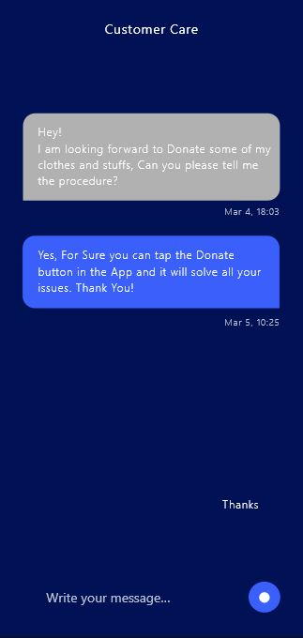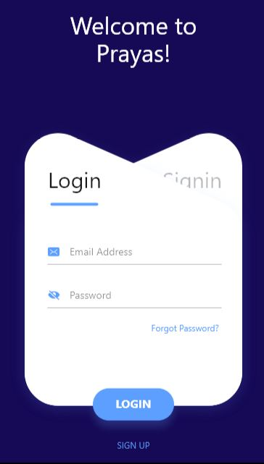

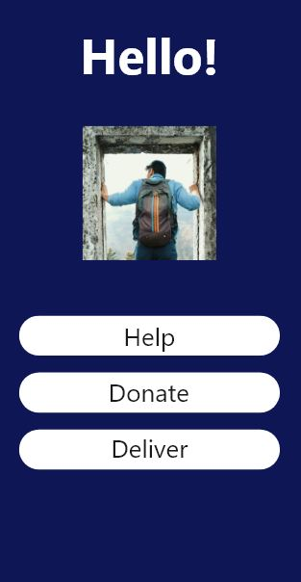

This is the chat box where the user can directly talk to the employees of Prayas

This is the homescreen for the app which will be the first screen to appear after the application opens.

FUNCTIONALITY: The user can donate the stuffs that he wants to donate, deliver if the orphanage is nearby, help if the user want to teach or help them morally

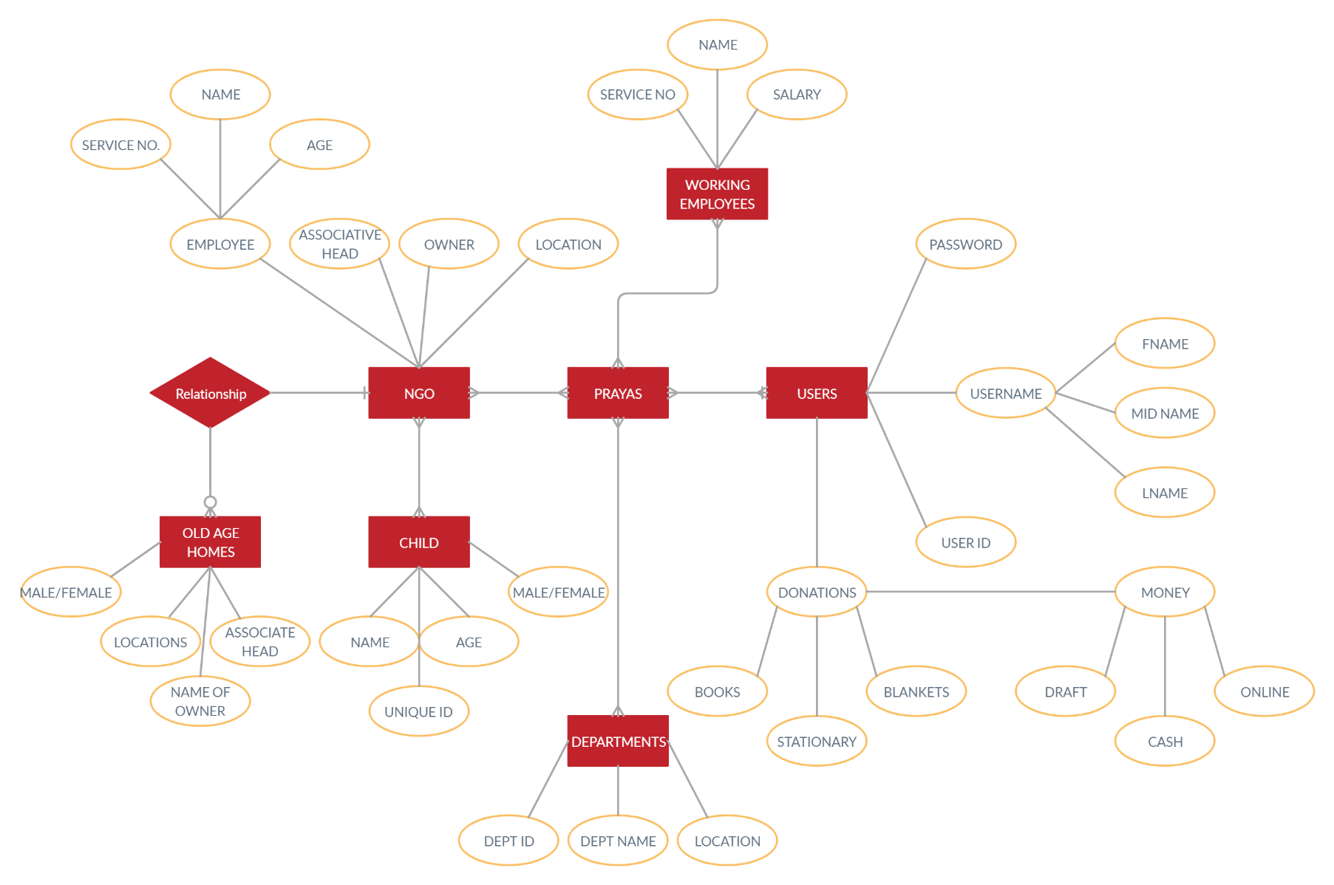**ER DIAGRAM**

**DATA FLOW DIAGRAM**

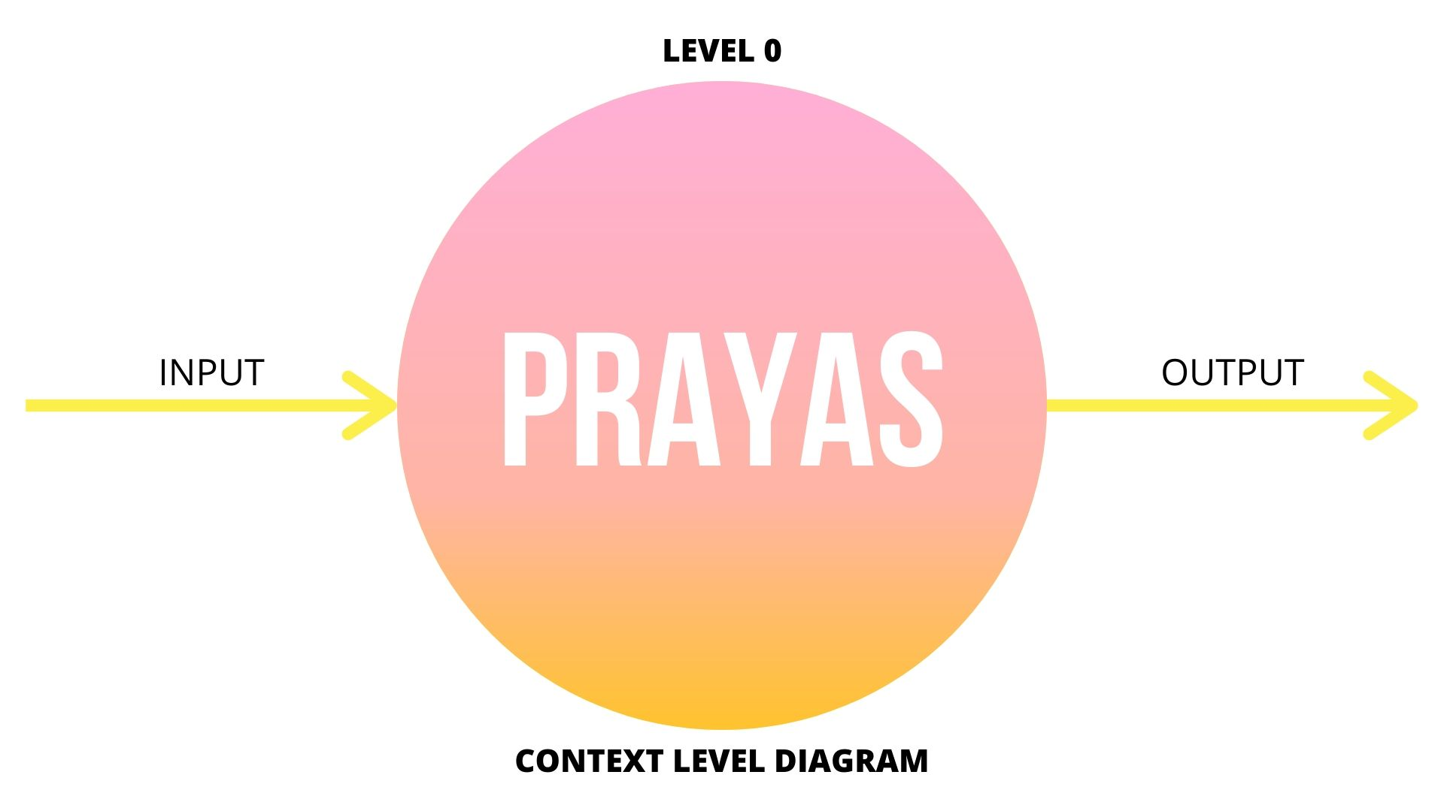

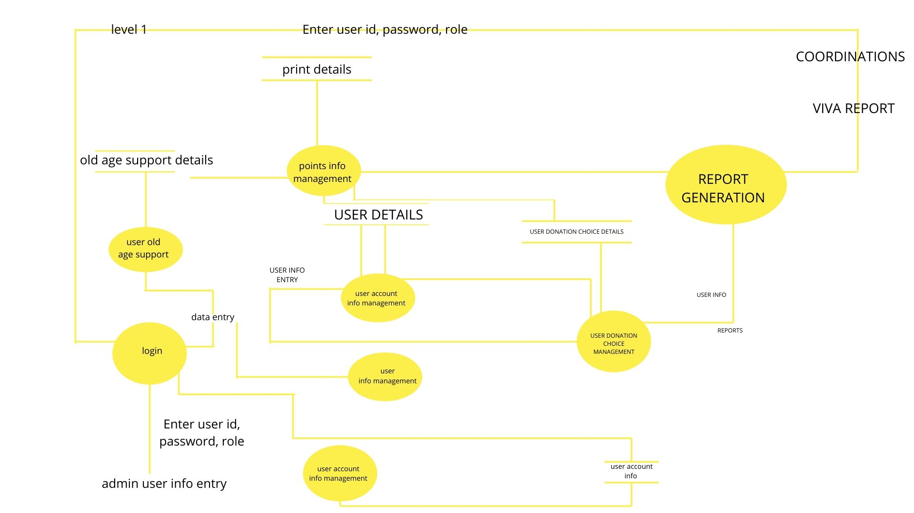

**LEVEL2**

1. User Account Maintenance

Access User Info

Admin User Account Info

Enter/Update/Delete user info

Update/delete

User info

1. Login

User account info

Retrieves user Info

Enter User ID, Password, Enter user ID, Password, ROLE Role Coordinator

**Data Entry Operator**

Points entry

Enter user ID, Password, Role

Enter user ID, Password

**Admin**

1. User Info Management

Access user info

**Data Entry Operator**

Display user info Retreives user info

Enter/Update/Delete user ID

User ID Info

Validate/Process user

Info

Update/Delete user ID Info

1. Donation Information Management

Access user info

**Data Entry Operator**

Display user info Retreives donation info

Enter/Update/Delete Donation info

Donation Info

Validate/Process user

Info

Update/Delete user Donation In

**CONCLUSIONS –**

1. This open system allows users to create interactive checklists that will help them ensure a child getting all the donations which are sent by them.
2. Users can check the daily statistics on the open system
3. Users get database of all the NGO’s at one place and statistics of the data at the same place.
4. Users can donate things at one click and go thus the open system which will be user friendly.
5. Easy cash payments. With complete security check.
6. Acknowledgments will be provided to users once their donations are reached to the respective NGO’s.
7. Limiting children’s exposure to hazards and reducing children’s risk of harm.
8. Changing children’s surroundings and influencing child with a new environment. Under the eye of guardian (old age homes).
9. Providing good education to children’s who didn’t got the opportunity to enter in expensive universities.
10. Promote NGO’s, and give shelter to homeless.
11. **“**Prayas” provide shoulder to every living person around us, who need our support.



***REFRENCES***

* Video’s from youtube - https://youtu.be/RD0u_K6nVSU, https://youtu.be/CNPM0OgQtIA, https://youtu.be/dh7-iNj6XTI
* Github.com
* Wikipedia - <https://timesofindia.indiatimes.com/blogs/voices/orphans-of-india/>, <https://www.soschildrensvillages.ca/india-now-home-20-million-orphans-study-finds>, <https://www.gooverseas.com/volunteer-abroad/india/volunteer-india/26785>, <https://en.wikipedia.org/wiki/Category:Orphanages_in_India>, <https://ngosindia.com/>.