

PRAYAS

*Matching the humane*

**SUBMITED TO** : DR DURGANSH SIR

**SUBMITTED BY :** THE SOULED

**GROUP MEMBERS** :

1.ARUSHI SHAH 11

2.VATASLYA TEGWAL 78,3. SURMAI ADHIKARI 80

*REMEMBERING AGILE MANIFESTO:*

1. ***Individuals and interactions over processes and tools***
2. ***Working software over comprehensive documentation***
3. ***Customer collaboration over contract negotiation***
4. ***Responding to change over following a plan***

**ABSTRACT :** The objective of this report is undergo deep into the agile based project.and to prepare a proper documentation before deep digging into the user interface.

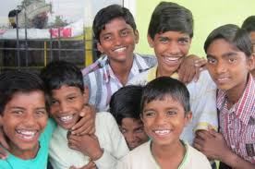

**INTRODUCTION**

As seen there are many platforms available already in the market for eg. Amazon.com is a vast Internet-based enterprise that sells books, music, movies, house wares, electronics, toys, and many other goods, either directly or as the middleman between other retailers and Amazon.com’s millions of customers. Its Web services business includes renting data storage and computing resources, so-called “cloud computing,” over the Internet. Or we can see **Facebook**, American company offering online social networking services. Facebook was founded in 2004 by Mark Zuckerberg, Eduardo Saverin, Dustin Moskovitz, and Chris Hughes, all of whom were students at Harvard University. Facebook became the largest social network in the world. And many more,such we want to introduce the system PRAYAS which is a open platform where we are eligible to donate our secondary or unused things to needy peoples with our choice of NGO’s With a secured network and certified database of different ngo’s. Basically PRAYAS is developing a open source system which comes under the agenda of helping and showing concerned with the humanities. PRAYAS is developing a system which is child centered, merciful . Which surrounds around civilized compassion Such that an open platform where million or billion of users  can help to the needy ones on just a click away with a secured network ID .where all other networks lack due to the interface they provide . Prayas can be a widely connected networking platform due to the connections it will form with NGO's and OLD AGE HOMES. In addition to theories of unemployment, the effects of unemployment within the economic system. Prayas provide employment too. The delivery executives or the employees which take the donations to the desired locations,and also sending the acknowledgments to the users who have provided the donations Also With secured network Prayas will provide the payment gateways to the people with easy transactions. People will be able to donate money as well to the NGO’S. With full security like other money transaction apps also have. it allows the users to check the growth of PRAYAS on day to day basis by checking the statistics. A Statistics will be daily maintained according to the transactions which will be happening on the day to day basis. And how much progress it makes because it is for good cause and people will be interested to check the changes or progress they make by showing a little help. Such that prayas gives an open platform to billion people to give donations to the needy ones .

**AIM**

To develop a open system for social awareness .

**OBJECTIVES**

* Give resources to the child who are not able to buy for themselves
* Provide shelters
* Reduce Unemployment
* To provide the interface between the donor and the receiver
* Open platform donation website.
* Helping people on a larger platform
* Creating a Interactive user friendly enviorment.
* Rehabilitation measures in the social problem issues like delinquency,child poronography.
* Social and economical development
* Reduce child labours
* Transparency over a network
* Security to the users

**SCOPE**

* Organize events on behalf “PRAYAS”.
* Increase  the effectiveness
* Can be converted into a app for users who wants to access on there smart phones.
* Further unit distribution of system can give rise to many other small project
* Implement it as website for ease of access to end user and the user who doesn’t have smart phones.
* The main thing that we provide is to give platform to thousand of NGO‟S and Old age homes, so that people can easily get information about them.

***SOFTWARE REQUIREMENT SPECIFICATION***

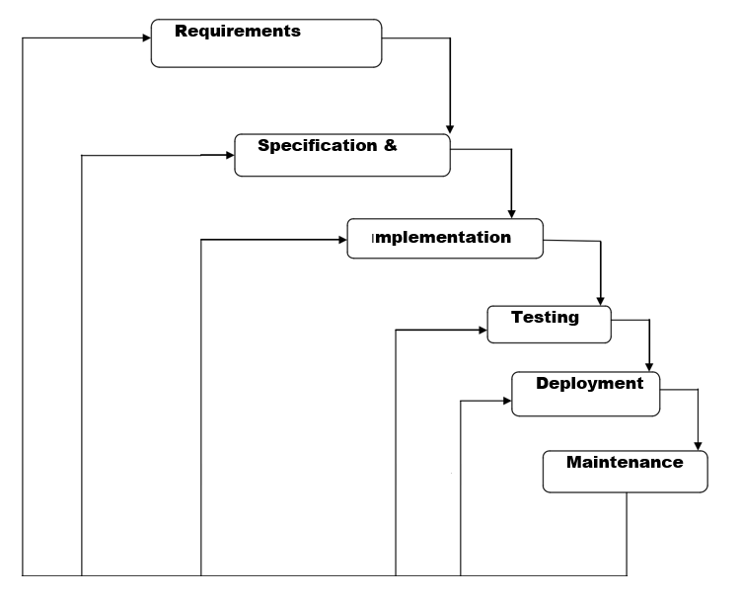

**METHODLOGY**

*WATER FALL MODEL-*

*REQUIRMENTS:*

* Database of different NGO’s - we will be collecting information of different Ngo”s near by the user ., eg.owner,associative head.also our website will map the Google database with user so it becomes easy for the user to choose the place where they want to donate.
* Open working platform - open platform will be build by the software so the website becomes user friendly. Such that multiple users can access through it .{AM.1}
* Security : As the website contains different users so each user will be having unique identification such that they can safely login and donate the things. The user passward and login can be changed on the user prefrences .
* Users - Users are required to make the website working as they will be the main entity in the project to contribute towards donations.{AG:3}
* Donor and Donations - website will accept different forms donations for eg. Books,cloths,blankets,stationary,cash.
* Delivery Executives/employees – To transfer the Donations from one place to another.hence which increase the employment.

*SYSTEM DESIGN:*

A working website will be made by using the output of the requirements. Where user can safely login to their account by the unique id and password once they login a map will pop up with the information of different NGO’s in there surrounding or in their respective diameter Prayas contains easy money transactions same as other payments we done for shopping online. With user security at good interface.

At each cash donations or the other donations user will get the bonus points which can be converted into the bank cash. i.e the more donations will done by the user the more coins they get. Which will attract the users.

. *Also there will be 4 icons which will pop saying.*

* DONATE -

Old books,stationary,cloths,blankets,cash. On each good donations user will get coupons and coin for which converted to there bank account.

CONTRIBUTE-

Contribute to the NGO’s as a volunteer for the different activities which takes place in, contributer will be assigned according to there social skills and get a approval from the NGO’s.

* TEACHERS TO NEEDY-

The students who are in universities and willing to share skills to the poor children’s who didn’t get a chance to acknowledge the good education. They can contribute to their nearest NGO and teach the children’s and can utilize their summer vacations by nominating themselves. They can nominate themselves on website. And can pull request which should be sent to the NGO’s.

* MATCH WITH OLD AGE- Prayas allows to match with the old citizens with children’s who have never seen the care and concern of the guardians . Prayas taking an initiative to match the old age people to the childrens .there will be daily database of people who wants to interact to the kids ,they can pull a request on the website and automatically the time and date will get generated by checking all the nessecary conditions . By getting the one can easily visit to the NGO’s. it helps both the parties to feel less lonely. Users will have the access to take 2 people under them .one old citizen and other the child so. User will have the access to arrange meet ups and provide online donations to both the parties at the same level.

*IMPLIMENTATION –*

With inputs from the system design, the system is first developed in small programs called units, which are integrated in the next phase. Each unit is developed and tested for its functionality, which is referred to as Unit Testing. The first unit will be the complete database which will be getting from different websites,users,employess,contributers.Once all the database will get prepared we will make the website functional using the database of different entity and also matching them with their attributes. Using html/css /php . we will be using c++ to make the payment gateways functional . once the data and icons get established in the website we will make it functional using CSS.

There will be different panels for both the users and employee updates.so that million of people can process over a single tool to interact with different NGO’s and people . who are already keep working for the good cause.{AM :1}

*INTEGRATION AND TESTING -*

All the units developed in the implementation phase are integrated into a system after testing of each unit. Post integration the entire system is tested for any faults and failures. if any failure occurs we will go back to the previous stage to check what is gone wrong . checking errors will be perfect to make the project work.

*DEPLOYMENT OF THE SYSYTEM* **–**

Once the functional and non-functional testing is done; the product is deployed in the customer environment or released into the market.

*MAINTANENCE –*

There are some issues which come up in the client environment. To fix those issues, patches are released. Also to enhance the website some better versions are released. Maintenance is done to deliver these changes in the customer environment. PRAYAS will be able to fix the bugs which will occur with website such that it understands the user point of view and try to make it more flexible and reliable to the users where they can easily understand the website and able to share what changes are required.{AM :4}

**CONCLUSIONS –**

1. This open system allows users to create interactive checklists that will help them ensure a child getting all the donations which are sent by them.
2. Users can check the daily statistics on the open system
3. Users get database of all the NGO’s at one place,and statistics of the data at the same place.
4. Users can donate things at one click and go,thus the open system which will be user friendly.
5. Easy cash payments. With complete security check .
6. Acknowledgments will be provided to users once their donations are reached to the respective NGO’s.
7. Limiting children’s exposure to hazards and reducing children’s risk of harm.
8. Changing children’s surroundings and influencing child with a new environment. Under the eye of guardian (old age homes).
9. Providing good education to children’s who didn’t got the opportunity to enter in expensive universities.
10. Promote NGO’s, and give shelter to homeless.
11. **“**Prayas” provide shoulder to every living persons around us, who need our support.



***REFRENCES***

* Video’s from youtube - https://youtu.be/RD0u_K6nVSU, https://youtu.be/CNPM0OgQtIA, https://youtu.be/dh7-iNj6XTI
* Github.com
* Wikipedia - <https://timesofindia.indiatimes.com/blogs/voices/orphans-of-india/>, <https://www.soschildrensvillages.ca/india-now-home-20-million-orphans-study-finds>, <https://www.gooverseas.com/volunteer-abroad/india/volunteer-india/26785>, <https://en.wikipedia.org/wiki/Category:Orphanages_in_India>, <https://ngosindia.com/>.