# CURRICULUM VITAE

**SUROJIT SAMUI**

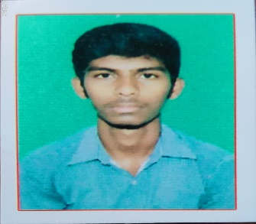

|  |
| --- |
| **Permanent Address** |
| **VILL-CHAK JANARDAN**  **P.O.- KANKROL**  **P.S.- JOYPUR**  **Dist.- HOWRAH**  **Pin – 711401** |

Email_ID:[surojitsamui007@gmail.com](mailto:surojitsamui007@gmail.com) CONTACT NO: 8436993268

**OBJECTIVE: To work in an organization that provides an opportunity to gain acquaintance and experience. Wish to optimally utilize my potential and add value to the organization.**

## *PERSONAL PROFILE

Name : SUROJIT SAMUI

Date of Birth : 28/05/2000

Father's Name : BISWANATH SAMUI

Current Status : BCA GRADUATE

Discipline : COMPUTER APPLICATION

Sex : MALE

Nationality : INDIAN

State : WEST BENGAL

## * ACADEMIC QUALIFICATION:

|  |  |  |  |  |
| --- | --- | --- | --- | --- |
| **Name of the examination** | **Board** | **Name of the establishment** | **Year** | **Average (%)** |
| **Madhyamik** | **West Bengal Board of Secondary Education** | **Joypur Phakirdas**  **Institution** | **2016** | **44%** |
| **H.S.** | **West Bengal State Council Of Technical And Vocational Education & Skill Development** | **Joypur Phakirdas Institution** | **2018** | **76.6%** |

**\*TECHNICAL QUALIFICATION:**

|  |  |  |  |  |
| --- | --- | --- | --- | --- |
| **Name of the examination** | **Board /University** | **Name of Institute** | **Year** | **Average (Points)** |
| **BCA** | **WBUT** | **PITM** | **2021** | **Pursuing** |

**\*Core Subjects : COMPUTER PROGRAMMING**

* TECHNICAL SKILL : HTML, PHP, MY SQL, JAVASCRIPT, JQUARY, CSS,C, C++, DATA STRUCTURE ,etc.

**\*Personal strengths : Hard working ability with my full effort and responsibility,**

ability to adjust in any environment and also my greatest strength is concentration & patience.

## *ADDITIONAL INFORMATION:

LANGUAGES KNOWN : Bengali, English, Hindi. INTERESTS : Netsurfing, Movies & Music.

COMPUTER SKILL : MS Word, MS PowerPoint, MS Excel etc.

## *DECLERATIONS:

I hereby declare that the above mentioned information is correct to the best of my knowledge and I bear the responsibility for the correctness of the above mentioned particulars.

Date: ……………………………. ……………………………..

Signature Of The Applicant