SupportIQ — Project Deliverables & Explanation Document
This document explains the overall idea, architecture, AI decisions, implementation approach, and final deliverables of the SupportIQ project in a simple and understandable way.
Project Title
SupportIQ — AI-Powered Customer Support Insight Platform

1. Project Summary
SupportIQ is an AI-powered customer support insight platform built for e-commerce and support-based businesses.
The idea behind the project was to create a system that can automatically analyze customer support tickets and help companies understand what customers are facing, what problems are occurring frequently, and which issues need urgent attention.
The main goal of the project is to help companies analyze customer support tickets and extract useful business insights from customer messages.
The system processes customer complaints, detects sentiment and frustration, identifies recurring issues, estimates revenue impact, and generates suggested responses for support agents.
The project includes:
- AI processing pipeline
- FastAPI backend
- Streamlit frontend dashboard
- SQLite database
- Docker deployment
- GitHub Actions CI/CD pipeline
- Cloud deployment on Render

2. Problem Statement
Modern companies receive a large number of customer support messages through:
- Emails
- Chat systems
- Website support tickets
It becomes difficult for support teams to manually:
- Identify common customer issues
- Detect frustrated customers
- Prioritize critical tickets
- Understand revenue-impacting problems
- Generate quick support responses
SupportIQ solves this problem by automatically analyzing support tickets and converting them into actionable business insights.

3. AI Choices
The project uses a lightweight AI pipeline for customer support analysis.
The system performs:
- Text cleaning
- Ticket categorization
- Sentiment analysis
- Frustration detection
- Keyword extraction
- Suggested response generation
VADER sentiment analysis was used because it is lightweight, fast, and works well on short customer support messages.
Rule-based ticket categorization was chosen instead of large machine learning models because it is easier to explain, easier to debug, and more suitable for a prototype assignment.
Suggested responses are generated using predefined templates based on ticket categories and customer sentiment.
4. Data Model
The project started with a public spam/ham email dataset.
The dataset was enriched into a customer-support style dataset.
Additional fields added include:
- ticket_id
- timestamp
- customer_id
- channel
- product
- order_value
- customer_country
- sentiment
- frustration_level
- resolution_status
- suggested_response
The processed data is stored in:
- CSV format
- SQLite database
SQLite was selected because it is lightweight and easy to use for a prototype-level application.
5. Software Architecture
The project follows a modular architecture.
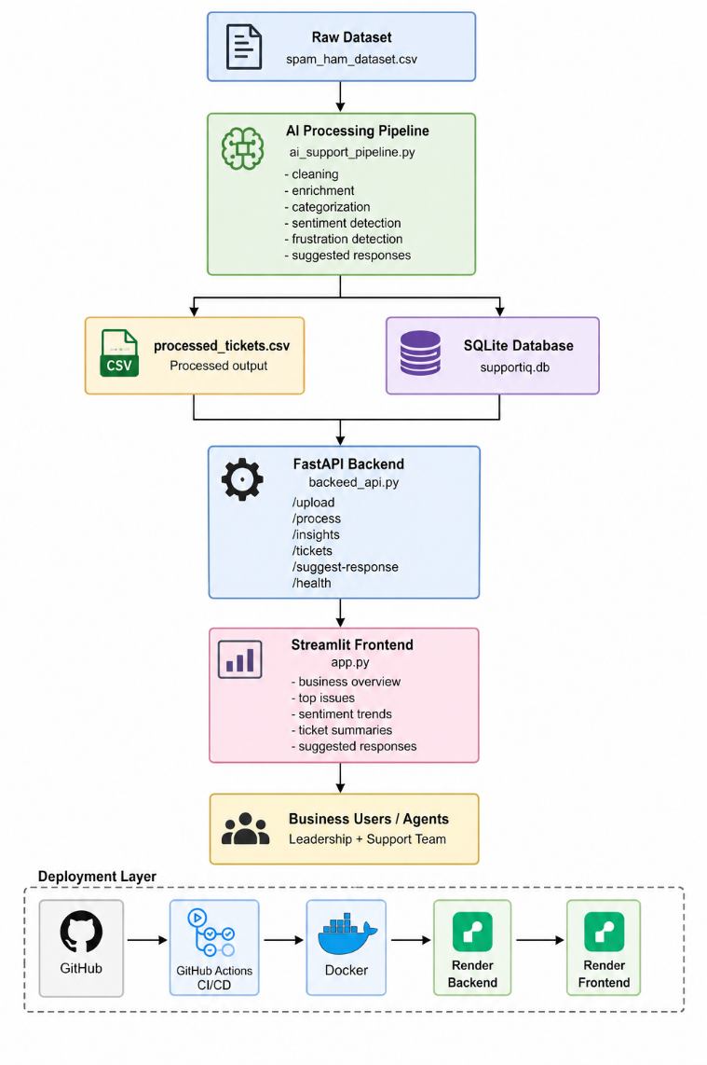
Main components:
AI Processing Pipeline
Processes raw customer messages and generates structured insights.
Backend API
Built using FastAPI.
Provides APIs for:
- Uploading tickets
- Processing tickets
- Retrieving insights
- Generating suggested responses
Frontend Dashboard
Built using Streamlit.
Displays:
- Ticket summaries
- Top issues
- Sentiment trends
- Revenue impact
- Suggested responses

6. Scalability
The project was designed with future scalability in mind.
The frontend and backend are separated, allowing independent scaling.
Docker was used to containerize the services for easier deployment.
FastAPI supports handling multiple API requests efficiently.
Currently, SQLite is used for simplicity, but PostgreSQL can be added in future versions for larger-scale deployments.
The modular architecture also allows AI components to be upgraded later without rebuilding the complete system.
7. Tradeoffs
The project mainly focuses on creating a practical and working prototype rather than building an overly complex AI system.
The goal was to keep the architecture simple, understandable, and easy to deploy while still demonstrating real AI-based ticket analysis capabilities.
Some tradeoffs include:
- Rule-based categorization instead of advanced ML models
- SQLite instead of PostgreSQL
- Template-based responses instead of LLM-generated responses
These choices reduced system complexity and made the project easier to build, test, and deploy within the assignment timeline.

8. CI/CD and Deployment
The project includes:
- Docker containerization
- GitHub Actions CI/CD pipeline
- Cloud deployment using Render
The CI/CD pipeline automatically:
- Installs dependencies
- Runs the AI pipeline
- Builds Docker images
- Validates the project structure

9. Project Links
GitHub Repository
https://github.com/SurojuAkshayKumar/supportiq
Frontend Deployment
https://supportiq-frontend.onrender.com
Backend API Documentation
https://supportiq-backend-7ouo.onrender.com/docs
Backend Health Check
https://supportiq-backend-7ouo.onrender.com/health
Demo Video / Google Drive Link
https://drive.google.com/file/d/1wB7A24wh-dXUK1CV9yQhVZkmdury6LMQ/view?usp=drive_link

10. Deliverables
The final project deliverables include:
- GitHub repository
- Working FastAPI backend
- Working Streamlit frontend
- Dockerized application
- Cloud deployment links
- CI/CD pipeline
- Design document
- Demo video
- Architecture explanation

11. Business Value
SupportIQ helps businesses by:
- Reducing support workload
- Detecting critical customer issues
- Improving response speed
- Understanding customer sentiment
- Identifying revenue-impacting problems
- Improving customer satisfaction
The system demonstrates how AI can be used to convert customer support data into meaningful business insights.

12. Future Improvements
Future versions of the project can include:
- PostgreSQL integration
- LLM-based response generation
- Embeddings and semantic search
- Real-time ticket processing
- Authentication system
- Monitoring and logging
- Auto-scaling cloud deployment
- Advanced AI classification models

13. Conclusion
Overall, SupportIQ demonstrates how AI, APIs, dashboards, databases, Docker, and cloud deployment can work together to solve a real business problem.
Instead of focusing only on theory, the project was designed as a practical end-to-end implementation that includes data processing, business analytics, deployment, and frontend visualization.
The project combines AI processing, backend APIs, frontend dashboards, Docker deployment, and CI/CD practices into one working system.
The final system demonstrates both technical implementation and business understanding while maintaining a simple and scalable architecture.

Prepared by :Suroju Akshay Kumar

