CMPG325-2026-126
INDIVIDUAL SEMESTER PROJECT
MILESTONE 1: CLIENT DESIGN REVIEW

Project ID | CMPG325-2026-126
Student | SELOWA, S
Student Number | 45192472
Client ID | CLI-126
Organisation | Moribo Live Music Venue (Kimberley)
Industry | Entertainment
Date | 28 August 2026

TABLE OF CONTENTS
- Client Requirements
- Physical Topology
- Logical Topology
- IP Addressing Plan
- Initial GitHub Repository
- Design Decisions Summary
- Next Steps

1. CLIENT REQUIREMENTS
1.1 Client Overview

Attribute | Details
Client ID | CLI-126
Organisation | Moribo Live Music Venue
Location | Kimberley, South Africa
Industry | Entertainment
Assigned Addressing Block | 172.30.80.0/23
Assigned Networking Challenge | Inter-VLAN Routing (L3 switch / SVI)
Design Constraint | Remote management of network devices for off-site IT contracto
Change Request | CR10: Four additional point-of-sale terminals deployed

1.2 Business Context
Moribo Live Music Venue is an entertainment establishment located in Kimberley. The venue hosts live music events, concerts, and performances on a regular basis. As a busy entertainment venue, it requires a robust and reliable computer network to support its daily operations, including:
- Ticketing and admissions – Processing ticket sales at the entrance
- Merchandise sales – Selling band merchandise and venue memorabilia
- Concessions and bar operations – Processing food and beverage payments
- Administrative functions – Staff workstations for management and operations
- Guest services – Providing Wi-Fi access to patrons
- IT management – Remote monitoring and management by external IT contractor

1.3 Functional Requirements
Basd on the client brief, the network must satisfy the following functional requirements:
Requirement ID | Description
R1 | Provide appropriate connectivity and network services for the venue
R2 | Accommodate Inter-VLAN Routing using a Layer 3 switch with SVIs
R3 | Enable remote management of network devices for off-site IT contractor
R4 | Integrate four additional POS terminals (Change Request CR10)
R5 | Support successful data exchange between appropriate nodes
R6 | Be testable and verifiable in Cisco Packet Tracer

1.4 Technical Requirements
Category | Specification
Simulation Tool | Cisco Packet Tracer
Addressing Block | 172.30.80.0/23
Routing Method | Inter-VLAN Routing (L3 switch / SVI)
Management Protocol | SSH (Secure Shell) for remote access
VLAN Count | Minimum of 4 VLANs
Difficulty Level | Intermediate

1.5 Design Constraints
The following constraints must be addressed in the network design:
- Remote Management Constraint: The off-site IT contractor must be able to securely access and manage network devices from an external location. This requires SSH configuration on all network infrastructure devices.
- Addressing Constraint: All IP addressing must be derived from the assigned block 172.30.80.0/23 using appropriate subnetting.
- Change Request CR10: The network must accommodate four additional POS terminals beyond the existing two, bringing the total to six POS terminals.

1.6 Change Request CR10 Analysis
Aspect | Details
Change Request ID | CR10
Description | Four additional point-of-sale terminals deployed
Impact | Network expansion – POS device count increases from 2 to 6
Implementation | Add new POS devices to existing POS VLAN and subnet
Addressing Impact | None – POS subnet has sufficient capacity
Performance Impact | Minimal – six POS terminals generate low network traffic

1.7 Assumptions
The following assumptions were made during the design process:
The venue operates from a single physical location in Kimberley.
- All end devices (staff PCs, POS terminals) are connected via wired Ethernet.
- Guest Wi-Fi is provided via a wireless access point for patrons.
- Network devices are managed via SSH with local authentication.
- DHCP is used for dynamic IP assignment to end devices.
- The venue does not require a dedicated server for file sharing or database services.
- The off-site IT contractor has a reliable internet connection for remote management.
2. PHYSICAL TOPOLOGY
2.1 Topology Overview
The physical topology adopts a hierarchical star-based design with a central distribution layer (Layer 3 switch) and multiple access switches (Layer 2 switches) connecting end devices. This design provides:
- Scalability: Easy addition of new devices and switches
- Manageability: Centralised control and monitoring
- Performance: Dedicated links between access and distribution layers
- Simplicity: Clear separation of core, distribution, and access layers

2.2 Topology Diagram

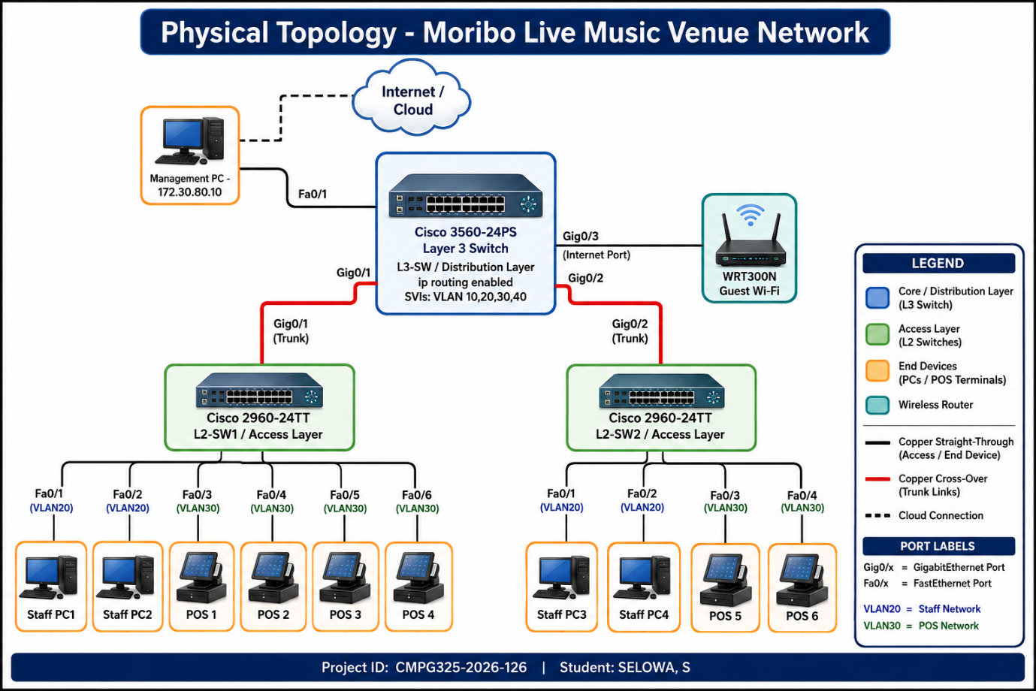

2.3 Device Inventory
Device Type | Model | Quantity | Role | VLAN Assignment
Layer 3 Switch | Cisco 3560-24PS | 1 | Distribution/Core routing | VLAN 10 (Management)
Layer 2 Switch 1 | Cisco 2960-24TT | 1 | Access layer | VLAN 10 (Management)
Layer 2 Switch 2 | Cisco 2960-24TT | 1 | Access layer | VLAN 10 (Management)
Wireless Router | WRT300N | 1 | Guest Wi-Fi access | VLAN 40 (Guest)
Staff PCs | PC-PT | 4 | Administrative workstations | VLAN 20 (Staff)
POS Terminals | PC-PT | 6 | Point-of-Sale systems | VLAN 30 (POS)
Management PC | PC-PT | 1 | Network administration | VLAN 10 (Management)

2.4 Physical Connections
Connection | Cable Type | Source Port | Destination Port
L3-SW ↔ L2-SW1 | Copper Cross-over | Gig0/1 | Gig0/1
L3-SW ↔ L2-SW2 | Copper Cross-over | Gig0/2 | Gig0/1
L3-SW ↔ WRT300N | Copper Straight-through | Gig0/3 | Internet Port
L3-SW ↔ Management PC | Copper Straight-through | Fa0/1 | FastEthernet0
L2-SW1 ↔ Staff PC1 | Copper Straight-through | Fa0/1 | FastEthernet0
L2-SW1 ↔ Staff PC2 | Copper Straight-through | Fa0/2 | FastEthernet0
L2-SW1 ↔ POS Terminal 1 | Copper Straight-through | Fa0/3 | FastEthernet0
L2-SW1 ↔ POS Terminal 2 | Copper Straight-through | Fa0/4 | FastEthernet0
L2-SW1 ↔ POS Terminal 3 (CR10) | Copper Straight-through | Fa0/5 | FastEthernet0
L2-SW1 ↔ POS Terminal 4 (CR10) | Copper Straight-through | Fa0/6 | FastEthernet0
L2-SW2 ↔ Staff PC3 | Copper Straight-through | Fa0/1 | FastEthernet0
L2-SW2 ↔ Staff PC4 | Copper Straight-through | Fa0/2 | FastEthernet0
L2-SW2 ↔ POS Terminal 5 (CR10) | Copper Straight-through | Fa0/3 | FastEthernet0
L2-SW2 ↔ POS Terminal 6 (CR10) | Copper Straight-through | Fa0/4 | FastEthernet0

3. LOGICAL TOPOLOGY
3.1 VLAN Design
The network will be segmented into the following VLANs based on functional requirements and industry best practices:
VLAN ID | VLAN Name | Purpose | Subnet | Gateway (SVI)
10 | Management | Network device management (SSH access) | 172.30.80.0/26 | 172.30.80.1
20 | Staff | Administrative and office staff workstations | 172.30.80.64/26 | 172.30.80.65
30 | POS | Point-of-Sale terminals (includes CR10 expansion) | 172.30.80.128/26 | 172.30.80.129
40 | Guest | Public Wi-Fi for venue patrons | 172.30.80.192/27 | 172.30.80.193
99 | Native | Untagged traffic on trunk links | N/A | N/A

3.2 VLAN Design Rationale
VLAN | Rationale
VLAN 10 (Management) | Isolates management interfaces for security. IT contractor can access all devices via SSH on this VLAN. Aligns with best practices for secure device management.
VLAN 20 (Staff) | Separates administrative traffic from operational systems. Prevents staff devices from directly accessing POS or management networks.
VLAN 30 (POS) | Critical security isolation for payment card environment. Protects POS traffic from general network traffic. Provides dedicated bandwidth for payment processing.
VLAN 40 (Guest) | Isolates public Wi-Fi traffic from internal business networks. Prevents guest devices from accessing sensitive systems. Provides internet-only access.

3.3 Logical Topology Diagram
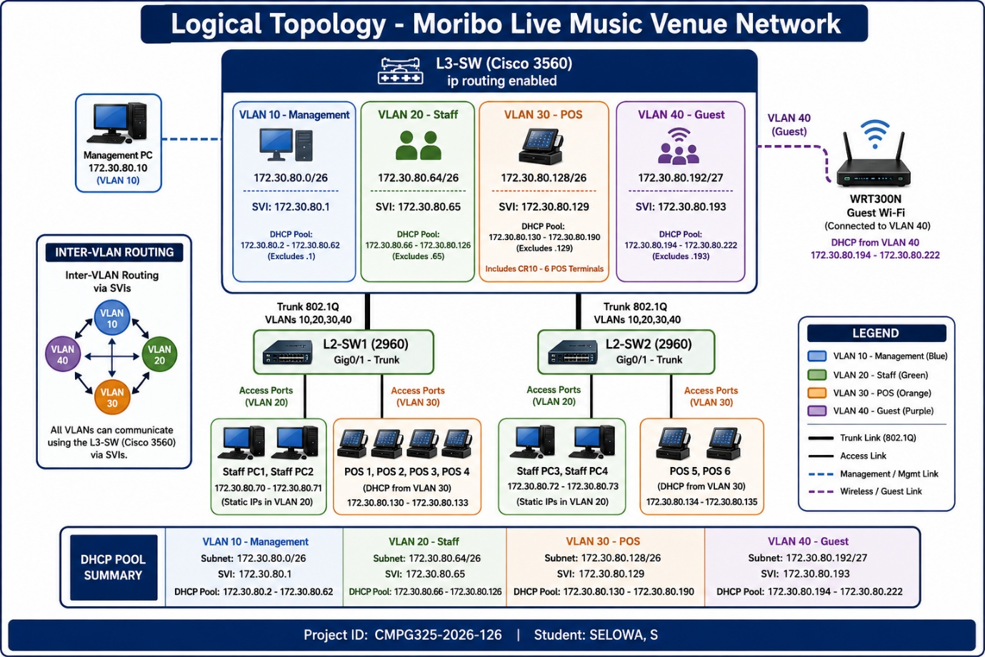

3.4 Inter-VLAN Routing Design
Inter-VLAN routing will be implemented using Switch Virtual Interfaces (SVIs) on the Layer 3 switch (Cisco 3560). This approach is chosen because:
Advantage | Description
Performance | Hardware-based routing at near-wire speed
Efficiency | Eliminates need for external router
Scalability | SVIs can be easily added for new VLANs
Management | Centralised routing configuration
Cost-effective | Utilises existing switch hardware

SVI Configuration Overview:
interface vlan 10
ip address 172.30.80.1 255.255.255.192
no shutdown

interface vlan 20
ip address 172.30.80.65 255.255.255.192
no shutdown

interface vlan 30
ip address 172.30.80.129 255.255.255.192
no shutdown

interface vlan 40
ip address 172.30.80.193 255.255.255.224
no shutdown

3.5 Remote Management Design
To satisfy the remote management constraint, the following design decisions were made:
Feature | Implementation
Secure Access | SSH v2 configured on all switches
Management VLAN | All management interfaces on VLAN 10
VTY Lines | Configured for SSH only (Telnet disabled)
Authentication | Local user database with encrypted passwords
Domain Name | moribo.local for SSH key generation

SSH Configuration Overview:
username admin secret admin123
line vty 0 4
transport input ssh
login local
ip ssh version 2
ip domain-name moribo.local
crypto key generate rsa modulus 1024

4. IP ADDRESSING PLAN
4.1 Subnetting the Assigned Block
The assigned addressing block is 172.30.80.0/23, providing 512 total addresses (172.30.80.0 – 172.30.81.255). Using VLSM (Variable Length Subnet Masking), the block is subnetted as follows:
Subnet | Network Address | CIDR | Usable Hosts | Broadcast Address | VLAN Assignment
Subnet 0 | 172.30.80.0 | /26 | 62 | 172.30.80.63 | VLAN 10 (Management)
Subnet 1 | 172.30.80.64 | /26 | 62 | 172.30.80.127 | VLAN 20 (Staff)
Subnet 2 | 172.30.80.128 | /26 | 62 | 172.30.80.191 | VLAN 30 (POS)
Subnet 3 | 172.30.80.192 | /27 | 30 | 172.30.80.223 | VLAN 40 (Guest)
Reserved | 172.30.80.224 | /27 | 30 | 172.30.80.255 | Future expansion
Reserved | 172.30.81.0 | /24 | 254 | 172.30.81.255 | Future expansion

5. INITIAL GITHUB REPOSITORY
5.1 Repository Information
Attribute | Details
Repository Name | CMPG325-2026-126-Moribo-Venue-Network
Owner | SELOWA, S (45192472)
Visibility | Public
Created | 24 August 2026
URL | https://github.com/Surprise12/CMPG325-2026-126-Moribo-Venue-Network

5.2 README.md Content
The repository includes a comprehensive README.md file with the following sections:

- Project Overview – Description of the Moribo Live Music Venue network project
- Key Features – Inter-VLAN routing, VLAN segmentation, remote management
- Addressing Block – 172.30.80.0/23 with subnet details
- Technical Stack – Cisco Packet Tracer, 3560/2960 switches, SSH
- Repository Structure – Explanation of folders and files
- Milestones – Key project deadlines
- Author – Student information

6. DESIGN DECISIONS SUMMARY

Decision | Rationale
Layer 3 switch (3560) for routing | Provides high-performance inter-VLAN routing via SVIs; eliminates need for separate router
VLAN segmentation (4 VLANs) | Isolates management, staff, POS, and guest traffic for security and performance
/26 subnets for core VLANs | Provides 62 usable addresses per VLAN, accommodating growth
Dedicated POS VLAN | Essential security practice for payment card environments
SSH-only remote management | Secure alternative to Telnet; satisfies off-site IT contractor constraint
DHCP for end devices | Simplifies administration and reduces configuration errors
Static addressing for infrastructure | Ensures consistent, predictable management access
Hierarchical topology | Provides scalability, manageability, and performance
Trunk links between switches | Allows multiple VLANs to traverse a single physical connection
WRT300N for guest Wi-Fi | Provides isolated wireless access for patrons

6.1 Key Design Principles Applied
- Security First – Management and POS traffic are isolated in dedicated VLANs
- Scalability – Subnet sizes accommodate future growth
- Simplicity – Design is easy to implement and maintain
- Best Practices – Follows Cisco and industry networking standards
- Remote Management – SSH configuration for off-site access

6.2 Change Request CR10 Integration
Aspect | Implementation
Impact Assessment | POS VLAN has 62 addresses, currently uses 2, adding 4 is minimal impact
Addressing | No subnet changes required – new terminals use existing DHCP pool
Physical Connectivity | Additional POS terminals connected to available switch ports
Configuration | Set switchports to access VLAN 30 for new POS terminals
Testing | Verify connectivity and DHCP lease assignment

7. NEXT STEPS (MILESTONE 2 PREPARATION)
The following tasks will be completed for Milestone 2 (due 2 October 2026):
7.1 Implementation Tasks
Task | Description | Status
1. Build Physical Topology | Create network in Cisco Packet Tracer | Pending
2. Configure VLANs | Create VLANs 10, 20, 30, 40 on all switches | Pending
3. Configure Trunk Links | Set up 802.1Q trunking between switches | Pending
4. Configure SVIs | Set up SVIs on Layer 3 switch for inter-VLAN routing | Pending
5. Enable ip routing | Enable routing on the Layer 3 switch | Pending
6. Configure DHCP | Set up DHCP pools on L3 switch | Pending
7. Configure SSH | Enable secure remote management | Pending
8. Connect End Devices | Add PCs, POS terminals, and WRT300N | Pending
9. Test Connectivity | Verify all VLANs can communicate | Pending
10. Verify CR10 | Confirm four new POS terminals work | Pending

7.2 Testing Plan
Test | Method | Expected Result
Intra-VLAN Ping | Ping within same VLAN | Successful
Inter-VLAN Ping | Ping between different VLANs | Successful (routed)
SSH Remote Access | SSH from management PC to L3-SW | Successful login
DHCP Assignment | Check IP addresses on end devices | Correct subnet IPs
POS Connectivity | Ping from POS to gateway | Successful
CR10 Verification | All 6 POS terminals online | Working

7.3 Documentation to Complete
- Packet Tracer .pkt file
- Device configuration files
- Connectivity test results with screenshots
- SVI verification results
- SSH access verification
- CR10 implementation evidence

8. REFERENCES
- Cisco Systems. (2023). Inter-VLAN Routing Configuration Guide. Cisco Documentation. Retrieved from https://www.cisco.com/
- Cisco Systems. (2023). Catalyst 3560 Switch Software Configuration Guide. Cisco Documentation.
- Cisco Systems. (2023). Catalyst 2960 Switch Software Configuration Guide. Cisco Documentation.
- Cisco Business. (2024). VLAN Best Practices and Security Tips. Cisco Business Blog.
- CMPG325 Project Handbook. (2026). North-West University.
- Odom, W. (2020). CCNA 200-301 Official Cert Guide Library. Cisco Press.
- Graziani, R., & Johnson, A. (2018). Routing and Switching Essentials Companion Guide. Cisco Networking Academy.

