**PRACTICAL 1**

**Import the legacy data from different sources such as ( Excel , SqlServer, Oracle etc.) and load in the target system. ( You can download sample database such as Adventureworks, Northwind, foodmart etc.)**

**Step 1: Open Sql Server Data Tools.**

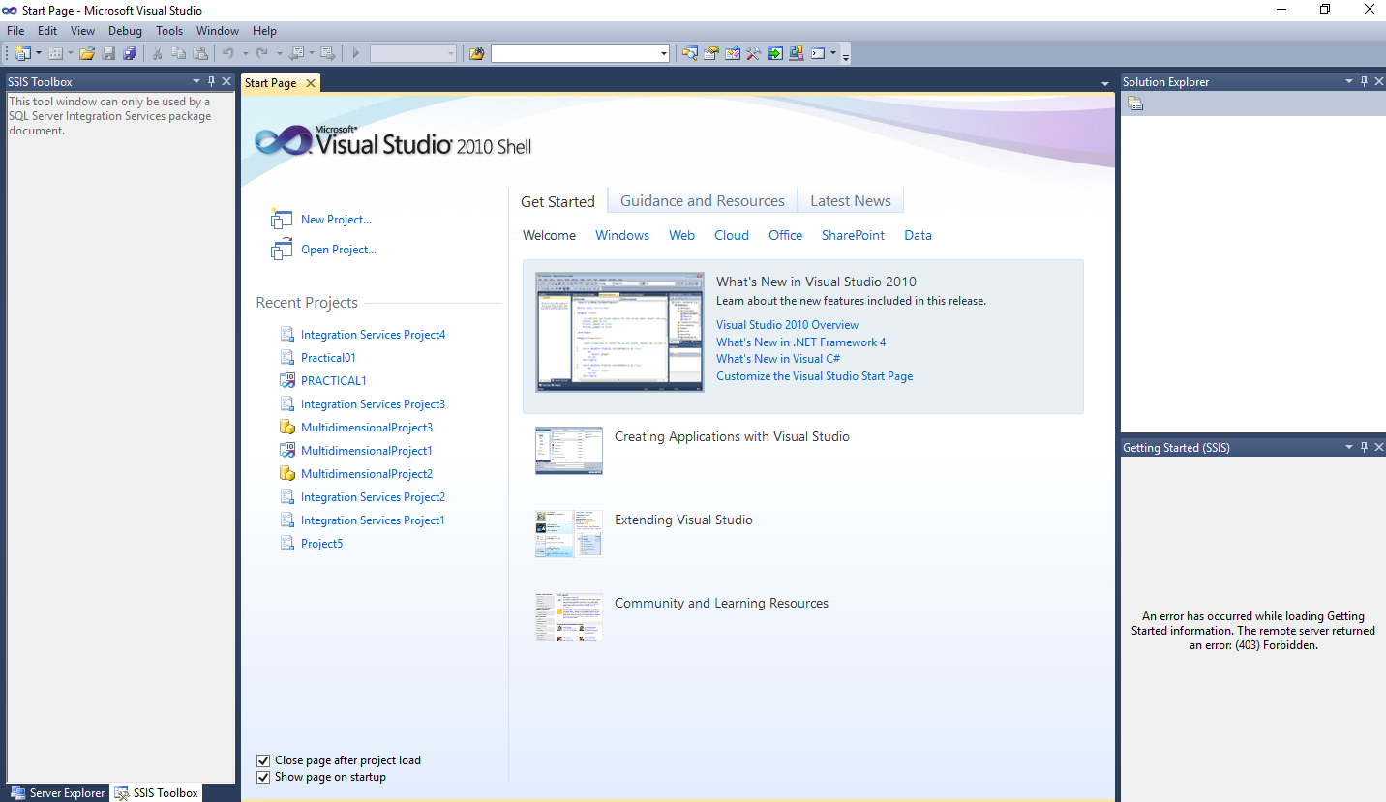

**Step 2: click on New Project and Select Integration Services Project and click on Ok.**

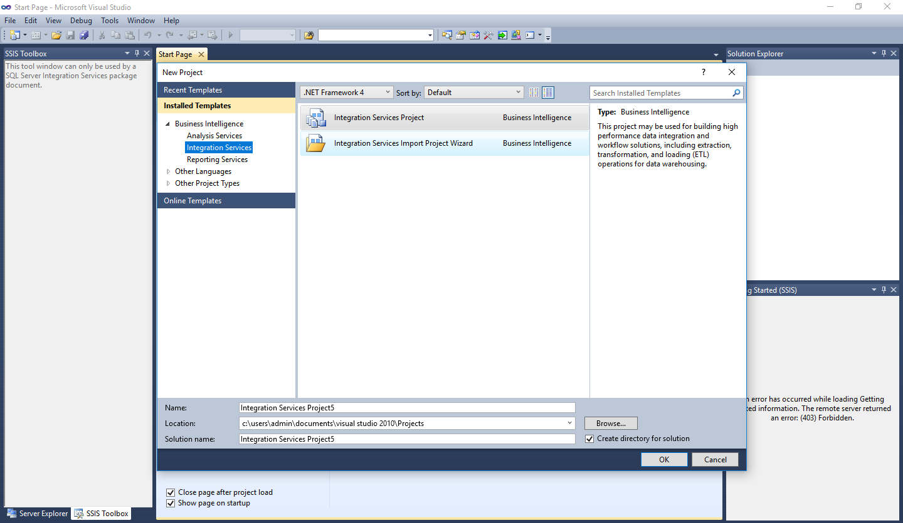

Step 3: Open This Window then Select Data Flow Task.

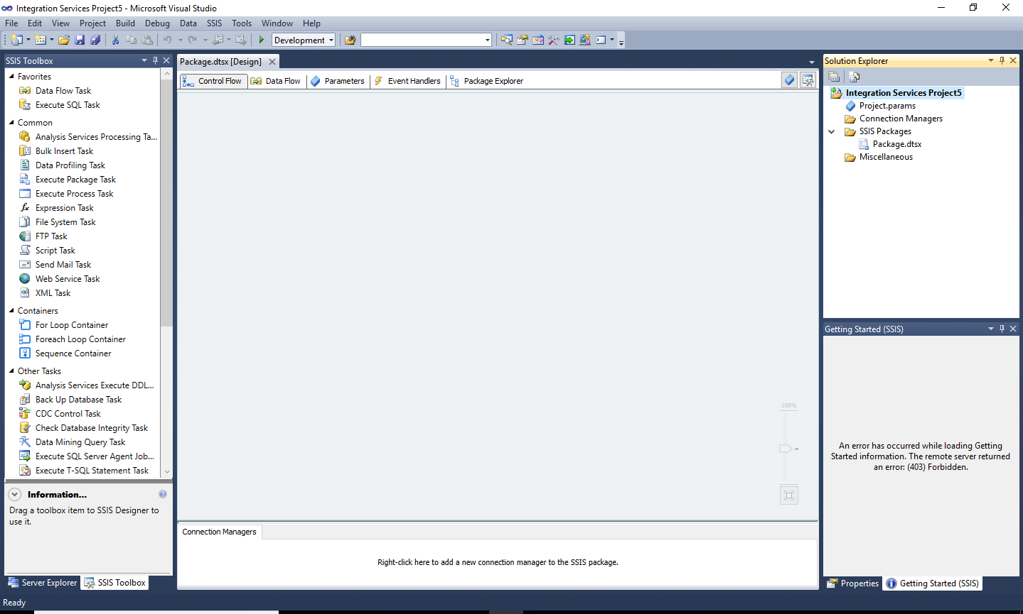

Step 4: Add 2 Data Flow Task and rename as Source and Destination. After that connect it.

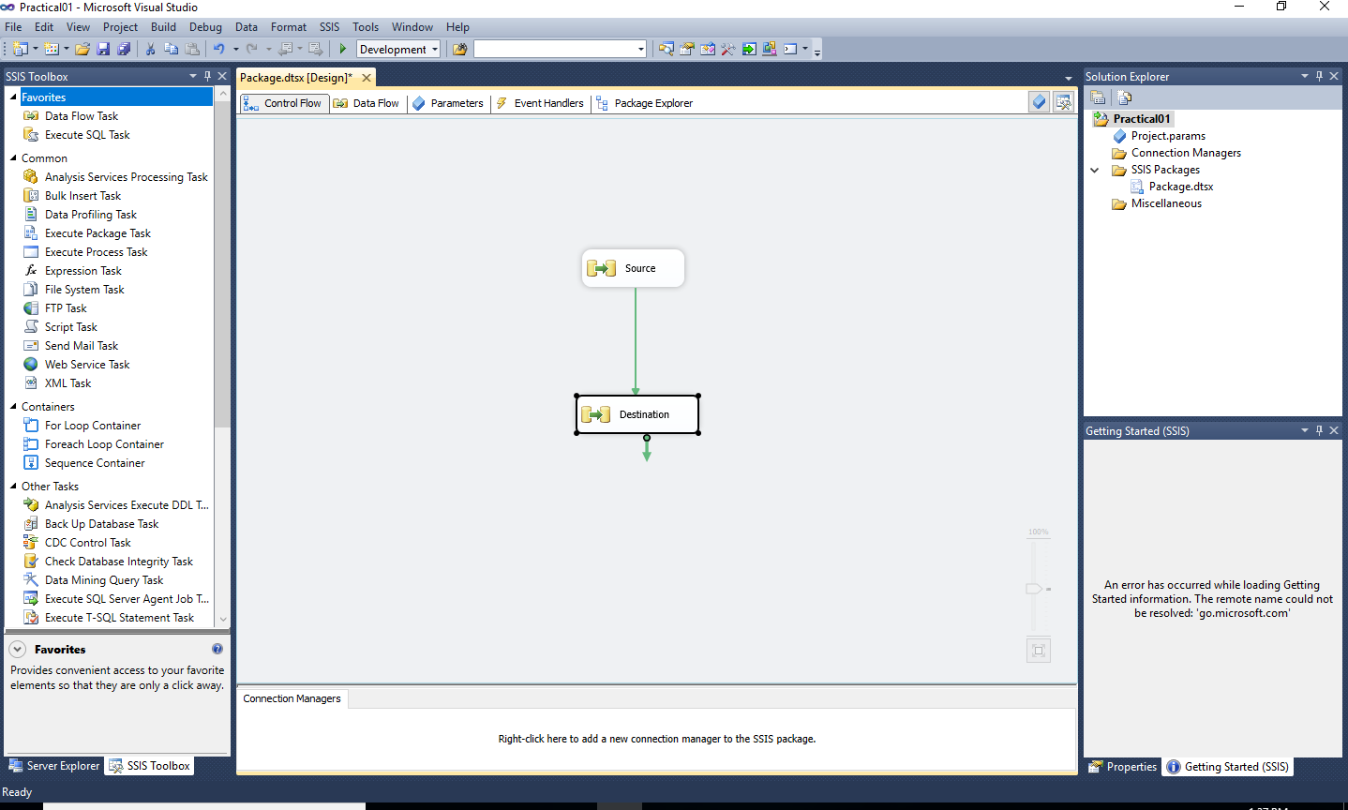

Step 5: And click on Source then add select source as Excel Source and Destination as OLE DB Destination from SSIS Toolbox.

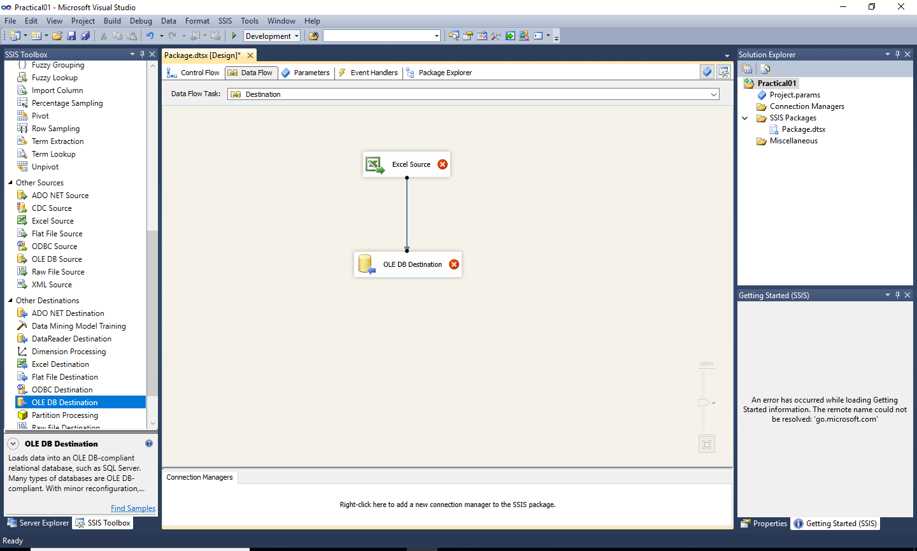

Step 6: Create new excel file.



Step 7 : Double Click on Excel Source and Select Excel Source, after click on New open the Excel Connection Manager window then Browse the excel file (Prac01)and click on Ok.

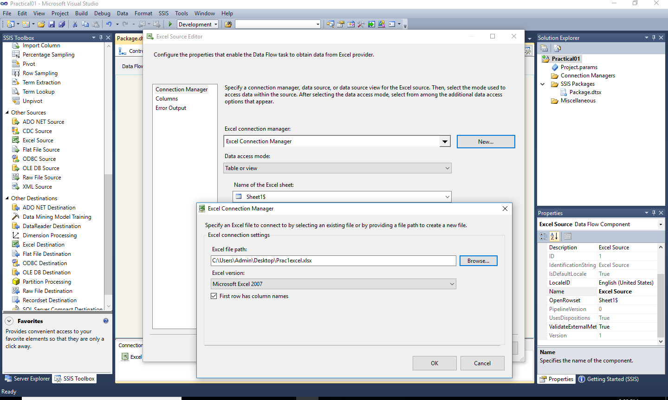

Step 8: After that Click on Columns then check the fields and click on Ok.

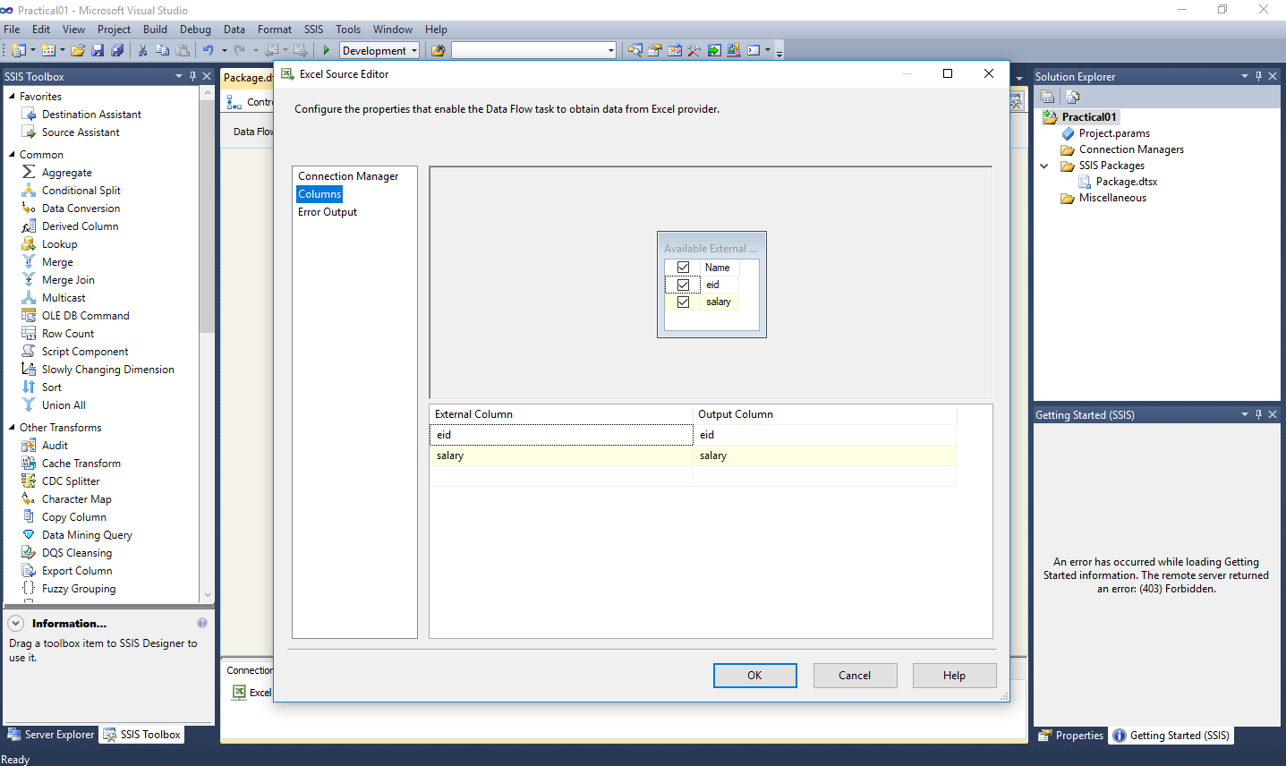

Step 9: Double click on OLE DB Destination then click on New Button.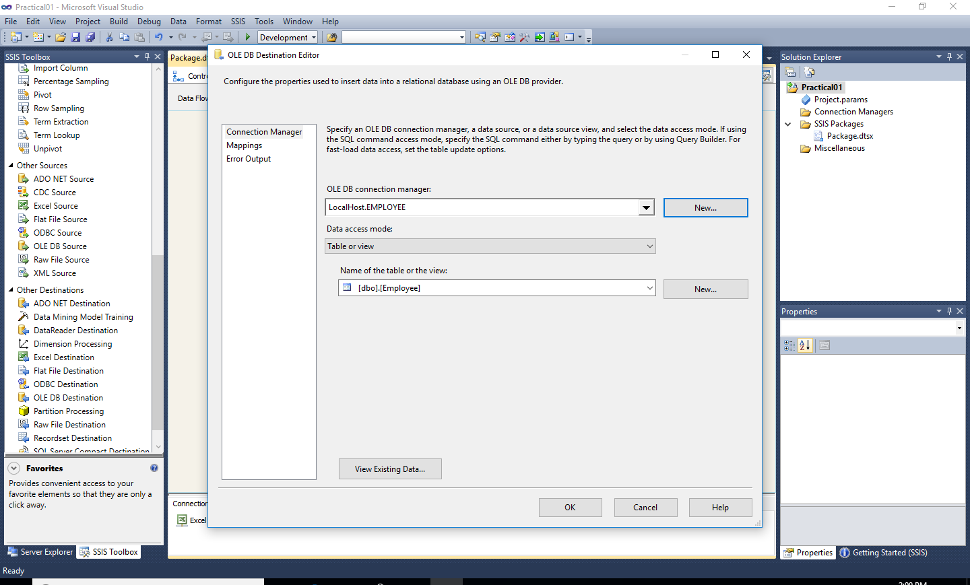

Step10: Then select data connections (Your Data Base Name) from this window and click on Ok. 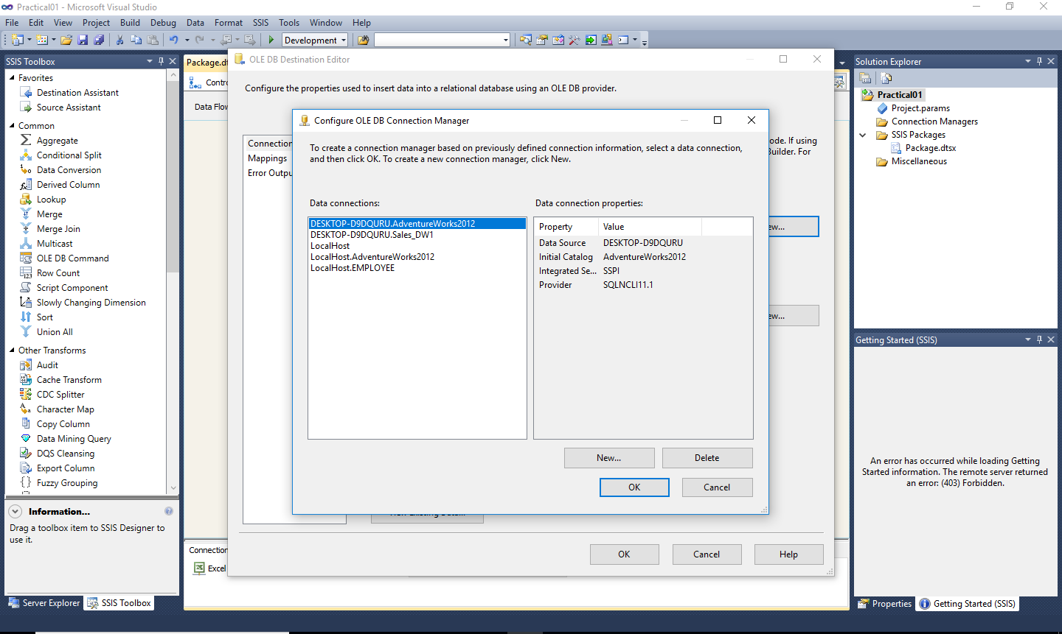

Step 11: After that Click on Mappings then select the appropriate fields and click on Ok 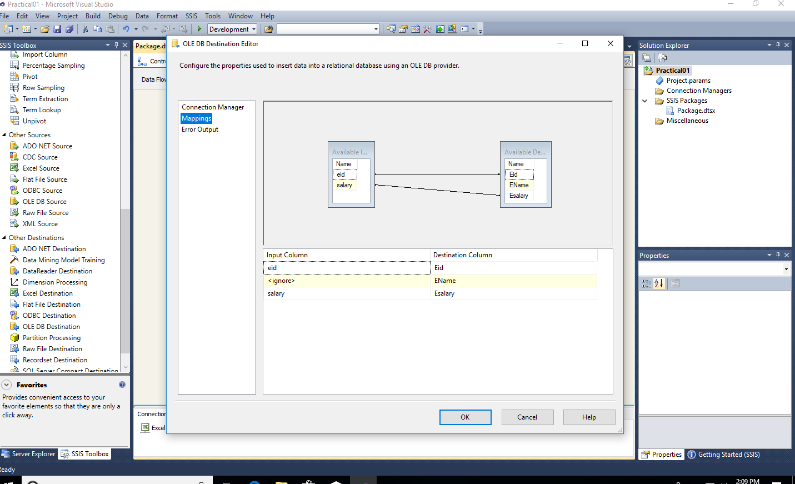

Step 12: Run the Project.

