**Practical 2**

**Perform the Extraction Transformation and Loading (ETL) process to construct the database in the SQL server.**

**Step1:** Click on new project and select Integration Services Project.

**Step 2:** Drag and Drop two Data Flow Task on control flow panel and rename as Input and Output.

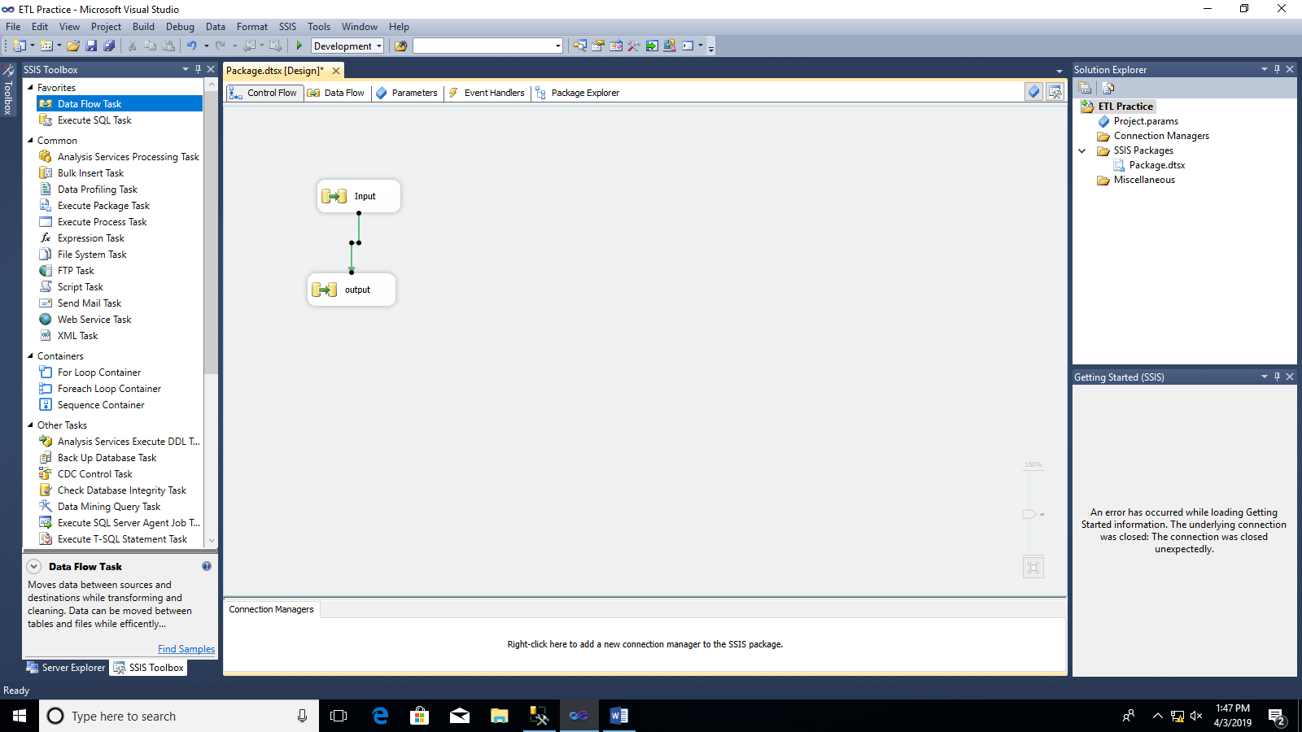

**Step3:** Drag and Drop OLE DB source and Flat File Destination on Data Flow Panel.

**Step4:** Double click on ADO.NET Source. Select New, again select New. Enter . (dot) in server name.

Select Database name as “employee” or any database you want and then click OK.

Select name of table as “dbo.emp” or any table from database you want.

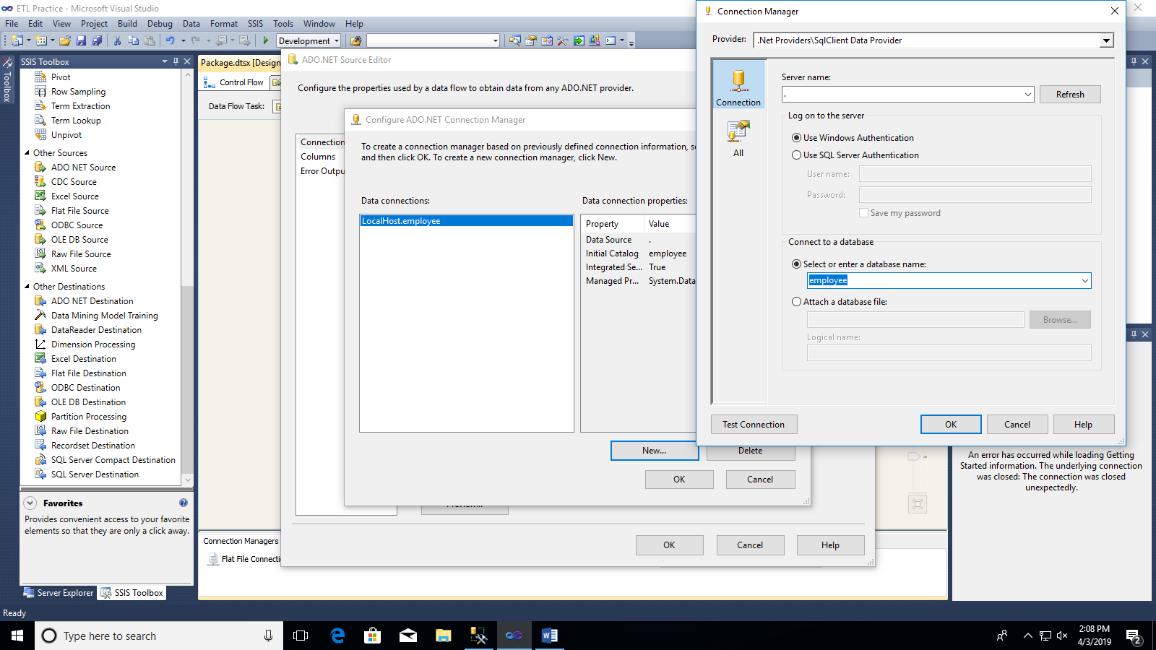

**Step5:** Create new CSV file and enter column name same as table columns.

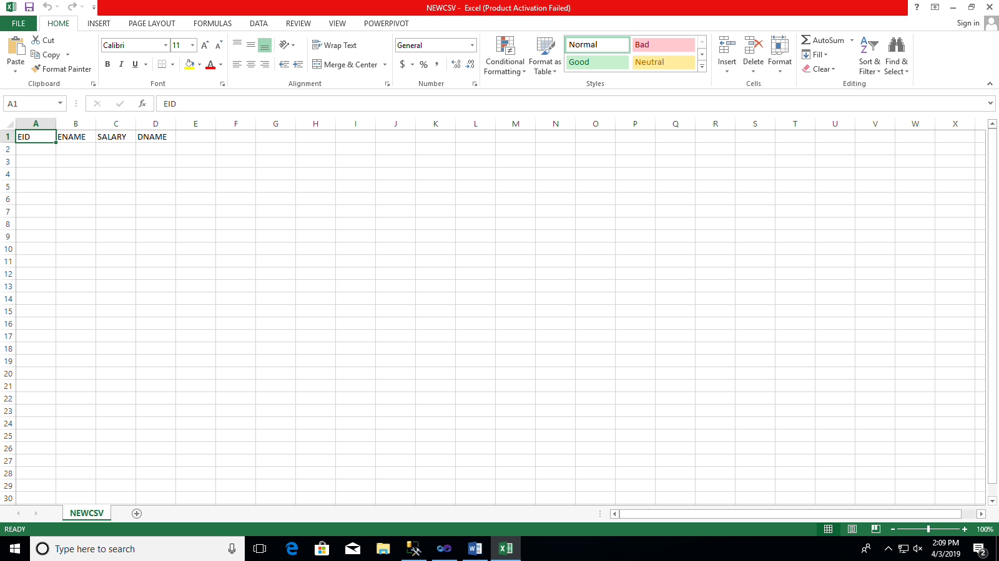

**Step 6:** Double click on flat file destination. Click on New and then select delimited and Ok

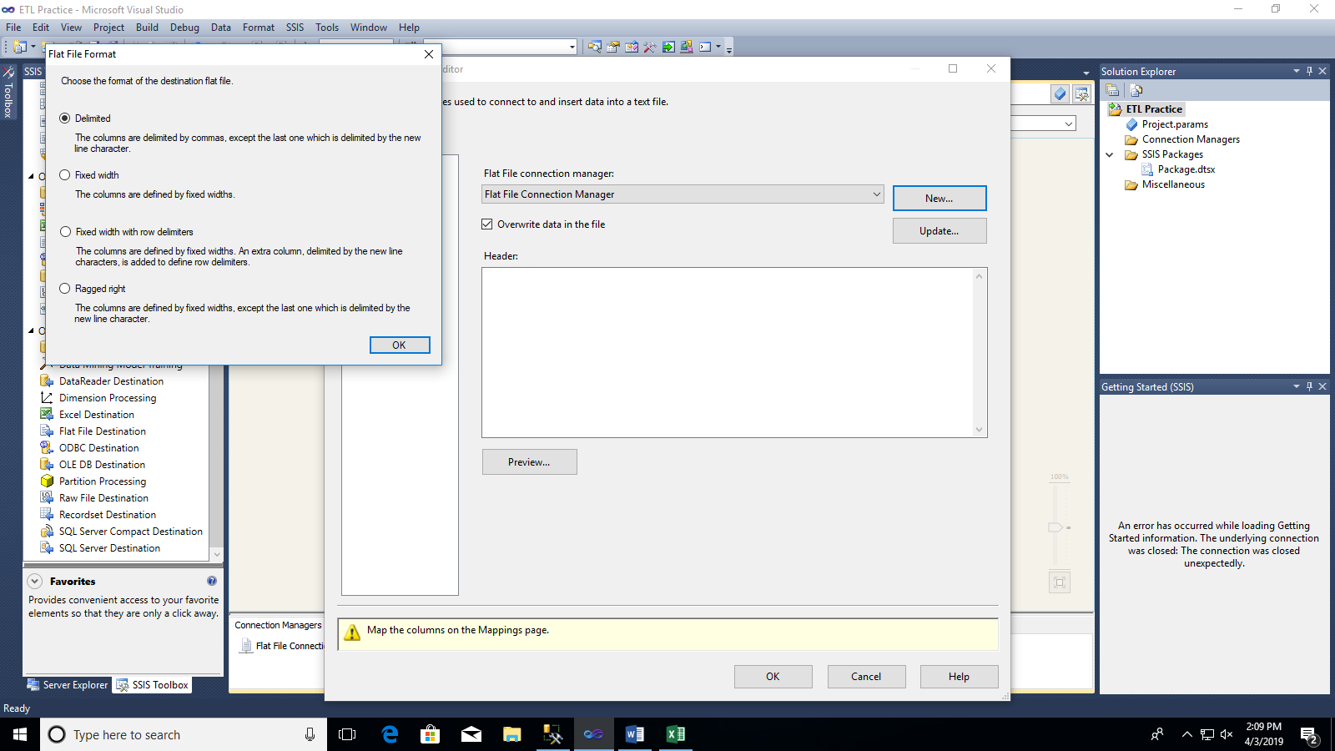

**Step7:** Browse the newly created CSV file. In Header Row Delimiter select “Comma”.

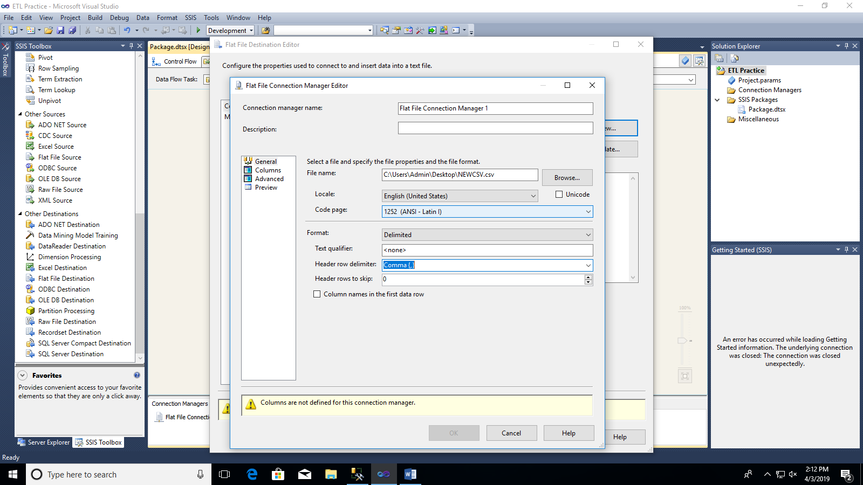

**Step 8:** Double click on mappings and connect Input Column to Destination Column.

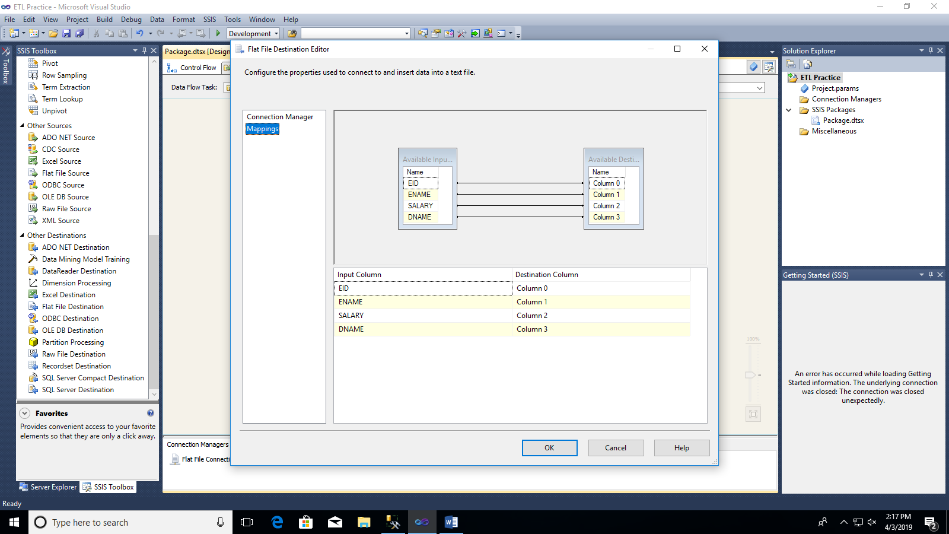

**Step 9:** Click on Run Button. View the result in CSV file.

