Import the datawarehouse data in Microsoft Excel and create the Pivot table and Pivot Chart (Ms Office Professional is used to make sure Power View is enabled for visualization.) Step 1: Open Excel 2013 (Professional) Go to Data tab → Get External Data → From Other Sources → From Data Connection Wizard

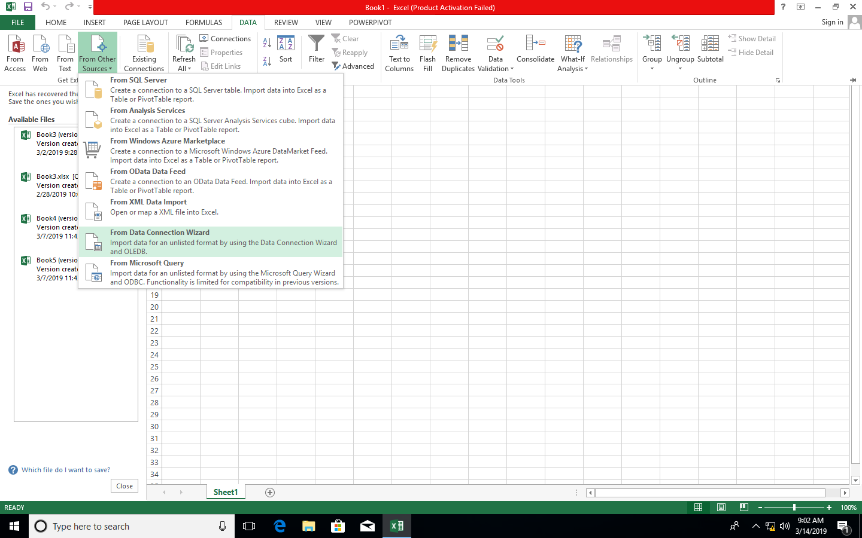

***Step 2: In Data Connection Wizard → Select Microsoft SQL Server → Click on Next***

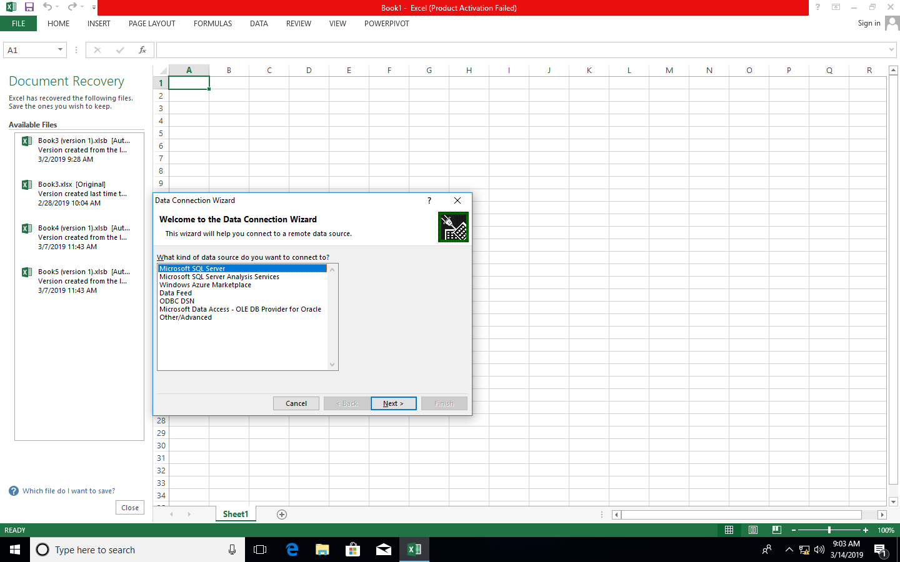

***Step 3: In connect to Database Server provide Server name(.) and select Use Windows Authentication and Click on Next***

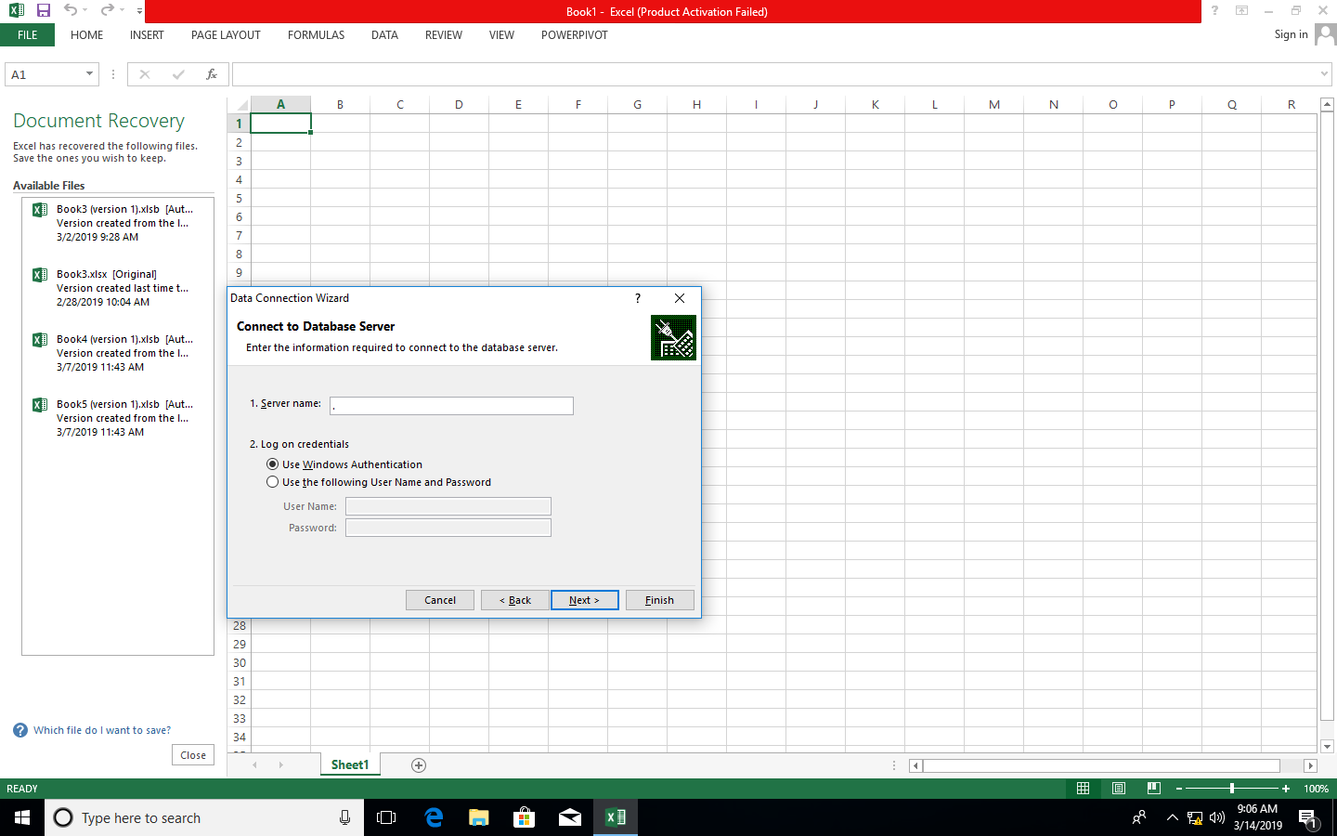

***Step 4: In Select Database and Table→ Select Sales_DW (already created in SQL) → check all dimensions and import relationships between selected tables***

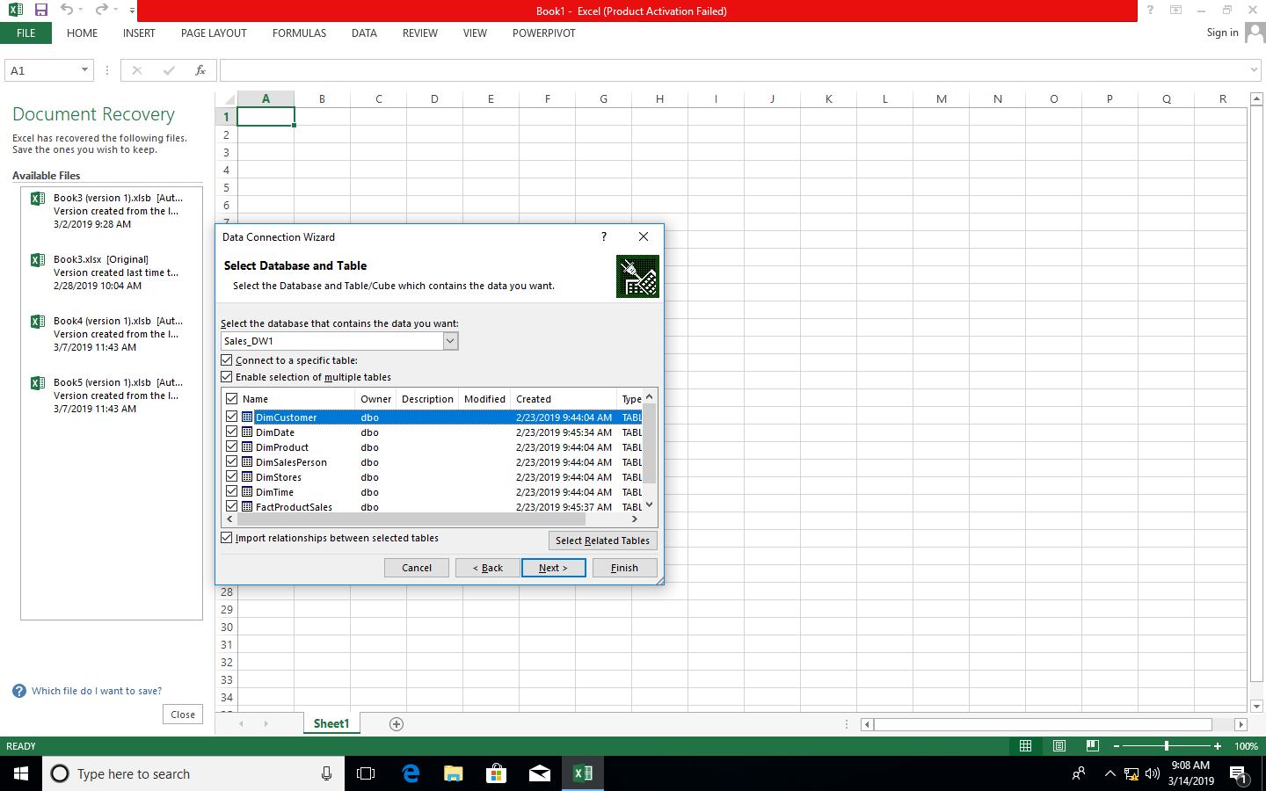

***Step 5: In save data connection files browse path and click on Finish***

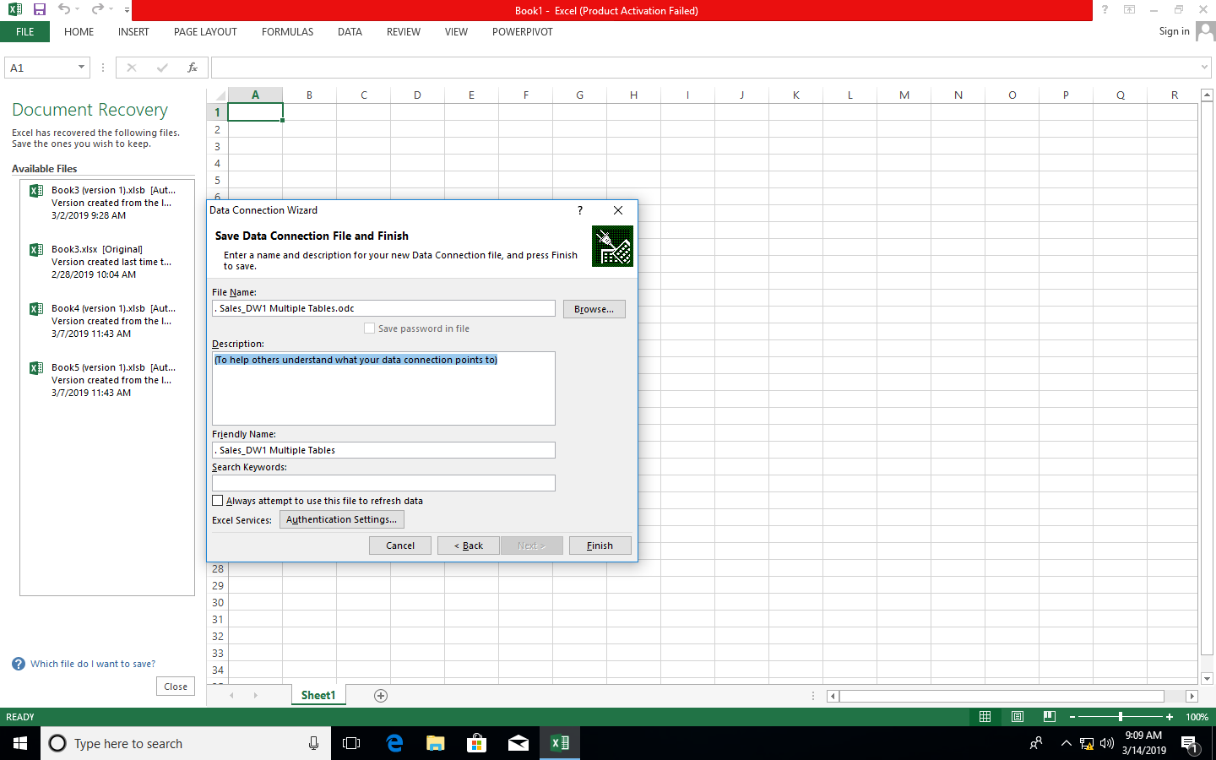

***Step 6: In import data select Pivot Chart and click on OK***

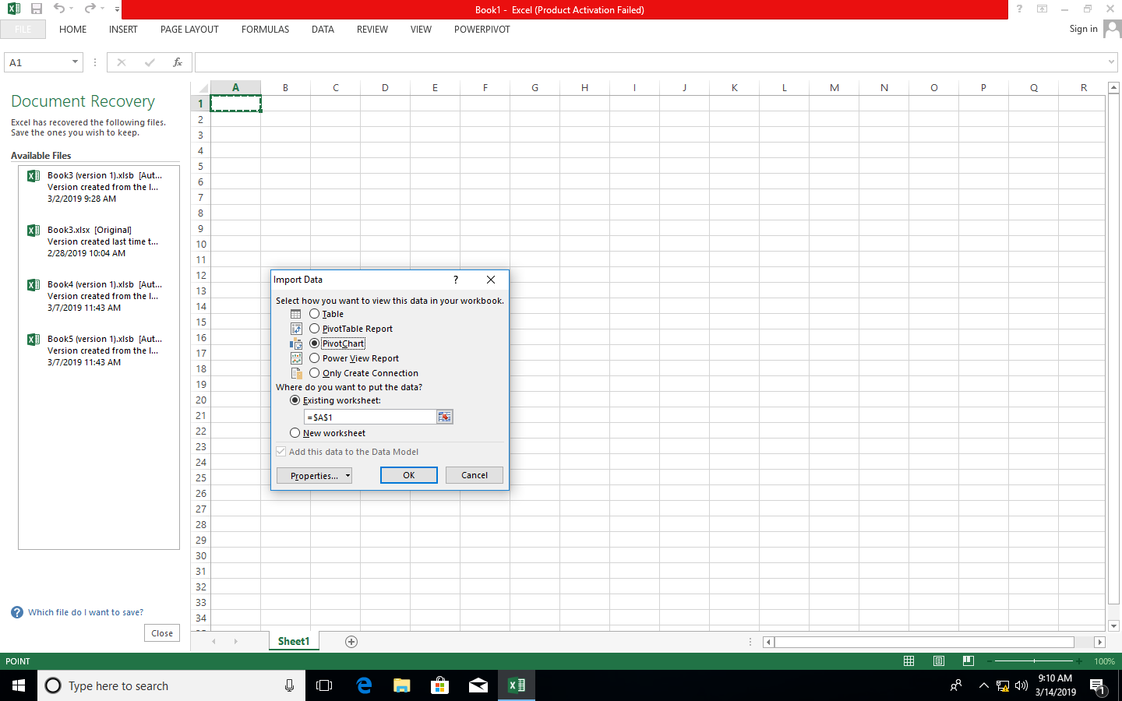

***Step 7: In fields put SalesDateKey in filters, FullDateUK in axis and Sum of ProductActualCost in values***

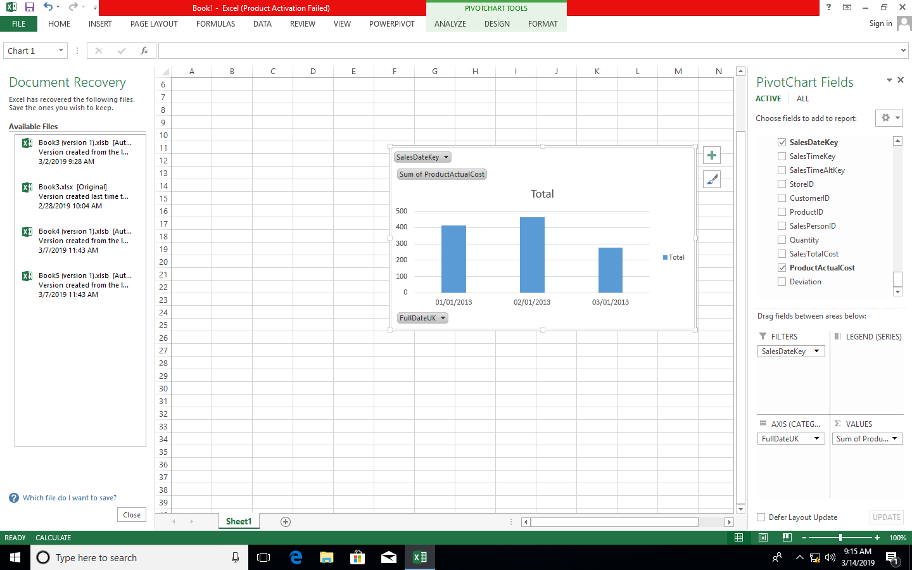

***Step 8: In Insert Tab → go to Pivot Table***

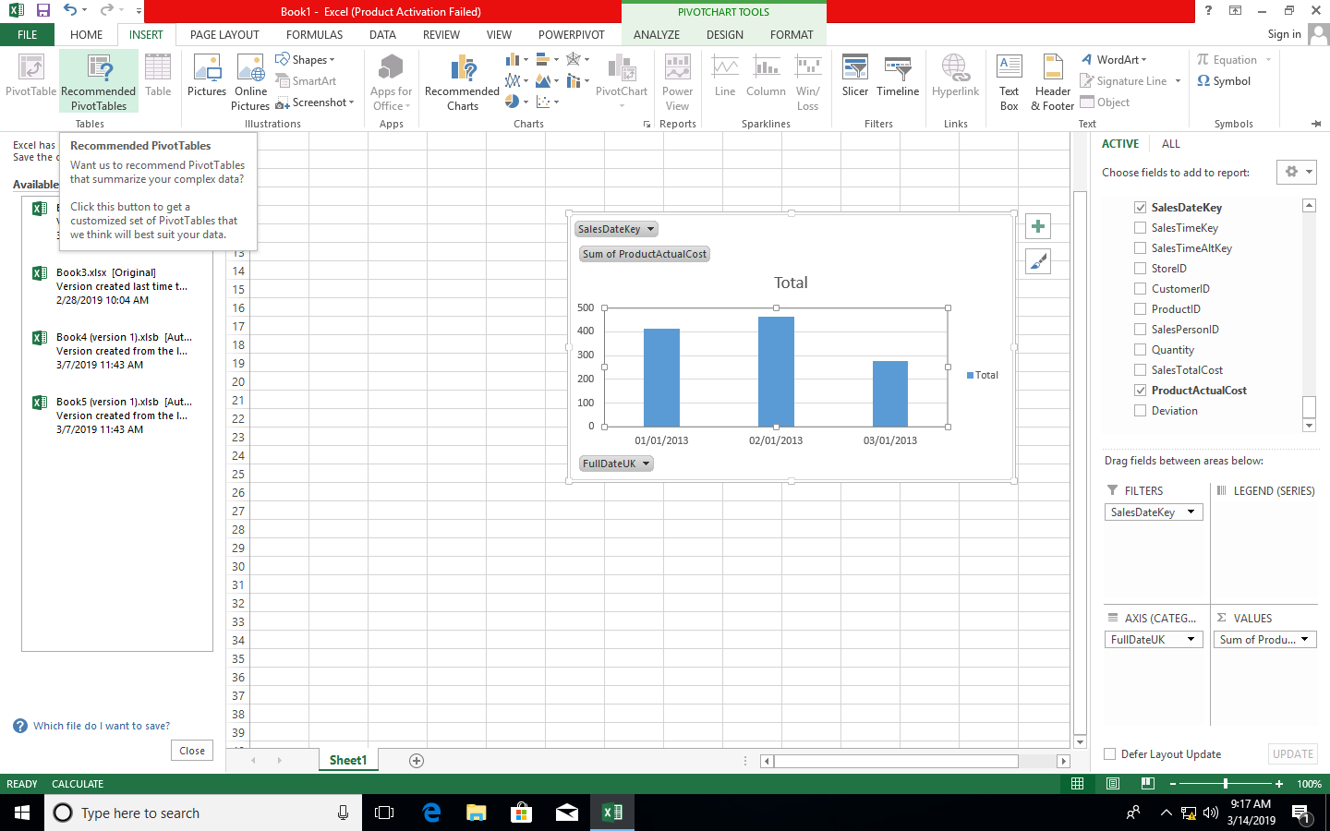

***Step 9: Click on Choose Connection to select existing connection with Sales_DW and click on open***

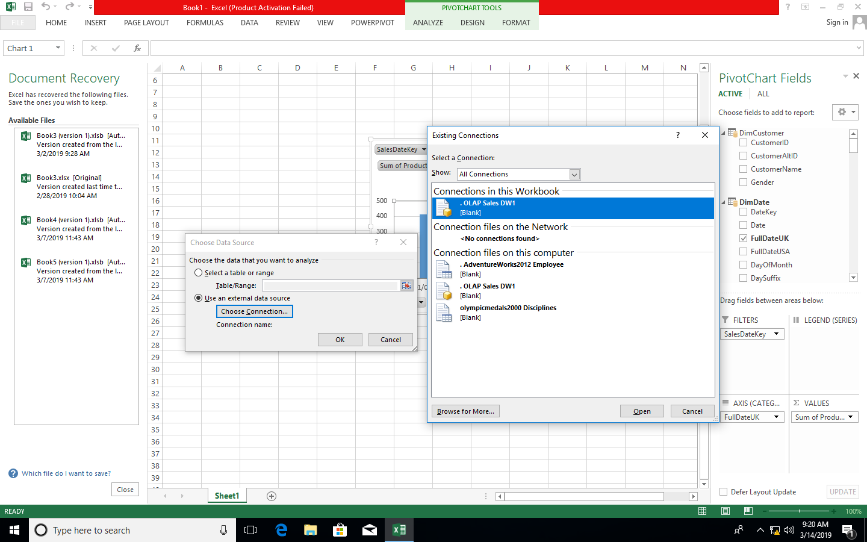

***Pivot table and Pivot chart is created***

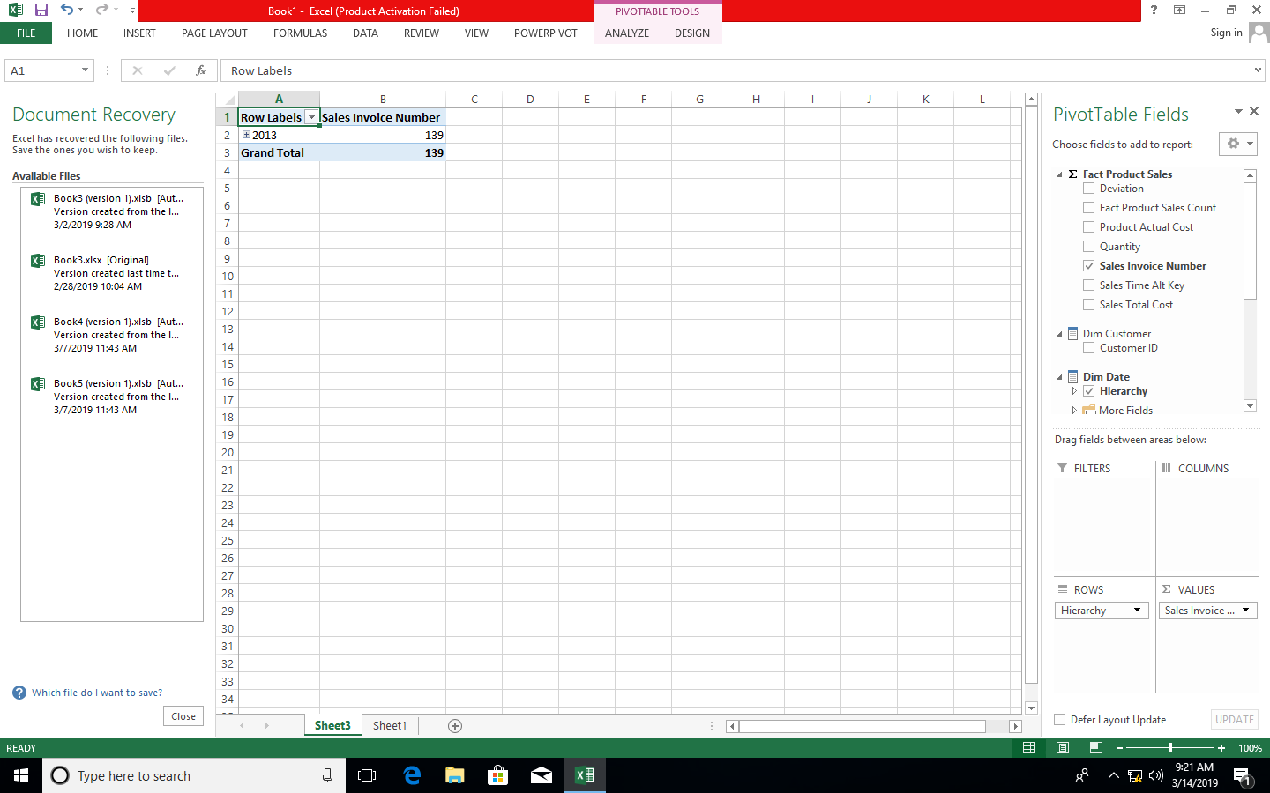

***B) Import the cube in Microsoft Excel and create the Pivot table and Pivot Chart to perform data analysis.***

Step 1: Open Excel 2013 (Professional) Go to Data tab → Get External Data → From Other Sources → From Analysis Services

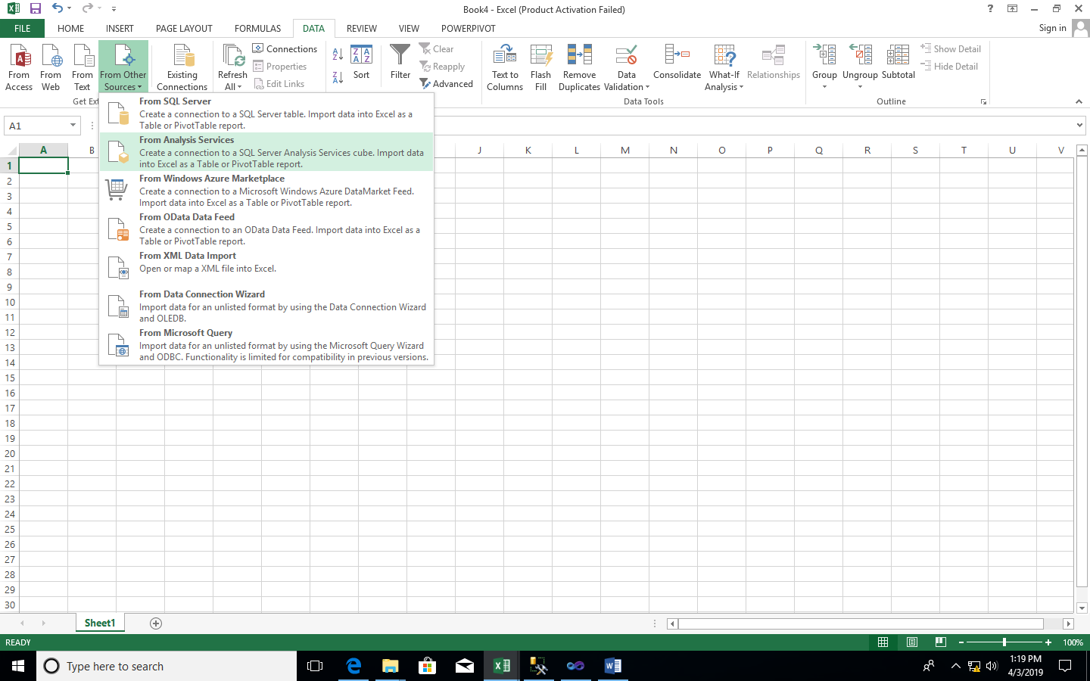

Step 2: Select Server name and Windows Authentication and click on Next

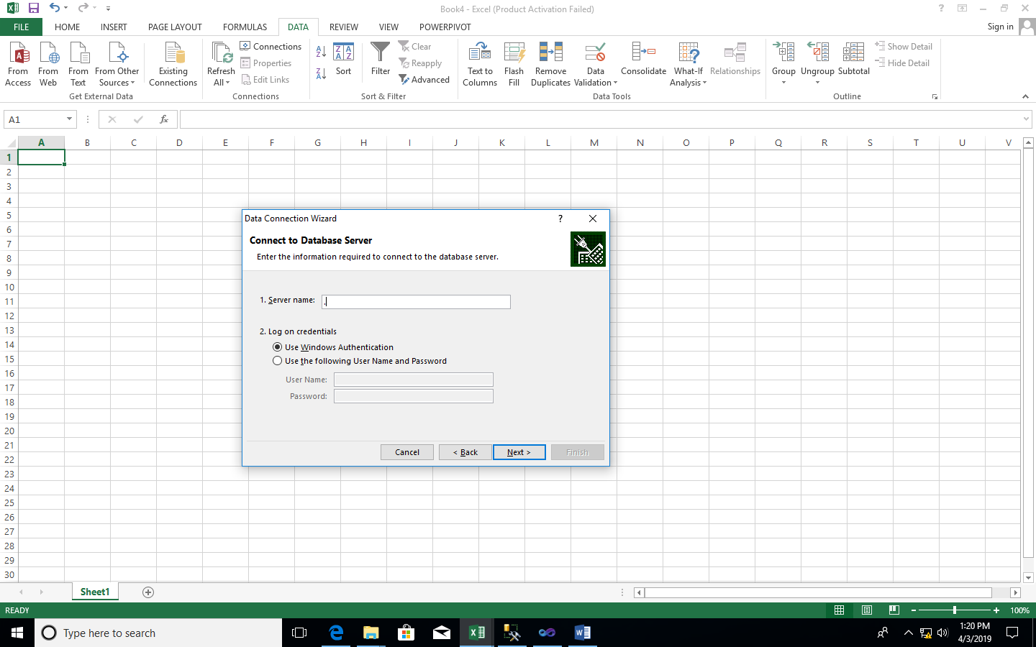

Step 3: Select OLAP(as per created before) click on Next

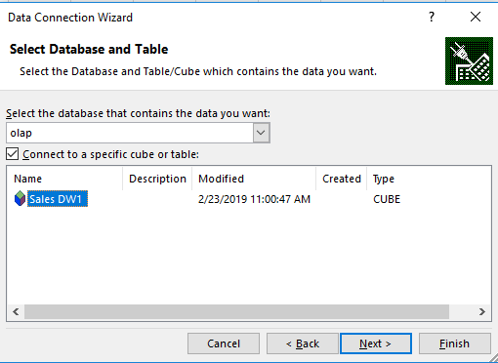

Step 4: Browse and select path name and click on Finish

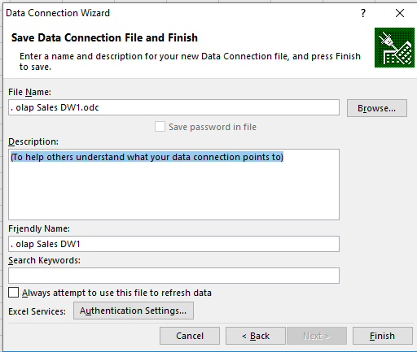

Step 5: Select PivotTableReport → OK

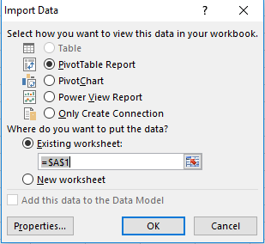

Step 6 : Drag and Drop Fields in rows column and values

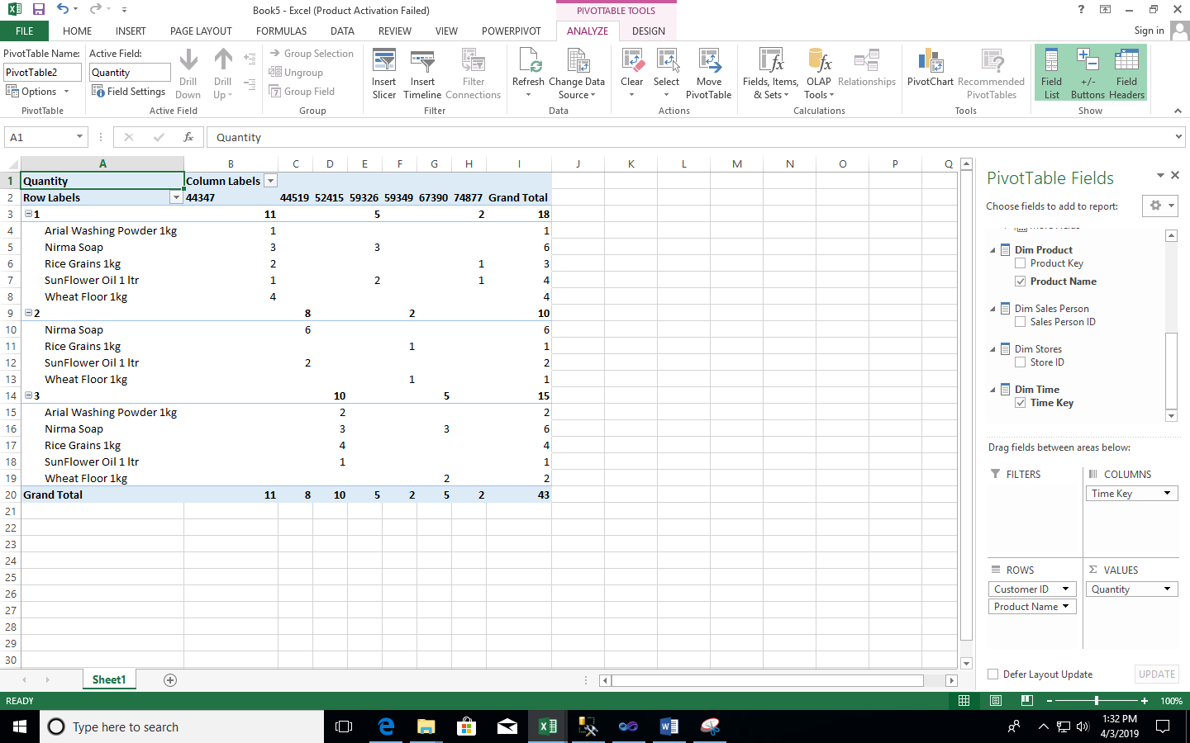

Step 7- Go to insert and select pivotchart

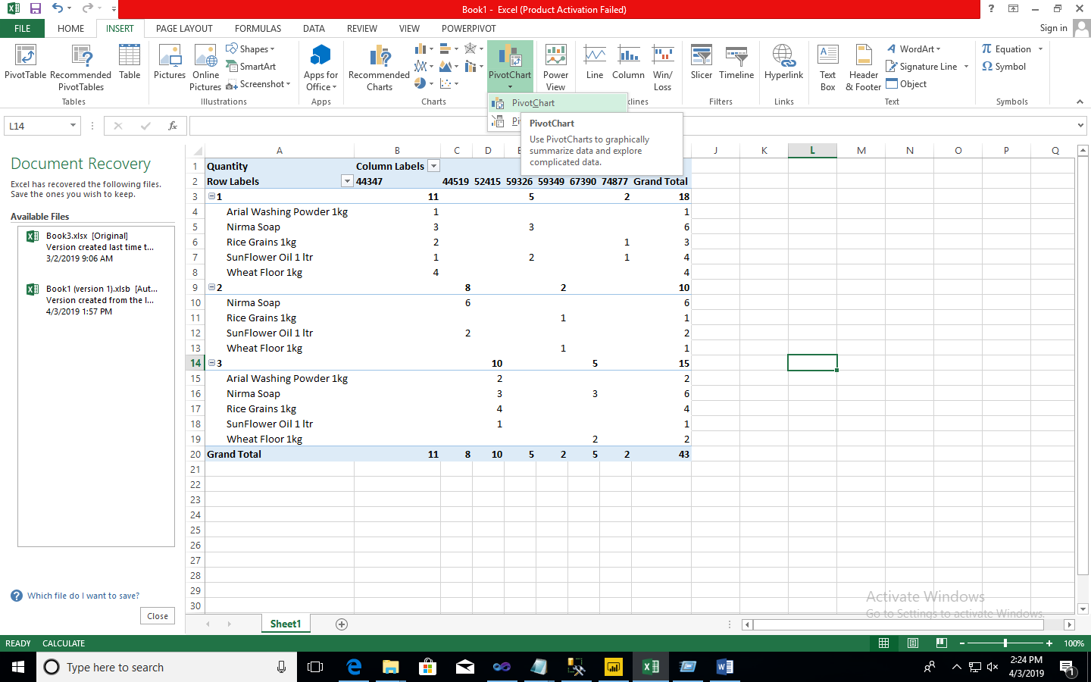

Step8 choose connection and click ok

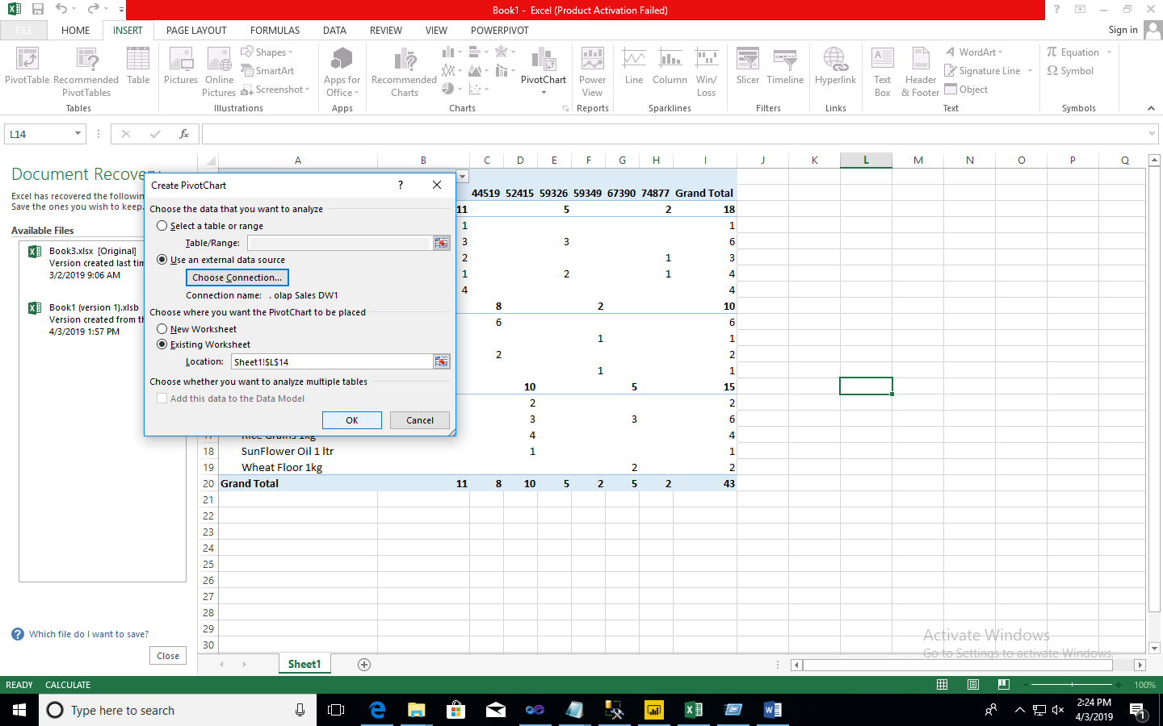

Step9 – Drag and drop the fields mentioned below

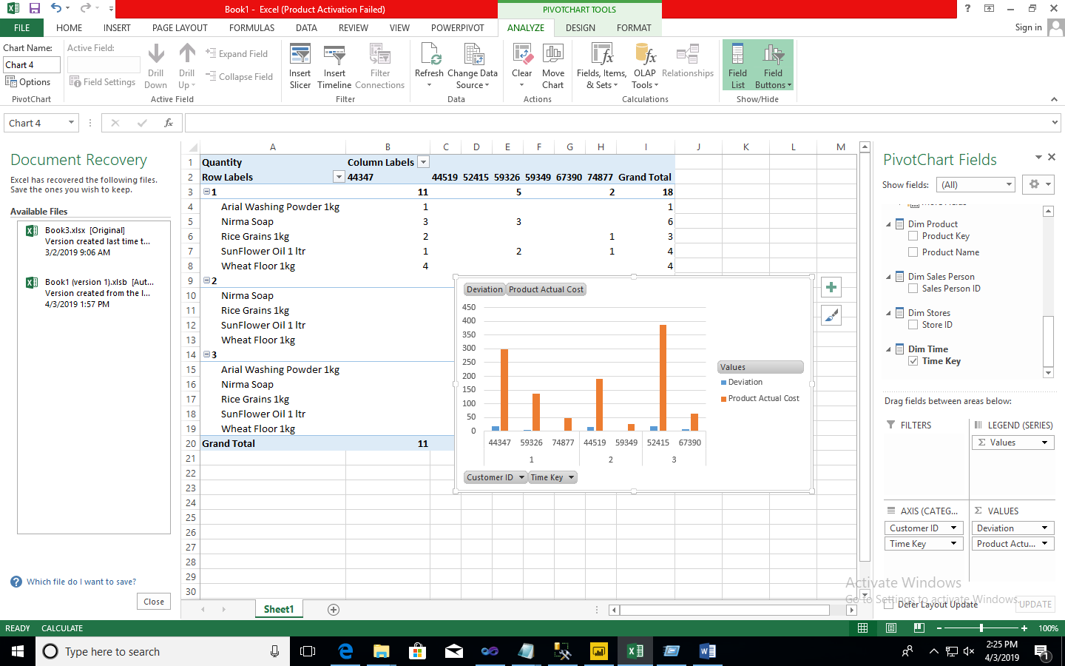w