***B) Import the cube in Microsoft Excel and create the Pivot table and Pivot Chart to perform data analysis.***

Step 1: Open Excel 2013 (Professional) Go to Data tab → Get External Data → From Other Sources → From Analysis Services

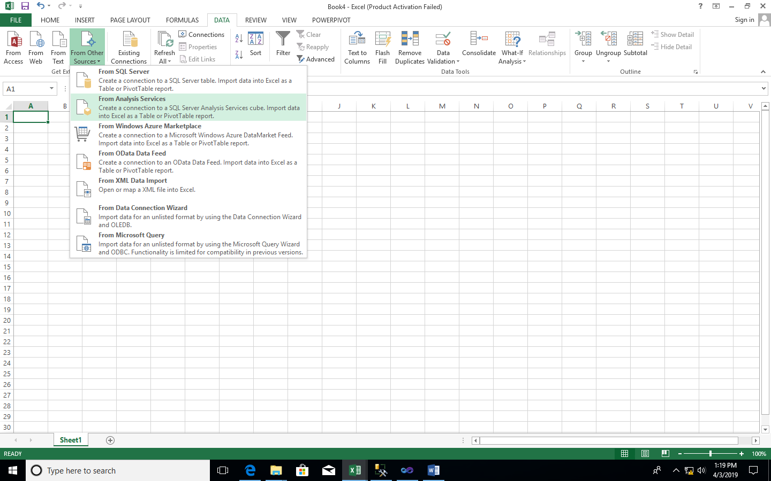

Step 2: Select Server name and Windows Authentication and click on Next

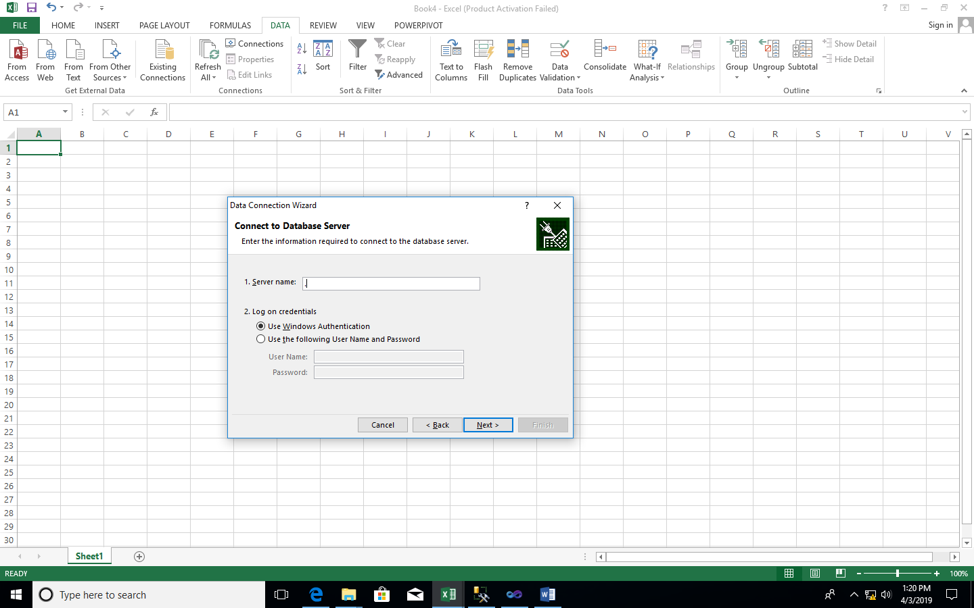

Step 3: Select OLAP(as per created before) click on Next

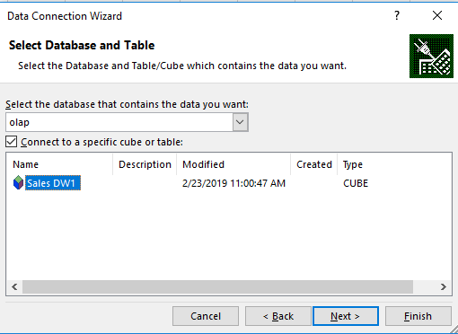

Step 4: Browse and select path name and click on Finish

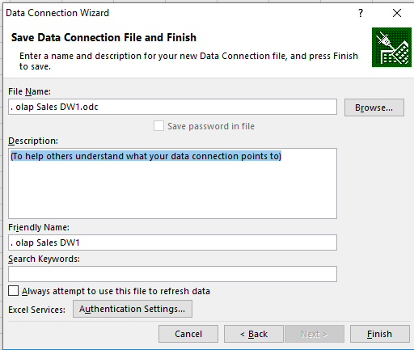

Step 5: Select PivotTableReport → OK

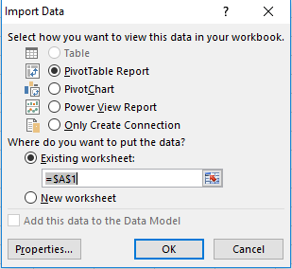

Step 6 : Drag and Drop Fields in rows column and values

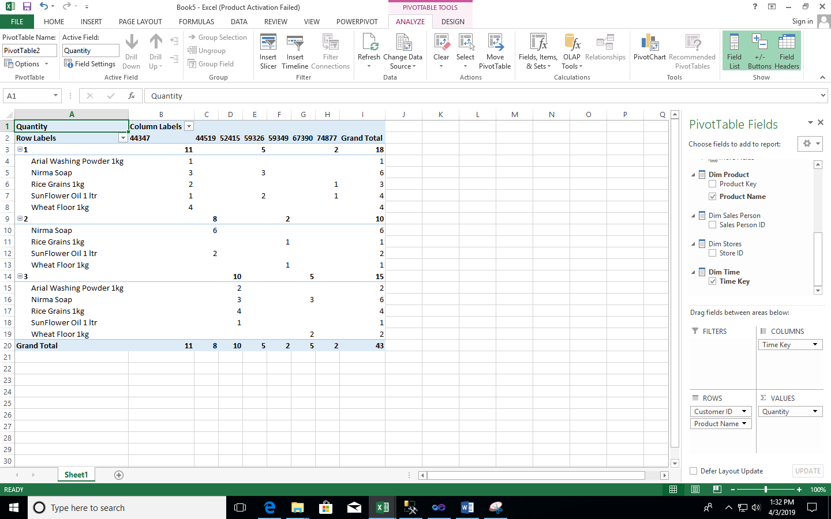

Step 7- Go to insert and select pivotchart

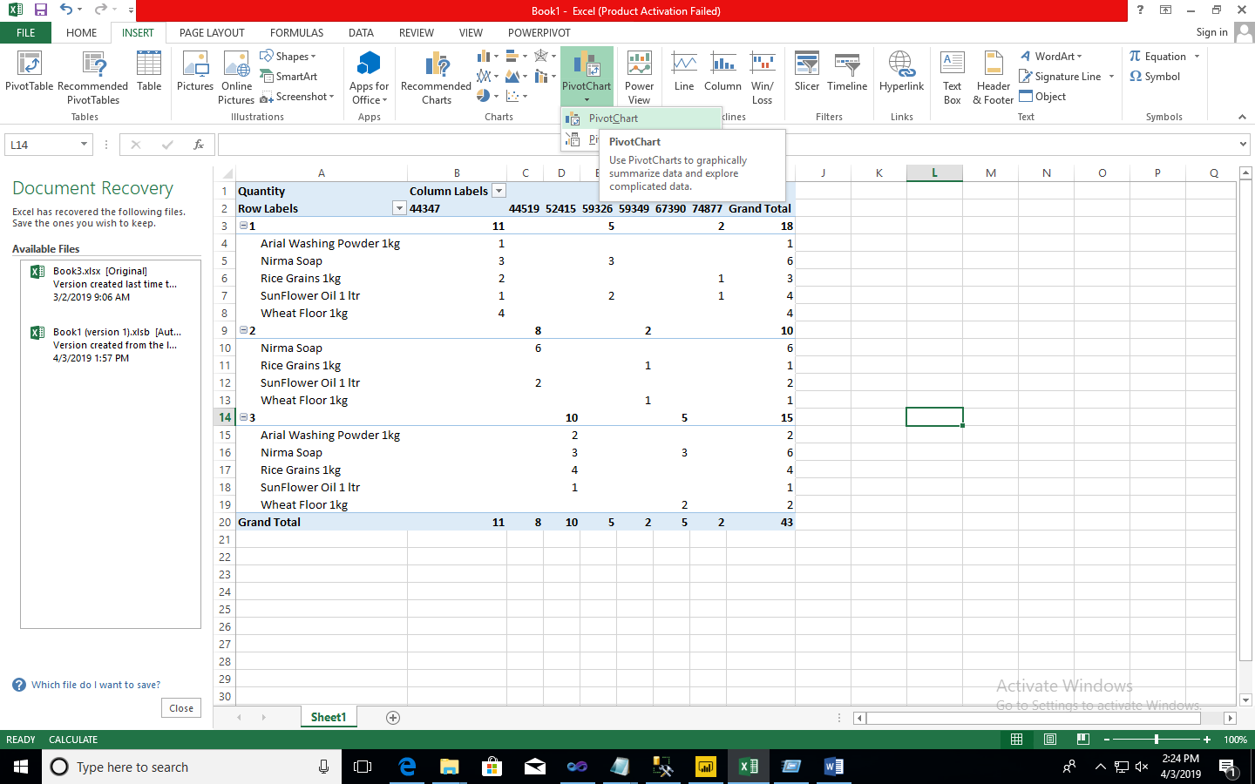

Step8 choose connection and click ok

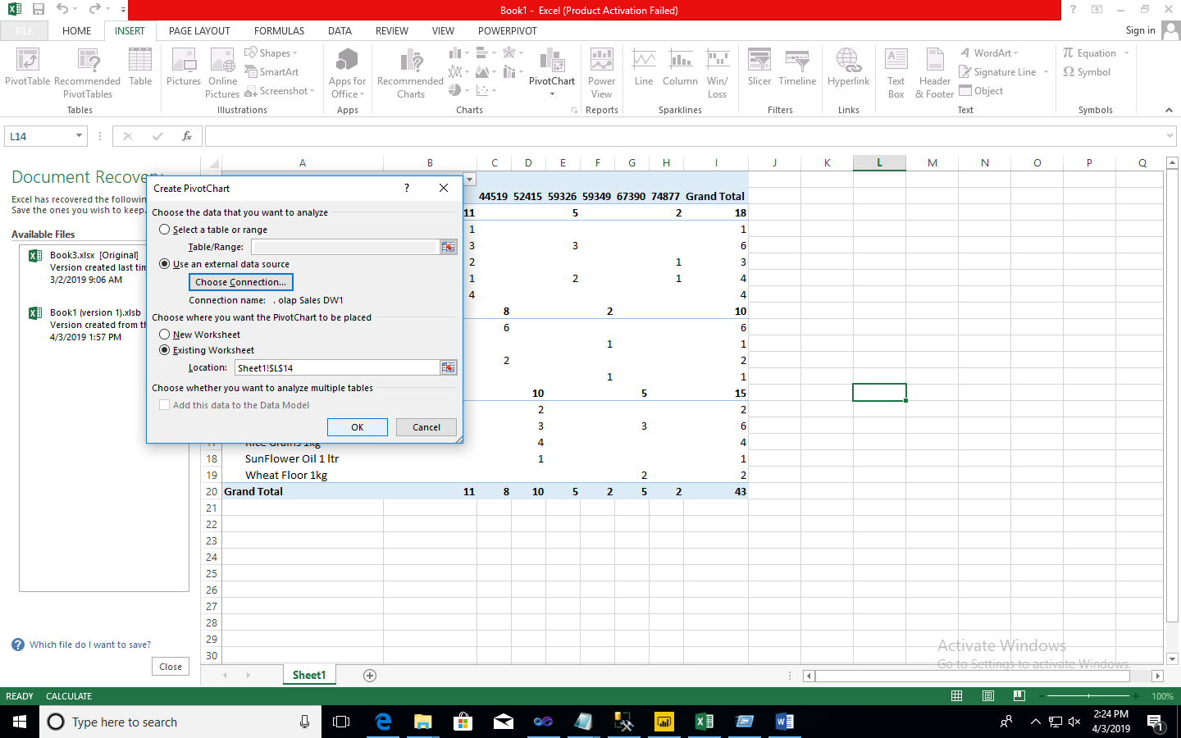

Step9 – Drag and drop the fields mentioned below

