**PRACTICAL 6**

**Apply the what – if Analysis for data visualization. Design and generate necessary reports based on the data warehouse data.**

**Step 1**: Open Excel and Enter Your pointers for Semester I to Semester IV.

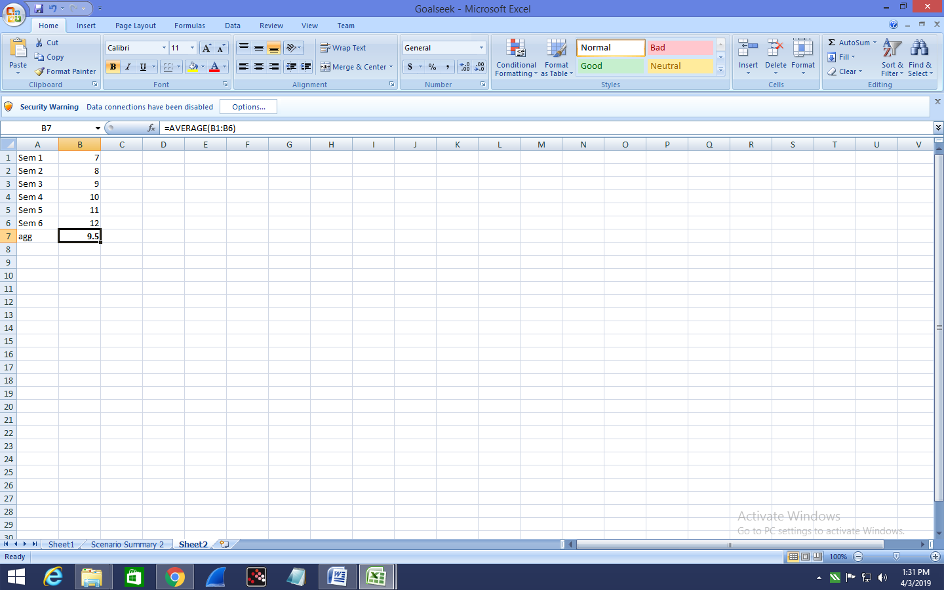

**Step 2**: In Excel, On the Data tab, in the Data tools group, click What-If Analysis and select Scenario Manager.

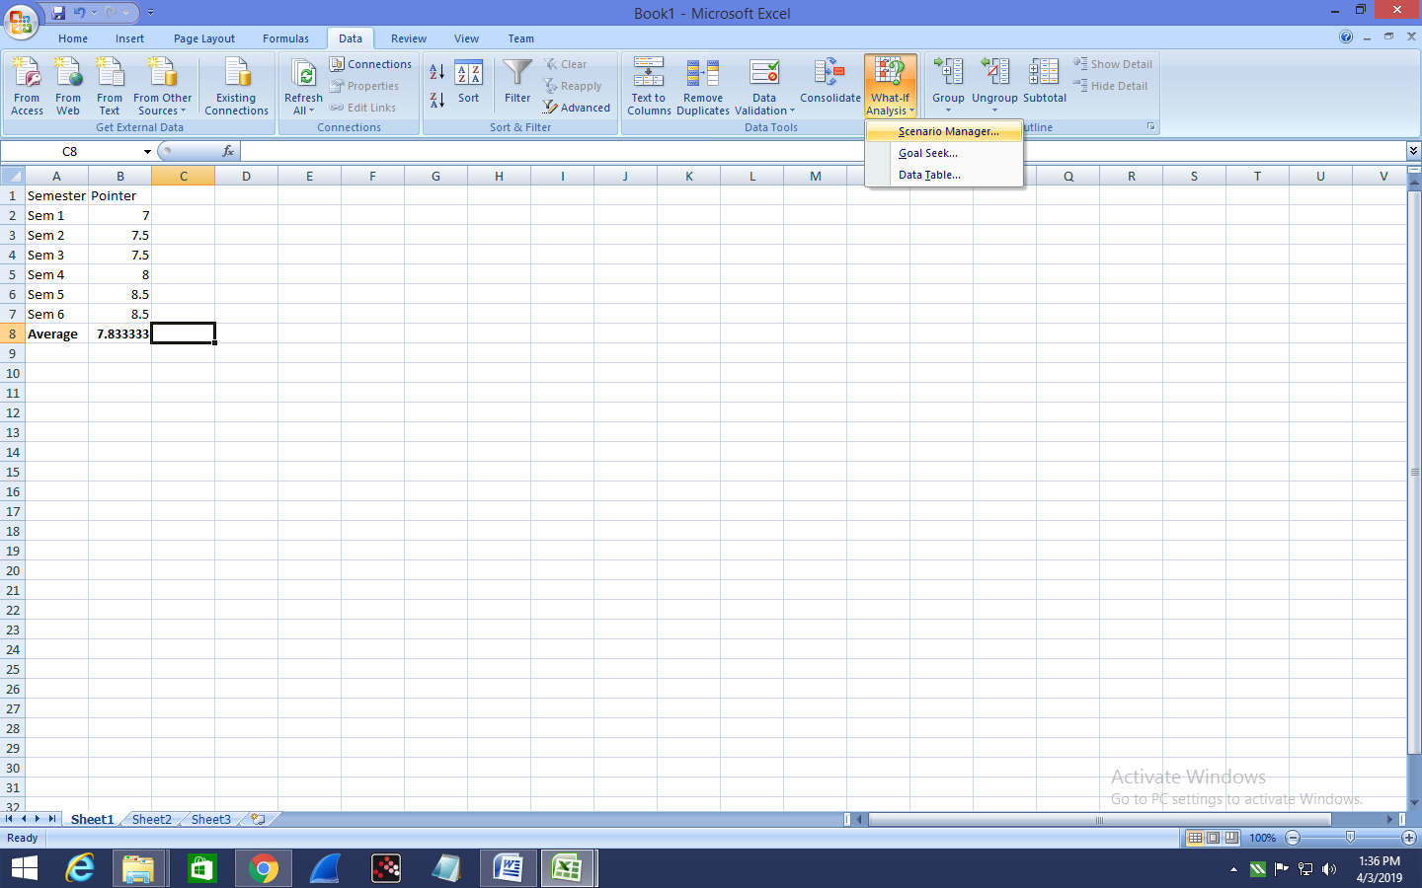

The Scenario Manager Dialog box appears.

**Step 3**: Add a scenario by clicking on Add.

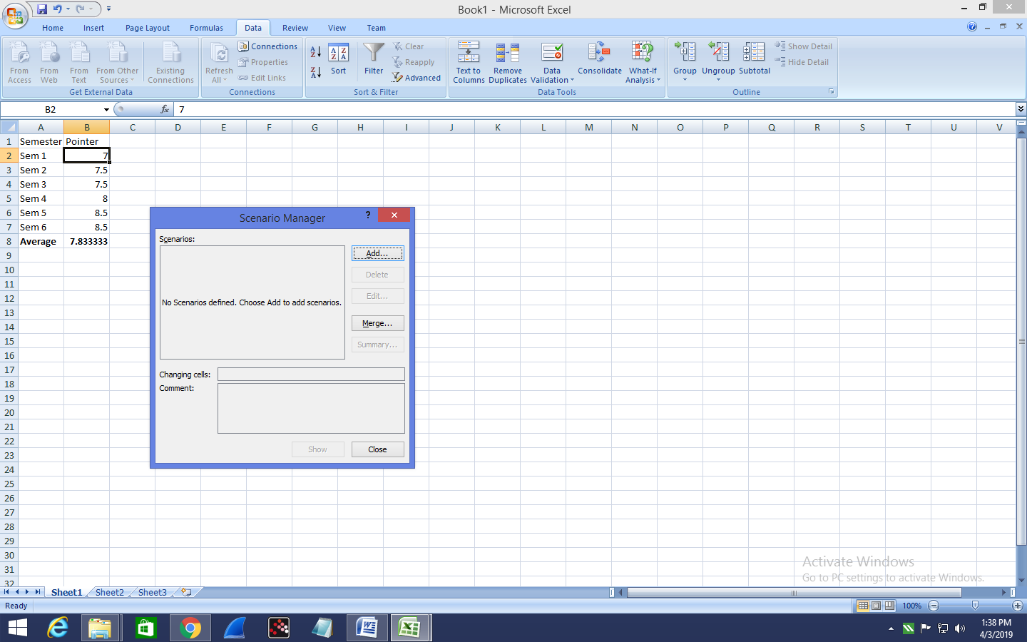

**Step 4** : Add Name To the Scenario and select cells for the Changing Cells and click on OK!

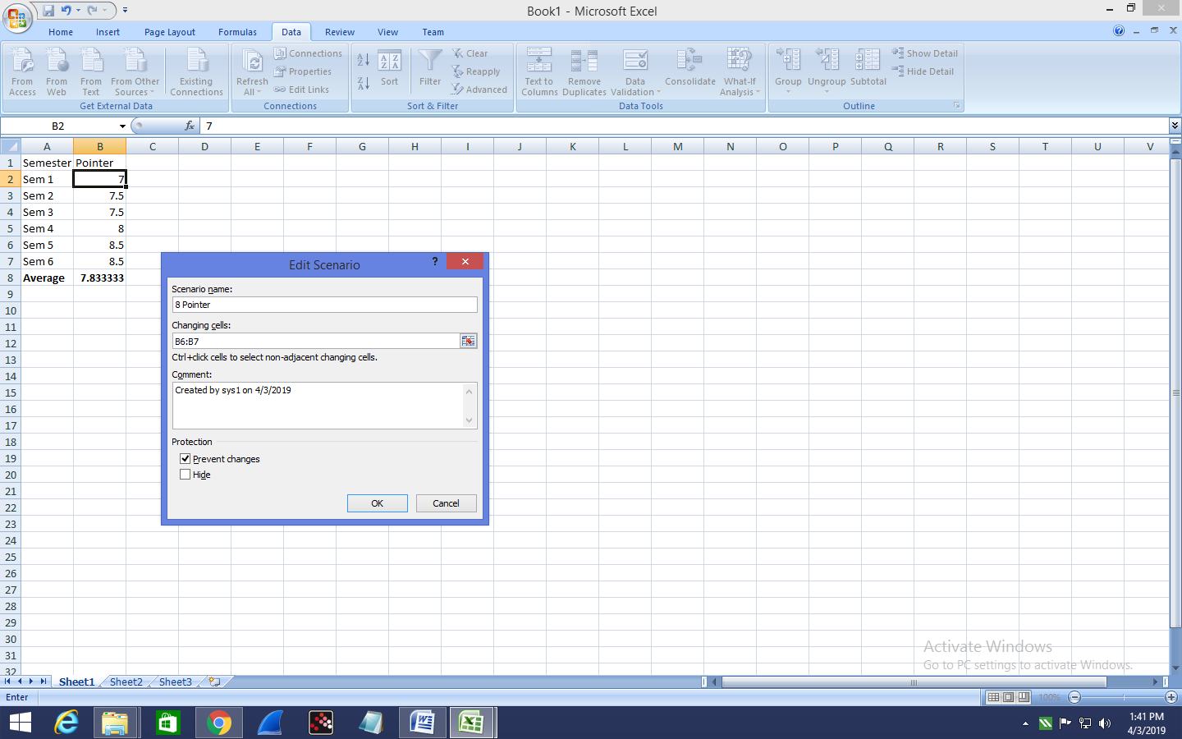

**Step 5** : Add Values for each of the changing cells.

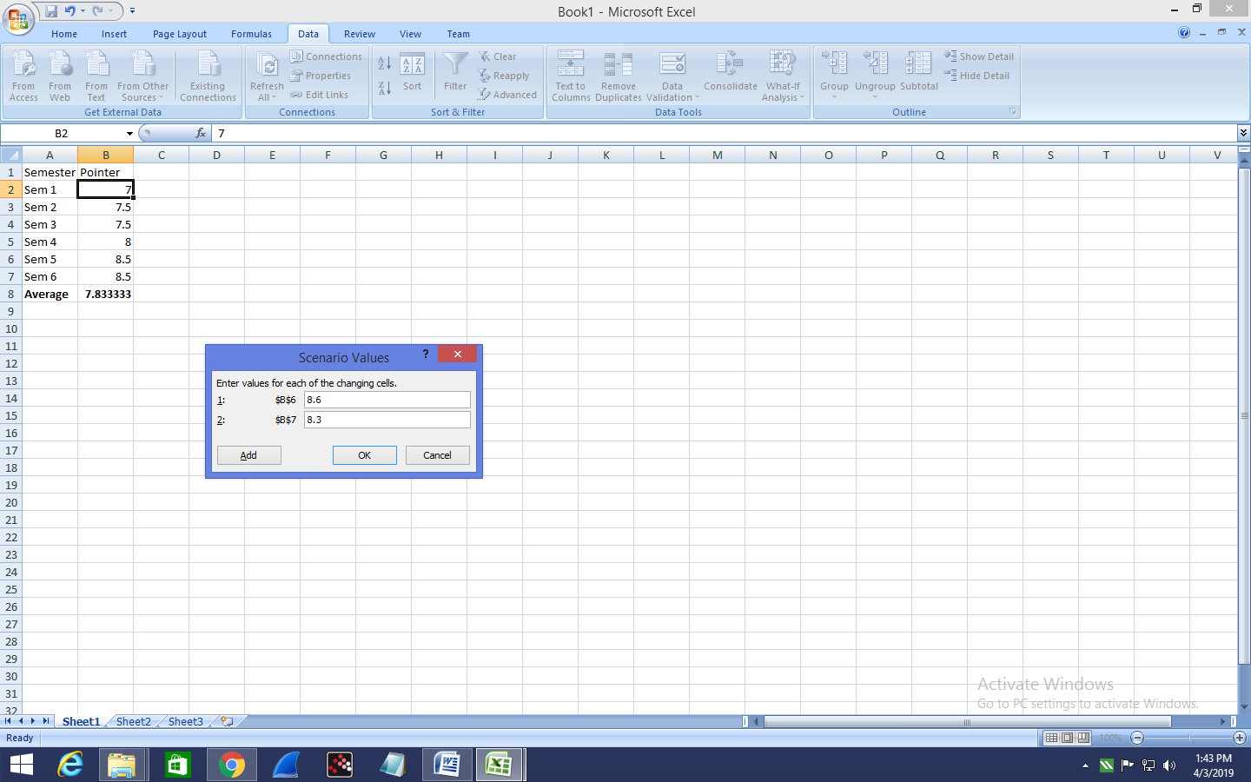

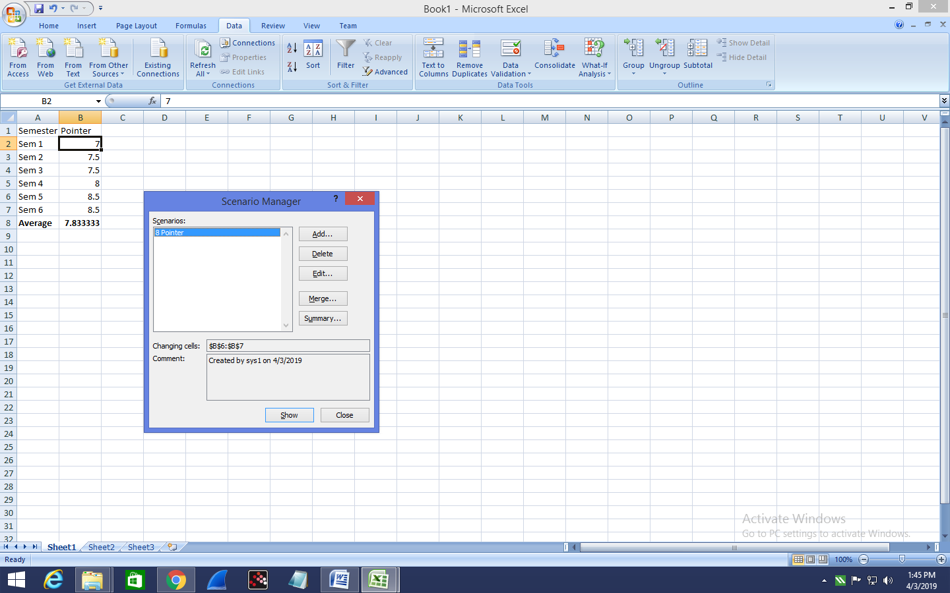

**Step 6** : To apply Scenarios click on show

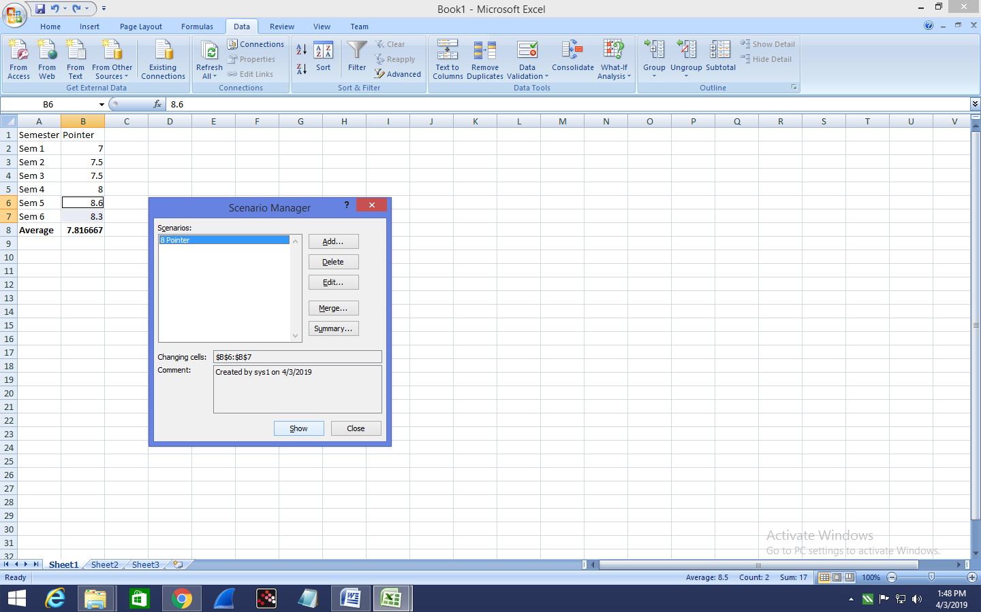

**Step 7** :Now, add other scenarios.

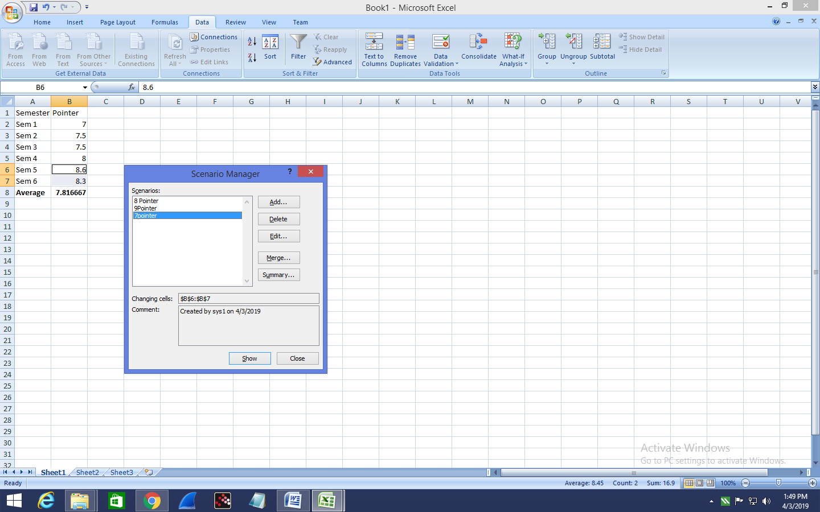

**Step 8** : Finally, Click on summary then select the result cell and click on OK to get the scenario summary.

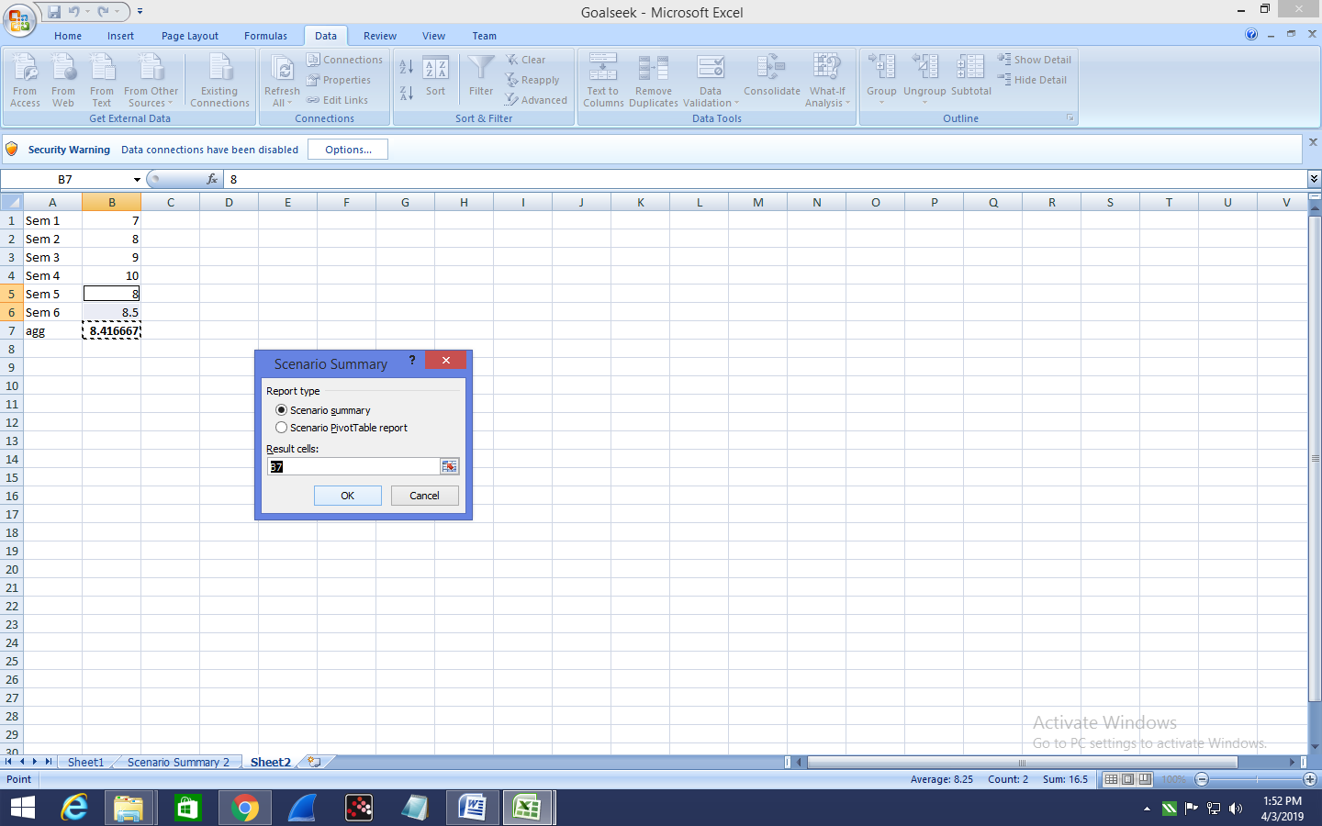

The Scenario summary is displayed as follows:

