Milestone 3

Team: Dragos Surugiu, Claudiu Negru

**Current Development Stage:**

* Still need to make P2P logic work and to add minor details to frontend; everything else is done

**Deployment:**

* Two client instances are deployed locally
* WebRTC Signaling Server is deployed locally (only for the presentation)
* Backend Server is deployed locally (only for the presentation)
* Database is deployed on a NAS

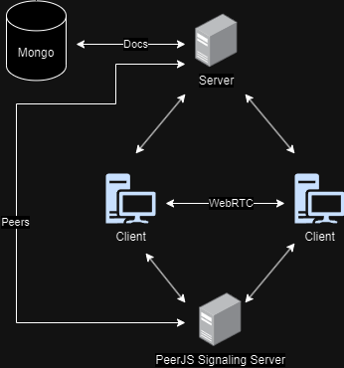

**Team Involvement:**

* Dragos: Frontend, Rust Backend Server, WebRTC Signaling Server, NAS setup
* Claudiu: Frontend, CRDT algorithm, Database design