ARGUS
Agentic Fraud Investigation and Decision Intelligence
From uncertain signals to defensible action.
Complete project record
Conversation, product specification, working prototype, system architecture, workflow, features, required partners, advantages and disadvantages.
Prepared | 20 September 2026
Project | ARGUS investigation interface for a TigerGraph fraud-investigation challenge
Status | Working front-end prototype (single HTML file). It runs on simulated data. The TigerGraph, MCP, GraphRAG and agent connections are designed but not yet built.
Prototype file | argus.html
Published prototype | https://claude.ai/artifact/9X2SV7kCbYeZJvf6ECvgwx

Contents
- Executive summary
- Conversation record
- Product specification and how the prototype meets it
- What was built, including screenshots
- System architecture
- How it works
- Complete feature list
- Required partners and dependencies
- Advantages
- Disadvantages and risks
- Recommended next steps
- Appendices: code map, sharing options, glossary

1. Executive summary
ARGUS is the interface and workflow for an AI agent that investigates suspected fraud on a graph of customers, accounts, devices, IP addresses, transactions, merchants and earlier cases. It is built for a TigerGraph fraud-investigation challenge. The challenge judges whether the agent can investigate, decide when evidence is enough, gather more when it is not, explain its reasoning, respect approval rules and learn from closed cases.
The page a judge sees is meant to feel like one continuous investigation. A suspicious case opens, the graph reveals a shared device, prior cases are retrieved, and the agent notices it does not yet know whether the customer authorized the payment. It asks for that evidence, the answer comes back, risk and confidence change, the recommendation changes, a human approves, and the case is stored in memory for the next investigation.
Where the project stands
A complete, clickable prototype exists and works end to end on simulated data. It demonstrates the product story and the interface. It does not yet contain the real agent, the TigerGraph connection or the official 20 evaluation cases. Those are the main work left before submission.

Key facts
Visual direction | Light theme only: warm off-white base, white cards, indigo and teal accents, thin borders, soft shadows. No dark dashboard, no neon.
Core idea | Every animation, hover, slider and transition must serve a functional purpose or show system state.
Main screens | Landing, command center, investigation workspace, case memory, policy viewer, benchmark center, case report.
Headline demo | Risk 82 to 96, confidence 67% to 94%, recommendation changes from "Request customer validation" to "Escalate to analyst" after the customer denies the transaction.
Technology in the prototype | One HTML file with plain JavaScript and canvas. No build step and no libraries. Fonts come from Google Fonts.
Target technology | TigerGraph with GSQL and graph algorithms, a TigerGraph MCP server, GraphRAG, an LLM-based agent orchestrator and an approval gate.

2. Conversation record
The table below lists every request in the conversation and what was delivered in response, in order.
# | Request | Response
1 | Pasted the complete ARGUS product pipeline: 37 sections covering the user journey, screens, motion, cursor, colour, technical pipeline and the final judge experience. No explicit instruction was given. | Built the full interactive prototype from the specification, tested the whole flow in a headless browser, and published it as an artifact.
2 | "I need to share the output link" | Gave the artifact link and explained that sharing is set from the artifact card.
3 | "Make it public" | Explained that visibility cannot be changed from the assistant side. The person must use the artifact share control, and the widest option depends on the account or workspace.
4 | "give me complete code" | Presented argus.html as a downloadable file (a single self-contained page of about 900 lines) and named the functions to replace when connecting TigerGraph.
5 | Publish the file as an artifact (repeat request) | Republished the same file, updating the existing artifact.
6 | "I need to share this prototype" | Offered three ways: the artifact link, sending the HTML file, or a public Vercel deployment.
7 | A single apostrophe | Asked what was meant and repeated the Vercel option.
8 | Convert all chat and output into one Word file, adding system architecture, advantages, disadvantages, how it works, all features and needed partners | This document. "Paterner" was read as partners and dependencies, and a short design-patterns table is included as well.
9 | Add screenshots of the project into the Word file | Captured screenshots from the running prototype and added 22 of them (19 desktop, 3 phone size) as section 4.6. Capturing exposed three small issues, now fixed in the prototype and the published page: the device card showed 5 linked accounts instead of 4, the graph sat small in its panel, and the phone navigation was cut off.

3. Product specification and how the prototype meets it

3.1 Visual direction
- Light theme only. Warm or off-white base, white cards, very light blue, indigo and teal accents, subtle gradients, soft shadows and thin borders.
- Motion-heavy but purposeful. Animated data visualisation, smooth page transitions, animated graph relationships, interactive sliders, a magnetic cursor, card hover effects, animated counters and progressive loading states.
- Not allowed: a black dashboard, neon cyberpunk styling, or an excessive purple AI look.
- Reference feeling: a premium financial-intelligence product with modern data visualisation and cinematic motion.
- Colour meaning: deep blue or indigo for primary, teal for secondary, red for risk, amber for warning, green for success, dark graphite for text, slate grey for secondary text. Colour communicates meaning, not decoration.

3.2 Continuous user journey
The whole application is one investigation from a landing screen to case memory:
- Landing
- Command center
- Investigation queue
- Case opened
- Investigation workspace
- Graph investigation
- Evidence collection
- Fraud pattern analysis
- Risk and uncertainty
- Evidence sufficiency check
- If evidence is not enough: additional evidence, evidence received, reassessment. If it is enough: next best action, policy check, approval
- Action or escalation
- Case resolution
- Case memory
- Future investigations retrieve the stored case

3.3 Section-by-section status
All 37 sections of the specification are listed with their status in the prototype.
Spec section | What the specification asks for | Status in the prototype
1. User journey | One continuous flow from landing to case memory. | Built. Each stage is a screen or a state.
2. Landing | Title, tagline, enter button, a slow network of nodes behind it, node hover card, custom cursor. | Built. Hover shows type, ID, connected entities and historical cases.
3. Page transitions | Shared-element transition from a case card into the workspace; fade and slide elsewhere. | Built for queue to workspace. Other navigation uses fade and slide.
4. Command center header | Nav for Overview, Investigations, Graph, Cases, Memory, Reports; system status, notifications, profile. | Built with a slightly different nav: Command center, Investigation, Case memory, Policy, Benchmark, Report. The graph lives inside the workspace.
5. Hero metrics | Five large cards with count-up numbers and hover lift, accent border and tiny animated line. | Built. Values are computed from the live case list.
6. Risk distribution slider | A real slider that filters the case grid. | Built with a histogram of cases by risk band.
7. Investigation queue | Cards with risk, trigger, evidence bar, status and an Open case button that appears on hover. | Built. 24 active cases, sorted by risk.
8. Filter bar | Risk, status, trigger, fraud pattern, evidence sufficiency, date range slider. | Built. The date slider filters by hours since the case opened.
9. Workspace layout | Header, timeline on the left, graph in the centre, agent panel on the right, evidence dock at the bottom. | Built. Stacks vertically on narrow screens.
10. Case header | Case ID, risk, confidence, uncertainty, status, numbers animate on load. | Built.
11. Case timeline | Vertical timeline that grows as the agent works, reflecting real workflow state. | Built. Driven by workflow state, not fake typing.
12. Graph centerpiece | Seven node types, animated edges, particles on active relationships, hover, selection, zoom, pan, focus, highlighting. New connections animate and light up nodes. | Built on canvas. Unexplored nodes are drawn faint and dashed until the agent reaches them.
13. Relationship depth slider | Depth 1 to 4 expands the graph. | Built. The agent also raises the depth itself when it discovers links.
14. Node hover card | Type, ID, linked accounts, transactions, risk associations, Investigate button, investigation cursor. | Built. Investigate expands and focuses the node.
15. Evidence panel | Bottom panel with Evidence, Findings, Prior cases, Policy, Decision tabs. | Built and collapsible.
16. Agent panel | Not a chat window: objective, assessment, findings, evidence gap. | Built.
17. Agent activity | Collapsible timestamped log. | Built.
18. Uncertainty visualisation | Radial confidence meter and a horizontal uncertainty bar that animate when evidence arrives. | Built.
19. Evidence sufficiency | Animated bar, 85% threshold, warning and a Request additional evidence button. | Built. The threshold marker is drawn on the bar.
20. Evidence request modal | Reason, three options, estimated impact, cancel or request. The chosen option runs its workflow. | Built. Customer validation, step-up authentication, analyst request.
21. Customer validation simulation | "Did you authorize this transaction?" with amount, merchant, date and Yes or No; evidence animates back to ARGUS. | Built, including the flying "Evidence received" chip.
22. Decision evolution | Before and after: risk, confidence, recommendation. | Built as a side-by-side panel with arrows.
23. Next best action card | Recommended action, reasons, confidence, approval requirement, Review evidence and Request approval. | Built. The action library highlights the recommended actions.
24. Approval experience | Action, risk, evidence count, policy; Approve, Reject, Request more evidence. | Built. Each button leads to a real state change.
25. Case memory | Counter, search, similarity slider, list of similar cases with outcomes. | Built. Similarity values are sample data.
26. Case memory to graph | Clicking a historical case animates its relationships into the graph. | Built. Shows current case, shared device, historical case, previous outcome.
27. Policy viewer | Document-style page with the relevant section, why it was retrieved and the source. | Built with sample policy text and a retrieval path.
28. Case closure | The timeline completes with six checks, then "Case resolved". | Built.
29. Full case report | Trigger through outcome as a structured record. | Built with eleven fields.
30. 20-case benchmark center | Twenty official cases, completed and remaining counts, each opens its record. | Built. The 14 completed cases are placeholders, not real agent output.
31. Motion system | Fade and slide for pages, lift for cards, count-up numbers, radial progress, progressive timeline, slide-in evidence, scale and fade for modals. | Built.
32. Cursor system | Dot and ring; ring grows on interactive items; reticle over nodes; grab state; magnetic buttons; reduced motion respected. | Built for mouse devices. Touch devices keep the normal cursor.
33. Card hover system | Lift 4 to 6 px, shadow, accent border. Not every small element floats. | Built on meaningful cards only.
34. Colour system | Warm white, indigo, teal, red, amber, green, graphite, slate. | Built as design tokens.
35. What makes it professional | Effects must answer questions about the investigation. | Followed. Each animation is tied to a state change.
36. Technical pipeline | Dataset to TigerGraph to GSQL to MCP to agent tools to GraphRAG to orchestrator to approval to case memory to frontend. | Designed. Not connected. See section 5.
37. Final experience | A 17-step judge walk-through. | Works end to end in the prototype. See section 4.3.

3.4 The rule behind the design
Every animation, hover, slider, card, graph interaction and transition must serve a functional purpose or communicate system state. Examples from the specification:
- A graph connection appears because the agent discovered it.
- The risk changes because new evidence arrived.
- The timeline progresses because the investigation progressed.
- The recommendation changes because uncertainty decreased.

4. What was built

4.1 Deliverables
Deliverable | Details
argus.html | Complete prototype in one self-contained file: HTML, CSS and JavaScript together. Open it in any browser. Only the fonts need an internet connection.
Published artifact | https://claude.ai/artifact/9X2SV7kCbYeZJvf6ECvgwx. Private to the owner until shared from the artifact card.
Screenshots | 22 images of the running prototype (19 desktop, 3 phone size), in section 4.6 of this document.
This Word document | The full record of the project.

4.2 How the prototype is organised
- Seven views: landing, command center, investigation workspace, case memory, policy, benchmark, report.
- Data: 24 active cases plus 14 completed benchmark cases and 10 memory cases, all generated from fixed seeds so the demo behaves the same every time.
- Workflow engine: a small state machine (new, investigating, gap, awaiting evidence, ready, closing, resolved) that drives the timeline, meters, graph, dock and buttons together.
- Graph engine: custom canvas code with a force layout, depth-based visibility, pan and zoom, hit testing and animated edges.
- Accessibility touches: respects the reduced-motion setting, keyboard-focusable case cards, visible focus outlines, and a layout that stacks on phones.

4.3 Demo script for judges
- Open ARGUS and hover a node on the landing screen, then press Enter investigation center.
- On the command center, drag the risk slider to 80 and watch the case grid filter.
- Open FR-20481. The card expands into the workspace.
- Watch the timeline build and the graph light up: transaction, shared device, three connected accounts, prior case FR-18392.
- Open the Evidence and Prior cases tabs, and hover a node to see its card.
- Move the Relationship depth slider from 1 to 4.
- Read the evidence gap: customer authorization is not established. Sufficiency is 78% against an 85% threshold.
- Press Request additional evidence, choose Customer validation, then answer No, I did not.
- Watch risk, confidence and recommendation change in the Decision tab.
- Open the Policy tab or the policy page to see section 4.2 and 6.1.
- Press Request approval and approve the action.
- Watch the case close, then open the case report.
- Open Case memory, choose a historical case and press Show in graph.
- Open another case from the command center. The case you just resolved appears first among its prior cases.

4.4 Numbers shown in the demo
Measure | After first investigation | Customer denies (or step-up fails) | Customer confirms
Risk | 82 | 96 | 37
Confidence | 67% | 94% | 91%
Uncertainty | 33% (Medium) | 6% (Low) | 9% (Low)
Evidence sufficiency | 78% (threshold 85%) | 96% | 92%
Recommendation | Request customer validation | Escalate to analyst. Human approval required. | Allow with monitoring. No approval required.

The analyst information request always returns the adverse result. Rejecting an approval keeps the recommendation open. "Request more evidence" in the approval dialog reopens the evidence request.

4.5 What was checked
- Checked: the script passes a syntax check, and a scripted headless-browser run completed the full flow without errors: landing, filters, open case, evidence request, customer denial, approval, closure, case report, memory, policy, benchmark and opening a second case. The run was repeated with motion enabled and with reduced motion.
- Not checked: appearance on real phones and tablets (a phone-sized emulation was captured), performance on low-end devices, screen-reader behaviour, and behaviour with a large real graph.

4.6 Screenshots of the prototype
The screenshots below were captured from the running prototype in a desktop browser at 1440 px width, following the demo script in section 4.3. The last three were captured at phone size (390 px). The capture environment could not load Google Fonts, so the text appears in a system font. In a normal browser the page uses Bricolage Grotesque and Instrument Sans.
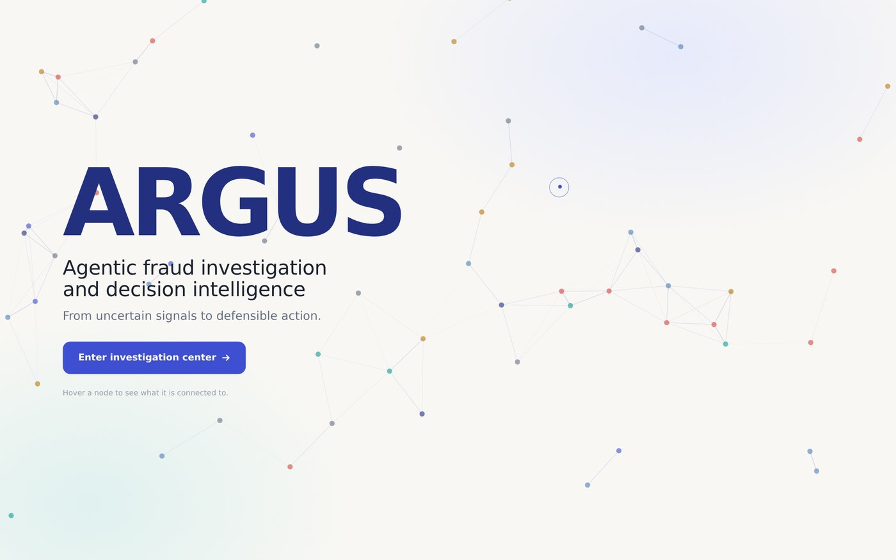
Screenshot 1. Landing. A slow network of customers, accounts, devices and transactions sits behind the title. Hovering a node shows what it is connected to.
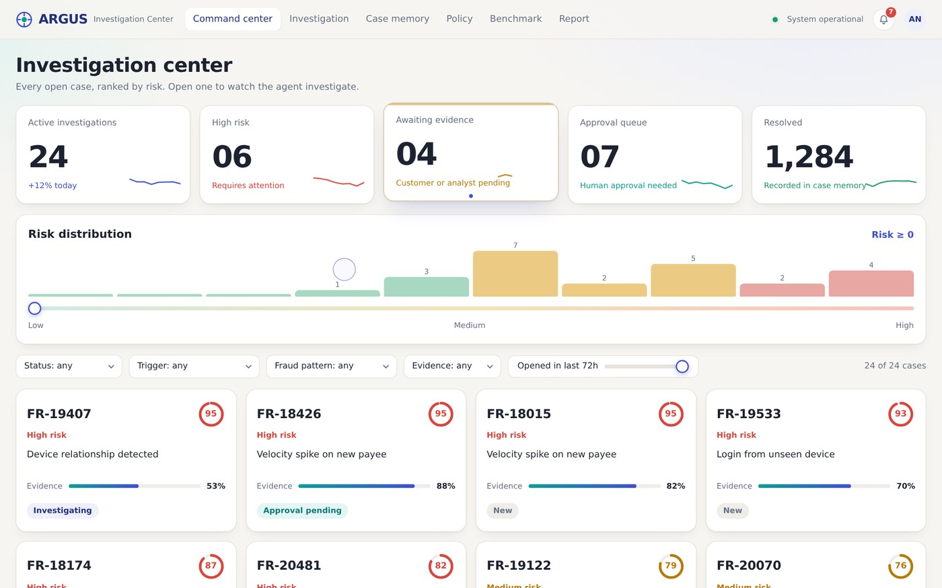
Screenshot 2. Command center. Five metric cards count up on load. The histogram shows open cases by risk band, and the case cards below are ranked by risk.
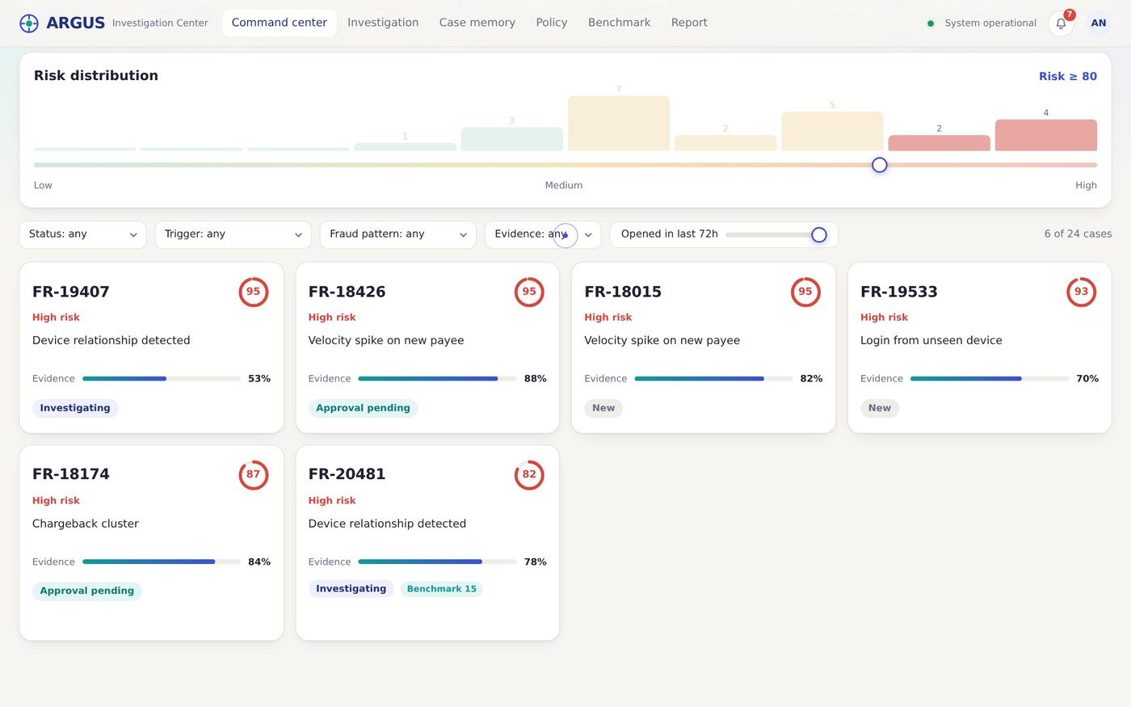
Screenshot 3. Risk slider filter. Dragging the risk slider to 80 leaves the six highest-risk cases. The counter reads "6 of 24 cases" and the histogram dims the lower bands.
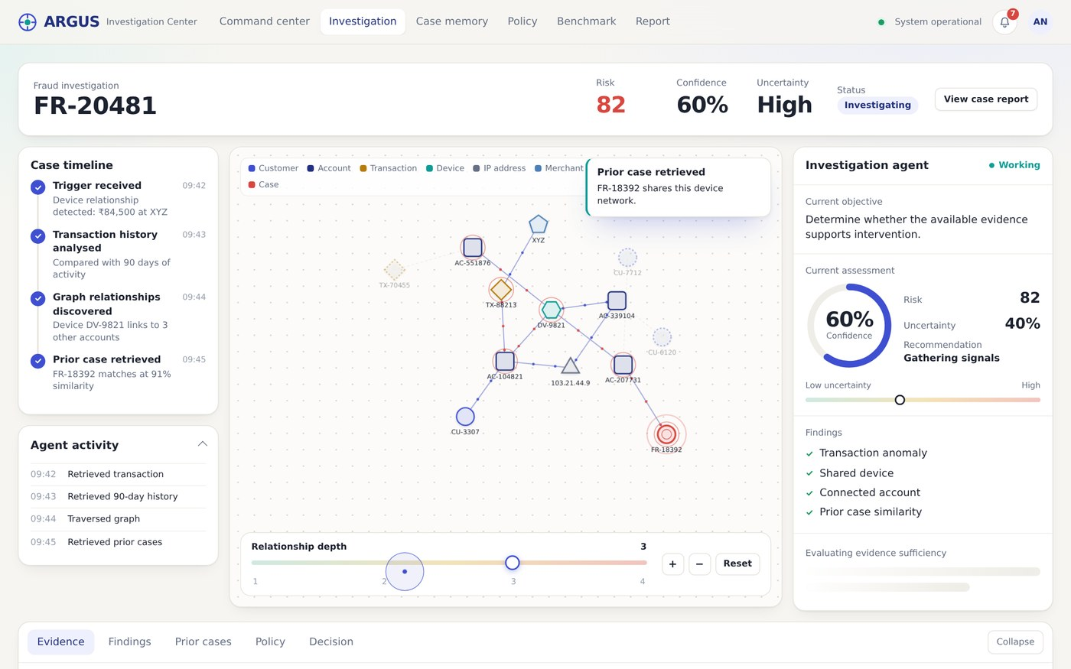
Screenshot 4. Investigation in progress. The timeline builds as the agent works and the graph lights up as relationships are found. Confidence is still climbing (60%) and the sufficiency panel is loading.
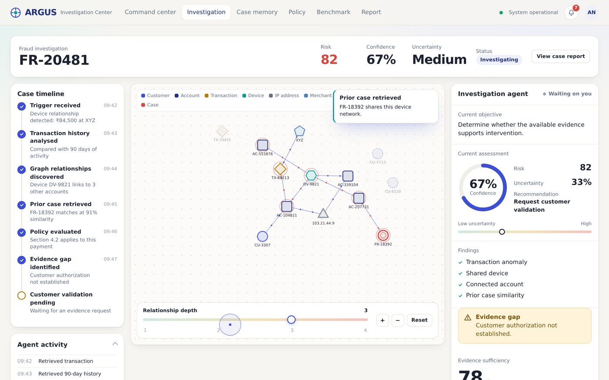
Screenshot 5. Workspace with an evidence gap. After six steps risk is 82 and confidence is 67%. The agent reports that customer authorization has not been established and recommends requesting validation.
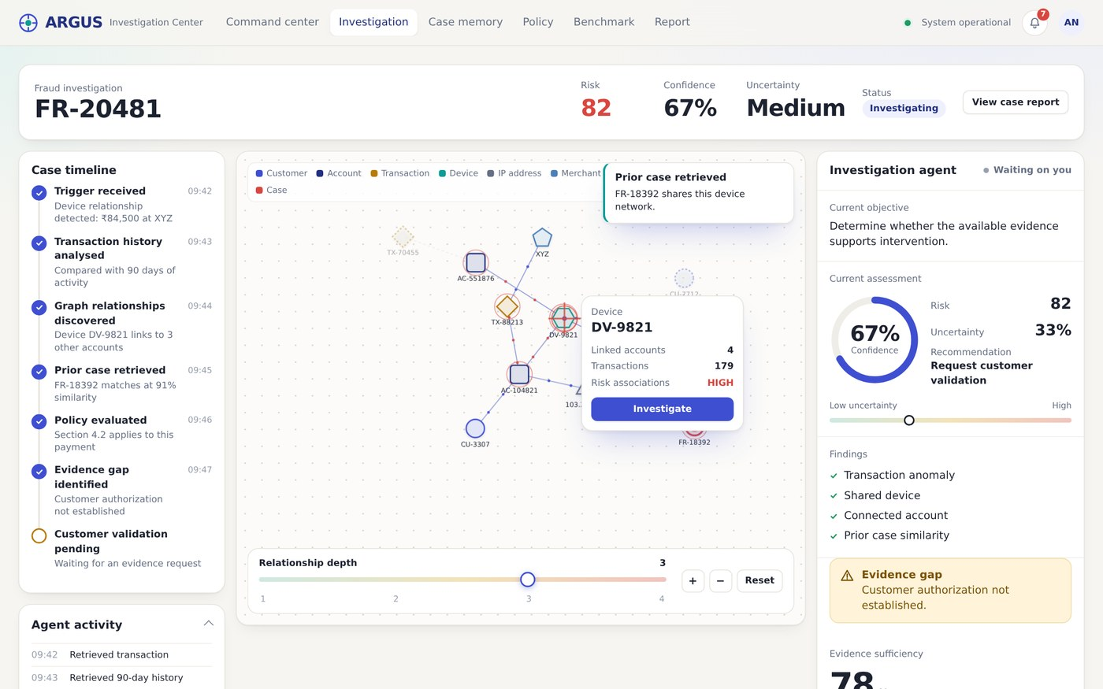
Screenshot 6. Node hover card. Hovering device DV-9821 shows its linked accounts, transactions and risk association with an Investigate button. The cursor turns into a targeting reticle over a node.
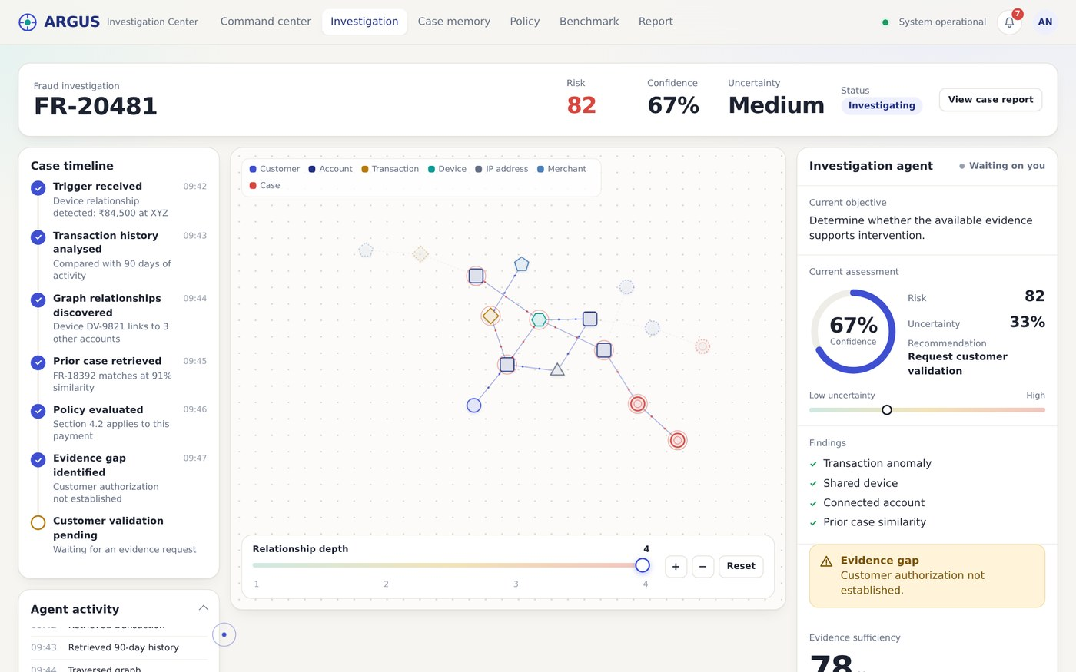
Screenshot 7. Relationship depth 4. Moving the depth slider to 4 expands the graph to the prior case and its outcome. Nodes the agent has not reached yet are faint and dashed.
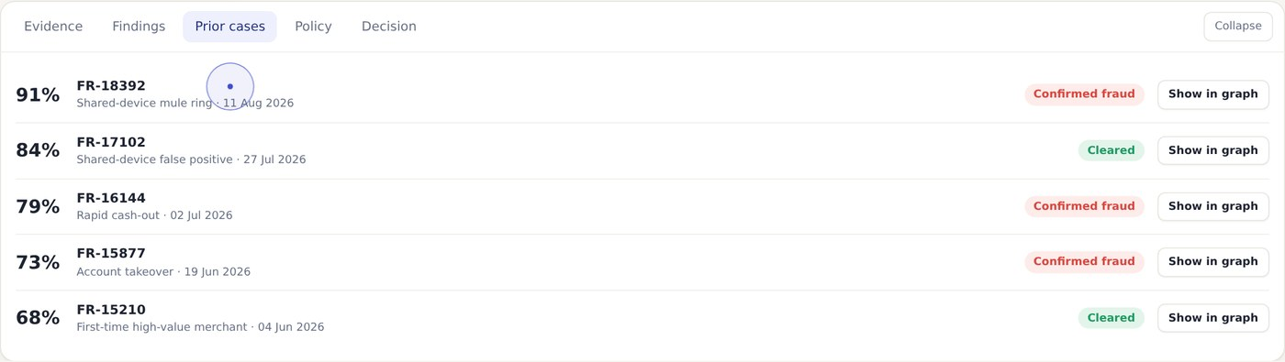
Screenshot 8. Prior cases tab. Similar resolved cases with similarity and outcome. Show in graph draws the chosen case into the network.
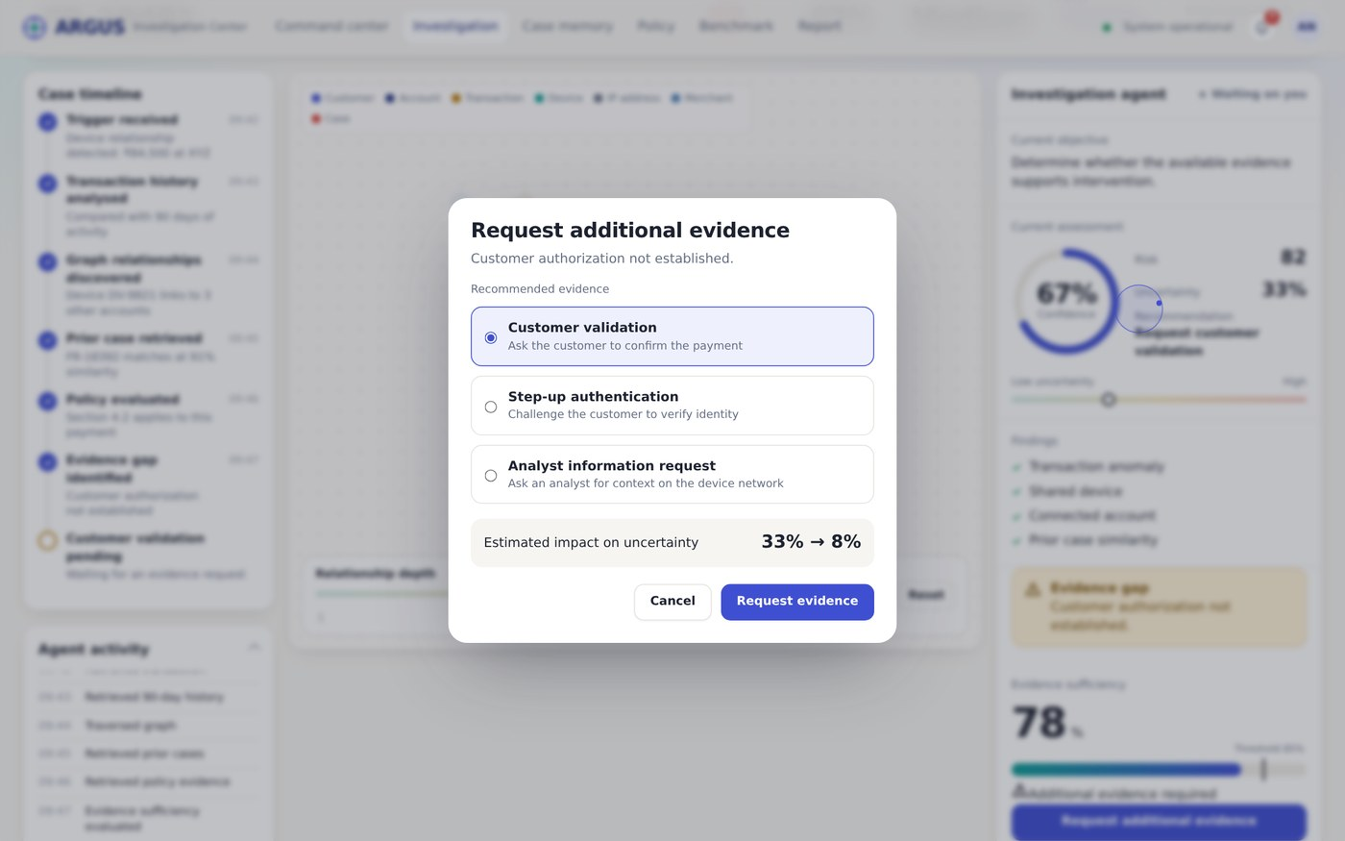
Screenshot 9. Request additional evidence. The dialog explains why evidence is needed and offers customer validation, step-up authentication or an analyst request, with the estimated effect on uncertainty.
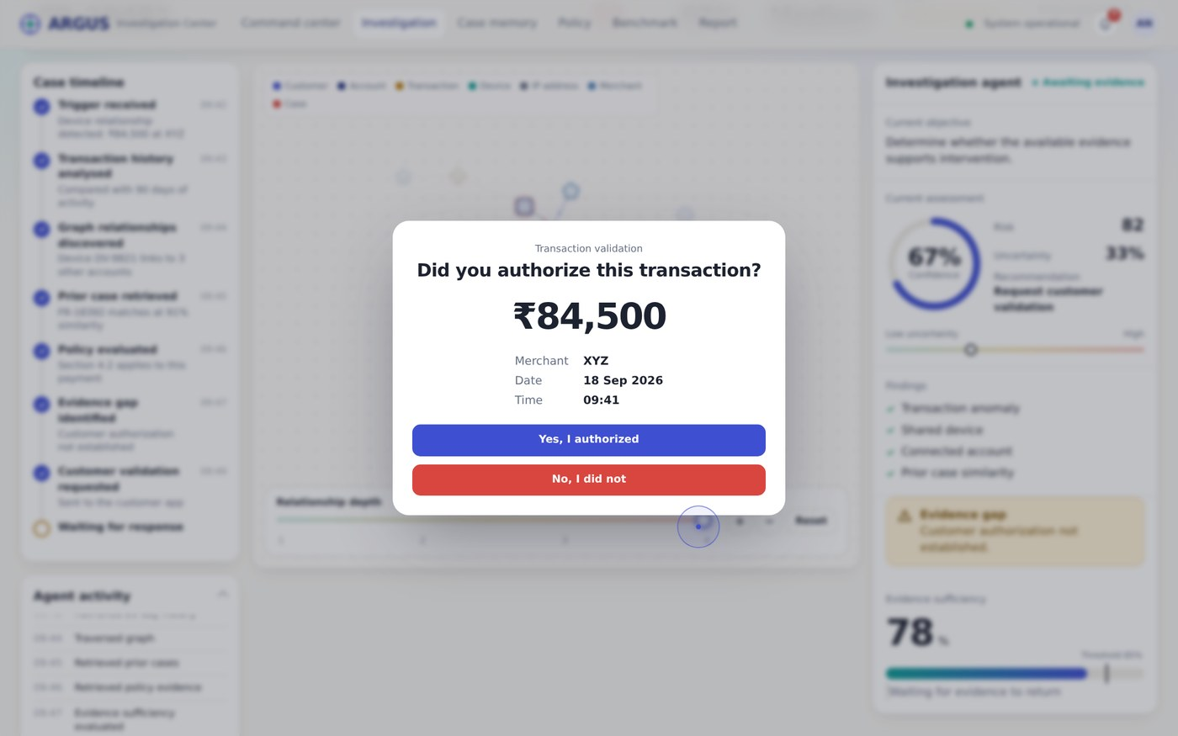
Screenshot 10. Customer validation. The customer-facing question with amount, merchant, date and time. Answering "No, I did not" sends the evidence back to ARGUS.
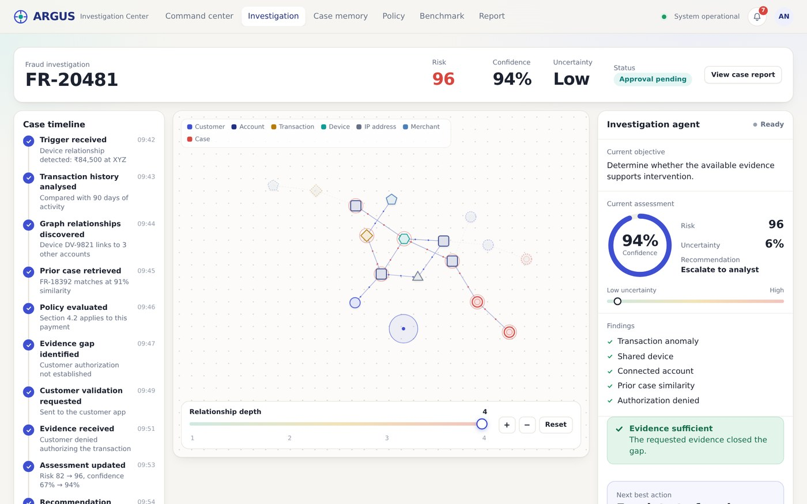
Screenshot 11. After the evidence arrives. Risk is now 96, confidence 94% and uncertainty Low. The timeline shows evidence received, assessment updated and recommendation changed. The next best action is Escalate to fraud analyst.
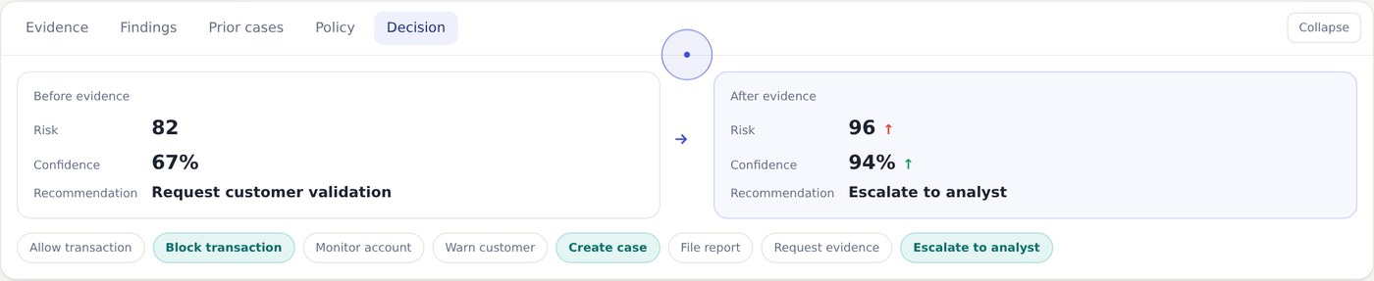
Screenshot 12. Decision evolution. Before and after: risk 82 to 96, confidence 67% to 94%, and the recommendation changes from Request customer validation to Escalate to analyst. The action library highlights the recommended actions.
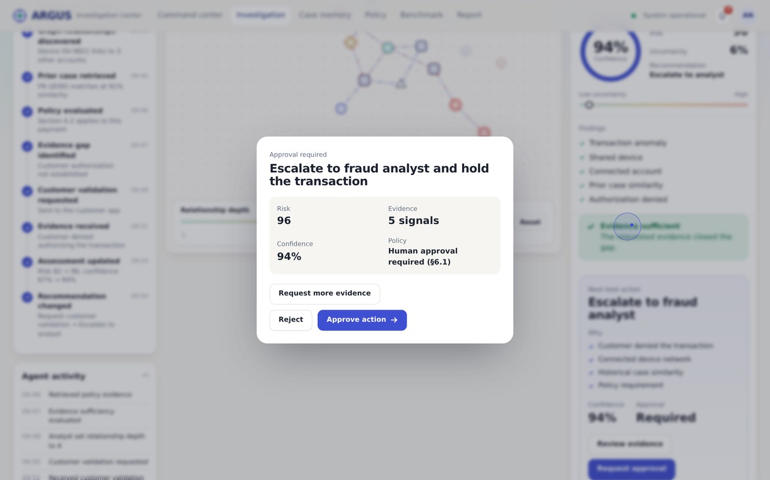
Screenshot 13. Approval dialog. The action needs a human decision. The analyst can approve, reject or request more evidence.
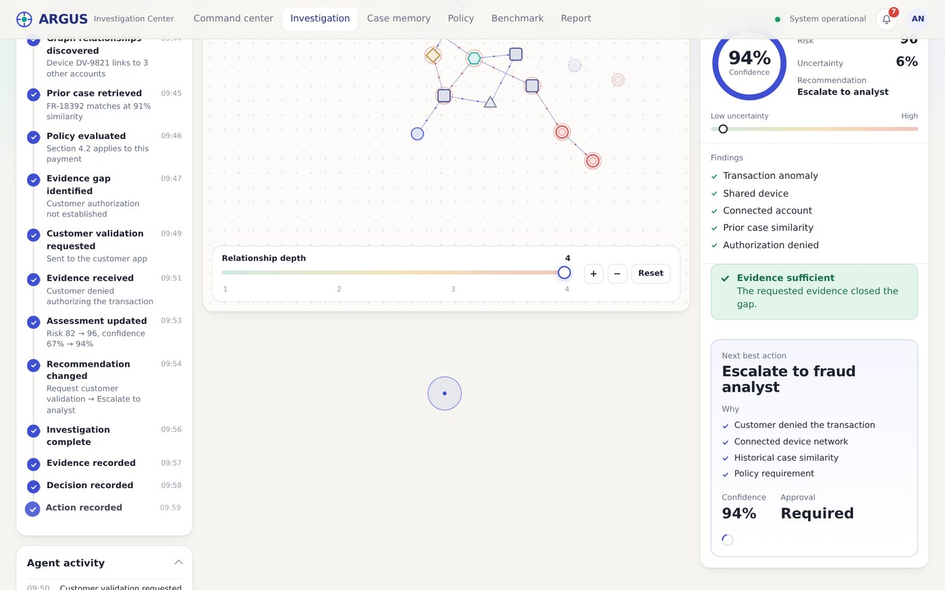
Screenshot 14. Case closing. The timeline completes with investigation, evidence, decision, action, approval and case memory checks.
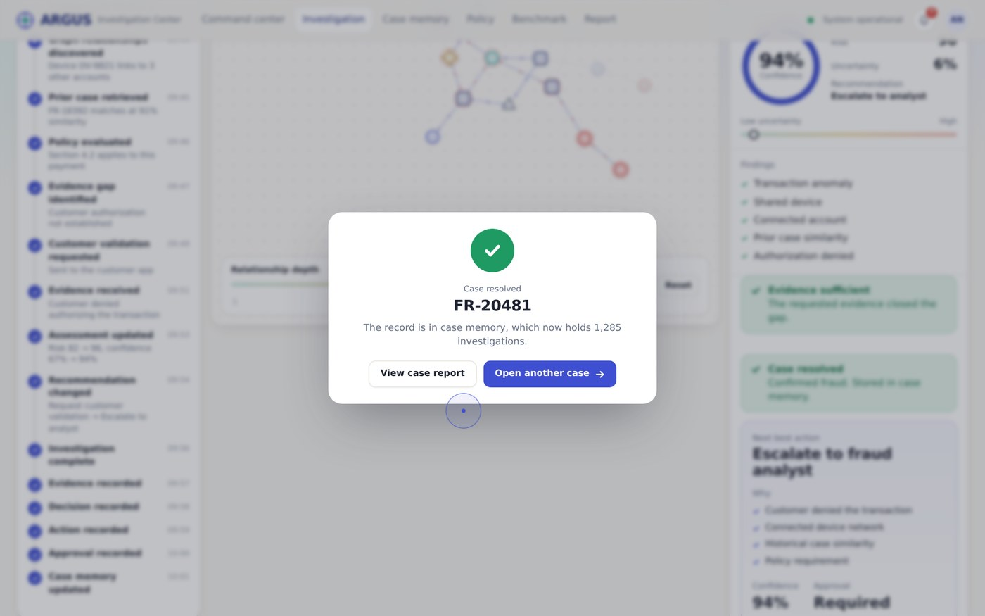
Screenshot 15. Case resolved. The record is stored in case memory, which now holds 1,285 investigations. The analyst can open the report or the next case.
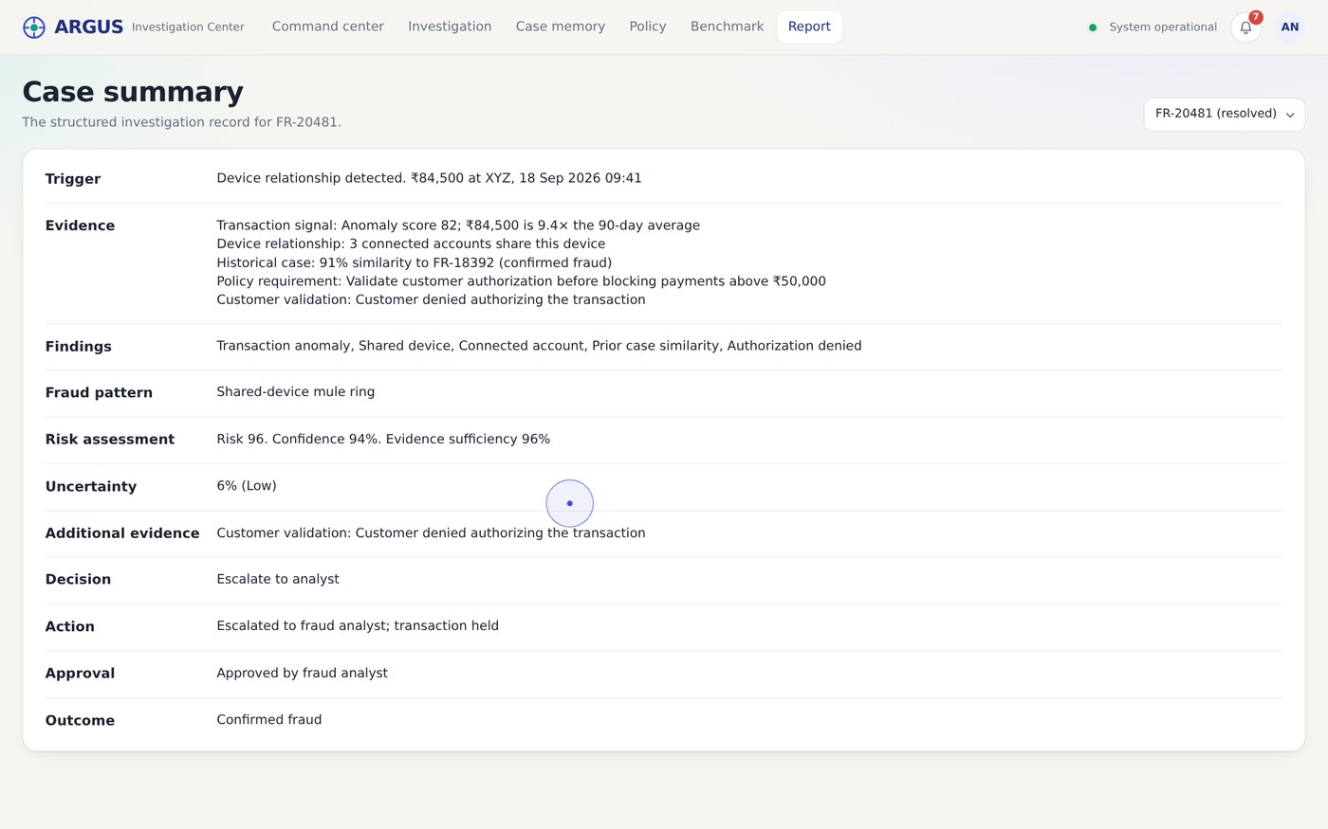
Screenshot 16. Case report. The structured record of the case, from trigger to outcome.
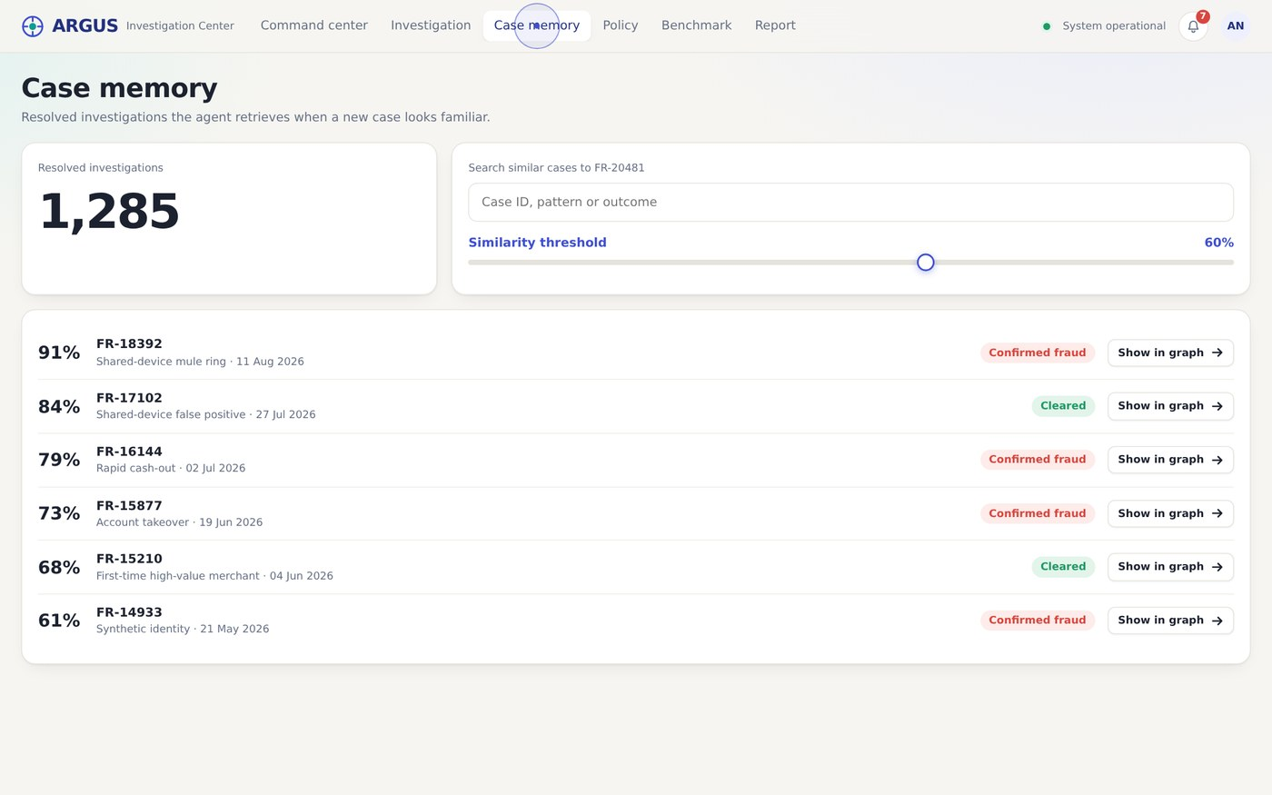
Screenshot 17. Case memory. Search, a similarity threshold slider and a list of similar resolved cases with their outcomes.
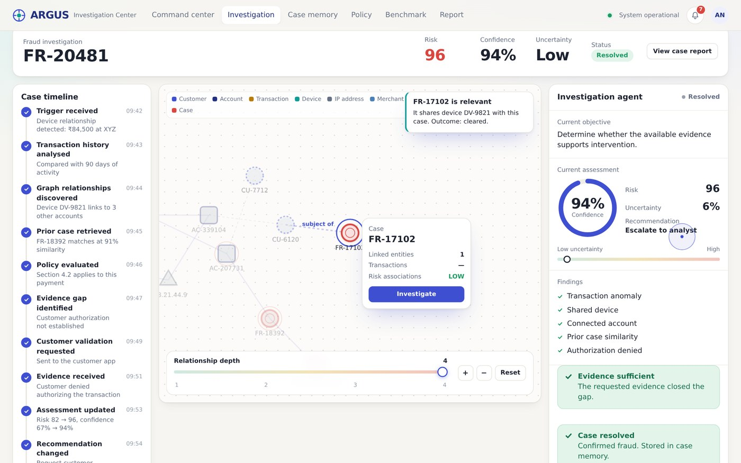
Screenshot 18. Case memory shown in the graph. FR-17102 is drawn into the network through the shared device, with a note explaining why it is relevant and how it ended.
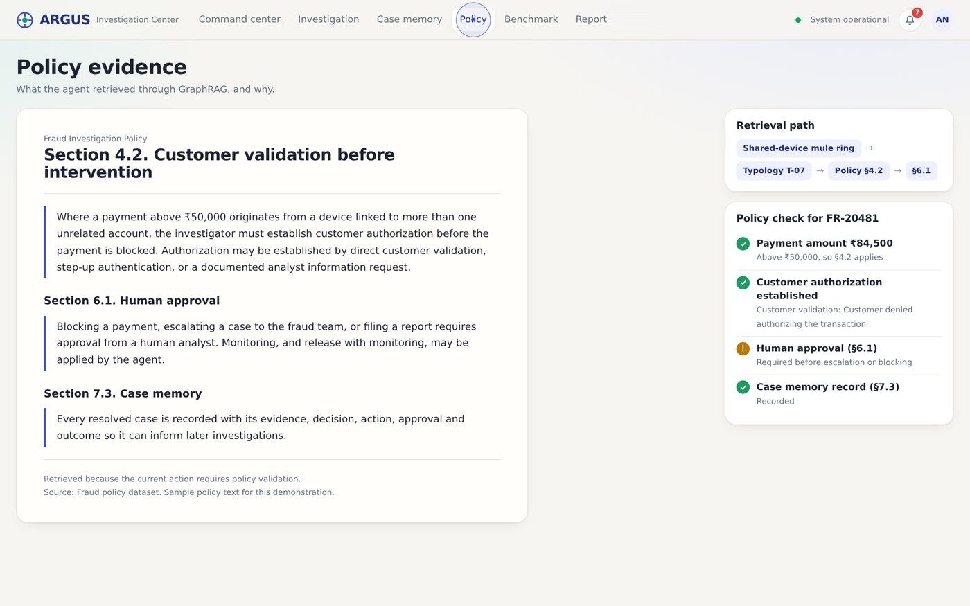
Screenshot 19. Policy viewer. The retrieved policy sections in a document layout, the retrieval path from fraud pattern to policy, and a live policy check for the case. The policy text is sample text.
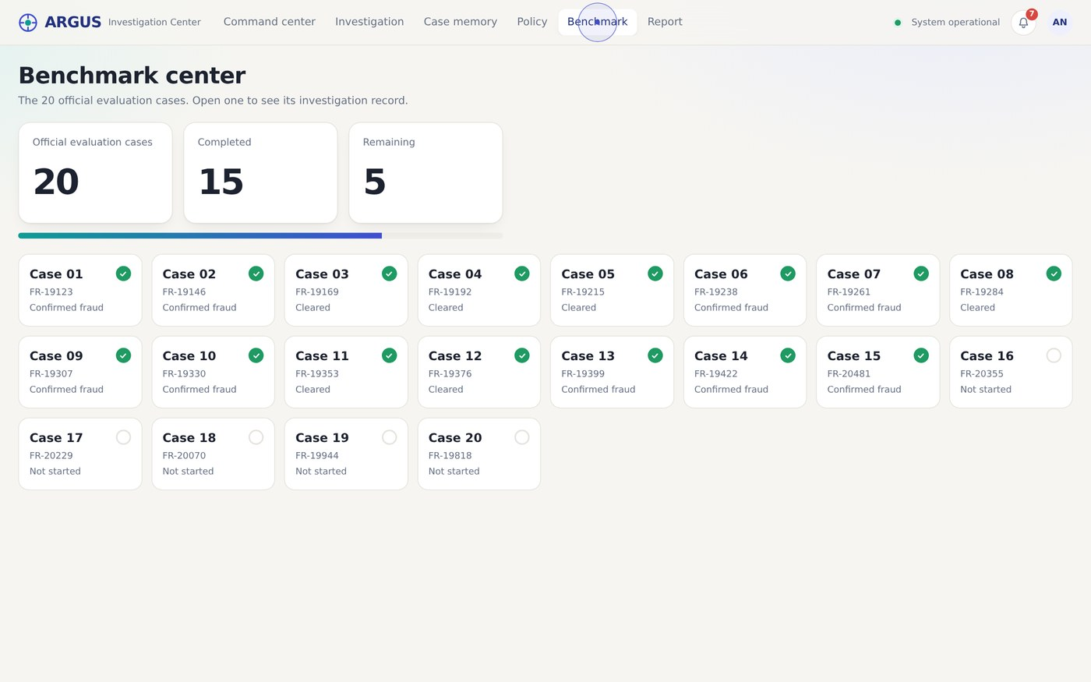
Screenshot 20. Benchmark center. Twenty evaluation cases. After resolving FR-20481 (case 15) the counters read 15 completed and 5 remaining. The completed cards are placeholders.
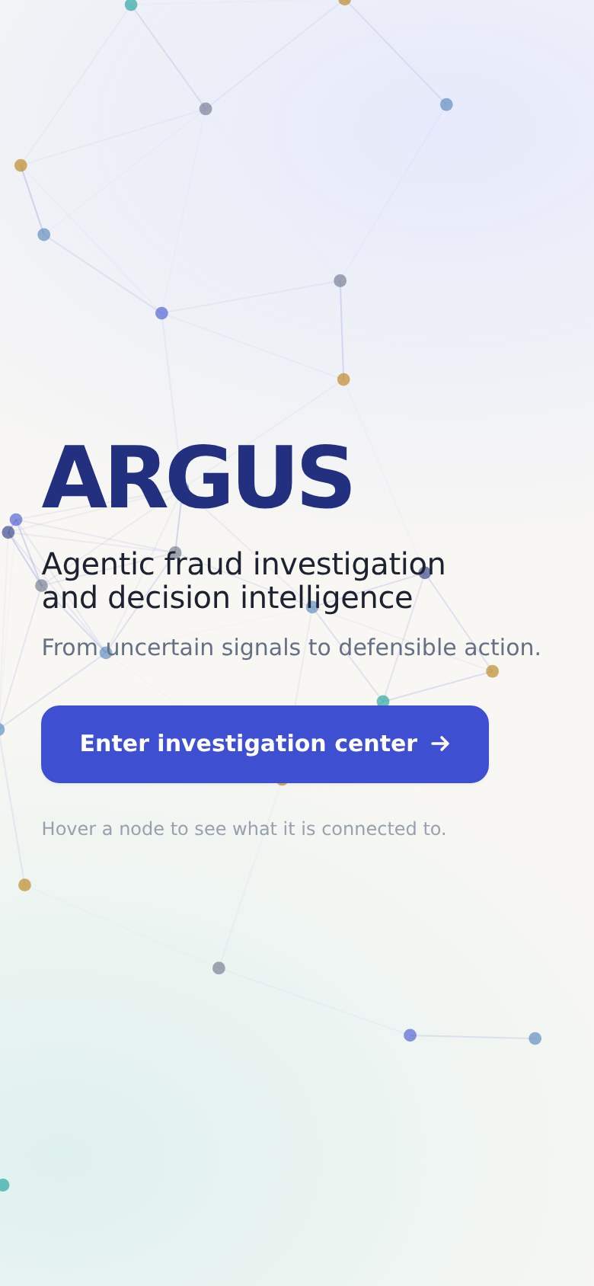  Screenshot 20. Landing | 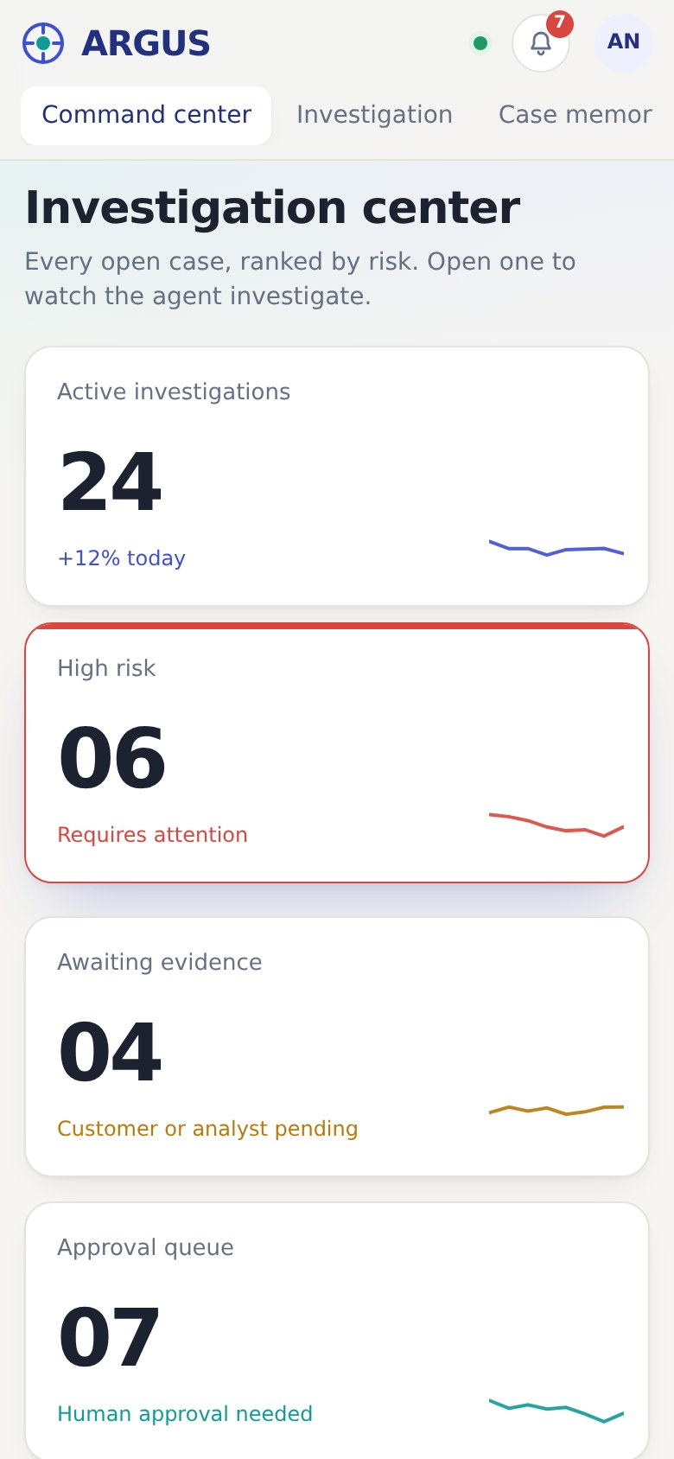  Screenshot 21. Command center | 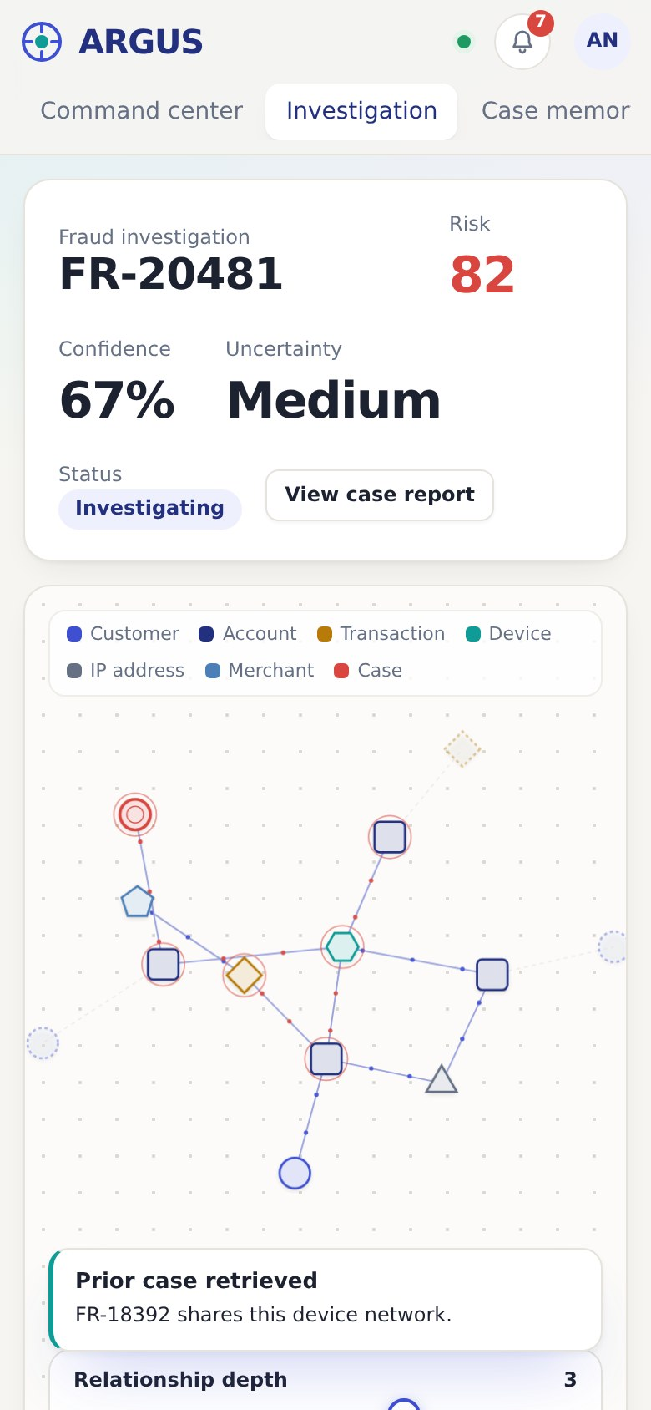  Screenshot 22. Workspace
On a phone the panels stack, the top navigation wraps under the logo, and the graph keeps its depth slider and zoom buttons.

5. System architecture

5.1 Overview
The target system has five layers. The interface asks the agent to investigate. The agent plans the work, calls tools that query the graph and retrieve policy and past cases, judges whether evidence is sufficient, proposes an action, and waits at an approval gate when policy demands it. Results flow back up to the interface as state that the timeline, graph and meters display.
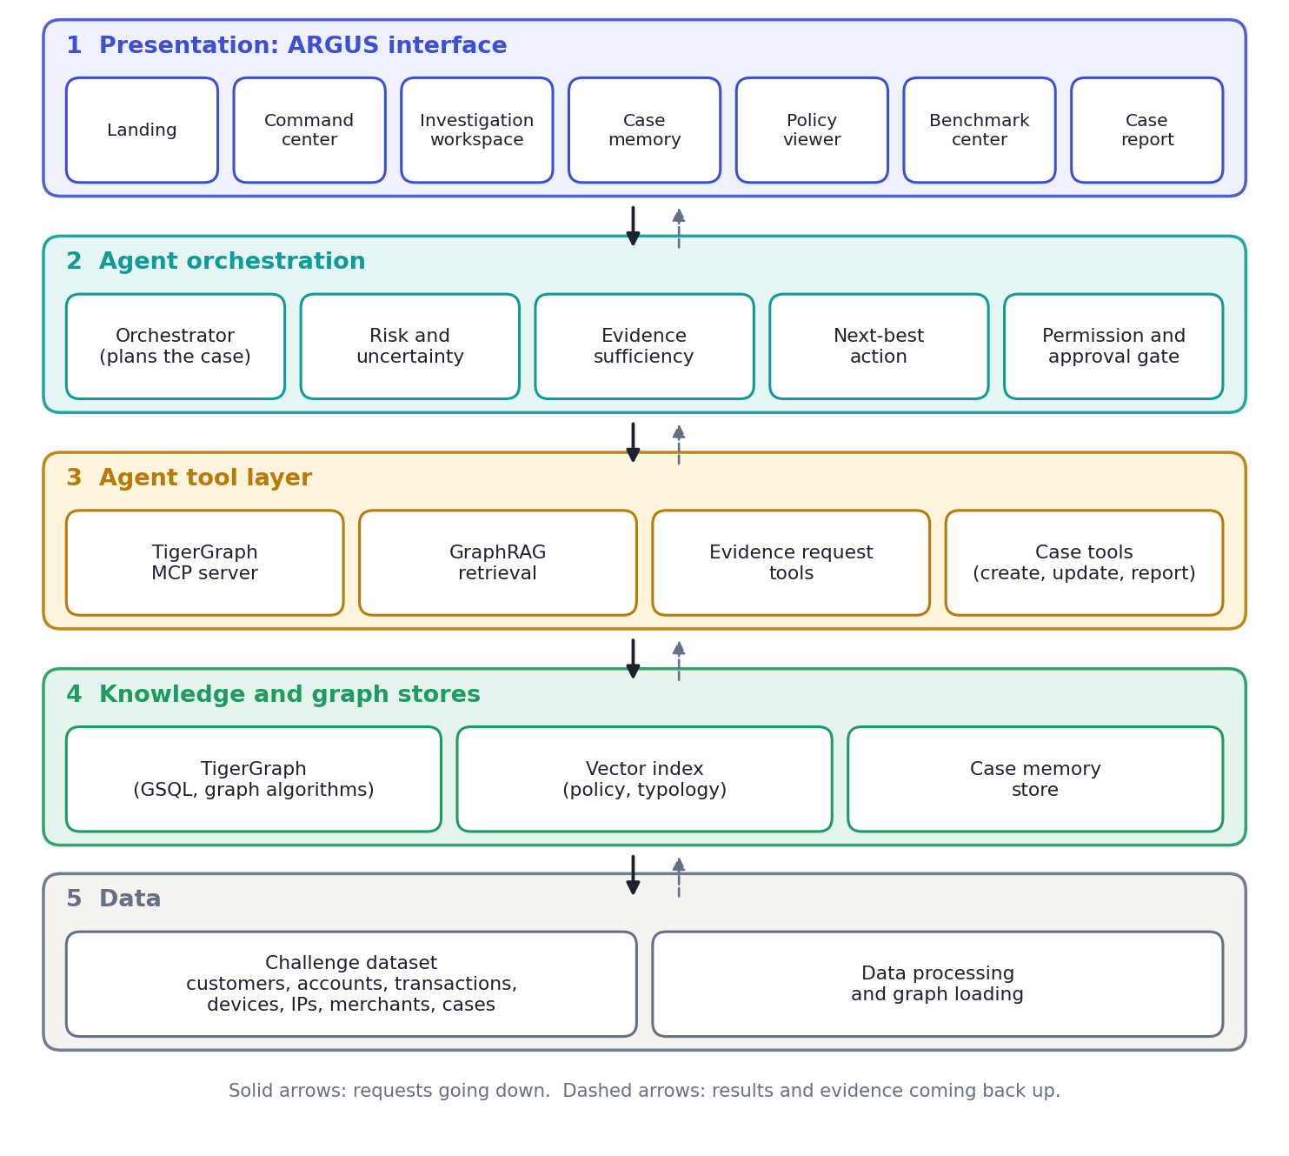
Figure 1. ARGUS layered architecture

5.2 Layers and responsibilities
Layer | Components | Responsibility
1. Presentation | Landing, command center, workspace (timeline, graph, agent panel, evidence dock), case memory, policy viewer, benchmark center, report | Shows state and collects analyst actions. Never decides on its own.
2. Agent orchestration | Orchestrator, risk and uncertainty scoring, evidence sufficiency, next-best-action, permission and approval gate | Plans the investigation, decides whether evidence is enough, chooses the next action and enforces approval rules.
3. Agent tool layer | TigerGraph MCP server, GraphRAG retrieval, evidence request tools, case tools | The only way the agent touches data or the outside world. Every tool call is logged as agent activity.
4. Knowledge and graph stores | TigerGraph (GSQL queries and graph algorithms), vector index for policy and typology text, case memory store | Holds relationships, retrieved knowledge and resolved cases.
5. Data | Challenge dataset, data processing and graph loading | Turns raw customer, account, transaction, device, IP, merchant and case records into the graph.

5.3 End-to-end data pipeline
From the specification (section 36):
- Dataset
- Data processing
- TigerGraph
- GSQL and graph algorithms
- TigerGraph MCP
- Agent tool layer
- GraphRAG
- Policy and case memory
- Agent orchestrator
- Evidence sufficiency
- Next best action
- Permission and approval
- Case update
- Case memory
- Frontend

5.4 Prototype compared with the target system
Concern | In the prototype | In the target system
Data source | Generated in the browser from fixed seeds | Challenge dataset loaded into TigerGraph
Graph | Hand-built template graph per case, drawn on canvas | Subgraph returned by GSQL queries through the MCP server
Agent | Scripted sequence of six steps | LLM orchestrator calling tools and reasoning over results
Risk and confidence | Fixed numbers derived from the case score | Computed from graph algorithms and evidence weights
Policy and prior cases | Sample text and a static list of 10 cases | GraphRAG over real policy, typology and case memory
Evidence requests | Simulated dialogs | Real customer channel, step-up provider and analyst queue
Approval | A dialog in the same page | Role-based approval with an audit trail
Persistence | None. A refresh resets everything. | Database-backed cases, decisions and memory
Users and security | None | Sign-in, roles, logging, data protection

5.5 Design patterns used
Pattern | How it is used in ARGUS
Plan, act, observe loop | The agent gathers signals, checks sufficiency, acts, and reassesses when evidence returns.
Human in the loop | Actions such as escalating or blocking wait for analyst approval. Reject and Request more evidence are first-class choices.
Evidence sufficiency gate | A numeric threshold (85%) decides between requesting more evidence and recommending an action.
Retrieval-augmented reasoning | Policy, typology and prior cases are retrieved and shown with the reason they were retrieved.
Case-based reasoning | Resolved cases are stored and returned by similarity for the next investigation.
State-driven interface | One case state object drives the timeline, meters, graph, dock and buttons, so the interface cannot disagree with itself.
Explainable motion | Animation appears only when the underlying state changes.

6. How it works

6.1 Investigation workflow
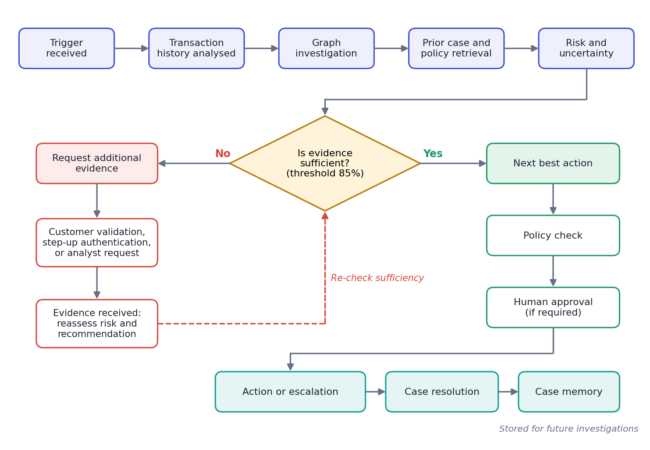
Figure 2. Investigation workflow, including the additional-evidence loop

6.2 Step by step
# | What the agent does | What the analyst sees
1 | Receives the trigger and reads the flagged transaction. | Timeline: "Trigger received". Transaction signal card. Risk starts to rise. Finding: transaction anomaly.
2 | Compares the payment with 90 days of history. | Timeline: "Transaction history analysed". Merchant node lights up.
3 | Traverses the graph from the account. | Edges animate, the device and three connected accounts light up, depth expands to 2, and a discovery card appears. Findings: shared device, connected account.
4 | Retrieves similar prior cases. | Prior case node and its outcome light up, depth expands to 3. Finding: prior case similarity.
5 | Retrieves policy evidence. | Policy requirement card: validate the customer before blocking payments above ₹50,000.
6 | Evaluates evidence sufficiency. | Sufficiency 78% against 85%. Warning and an evidence gap: customer authorization not established.
7 | Waits. The analyst requests evidence. | Modal with three evidence options and the estimated effect on uncertainty.
8 | Receives the response and reassesses. | The evidence flies to the panel. Risk, confidence, uncertainty and the recommendation animate to new values.
9 | Proposes the next best action. | Next-best-action card with reasons, confidence and whether approval is required.
10 | Requests approval where policy requires it. | Approval dialog: approve, reject or request more evidence.
11 | Closes the case and updates memory. | Six completion checks, "Case resolved", memory count goes up, a case report is available.
12 | Uses the stored case later. | Another case shows the resolved case first among its prior cases.

6.3 Case states
State | Meaning | What the analyst can do
Investigating | The agent is working through its steps. | Explore the graph, read evidence as it appears.
Evidence gap | Sufficiency is below the threshold. | Request additional evidence.
Awaiting evidence | A request is out and a response is pending. | Wait for the response.
Ready | A recommendation exists. | Review evidence, request approval or apply the action.
Approval pending | The action needs a human decision. | Approve, reject or ask for more evidence.
Closing | The case is being recorded. | Wait a few seconds.
Resolved | Outcome recorded and stored in memory. | Open the case report or the next case.

6.4 Approval and policy rules used
Sample policy text
The three policy sections below are sample text written for the demonstration. They are not from a real institution and must be replaced by the challenge policy dataset.

- Section 4.2, customer validation: for a payment above ₹50,000 from a device linked to several unrelated accounts, authorization must be established before the payment is blocked. This can be done by customer validation, step-up authentication or a documented analyst request.
- Section 6.1, human approval: blocking, escalating or filing a report needs a human analyst. Monitoring, and release with monitoring, may be applied by the agent.
- Section 7.3, case memory: every resolved case is recorded with its evidence, decision, action, approval and outcome.

6.5 Actions the agent can recommend
The specification requires a full set of actions. All eight appear in the action library and are highlighted when recommended: allow transaction, block transaction, monitor account, warn customer, create case, file report, request evidence, and escalate to analyst.

7. Complete feature list
Area | Feature | Behaviour
Landing | Animated network | Nodes drift, links appear and fade with distance. Hovering a node shows its type, ID, connected entities and historical cases.
Landing | Enter button | Magnetic button that fades the landing screen into the command center.
Navigation | Top bar | Six sections, system status, a notification bell that jumps to cases awaiting approval, and a profile badge.
Navigation | Page transitions | Fade and slide between views. The selected case card expands into the workspace.
Command center | Metric cards | Five cards with count-up numbers, hover lift, accent border and a small animated line.
Command center | Risk slider and histogram | A slider filters cases by minimum risk. The histogram shows how many cases sit in each risk band.
Command center | Filter bar | Status, trigger, fraud pattern, evidence sufficiency and an opened-within-hours slider, with a live count and a reset option.
Command center | Case cards | Risk gauge, band label, trigger, evidence bar, status chip, benchmark tag and an Open case button.
Workspace | Case header | Case ID, risk, confidence, uncertainty, status and a link to the report. Numbers animate on load.
Workspace | Timeline | Vertical, grows with the workflow. A pending step pulses until it resolves.
Workspace | Agent activity log | Collapsible, timestamped record of every tool action and analyst action.
Graph | Seven node types | Customer, account, transaction, device, IP address, merchant and case, each with its own colour and shape.
Graph | Discovery animation | Edges draw in, particles flow along active links and newly found nodes pulse. Unexplored nodes are faint and dashed.
Graph | Relationship depth slider | Depth 1 to 4 reveals more of the network. The agent raises it automatically on discoveries.
Graph | Selection and highlighting | Selecting a node highlights its links, labels them and dims the rest.
Graph | Node hover card | Type, ID, linked entities, transactions, risk association and an Investigate button.
Graph | Pan, zoom and focus | Drag to pan, wheel or buttons to zoom, reset, and smooth focus on a chosen node.
Graph | Legend and discovery note | Colour key and a short note explaining each discovery.
Agent panel | Assessment | Radial confidence meter, risk, uncertainty and the current recommendation.
Agent panel | Uncertainty bar | A marker slides along a low-to-high scale as uncertainty falls.
Agent panel | Findings | A running list of confirmed findings.
Agent panel | Evidence gap | Amber notice while evidence is missing, green when it is sufficient.
Agent panel | Evidence sufficiency | Large percentage, animated bar and a marked 85% threshold, with a button to request evidence.
Evidence request | Three request types | Customer validation, step-up authentication, analyst information request, each with an estimated effect on uncertainty.
Evidence request | Customer validation screen | Amount, merchant, date and time with Yes and No buttons.
Evidence request | Step-up and analyst simulations | A pass or fail choice for step-up, and a short waiting state for the analyst reply.
Decision | Decision evolution | Before and after values for risk, confidence and recommendation, with arrows.
Decision | Next best action | Action, reasons, confidence, approval requirement and buttons.
Decision | Action library | The eight possible actions, with the recommended ones highlighted.
Decision | Approval dialog | Action, risk, evidence count, policy rule and three outcomes: approve, reject, request more evidence.
Decision | Two outcome paths | A denial leads to escalation. A confirmation leads to release with monitoring and no approval.
Evidence dock | Five tabs | Evidence, findings, prior cases, policy and decision, collapsible.
Evidence dock | Evidence cards | Each with its source (transaction data, TigerGraph, case memory, policy dataset, customer response). New cards slide in.
Case closure | Completion sequence | Six checks animate in, then a Case resolved dialog with links to the report and the next case.
Case memory | Counter and search | Animated total of resolved investigations and a text search.
Case memory | Similarity slider | Filters the list by similarity threshold.
Case memory | Show in graph | Draws the historical case into the current graph through the shared device, with its outcome.
Case memory | Session learning | A case resolved in the session appears at the top of later prior-case lists.
Policy | Policy viewer | Document-style page with three sections, source and the reason for retrieval.
Policy | Retrieval path and checks | Shows how the pattern led to the policy, and a live checklist for the current case.
Benchmark | Benchmark center | Twenty cards with completed and remaining counts, a progress bar and links to each record or investigation.
Report | Case summary | Trigger, evidence, findings, fraud pattern, risk, uncertainty, additional evidence, decision, action, approval and outcome, for any case.
Experience | Custom cursor | Dot and ring, larger on controls, reticle on nodes, grab states and magnetic pull on buttons. Only on mouse devices.
Experience | Reduced motion | Animations and the cursor trail are reduced or removed when the system asks for less motion.
Experience | Responsive layout | Panels stack on tablets and phones, and the top navigation scrolls sideways.
Experience | Keyboard support | Cards open with Enter or Space, focus outlines are visible and Escape closes standard dialogs.

8. Required partners and dependencies
A working ARGUS needs technology providers, data owners and people. The table shows what each contributes and whether the prototype already stands in for it.
Partner or component | What it provides | Needed for | In the prototype
TigerGraph | Graph database, GSQL queries, graph algorithms | Relationship discovery, shared-device and ring detection | Simulated
TigerGraph MCP server | A standard tool interface between the agent and the graph | Letting the agent query the graph safely | Not built
GraphRAG | Retrieval of policy, typology and case context over the graph | Policy viewer, prior-case retrieval | Sample text
LLM provider | The reasoning model behind the orchestrator (for example Claude through its API) | Planning, evidence sufficiency, explanations | Scripted
Vector or embedding index | Similarity search over policy text and case summaries | Case memory similarity | Fixed numbers
Challenge organiser | The dataset, the 20 evaluation cases and the scoring rules | Benchmark center and submission | Placeholders
Policy owner (compliance team) | The real fraud policy and typology documents | Policy checks and approval rules | Sample text
Customer contact channel | A way to reach the customer (app push, SMS or call) | Customer validation | Simulated dialog
Step-up authentication provider | Identity challenge such as one-time code or biometric | Step-up authentication | Simulated dialog
Fraud analysts | Human review and approval | Escalation, blocking, reports | One dialog
Identity and access management | Sign-in and role-based permissions | Who may approve which action | Not built
Case management and reporting system | Where cases and reports are filed | Create case, file report | Not built
Audit and log storage | Permanent record of tool calls, decisions and approvals | Defensible, reviewable decisions | Not built
Hosting | Static or application hosting (for example Vercel) | Sharing the demo and running the app | Artifact link
Google Fonts | Bricolage Grotesque and Instrument Sans | Typography in the prototype | Used

9. Advantages

For decision quality
- Defensible decisions. Every recommendation is tied to visible evidence, a source, a confidence figure and a policy rule.
- Uncertainty is shown, not hidden. The agent says when it does not know enough and asks for the specific missing evidence.
- The graph shows what tables miss. A shared device linking four accounts is obvious on the graph and easy to overlook in rows.
- Two-way reasoning. The same evidence loop can raise risk (customer denies) or lower it (customer confirms), so it does not only confirm suspicion.
- Human control by design. High-impact actions wait for approval, and rejecting or asking for more evidence are normal paths.
- Institutional memory. Closed cases feed later investigations, and the analyst can see why an earlier case was relevant.

For the challenge and the demo
- Traceable to the brief. Each screen maps to a requirement, so a judge can see investigation, evidence gathering, uncertainty, actions, explanations, permissions and memory.
- Works today. One file, no installation, no build. It runs in a browser and can be shared as a link or a file.
- One continuous story. The judge walk-through goes from a suspicious case to a stored memory in about ten minutes without leaving the product.
- Motion that explains. The animations answer "what changed and why", which is easier to defend than decoration.

For engineering
- Clear seams. The data, workflow and rendering are separate, so real services can replace the simulated functions without redesigning the screens.
- Single state object per case. The interface cannot show a timeline, meter or button that disagrees with the case state.
- Light dependencies. Plain JavaScript and canvas, with no framework to upgrade.
- Accessible foundations. Reduced motion, keyboard use, visible focus and responsive layout are already in place.

10. Disadvantages and risks
Read this first
The prototype demonstrates the product, not the agent. The challenge asks for agent output on the 20 official cases. Those results must come from the real system. The completed benchmark cards in the prototype are placeholders and must not be presented as agent results.

Limitation or risk | Why it matters | Mitigation
Simulated data and logic | No real graph, agent, policy or benchmark results are behind the screens. | Connect TigerGraph, MCP and GraphRAG, then load the official cases.
No backend or saving | A refresh resets all cases, decisions and memory. | Add a service and database for cases, decisions and memory.
Sample policy and typology text | It could be mistaken for real policy. | Replace it with the challenge documents and label the source.
Single-file code | About 900 dense lines are harder to maintain, test and extend. | Move to a component framework with typed data models and tests.
Custom canvas graph | Hundreds of nodes are fine, but thousands will slow down. | Limit depth, sample large subgraphs, or use a WebGL graph library.
Heavy motion | Can distract analysts working at volume and can strain low-end devices. | Offer a reduced-motion toggle in settings and test on real devices.
Custom cursor | Replaces the system cursor on desktops, which some users find hard to follow. | Make it optional and keep the system cursor in text fields.
LLM behaviour | A real agent can misjudge, invent detail, run slowly or cost more than expected. | Ground every claim in tool results, log tool calls, and keep the approval gate.
Dependence on TigerGraph | GSQL queries and MCP tools tie the system to one vendor. | Keep the tool layer thin so the graph store can be replaced.
Customer contact and privacy | Sending validation requests and holding personal data brings consent and data-protection duties. | Review consent, retention and regulatory rules with compliance before live use.
Workflow overhead | A guided flow is slower than a plain table for an analyst clearing many easy cases. | Add a fast queue mode for low-risk cases.
Limited testing | Only a scripted headless run was done. Real phones, screen readers and load were not tested. | Test on devices, run an accessibility review and load test the real backend.
Fixed demo numbers | The 82 to 96 change is scripted, so it shows the design, not model accuracy. | Show computed scores from real algorithms in the final build.

11. Recommended next steps
- Confirm the challenge inputs: the dataset, the 20 evaluation cases, the required output format and the scoring rules.
- Load the data into TigerGraph and write the GSQL queries and graph algorithms for device sharing, connected accounts and case similarity.
- Stand up the TigerGraph MCP server and define the agent tools: graph query, prior-case retrieval, policy retrieval, evidence request and case update.
- Build GraphRAG over the real policy, typology and case-memory documents.
- Build the orchestrator with the sufficiency threshold, action selection and the approval gate, and log every tool call.
- Replace the simulated functions in the prototype (cases, buildGraph, priorFor, investigate, runEvidence) with calls to the new service.
- Run the 20 official cases and store each investigation record for the benchmark center.
- Test and harden: real devices, accessibility, performance, and a clear "simulated" label on any remaining placeholder data.
- Publish a public link (for example a Vercel deployment) for judges.

Appendix A. Prototype code map
Main parts of argus.html and what they do. The ones to replace for a live system are marked.
Part | Purpose | Replace for live use
cases, done, MEM, priorFor | Generated case list, completed cases, memory cases and similarity | Yes
buildGraph, attachHistory | Builds each case graph and adds historical cases to it | Yes
GR engine (graphStep, graphDraw) | Force layout, canvas drawing, hit testing, pan and zoom | No
investigate | The six-step scripted investigation | Yes
runEvidence, askCustomer, askStepUp, askAnalyst | Evidence request workflows and simulated responses | Yes
openApproval, closeCase | Approval dialog and case closure | Partly
paintMeters, renderTL, renderSlot, renderDock | Update the workspace from the case state | No
renderCenter, paintGrid, openCase | Command center, filters and the shared-element transition | No
renderMemory, renderPolicy, renderBench, renderReport | The four secondary pages | Data only
go, modal, toast | View switching, dialogs and notices | No
Landing IIFE and cursor IIFE | Landing network and the custom cursor with magnetic buttons | No

Appendix B. Sharing options
- Artifact link: https://claude.ai/artifact/9X2SV7kCbYeZJvf6ECvgwx. Set who can view it from the artifact card. The widest option depends on the account or workspace.
- Send the file: argus.html works by double-clicking it. It needs no account and is a good choice for reviewers.
- Public deployment: deploy the file as a static site (for example on Vercel) to get a normal public URL.

Appendix C. Glossary
Term | Meaning
GSQL | TigerGraph's query language for graph queries and algorithms.
MCP | Model Context Protocol, a standard way for an AI agent to call tools.
GraphRAG | Retrieval of knowledge for an AI agent using the structure of a graph, not only text similarity.
Evidence sufficiency | A measure of whether the evidence gathered is enough to justify an action. Here the threshold is 85%.
Uncertainty | How much the agent does not know. It falls as evidence arrives.
Next best action | The recommended step given current evidence, policy and risk.
Case memory | The store of resolved investigations used to inform new ones.
Step-up authentication | An extra identity check, such as a one-time code, requested when risk is high.
Typology | A named fraud pattern, such as a shared-device mule ring.

