SURUCHI KUMARI

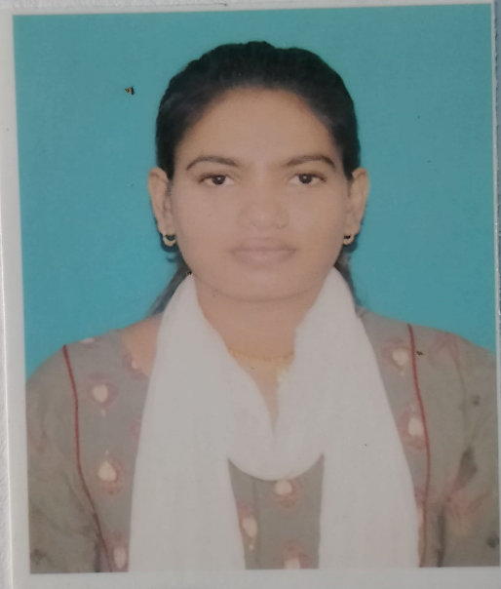

# Profile



Contacts

+91-6299361192

[suruchikumari1964@gmail.com](mailto:suruchikumari1964@gmail.com)

Jarkha,Patna(Bihar)

<https://github.com/Suruchikum?tab=repositories>

https://www.linkedin.com/feed/

Skills

React NodeJs MongoDb Express HTML5

Javascript Java

Web application developer (MERN stack) with a flair for creating elegant solutions with in the time. Technically sound professional with over 5+ years of experience in the area of software development, designing and developing user interfaces, debugging and deploying application. Self-motivated and constant learner able to create responsive web applications from scratch till final deployment. Capable of working in small, medium and large teams.

# Experience

## NMDC

30 May 2024 -28 July 2024

 Designation : Information Technology

* Role : Vocational Training
* Description : In this vocational training I have learned to create a website by using HTML, CSS , Node.js and JavaScript.

Feb 2014 - Jan 2015

|  |  |
| --- | --- |
| Education |  |
| Rajiv Gandhi Institute of Petroleum Technology  Information Technology (B-Tech)  CGPA - 6.1 | 2022 – 2024 currently |
| R.L.S.Y.College,Paliganj,Patna  Bihar School Examination Board(Secondary)  Class 12th 82%  Bihar School Examination Board  2018-2020  Jul 2012 - Jan 2014  Sardar Patel High School Jarkha,Patna  Class 10th 62%  Strength  Leadership  Hostaplity Team  Council Of Science And Technology,UP  Organized Workshop  Intellectual Property Rights Certification Of Participation And Appreciation  Hobbies  Kabbadi,Badminton  Learning about the new/old technology | 2017 - 2018 |