**RESULTS**

In this Project, we have assessed the efficiency of CNN-based finger joint detection. For this project, some X-ray pictures of the fingers are taken for training and testing. All images give accurate results. The X-ray images are predicted for both healthy and unhealthy patients. The remedies are then expected to be displayed for patients who are affected by Arthritis. This will help doctors to see whether their prediction is right or not.



**STEP 1**

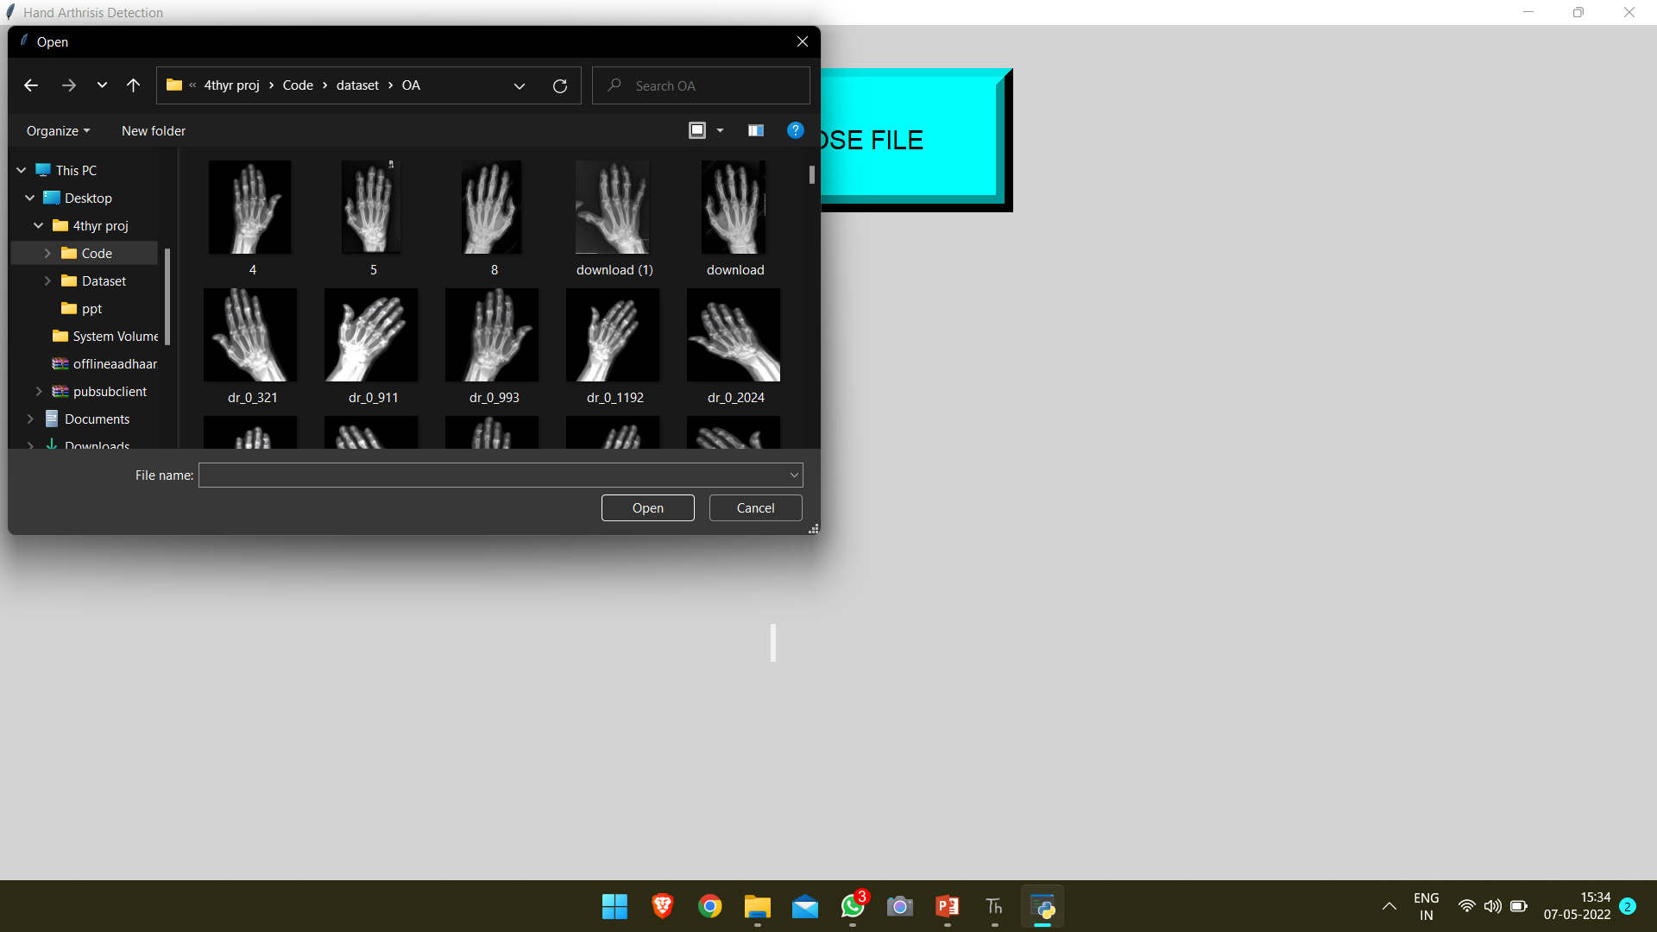

**STEP 2**

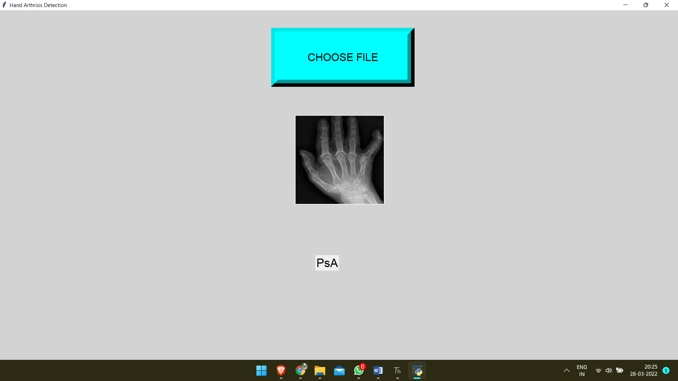

**STEP 3**

