**Security:**

**Create role:**

Setup🡪role🡪setup role

**Create Profile:**

Setup🡪 Profile

**Create user:**

Setup🡪 user

**Profile level security:**

**Key:**

* If we need to give visibility of tab to any profile which was not given initially then we have to provide profile level access and give tab as default on and also provide object permissions
* If u don’t give view all and modify all then the user cannot delete the other user record

**Tab visibility:**

Default on, Default off, tab hidden

**Object access:**

Read, edit, delete, view all, modify all.

**Field level Security:**

Visible, read only

**Key:**

* If u check visible and read-only for the profile, then the assigned profile cannot edit the particular field.
* If u check visible for the profile, then the assigned profile can edit the particular field.
* If u uncheck visible for the profile, then the assigned profile cannot view the particular field.

**Permission Set:**

* If u need to give permission for one user with profile(with many user) then assign permission set for that user to give access to particular field or object

**Permission set groups:**

* If u want to assign permission for more than one person then we can go for permission set groups

**Record Level Security:**

**OWD**🡪**org wide default**

* Setup🡪sharing setting
* Private,public read only,public read/write
* Private🡪only user who creates the record can view
* public read only🡪user can see all the records
* public read/write🡪 user can see and edit all the records
* In profile object level when we check view all and modify all then user can view all record despite assigning owd as private(Profile level access overrides record level access)
* Secority pyramid
* 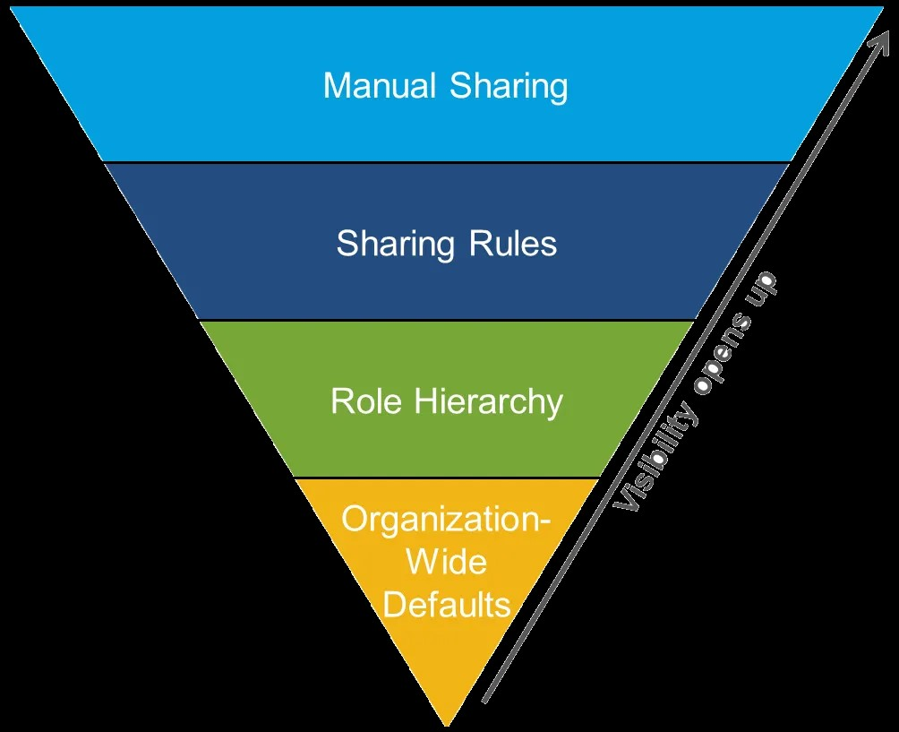

**Role Hierarchy:**

* Based on role hierarchy the record can be viewed by the higher role wen the lower role created the record even though owd as private
* But the senior role cannot be able to delete the record we should provide profile level access for delete permission
* So basically profile level security overrides owd record level security
* If owd is private and profile level security also we can uncheck view all and modify all then based on role hierarchy user can view the subordinate record
* Grant access using hierarchy is for custom object default checked for standard object

**Sharing Rules:**

Owd🡪below🡪sharing rules.

* Based on record owner
* Based on criteria

Public groups:Quick find🡪public groups

**Manual Sharing:**

* Wen u want to share one or two records
* If owd is private then only sharing button will appear whereas if it is public then we cannot view sharing button

**Apex managed sharing:**