9/24/2021

Surveilia Proposal

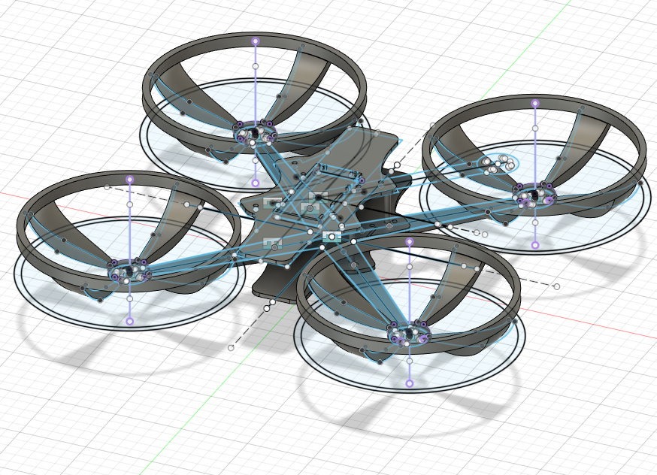

Ben Kennedy, Chase Westlake, Ethan Pyle, Kaden Talor

Camosun College

Memorandum

To: Kimberly Lemieux

CC: ECET Stakeholders

From: Surveilia Capstone Team

Date: September 24, 2021

Re: Surveilia Capstone Proposal

Summary

Surveilia is an autonomous drone that patrols areas on a designated flight path, using ArduPilot software. It is meant to replace or enhance characteristics of security guards and security cameras. Guards can cost between $10,342.08 and $18,144, whereas Surveilia is a onetime $545 fee.

Surveilia can be properly prototyped with a strong baseline of functionality by mid-December. System functionality includes autonomous flight, easy-to-use interface, and human recognition for security alerts.

Introduction

Surveilia is an autonomous security drone which can replace or enhance the capabilities of physical and remote security.

The idea for *Surveilia* started with both a fascination with drone technology and recognizing market needs for security technology. Surveilia is a security drone that flies in a designated flight path, without the need for human interaction. As the drone is patrolling, a camera returns video feed and sends alerts if it encounters people. All flight activity will be logged and data is sent to an interface running on a user's computer. Surveiliacan help property owners with varied quantities of land and buildings keep their assets safe at a low cost.

Although static cameras and patrolling guards can significantly contribute to security of a site, there are limitations. Cameras are positioned statically and physical guards can become fatigued and miss crucial details in reports or risk assessments. Both can cost quite a bit of money. Surveilia is a onetime cost, can’t fatigue or miss detail and provides the best of both static cameras and physical guards.

Theory

Security is a highly productive industry that is currently facing high demand and low supply. The industry is highly competitive in contract bids and workers are expecting higher wages, while consumers are trying to maximize their value and limit their liabilities. Companies and individuals can see benefits regarding both asset protection and prime insurance rates with proper security coverage, and the value enjoyed can be enhanced with better rates from security solution providers. In theory, Surveilia should be able to augment or replace residential or commercial security contracts.

Security can demand long hours, increasing fatigue of guards. Guards can also come with a heavy cost on the client as most physical security is contractual and fulfilled by third parties. Security guards are paid between $15.39 to $27.00 in British Columbia, and many sites have the requirement for 24-hour security, which can generate monthly wage costs (before third party fees), between $10,342.08 and $18,144 [1].

Security cameras have been viewed as a cost-effective solution and alternative to physical security. It is true that cameras are cheaper than physical security. However, cameras do not provide better quality protective services and are entirely static.

A prototype of Surveilia will cost just under $500 dollars and is expected to see manufacturing costs drop after prototyping.

|  |  |  |
| --- | --- | --- |
| Camera | Guard | Surveilia |
| $80 - $2000 per camera without installation | $10,342 - $18,144 per month | $500 onetime fee |

Scope

Surveilia will be able to

* Maneuver in a 3D path autonomously
* Log and send alerts when a person is encountered within flight path area
* Feed flight information to a windows application for user viewing

Surveilia is not currently planned to have robust artificial intelligence capabilities. Meaning, it will not be able to conduct facial recognition and access criminal databases, or do advanced suspicious activities routines. Surveilia is designed to be a roaming alert system.

Procedures

The drone must;

* Remain stable in flight
* Maneuver in a 3D path autonomously
* Log when a person is encountered in the flight path
* Be configurable
* Have a plottable path
* Have a manual interrupt
* Initialize upon start up

Tests will be conducted to ensure each of these requirements are met.

The drone must not oscillate when it's flying; this means the drone can't tilt from one side to another. Smooth acceleration forward, backward, as well as, descending and ascending is required for a pass in this requirement.

This will include physically flying the drone through the air in three dimensions. An autopilot override will be included just in case the drone starts to react in an unintended way. Visually observing the drone move in real time will be considered a pass.

If the drone can send video data back to the home operating computer, then processing the video quickly, determines if there was a human encountered during the drones flight path. If a notification alert is sent to the GUI with the data from the interaction this will be passed.

For a better ease of use for the user of the drone, it needs to be configurable. Where the drone will fly, at what time interval will it do that and for how long. These are all settings that can be added to the GUI that then will interface with the drone.

When the drone is flying a 2D dementia flight path needs to be plotted on a map. This map could possibly be google maps or another. The requirement is to have it be displayed on a tab in the GUI.

As soon as the drone is powered it connects to a home computer and loads any flight data. Then does a pre-flight check of the on board systems, if it passes these then the drone will automatically start its roaming fight. If there is a problem then the drone will not start flying, possibly giving a notification to the GUI in order to help the user find and fix the problem.

Tasks

The drones base CAD model is complete, however, adding mounting holes or stand offs still need to be done as well as 3D printing the body. PLA will be used for this at 20% infill for prototyping. The fitment of everything will not be perfect the first time so PLA will be used for this. Once this is complete the final print will be in ABS or PETG at a higher density infill so none of the parts can flix when flying.

Once all electronics arrive wiring and testing will need to start. This includes but is not limited to wiring the Kakute F7 flight controller to communicate over radio, as well as taking inputs then be sent to the ESC to control the four motors. Camera system and video transmitter will be needed. On the other side of the system resources will be needed to take all that data and parse it into usable information.

From there, A.I. programming will be used to determine if the drone encountered a human being or not. Much GUI work will be needed to display all of this data that is being sent. Slider option or some type of setting will be needed to control the barometer of the drone.

Components

The drone consists of the physical body (ABS or PETG at 50% infill), GPS, Kakute F7 flight controller, Atlatl HV V2 video transmitter, 4 motors, 4 propellers, 4 motor ESC, camera, and LiPo battery.

The Kakute F7 flight controller integrates a flight controller and on-screen display all in one. The microcontroller is an STM32F745 32-bit processor. It will be serving as the brain of the drone as all other flight-related tasks are commanded from it. It has a serial port for the GPS which is required for autonomous functionality. It also has an InvenSense ICM20689 IMU, a 6-axis MotionTracking device that combines a 3-axis gyroscope and 3-axis accelerometer into one package.

The accelerometer and gyroscope are required to feed values related to the drone’s position in 3D space (XYZ) to the drone’s proportional-integral-derivative (PID) controller. The PWM outputs are marked M1-M4 which are required to control the motors. The pinout for the controller can be seen below in Figure 1A.

ArduPilot, an open-source unmanned vehicle autopilot software for various autonomous systems, will be the software controls used to generate the autonomous functionality required of Surveilia.There are some minor firmware limitations when using the Kakute F7 flight controller, as it doesn’t have enough flash memory to store the full firmware package, Ardupilot will allow us to fully utilize tools that are available via the Kukate F7 such as power and battery monitoring, PID tuning, RF receiver settings, and more.

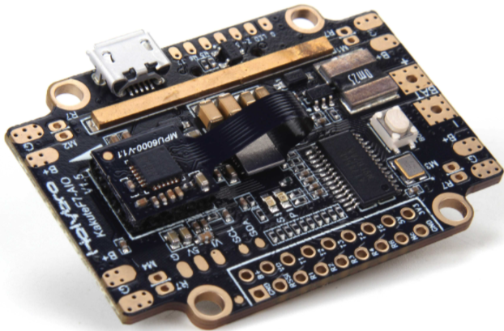

*Figure 1A, Pin MAP of Kakute F7 flight controller [2]*

The Atlatl HV V2 is a video transmitter that will be used on the flight control stack. The HV V2 is a highly customizable board that will allow us to interface effectively with the Kakute F7 and provide video feedback to a ground station. The HV V2 also provides smart audio that has the possibility of being used for additional functionality if digital filtering is possible within the Surveilia project timeline.

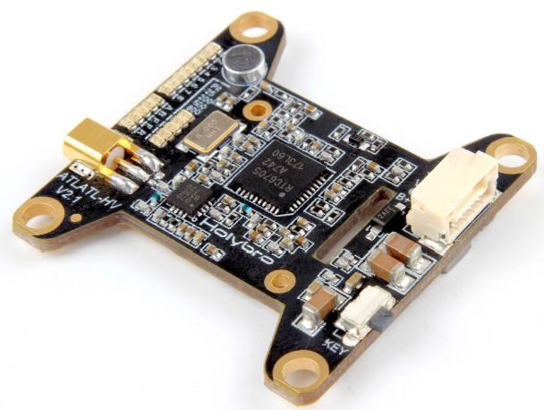

*Figure 2, VTx: Atlatl HV V2 [3]*

FatalIncidentals

Currently, there are limitations to licensing for autonomous vehicles and the limits which certain drones are allowed to fly. Due to the prototyping of Surveilia, we currently could not receive proper licensing and registration to conduct the scope of operations. However, resources would be allocated to reduce weight below 250 grams after a successful prototype to ensure licensing could be bypassed. Should we add something about us getting a license to fly?

***Logistics*** *Materials/parts, suppliers, transportation, storage*

We are 3D printing all of the mechanical parts that make up the frame of the drone. These components are the four arms, the battery container, the four blade-shields, the bottom body, the top body, the body’s standoffs, the camera case, and the housing for the Kakute F7 flight controller. For the initial prototype, we are using polylactic acid (PLA). We are planning on using acrylonitrile butadiene styrene (ABS) or a glycol modified version of polyethylene terephthalate (PETG) for the final version of the drone. We also plan on upgrading the percent infill in the final drone from 20% to 50%. This means that the amount of plastic that will be used inside of the prints will increase by 150%.

The weight differences involved in changing not only the material of the parts but also the density of plastic that is used on the inside of the part can change the overall weight of the drone massively. We can see in the table below that our prototype frame is likely to weigh only half of what our final version will weigh. Because of this, all material/infill changes must go through a brief analysis before they are attempted to be implemented.

|  |  |  |  |
| --- | --- | --- | --- |
| **Material** | **Density [g/cm3]** | **Planned Infill (%)** | **Weight difference from prototype (%)** |
| PLA | 1.24 | 20 | 0 |
| ABS | 1.04 | 50 | +109.7 |
| PETG | 1.27 | 50 | +156.1 |

Our 4 motors, 4 propellers, 6s lipo battery, multifunctional balance charger, 4-in-1 45A ESC, and lipo guard bag were all purchased from [getfpv.com](https://www.getfpv.com/). Because GetFPV operates in the USA and we are located in British Columbia, the shipping of these components took a lot longer than if we were located in the USA. Of these components, they all arrived within 1-3 weeks after ordering. We anticipated this and ordered the parts in July so that we could begin prototyping early to have a good standing before September.

Our main flight controller, the Kakute F7, is going to be ordered from [holybro.com](http://www.holybro.com/). All international orders are expected to arrive within 2-4 weeks of shipping.

Schedule

|  |  |  |  |  |
| --- | --- | --- | --- | --- |
| Quarter | September | October | November | December |
| *1st* | School starts | Configuration and testing | Automation & AI development | System finalization and documentation |
| *2nd* | Logistics and planning | Drone flight testing | Automation & AI development | Finalization of system. Documentation submissions |
| *3rd* | Report submissions and final orders | Drone flight  testing | Automation & AI development, Testing, and Finalizing | Symposium |
| *4th* | Drone body print, assembly | Drone flight testing  Automation & AI development | System tests, reports, finalizations | *----* |

Facilities

Access to Camosun College lab rooms is required. Use of test equipment is needed to test electronics. The labs also have computers with Fusion 360 on them to work on CAD. Soldering stations are also needed to connect all the electrical components together. PCB production will be outsourced to JCLPCB, the design of the PCB will be made using the lab computers. Designated flight areas may be needed as well for testing flight and autopilot.

ManagementandResponsibilities

*Team lead: Chase* is responsible for troubleshooting and support, documentation, and team leadership.

* Troubleshooting includes support to each member in determining why aspects of the project aren’t working and how to fix it. Troubleshooting entails general support.
* Documentation requires overview and re-reading of assignment documents and organization of the GitHub repositories.
* Team leader includes interfacing with faculty

*Hardware: Kaden is responsible for research, hardware design, mounting, schematic and PCB design.*

* *Researching circuits, how hardware interfaces and works so it can be implemented into the project.*
* *All hardware and components need to be mounted to the drone's body. Using Fusion 360 to design mounting hardware.*
* *Designing schematics and placing them onto a PCB.*

*Software: Ethan is responsible for software and integrating the drone data into the user interface.*

* *Exploring different data structures and optimizing the code to be the most efficient as possible.*
* *Implementing the data from the gyro and the gps to properly reflect it’s position and speed for the clients purposes.*
* *Publishing the application to the android and google store for access by any client.*

*Design: Ben is responsible for mechanical design, integrating hardware, and writing low-level software/firmware.*

* *Researching mechanical and thermal concepts to optimize mechanical design.*
* *Developing efficient and convenient designs so that electronics can be easily integrated onboard the drone.*
* *Writing low-level software/firmware for the drone’s primary computer.*

Agreement

The cost is split between Camosun and Surveilia team equitably, with the physical end product being property of Camosun College. All team members are equally participating in the completion of this project. The project will remain open source to future students and security drone enthusiasts. Logistical and technical troubleshooting will be reported through the path of Mel Dundas, who has the highest authority in our group’s dynamic.

Financials

|  |  |
| --- | --- |
| **Component** | **Price (CAD or USD)** |
| GPS estimate | $55.00 CAD |
| PCB estimate | $50.00 CAD |
| Motors (4x) | $70.00 USD |
| Filament estimate | $40.00 CAD |
| Flight Controller Stack | $140.37 CAD |
| Propeller x 4 | $11.96 USD |
| LiPo Battery | $29.99 USD |
| Balance Charger | $39.99 USD |
| 4 Port ESC | $35.99 USD |
| LiPo Charge Bag | $14.99 USD |
| Total Cost: | $544.4 CAD |

Table 1. Cost analysis of drone components

With the primary and more powerful components of Surveilia being the Kakute F7 flight controller, the GPS, and the four Motors, the total price estimate is a reasonable $544.37 CAD. The mechanical aspect of the drone is custom 3D printed using ABS or PETG filament with 50% infill.

Surveilia also cuts down on costs and potential revisions by having a custom drone body and access to multiple 3D printers volunteered by Surveilia members. This is a very important note as the body is the most likely to break on any system failure. Surveilia is able to quickly replace and repair the body at a low cost, so the quoted estimate is likely to not change.

The evaluated component costs are covered by two parties. Camosun College provides a minimum $250 with a cost difference split between the 4 members of Surveilia. Each member of Surveilia will contribute $71.01 to the projects.

Conclusion

Ultimately, our drone has one purpose, to act as an automated security aid for our clients property. Through the use of the F7 Flight Controller Module, which sends the direction and data for our drone’s flight path, which interfaces with the rest of the hardware, including the ESC for distributing power to the motors, GPS for determining the location and where it should travel to, and the VTX video transmitter for viewing, recording, and gathering data footage, we are able to fly the drone, view video feed, and follow the path set out by the client. With a base of electronic components fit for our purpose, and a user interface that allows the client to monitor and control the intended flight paths, we have produced a beneficial option for security to rural clients who trust in a future fueled by automation.

*Appendices*

* [*Holybro_Kakute_F7_V1.5_Manual.pdf*](http://www.holybro.com/manual/Holybro_Kakute_F7_V1.5_Manual.pdf)
* [*Holybro-Atlatl-HV-v2-Manual.pdf*](http://www.holybro.com/manual/Holybro-Atlatl-HV-v2-Manual.pdf)
* Include 1-3 in your project proposal. (i.e. Drawings, timetables, calculations). Format the graphics appropriately.

<https://tc.canada.ca/en/aviation/drone-safety/drone-pilot-licensing/take-drone-pilot-online-exam-small-basic-exam>

References:

* [1] Paladin Security wages by province: [Security Guard Salary in Canada by Province in 2021 (paladinsecurity.com)](https://paladinsecurity.com/security-careers/security-guard-salary/)
* [2]
* [3] Atlatl HV V2 image, [Holybro-Atlatl-HV-v2-Manual.pdf](http://www.holybro.com/manual/Holybro-Atlatl-HV-v2-Manual.pdf)

