9/24/2021

Surveilia Proposal

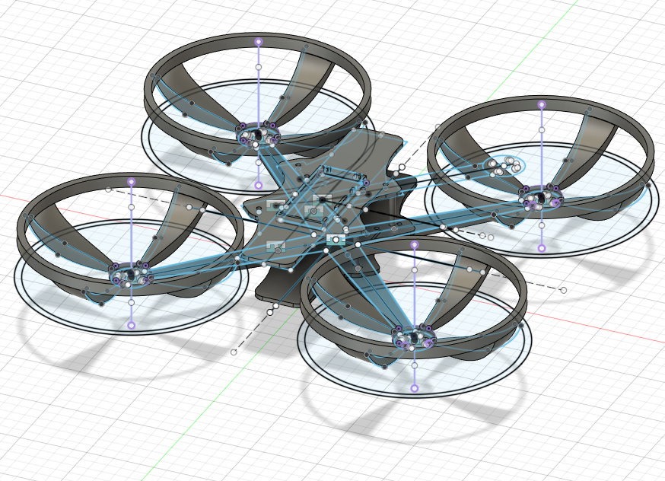

Ben Kennedy, Chase Westlake, Ethan Pyle, Kaden Taylor

Camosun College

Memorandum

To: Kimberly Lemieux

CC: ECET Stakeholders

From: Surveilia Capstone Team

Date: September 24, 2021

Re: Surveilia Capstone Proposal

Summary

Surveilia is an autonomous drone that patrols areas on a designated flight path, using ArduPilot software. It is meant to replace or enhance characteristics of security guards and security cameras. Guards can cost between $10,342.08 and $18,144 per month, whereas Surveilia is a onetime $600 fee.

Surveilia can be properly prototyped with a strong baseline of functionality by mid-December. System functionality includes autonomous flight, easy-to-use interface, and human recognition for security alerts.

Development is currently in initial stages and ready for your approval to enter a full production cycle.

Background

Surveilia is an autonomous security drone which can replace or enhance the capabilities of physical and remote security by

* Conducting autonomous and configurable patrols
* Reporting human activity
* Displaying video feed for roaming surveillance

All flight activity is logged and data will be sent to a visual interface running on a user's computer.

Although static cameras and patrolling guards can significantly contribute to security of a site, there are limitations. Cameras are positioned statically and physical guards can become fatigued and miss crucial details in reports or risk assessments. Both can cost quite a bit of money. Surveilia is a onetime cost, can’t fatigue or miss detail and provides the best of both static cameras and physical guards.

Technical

Security Market

Security is a highly productive industry that is currently facing high demand and low supply. In theory, Surveilia should be able to augment or replace residential and commercial security contracts.

Guards can also come with a heavy cost on the client as most physical security is contractual and fulfilled by third parties. 24-hour security can generate monthly wage costs (before third party fees), between $10,342.08 and $18,144 [1]. Static security cameras, although cost effective relative to guards, cannot provide wide range of observation.

|  |  |  |
| --- | --- | --- |
| **Camera** | **Guard** | **Surveilia** |
| $80 - $2000 per camera without installation | $10,342 - $18,144 per month | $600 onetime fee |

Capabilities

Surveilia will be able to

* Maneuver in a 3D path autonomously
* Log and send alerts when a person is encountered within flight path area
* Feed flight information to a windows application for user viewing

Surveilia as a prototype is not planned to have robust artificial intelligence capabilities. Meaning, it will not be able to conduct facial recognition and access criminal databases, or do advanced suspicious activities routines. Surveilia is intended to be a roaming alert system.

Testing Procedures

Rigorous testing will be conducted to ensure each of these requirements are met.

The most important test is of the drone flight control system. It will be verified to have stability in multiple experiments beginning with a work bench demonstration followed by flight tests. Automated flight is also considered to be hazardous in testing, and will only be conducted in a strict flight path with limited objects and humans. Only the Surveilia team with proper PPE will be present.

All subsequent tests are considered safe, and will be solely data driven.

Administrative

Schedule

|  |  |  |  |  |
| --- | --- | --- | --- | --- |
| Quarter | September | October | November | December |
| *1st* | School starts | Configuration and testing | Automation & AI development | System finalization and documentation |
| *2nd* | Logistics and planning | Drone flight testing | Automation & AI development | Finalization of system. Documentation submissions |
| *3rd* | Report submissions and final orders | Drone flight  testing | Automation & AI development, Testing, and Finalizing | Symposium |
| *4th* | Drone body print, assembly | Drone flight testing  Automation & AI development | System tests, reports, finalizations | *----* |

*\* Graphical User Interface (GUI) development will be on going throughout the production cycle.*

Tasks

The drone body has been completed, and the GUI has begun production. Next steps involve the arrival of the flight controller. In the meantime, firmware will begin development, motors will begin testing, and the drone body will begin assembly.

Upon arrival of the flight controller, testing in the form of “hello world” applications will be used for familiarity and ensure the control system works.

|  |  |  |
| --- | --- | --- |
| Hardware | Software | Firmware |
| *Drone Body manufacturing* | *GUI Design* | *Implementation of ArduPilot* |
| *Drone assembly* | *Drone data collection* | *Implementation of camera* |
| *PCB design* | *Drone Video connection* | *AI for human recognition* |
| *Flight controller configuration* | *AI for human recognition* | *Motor controls* |

Components

The drone consists of the physical body, GPS, flight controller, video transmitter, motors, propellers, Electronic Speed Controller (ESC), camera, and LiPo battery.

The Kakute F7 flight controller operates on an STM32F745 32-bit processor. It will be serving as the brain of the drone for all flight-related tasks. It has a serial port for the GPS which is required for autonomous functionality. It also has an ICM20689 IMU 6-axis device that combines a 3-axis gyroscope and 3-axis accelerometer into one package.

The accelerometer and gyroscope are required to feed values related to the drone’s position in 3D space (XYZ) to the drone’s proportional-integral-derivative (PID) controller. The Pulse Width Modulation (PWM) outputs are marked M1-M4 which are required to control the motors.

ArduPilot, an open-source autopilot software, will be the software used to perform the autonomous functionality required of Surveilia. ArduPilot will allow us to fully utilize tools that are available on the Kukate F7 such as power and battery monitoring, PID tuning, RF receiver settings, and more.

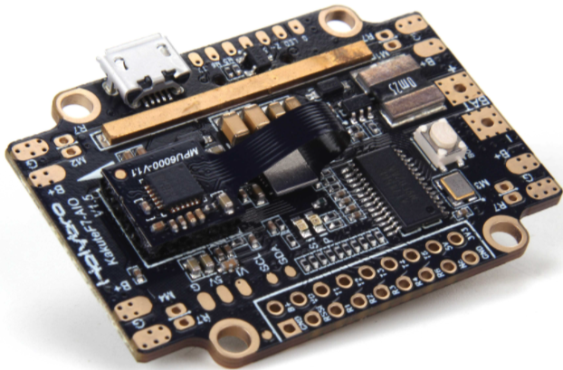

*Kakute F7 flight controller [2]*

The Atlatl HV V2 is a video transmitter that will be used on the flight control stack. The HV V2 is a highly customizable board that will allow us to interface effectively with the Kakute F7 and provide video feedback to a ground station. The HV V2 also provides smart audio that can be used for digital filtering.

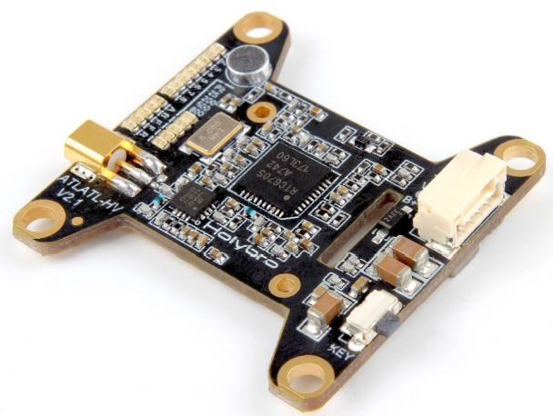

*VTx: Atlatl HV V2 [3]*

Legal and Safety

Currently, there are limitations to licensing for autonomous vehicles and there are municipal limits setting boundaries for drone flight. Surveilia will be acquiring licensing and registration and operate within the law by constructing manual interrupts to provide testing operators complete control of the system.

Logistics

The drone body will be constructed by in house 3D printing. For the initial prototype, we are using polylactic acid (PLA). After construction criteria is met a reprint will be done in acrylonitrile butadiene styrene (ABS). PLA will be substantially lighter (20% infill) to avoid excess cost and time consumption, as opposed to the 50% infill of our final ABS body.

The table below shows the prototype frame is likely to weigh only half of what the final version will weigh. Because of this, all material/infill changes must go through a brief analysis before they are attempted to be implemented.

|  |  |  |  |
| --- | --- | --- | --- |
| **Material** | **Density [g/cm3]** | **Planned Infill (%)** | **Weight difference from prototype (%)** |
| PLA | 1.24 | 20 | 0 |
| ABS | 1.04 | 50 | +109.7 |
| PETG | 1.27 | 50 | +156.1 |

Facilities

Access to Camosun College lab rooms is required. Use of test equipment is needed to test electronics. The labs have computers with crucial software for product development and soldering stations for all electrical component connections.

Printed Circuit Board (PCB) production will be outsourced to JLCPCB. PCB design will be conducted on Camosun lab computers or at home using Altium Designer Student Licensing.

Designated flight areas may be needed for flight and autopilot testing.

Roles & Responsibilities

**Team lead***:* Chaseis responsible for troubleshooting and support, documentation, and team leadership.

* Troubleshooting includes support to each member in determining why aspects of the project aren’t working and how to fix it and general technical support.
* Documentation, proof reading, and organization of the GitHub repositories.
* Planning activities and interfacing with faculty

**Hardware***:* Kadenis responsible for research, hardware design, mounting, schematic and PCB design.

* Circuit research, how hardware interfaces and works so it can be implemented into the project.
* All hardware and components need to be mounted to the drone's body. Using Fusion 360 to design mounting hardware to be implanted on the body.
* Designing schematics and placing them onto a PCB.

**Software***:* Ethan is responsible for software and integrating the drone data into the user interface.

* Code optimization
* Logging flight data
* GUI design and development

**Design***:* Ben is responsible for mechanical and electrical design

* Researching mechanical and thermal concepts to optimize mechanical design.
* Developing efficient and convenient designs so that electronics can be easily integrated onboard the drone.
* Writing low-level software/firmware for the drone’s primary computer.

Financial

Agreement

The cost is split between Camosun and Surveilia team equitably, with the physical end product being property of Camosun College. All team members are equally participating in the completion of this project. Logistical and technical troubleshooting will be reported to Mel Dundas or another relevant faculty member. Camosun College provides a minimum $250 with a cost difference split between the 4 members of Surveilia. Each member of Surveilia will contribute $71.01 to the project.

Cost

|  |  |
| --- | --- |
| **Component** | **Price (CAD or USD)** |
| GPS estimate | $55.00 CAD |
| PCB estimate | $50.00 CAD |
| Motors (4x) | $70.00 USD |
| Filament estimate | $40.00 CAD |
| Flight Controller Stack | $140.37 CAD |
| Propeller x 4 | $11.96 USD |
| LiPo Battery | $29.99 USD |
| Balance Charger | $39.99 USD |
| 4 Port ESC | $35.99 USD |
| LiPo Charge Bag | $14.99 USD |
| Total Cost: | $544.40 CAD |

Conclusion

Ultimately, our drone has one purpose, to act as an automated security aid for our client’s property. Through the use of the F7 Flight Controller Module, which sends the direction and data for our drone’s flight path, which interfaces with the rest of the hardware, including the ESC for distributing power to the motors, GPS for determining the location and where it should travel to, and the VTX video transmitter for viewing, recording, and gathering data footage, we are able to fly the drone, view video feed, and follow the path set out by the client. With a base of electronic components fit for our purpose, and a user interface that allows the client to monitor and control the intended flight paths, we have produced a beneficial option for security to rural clients who trust in a future fueled by automation.

* [*Holybro-Atlatl-HV-v2-Manual.pdf*](http://www.holybro.com/manual/Holybro-Atlatl-HV-v2-Manual.pdf)
* Include 1-3 in your project proposal. (i.e. Drawings, timetables, calculations). Format the graphics appropriately.

*Appendices Need three. Consider a screen shot of licensing, ArduPilot mission planner, and something else?*

This in the appendix<https://tc.canada.ca/en/aviation/drone-safety/drone-pilot-licensing/take-drone-pilot-online-exam-small-basic-exam>

References:

* [1] Paladin Security wages by province: [Security Guard Salary in Canada by Province in 2021 (paladinsecurity.com)](https://paladinsecurity.com/security-careers/security-guard-salary/)
* [2] [*Holybro_Kakute_F7_V1.5_Manual.pdf*](http://www.holybro.com/manual/Holybro_Kakute_F7_V1.5_Manual.pdf)
* [3] Atlatl HV V2 image, [Holybro-Atlatl-HV-v2-Manual.pdf](http://www.holybro.com/manual/Holybro-Atlatl-HV-v2-Manual.pdf)