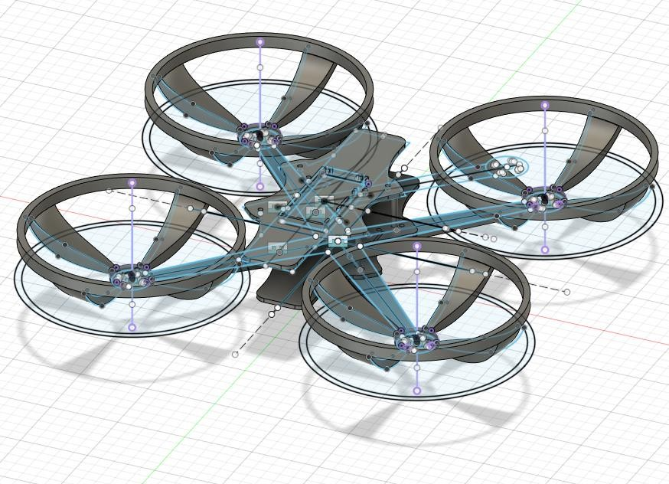

9/24/2021

SURVEILIA PROPOSAL

Ben Kennedy, Chase Westlake, Ethan Pyle, Kaden Taylor

CAMOSUN COLLEGE

**Memorandum**

**To**: Kimberly Lemieux

**CC**: ECET Stakeholders

**From**: Surveilia Capstone Team

**Date**: September 24, 2021

**Re**: Surveilia Capstone Proposal

**SUMMARY**

Surveilia is an autonomous drone that patrols areas on designated flight paths, using ArduPilot software for automation. It is meant to replace or enhance characteristics of security guards and security cameras, by combining attributes. Surveilia will be configured by the user to conduct patrols on a pre-determined basis and will update the flight data in real time to provide operators quick information to understand the condition of their site or residence.

Surveilia can be properly prototyped with a strong baseline of functionality by mid- December. System functionality includes configurable autonomous flight, easy-to-use interface, and human recognition for security alerts.

Development is currently in initial stages and ready for your approval to enter a full production cycle.

**BACKGROUND**

Security is a highly productive industry that is currently facing high demand and low supply. Surveilia should be able to augment or replace residential and commercial security contracts. The drone will address labor demand in the security industry by providing functionality such as:

* autonomous and configurable patrols
* reporting human activity
* displaying video feed for roaming surveillance

Surveilia also address some limitations of current commercially available solutions. Security cameras are positioned statically and cover a single line of sight, and guards can become fatigued and miss crucial details in reports or risk assessments. Both solutions have a high-cost association, whereas Surveilia is a onetime cost, can’t fatigue

or miss detail and provides mixed characteristics of both static cameras and physical guards.

# TECHNICAL

**SECURITY MARKET**

Guards are quite expensive for client, as most physical security is contractual and fulfilled by third parties. 24-hour security can generate monthly wage costs (before third party fees), between $10,342.08 and $18,144 [1]. Static security cameras, although cost effective relative to guards, cannot provide wide range of observation. Cameras can still be quite expensive and vary in price based on the type of camera installed [2].

|  |  |  |
| --- | --- | --- |
| **Camera** | **Guard** | **Surveilia** |
| $125 - $450 per camera  $500 - $1600 for 4 CCTV  cameras | $10,342 - $18,144 per  month | $600 onetime fee |

*Figure 1. Table outlining costs of Surveilia relative to other services available.*

**CAPABILITIES AND LIMITATIONS**

Surveilia will be able to

* maneuver in a 3D path autonomously
* log and send alerts when a person is encountered within flight path area
* feed flight information to a windows application for user viewing

The premise of Surveilia is intended to be a roaming alert and record keeping system as such, a Surveilia prototype is not planned to have robust artificial intelligence capabilities. Meaning, it will not be able to conduct facial recognition and access criminal databases or conduct advance suspicious activities routines.

**TESTING PROCEDURES**

Rigorous testing will be conducted to ensure each of these requirements are met.

The most important test is of the drone flight control system. It will be verified to have stability in multiple experiments beginning with a work bench demonstration followed by flight tests. Automated flight is also considered to be hazardous in testing and will only be conducted in a strict flight path with limited objects and humans. Only the Surveilia team with proper PPE will be present.

All subsequent tests are considered safe and will be solely data driven.

**TASKS**

*Hardware:* The Surveilia team was proactive in part selection during the summer months to avoid potentially long wait times from the U.S. All hardware, with the exception of the flight controller, has been received and is under going testing.

*Firmware:* Development will begin Saturday September 25th, 2021.

*Software:* Software is in developed for GUI functionality, and functionality is being developed to accept data from the drone during flight routines.

|  |  |  |
| --- | --- | --- |
| Hardware | Software | Firmware |
| *Drone Body manufacturing* | *GUI Design* | *Implementation of ArduPilot* |
| *Drone assembly* | *Drone data collection* | *Implementation of camera* |
| *PCB design* | *Drone Video connection* | *AI for human recognition* |
| *Flight controller configuration* | *AI for human recognition* | *Motor controls* |

*Figure 3. Overview of some hardware, software, and firmware components*

**COMPONENTS**

The drone consists of the physical body, GPS, flight controller, video transmitter, motors, propellers, Electronic Speed Controller (ESC), camera, and LiPo battery.

The Kakute F7 flight controller operates on an STM32F745 32-bit processor. It will be serving as the brain of the drone for all flight-related tasks. It has a serial port for the GPS which is required for autonomous functionality. It also has an ICM20689 IMU 6- axis device that combines a 3-axis gyroscope and 3-axis accelerometer into one package [3].

The accelerometer and gyroscope are required to feed values related to the drone’s position in 3D space (XYZ) to the drone’s proportional-integral-derivative (PID) controller. The Pulse Width Modulation (PWM) outputs are marked M1-M4 which are required to control the motors.

ArduPilot, an open-source autopilot software, will be the software used to perform the autonomous functionality required of Surveilia. ArduPilot will allow us to fully utilize tools that are available on the Kakute F7 such as power and battery monitoring, PID tuning, RF receiver settings, and more.

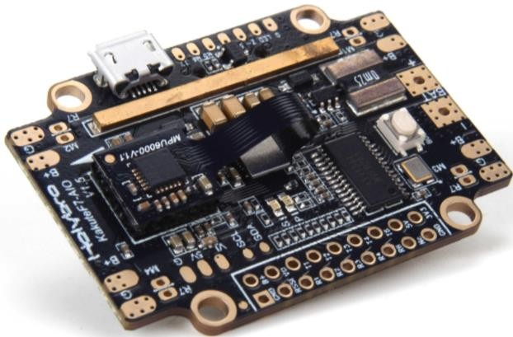

*Figure 4. Kakute F7 flight controller [3]*

The Atlatl HV V2 is a video transmitter that will be used on the flight control stack. The HV V2 is a highly customizable board that will allow us to interface effectively with the Kakute F7 and provide video feedback to a ground station. The HV V2 also provides smart audio that can be used for digital filtering [4].

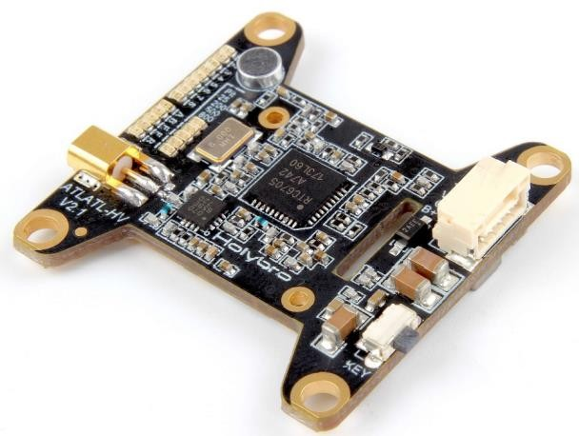

*Figure 5. VTx: Atlatl HV V2 [4]*

# ADMINISTRATIVE

**SCHEDULE**

|  |  |  |  |  |
| --- | --- | --- | --- | --- |
| Quarter | September | October | November | December |
| *1st* | School starts | Configuration, construction and testing | Automation & AI development | System finalization and documentation |
| *2nd* | Logistics and planning | Drone build flight testing | Automation & AI development | Finalization of system.  Documentation submissions |
| *3rd* | Report submissions and final orders | Drone flight testing | Automation & AI  development, Testing, and Finalizing | Symposium |
| *4th* | Drone body print, assembly | Drone flight testing  Automation & AI development | System tests, reports, finalizations | *----* |

*Figure 2. General Schedule for development*

*\* Graphical User Interface (GUI) development will be on going throughout the production cycle.*

**LEGAL AND SAFETY**

Currently, there are limitations to licensing for autonomous vehicles and there are municipal limits setting boundaries for drone flight. Surveilia will be acquiring licensing and registration and operate within the law by constructing manual interrupts to provide testing operators complete control of the system.

**LOGISTICS**

The drone body will be constructed by in house 3D printing. For the initial prototype, we are using polylactic acid (PLA). After construction criteria is met a reprint will be done in acrylonitrile butadiene styrene (ABS). PLA will be substantially lighter (20% infill) to avoid excess cost and time consumption, as opposed to the 50% infill of our final ABS body [5].

The table below shows the prototype frame is likely to weigh only half of what the final version will weigh. Because of this, all material/infill changes must go through a brief analysis before they are attempted to be implemented.

|  |  |  |  |
| --- | --- | --- | --- |
| **Material** | **Density [g/cm3]** | **Planned Infill (%)** | **Weight difference from prototype (%)** |
| PLA | 1.24 | 20 | 0 |
| ABS | 1.04 | 50 | +109.7 |
| PETG | 1.27 | 50 | +156.1 |

*Figure 6. 3D printer filament specifications for weight and density based on infill for drone body*

**FACILITIES**

Access to Camosun College lab rooms is required. Use of test equipment is needed to test electronics. The labs have computers with crucial software for product development and soldering stations for all electrical component connections.

Printed Circuit Board (PCB) production will be outsourced to JLCPCB. PCB design will be conducted on Camosun lab computers or at home using Altium Designer Student Licensing.

Designated flight areas may be needed for flight and autopilot testing.

**ROLES & RESPONSIBILITIES**

**Team lead***:* Chase is responsible for troubleshooting and support, documentation, and team leadership.

* Troubleshooting includes support to each member in determining why aspects of the project aren’t working and how to fix it and general technical support.
* Documentation, proof reading, and organization of the GitHub repositories.
* Planning activities and interfacing with faculty

**Hardware***:* Kaden is responsible for research, hardware design, mounting, schematic and PCB design.

* Circuit research, how hardware interfaces and works so it can be implemented into the project.
* All hardware and components need to be mounted to the drone's body. Using Fusion 360 to design mounting hardware to be implanted on the body.
* Designing schematics and placing them onto a PCB.

**Software***:* Ethan is responsible for software and integrating the drone data into the user interface.

* Code optimization
* Logging flight data
* GUI design and development

**Design***:* Ben is responsible for mechanical and electrical design

* Researching mechanical and thermal concepts to optimize mechanical design.
* Developing efficient and convenient designs so that electronics can be easily integrated onboard the drone.
* Writing low-level software/firmware for the drone’s primary computer.

**FINANCIAL AGREEMENT**

The cost is split between Camosun and Surveilia team equitably, with the physical end product being property of Camosun College. All team members are equally participating in the completion of this project. Logistical and technical troubleshooting will be reported to Mel Dundas or another relevant faculty member. Camosun College provides a

minimum $250 with a cost difference split between the 4 members of Surveilia. Each member of Surveilia will contribute $71.01 to the project.

**COST**

|  |  |
| --- | --- |
| **Component** | **Price (CAD or USD)** |
| GPS estimate | $55.00 CAD |
| PCB estimate | $50.00 CAD |
| Motors (4x) | $70.00 USD |
| Filament estimate | $40.00 CAD |
| Flight Controller Stack | $140.37 CAD |
| Propeller x 4 | $11.96 USD |
| LiPo Battery | $29.99 USD |
| Balance Charger | $39.99 USD |
| 4 Port ESC | $35.99 USD |
| LiPo Charge Bag | $14.99 USD |
| Total Cost: | $544.40 CAD |

*Figure 7. Cost analysis of critical drone components*

**CONCLUSION**

Surveilia is an automated security drone that has the potential to strengthen or possibly even replace some security systems altogether. A security guard can cost anywhere between

$10,000-$18,000 CAD per month while also having a limited ability to patrol effectively caused by human restraints such as time, physical range, and fatigue.

Surveilia is an inexpensive alternative or additive to a security team, costing only $600 CAD while having the capability to patrol between posts 24/7. With the ability to conduct autonomous patrols, report unwanted activity, and display an active and live video feed.

Early development has begun, and with your approval, the product prototype can be finished by mid-December.

**APPENDIX A**

This map from Transport Canada displays air space regulations and classification of regulation. Camosun falls within legal air space under Class F (500 ft limit) and Class CZ (2500 ft limit) airspace [6]. Autonomous testing is likely to take place is rural areas outside of the Victoria region

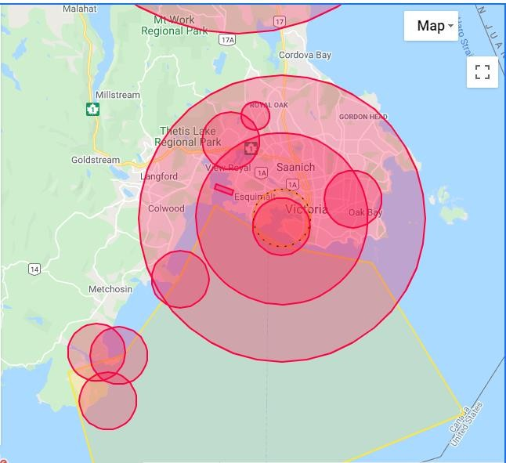

**APPENDIX B**

ArduPilot mission planner is going to be a critical component of our ArduPilot integration to allow the Surveilia to operate autonomously. Mission planner is a software suite of ArduPilot that provides a plottable path with various checkpoints [7].

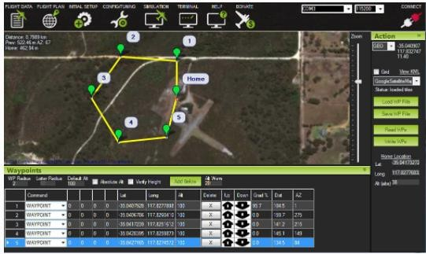

**APPENDIX C**

This is the fully assembled drone in Fusion360. In practice, each part of the drone will be printed and then assembled to create the final assembly. The estimated time to print is about 120 hours because of the density required. The printing will be choreographed between two printers belonging to members of the team to maximize efficiency.

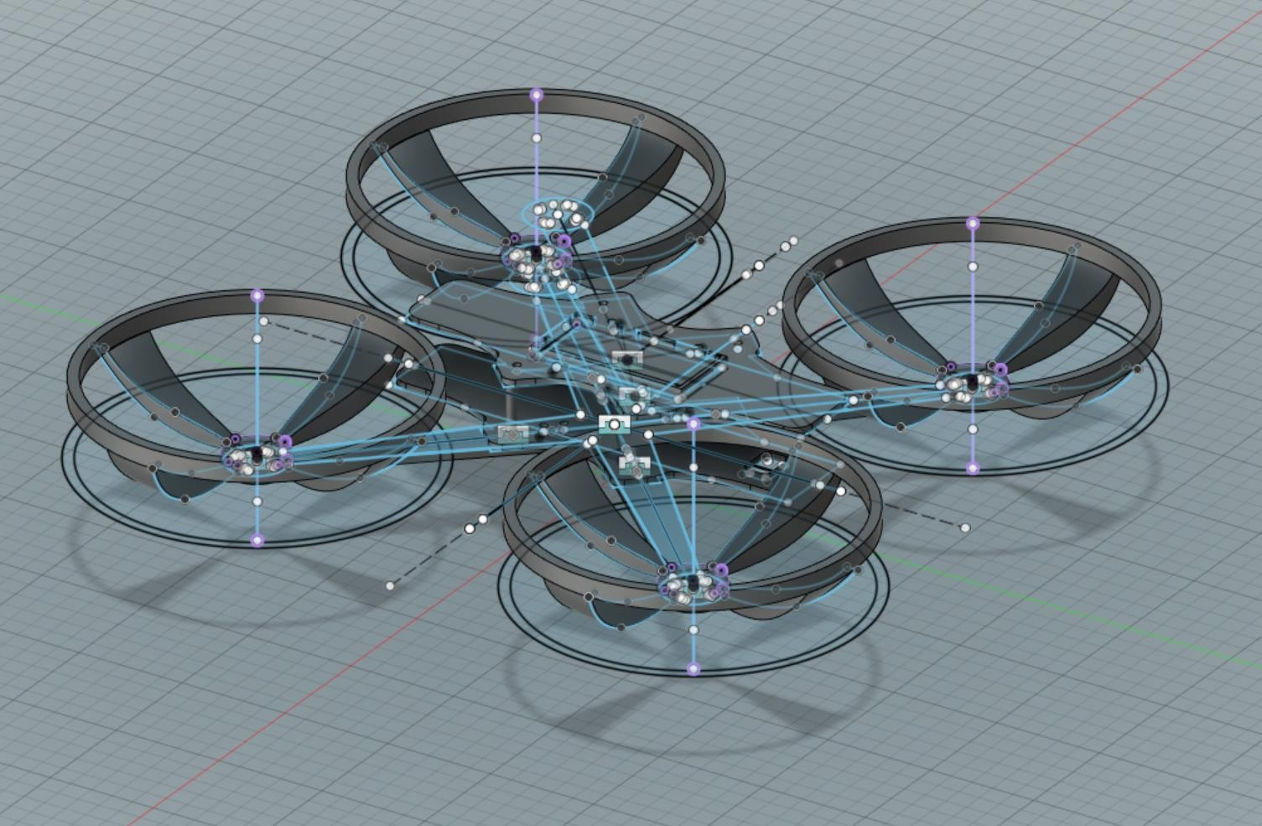

**REFERENCES**

1. “Security guard salary in Canada by province in 2021,” *Paladin Security*, 14-Nov-2020. [Online]. Available: https://paladinsecurity.com/security-careers/security-guard-salary/. [Accessed: 16-Sep-2021].
2. “2021 Security Camera Installation Cost | CCTV Surveillance System,” *HomeGuide*. [online]. https://homeguide.com/costs/security-camera-installation-cost. [Accessed: 20-Sep-2021.]
3. Holybro, “Kakute F7 V1.5 Specification Sheet.” [Online]. Available: <http://www.holybro.com/product/kakute-f7-v1-5/>
4. Holybro, “Atlatl Hv V2 5.8G FPV Video Transmitter” [Online]. Available: <http://www.holybro.com/product/atlatl-hv-v2/>
5. R. French, “The densities of all 3D printing materials,” *Bitfab*, Nov. 26, 2019. [online]. https://bitfab.io/blog/3d-printing-materials-densities. [Accessed: 19-Sep-2021].
6. Government of Canada, “Drone site selection tool | National Research Council

Canada,” *nrc.canada.ca*, Jul. 17, 2015. [online]. https://nrc.canada.ca/en/drone-tool/. [Accessed: 20-Sep-2021].

1. *“ArduPilot Mission Planner Home”, ardupilot.org*. [Online]. Available: https://ardupilot.org/planner. [Accessed*:* 16-Sep-2021].