9/15/2021

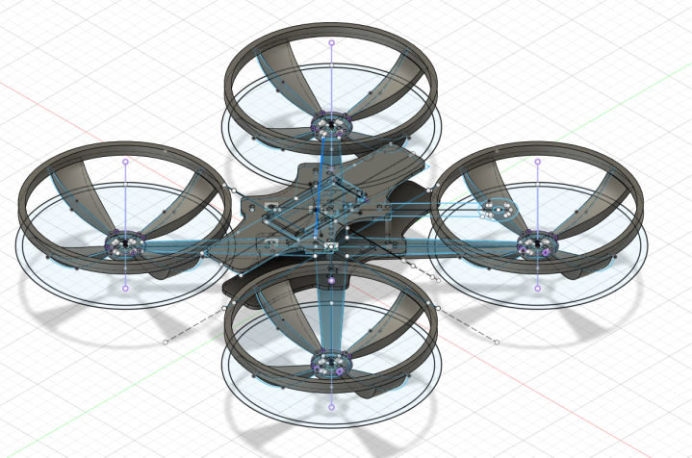

Ben Kennedy, Chase Westlake, Ethan Pyle, Kaden Taylor

Camosun College

Surveilia Requirements

|  |  |  |  |  |
| --- | --- | --- | --- | --- |
| **Reference #** | **Requirement** | **Test** | **Pass/Fail Criteria** | **Criteria Met** |
| 001 | *Drone has stable flight* | PID testing station, on a teetering wedge | *Pass if motors align parallel with workbench* | Pass / Fail |
| 002 | *Must fly in a 3D space autonomously* | *Create a boundary in the system, drone must fly randomly with control* | *Pass if drone moves in boundary with no conditioning* | Pass / Fail |
| 003 | *Must send flight data to remote console* | *Drone sends test data to GUI.* | *Pass if GUI receives 90% of data at 30 meters from router* | Pass / Fail |
| 004 | *Must recognize a human* | *Camera is pointed at random objects and humans* | *Pass if alert is created from viewing humans with 90% accuracy* | Pass / Fail |
| 005 | *Must have configurable instructions through a remote console* | *GUI must send test data to drone* | *Pass if drone receives 90% of data at 30 meters from router* | Pass / Fail |
| 006 | *Must have a plottable flight path* | *Create flight path with ArduPilot and waypoints* | *Pass if drone collects 100% of waypoints* | Pass / Fail |
| 007 | *Must go idle if outside of control range* | *Send drone outside of boundary* | *Pass if drone pauses all processes and hovers indefinitely* | Pass / Fail |
| 008 | *Must have automatic initialization* | *Initialize functions on startup* | *Pass if startup procedure is followed* | Pass / Fail |
| 009 | *Must have manual interrupt of tasks* | *Interrupt automated flight path with command* | *Pass if tasks are paused after interrupt* | Pass / Fail |
| 010 | *Must have battery efficiency* | *Drone is in a hover with all peripherals active* | *Pass if hovers for 59 minutes without recharging* | Pass / Fail |
| 011 | *Must have auto-home* | *Drone hovers off of pad and is ordered to home* | *Pass if drone lands back at designated home when commanded* | Pass / Fail |