9/13/2021

Surveilia Scope

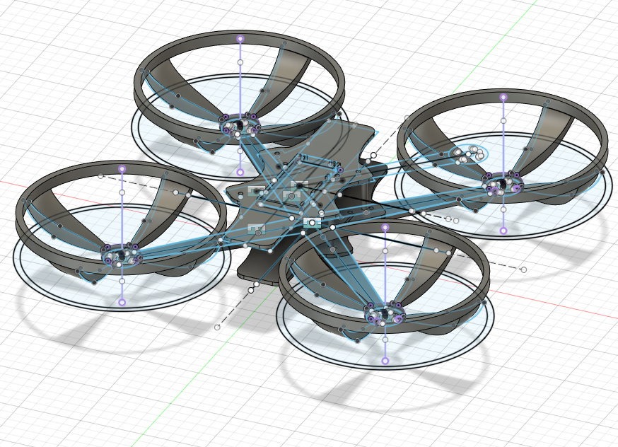

Ben Kennedy, Chase Westlake, Ethan Pyle, Kaden Taylor

Camosun College

Concept

Surveilia is an autonomous security drone, powered by a Raspberry Pi Zero W.

Intent

Surveilia is a security drone designed to do autonomous patrols in designated areas or routes. The drone could be used to replace or augment physical security with automation. The drone is capable of night vision, allowing it to operate 24 hours a day. Application software allows the user to easily schedule tasks and generate customized settings for preferred behavior.

Requirements

The drone must be able to;

* Maneuver in a 3D geometric path
* Log when a person is encountered in the designated flight path
* Feed flight information (flight data, human encounters, video feed) back to an interface.

ProductLimits

Surveilia will encounter commercial issues regarding licensing if it can be considered a viable product. Drones require licensing after 249 grams in weight. The current prototype exceeds this weight. There will also be liability and licensing concerns with an automated product.

There are mapping concerns for automated paths of flight. Decisions would have to be made at earlier stages on how the drone will navigate routes. In a retail or wholesale environment, technicians would need to be considered for personalized configuration for proper operation in a security setting. The mapping problem could be solved with extra R&D for mapping software.

Sensors are a serious problem in autopiloting operations. Ultrasonic transducers are a likely solution to some roaming issues. However, the number of displacement sensors required for reliable automation could exceed current or voltage limits and add complexity that may not be realistic for this prototype. Our current intent is to use several ultrasonic transducers and strict flight paths for landing, lifting, and strict pathfinding.

Optional Applications

* Autonomously track a GPS plotted layout and then return to home after being traced.
* The drone can charge itself without a human needing to plug the drone in.
* Send a video feed or notification to a user's phone.
* Night time flight and human detection.
* Autonomous route design.

While our ideal goal is to have the drone be completely finished, meaning that the drone would be capable of following complex property routes and add on capabilities, realistically our drone will be more in the prototype phase. However, this does not mean that it will not be capable of flight and basic routes.

Finance

|  |  |
| --- | --- |
| **Component** | **Price (CAD or USD)** |
| GPS estimate | $75.00 CAD |
| PCB estimate | $65.00 CAD |
| Motors (4x) | $70.00 USD |
| Filament estimate | $40.00 CAD |
| Pi Zero & Peripherals | $105.85 CAD |
| Propeller x 4 | $2.99 USD |
| LiPo Battery | $29.99 USD |
| Balance Charger | $39.99 USD |
| 4 Port ESC | $35.99 USD |
| LiPo Charge Bag | $14.99 USD |
| Accelerometer Gyroscope | $12.98 CAD |
| Total Cost CAD: | $652.2 |

*\* Estimates must be updated*

Scope

The drone proposed for property security. At the end of the project, it will not be capable of performing the ideal roving patrols around property. However, the drone will be capable of performing autonomous behavior within a well-defined set of geometric, 3D areas.

The drone will be capable of feeding flight data back with a video stream.

The drone will be capable of recognizing when a human is within its area and send a notification to the user.

The drone will not be capable of substantial manual flight.

The drone will not be capable of long-range RF.

The Surveilia team will develop the GUI, control system, drone body, and flight software

The Surveilia team will purchase all specialized sensors and peripherals outside of the scope unspecified under team development.

The Surveilia team will use libraries for automation on the Raspberry Pi Zero W. The team will utilize tools already created to interface with the drone.

Stakeholders

Alan Duncan – Chair of Electronics and Computer Engineering

Kim Lemieux – English instructor

Mel Dundas – Project coordinator

Surveilia Team – Design team