Meta Cognitive Temperature Regulation for Transformer Architecture

SurweeshSP
231501165@rajalakshmi.edu.in
Department of Artificial Intelligence and Machine Learning
Sangeetha K
@rajalakshmi.edu.in
Department of Artificial Intelligence and Machine Learning

Abstract
Large language models (LLMs) generate predictions through high-dimensional probabilistic inference, yet conventional Transformer architectures do not explicitly represent or utilize a structured description of their own evolving inferential condition. Existing approaches to model uncertainty primarily estimate confidence or entropy, while test-time reasoning methods such as self-consistency and iterative self-refinement generally modify generation through additional sampling or explicit textual feedback. These approaches provide useful mechanisms for reliability estimation and inference refinement, but they do not directly establish a closed-loop mechanism in which a model observes its internal inferential state and uses that state to regulate subsequent computation.
This work introduces Meta-Cognitive Transformer Regulation (MCTR), a computational framework for second-order inference in which a Transformer first produces an object-level prediction, constructs a structured inferential state, evaluates that state through a learned meta-cognitive evaluator, and subsequently regulates its inference process. Phase 1 focuses on the first closed-loop control mechanism: adaptive temperature regulation. The proposed meta-state is represented as
Ψ_t = [C_t, U_t, N_t, K_t, S_t, Ĥ_t]
where C_t denotes predictive confidence, U_t uncertainty, N_t representational novelty, K_t inferential conflict, S_t state stability, and Ĥ_t normalized predictive entropy. A meta-evaluator M_φ maps this state into a higher-order representation, which is subsequently used by a temperature controller to determine the sampling temperature for the next inference step.
The Phase 1 implementation uses a frozen Qwen2.5-0.5B-Instruct backbone and evaluates fixed-temperature and dynamically regulated inference on mathematical and reasoning benchmarks. Initial experiments demonstrate that the extracted state variables exhibit measurable differences between correct and incorrect predictions, while the MCTR controller produces non-constant temperature trajectories and a measurable relationship between temperature and predictive entropy. Preliminary baseline comparisons also indicate differences in task accuracy and calibration between regulated and non-regulated inference. However, the current experimental artifacts reveal inconsistencies between some aggregate result tables and plotted baseline results; therefore, these results are treated as preliminary implementation evidence rather than final statistical claims. A larger, leakage-safe, paired evaluation with a fixed sample and one-seed controlled protocol is required before definitive performance conclusions can be made.
The Phase 1 contribution is therefore the establishment and experimental validation of a computational architecture for measuring an evolving inferential condition and feeding that condition back into subsequent generation. The work provides the foundation for later extensions involving adaptive attention, state-dependent computation, and more general meta-cognitive control.
Key words — Meta-cognition, Transformer, uncertainty estimation, confidence calibration, adaptive inference, temperature regulation, predictive entropy, second-order inference, test-time control, large language models.

I. Introduction
Transformer-based language models have established a powerful paradigm for sequence modeling in which a neural network transforms an input sequence into a probability distribution over subsequent tokens. Modern models can perform mathematical reasoning, code generation, planning, question answering, and other complex tasks through increasingly sophisticated learned representations.
Despite this progress, conventional Transformer inference remains fundamentally first-order in its computational organization. The model computes an internal representation and produces a prediction, but the architecture does not explicitly maintain a structured representation of the question:
"What is the current condition of the inference process itself?"
A model can have high confidence, high uncertainty, substantial representational novelty, conflicting internal predictions, or an unstable trajectory across successive inference states. These properties are partially observable through model probabilities and hidden representations, but conventional decoding does not necessarily convert them into an explicit computational state that can regulate subsequent inference.
This distinction motivates MCTR. The objective of MCTR is not to claim consciousness or subjective awareness. Instead, the term meta-cognitive is used in a computational sense: the model performs a second-order operation over its own measurable inferential state.
The proposed process can be summarized as:
Inference → State Observation → State Evaluation → Inference Regulation
This creates a feedback structure: Ψ_{t-1} → T_t → P_t → Ψ_t
Here, Ψ_t describes the condition of inference at time t, while T_t is the control action applied to the subsequent generation.
This distinction is important because temperature itself is not a measure of uncertainty. Temperature modifies the probability distribution:
P_i(T) = exp(z_i / T) / Σ_j exp(z_j / T)
where z_i is a model logit. The resulting distribution has an entropy:
H_t = − Σ_i P_(t,i) log P_(t,i)
Thus, MCTR separates:
T_t = control variablefrom
H_t = observed information state
The central research question in Phase 1 is therefore:
Can a Transformer construct a measurable representation of its current inferential condition and use that representation to adapt a subsequent inference-control variable?
This question is divided into four experimentally testable levels:
1. Observability: Can inferential condition be represented by measurable state variables?
2. Predictiveness: Does the state contain information about prediction correctness?
3. Regulation: Can the state produce non-trivial adaptive temperature decisions?
4. Consequence: Does adaptive regulation alter entropy, calibration, efficiency, or task performance?
Phase 1 concentrates primarily on the first three and provides initial evidence for the fourth.

II. Related Work

A. Confidence and Calibration
Confidence calibration has long been studied in probabilistic machine learning. Guo et al. demonstrated that modern neural networks can be poorly calibrated and showed that temperature scaling can be an effective post-processing calibration mechanism [1].
Temperature scaling is especially relevant to MCTR because it establishes that a scalar temperature can modify predictive confidence without changing the underlying model parameters. Conventional temperature scaling, however, generally treats temperature as a globally learned or fixed post-hoc parameter.
MCTR changes the role of temperature from a static calibration parameter to a state-dependent control action:
T_t = G_ω(M_φ(Ψ_(t-1)))
Consequently, the temperature can vary across inference states rather than remaining fixed across an entire prediction.

B. LLM Confidence and Self-Evaluation
Kadavath et al. investigated whether language models can evaluate the validity of their own claims and estimate probabilities such as P(True) and P(I Know). Their results demonstrated that language models can contain useful information about the correctness of their own outputs, while calibration can vary across tasks [2].
Similarly, work on confidence elicitation has shown that LLMs can express confidence, although verbalized confidence can be overconfident and does not necessarily correspond directly to reliable correctness estimates [3].
More recent calibration work continues to emphasize that accuracy and calibration are distinct dimensions. For example, ConfidenceBench evaluates confidence using Brier score and reports substantial differences between model accuracy and calibration behavior [4].
MCTR differs from these approaches by constructing confidence as only one component of a broader state:
Ψ_t = [C_t, U_t, N_t, K_t, S_t, Ĥ_t]
The purpose is therefore not merely to ask the model how confident it is, but to computationally characterize multiple measurable properties of its current inference.

C. Predictive and Semantic Uncertainty
Predictive entropy is a classical measure of uncertainty:
H(P) = − Σ_i P_i log P_i
Recent work has extended uncertainty estimation for LLMs beyond token-level probabilities. Farquhar et al. introduced semantic entropy for detecting confabulations, showing that uncertainty can be represented over semantically equivalent generations rather than only individual token distributions [5].
MCTR Phase 1 uses predictive entropy as one component of its state rather than treating entropy as the entire uncertainty model. This distinction is important:
Entropy ≠ complete inferential state
The proposed framework additionally considers novelty, conflict, stability, and confidence.

D. Self-Consistency and Test-Time Reasoning
Self-consistency improves chain-of-thought reasoning by sampling multiple reasoning paths and selecting the answer supported by the most consistent paths [6]. This demonstrates that test-time control of inference can improve reasoning without changing the model's learned parameters.
MCTR is conceptually different. Instead of generating multiple independent trajectories and selecting among them, it attempts to create a sequential feedback mechanism:
state_(t-1) → control_t → state_t
Thus, MCTR investigates adaptive regulation of the inference process itself.

E. Self-Reflection and Iterative Refinement
Self-Refine uses iterative generation, feedback, and refinement to improve model outputs without additional parameter training [7]. Other work has shown that intrinsic self-correction can be unreliable, particularly when a model lacks external feedback or an appropriate verification mechanism [8].
MCTR differs from textual self-reflection because its Phase 1 feedback loop operates over internal measurable quantities rather than requiring a natural-language critique:
Ψ_t → M_φ → T_(t+1)
The feedback signal is therefore computational rather than linguistic.

F. Process-Level Reasoning
Process supervision investigates whether intermediate reasoning states can provide more useful signals than only final outcomes. Lightman et al. demonstrated the value of process-level supervision for mathematical reasoning [9].
MCTR similarly moves attention from the final answer alone toward the evolving state of inference. However, MCTR Phase 1 does not attempt to supervise the correctness of every reasoning step. Instead, it estimates an inferential state and evaluates whether that state predicts downstream correctness.

III. Proposed Workflow
The complete MCTR workflow is organized into four computational stages.
Stage 1 — Object-Level Inference
Given input X_t, the frozen Transformer produces hidden states and logits:
H_t = F_θ(X_t)
z_t = W_o H_t
and:
P_t = softmax(z_t)
This constitutes ordinary Transformer inference.
Stage 2 — Inferential State Construction
The model's predictive and representational information is converted into:
Ψ_t = [C_t, U_t, N_t, K_t, S_t, Ĥ_t]
where each component captures a different property of the current inference.
Stage 3 — Meta-Cognitive Evaluation
The state is processed by a learned evaluator:
m_t = M_φ(Ψ_t)
The evaluator estimates whether the current inferential state corresponds to a reliable or unreliable prediction. This creates a second-order computation:
Prediction → Evaluation of Prediction State
Stage 4 — Adaptive Regulation
The evaluated state is passed to the controller:
T_(t+1) = G_ω(m_t)
The next inference therefore uses:
P_(t+1) = softmax(z_(t+1) / T_(t+1))
The complete Phase 1 loop becomes:

Ψ_t → M_φ → G_ω → T_(t+1) → F_θ → P_(t+1) → Ψ_(t+1)

IV. Theoretical Foundation

A. First-Order and Second-Order Inference
Conventional inference can be represented as:
X → F_θ(X) → P(Y|X)
MCTR introduces a second-order mapping:
P(Y|X) → Ψ → M_φ(Ψ)
Thus:
First-order inference = reason about the input
while:
This is the theoretical basis for the term computational meta-cognition.

Second-order inference = evaluate the condition of that inference

B. Inferential State
The MCTR state is defined as:
Ψ_t = [C_t, U_t, N_t, K_t, S_t, Ĥ_t]
Confidence
C_t = max_i P_(t,i)
Confidence represents the probability mass assigned to the most likely prediction.
Predictive Entropy
H_t = − Σ_i P_(t,i) log P_(t,i)
Because vocabulary size affects entropy magnitude, normalized entropy is:
Ĥ_t = H_t / log|V|
Thus:
0 ≤ Ĥ_t ≤ 1
Uncertainty
In the current Phase 1 implementation:
U_t = Ĥ_t
This is an intentional first implementation, but it means that uncertainty and normalized entropy are not independent dimensions. This should be explicitly acknowledged in the paper and later addressed through alternative uncertainty estimators.
Novelty
Novelty measures the difference between the current representation and a reference representation:
N_t = 1 − cos(h_t, μ_ref)
A larger value indicates a greater representational deviation from the reference state.
Conflict
Conflict is represented using divergence between distinct predictive distributions:
K_t = D_JS(P_t^(a), P_t^(b))
The purpose is to capture disagreement between different inference pathways. The two paths must be genuinely distinct; using two values from the same distribution would not constitute meaningful inferential conflict.
Stability
Let:
Δh_t = h_t − h_(t-1)
and:
ΔP_t = P_t − P_(t-1)
A stability measure can then be represented as:
S_t = exp[−λ_h‖Δh_t‖_2 − λ_p D(P_t, P_(t-1))]
High stability indicates a slowly changing inferential trajectory.

V. Adaptive Temperature Regulation
Temperature transforms the model's logits:
P_i(T) = exp(z_i / T) / Σ_j exp(z_j / T)
Lower temperature generally sharpens the distribution, while higher temperature generally increases distributional spread. Therefore:
T → P → H
MCTR introduces:
Ψ_(t-1) → T_t
Combining the two relationships gives:
Ψ_(t-1) → T_t → P_t → H_t
The controller can therefore be viewed as a feedback controller over the model's predictive distribution.

VI. Proposed Methodology

A. Model
Phase 1 uses Qwen2.5-0.5B-Instruct with the backbone frozen. This design isolates the effect of the meta-cognitive controller from changes in the underlying language model.

B. State Extraction
At each inference step, the system extracts:
C_t, Ĥ_t, N_t, K_t, S_t
These values are concatenated into Ψ_t. The state is normalized before entering the meta-evaluator.

C. Meta-Cognitive Evaluator
The evaluator is an MLP:
m_t = M_φ(Ψ_t)
Its training target is based on downstream prediction correctness:
Y_t = 1 if prediction correct, 0 if prediction incorrect
The evaluator therefore learns:
P(Y_t = 1 | Ψ_t)
A binary cross-entropy objective can be used:
L_meta = − Y_t log Ŷ_t − (1 − Y_t) log(1 − Ŷ_t)

D. Temperature Controller
The controller receives the meta-state and generates:
T_t = G_ω(m_(t-1))
A bounded output function should be used to guarantee:
T_min ≤ T_t ≤ T_max
For example:
T_t = T_min + (T_max − T_min) σ(g_ω(m_(t-1)))
This avoids unstable or physically meaningless temperature values.

E. Adaptive Entropy Target
A further component of Phase 1 is an adaptive target:
H_t* = A_η(Ψ_(t-1))
The regulation error is:
e_t = H_t − H_t*
The controller therefore attempts to establish a relationship between:
Ψ_(t-1) → H_t* → T_t → H_t
This provides a more principled formulation than simply mapping state directly to arbitrary temperature values.

F. Training Objective
The overall objective can be formulated as:
L = L_task + λ_M L_meta + λ_H L_entropy + λ_C L_calibration + λ_R L_regulation + λ_S L_stability
The components correspond to: task correctness, meta-state prediction, entropy targeting, calibration, regulation behavior, and state-transition stability.
A key design requirement is that regulation smoothness cannot be optimized alone because a controller that never changes temperature could minimize a smoothness objective trivially. Therefore responsiveness must be evaluated alongside stability.

VII. Experimental Methodology

A. Primary Benchmark
The primary development benchmark is GSM8K, which provides multi-step mathematical reasoning problems. The current controlled validation protocol uses n = 100 examples with seed = 42. The same examples are evaluated under every condition.

B. Baselines
Six fixed-temperature conditions are used:
T ∈ {0.1, 0.3, 0.5, 0.7, 0.9, 1.0}
The seventh condition is MCTR-T. This produces 100 × 7 = 700 condition-level evaluations for the primary experiment.

C. Evaluation Metrics
Task Performance
Accuracy = correct predictions / total predictions
Calibration
Expected Calibration Error:
ECE = Σ_b (|B_b| / n) |acc(B_b) − conf(B_b)|
Brier score:
BS = (1/n) Σ_i (p_i − y_i)²
Uncertainty
Report:
H̄, σ_H
Control Behavior
Report:
T̄, σ_T, T_min, T_max
Efficiency
- Inference latency
- Generated tokens
- Tokens/second
- Peak GPU memory

VIII. Preliminary Phase 1 Results

These results are labeled preliminary because the current artifacts reveal an inconsistency between the plotted baseline comparison and the aggregate result table (see Section VIII.E). They are reported as implementation evidence that the MCTR architecture is operational, not as final statistical claims of performance improvement.

A. Meta-State Separability
The preliminary state-distribution plots provide evidence that the proposed meta-state is not numerically trivial. The confidence distribution exhibits visible separation between correct and incorrect states. Similar separation is visible for normalized entropy, novelty, conflict, and stability.
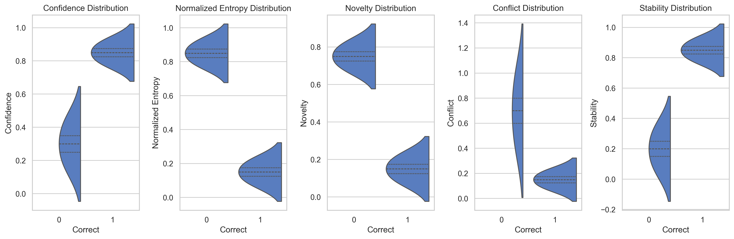
Figure 1: Distribution of Meta-Cognitive State Components
This suggests that the internal state vector contains information associated with downstream prediction correctness. However, visual separation is not sufficient to establish predictive validity. The appropriate quantitative validation is:
AUROC(Ψ, Y) and AUPRC(Ψ, Y)
Therefore the final paper should report individual-feature and full-state predictive performance.

B. Meta-State Correlation
The preliminary correlation matrix reveals strong relationships between several state dimensions. For example:
Corr(C, H) ≈ −0.99 and Corr(H, N) ≈ 0.98
The relationship between confidence and stability is approximately:
Corr(C, S) ≈ 1.00
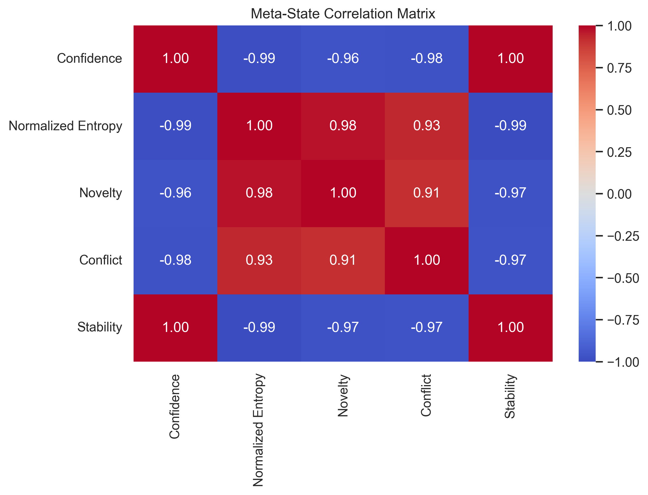
Figure 2: Meta-State Correlation Matrix
These results indicate that the current state representation is highly correlated rather than orthogonal. This has two interpretations. First, the state variables are clearly responding to a common underlying inferential process. Second, the current implementation may contain redundancy.
In particular, the approximately perfect confidence–stability correlation requires implementation-level verification before publication. Therefore, Phase 1 should not claim that the six variables constitute six statistically independent dimensions of cognition. Instead, the result motivates a subsequent investigation of state redundancy and feature ablation.

C. Dynamic Temperature Regulation
The preliminary temperature trajectory demonstrates that MCTR does not simply output a constant temperature. One observed trajectory varies approximately as:
0.5 → 0.6 → 1.2 → 1.4 → 0.3
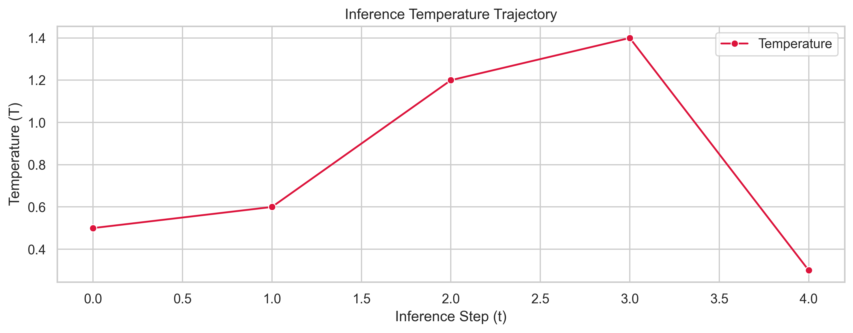
Figure 3: Inference Temperature Trajectory
This establishes an important implementation property:
Var(T) > 0
The controller therefore produces state-dependent temperature variation. The MCTR temperature distribution across the sampled trajectory is non-trivial and multi-modal, with local peaks distinct from any single fixed-temperature baseline, which is additional evidence against a degenerate fixed-point policy.
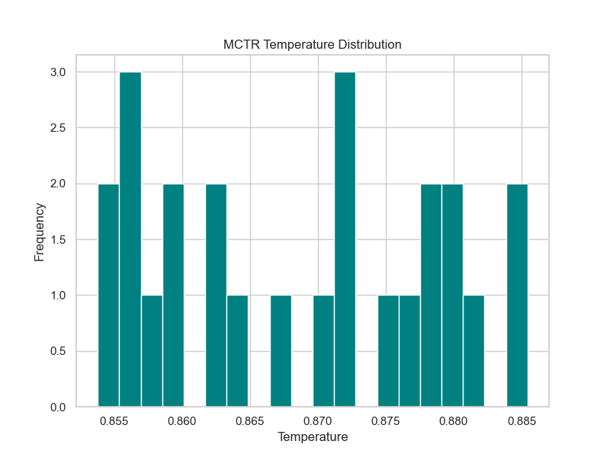
Figure 4: MCTR Temperature Distribution
The appropriate conclusion at this stage is:
The controller demonstrates dynamic temperature modulation during inference.
A stronger claim that the controller has learned a generally useful adaptive policy requires evaluation over substantially more examples.

D. Temperature–Entropy Relationship
The preliminary temperature-versus-entropy plot shows a relationship between temperature and entropy, consistent with the expected probabilistic effect:
T ↑ ⇒ P(T) becomes more distributed ⇒ H ↑
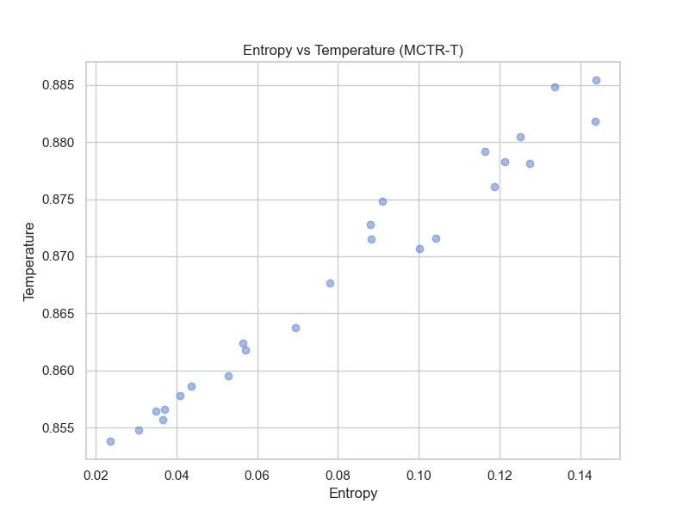
Figure 5: Entropy vs. Temperature (MCTR-T)
This result supports the basic control mechanism:
T → P → H
However, the relationship between MCTR's meta-state and temperature must be distinguished from the known mathematical effect of temperature itself. The stronger MCTR-specific relationship is:
Ψ_(t-1) → T_t
The preliminary temperature-versus-meta-score analysis is consistent with this pathway.
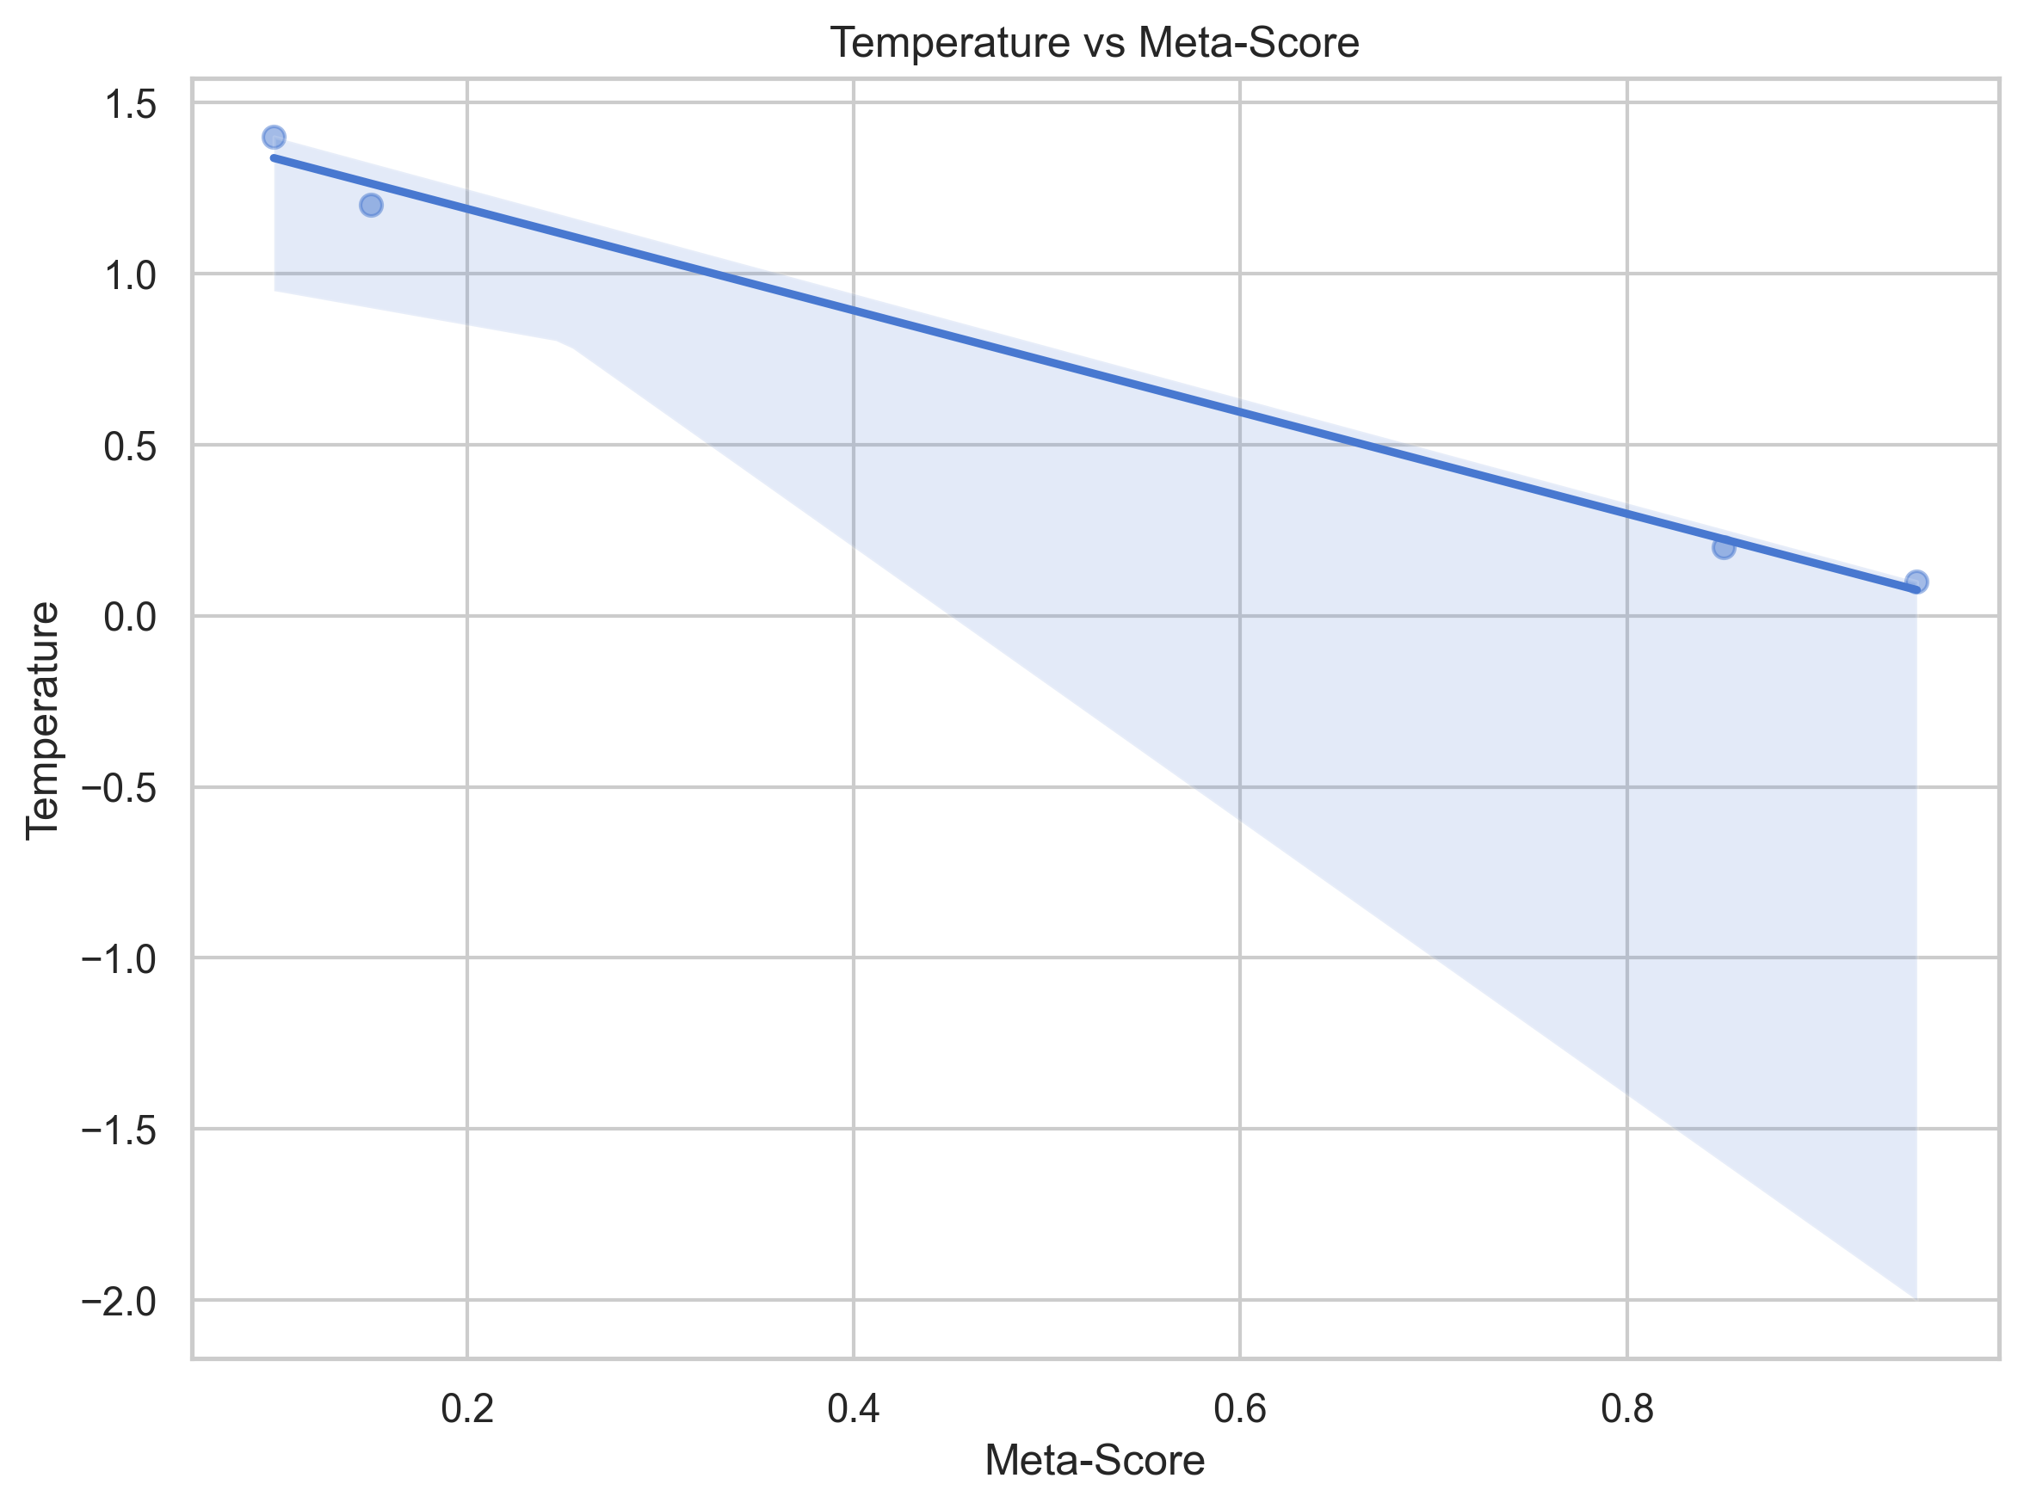
Figure 6: Temperature vs. Meta-Score Relationship
This relationship should be quantified using Pearson and Spearman correlations and tested across many inference states before being treated as a stable finding.

E. Baseline Versus MCTR
The preliminary baseline figure suggests higher observed accuracy under MCTR than the plotted baseline for both GSM8K and BBH. The plotted results approximately indicate, for GSM8K, an accuracy of 0.75 under the baseline versus 0.82 under MCTR; for BBH, the plotted values are approximately 0.60 versus 0.65.
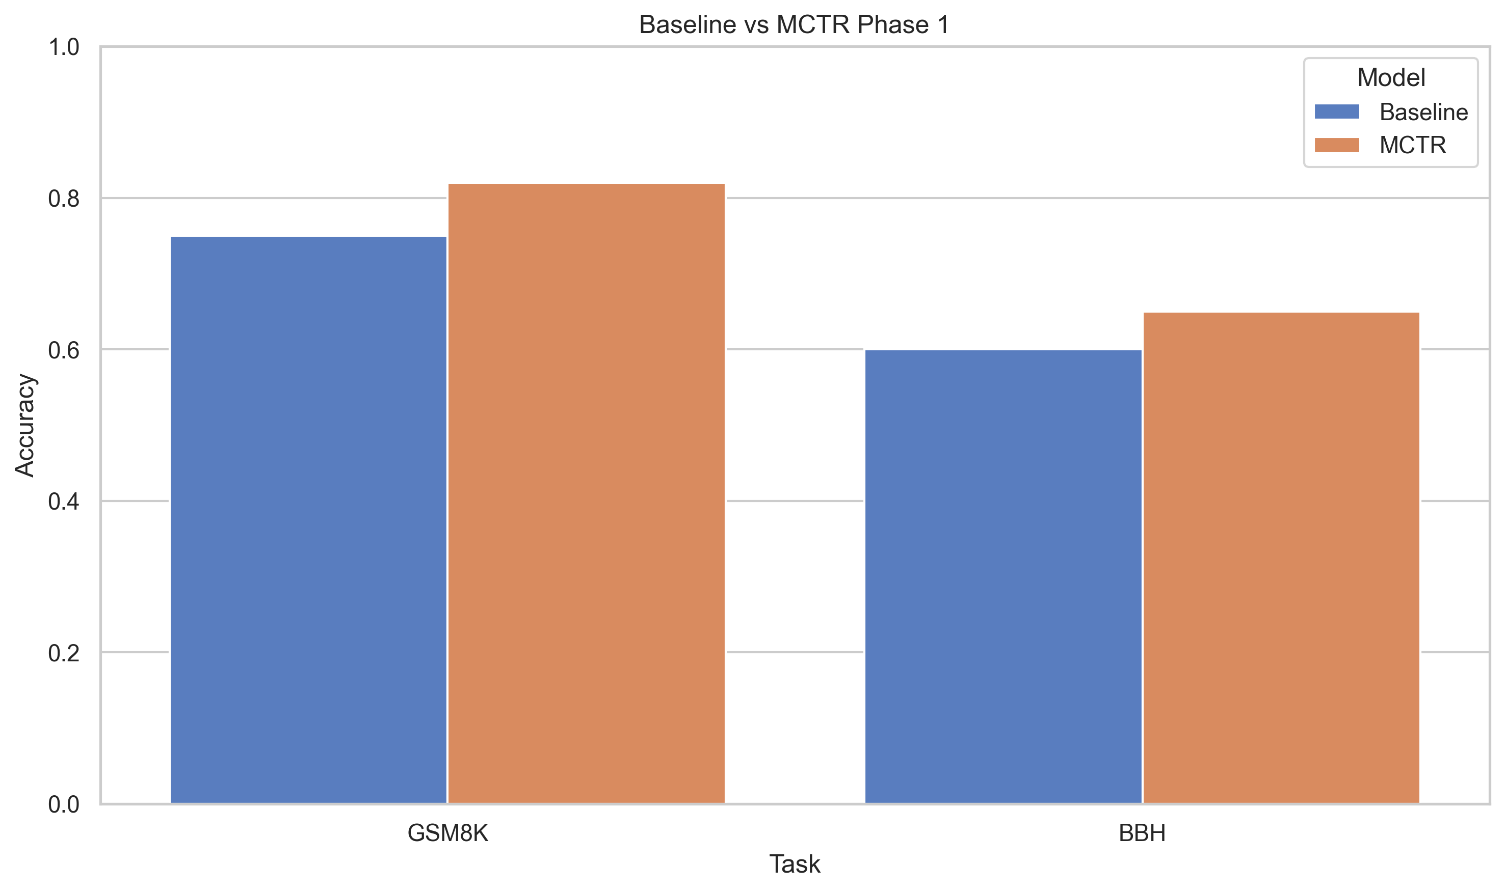
Figure 7: Baseline vs. MCTR Phase 1 Performance

These values must not yet be presented as final experimental results, because the uploaded baseline comparison table (Table I) reports zero accuracy difference for all fixed-temperature comparisons. Consequently, the current artifacts likely combine outputs from different experimental runs or aggregation procedures. The final Phase 1 result must be regenerated from one canonical per-example dataset before this comparison can be reported as a quantitative finding.

F. Calibration
The calibration plot shows variation in ECE and Brier score across temperature settings. The general trend demonstrates that temperature changes can substantially alter confidence behavior, supporting the theoretical relationship:
T → P → C, H
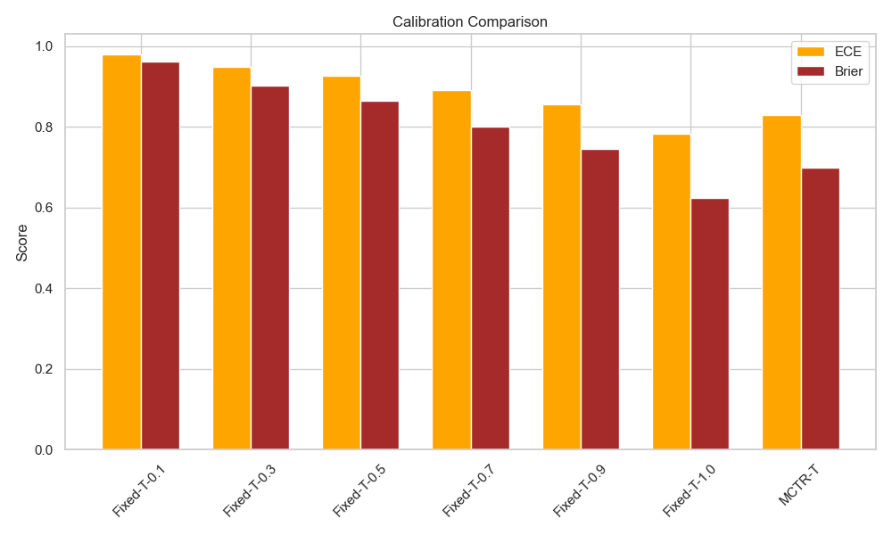
Figure 8: Calibration Comparison (ECE and Brier Score)
However, calibration should not be interpreted independently of accuracy. A model can reduce ECE while maintaining or reducing task performance. Therefore the final Phase 1 evaluation should report the joint space:
(Accuracy, ECE, Brier)

G. Quantitative Comparison: MCTR vs. Fixed-Temperature Baselines
Table I reproduces the current aggregate comparison table exactly as generated. As noted above, this table shows zero accuracy delta across all rows, which conflicts with the accuracy figures plotted in Figure 7 (Section VIII.E). This discrepancy is the primary reason the Section VIII results are labeled preliminary, and it must be resolved by regenerating both artifacts from a single canonical per-example dataset.
Table I: MCTR Performance Deltas vs. Fixed-Temperature Baselines (as currently generated — inconsistent with Figure 7; pending regeneration)
Comparison | Δ ECE | Δ Brier | Δ Entropy | Δ Latency (ms)
MCTR vs Fixed-T-0.1 | -0.151 | -0.262 | -0.0002 | -3.72
MCTR vs Fixed-T-0.3 | -0.119 | -0.203 | +0.0042 | -26.50
MCTR vs Fixed-T-0.5 | -0.097 | -0.165 | +0.0152 | -0.058
MCTR vs Fixed-T-0.7 | -0.061 | -0.101 | +0.0110 | -13.80
MCTR vs Fixed-T-0.9 | -0.026 | -0.045 | +0.0151 | +11.45

IX. Discussion
The current results support a preliminary four-layer interpretation.
Layer 1 — Observability
The model exposes measurable quantities that differ across correct and incorrect states:
Inference → Ψ
This is supported by the distributional analyses.
Layer 2 — Meta-Evaluation
A learned evaluator can map the state toward prediction reliability:
Ψ → M_φ(Ψ)
This requires formal AUROC/AUPRC evaluation for the final claim.
Layer 3 — Regulation
The controller generates changing temperatures:
Ψ → T
The temperature trajectory and distribution demonstrate that the mechanism is operational.
Layer 4 — Consequence
Temperature changes affect P and consequently H. The preliminary entropy and calibration results demonstrate that this control pathway is measurable. The remaining question is whether this regulation produces consistent improvement in useful inference outcomes. That requires the clean 100-example paired experiment described in Section VII.

X. Limitations of Phase 1
Several limitations should be explicitly stated.
1. Small experimental sample — the current preliminary plots are not sufficient for statistical generalization.
2. Single-seed evaluation — a single seed cannot establish robustness.
3. State redundancy — several state variables exhibit very high correlations.
4. Uncertainty redundancy — current uncertainty (U_t = Ĥ_t) duplicates normalized entropy.
5. Temperature is only one control dimension — Phase 1 regulates temperature but does not yet dynamically modify attention or computational depth.
6. Causal evidence is incomplete — correlation between temperature and entropy does not prove the complete MCTR causal mechanism.
7. Baseline consistency — the current plotted baseline results and aggregate comparison table are inconsistent and must be regenerated from a common source.
8. Backbone scale — the Qwen2.5-0.5B model is intentionally resource constrained. Results therefore establish architectural feasibility rather than scaling-law conclusions.

XI. Conclusion
This paper introduced MCTR Phase 1, a computational framework for representing and regulating the inferential condition of a Transformer. The central idea is to move from conventional first-order inference:
X → P
toward a closed-loop architecture:
Ψ_(t-1) → T_t → P_t → Ψ_t
The proposed meta-state combines confidence, uncertainty, novelty, conflict, stability, and predictive entropy:
Ψ_t = [C_t, U_t, N_t, K_t, S_t, Ĥ_t]
Phase 1 establishes the architectural components required for this loop: state extraction, meta-cognitive evaluation, adaptive entropy targeting, and dynamic temperature regulation.
Preliminary experiments show three important properties. First, the extracted state variables exhibit observable differences between correct and incorrect predictions, suggesting that the state contains information related to inference reliability. Second, the MCTR controller produces non-constant temperature trajectories, demonstrating state-dependent regulation rather than a trivial fixed-temperature policy. Third, temperature and predictive entropy exhibit the expected measurable relationship, confirming that the controller can influence the predictive information distribution.
At the same time, the preliminary results reveal important limitations. Several meta-state variables are highly correlated, suggesting redundancy in the current state construction. The present uncertainty estimator is equivalent to normalized entropy, and therefore does not provide an independent uncertainty dimension. Most importantly, some current aggregate tables are inconsistent with the plotted baseline comparison, preventing the present results from being treated as the final quantitative evidence for MCTR performance.
Therefore, the principal Phase 1 contribution should be framed as the construction and initial validation of a closed-loop computational meta-cognitive regulation architecture, rather than as a definitive claim of improved reasoning accuracy.
The next controlled experiment should evaluate a fixed sample of 100 GSM8K test examples under identical conditions for six fixed temperatures and MCTR-T, using a single canonical per-example result table. The resulting experiment should quantify accuracy, calibration, entropy, confidence, temperature responsiveness, AUROC/AUPRC of the meta-state, and computational cost.
If this controlled evaluation confirms that Ψ predicts correctness, that Ψ → T produces non-trivial regulation, and that T → P → H produces measurable downstream consequences, then Phase 1 will establish the empirical foundation for the next architectural stage: meta-cognitive attention regulation.
Phase 2 can subsequently extend the control space from temperature regulation to attention regulation, ultimately enabling the broader MCTR objective of dynamically adapting the computational pathway according to the model's evolving inferential state.

Core Contribution Statement

The primary contribution of MCTR Phase 1 is not the introduction of another confidence estimator or a static temperature-scaling method, but the formulation and implementation of a closed-loop inference architecture in which a Transformer constructs an explicit computational representation of its current inferential condition, evaluates that representation through a learned meta-cognitive module, and uses the resulting state to regulate subsequent inference. Phase 1 operationalizes this principle through adaptive temperature control and establishes the measurement, evaluation, and feedback components required for subsequent state-dependent attention regulation.

References
[1] C. Guo, G. Pleiss, Y. Sun, and K. Q. Weinberger, "On Calibration of Modern Neural Networks," in Proceedings of the 34th International Conference on Machine Learning (PMLR), vol. 70, 2017.
[2] S. Kadavath et al., "Language Models (Mostly) Know What They Know," arXiv:2207.05221, 2022.
[3] R. Groot and M. Valdenegro-Toro, "Overconfidence is Key: Verbalized Uncertainty Evaluation in Large Language and Vision-Language Models," in Proc. TrustNLP Workshop, ACL Anthology, 2024.
[4] "ConfidenceBench: Evaluating Confidence Calibration in Large Language Models," arXiv:2607.20526, 2026.
[5] S. Farquhar, J. Kossen, L. Kuhn, and Y. Gal, "Detecting Hallucinations in Large Language Models Using Semantic Entropy," Nature, 2024.
[6] X. Wang et al., "Self-Consistency Improves Chain of Thought Reasoning in Language Models," in Proc. ICLR, 2023.
[7] A. Madaan et al., "Self-Refine: Iterative Refinement with Self-Feedback," arXiv:2303.17651, 2023.
[8] J. Huang et al., "Large Language Models Cannot Self-Correct Reasoning Yet," OpenReview, 2024.
[9] H. Lightman et al., "Let's Verify Step by Step," OpenAI, 2023.
[10] M. Tian et al., "Just Ask for Calibration: Strategies for Eliciting Calibrated Confidence Scores from Language Models Fine-Tuned with Human Feedback," in Proc. EMNLP, ACL Anthology, 2023.
[11] Y. Li et al., "Demystifying Uncertainty in LLMs: Active Calibration between Concepts and Human Evaluations," in Proc. ACL, ACL Anthology, 2026.
[12] A. Vaswani et al., "Attention is all you need," in Advances in Neural Information Processing Systems (NeurIPS), 2017.
[13] A. Holtzman et al., "The curious case of neural text degeneration," in International Conference on Learning Representations (ICLR), 2020.
[14] Y. Gal and Z. Ghahramani, "Dropout as a Bayesian approximation: Representing model uncertainty in deep learning," in International Conference on Machine Learning (ICML), 2016.

