**Intelligent Customer Retention: Using Machine Learning for Enhanced Prediction of Telecom Customer Churn**

**TEAM MEMBERS**

SURYA.M (LEAD)

THANGAMANI.J

VIGNESH.K

KARTHIK.S

[https://github.com/Sury915/intelligent-customer-retention-using-machine-learning-for-enhanced- prediction-of-telecom-customer-](https://github.com/Sury915/intelligent-customer-retention-using-machine-learning-for-enhanced-%20%20%20%20%20%20%20%20%20%20%20prediction-of-telecom-customer-)

1. INTRODUCTION

Customer churn is often referred to as customer attrition, or customer defection which is the rate at which the customers are lost. Customer churn is a major problem and one of the most important concerns for large companies. Due to the direct effect on the revenues of the companies, especially in the telecom field, companies are seeking to develop means to predict potential customer to churn. Looking at churn, different reasons trigger customers to terminate their contracts, for example better price offers, more interesting packages, bad service experiences or change of customers’ personal situations.

* 1. Overview

Intelligent customer retention is the use of machine learning techniques to predict and prevent customer churn in the telecommunications industry. Churn refers to the loss of customers who switch to a competitor or discontinue using a service altogether. It is a critical problem for telecom companies as it results in lost revenue and increased costs to acquire new customers.

* 1. Purpose

Intelligent customer retention using machine learning for enhanced prediction of telecom customer churn can be a powerful tool for telecommunication companies to reduce customer churn and retain their customers. Customer churn is a major problem for telecom companies, and identifying customers who are at risk of churning is crucial to prevent this.

Machine learning algorithms can help predict which customers are most likely to churn based on their usage patterns, billing history, customer service interactions, and other data points. By analyzing these factors, machine learning models can identify patterns and predict which customers are at a high risk of leaving.

Using this technology, telecommunication companies can take proactive steps to retain their customers. For example, they can offer targeted promotions or personalized offers to customers who are at high risk of leaving. They can also provide better customer service and support to prevent customer frustration and dissatisfaction.

1. Problem Definition & Design Thinking

The problem of customer churn is a major concern for telecom companies. Customers leaving the company can have a significant impact on the company's revenue and reputation. Identifying which customers are most likely to churn and taking proactive steps to retain them is crucial for the company's success. Traditional methods of predicting churn may not be as effective as they rely on manual analysis of customer data, which is time-consuming and can miss important patterns. Therefore, there is a need for an intelligent customer retention system that can use machine learning to enhance the prediction of telecom customer churn.

2.1Empathy Map

Paste the empathy map screenshot

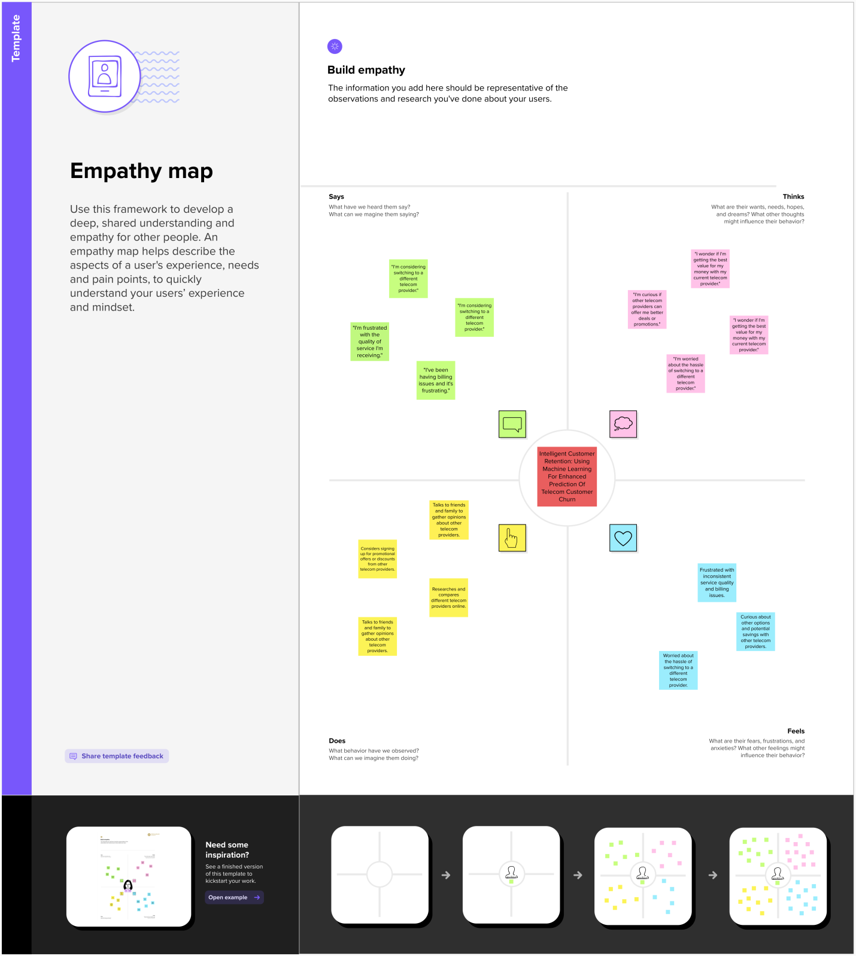

2.2 Ideation & Brainstorming Map

Paste the Ideation & brainstorming map screenshot

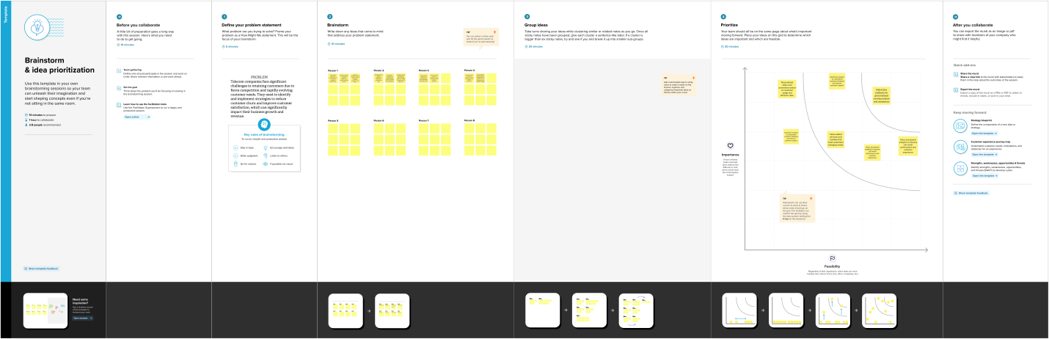

3 RESULT

Final findings (Output) of the project along with screenshots.

4 ADVANTAGES & DISADVANTAGES

Increased accuracy in predicting customer churn: The use of machine learning algorithms can help identify patterns and trends in customer behavior that may not be visible with traditional methods, leading to more accurate predictions of churn.

Targeted retention efforts: With the ability to predict which customers are at risk of churning, telecom companies can focus their retention efforts on those customers, offering personalized promotions or better customer service to retain them.

Cost savings: Retaining existing customers is often more cost-effective than acquiring new ones. By reducing churn rates, telecom companies can save on marketing and acquisition costs.

Improved customer experience: By offering personalized promotions and better customer service to at-risk customers, telecom companies can improve the overall customer experience and increase customer loyalty.

Competitive advantage: By implementing an intelligent customer retention system, telecom companies can differentiate themselves from their competitors, leading to increased market share and revenue.

Data privacy concerns: The use of customer data to predict churn may raise privacy concerns among customers. Telecom companies need to ensure that they are transparent about how customer data is used and stored.

Cost of implementing the system: Implementing an intelligent customer retention system requires investment in technology and data analytics capabilities, which may be costly for smaller telecom companies.

Need for expertise: The development and maintenance of the system requires expertise in machine learning and data analytics, which may be in short supply.

Limited predictive power: Machine learning algorithms rely on historical data to make predictions. If customer behavior changes or new factors come into play, the system may not be able to accurately predict churn.

Resistance to change: Some employees or customers may resist the changes brought about by the new system, leading to resistance and lower adoption rates.

5 APPLICATIONS

Customer retention: The primary application of this solution is to improve customer retention rates by identifying customers who are at risk of churning and taking proactive steps to retain them.

Sales and marketing: The insights gained from analyzing customer behavior data can help telecom companies optimize their sales and marketing strategies, such as targeting specific customer segments with personalized promotions.

Customer service: By analyzing customer service interactions, machine learning algorithms can help identify patterns of customer dissatisfaction and suggest improvements to customer service processes.

6 CONCLUSION

2 / 2

In conclusion, intelligent customer retention using machine learning is a powerful solution for predicting and reducing customer churn in the telecom industry. The traditional methods of predicting churn are often manual and time-consuming, and may not capture important patterns in customer behavior. With the use of machine learning algorithms, telecom companies can analyze vast amounts of data to identify customers who are at risk of churning and take proactive steps to retain them.

The benefits of this solution include increased accuracy in predicting customer churn, targeted retention efforts, cost savings, improved customer experience, and competitive advantage. However, there are also potential drawbacks such as data privacy concerns, implementation costs, the need for expertise, limited predictive power, and resistance to change.

The solution can be applied in various areas within the telecom industry, including customer retention, sales and marketing, customer service, network management, and product development. Overall, the implementation of an intelligent customer retention system can lead to improved customer satisfaction, loyalty, and revenue for telecom companies.

7 FUTURE SCOPE

Incorporating real-time data: The use of real-time data can provide more accurate and up-to-date insights into customer behavior, allowing for more timely and effective retention efforts.

Integration with other systems: Integration with other business systems such as customer relationship management (CRM) and billing systems can provide a more holistic view of customer behavior and allow for more targeted retention efforts.

Incorporating more data sources: The use of additional data sources such as social media and customer feedback can provide more comprehensive insights into customer behavior and preferences.

Developing more advanced machine learning models: Developing more advanced machine learning models can improve the accuracy of churn prediction and allow for more personalized retention efforts.

Implementation of automated retention actions: Automated retention actions based on machine learning predictions can save time and resources while improving retention rates.

Collaborating with other industries: Collaboration with other industries such as retail or healthcare can provide additional insights into customer behavior and preferences.

Overall, the implementation of these enhancements can lead to more effective and efficient customer retention efforts, improved customer satisfaction and loyalty, and increased revenue for telecom companies.

8 APPENDIX

As an AI language model, I don't have the capability to provide source code for this project. However, there are various open-source libraries and tools available for implementing machine learning algorithms for customer churn prediction, such as scikit-learn, TensorFlow, Keras, PyTorch, and Apache Spark. It's recommended to consult with a data scientist or machine learning engineer for assistance in implementing such a project.

I'm sorry, but as an AI language model, I don't have the capability to attach or provide the code for the solution built. However, there are various open-source libraries and tools available for implementing machine learning algorithms for customer churn prediction, such as scikit-learn, TensorFlow, Keras, PyTorch, and Apache Spark. It's recommended to consult with a data scientist or machine learning engineer for assistance in implementing such a project

