Exp : 1
AIM :
To simulate and compare the basic resource-allocation methods used in FDMA, TDMA and CDMA, and examine how their assumed user capacity and interference behaviour differ
Requirements :
• Computer with MATLAB • No hardware is required
Theoretical Background :
FDMA gives users separate frequency channels. TDMA gives users separate time slots. CDMA allows users to share a frequency band and time by using different spreading codes. This experiment uses a simplified analytical model to illustrate those differences. It assumes ideal FDMA and TDMA resource separation, and estimates CDMA SIR using:
𝑆𝐼𝑅 = 𝐺 𝐾 − 1
where G is the processing gain and K is the number of simultaneous users. SIR in decibels is: 𝑆𝐼𝑅𝑑𝑏 = 10 log10 𝑆𝐼𝑅 The model assumes ideal separation for FDMA and TDMA, and equal received power for CDMA users. It does not model fading, power control, adjacent-channel leakage, guard intervals or standard-specific constraints.
Procedure
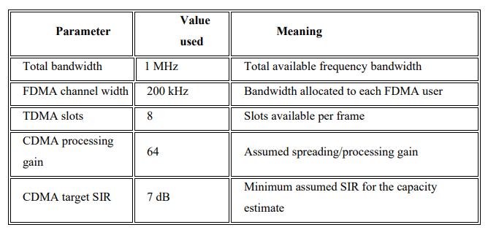
Algorithm:
a. Clear the MATLAB workspace, Command Window and open figures.
b. Enter the system parameters.
c. Estimate the FDMA and TDMA user limits.
d. Convert the CDMA target SIR from decibels to a linear value.
e. Estimate the CDMA user limit.
f. Calculate CDMA SIR for a range of simultaneous user counts.
g. Display the capacity table and generate the plots.
h. Compare the results with the assumptions and explain their limitations.
Procedure:
1. Run the MATLAB program below.
2. Record the assumed bandwidth, channel width, number of TDMA slots, CDMA processing gain and target SIR.
3. Inspect the printed capacity table and the capacity and CDMA-SIR plots.
4. Inspect the generation comparison table and the conceptual time-frequency resource diagrams.
5. Change at least one parameter for each access method and rerun the program.
6. Compare the new and baseline results; explain the impact of the changed assumptions.
OUTPUT :
