A. Single Prospect Analysis Flow (POST /api/analyze)
A prospect analysis evaluates 8 core parameters (Company Scale, Business Growth, Market Position, Financial Strength, Insurance Performance, Operational Scale, Technology Activity, Strategic Activity) with a hard cap of 2 search queries per parameter (16 total search queries):
Component / Service | Total Calls per Run | Code Location | Nature of Request
Google Gemini LLM | 1 LLM call | backend/analysis/summarizer.py#L236 | Single comprehensive grounded JSON synthesis covering all parameters, verdict, scorecard, and data gaps.
Tavily AI Search API | 16 API calls | backend/research/collectors/tavily_search.py#L36 | 8 parameters × 2 queries. Extracts AI-curated contextual passages.
Serper.dev Search API | 16 API calls | backend/research/collectors/serper_search.py#L36 | 8 parameters × 2 queries. Queries Google organic search index for canonical URLs and filings.
WebCrawlerAPI / Firecrawl | Up to 8 calls | backend/research/collectors/webcrawler_crawler.py#L40 | Max 1 deep crawl per parameter on high-scoring URLs. (Falls back to local trafilatura if unconfigured).
GLEIF LEI Registry | 1 API call | backend/services/entity_resolver.py#L281 | Open public REST call to verify legal entity identity and LEI number.
Google News RSS Feed | 16 HTTP requests | backend/research/collectors/web_search.py#L13 | Free public RSS queries for recent press and statutory releases.
Prospect Analysis Totals: 1 LLM call + 32 to 40 Keyed Search/Crawl API calls (+ 17 free requests).

B. Single Proposal / RFP Analysis Flow (POST /api/proposal/...)
[Step 1: Upload & Extract] ──> [Step 2: AI Parameter Rec] ──> [Step 3: Prospect Fit Analysis]
(1 LLM Call, 0 Search) (1 LLM Call, 0 Search) (N Parameter Evals + 1 Summary)

Stage | Endpoint & Code Reference | LLM Calls (Gemini) | Search / Web API Calls | Service / Call Type
Step 1: Profile Extraction | proposal_service.py#L413 | 1 LLM call (16 dimensions) | 0 calls (Document text only) | Gemini (extract_proposal_profile)
Step 2: Parameter Recommendation | proposal_parameter_service.py#L152 | 1 LLM call (15 catalog params) | 0 calls | Gemini (evaluate_all_parameters)
Step 3: Fit Analysis Research | proposal_analysis_service.py | — | 12 Tavily ($6×2$)  12 Serper ($6×2$)  Up to 6 Firecrawl | Tavily (12) + Serper (12) + Firecrawl (up to 6)
Step 3: Per-Parameter Evaluation | proposal_analysis_service.py#L206 | 6 LLM calls (1 per parameter) | — | Gemini (evaluate_parameter_against_proposal × 6)
Step 3: Executive Summary Synthesis | analysis_summary_service.py#L264 | 1 LLM call | — | Gemini (generate_executive_summary)

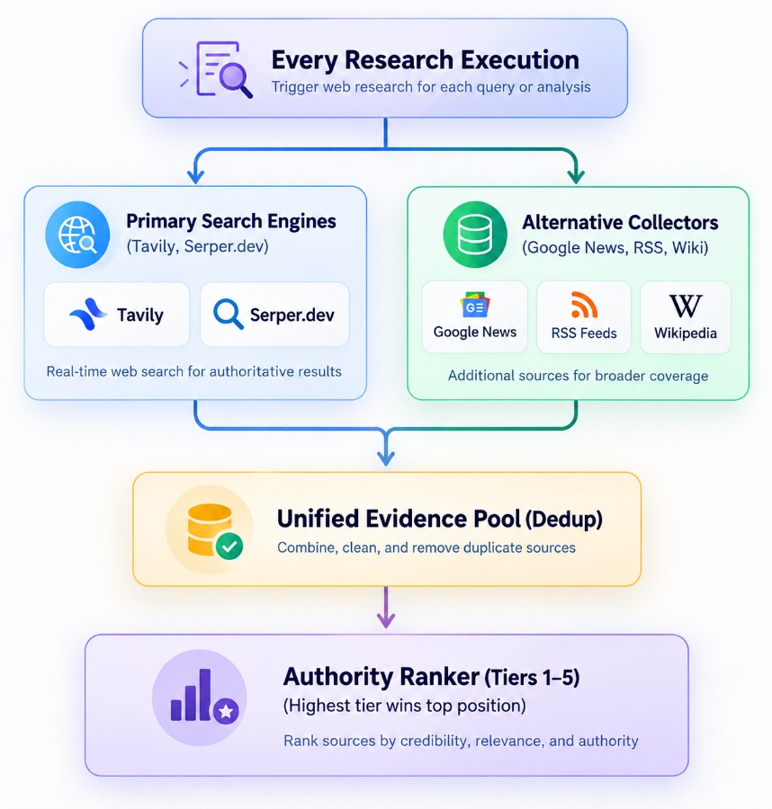
- Both run concurrently: The system does not wait for primary sources to fail before calling alternative sources. Both run on every analysis.
- Alternative sources are actively included: If Google News RSS or domain collectors discover an official regulatory notice (Tier 1), it outranks general web results from Tavily/Serper in the final report.
- No wasted calls: Deduplication merges identical URLs from different sources and preserves the highest-quality metadata snippet.
A. The 5 Authority Tiers Defined in authority_ranker.py
- Tier 1 — Statutory & Regulators (Base Score: 1.00): irdai.gov.in, sec.gov, mca.gov.in, .gov.in, .gov, official insurer portal domains (sbilife.co.in, hdfclife.com).
- Tier 2 — Audited Financials & Stock Exchanges (Base Score: 0.90): nseindia.com, bseindia.com, URLs containing annual-report, financial-results, investor-relations.
- Tier 3 — Credit Rating Agencies (Base Score: 0.85): crisil.com, icra.in, ambest.com, careedge.in, spglobal.com, moodys.com.
- Tier 4 — Tier-1 Financial & Industry Press (Base Score: 0.75): reuters.com, bloomberg.com, economictimes.indiatimes.com, livemint.com, business-standard.com, insurancejournal.com.
- Tier 5 — General Web & Blogs (Base Score: 0.50): Medium, Substack, Reddit, forums, unverified aggregators.
B. Mathematical Evidence Scoring Formula
In score_evidence_item(), every item receives a composite score:
Score=(Authority×0.35)+(Relevance×0.25)+(Recency×0.15)+(Directness×0.15)+(Cross-Source×0.10)
Only items with $\text{Score}≥0.40$ are retained.
Evidence items are tagged with their tier before entering the prompt
- [TIER 1 STATUTORY | Period: FY24 | IRDAI Filing] Solvency Ratio: 1.95x; Net worth: INR 14,200 Cr.
- [TIER 2 CREDIT RATING | CRISIL] Rating: CRISIL AAA/Stable; Retention: 85%.
- [TIER 4 NEWS/WEB | The Economic Times] Carrier deployed Agentic AI claims automation.

Analysis Type | LLM Calls | API calls
Prospect Analysis | 1 Gemini | 32-40(16 Serper+16 Tavily+8 Firecrawl)
Proposal / RFP Analysis | 9 Gemini | 24-30

