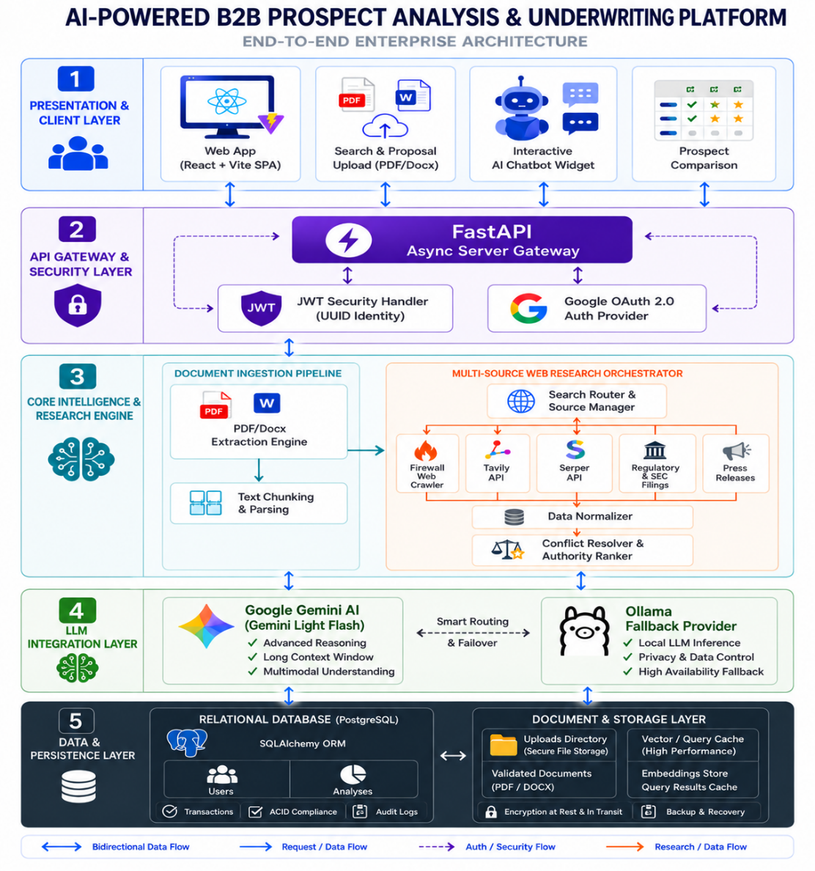

ALGORITHM:
Unified_Insurance_Prospect_and_Proposal_Platform:
INPUT: User Request (Prospect Name, Mode: [STANDALONE_PROSPECT | Proposal File/Text, Selected Parameters)
OUTPUT: Qualitative, Evidence-Backed Underwriting Intelligence Dossier

================================================================================
PHASE A: COMMON INGESTION & DETERMINISTIC VALIDATION GATE
================================================================================
STEP 1: USER AUTHENTICATION & INPUT SANITIZATION
- Verify user session and extract UUID for multi-tenant data isolation.
- Clean conversational prefixes and punctuation from input string.

STEP 2: CANONICAL PROSPECT RESOLUTION
- Validate prospect against the 250-carrier universe (INS-0001 to INS-0250).
- Match via: ID -> Exact Name -> Curated Alias -> Normalized Name -> Fuzzy Overlap.
- IF carrier not found or ambiguous -> STOP and return error / candidate list.

STEP 3: BRANCH ON ANALYSIS MODE
- IF Mode == "STANDALONE_PROSPECT":
Execute Phase B (Case 1: General Prospect Intelligence).

PHASE B: STANDALONE PROSPECT INTELLIGENCE (CASE 1)
STEP B1: RESEARCH ORCHESTRATION
- Query official filings, IRDAI/NAIC statutory disclosures, rating agencies, and Tavily search across 8 core underwriting parameters (Scale, Solvency, Claims, Performance, etc.).
- Stop if no verifiable disclosures exist.

STEP B2: TWO-TIER AI PROSPECT SYNTHESIS
- Synthesize parameter summaries, exposures, and executive summary.
- Primary: Google Gemini -> Fallback: Local Ollama -> Error.

STEP B3: PROSPECT METRICS:
- Extract factual ratios (e.g. Solvency Margin, Combined Ratio, Ratings) without inventing numbers.

PHASE C: PROPOSAL / RFP GROUNDED UNDERWRITING ANALYSIS (CASE 2)

STEP C1: PROPOSAL DOCUMENT EXTRACTION
- Read uploaded PDF/DOCX file.
- Deterministically extract: Sums Insured, Premiums, Deductibles, Underwriting Conditions Precedent, Exclusions.
- Extract dynamic RFP-specific parameters (tagged 'Proposal-derived').

STEP C2: DETERMINISTIC COMPATIBILITY MATRIX (BEFORE AI)
- Classify Carrier Archetype vs Proposal Line of Business.
- Evaluate statutory compatibility: HIGH | MEDIUM | LOW.
- Hard constraint: If carrier license legally bars the requested line (e.g., Life carrier bidding on Property) -> Enforce LOW compatibility before AI analysis.

STEP C3: TARGETED CREDIT-EFFICIENT RESEARCH
- Run public research ONLY for parameters selected by the user (Recommended + Dynamic).
- Group queries by shared source domains to minimize external API/web crawl credits.

STEP C4: PARAMETER FIT EVALUATION & EVIDENCE CLASSIFICATION
- Classify evidence authority: CONFIRMED | SUPPORTED | INFERRED | UNKNOWN.
- Assess qualitative alignment: FIT | PARTIAL FIT | GAP | UNKNOWN.
- Identify Key Strengths, Key Gaps, Risks, and Producer Action Plan.
- Proceed to Phase D.

PHASE D: COMMON GUARDRAILS, PERSISTENCE & COPILOT CONTEXT
STEP 4: OUTPUT GUARDRAILS & ZERO-SCORING ENFORCEMENT
- Set all numerical fit scores to NULL (Qualitative compliance).
- Clean markdown artifacts, table dumps, and HTML noise.
- Cap sources and facts to a maximum of 5 items per parameter.

STEP 5: DATABASE PERSISTENCE (POSTGRESQL)
- Persist complete analysis linked to `user_uuid`.

STEP 6: INTERACTIVE COPILOT CHAT READY
- Initialize chat session grounded strictly in the active dossier disclosures.
- Return final dossier to frontend UI.

# 1. Unified Dispatch Gateway
FUNCTION RUN_UNIFIED_ANALYSIS(request, current_user, db_session):
prospect, candidates, status = RESOLVE_PROSPECT(request.prospect_name)
IF status != "MATCHED":
RETURN GENERATE_RESOLUTION_ERROR(status, candidates)

IF request.analysis_mode == "STANDALONE_PROSPECT":
dossier = EXECUTE_PROSPECT_INTELLIGENCE_FLOW(prospect, request.parameters)
ELSE:
dossier = EXECUTE_PROPOSAL_UNDERWRITING_FLOW(prospect, request.proposal_input, request.selected_parameters)

RETURN PERSIST_DOSSIER_TO_DB(APPLY_OUTPUT_GUARDRAILS(dossier), current_user.uuid, db_session)

# 2. Prospect Resolution (Tiered Match)
FUNCTION RESOLVE_PROSPECT(raw_query):
query = CLEAN_STRING(raw_query)
FOR match_fn IN [GET_BY_ID, GET_BY_NAME, GET_BY_ALIAS]:
IF item := match_fn(query):
RETURN (item, [item], "MATCHED")
candidates = SEARCH_CATALOG_TOKEN_OVERLAP(query)
IF LENGTH(candidates) == 1:
RETURN (candidates[0], candidates, "MATCHED")
RETURN (NULL, candidates, "MULTIPLE_MATCHES" IF candidates ELSE "NOT_FOUND")

# 3. Prospect Intelligence Flow
FUNCTION EXECUTE_PROSPECT_INTELLIGENCE_FLOW(prospect, requested_parameters):
evidence = SEARCH_PUBLIC_DISCLOSURES(prospect.name, requested_parameters OR DEFAULT_8_CORE_PARAMETERS)
IF NO_EVIDENCE_FOUND(evidence):
RETURN GENERATE_INSUFFICIENT_DATA_DOSSIER(prospect.name)
ai_result = SYNTHESIZE_AI_WITH_FALLBACK(prospect.name, evidence, "PROSPECT_INTELLIGENCE")
RETURN {
"company_name": prospect.name,
"analysis_mode": "STANDALONE_PROSPECT",
"executive_summary": ai_result.executive_summary,
"parameters": ai_result.parameters,
"metrics_scorecard": EXTRACT_FACTUAL_METRICS_SCORECARD(evidence),
"underwriting_verdict": EXTRACT_UNDERWRITING_VERDICT(ai_result),
"critical_data_gaps": ai_result.critical_data_gaps
}
# 4. Proposal Underwriting Flow
FUNCTION EXECUTE_PROPOSAL_UNDERWRITING_FLOW(prospect, proposal_input, user_selected_params):
raw_text = EXTRACT_TEXT(proposal_input.file, proposal_input.text)
compatibility = EVALUATE_ARCHETYPE_COMPATIBILITY(prospect.name, raw_text)

checklist = GENERATE_PROPOSAL_CHECKLIST(raw_text)
selected_params = user_selected_params OR checklist.recommended_parameters
evidence = EXECUTE_CREDIT_EFFICIENT_RESEARCH(prospect.name, selected_params)
rfp_reqs = EXTRACT_PROPOSAL_REQUIREMENTS(raw_text)
evaluated_params = [
EVALUATE_SINGLE_PARAMETER_FIT(
param=p,
req=rfp_reqs.GET(p, ""),
evidence=evidence.GET(p, []),
source="Proposal-derived" IF p IN checklist.dynamic_names ELSE "Master Checklist"
)
FOR p IN selected_params
]
ai_summary = SYNTHESIZE_AI_WITH_FALLBACK(prospect.name, {"compatibility": compatibility, "parameters": evaluated_params}, "PROPOSAL_DOSSIER")

RETURN {
"company_name": prospect.name,
"proposal_name": proposal_input.filename OR "Uploaded Proposal Document",
"analysis_mode": "PROPOSAL_BASED",
"proposal_compatibility": compatibility.rating,
"compatibility_reason": compatibility.reason,
"executive_summary": ai_summary.executive_summary,
"selected_parameters": evaluated_params,
"key_strengths": FILTER_BY_ASSESSMENT(evaluated_params, "FIT"),
"key_gaps": FILTER_BY_ASSESSMENT(evaluated_params, "GAP"),
"key_risks": FILTER_BY_ASSESSMENT(evaluated_params, "PARTIAL FIT"),
"overall_proposal_fit": DERIVE_QUALITATIVE_FIT(compatibility.rating, evaluated_params),
"producer_action_plan": GENERATE_PRODUCER_ACTION_PLAN(evaluated_params)
}
# 5. Compatibility & Parameter Fit
FUNCTION EVALUATE_ARCHETYPE_COMPATIBILITY(prospect_name, proposal_text):
archetype = CLASSIFY_CARRIER_ARCHETYPE(prospect_name)
line = CLASSIFY_PROPOSAL_LINE(proposal_text)
RULES = {
"Composite": ("HIGH", "Composite carrier authorized across all lines."),
"Reinsurance": ("HIGH", "Authorized treaty/facultative reinsurer.") IF "Reinsurance" IN line ELSE ("LOW", "Reinsurers cannot underwrite direct retail RFPs."),
"Life Insurance": ("HIGH", "Authorized for life/pensions.") IF "Life" IN line ELSE ("LOW", "Statutory life license bars non-life underwriting."),
"Commercial P&C": ("HIGH", "Full non-life license.") IF ("Commercial P&C" IN line OR "Health" IN line) ELSE ("LOW", "Barred from pure life plans.")
}
rating, reason = RULES.GET(archetype, ("MEDIUM", "Requires line-by-line review."))
RETURN {"rating": rating, "reason": reason}

FUNCTION EVALUATE_SINGLE_PARAMETER_FIT(param, req, evidence, source):
snippets = EXTRACT_CLEAN_SNIPPETS(evidence)
IF NOT snippets:
RETURN {
"parameter_name": param, "source": source, "proposal_requirement": req,
"public_evidence": "No disclosures found.", "evidence_classification": "UNKNOWN",
"assessment": "UNKNOWN", "confidence": "LOW",
"gap": "Direct underwriter confirmation required.", "sources": []
}

text = JOIN(" ", snippets).TO_LOWER()
IF CONTAINS_ANY(text, ["licensed", "solvency", "capital", "network", "approved"]):
assessment, conf, gap = "FIT", "HIGH", "None identified."
ELSE IF CONTAINS_ANY(text, ["partial", "limited", "restriction", "deficit"]):
assessment, conf, gap = "PARTIAL FIT", "MEDIUM", "Requires operational endorsement."
ELSE:
assessment, conf, gap = "FIT", "MEDIUM", "No material gap detected."

RETURN {
"parameter_name": param, "source": source, "proposal_requirement": req,
"public_evidence": LIMIT_SENTENCES(text, 3),
"evidence_classification": "CONFIRMED" IF HAS_STATUTORY_FILING(evidence) ELSE "SUPPORTED",
"assessment": assessment, "confidence": conf, "gap": gap,
"sources": EXTRACT_VALID_SOURCES(evidence, limit=5)
}
# 6. AI Multi-Tier Fallback
FUNCTION SYNTHESIZE_AI_WITH_FALLBACK(company, context, prompt_type):
prompt = COMPILE_GROUNDED_PROMPT(company, context, prompt_type)
FOR runner IN [CALL_GEMINI, LAMBDA p: CALL_OLLAMA(p, model="qwen2.5:1.5b")]:
TRY:
IF res := runner(prompt):
IF IS_VALID_JSON(res): RETURN res
CATCH:
CONTINUE
RETURN GENERATE_DETERMINISTIC_SYNTHESIS(company, context)

