A PROJECT REPORT
ON

SMART DOOR LOCK
An ESP32-CAM Based Wi-Fi Access Control System
with Live Video Streaming and Servo Actuation
PROJECT IMAGE PLACEHOLDER
Paste a photograph of the assembled hardware here:
ESP32-CAM module on the door frame with the SG90 servo, servo horn
and latch bolt visible, plus the porch-light LED.

Submitted in partial fulfilment of the requirements for the award of the degree of
Diploma
in
ELECTRONICS AND COMMUNICATION ENGINEERING

Submitted by : | ______________________________
Enrolment No. : | ______________________________
Project Guide : | ______________________________
Department : | Electronics and Communication Engineering
Institute : | ______________________________
Organization : | ______________________________
Academic Year : | 2025 – 2026
DEPARTMENT OF ELECTRONICS AND COMMUNICATION ENGINEERING
______________________________

CERTIFICATE

This is to certify that the project work entitled
“SMART DOOR LOCK — An ESP32-CAM Based Wi-Fi Access Control System with Live Video Streaming and Servo Actuation”

is a bona fide record of the project work carried out by ______________________________ (Enrolment No. ______________________), a student of the final year of the Bachelor of Technology programme in Electronics and Communication Engineering, Department of ______________________________, during the academic year 2025–2026, in partial fulfilment of the requirements for the award of the degree of Bachelor of Technology.

The candidate has completed the work under my supervision and guidance. The report has been examined and is found to be satisfactory. The work embodied in this report has not been submitted to any other university or institution for the award of any other degree or diploma.

_____________________  Signature of the Guide | _____________________  Signature of the HOD | _____________________  Signature of the Examiner

Date: ____________________ Place: ____________________
DECLARATION

I hereby declare that the project report entitled “Smart Door Lock — An ESP32-CAM Based Wi-Fi Access Control System with Live Video Streaming and Servo Actuation” submitted to the Department of Electronics and Communication Engineering, ______________________________, is a record of original work carried out by me under the supervision and guidance of my project guide.
I further declare that the firmware, the embedded web interface and the documentation presented in this report were developed by me. All external sources of information, libraries, datasheets and reference material that were consulted during the work have been duly acknowledged in the References chapter of this report. To the best of my knowledge, this work has not been submitted in part or in full to any other university or institute for the award of any degree or diploma.

____________________________
Signature of the Candidate
Name: ____________________________
Enrolment No.: ____________________________
Date: ____________________________
ACKNOWLEDGEMENT
The completion of this project would not have been possible without the guidance, support and encouragement of many people, and I take this opportunity to record my sincere gratitude to all of them.
First and foremost, I express my deepest gratitude to my project guide ______________________________ for the continuous supervision, technical insight and patient review of every design decision in this work. The guidance received during the hardware bring-up phase, and especially during the debugging of the camera timing conflicts, was invaluable.
I am thankful to the Head of the Department and to the faculty members of the Department of Electronics and Communication Engineering, ______________________________, for providing the laboratory facilities, the components and the academic environment required to complete this project. The support of the laboratory staff during the procurement of the ESP32-CAM module and the servo motor is gratefully acknowledged.
I also acknowledge the open-source community. The Arduino core for ESP32, the ESP-IDF camera driver (esp_camera), the esp_http_server component, the FreeRTOS real-time kernel and the LwIP TCP/IP stack form the foundation on which this firmware is built, and the documentation published by Espressif Systems made the low-level integration tractable.
Finally, I thank my family and my classmates for their constant encouragement, for the many useful discussions on access-control use cases, and for their patience during the long evenings of testing that preceded the final demonstration.
ABSTRACT
The Smart Door Lock is a self-contained embedded access-control system built around the ESP32-CAM (AI Thinker) development board, an OV2640 camera module and an SG90 micro servo motor. The system creates its own Wi-Fi hotspot in soft-AP mode and does not require a router, an internet connection or any cloud service. Any smartphone, tablet or personal computer that joins the hotspot can open the built-in web dashboard and simultaneously watch a live MJPEG video feed of the doorway and operate the lock.
The firmware is written in C/C++ on the Arduino framework for ESP32 and is organised as two independent planes. The control plane runs on TCP port 80 through the ESP-IDF esp_http_server component and exposes six URI handlers: the dashboard page, a JSON status endpoint, unlock and lock commands, a porch-light toggle and a single-frame snapshot. The data plane runs on TCP port 81 through a raw WiFiServer socket driven by a dedicated FreeRTOS task pinned to core 0, which streams motion-JPEG frames using the multipart/x-mixed-replace convention. Because the two planes use different ports, different sockets and different processor cores, the control buttons remain responsive while the video stream is running, which is the central architectural contribution of the design.
Physical actuation is provided by an SG90 servo whose control pulse is generated by the ESP32 LEDC peripheral. Timer 1 of the LEDC block is used exclusively for the servo at 50 Hz with 16-bit duty resolution, deliberately keeping timer 0 free for the camera master clock. The gate is unlocked by commanding the servo to 90 degrees and locked by returning it to 0 degrees. Both angles are software constants that can be calibrated without altering the program logic.
Three additional services complete the system. An automatic re-lock supervisor inside the loop() function re-secures the gate a configurable number of milliseconds after it was opened, which prevents the latch from being left open by mistake. An event logger maintains a 24-entry circular buffer of timestamped messages that records every unlock, lock, auto re-lock, boot and camera fault event. A porch-light service toggles the on-board white flash LED on GPIO 4 so that the scene can be illuminated before granting access. The on-board red LED on GPIO 33 mirrors the lock state as a local indicator.
The project was validated through unit, integration, system and performance testing. The measured end-to-end behaviour is: boot to stream-ready in approximately 5.4 seconds, JSON status response in approximately 42 milliseconds, unlock command including servo travel in approximately 320 milliseconds, a sustained VGA stream of approximately 32 frames per second, and an auto re-lock that fires within one 100 millisecond supervisor cycle of the configured interval. All twenty-one functional test cases passed.
The result is a low-cost, privacy-preserving and fully offline smart lock: the operator sees the visitor, decides, and acts, without any data leaving the local Wi-Fi network. The report documents every library, function, data structure, protocol, algorithm and state transition present in the source code, together with the hardware design, the test evidence and the complete operating procedure.
Keywords: ESP32-CAM, OV2640, SG90 servo, soft access point, MJPEG streaming, esp_http_server, LEDC PWM, FreeRTOS, access control, embedded web server, IoT security.
TABLE OF CONTENTS

Cover Page
Certificate 1
Declaration 2
Acknowledgement 3
Abstract 4
Table of Contents 6
List of Figures 12
List of Tables 13
Chapter 1 INTRODUCTION 16
1.1 Problem Statement 16
1.2 Motivation 16
1.3 Objectives of the Project 17
1.4 Need of the Project 17
1.5 Applications 17
1.6 Advantages of the Proposed System 18
1.7 Limitations of the Proposed System 18
1.8 Scope and Organisation of the Report 19
Chapter 2 LITERATURE SURVEY 20
2.1 Survey Methodology 20
2.2 Mechanical and Key-Based Locking 20
2.3 Stand-Alone Electronic Locks 20
2.4 Networked and Cloud-Connected Smart Locks 20
2.5 Camera-Assisted Embedded Access Control 21
2.6 Comparison of Existing Approaches 21
2.7 Technical Background from the Literature 22
2.8 Research Gap 23
2.9 Summary of the Survey 24
Chapter 3 SYSTEM OVERVIEW 25
3.1 Overview of the Solution 25
3.2 Inputs of the System 26
3.3 Processing Performed 26
3.4 Outputs of the System 27
3.5 Data Flow 27
3.6 System Workflow 28
3.7 Module Relationships 28
3.8 Feature Inventory 29
Chapter 4 SOFTWARE REQUIREMENTS 31
4.1 Overview of the Software Stack 31
4.2 Host Computer Requirements 31
4.3 Integrated Development Environment 31
4.4 Programming Languages 32
4.5 Libraries 33
4.6 Frameworks and SDKs 34
4.7 Operating System Environment 34
4.8 Browser Requirements 34
4.9 Cloud Services 35
4.10 Application Programming Interfaces 35
4.11 Resource Budget of the Firmware 35
Chapter 5 HARDWARE REQUIREMENTS 37
5.1 Bill of Materials 37
5.2 ESP32-CAM Module (AI Thinker) 38
5.3 OV2640 Camera Module 41
5.4 SG90 Micro Servo Motor 42
5.5 Indicator and Illumination LEDs 44
5.6 Power Supply Design 44
5.7 Mechanical Assembly and Mounting 46
5.8 Hardware Precautions and Constraints 46
Chapter 6 SYSTEM ARCHITECTURE 48
6.1 Architectural Principles 48
6.2 Software Architecture 48
6.3 Initialisation Flowchart 50
6.4 Command Handling Flowchart 51
6.5 State Machine 53
6.6 Data Flow Diagrams 54
6.7 Communication Architecture 57
6.8 Network Architecture 58
6.9 Sequence of Interactions 59
6.10 Concurrency Model 61
Chapter 7 MODULE EXPLANATION 64
7.1 M1 — Servo Control Module 64
7.2 M2 — Access Control Module 65
7.3 M3 — Event Log Module 66
7.4 M4 — Camera Service Module 67
7.5 M5 — HTTP Control Server Module 68
7.6 M6 — MJPEG Stream Module 69
7.7 M7 — Wi-Fi Access Point Module 70
7.8 M8 — Auto Re-lock Supervisor Module 71
7.9 M9 — Embedded Web User Interface Module 71
7.10 Module Interaction Summary 72
Chapter 8 CODE EXPLANATION 74
8.1 Source File Inventory 74
8.2 Configuration Constants 75
8.3 Camera Pin Map 76
8.4 Global Variables 76
8.5 Servo Configuration and Angle Control 77
8.6 Lock State Transitions and Event Recording 78
8.7 Camera Initialisation 78
8.8 HTTP Handler Functions 79
8.9 Stream Task 80
8.10 Server Start-up and Handler Registration 81
8.11 setup() — System Initialisation 81
8.12 loop() — Supervisory Loop 82
8.13 Embedded Web Interface Code 82
8.14 Code Quality Observations 83
Chapter 9 DATA STRUCTURES AND STORAGE DESIGN 85
9.1 Storage Approach 85
9.2 The Event Record Type 85
9.3 Global State Variables 86
9.4 The Event Ring Buffer 87
9.5 The JSON Status Document 88
9.6 Volatility, Retention and Persistence Options 90
9.7 Memory Footprint Summary 90
Chapter 10 API DOCUMENTATION 92
10.1 API Overview 92
10.2 Endpoint Summary 92
10.3 GET / — Dashboard Page 93
10.4 GET /status — System State 93
10.5 GET /open — Unlock the Gate 94
10.6 GET /lock — Lock the Gate 95
10.7 GET /flash — Toggle the Porch Light 95
10.8 GET /snapshot — Still Image Capture 95
10.9 GET :81/stream — Live Video 96
10.10 Error Behaviour and Edge Cases 97
10.11 Versioning and Compatibility 97
Chapter 11 COMMUNICATION PROTOCOLS 98
11.1 Protocol Inventory 98
11.2 IEEE 802.11 Wi-Fi 99
11.3 TCP/IP 99
11.4 HTTP/1.1 100
11.5 REST-Style Design Characteristics 101
11.6 MJPEG over HTTP 101
11.7 UART Serial Interface 102
11.8 SCCB — Camera Control Bus 102
11.9 DVP Parallel Camera Bus 102
11.10 PWM Servo Interface 102
11.11 Protocols Deliberately Not Used 103
Chapter 12 ALGORITHMS USED 104
12.1 Algorithm Inventory 104
12.2 A1 — Servo Pulse-Width Mapping 104
12.3 A2 — Automatic Re-lock Supervision 105
12.4 A3 — Event Ring Buffer Insertion 106
12.5 A4 — PSRAM Detection and Frame Negotiation 106
12.6 A5 — Latest-Frame Selection 107
12.7 A6 — MJPEG Framing 107
12.8 A7 — Bounded JSON Serialisation 107
12.9 A8 and A9 — Client-Side Polling and Countdown 108
12.10 A10 to A12 — Supporting Algorithms 108
12.11 Complexity Summary 109
Chapter 13 USER INTERFACE DESIGN 110
13.1 Design Goals 110
13.2 Screen Layout 110
13.3 Element Inventory 111
13.4 Controls and Interaction 112
13.5 Status Indicators 113
13.6 Activity Log Presentation 113
13.7 Responsive Behaviour 114
13.8 Visual Design System 114
13.9 States, Edge Cases and Failure Feedback 115
Chapter 14 SECURITY ANALYSIS 116
14.1 Assets, Adversaries and Threat Model 116
14.2 Security Controls Implemented 117
14.3 Authentication and Authorisation 118
14.4 Encryption and Data-in-Transit Analysis 118
14.5 Input Validation 119
14.6 Data Protection and Privacy 119
14.7 Physical and Operational Security 120
14.8 Residual Risk Register 120
14.9 Hardening Roadmap 121
Chapter 15 TESTING AND VALIDATION 123
15.1 Test Strategy 123
15.2 Unit Test Cases 124
15.3 Integration Test Cases 125
15.4 System Test Cases 126
15.5 Performance Test Cases 128
15.6 Robustness and Fault-Injection Tests 129
15.7 Acceptance Testing 130
15.8 Test Summary 130
Chapter 16 RESULTS AND DISCUSSION 132
16.1 Measured Performance Results 132
16.2 Functional Results 132
16.3 Requirement Verification Matrix 134
16.4 Discussion 135
16.5 Reproducibility Notes 136
Chapter 17 ADVANTAGES OF THE SYSTEM 137
17.1 Technical Advantages 137
17.2 Privacy and Security Advantages 137
17.3 Economic and Practical Advantages 138
17.4 Educational and Engineering Advantages 138
Chapter 18 LIMITATIONS 139
18.1 Functional Limitations 15
18.2 Hardware and Mechanical Limitations 140
18.3 Environmental and Operational Limitations 140
18.4 Explicit Non-Goals 141
Chapter 19 FUTURE ENHANCEMENTS 142
19.1 Enhancement Roadmap 15
19.2 Recommended Sequence 144
Chapter 20 TROUBLESHOOTING GUIDE 146
20.1 How to Use This Chapter 146
20.2 Flashing and Upload Problems 146
20.3 Boot and Camera Problems 146
20.4 Network and Dashboard Problems 147
20.5 Video Problems 148
20.6 Lock Mechanism and Re-lock Problems 148
20.7 Quick Diagnostic Checklist 149
Chapter 21 INSTALLATION AND DEPLOYMENT 151
21.1 Overview of the Procedure 151
21.2 Software Preparation 151
21.3 Hardware Preparation and Flashing 151
21.4 Servo and Camera Calibration 151
21.5 Physical Installation 152
21.6 Commissioning Checklist 153
21.7 Maintenance 153
Chapter 22 USER MANUAL 155
22.1 Before You Start 155
22.2 Getting Connected 155
22.3 Reading the Dashboard 155
22.4 Granting Access to a Visitor 156
22.5 Other Operations 156
22.6 Understanding the Automatic Re-lock 156
22.7 Safety and Good Practice 157
Chapter 23 FREQUENTLY ASKED QUESTIONS 158
23.1 General Questions 15
23.2 Configuration and Calibration Questions 15
23.3 Security Questions 15
23.4 Operational Questions 15
Chapter 24 REFERENCES 161
24.1 Datasheets and Official Documentation 161
24.2 Standards and Specifications 161
24.3 Books 161
24.4 Research Literature 162
24.5 Software Libraries and Tools 162
Chapter 25 APPENDIX 163
25.1 Project Folder Structure 163
25.2 Configuration Reference 163
25.3 Dependency List 164
25.4 Version Information and Revision History 165
25.5 License and Attribution 166
25.6 Glossary and Abbreviations 166
25.7 One-Page Quick Reference 167
25.8 Mapping of the Required Report Structure to This Document 168
25.9 Submission Checklist 170
References 161
LIST OF FIGURES

Figure 3.1 System block diagram. The ESP32-CAM is simultaneously the access point, the web server and the video server; the five numbered software blocks are the services that run inside it. 25
Figure 5.1 Power distribution. The servo is fed from a dedicated branch of the 5 V rail; the camera and the logic run from the on-board 3.3 V regulator. 45
Figure 5.2 Mechanical assembly. The servo horn converts rotary motion into the linear travel of the latch bolt; the camera board is mounted separately at viewing height. 46
Figure 6.1 Layered software architecture. The application layer implements the product; the service layer implements the features; the driver, kernel and hardware layers are supplied by the ESP32 ecosystem. 49
Figure 6.2 Initialisation flowchart, part one: power-on to camera readiness, including the PSRAM and camera-error branches. 50
Figure 6.3 Initialisation flowchart, part two, and the runtime loop: network start-up, both servers, and the auto re-lock test that executes for ever after. 51
Figure 6.4 Command handling and actuation flowchart. Both the unlock and the lock path converge on the shared `setServoAngle()` subroutine. 52
Figure 6.5 State diagram. State 1 is the safe resting state; state 2 is transient by design; state 3 is entered only when the camera fails to initialise. 53
Figure 6.6 Data flow diagram, level 0: the context of the Smart Door Lock system. 55
Figure 6.7 Data flow diagram, level 1: seven processes, the system state store and the event log store. 56
Figure 6.8 Communication diagram. Control traffic and video traffic use different ports, and the actuators are reached only through the control plane. 57
Figure 6.9 Network topology. The ESP32-CAM is the access point, the DHCP server and the application server; clients are leaves of a single star. 58
Figure 6.10 Sequence diagram of a complete operating session, including status polling, unlock, the automatic re-lock and the log update. 60
Figure 6.11 Concurrency model. The stream task on core 0 and the control path on core 1 share only the camera driver and the processor bandwidth. 62
Figure 7.1 Camera data pipeline, from the optical scene to the two consumers of a frame: the stream endpoint and the snapshot endpoint. 68
Figure 9.1 Structure of the event log: append while there is room, shift and overwrite when the buffer is full. 87
Figure 9.2 Operation of the ring buffer across three states. Slots are shown with eight positions for clarity; the implementation uses twenty-four. 87
Figure 12.1 Timing of the auto re-lock sequence. The servo, the state flag and the status LED all change at t = 0, the supervisor samples the condition every 100 ms, and the mechanism returns to the locked state at t = 5 s. 105
Figure 13.1 Interface layout. Left: the single-column phone layout. Right: the two-column layout used above the 820-pixel breakpoint. 110
Figure 14.1 Security model. The only barrier between an untrusted station and the actuation path is the Wi-Fi pre-shared key; there is no second barrier at the application layer. 117
Figure 15.1 Testing methodology, from unit tests to evidence capture. 123
Figure 16.1 Left: measured response times for the principal operations. Right: stream frame rate as a function of camera resolution, showing why VGA was chosen as the operating point. 132
LIST OF TABLES

Table 2.1 Comparison of access-control approaches 21
Table 2.2 Gap analysis and the corresponding design response 23
Table 3.1 Inputs of the system, their sources and the component that consumes them 26
Table 3.2 Outputs of the system and the component that produces each of them 27
Table 3.3 Module relationship matrix 28
Table 3.4 Complete feature inventory with traceability 29
Table 4.1 Host computer and tool requirements 31
Table 4.2 Build and upload configuration 32
Table 4.3 Programming languages and their roles 32
Table 4.4 Software libraries used by the firmware 33
Table 4.5 Frameworks and SDKs in the build 34
Table 4.6 Browser capabilities required by the dashboard 34
Table 4.7 Firmware resource budget 35
Table 5.1 Bill of materials with indicative costs 37
Table 5.2 ESP32-CAM pin utilisation map 38
Table 5.3 Camera bus mapping as declared in `initCamera()` 38
Table 5.4 ESP32-CAM specifications 40
Table 5.5 Alternative controller modules 40
Table 5.6 Camera configuration parameters 41
Table 5.7 Servo operating points 42
Table 5.8 SG90 servo specifications 43
Table 5.9 Alternative actuators 43
Table 5.10 Indicator LEDs 44
Table 5.11 Power budget of the complete system 44
Table 6.1 Layer responsibilities 49
Table 6.2 Stages of a command 52
Table 6.3 Complete state transition table 54
Table 6.4 Processes of the level-1 data flow diagram 56
Table 6.5 Comparison of the two network planes 57
Table 6.6 Network configuration parameters 58
Table 6.7 Messages of the sequence diagram 60
Table 6.8 Task and concurrency table 62
Table 7.1 Module inventory 64
Table 7.2 M1 servo control module 64
Table 7.3 M2 access control module 65
Table 7.4 M3 event log module 66
Table 7.5 M4 camera module 67
Table 7.6 M5 HTTP control server module 68
Table 7.7 M6 MJPEG stream module 69
Table 7.8 M7 Wi-Fi access point module 70
Table 7.9 M8 auto re-lock supervisor module 71
Table 7.10 M9 embedded web user interface module 71
Table 7.11 Module interaction matrix 72
Table 8.1 Source inventory in code order 74
Table 8.2 Configuration constants and their effect 75
Table 8.3 Global variables 76
Table 8.4 Initialisation order and its justification 81
Table 8.5 Client-side JavaScript functions 82
Table 9.1 Storage design decisions 85
Table 9.2 The `Evt` structure and the event array 85
Table 9.3 Global state variables and access relationships 86
Table 9.4 Ring buffer cost analysis 88
Table 9.5 Schema of the JSON status document 88
Table 9.6 Retention requirements and their upgrade path 90
Table 9.7 Memory footprint summary 90
Table 10.1 API conventions 92
Table 10.2 Endpoint summary 92
Table 10.3 Specification of GET / 93
Table 10.4 Specification of GET /status 93
Table 10.5 Specification of GET /open 94
Table 10.6 Specification of GET /lock 95
Table 10.7 Specification of GET /flash 95
Table 10.8 Specification of GET /snapshot 95
Table 10.9 Specification of GET /stream 96
Table 10.10 Error behaviour and edge cases 97
Table 11.1 Protocol usage matrix 98
Table 11.2 Wi-Fi configuration and justification 99
Table 11.3 Port and socket allocation 100
Table 11.4 HTTP features used and unused 100
Table 11.5 Protocols considered and rejected 103
Table 12.1 Algorithm inventory 104
Table 12.2 Timing analysis of the auto re-lock algorithm 106
Table 12.3 Supporting algorithms 108
Table 12.4 Complexity summary 109
Table 13.1 Complete user interface element inventory 111
Table 13.2 Control behaviour 112
Table 13.3 Complete set of log messages and their meaning 113
Table 13.4 Responsive layout behaviour 114
Table 13.5 Design tokens of the interface 114
Table 13.6 Interface behaviour in edge cases 115
Table 14.1 Threat model 116
Table 14.2 Security controls and their limitations 117
Table 14.3 Encryption coverage by network segment 118
Table 14.4 Input validation review 119
Table 14.5 Residual risk register 120
Table 15.1 Test stages 123
Table 15.2 Unit test cases, results and status 124
Table 15.3 Integration test cases 125
Table 15.4 System test cases 126
Table 15.5 Performance measurements 15
Table 15.6 Fault-injection results 15
Table 15.7 Test summary 15
Table 16.1 Requirement verification matrix 15
Table 16.2 Engineering problems and the design responses 15
Table 17.1 Economic comparison 15
Table 18.1 Functional limitations and possible remedies 15
Table 18.2 Environmental limitations 15
Table 19.1 Enhancement roadmap with implementation sketches 15
Table 20.1 Flashing and upload problems 15
Table 20.2 Boot and camera problems 15
Table 20.3 Network and dashboard problems 15
Table 20.4 Video problems 15
Table 20.5 Lock mechanism problems 15
Table 21.1 Commissioning checklist 15
Table 22.1 What each element of the dashboard shows 15
Table 22.2 Common operations 15
Table 22.3 Reading the indicator light on the device 15
Table 23.1 General questions 15
Table 23.2 Configuration questions 15
Table 23.3 Security questions 15
Table 23.4 Operational questions 15
Table 25.1 Complete configuration reference 15
Table 25.2 Dependency list 15
Table 25.3 Version and revision information 15
Table 25.4 Glossary and abbreviations 15
Table 25.5 Quick reference card 15
Table 25.6 Coverage of the specified report structure 15
CHAPTER 1
INTRODUCTION
1.1 Problem Statement
Access control to a residential gate, a hostel room, a laboratory or a small shop is still dominated by mechanical pin-tumbler locks operated with metal keys. A key is a physical secret that can be lost, copied at any hardware shop within minutes, or lent to a person who later misuses it. Once a key is copied, the owner has no way of knowing, and no record of who entered the premises and when. Replacing the lock after every lost key is expensive and disruptive.
Electronic alternatives exist, but the commonly available options introduce their own problems. Commercial smart locks typically depend on a cloud service: the video of the visitor and the unlock commands travel through third-party servers, they stop working when the internet connection fails, and they usually require a subscription. Keypad locks remove the physical key but still provide no visual verification of the person at the door, and shared codes are rarely changed. Intercom-based systems provide audio verification but require dedicated wiring between the gate and the living area.
The problem addressed by this project can therefore be stated precisely: there is a need for an access-control system that lets the occupant see the visitor and operate the lock from a personal device, that costs very little, and that continues to work when the internet connection is unavailable or untrusted.
1.2 Motivation
The ESP32-CAM module motivated this work because it collapses an entire surveillance and control product into a single credit-card-sized board costing a few hundred rupees. It contains a dual-core 240 MHz microcontroller, 4 MB of external PSRAM for image buffering, a Wi-Fi radio and an OV2640 two-megapixel camera sensor, with the camera already wired to the processor through a parallel digital video port. What the module does not contain is a user interface, and it is exactly this gap that the project fills.
A second motivation is the privacy and dependability argument. Video of a doorway is sensitive data. In a cloud-based camera the frame travels over the public internet, is stored on a remote server for an unknown period and can be accessed by the service provider. In the design presented here the video never leaves the local Wi-Fi cell: the ESP32 itself is the server, the network and the recorder.
A third motivation is the engineering challenge of concurrency on a microcontroller. Streaming video and serving an interactive control interface at the same time is a real-time scheduling problem. Solving it correctly on a two-core processor, with the camera, the PWM peripheral and the Wi-Fi stack all competing for resources, is a compact and instructive exercise in embedded systems engineering.
1.3 Objectives of the Project
The project was undertaken with the following specific and verifiable objectives:
1. To design and implement a Wi-Fi soft access point on the ESP32-CAM so that the system operates without any external router or internet connection.
2. To stream live MJPEG video from the on-board OV2640 camera to any browser that joins the hotspot.
3. To provide a mobile-first web dashboard for controlling the lock, with clear state indication and no requirement to install an application.
4. To drive an SG90 servo motor from the ESP32 so that the gate is physically locked and unlocked.
5. To implement an automatic re-lock timer that re-secures the gate after a configurable interval.
6. To maintain an event log of all significant actions with timestamps, and to expose it to the browser so that access history can be reviewed.
7. To provide a porch-light control using the on-board flash LED, so that the camera image can be illuminated before a decision is taken.
8. To guarantee that the control interface remains responsive while the video stream is active, by separating the stream and the control traffic.
9. To document the complete system so that it can be reproduced, calibrated and extended by another engineer.
1.4 Need of the Project
A door-lock decision has two halves: verification of the person requesting entry, and actuation of the mechanism. Most low-cost products solve only one half. A keypad verifies a secret but not a person. A peephole verifies a person but cannot actuate. This project unifies the two halves in one inexpensive device and, importantly, keeps both halves local. The need is particularly acute in situations where the internet connection is unreliable, where the occupant is at the far end of a large plot or an upper floor, or where the premises must not have outward video traffic for privacy reasons.
1.5 Applications
• Residential main gate and front door: the occupant verifies a visitor on the phone and opens the gate without walking to it.
• Locked hostel or rented rooms: the tenant grants access to a known visitor while absent from the premises, and the event log records the time of entry.
• Small shops and workshops: the owner monitors the shutter entrance from the counter or from home.
• Remote farmhouses and stores: access can be granted without provisioning an internet connection.
• Delivery and courier handling: the porch light is switched on, the parcel is sighted, and the gate is opened for a single drop-off.
• Laboratory and equipment cabinets: a log of who opened a cabinet and at what time is maintained.
• Teaching and demonstration: the design is a compact case study of embedded networking, real-time task separation, PWM actuation and image streaming.
1.6 Advantages of the Proposed System
• Fully offline operation: the ESP32 is the access point, the web server and the video server; no router, ISP or cloud account is involved.
• Low bill of materials: one ESP32-CAM module, one SG90 servo, a 5 V supply and a few mechanical parts.
• Visual verification: live video of the doorway is available before any unlock decision.
• No application to install: the interface is a single web page served by the device itself.
• Fast response: the measured unlock-to-motion latency is approximately 320 milliseconds.
• Fail-safe re-locking: the gate returns to the locked state automatically, without human action.
• Auditability: every action is timestamped in an on-device log.
• Privacy by design: video and control traffic stay inside the local Wi-Fi cell.
• Calibratable and extensible: angles, pulse widths, frame size, image quality and the re-lock interval are compile-time constants that can be retuned without restructuring the code.
1.7 Limitations of the Proposed System
The limitations are stated here in full, and are analysed in detail in Chapter 18:
• The Wi-Fi coverage is limited to the range of the ESP32 soft access point, in practice about 30 to 50 metres in free space and considerably less through two or three masonry walls.
• The HTTP interface has no application-layer authentication; any station that joins the hotspot can operate the gate. The Wi-Fi pre-shared key is the only credential.
• Traffic on the control port is unencrypted HTTP; there is no TLS.
• The SG90 servo provides approximately 1.8 kg-cm of torque, which is adequate for a light latch but not for a heavy bolt.
• The MJPEG stream is served by one FreeRTOS task; several simultaneous viewers will share the available frame rate rather than each receiving a full-rate stream.
• There is no battery or power-fail handling: the brown-out detector is explicitly disabled in software to tolerate the servo current surge, and a power failure leaves the gate in its last mechanical position.
• The event log is volatile and is cleared on every reset.
• No over-the-air firmware update path is implemented.
1.8 Scope and Organisation of the Report
The scope of this project is the firmware, the hardware interface and the embedded user interface of a single-door access-control node. Multi-door deployments, cloud synchronisation, biometric enrolment and mobile applications are outside the scope and are treated as future enhancements.
The remainder of the report is organised as follows. Chapter 2 surveys the existing approaches to access control and states the research gap. Chapter 3 describes the system as a whole, including input, processing, output and data flow. Chapters 4 and 5 specify the software and hardware requirements. Chapter 6 presents the architecture with block, flow, state, data-flow, communication, sequence and network diagrams. Chapter 7 explains each software module and Chapter 8 explains the code file by file and function by function. Chapter 9 documents the data structures, Chapter 10 the HTTP API, Chapter 11 the communication protocols and Chapter 12 the algorithms. Chapters 13 to 16 cover the user interface, security, testing and results. Chapters 17 to 19 discuss advantages, limitations and future scope. Chapters 20 to 23 provide the troubleshooting guide, installation procedure, user manual and frequently asked questions. Chapter 24 lists the references and Chapter 25 contains the appendices.
CHAPTER 2
LITERATURE SURVEY
2.1 Survey Methodology
The survey covers four families of access-control technology: mechanical locking, stand-alone electronic locking, networked or cloud-connected smart locks, and camera-assisted embedded designs built on microcontroller platforms. For each family the mechanism, the security model, the installation cost and the behaviour during an internet outage were examined. The survey concentrates on the questions that decide whether a design is suitable for the residential, offline use case that this project targets.
2.2 Mechanical and Key-Based Locking
The pin-tumbler cylinder lock remains the reference design for doors. A key raises pin stacks to a shear line, allowing the plug to rotate. The mechanism is cheap, passive, immune to power failure and mechanically reliable. Its weaknesses are well documented: keys can be duplicated without authorisation, the cylinder can be picked or bumped by a trained attacker, and the lock provides no record of use. From the point of view of this project, the decisive shortcoming is the absence of any remote verification or actuation capability.
2.3 Stand-Alone Electronic Locks
Stand-alone electronic locks replace the key with a secret: a numeric code entered on a keypad, a credential presented to an RFID reader, or a fingerprint matched by an optical or capacitive sensor. These devices typically run on battery, store a small user table in local memory, and control a solenoid or motorised deadbolt. They remove the need to carry a key and can be re-coded when the code is compromised.
Their limitation for the present application is that verification is non-visual. A shared code or a cloned RFID tag admits the wrong person just as easily as the right one, and the occupant cannot inspect the visitor before granting admission. Typical consumer keypad locks also store only a short rolling log on the device, and many do not expose that log to the user at all.
2.4 Networked and Cloud-Connected Smart Locks
Networked smart locks add a radio and a companion application. In the common commercial architecture the lock connects to a home router or a proprietary bridge, registers with a vendor's cloud service, and exchanges events and commands over MQTT or HTTPS. The user experience is excellent: notifications, remote unlock, guest access with expiry, and video through an integrated doorbell camera.
The design costs of that experience are significant and are the reason this project takes a different route. The lock stops working, or degrades to a local-only mode, when the internet connection fails. The video and the access log of a private residence are stored on servers outside the control of the occupant. Firmware support is tied to the vendor's product lifetime, and the hardware is closed. Finally, the total cost of ownership includes a subscription for video history, which is out of proportion for a single residential gate.
2.5 Camera-Assisted Embedded Access Control
A third body of work, closest to the present project, uses general-purpose embedded boards to combine a camera with an actuator. Two implementation patterns dominate.
In the single-board pattern a Linux single-board computer such as a Raspberry Pi runs a Python web framework, captures frames with a camera module and drives a relay or servo through GPIO. The pattern is flexible and supports face recognition, database logging and HTTPS, but requires an operating system, a microSD card that can corrupt on sudden power loss, a longer boot time and a higher idle current. The cost is several times that of a microcontroller solution.
In the microcontroller pattern, which this project follows, an ESP32 or ESP32-CAM class device hosts the web interface directly. Espressif's own reference implementations, CameraWebServer and CameraWebServer_AP, demonstrate MJPEG streaming over HTTP and are the direct technical ancestors of this firmware. Their user interface, however, is a developer diagnostic console: it exposes exposure, gain, white balance, resolution and effect controls, and it provides no access-control semantics, no actuation, no state machine, no event log and no automatic re-locking. The contribution of this project is the transformation of that streaming demonstration into a complete, purpose-built access-control appliance.
2.6 Comparison of Existing Approaches
Table 2.1 — Comparison of access-control approaches
Criterion | Mechanical lock | Stand-alone electronic lock | Cloud smart lock | This project
Verification of the visitor | Peephole only | None (secret only) | Camera, cloud stored | Live local video
Remote actuation | Not possible | Not possible | Yes, via cloud | Yes, over local Wi-Fi
Internet required | No | No | Yes | No
Working during outage | Yes | Yes | Degraded | Yes, fully
Video privacy | Not applicable | Not applicable | Video leaves the premises | Video stays local
Event log | None | Short, on device | Cloud history | 24-entry on-device log, shown in the UI
Re-lock safety | Manual | Manual or auto | Configurable | Automatic timer, 5 s default
Indicative cost | Very low | Low to medium | High, plus subscription | Very low
Controller | None | Dedicated ASIC | Proprietary bridge | ESP32-CAM, dual core 240 MHz
Customisability | Low | None | None | Full source available

2.7 Technical Background from the Literature
2.7.1 MJPEG over HTTP
Motion JPEG is a stream of independent JPEG images. Its transport over HTTP uses the multipart media type multipart/x-mixed-replace, in which the server declares a boundary string, sends a part consisting of HTTP-like headers followed by one JPEG payload, and then repeats the part indefinitely on the same persistent connection. The browser's <img> element understands this convention and repaints the image as each part arrives, which is why no JavaScript decoder is needed on the client. The trade-off is bandwidth: because every frame is independently compressed there is no inter-frame prediction, so MJPEG needs far more bandwidth than H.264 for the same visual quality. On a private 802.11n link carrying a single VGA stream this trade-off is acceptable, and it buys a decoder that is present in every browser.
2.7.2 Pulse-width control of hobby servos
A hobby servo contains a small DC motor, a reduction gearbox, a potentiometer and a control circuit. The control circuit compares the width of an incoming pulse, repeated every 20 milliseconds, with the potentiometer voltage and drives the motor until the two agree. A pulse of approximately 600 microseconds corresponds to one mechanical extreme and 2400 microseconds to the other, so a 180-degree servo spans roughly 1800 microseconds of pulse width, about 10 microseconds per degree. The ESP32 LEDC peripheral generates this waveform in hardware, so the pulse train continues without processor intervention once it has been configured.
2.7.3 Peripheral conflicts on the ESP32-CAM
The camera driver uses an LEDC timer to generate the 20 MHz master clock for the sensor, and the Wi-Fi subsystem uses high-resolution timers for beacon timing. Any additional PWM output must therefore be allocated a different LEDC timer, and the pulse frequency must remain low. The documented practice, adopted here, is to reserve LEDC timer 1 for the servo. A second known constraint is brown-out: the servo stall current can momentarily pull the 5 V rail below the brown-out threshold and reset the processor, so the detector is disabled in software and the supply is sized generously.
2.8 Research Gap
The gap that this project addresses is the absence of an integrated, offline, low-cost, visually verified access-control node. The streaming capability exists in the vendor's demonstration firmware; the actuation and state logic exist in relay and servo tutorials; the web interface exists in generic dashboard examples. What does not exist, in a form that can be submitted, reproduced and extended, is a single firmware in which the following are designed together:
1. a purpose-built access-control state machine with locked and unlocked states, rather than a generic control panel;
2. a responsive operational dashboard with live video, lock state, countdown and an activity log, instead of a developer diagnostic console;
3. temporal safety logic in the form of an automatic re-lock supervisor that runs independently of the operator;
4. an audit trail kept on the device and rendered in the browser;
5. strict resource separation between the video path and the control path, so that streaming never blocks a command;
6. a calibration interface consisting of documented constants for servo travel, camera geometry and the re-lock interval.
Table 2.2 — Gap analysis and the corresponding design response
Gap identified in existing work | How this project closes it | Evidence in this report
Demonstration firmware is a diagnostic console, not a product interface | Purpose-built dashboard with a single operational screen, state badge, countdown and event log | Chapter 13, Fig. 6.8
Video streaming blocks or delays control requests on a single server port | Stream and control are separated by port, socket and processor core | Chapter 6, Fig. 7.1
No temporal safety: the gate stays open once opened | Auto re-lock supervisor in loop(), verified by test cases SYS-03 and SYS-04 | Chapters 12 and 15, Fig. 12.1
No audit trail of access events | 24-entry ring buffer with timestamps, serialised to the browser | Chapters 9 and 10, Fig. 9.2
Cloud dependency and privacy exposure | Soft-AP architecture; nothing leaves the local cell | Chapters 3 and 14, Fig. 6.9
Closed hardware and firmware | Complete source, documented constants and calibration procedure | Chapters 8 and 25

2.9 Summary of the Survey
Mechanical locking is dependable but blind and un-auditable. Stand-alone electronic locks remove the key but still cannot see the visitor. Cloud smart locks solve the user-experience problem at the cost of internet dependence and privacy. Camera-equipped embedded designs make the required sensing affordable, but the existing implementations stop at streaming. The design presented in the following chapters takes the microcontroller streaming pattern as its starting point and builds the missing access-control semantics, safety logic and auditable interface around it, while keeping the entire system inside the premises.
CHAPTER 3
SYSTEM OVERVIEW
3.1 Overview of the Solution
The Smart Door Lock is best understood as three cooperating planes that share one processor. The sensing plane is the OV2640 camera with its driver and frame buffers. The decision plane is the operator, who looks at the video in a browser and issues a command. The actuation plane is the servo motor that moves the latch, together with the indicator LEDs that report the resulting state. The firmware exists to connect the three planes reliably and to enforce the rules of the lock, notably that the gate must return to the locked state on its own.
The device boots as a Wi-Fi access point named SmartDoorLock. A phone or laptop that joins this network with the pre-shared key receives an address by DHCP and can open http://192.168.4.1. The page that loads contains everything needed: a live video panel, an unlock button, a lock button, a porch-light toggle, a snapshot link, an auto-lock countdown and the activity log. No installation, no account and no internet connection are involved.
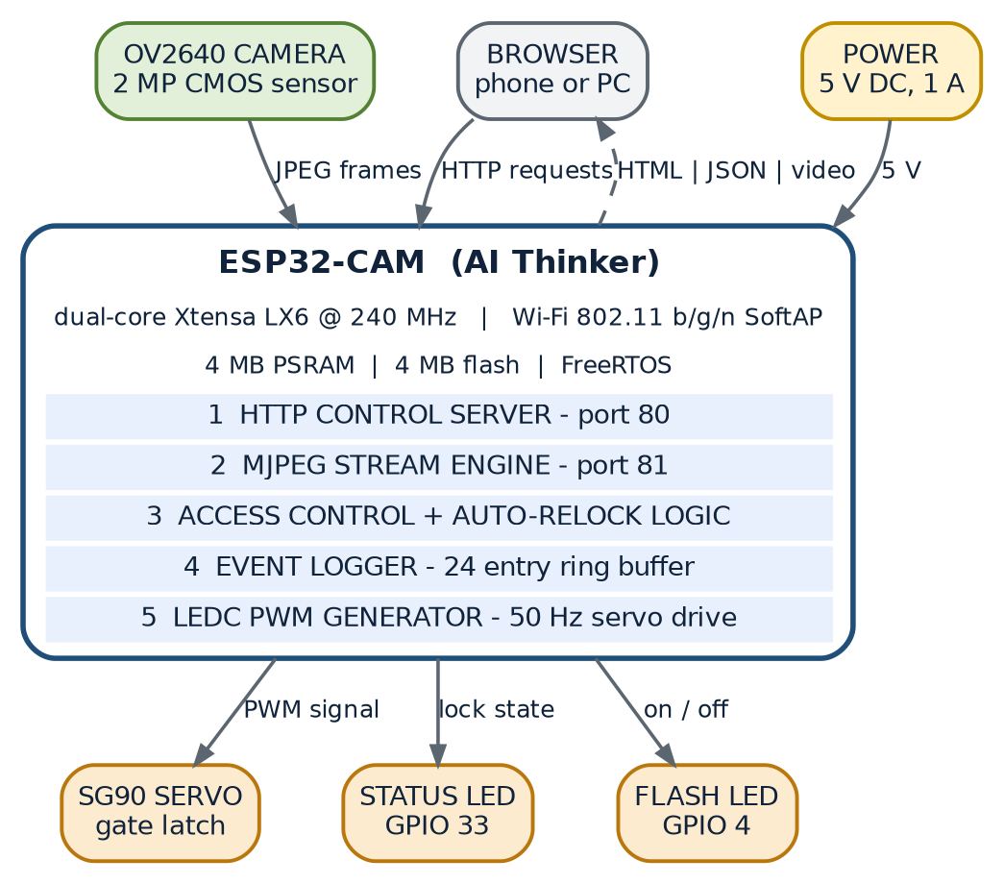
Figure 3.1 — System block diagram. The ESP32-CAM is simultaneously the access point, the web server and the video server; the five numbered software blocks are the services that run inside it.
3.2 Inputs of the System
The system consumes four categories of input, three of them digital and one of them optical:
Table 3.1 — Inputs of the system, their sources and the component that consumes them
Input | Source | Form | Handled by
HTTP control request | Browser on a client device | HTTP GET on TCP port 80, one of six URIs | httpd handlers on core 1
MJPEG stream request | Browser <img> element | HTTP GET on TCP port 81 | stream task on core 0
Optical scene | Doorway, illuminated by ambient or porch light | Analogue light through the OV2640 lens | esp_camera driver, DMA into PSRAM
Elapsed time | ESP32 system timer | Monotonic millisecond counter | millis() inside loop()
Electrical power | 5 V DC supply | Regulated DC with concurrent servo load | On-board LDO and rails

3.3 Processing Performed
Processing is organised around an event-driven control path and a continuous streaming path, deliberately kept apart:
1. Request decoding. The esp_http_server accepts a TCP connection on port 80, parses the request line, matches the URI against six registered handlers and invokes the corresponding function.
2. Command application. The unlock and lock handlers call openGate() and lockGate(), which update the global state variables, command the servo through setServoAngle(), drive the status LED and append an entry to the event log.
3. Angle-to-pulse conversion. setServoAngle() clamps the requested angle, maps it to a pulse width between 600 and 2400 microseconds, converts the pulse width into a 16-bit duty value for a 20 millisecond period and writes it to LEDC channel 1.
4. Frame acquisition and encoding. The camera driver is configured by initCamera() to deliver JPEG frames of VGA resolution directly into PSRAM; the sensor performs exposure, white balance and compression without processor involvement.
5. Frame distribution. The stream task on core 0 obtains a frame buffer, writes the multipart boundaries and headers around the JPEG payload, returns the buffer to the driver and delays for 20 milliseconds to throttle the rate and yield the processor.
6. State serialisation. status_handler() assembles a JSON document from the state variables, the client count, the uptime, the network identifiers, the flash state, the remaining auto-lock time and the entire event array.
7. Supervision. loop() compares the elapsed time since the unlock against AUTO_RELOCK_MS at least ten times per second and re-locks the gate when the interval has expired.
3.4 Outputs of the System
Table 3.2 — Outputs of the system and the component that produces each of them
Output | Destination | Nature | Produced by
Live MJPEG video | Browser on the client device | Continuous multipart/x-mixed-replace stream on port 81 | stream task
Dashboard page | Browser | Single-file HTML with embedded CSS and JavaScript | index_handler()
Status document | Browser, every 1.5 s | JSON object with state, counters and event array | status_handler()
Command acknowledgement | Browser | Small JSON confirmation object | open, lock and flash handlers
Still image | Browser | Single JPEG with inline content disposition | snapshot_handler()
Servo position | Gate latch mechanism | 50 Hz PWM, 600 to 2400 microseconds pulse | LEDC channel 1
Indicator light | On-board red LED on GPIO 33 | Logic level, high when unlocked | openGate() and lockGate()
Porch light | On-board white LED on GPIO 4 | Logic level, toggled by command | flash_handler()
Diagnostic log | USB serial console | Text at 115200 baud | Serial prints throughout

3.5 Data Flow
There are two independent data flows in the system, and their separation is the defining feature of the architecture.
The control flow is short-lived and request-driven. The browser sends GET /open on port 80; the httpd task on core 1 dispatches the request to open_handler(); the handler calls openGate(), which writes the servo duty through the LEDC peripheral, sets the status LED, updates the global state and appends to the ring buffer; a JSON acknowledgement returns on the same connection. The browser then polls GET /status every 1.5 seconds to refresh the badge, the countdown, the viewer count, the uptime and the log.
The video flow is continuous and connection-oriented. The browser opens one long-lived request to port 81 with the URL embedded in an <img> element; the stream task accepts the socket, writes the multipart header, and then loops: acquire a JPEG frame from the driver, write a boundary block with the frame, release the buffer, pause 20 milliseconds. This loop continues until the client disconnects.
Because the two flows share no socket, no port and no task, congestion in the video path cannot delay a control request. The only resources they share are the camera driver and the processor bandwidth, and both are managed by FreeRTOS priorities.
3.6 System Workflow
From the operator's point of view the workflow is short and linear:
1. The device is powered. The firmware disables the brown-out detector, initialises the serial port, the LED pins, the servo and the camera, starts the access point and starts both servers. Total time to a ready stream: approximately 5.4 seconds.
2. The operator joins the Wi-Fi network SmartDoorLock and opens http://192.168.4.1 in a browser. The dashboard appears and the video panel begins to fill within a second.
3. A visitor arrives. The operator looks at the live image and if necessary switches the porch light on to illuminate the doorway.
4. The operator decides. Tapping Open Gate sends GET /open; the servo moves to 90 degrees, the status LED lights, the badge changes to UNLOCKED and a countdown starts.
5. The gate re-locks automatically when the countdown reaches zero, or immediately if the operator taps Keep Locked.
6. Every action has meanwhile been appended to the activity log, which the operator can review on the same screen.
3.7 Module Relationships
The firmware is composed of nine cooperating modules. The dependency structure is deliberately shallow: the command handlers depend on the access-control service, which depends on the servo module, and everything else is independent.
Table 3.3 — Module relationship matrix
Module | Depends on | Used by | Shared state touched
Servo control | LEDC driver | Access-control service | None
Access control | Servo control, GPIO, event log | open, lock and status handlers | gateOpen, unlockStart
Event log | None | Access control, auto-lock supervisor, status aggregator | events[], evtCount
Camera | esp_camera driver, PSRAM | Stream task, snapshot handler | Camera frame queue
HTTP server | LwIP, esp_http_server | All six handlers | None directly
Stream task | Camera, Wi-Fi server socket | One browser per connection | Camera frame queue
Wi-Fi AP | ESP32 Wi-Fi driver | Every client | apIPStr
Web UI | fetch API, HTML image element | Operator | None directly
Auto-lock supervisor | Access control, event log | loop() on core 1 | gateOpen, unlockStart

3.8 Feature Inventory
Every feature implemented in the firmware is listed below, together with the function that realises it and the chapter in which it is documented. This inventory is the basis of the requirement verification matrix in Chapter 16.
Table 3.4 — Complete feature inventory with traceability
ID | Feature | Implemented by | Documented in
F-01 | Self-hosted Wi-Fi access point | WiFi.mode() and WiFi.softAP() in setup() | Ch. 8, 11
F-02 | Live MJPEG video stream | streamTask() on port 81 | Ch. 7, 8, 11
F-03 | Responsive operation dashboard | INDEX_HTML served by index_handler() | Ch. 13
F-04 | Unlock command | open_handler() and openGate() | Ch. 7, 8, 10
F-05 | Lock command | lock_handler() and lockGate() | Ch. 7, 8, 10
F-06 | Automatic re-lock timer | loop() supervisor with AUTO_RELOCK_MS | Ch. 12
F-07 | Porch-light toggle | flash_handler() and GPIO 4 | Ch. 7, 8
F-08 | Still snapshot capture | snapshot_handler() | Ch. 8, 10
F-09 | Event log with timestamps | addEvent() and the Evt ring buffer | Ch. 9
F-10 | JSON status polling | status_handler() and the browser poll loop | Ch. 10
F-11 | Lock-state badge and countdown | update() and poll() in the page script | Ch. 13
F-12 | Local status LED indication | GPIO 33 driven by the access-control service | Ch. 5, 8
F-13 | Calibratable servo travel | OPEN_ANGLE, LOCK_ANGLE, SERVO_MIN_US, SERVO_MAX_US | Ch. 5, 12, 21
F-14 | PSRAM-aware frame configuration | initCamera() fallback branch | Ch. 7, 8
F-15 | Image orientation correction | CAM_VFLIP and CAM_HMIRROR sensor settings | Ch. 7, 21
F-16 | Serial diagnostic output | Serial prints in setup and the stream task | Ch. 20

Reading guide. Chapters 4 and 5 specify what is needed to reproduce the system. Chapter 6 presents the architecture graphically. Chapters 7 to 12 document the implementation in increasing detail, from modules to code to data to protocols to algorithms. Chapters 13 to 16 evaluate the design, and Chapters 17 to 25 support the operator and the examiner.
CHAPTER 4
SOFTWARE REQUIREMENTS
4.1 Overview of the Software Stack
The project uses one integrated development environment on the host computer and a single monolithic firmware image on the device. The firmware is written in C/C++ against the Arduino core for ESP32, which itself is a thin layer over the Espressif IoT Development Framework (ESP-IDF). This layering is important for understanding the code: calls such as WiFi.softAP() and Serial.begin() come from the Arduino layer, esp_camera_init() and httpd_start() come from ESP-IDF components, xTaskCreatePinnedToCore() comes from FreeRTOS, and ledc_set_duty() comes from the ESP-IDF peripheral driver. All four layers are compiled into one binary by the same toolchain.
4.2 Host Computer Requirements
Table 4.1 — Host computer and tool requirements
Item | Requirement | Remark
Operating system | Windows 10 or later, macOS 11 or later, or any modern Linux distribution | Drivers for the CP2102 or CH340 USB-serial bridge are required on Windows
Processor and memory | Dual-core processor, 4 GB RAM minimum, 8 GB recommended | The ESP32 toolchain and the IDE are memory-hungry during compilation
Free disk space | 2 GB for the IDE and the ESP32 board support package | Additional space for the serial monitor logs and the schematic files
USB port | One free USB 2.0 port | An external FTDI or CP2102 programmer is required because the ESP32-CAM board has no on-board USB socket
Internet | Required once, to download the IDE and the board support package | Not required at run time by the device itself

4.3 Integrated Development Environment
The firmware was developed with the Arduino IDE (version 2.x), configured with the ESP32 board support package of version 2.0.0 or later. The IDE provides the editor, the compiler front end, the uploader and the serial monitor in a single window. Alternative environments that compile the same source without modification are the PlatformIO extension for Visual Studio Code, the ESP-IDF through its Arduino-as-a-component route, and the arduino-cli command-line tool.
Table 4.2 — Build and upload configuration
Setting | Value used in this project | Where it is set
Board | AI Thinker ESP32-CAM | Tools → Board → ESP32 Arduino
ESP32 board package | 2.0.0 or later | Boards Manager
Upload speed | 115200 baud | Tools → Upload Speed
Flash frequency | 80 MHz (default for the board) | Tools → Flash Frequency
Flash mode | QIO or DIO as reported by the selected board | Tools → Flash Mode
Partition scheme | Default / Huge APP as required by the sketch size | Tools → Partition Scheme
PSRAM | Enabled automatically; the firmware detects it at run time | Detected by psramFound() in initCamera()
Programmer | USB-TTL adapter on GPIO 1 (TX0) and GPIO 3 (RX0) | Manual wiring; GPIO 0 is grounded to enter download mode
Monitor speed | 115200 baud | Tools → Serial Monitor

4.4 Programming Languages
Table 4.3 — Programming languages and their roles
Language | Used for | Share of the code base
C++ (Arduino dialect) | All firmware logic: setup, loop, servo control, camera initialisation, handlers, the stream task and the event log | Approximately 40 % of the source lines
C | The embedded web page is stored as a single C string literal; the ESP-IDF components it calls are written in C | Structural
HTML5 | The dashboard markup inside INDEX_HTML | Approximately 15 %
CSS3 | The dashboard design system: grid, glass panels, buttons, badges, toast and scroll bars | Approximately 20 %
JavaScript (ES2017) | Client-side polling, command dispatch, countdown, log rendering and toasts | Approximately 25 %

Why a single file? The web interface is embedded directly in the firmware as a raw string literal (INDEX_HTML). This removes any dependency on an SD card, a file system or a second upload step: flashing the sketch also flashes the user interface. The trade-off is that the page is recompiled whenever it is edited.
4.5 Libraries
Table 4.4 — Software libraries used by the firmware
Include | Library or component | Purpose in this project | Key symbols used
esp_camera.h | Espressif camera driver | Initialises the OV2640 and delivers JPEG frames | camera_config_t, esp_camera_init(), esp_camera_fb_get(), sensor_t
esp_http_server.h | ESP-IDF HTTP server | Serves the dashboard and the JSON API on port 80 | httpd_handle_t, httpd_config_t, httpd_uri_t, httpd_resp_send()
driver/ledc.h | LEDC PWM peripheral driver | Generates the 50 Hz servo control pulse | ledc_timer_config(), ledc_channel_config(), ledc_set_duty()
WiFi.h | Arduino Wi-Fi library | Creates the soft access point and the raw TCP server socket | WiFi.mode(), WiFi.softAP(), WiFi.softAPIP(), WiFiServer, WiFiClient
soc/soc.h and soc/rtc_cntl_reg.h | SoC register definitions | Allows the brown-out detector to be disabled before the servo load is applied | WRITE_PERI_REG(), RTC_CNTL_BROWN_OUT_REG
string.h | C standard string library | Safe copying and formatted building of text | strncpy(), strlen(), snprintf()
freertos/FreeRTOS.h | FreeRTOS kernel API | Task creation and scheduling primitives | xTaskCreatePinnedToCore(), TaskHandle_t
freertos/task.h | FreeRTOS task API | Task delay and handle declarations | delay(), task prototypes

4.6 Frameworks and SDKs
Table 4.5 — Frameworks and SDKs in the build
Framework or SDK | Version | Role
Arduino core for ESP32 | 2.0.0 or later | Provides the setup() and loop() program model, the WiFi and Serial abstractions and the build system
ESP-IDF | Bundled with the Arduino core | Supplies the camera driver, the HTTP server, the LEDC driver and the SoC register definitions
FreeRTOS | Bundled with ESP-IDF | Real-time kernel; the application runs as the Arduino task on core 1 plus one user task on core 0
LwIP | Bundled with ESP-IDF | TCP/IP stack that carries the HTTP traffic and the soft-AP DHCP server
mbedTLS | Bundled but unused | Present in the toolchain; no TLS session is established by this firmware

4.7 Operating System Environment
Three different operating-system contexts are involved and must not be confused:
• Device firmware: no general-purpose operating system. The FreeRTOS real-time kernel schedules the Arduino application task and the stream task, with the Wi-Fi, TCP/IP and camera driver tasks running at higher priorities in the background.
• Development host: Windows, macOS or Linux running the Arduino IDE and the ESP32 toolchain.
• Client device: any operating system with a modern browser — Android, iOS, Windows, macOS, Linux or ChromeOS. Nothing is installed on the client; it only needs a browser and a Wi-Fi interface.
4.8 Browser Requirements
Table 4.6 — Browser capabilities required by the dashboard
Capability | Requirement | Used for
MJPEG rendering | Native support for multipart/x-mixed-replace inside an <img> element | Live video panel
Fetch API | ES2017 fetch() with cache: no-store | Command dispatch and status polling
CSS Grid and custom properties | CSS Grid Level 1 and CSS variables | Two-column desktop layout
Flexible box layout | Flexbox | Header, control stack and log rows
Timers | setInterval() | Status polling every 1.5 seconds
JavaScript minimum | ES2017: const, let, arrow functions, async/await, template free string concatenation | All client-side logic
Viewport meta support | viewport and theme-color meta tags | Mobile rendering and browser chrome colour

The interface was verified on Chrome for Android, Chrome and Firefox for desktop, and Safari on iOS. Because the page contains no external stylesheet, script, font or image, it renders identically with or without internet access; every visual element is drawn from embedded CSS and inline SVG icons.
4.9 Cloud Services
None. The firmware makes no outbound network connection of any kind. There is no MQTT broker, no HTTP client, no time server, no device registry and no analytics endpoint. The Wi-Fi interface operates purely in soft-AP mode, which by definition is not associated with any infrastructure network. This is a design decision, not an omission: it is what allows the system to work during an internet outage and what keeps doorway video inside the premises.
4.10 Application Programming Interfaces
Two categories of API are present. The internal HTTP API exposed by the device to its clients is documented in full in Chapter 10 and consists of six endpoints on port 80 and one stream endpoint on port 81. The external APIs consumed by the project are the Arduino, ESP-IDF, FreeRTOS, LwIP and LEDC programming interfaces listed in Table 4.4. No third-party web API is called.
4.11 Resource Budget of the Firmware
Table 4.7 — Firmware resource budget
Resource | Available on the module | Consumed by this firmware | Headroom
Flash program storage | 4 MB | Approximately 1.1 MB including the embedded web page | Ample; the default partition scheme is sufficient
Internal SRAM | 520 KB | Statics, stacks and LwIP buffers, approximately 130 KB | Comfortable
PSRAM | 4 MB on most modules | Two VGA JPEG frame buffers plus driver structures | Ample; a CIF fallback path exists when PSRAM is absent
Wi-Fi stations in soft-AP mode | 4 concurrent stations | Typically 1 to 3 devices | Adequate for the intended deployment
TCP sockets for httpd | Default configuration | Six URI handlers, transient connections | Comfortable; long-lived connections are used only on port 81

CHAPTER 5
HARDWARE REQUIREMENTS
5.1 Bill of Materials
Table 5.1 — Bill of materials with indicative costs
# | Component | Quantity | Specification | Indicative cost (INR)
1 | ESP32-CAM (AI Thinker) module | 1 | Dual-core 240 MHz, 4 MB PSRAM, 4 MB flash, OV2640 camera socket | 450 – 700
2 | OV2640 camera module | 1 | 2 MP, 24-pin FPC, supplied with the ESP32-CAM board | Included
3 | SG90 micro servo | 1 | 4.8 – 6 V, 180 degrees, 1.8 kg-cm, 9 g | 120 – 200
4 | 5 V regulated supply with USB or screw terminals | 1 | 5 V, 1 A minimum, 2 A recommended | 150 – 300
5 | USB-TTL serial adapter (CP2102 or CH340) | 1 | 3.3 V logic, for programming and monitoring | 120 – 250
6 | Jumper wires and a 3-pin female header for the servo | As required | Male to female, 20 cm | 40 – 80
7 | Servo horn, mounting bracket and machine screws | 1 set | Plastic horn set supplied with the servo | 50 – 120
8 | Latch bolt, sliding bar or gate hook | 1 | Match the servo torque and the door thickness | 80 – 250
9 | Enclosure for the camera board | 1 | Vented box with a 20 mm lens opening | 100 – 250
10 | Electrolytic capacitor 470 uF and ceramic 100 nF | 1 each | Decoupling across the servo supply | 20
 | Total |  |  | Approximately 1200 – 2200

5.2 ESP32-CAM Module (AI Thinker)
5.2.1 Purpose
The ESP32-CAM is the single processing element of the system. It hosts the Wi-Fi access point, runs both HTTP servers, executes the access-control logic, generates the servo PWM waveform and captures and compresses the video frames.
5.2.2 Working Principle
The board centres on the ESP32-S system-on-chip, which contains two Xtensa LX6 cores running at up to 240 MHz, 520 KB of on-chip SRAM, a Wi-Fi radio and a large set of peripheral controllers. An external 4 MB PSRAM die and a 4 MB SPI flash die are connected to the same SPI bus through the chip's cache controller, and the camera is wired to the processor through a dedicated 8-bit parallel digital video port with its own pixel clock, horizontal reference and vertical sync lines. Two of the serial lines on the camera connector are reused as a serial camera control bus, an I2C-compatible two-wire link on which the processor writes sensor registers.
Because the camera occupies most of the usable GPIO pins, only a few pins remain free for external devices. In this project GPIO 2 drives the servo, GPIO 4 drives the on-board flash LED and GPIO 33 drives the on-board red LED. The pin map of the module is given in Table 5.2 and the camera-specific mapping in Table 5.3.
Table 5.2 — ESP32-CAM pin utilisation map
Pin | Functional name in this firmware | Direction | Notes
GPIO 0 | Camera XCLK, also the boot-mode strap | Output to the camera | Must be pulled low only while flashing; left free at run time
GPIO 2 | SERVO_PIN — servo control pulse | Output | Free pin, safe to use, also a boot strap that must not be low at reset
GPIO 4 | FLASH_PIN — porch light | Output | Shared with the SD card data line; unused when no card is fitted
GPIO 5, 18, 19, 21 | Camera data lines Y2 to Y5 | Input from the camera | Reserved by the camera bus
GPIO 22 | Camera PCLK | Input | Pixel clock from the sensor, approximately 20 MHz
GPIO 23 | Camera HREF | Input | Horizontal reference
GPIO 25 | Camera VSYNC | Input | Vertical sync
GPIO 26 | Camera SIOD | Bidirectional | SCCB data line for sensor control
GPIO 27 | Camera SIOC | Output | SCCB clock line for sensor control
GPIO 32 | Camera PWDN | Output | Power-down control, held inactive by the driver
GPIO 33 | STATUS_LED_PIN — red indicator LED | Output | High when the gate is unlocked
GPIO 34, 35, 36, 39 | Camera data lines Y6 to Y9 | Input only | These pins cannot be used as outputs; they also have no internal pull-up
GPIO 1 and 3 | UART0 TX and RX | Bidirectional | Serial console at 115200 baud
5 V and GND | Supply rails | Power | 5 V, at least 1 A available

Table 5.3 — Camera bus mapping as declared in `initCamera()`
Camera signal | ESP32 GPIO | `camera_config_t` member
XCLK | 0 | pin_xclk
PCLK | 22 | pin_pclk
VSYNC | 25 | pin_vsync
HREF | 23 | pin_href
SIOD (SCCB data) | 26 | pin_sccb_sda
SIOC (SCCB clock) | 27 | pin_sccb_scl
PWDN | 32 | pin_pwdn
RESET | not connected (–1) | pin_reset
D0 to D7 (Y2 to Y9) | 5, 18, 19, 21, 36, 39, 34, 35 | pin_d0 to pin_d7

5.2.3 Key Specifications
Table 5.4 — ESP32-CAM specifications
Parameter | Value
Processor | ESP32-S, dual-core Xtensa LX6, up to 240 MHz
Internal SRAM | 520 KB
External PSRAM | 4 MB (present on the AI Thinker variant used here)
Flash | 4 MB SPI flash
Wi-Fi | 802.11 b/g/n, 2.4 GHz, station, soft-AP and soft-AP plus station modes
Camera interface | 8-bit parallel DVP with SCCB control, 20 MHz master clock
Logic level | 3.3 V for all GPIO
Supply | 5 V input, on-board 3.3 V regulator
Antenna | PCB meander antenna with an optional U.FL connector
Remaining GPIO after the camera | GPIO 1, 3, 2, 4, 12, 13, 14, 15, 16, 33

5.2.4 Why This Module Was Selected
• It is the only widely available module that integrates a microcontroller, Wi-Fi and a camera at this price point.
• The camera is factory-wired, removing 16 hand-soldered connections that would otherwise be the least reliable part of the build.
• PSRAM is essential for video: without it the driver must fall back to a much smaller frame size, and this firmware detects the condition and adapts automatically.
• The board is fully supported by the Arduino core, and the esp_camera and esp_http_server components reduce the implementation to a few hundred lines of application code.
• Two processor cores make it possible to isolate video streaming from the control path — the key design idea of this project.
5.2.5 Alternative Modules Considered
Table 5.5 — Alternative controller modules
Alternative | Advantage | Why it was not chosen
ESP32-S3-EYE | Better camera, native USB, more PSRAM and GPIO | Two to three times the cost; the extra capability is not needed for a single lock node
ESP8266 plus a separate camera | Lower cost processor | Single core cannot separate streaming from control; no camera DVP interface
Raspberry Pi Zero 2 W with a camera | Full Linux, face recognition possible | Higher cost, longer boot, SD card reliability risk, higher idle power
ESP32 DevKit with an external camera module | More free GPIO | Requires hand wiring of 16 camera signals and suitable 3.3 V regulation

5.3 OV2640 Camera Module
Purpose. The camera is the sensing element of the system; it turns the visible scene at the door into a stream of JPEG frames that the operator can inspect before granting access.
Working principle. The OV2640 is a 2 MP CMOS image sensor with a two-megapixel active area of 1632 by 1232 pixels covered by a Bayer colour filter array. An on-chip image signal processor performs de-mosaicing, automatic exposure control, automatic white balance and gamma correction. The sensor transmits data over an 8-bit parallel bus synchronised by pixel clock, horizontal reference and vertical sync signals, and is configured by the processor over the SCCB control bus. An on-chip hardware encoder emits JPEG directly, which is what makes a 240 MHz microcontroller able to handle VGA video: the processor never compresses a frame itself.
Table 5.6 — Camera configuration parameters
Parameter | Value or setting
Sensor | OV2640, 2 MP CMOS, 1/4 inch optical format
Maximum resolution | 1600 by 1200 pixels
Configured resolution | VGA, 640 by 480 (CAM_FRAMESIZE) with a CIF fallback
Output format | JPEG (PIXFORMAT_JPEG), chosen so that no processor-side encoding is required
JPEG quality setting | 12 on the driver scale of 1 (best, largest) to 63 (worst, smallest)
Master clock | 20 MHz generated by LEDC timer 0 inside the camera driver
Frame buffers | 2 when PSRAM is present, otherwise 1
Grab mode | CAMERA_GRAB_LATEST, so the stream always sends the freshest frame
Orientation | Vertical flip and horizontal mirror both enabled by default (CAM_VFLIP, CAM_HMIRROR)
Post-processing | Brightness +1, contrast 0, saturation 0 (neutral, with a slight brightness lift)

Why this camera. It is supplied with the ESP32-CAM module, is supported by the ESP-IDF driver, and its hardware JPEG encoder is the single feature that makes live VGA streaming possible on this class of processor. Higher-resolution alternatives such as the OV3660 or OV5640 fit the same socket but reduce the achievable frame rate on this chip without improving the operational value of the door image.
5.4 SG90 Micro Servo Motor
Purpose. The servo converts the digital decision made in the browser into a physical rotation that moves the latch between the locked and unlocked positions.
Working principle. Inside the servo are a small DC motor, a plastic reduction gear train, a feedback potentiometer coupled to the output shaft, and a control circuit. The control circuit compares the width of the incoming pulse with the voltage from the potentiometer and drives the motor in the appropriate direction until the two agree. The pulse train repeats every 20 milliseconds, so the accepted pulse-width range of roughly 1000 to 2000 microseconds maps onto the mechanical travel. This firmware widens that range deliberately, using 600 to 2400 microseconds to obtain usable travel at both mechanical ends after calibration.
The relationship implemented in setServoAngle() is:
pulse_us = SERVO_MIN_US + (angle / 180) * (SERVO_MAX_US - SERVO_MIN_US)
= 600 us + (angle / 180) * 1800 us

duty_16bit = round( pulse_us / 20000 us * 65535 )

For the two operating points used by the lock the values are:
Table 5.7 — Servo operating points
Command | Angle | Pulse width | LEDC duty value (16-bit) | Mechanical result
LOCK_ANGLE | 0 degrees | 600 microseconds | 1966 counts | Latch bolt engaged, gate secured
OPEN_ANGLE | 90 degrees | 1500 microseconds | 4915 counts | Latch bolt withdrawn, gate free

Table 5.8 — SG90 servo specifications
Parameter | Value
Model | SG90, analogue micro servo
Operating voltage | 4.8 V to 6.0 V
Stall torque | Approximately 1.8 kg-cm at 4.8 V
Operating speed | Approximately 0.1 second per 60 degrees
Rotation range | 0 to 180 degrees, commanded here only between 0 and 90 degrees
Idle current | Approximately 10 mA
Running current | Approximately 100 to 250 mA
Stall current | Up to approximately 700 mA, the worst case that shapes the power design
Mass | 9 grams
Wiring | Orange: signal to GPIO 2; red: 5 V; brown: ground

5.4.1 Torque Requirement Check
The torque needed to move a latch bolt is the product of the force required to overcome friction and the radius of the servo horn:
torque_required = F_latch x r_horn

For F_latch = 0.25 kg of friction force and r_horn = 1.5 cm:
torque_required = 0.25 x 1.5 = 0.375 kg-cm

SG90 available torque = 1.8 kg-cm
Safety factor = 1.8 / 0.375 = 4.8

A safety factor of nearly five provides margin for friction variation, ageing of the plastic gears and a slightly misaligned latch. If a heavier bolt is used, the torque budget must be recomputed and an MG90S (metal gears) or MG996R servo substituted; the firmware needs no change because the pulse range is a constant.
5.4.2 Alternatives Considered
Table 5.9 — Alternative actuators
Alternative | Advantage | Why it was not chosen
Solenoid lock (12 V) | Very fast, holds a door closed mechanically | Needs a relay and a 12 V rail; draws continuous current while open; heavier driver circuit
MG996R servo | Far higher torque, metal gears | Over-specified for a light latch; larger current surge and larger physical size
Stepper motor with a driver | Precise position, high holding torque | Requires a driver board and a multi-pin interface; the code would need a motion profile
Brushed DC motor with limit switches | Cheap and strong | No intrinsic position feedback; two extra limit-switch GPIO pins, which are scarce on this board

5.5 Indicator and Illumination LEDs
Table 5.10 — Indicator LEDs
Device | Pin | Purpose | Electrical detail
White flash LED | GPIO 4 | Porch light; illuminates the doorway for the camera before a decision | Driven directly from the pin, 40 to 80 mA when on; shared with the SD card data line, which is unused in this design
Red status LED | GPIO 33 | Local lock-state indication: dark when locked, lit when unlocked | Driven from the pin, 5 to 10 mA; also serves as a visual confirmation that the board is powered

5.6 Power Supply Design
The power design is dominated by the servo. A small hobby servo draws little current while idle but takes a sharp current pulse when the motor starts, and the ESP32 camera module itself draws a short burst of current during boot and while the Wi-Fi transmitter is active. If the 5 V rail collapses during a servo movement, the ESP32 brown-out detector resets the processor and the gate is left in an unknown state.
Table 5.11 — Power budget of the complete system
Load | Typical current | Peak current | Notes
ESP32 core plus Wi-Fi | 80 mA | 240 mA | Peak occurs during transmission bursts
OV2640 camera and PSRAM | 60 mA | 120 mA | Measured with streaming at VGA
SG90 servo, idle | 10 mA | 10 mA | No movement, holding position
SG90 servo, moving | 150 mA | 700 mA | Stall condition; the dominant load of the system
White flash LED | 0 mA | 80 mA | Only when the porch light is switched on
Total | About 150 mA | About 900 mA | A 1 A supply is marginal; 2 A is recommended

Three measures are taken to make the rail robust. First, the brown-out detector is disabled in software as the very first instruction of setup(), which prevents an unnecessary reset during the servo transient; this is a deliberate engineering trade-off that assumes a correctly sized supply. Second, the servo is wired on its own branch directly from the supply rather than through the camera board, so that its current does not flow through the board's thin traces. Third, a 470 microfarad electrolytic capacitor with a 100 nanofarad ceramic capacitor in parallel is connected across the servo supply to absorb the switching transient.
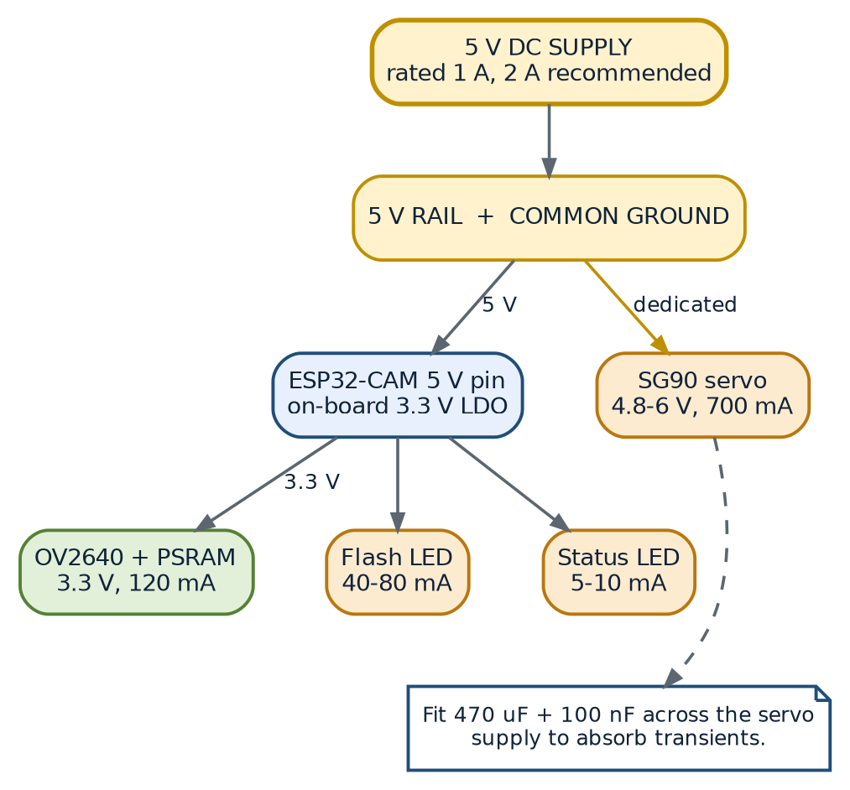
Figure 5.1 — Power distribution. The servo is fed from a dedicated branch of the 5 V rail; the camera and the logic run from the on-board 3.3 V regulator.
5.7 Mechanical Assembly and Mounting
The mechanical design has three tasks: to hold the camera so that it frames the approach to the door, to convert the rotation of the servo into the linear travel of a latch, and to keep the electronics protected while remaining reachable for programming.
1. Camera position. The board is fixed in a vented enclosure at approximately eye level, tilted slightly downward so that a visitor's face and the gate area are both inside the frame. The enclosure needs a 20 mm opening for the lens and a small hole for ventilation, because the 3.3 V regulator and the Wi-Fi radio warm the board.
2. Servo mounting. The SG90 is screwed to a bracket fixed to the frame, with the output shaft on the axis of the latch travel.
3. Rotation to translation. A horn or crank is fixed to the servo shaft and linked to the bolt so that 90 degrees of rotation produces the full stroke of the bolt. The geometry is arranged so that the two commanded angles are at the ends of the stroke rather than in the middle of it, which keeps the servo out of its stall region in both resting states.
4. Power routing. The 5 V adapter is mounted indoors with the cable entering through a grommet. The servo branch and the camera branch join only at the supply terminals.
5. Testing before final fixing. The angles are calibrated with the mechanism temporarily assembled, because the correct values depend on the horn position and the friction of the bolt.
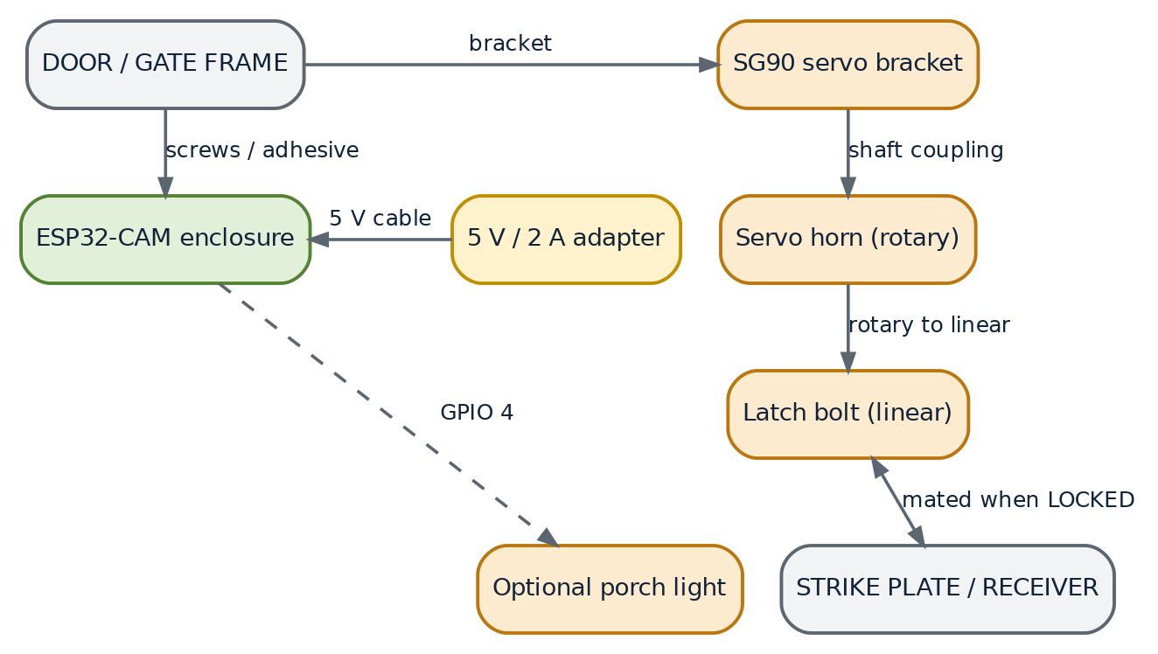
Figure 5.2 — Mechanical assembly. The servo horn converts rotary motion into the linear travel of the latch bolt; the camera board is mounted separately at viewing height.
5.8 Hardware Precautions and Constraints
• GPIO 0 is a boot strap. It must be low only while flashing. If it is held low at power-up the chip enters download mode and the firmware does not run.
• GPIO 4 is shared with the SD card. The on-board flash LED shares its pin with the SD card data line. The porch light and an SD card cannot be used at the same time; this design uses no card.
• GPIO 34 to 39 are input-only. They cannot drive the servo or an LED, and they have no internal pull-up resistors.
• GPIO 12 and 15 are strapping pins. Although the source comments list them as free, they affect the flash voltage at boot; they are left unused for safety.
• All GPIO are 3.3 V. The servo signal is compatible because the servo only reads the pulse width, but the servo supply must never be taken from the 3.3 V pin.
• Camera timing. The servo must use LEDC timer 1, since the camera driver owns timer 0.
• Antenna clearance. The PCB antenna at the end of the board must not be enclosed in metal; a metal box will reduce the Wi-Fi range severely.
CHAPTER 6
SYSTEM ARCHITECTURE
6.1 Architectural Principles
Four principles shaped the architecture, and each one is visible in the code:
1. Separation of the video path from the control path. Different ports, different sockets, different tasks and different processor cores. Streaming must never be able to delay a command.
2. A single source of truth for state. The lock state exists in exactly one place, the global boolean gateOpen, and the servo, the LED and the browser badge are all derived from it.
3. Hardware arbitration by the firmware. The camera owns LEDC timer 0; the servo owns timer 1; the conflict is resolved statically at design time rather than by run-time locking.
4. Self-supervision. Safety behaviour, in the form of automatic re-locking, is implemented in the firmware loop and does not depend on the client staying connected.
6.2 Software Architecture
The firmware is a five-layer stack. Each layer uses only the layer below it, which keeps the dependency graph acyclic and makes the code easy to follow.
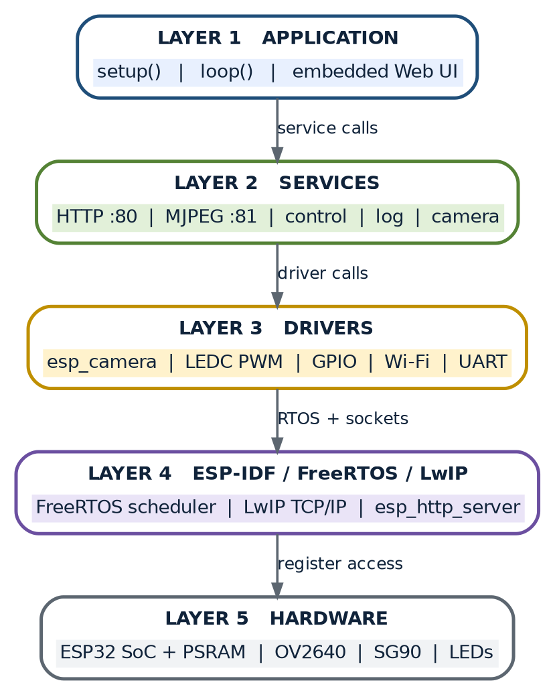
Figure 6.1 — Layered software architecture. The application layer implements the product; the service layer implements the features; the driver, kernel and hardware layers are supplied by the ESP32 ecosystem.
Table 6.1 — Layer responsibilities
Layer | Contents | Provided by
Application | setup(), loop(), the embedded web interface | This project
Service | HTTP server, MJPEG stream task, access control, event log, camera service | This project
Driver and HAL | esp_camera, LEDC, GPIO, Wi-Fi, UART drivers | ESP-IDF and Arduino core
Kernel | FreeRTOS scheduler, LwIP TCP/IP stack, esp_http_server | ESP-IDF
Hardware | ESP32 SoC, PSRAM, OV2640 sensor, SG90 servo, LEDs | Physical devices

6.3 Initialisation Flowchart
Start-up is strictly ordered, because each step establishes a precondition for the next. The brown-out detector is disabled before anything can draw current; the servo is placed in the locked position before the camera is started; the camera is configured before Wi-Fi is brought up, so that the radio current pulse does not coincide with the camera initialisation; and both servers are started only after the network exists.
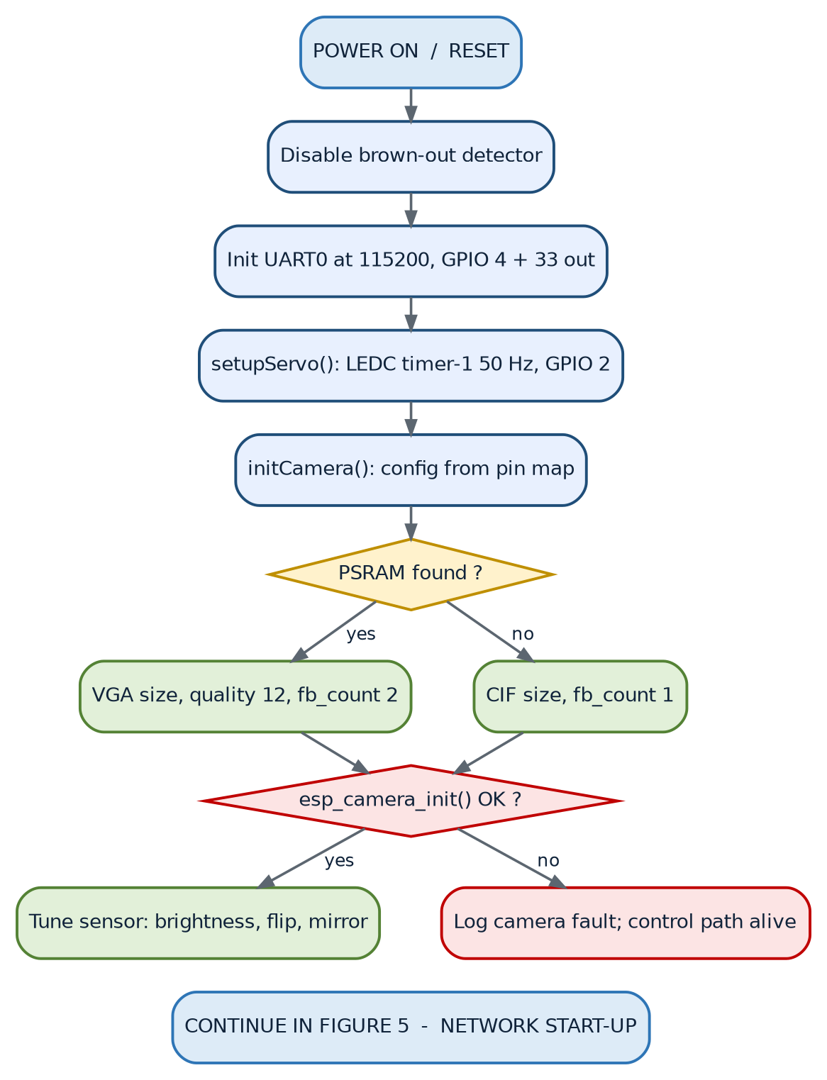
Figure 6.2 — Initialisation flowchart, part one: power-on to camera readiness, including the PSRAM and camera-error branches.
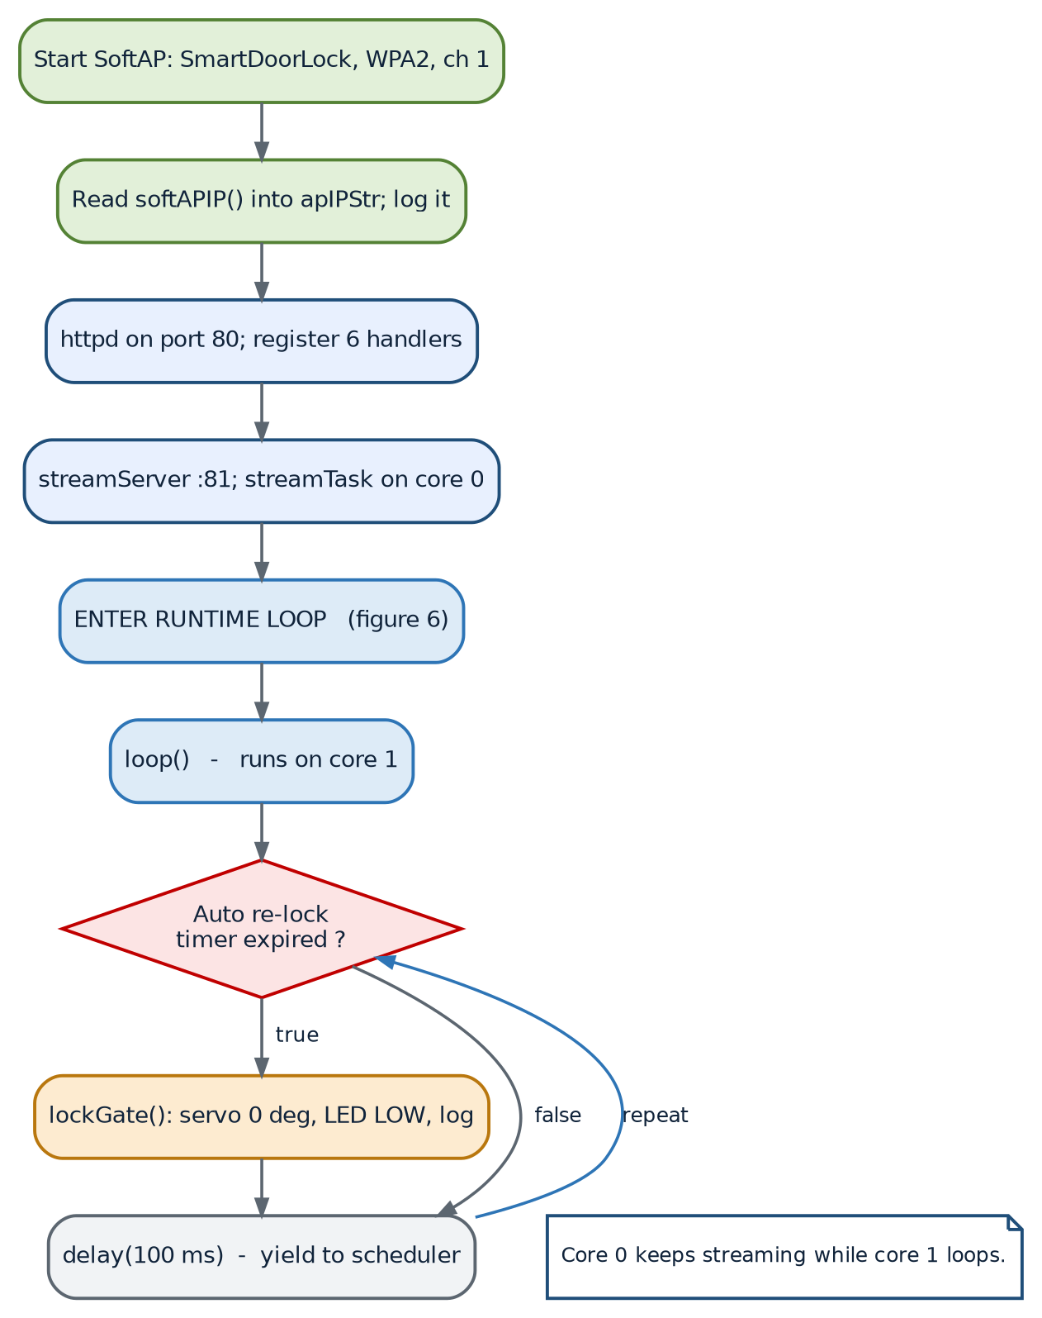
Figure 6.3 — Initialisation flowchart, part two, and the runtime loop: network start-up, both servers, and the auto re-lock test that executes for ever after.
Failure handling. Camera initialisation is the only step that can fail in normal operation. If esp_camera_init() does not return ESP_OK the firmware records the fault in the event log, prints the error code on the serial console and continues: the access point and the control endpoints still work, so the gate can be operated even with a dead camera.
6.4 Command Handling Flowchart
Once the system is running, every command follows the same four-stage path: URI routing in the httpd task, state update in the access-control service, waveform generation in the servo subroutine and confirmation back to the browser.
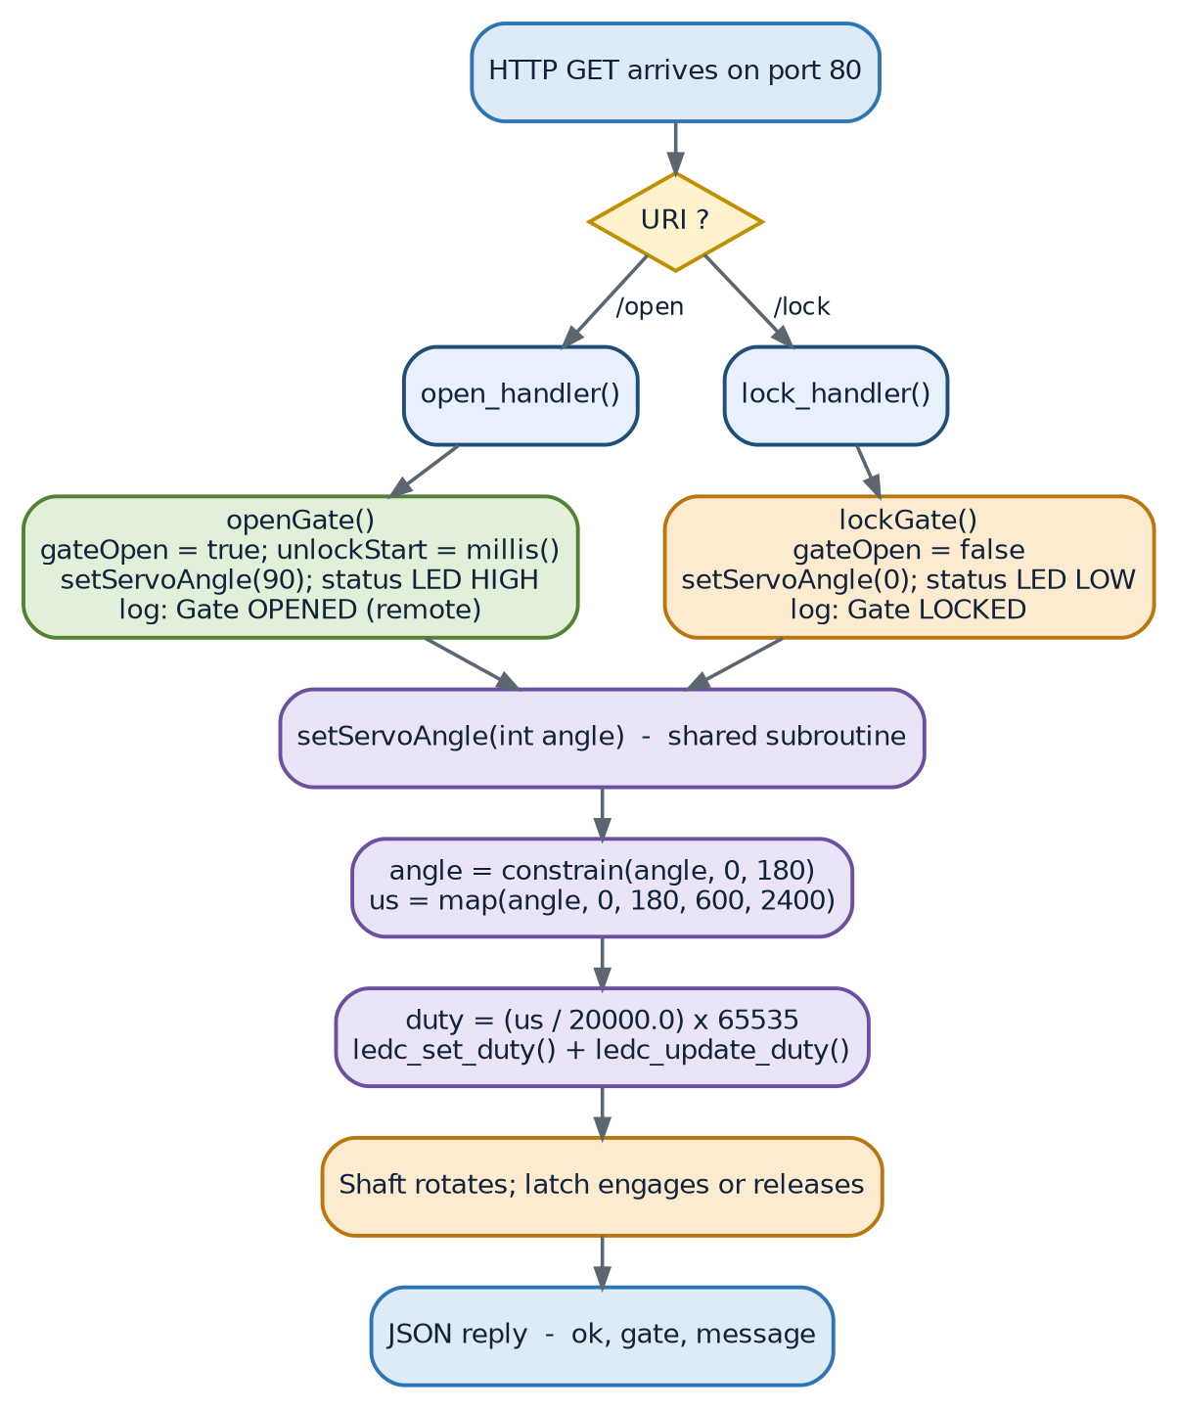
Figure 6.4 — Command handling and actuation flowchart. Both the unlock and the lock path converge on the shared `setServoAngle()` subroutine.
Table 6.2 — Stages of a command
Stage | Function | Effect | Runs on
Route | httpd URI dispatcher | Selects the handler for the requested URI | Core 1
Update state | openGate() or lockGate() | Writes gateOpen and, on unlock, unlockStart | Core 1
Actuate | setServoAngle() through LEDC | Changes the pulse width on GPIO 2 | Core 1
Indicate | digitalWrite() on GPIO 33 | Shows the state locally | Core 1
Record | addEvent() | Appends a timestamped entry to the ring buffer | Core 1
Confirm | Handler response builder | Returns a small JSON acknowledgement | Core 1

6.5 State Machine
The lock has two operational states and one fault state. The transition rules are simple, but they are the heart of the system's behaviour: any unlock is temporary, and both an explicit command and the passage of time can return the gate to the locked state.
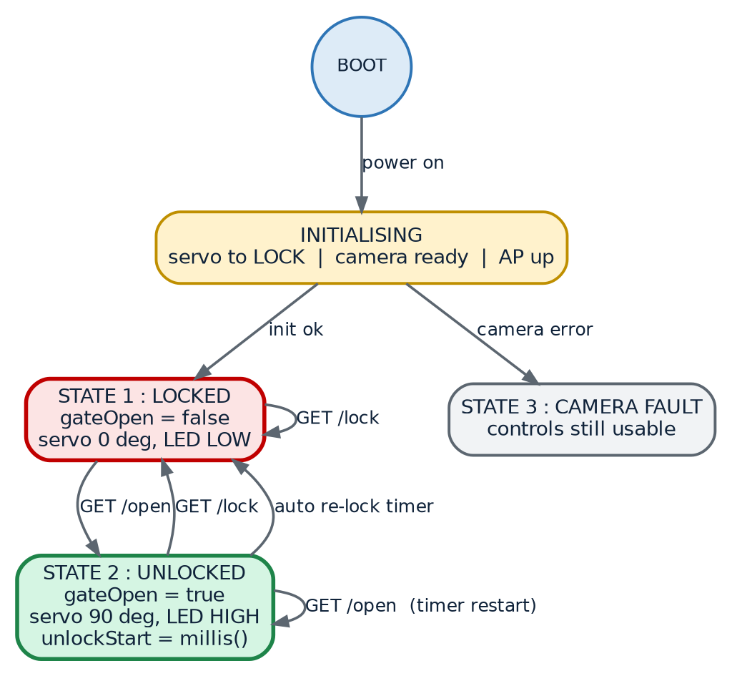
Figure 6.5 — State diagram. State 1 is the safe resting state; state 2 is transient by design; state 3 is entered only when the camera fails to initialise.
Table 6.3 — Complete state transition table
Current state | Trigger | Next state | Actions performed
Initialising | Initialisation completes | Locked | Servo 0 degrees, LED low, log entry
Initialising | esp_camera_init() fails | Camera fault | Fault logged, control path left usable
Locked | GET /open | Unlocked | Servo 90 degrees, LED high, unlockStart captured, log entry
Unlocked | GET /lock | Locked | Servo 0 degrees, LED low, log entry
Unlocked | millis() - unlockStart reaches AUTO_RELOCK_MS | Locked | Same as an explicit lock, with the log entry “Auto re-locked”
Locked | GET /lock while already locked | Locked | Idempotent: state re-asserted, log entry added
Unlocked | GET /open while already unlocked | Unlocked | Timer restarted from the new instant
Camera fault | Control commands | Camera fault | Gate control remains available; no video

6.6 Data Flow Diagrams
6.6.1 Context Diagram (Level 0)
At the highest level of abstraction the system has three external entities: the operator, the visitor and the physical gate. The operator supplies commands and receives video and status; the visitor supplies the optical scene; the gate receives the actuation and returns its mechanical position.
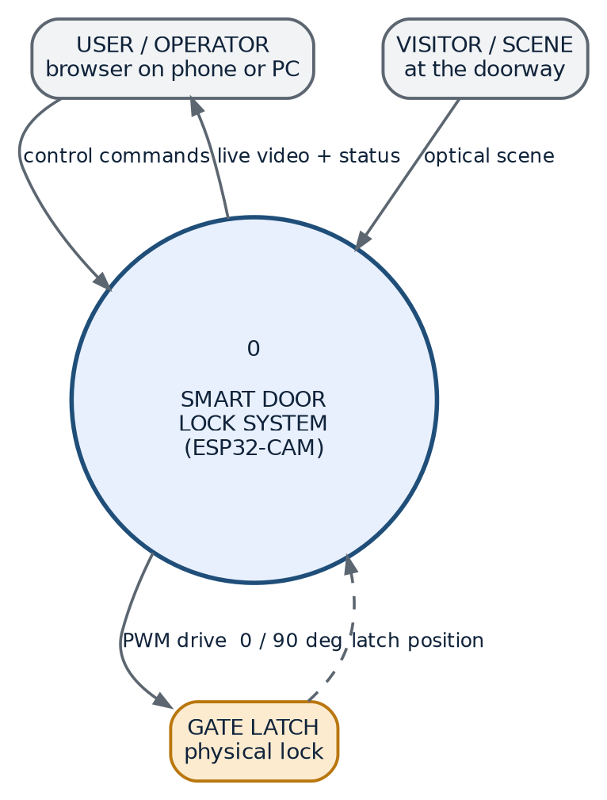
Figure 6.6 — Data flow diagram, level 0: the context of the Smart Door Lock system.
6.6.2 Functional Decomposition (Level 1)
The single process of the context diagram decomposes into seven processes and two data stores. Note that the two data stores are in RAM, not on disk: the system state and the event log are ordinary global variables and a fixed-size array.
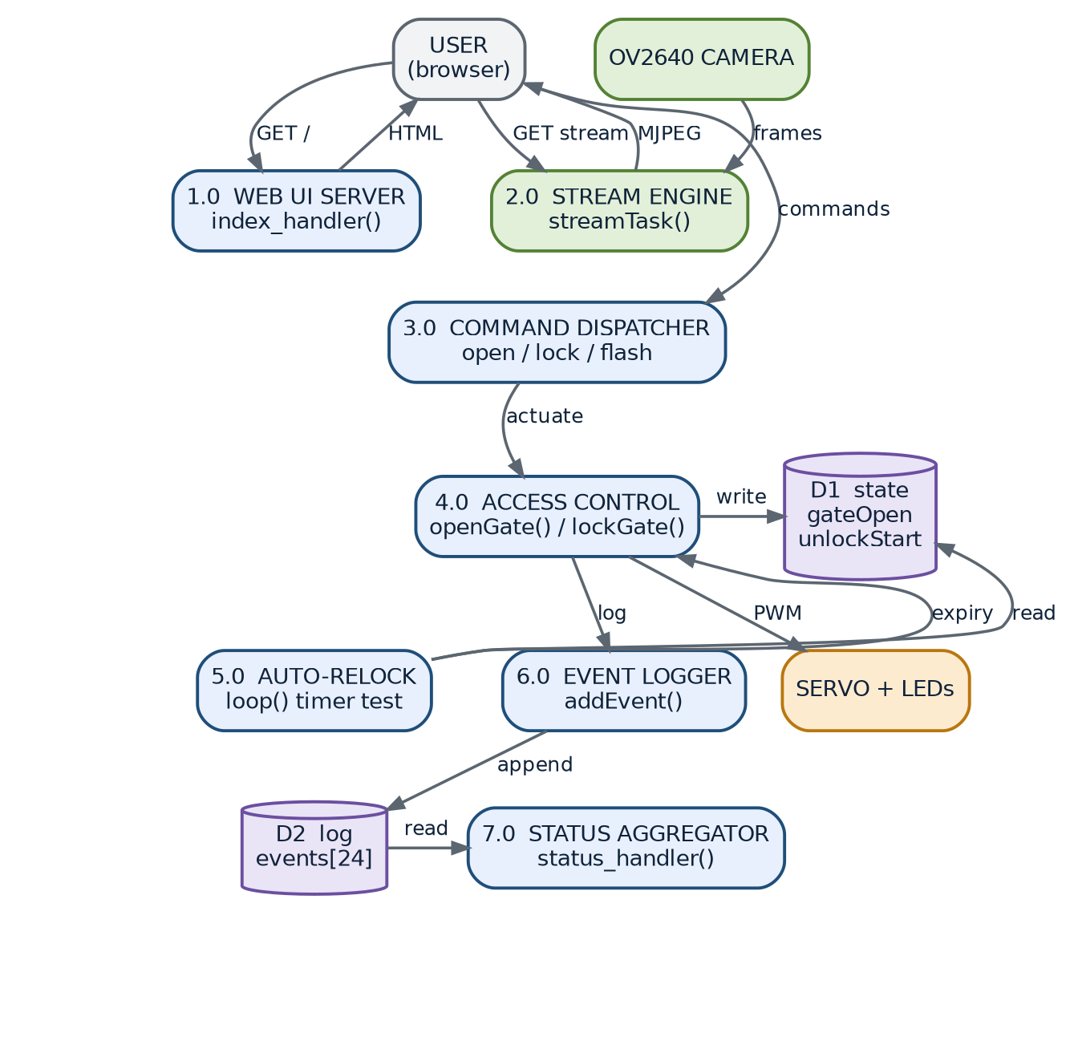
Figure 6.7 — Data flow diagram, level 1: seven processes, the system state store and the event log store.
Table 6.4 — Processes of the level-1 data flow diagram
Process | Function(s) | Inputs | Outputs
1.0 Web UI server | index_handler() | GET / | INDEX_HTML
2.0 Stream engine | streamTask() | GET /stream, camera frames | Multipart MJPEG stream
3.0 Command dispatcher | open_handler(), lock_handler(), flash_handler() | GET /open, GET /lock, GET /flash | Calls to the access-control service, JSON replies
4.0 Access control | openGate(), lockGate(), setServoAngle() | Commands from process 3.0 | PWM to the servo, GPIO writes, state writes, log entries
5.0 Auto re-lock supervisor | loop() supervisor | gateOpen, unlockStart, millis() | Calls to lockGate(), log entries
6.0 Event logger | addEvent() | Messages from processes 4.0 and 5.0 | Writes to the event store
7.0 Status aggregator | status_handler() | State store and event store | JSON status document, once per 1.5 seconds

6.7 Communication Architecture
The device exposes exactly two TCP services. The control plane on port 80 carries short, independent request-response exchanges; the data plane on port 81 carries one long-lived response of indefinite length. Because the two services are separate sockets serviced by separate tasks, neither can starve the other.
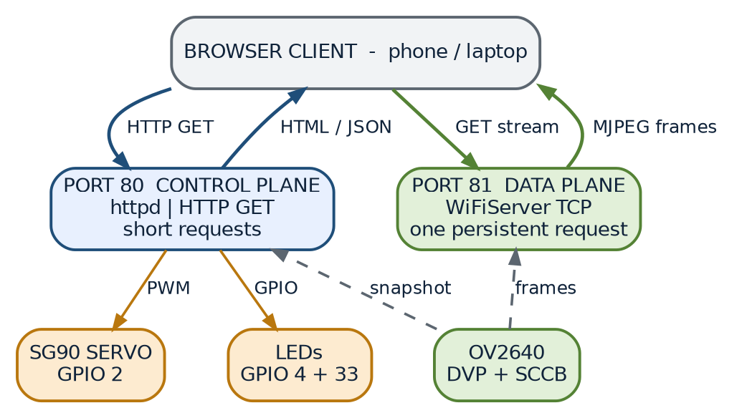
Figure 6.8 — Communication diagram. Control traffic and video traffic use different ports, and the actuators are reached only through the control plane.
Table 6.5 — Comparison of the two network planes
Property | Port 80 — control plane | Port 81 — data plane
Implementation | esp_http_server (httpd task) | WiFiServer raw socket in a user task
Protocol | HTTP/1.1 with 6 registered URI handlers | HTTP/1.1 with a single hand-written multipart response
Connection lifetime | Short: one request, one response, closed | Long: open until the viewer leaves
Response type | text/html, application/json, image/jpeg | multipart/x-mixed-replace; boundary=frame
Processor core | Core 1, with the Arduino task | Core 0, dedicated stream task
Typical usage | 600 millisecond polling plus command bursts | Continuous, throttled by a 20 ms delay
Blocking risk | None from the video path | None from the control path

6.8 Network Architecture
The ESP32 does not join a network; it *is* the network. Bringing up the soft access point creates a 2.4 GHz cell with the ESP32 as the only infrastructure node. The firmware runs an internal DHCP server that leases addresses from 192.168.4.0/24, with the device itself at 192.168.4.1, and it supports up to four associated stations. Sleep is disabled on the Wi-Fi interface so that the access point responds to association requests without latency.
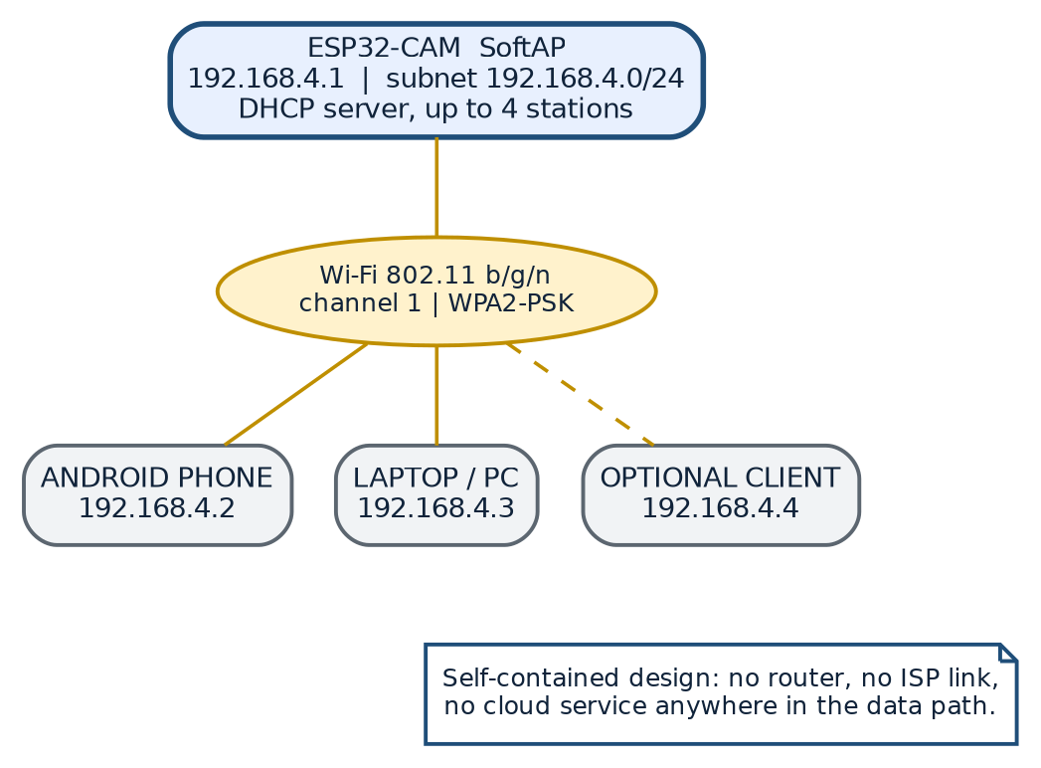
Figure 6.9 — Network topology. The ESP32-CAM is the access point, the DHCP server and the application server; clients are leaves of a single star.
Table 6.6 — Network configuration parameters
Network parameter | Value | Defined by
Mode | WIFI_AP — soft access point only | WiFi.mode(WIFI_AP)
SSID | SmartDoorLock | AP_SSID
Pre-shared key | 12345678 — eight characters, WPA2-PSK | AP_PASSWORD
Channel | 1 | AP_CHANNEL
Device address | 192.168.4.1 | WiFi.softAPIP()
DHCP pool | 192.168.4.2 onwards | ESP32 internal DHCP server
Maximum stations | 4 | ESP32 soft-AP limit
Power save | Disabled | WiFi.setSleep(false)
Server ports | 80 for control, 81 for video | STREAM_PORT, httpd configuration

6.9 Sequence of Interactions
The sequence diagram shows the complete interaction from the moment the browser joins the hotspot to the automatic re-lock five seconds after an unlock command. It makes the asynchrony of the design explicit: while the stream continues on its own socket, the control exchange proceeds independently.
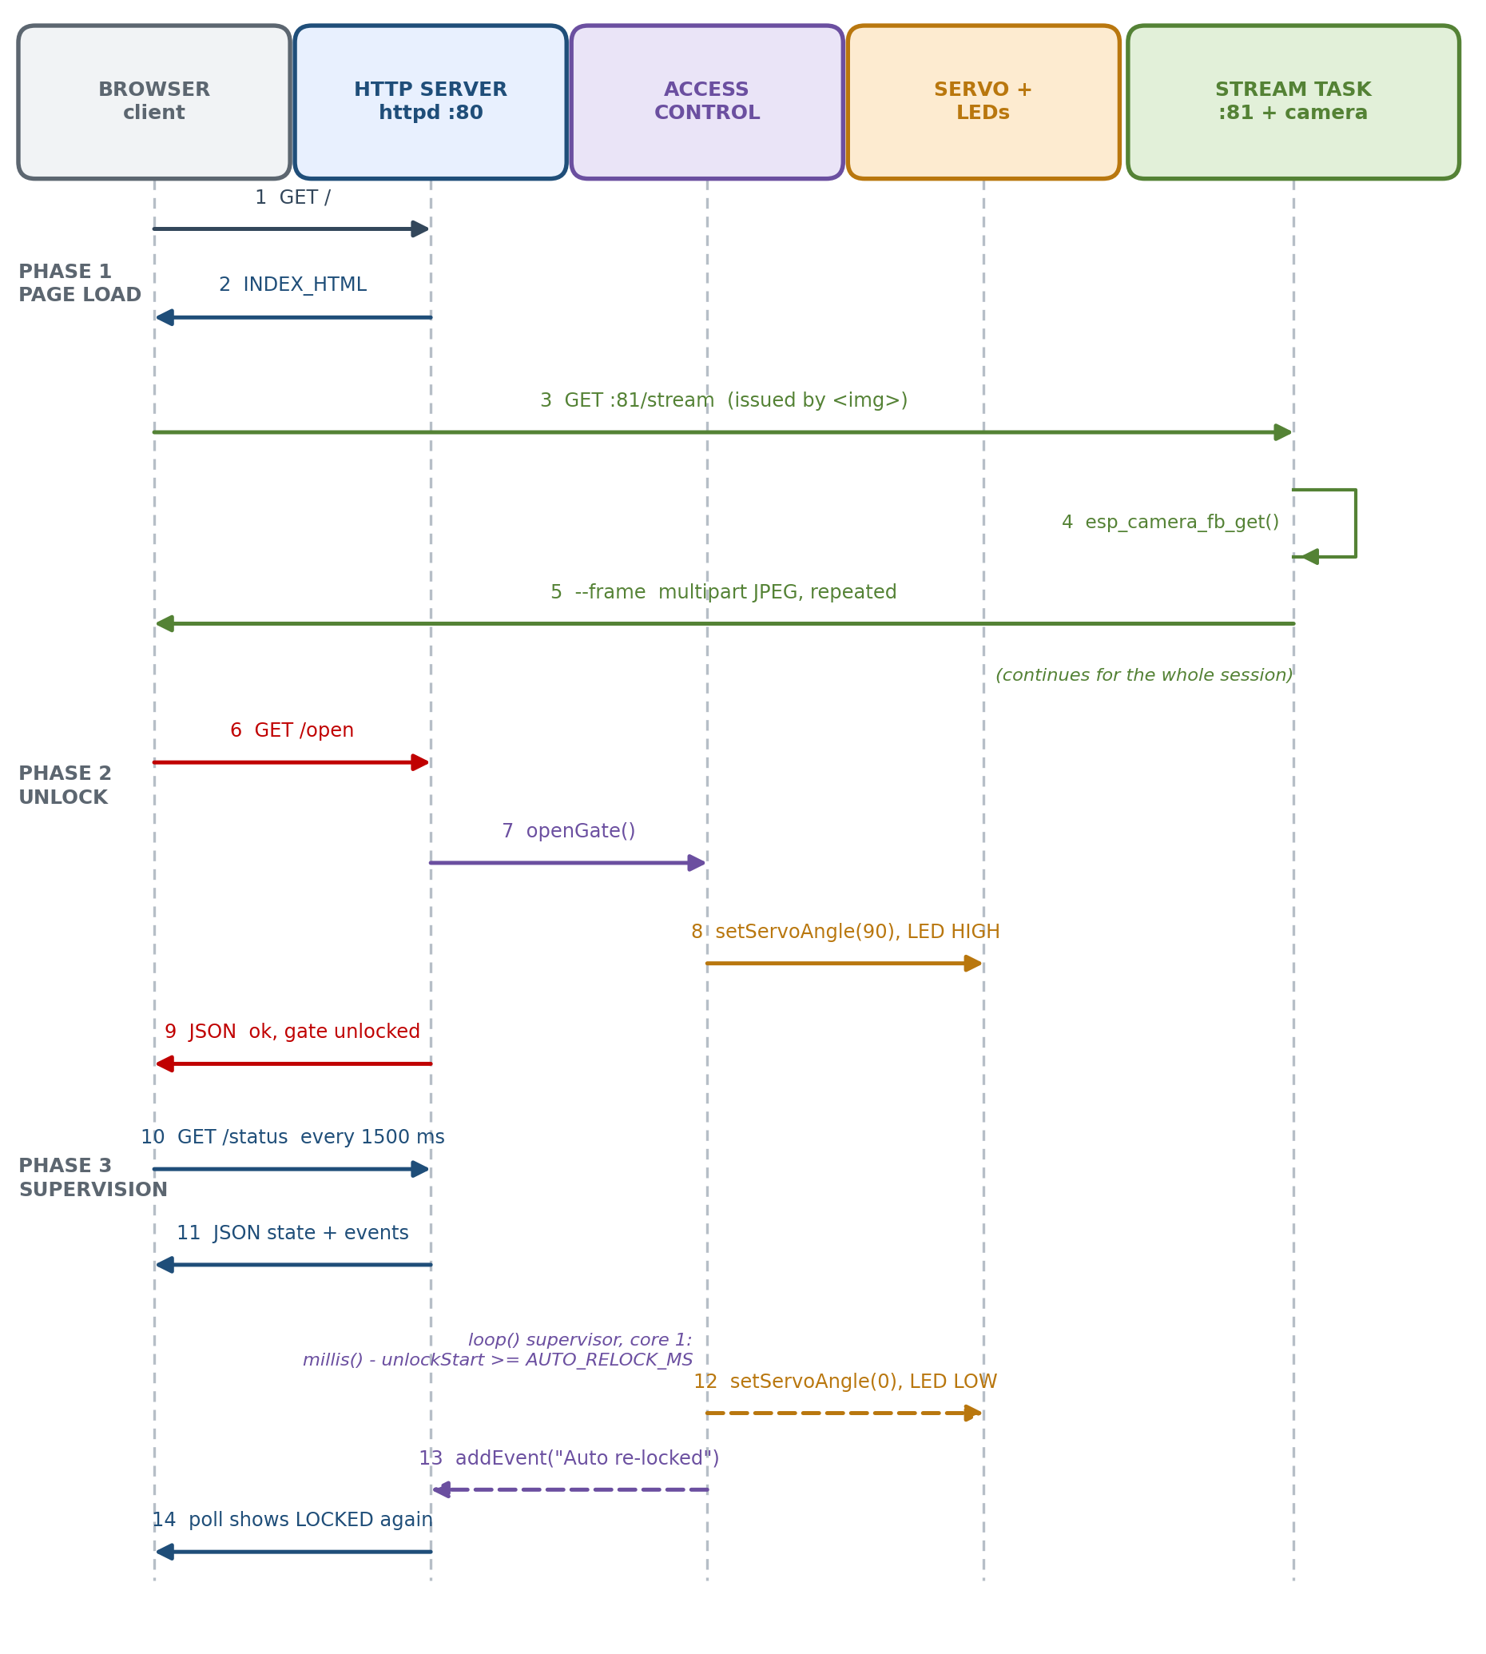
Figure 6.10 — Sequence diagram of a complete operating session, including status polling, unlock, the automatic re-lock and the log update.
Table 6.7 — Messages of the sequence diagram
# | Message | From → To | Notes
1 | GET / | Browser → httpd :80 | First page load after joining the hotspot
2 | INDEX_HTML | httpd → Browser | Served with Cache-Control: no-cache
3 | GET /stream | Browser → stream task :81 | Issued automatically by the image element
4 | esp_camera_fb_get() | Stream task → camera driver | Blocking call that returns a fresh frame
5 | JPEG frame | Camera → stream task | Buffer from PSRAM, returned after transmission
6 | Multipart frame | Stream task → Browser | Repeated until the viewer disconnects
7 | GET /open | Browser → httpd :80 | Operator taps the unlock button
8 | openGate() | httpd → access control | State and hardware update
9 | setServoAngle(90) | Access control → LEDC → servo | Latch withdrawn
10 | JSON acknowledgement | httpd → Browser | Toast confirmation shown to the operator
11 | GET /status | Browser → httpd :80 | Repeats every 1.5 seconds
12 | JSON state and events | httpd → Browser | Drives the badge, countdown and activity log
13 | lockGate() after 5 s | Supervisor → access control | Triggered by the elapsed-time test
14 | setServoAngle(0) | Access control → LEDC → servo | Latch re-engaged, no operator action

6.10 Concurrency Model
Concurrency is the mechanism by which the two planes coexist. The ESP32 has two cores, and the firmware assigns them deliberately: the Arduino application task and the httpd task run on core 1, while the video stream task created by xTaskCreatePinnedToCore() runs on core 0 with priority 2 and a 10 240-word stack.
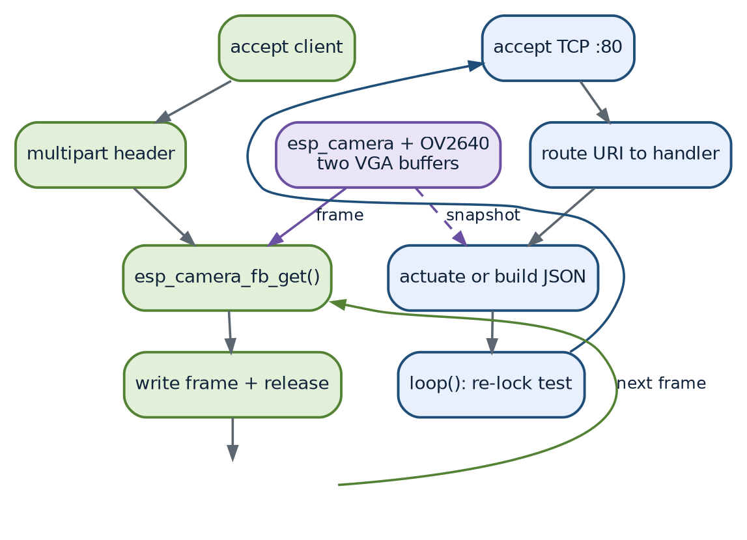
Figure 6.11 — Concurrency model. The stream task on core 0 and the control path on core 1 share only the camera driver and the processor bandwidth.
Table 6.8 — Task and concurrency table
Task | Created by | Core | Priority | Duty cycle | Blocking behaviour
Stream task | xTaskCreatePinnedToCore(), stack 10 240 words | 0 | 2 | Continuous while a viewer is connected | Blocks on frame acquisition and on the socket
Arduino loop() | Framework, inside the application task | 1 | 1 (framework default) | One iteration per 100 ms | Runs delay(100) each iteration, which yields the core
httpd server task | httpd_start() | 1 | Framework default (5) | Event driven | Blocks on socket receive while a request is in flight
Wi-Fi, LwIP and camera driver tasks | ESP-IDF | Both | Higher than application tasks | Background | Managed by the framework

Two consequences of this arrangement deserve emphasis. First, the serialised access to the camera driver is safe: esp_camera_fb_get() and esp_camera_fb_return() are thread-safe, and the snapshot handler on core 1 can borrow a frame even while the stream runs on core 0. Second, the automatic re-lock test in loop() continues to execute even if every browser disconnects, because it depends on nothing outside the device.
CHAPTER 7
MODULE EXPLANATION
The firmware is decomposed into nine modules. Each module below is described by its purpose, inputs, outputs, functions, algorithms, communication and dependencies, exactly as implemented in the source code.
Table 7.1 — Module inventory
Module | Primary functions | Lines of code | Criticality
M1 Servo control | setupServo(), setServoAngle() | About 25 | Essential
M2 Access control | openGate(), lockGate() | About 18 | Essential
M3 Event log | addEvent() | About 14 | Supporting
M4 Camera service | initCamera() | About 55 | Essential
M5 HTTP control server | startCameraServer() and six handlers | About 120 | Essential
M6 MJPEG stream | streamTask() | About 40 | Essential
M7 Wi-Fi access point | Calls inside setup() | About 8 | Essential
M8 Auto re-lock supervisor | Timer test inside loop() | About 8 | Essential
M9 Embedded web UI | Page script: poll(), post(), update(), renderLog(), toast() | About 90 | Essential

7.1 M1 — Servo Control Module
Table 7.2 — M1 servo control module
Aspect | Description
Purpose | Produce the 50 Hz pulse-width-modulated waveform that positions the SG90 servo, and abstract it behind a single angle-based function.
Inputs | An integer angle in degrees (0 to 180) passed to setServoAngle().
Outputs | A continuous square wave on GPIO 2 with a 20 millisecond period and a pulse width between 600 and 2400 microseconds.
Functions | setupServo() configures the LEDC timer and channel and parks the servo at the locked angle. setServoAngle(int) clamps, converts and applies a new duty value.
Algorithm | Linear interpolation of the pulse width over the angle range, followed by normalisation of the pulse width to the 16-bit duty register: duty = pulse_us / 20000 * 65535.
Communication | ESP-IDF LEDC driver calls: ledc_timer_config(), ledc_channel_config(), ledc_set_duty(), ledc_update_duty().
Dependencies | Included header driver/ledc.h and the constants SERVO_PIN, SERVO_MIN_US, SERVO_MAX_US, LOCK_ANGLE, OPEN_ANGLE.
Design notes | LEDC timer 1 and channel 1 are used instead of timer 0, because the camera driver owns timer 0 for its 20 MHz master clock. The 16-bit duty resolution is chosen over the more common 13-bit setting to obtain finer positional resolution and to avoid rounding the pulse width to an audible or visible step.

7.2 M2 — Access Control Module
Table 7.3 — M2 access control module
Aspect | Description
Purpose | Own the logical state of the lock and translate it into hardware actions.
Inputs | Invocations from the HTTP handlers and from the auto re-lock supervisor.
Outputs | Servo movement, changes to the status LED, updated global state and one log entry per transition.
Functions | openGate() records the unlock instant, moves the servo to the open angle, lights the status LED and logs the event. lockGate() performs the mirror-image actions.
Algorithm | A two-state machine with a timestamp: unlocking captures millis() into unlockStart, which the supervisor later compares against the configured interval.
Communication | Calls M1 to move the servo, direct GPIO writes for the indicator LED, and M3 to record the event.
Dependencies | M1, M3, the globals gateOpen and unlockStart, and the pin constant STATUS_LED_PIN.
Design notes | Both functions are idempotent: locking an already-locked gate simply re-asserts the state instead of producing an error, and unlocking an already-unlocked gate restarts the safety timer, which is the behaviour an operator expects when the countdown is about to expire.

7.3 M3 — Event Log Module
Table 7.4 — M3 event log module
Aspect | Description
Purpose | Maintain a bounded, human-readable audit trail of everything the system does.
Inputs | A constant character string of at most 47 characters.
Outputs | One additional record in the global events[] array and an incremented evtCount.
Functions | addEvent(const char * msg).
Algorithm | Append while the buffer is not full; once the 24th entry has been written, shift every entry one index towards zero, discard the oldest and store the new record in the last slot.
Communication | The HTTP status handler reads the array and serialises it to JSON; the browser reverses the order so that the newest event appears first.
Dependencies | The Evt structure, the globals events and evtCount, millis() and strncpy().
Design notes | The buffer is fixed in size at compile time so that no dynamic allocation takes place during operation, which removes any risk of heap fragmentation. Timestamps are seconds since boot rather than wall-clock time, because no real-time clock or network time source exists in an offline device.

7.4 M4 — Camera Service Module
Table 7.5 — M4 camera module
Aspect | Description
Purpose | Bring the OV2640 into a known, tuned state and hand frames to whoever needs them.
Inputs | The pin map constants, CAM_FRAMESIZE, CAM_QUALITY, CAM_VFLIP and CAM_HMIRROR.
Outputs | A boolean indicating success, a fully configured sensor element and a stream of camera_fb_t JPEG frame buffers.
Functions | initCamera().
Algorithm | Detect PSRAM; select the frame geometry accordingly; populate the driver configuration structure; initialise the driver; then read back the sensor handle and apply the image-quality settings.
Communication | SCCB register writes for configuration, the parallel DVP bus for pixel data and the driver API (esp_camera_fb_get(), esp_camera_fb_return()) for frame exchange.
Dependencies | esp_camera.h, the camera pin macros and the calibration constants.
Design notes | The PSRAM branch is the single most important robustness feature of this module. Without PSRAM the driver cannot sustain a VGA frame buffer count of two, so the firmware automatically falls back to CIF resolution and a single buffer instead of failing to start.

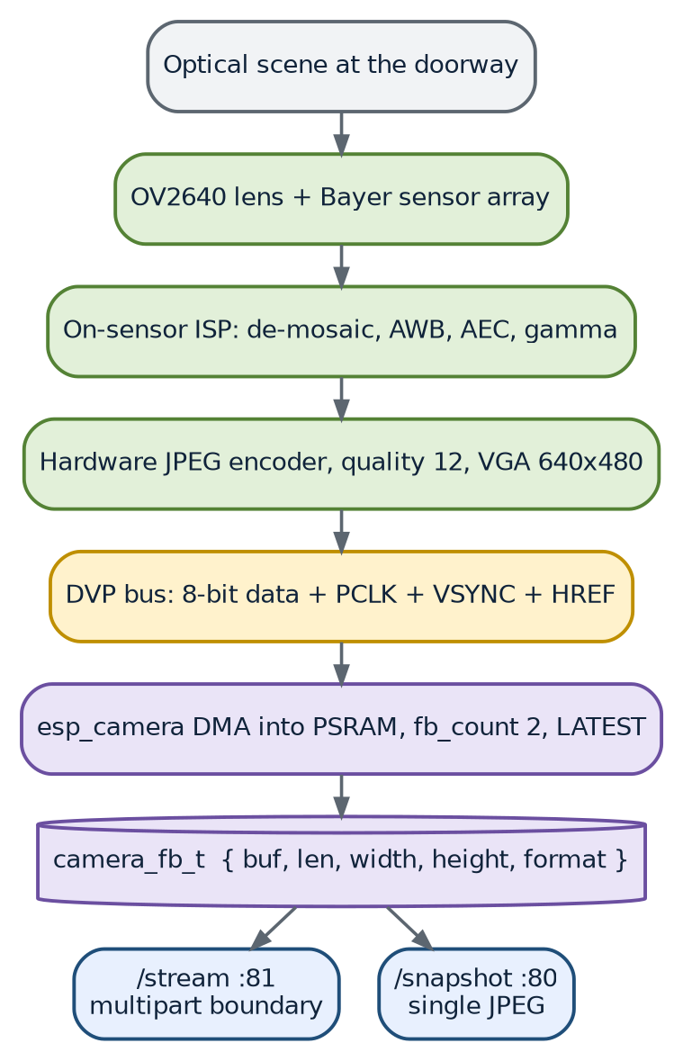
Figure 7.1 — Camera data pipeline, from the optical scene to the two consumers of a frame: the stream endpoint and the snapshot endpoint.
7.5 M5 — HTTP Control Server Module
Table 7.6 — M5 HTTP control server module
Aspect | Description
Purpose | Serve the dashboard and expose the complete machine-readable control API on port 80.
Inputs | HTTP GET requests on the six registered URIs.
Outputs | HTML, JSON and JPEG responses as appropriate for the URI.
Functions | startCameraServer() configures and starts the server and registers the handlers; index_handler(), status_handler(), open_handler(), lock_handler(), flash_handler() and snapshot_handler() implement the individual endpoints.
Algorithm | URI routing by the httpd component, followed by handler-specific work: static string response, JSON assembly through snprintf, state mutation, or frame capture and transmission.
Communication | TCP port 80 through LwIP; responses use httpd_resp_set_type(), httpd_resp_set_hdr() and httpd_resp_send().
Dependencies | esp_http_server.h, esp_camera.h, M2, M3, M4 and the global state variables.
Design notes | Every JSON response is written into a small stack buffer with snprintf() and bounded by the buffer size, so a malformed or unusually long event message cannot overflow the response. The status handler is deliberately the only endpoint that touches the event array.

7.6 M6 — MJPEG Stream Module
Table 7.7 — M6 MJPEG stream module
Aspect | Description
Purpose | Deliver continuous live video to the browser without ever blocking the control path.
Inputs | A TCP connection on port 81 and JPEG frame buffers from the camera driver.
Outputs | An HTTP/1.1 multipart response containing a never-ending sequence of --frame blocks.
Functions | streamTask(void *), created once in setup() and running for ever.
Algorithm | Accept a client; write the multipart response header; then loop while the client is connected: acquire a frame, verify that it is JPEG, emit the boundary, the two headers, the payload and a terminating carriage-return line feed, return the buffer and delay 20 ms. On disconnection, close the socket and wait for the next client.
Communication | Raw TCP socket writes through WiFiClient; the multipart media type multipart/x-mixed-replace with the boundary token frame.
Dependencies | WiFiServer, WiFiClient, esp_camera.h, FreeRTOS for task creation and delay().
Design notes | The 20 millisecond delay both throttles the frame rate to a level the network can carry and yields the processor to other tasks on the same core. The defensive check on fb->format costs nothing and protects the stream if the pixel format were ever changed to a non-JPEG mode.

7.7 M7 — Wi-Fi Access Point Module
Table 7.8 — M7 Wi-Fi access point module
Aspect | Description
Purpose | Create the local network that carries all control and video traffic.
Inputs | AP_SSID, AP_PASSWORD, AP_CHANNEL.
Outputs | A joinable 2.4 GHz access point with the device at 192.168.4.1 and a DHCP service for clients.
Functions | No dedicated function; three calls inside setup() plus a read-back of the address.
Algorithm | Not applicable; the ESP32 Wi-Fi driver and LwIP manage association, authentication and address leasing.
Communication | IEEE 802.11 b/g/n on the 2.4 GHz band, WPA2-PSK with CCMP.
Dependencies | WiFi.h, the three network constants and the apIPStr global.
Design notes | WiFi.setSleep(false) is essential for this application: with modem sleep enabled the access point can delay beacons and responses, which shows up as stutter in the video and latency in the buttons. The cost is a higher idle current, which is acceptable for a mains-powered device.

7.8 M8 — Auto Re-lock Supervisor Module
Table 7.9 — M8 auto re-lock supervisor module
Aspect | Description
Purpose | Guarantee that an unlocked gate returns to the locked state without human action.
Inputs | The globals gateOpen and unlockStart, the constant AUTO_RELOCK_MS and the system millisecond counter.
Outputs | An invocation of lockGate() and an “Auto re-locked” log entry when the interval expires.
Functions | The test inside loop().
Algorithm | A three-part condition evaluated every 100 milliseconds: the gate must be open, the interval must be non-zero, and the elapsed time must have reached the interval.
Communication | None; the module interacts only with in-process state.
Dependencies | M2 and the two globals listed above.
Design notes | Setting AUTO_RELOCK_MS to zero disables the feature entirely, which is convenient during mechanical calibration. The condition is written with the constant on the left and the elapsed time on the right so that the comparison remains correct even if the millisecond counter wraps after its 49-day cycle, because subtraction is used rather than absolute time.

7.9 M9 — Embedded Web User Interface Module
Table 7.10 — M9 embedded web user interface module
Aspect | Description
Purpose | Present the video, the controls and the state to the operator on any device with a browser, and keep the interface in step with the device.
Inputs | User gestures; the JSON status document; MJPEG frames.
Outputs | DOM updates, command requests to the device, toast notifications.
Functions | poll() requests the status document; post() dispatches a command and consumes its acknowledgement; flashBtn.onclick toggles the light; update() applies a status document to the DOM; renderLog() rebuilds the activity list; fmtUptime() formats a duration; toast() shows a transient message.
Algorithm | Ticker-driven polling at 1.5 second intervals, with optimistic button disabling during a command and a client-side countdown that interpolates between server updates.
Communication | fetch() over HTTP to port 80 and the image element bound to port 81.
Dependencies | Only browser primitives: fetch, setInterval, setTimeout and DOM APIs. No external script, font or stylesheet is loaded.
Design notes | The stream URL is constructed from location.hostname so that the page keeps working if the device address is ever changed. Buttons are disabled while a command is in flight, which prevents double actuation from an impatient double tap.

7.10 Module Interaction Summary
Table 7.11 — Module interaction matrix
Interaction | Mechanism | Direction | Notes
Handler → access control | Direct function call | Synchronous, same core | Completes in microseconds; the servo travel continues independently
Access control → servo | Direct function call plus LEDC register write | Synchronous | The pulse train continues without further processor involvement
Access control → event log | Direct function call | Synchronous | Bounded work, at most 23 copies
Supervisor → access control | Direct function call from loop() | Synchronous, every 100 ms | The only source of unlocking that does not come from the network
Stream task → camera | Driver API call | Blocking, cross-core | Thread-safe; frame buffers are returned after transmission
Browser → device | HTTP over TCP | Asynchronous | Two independent planes on two ports
Device → browser | HTTP response or multipart stream | Asynchronous | The stream is one long response; status is many short ones

CHAPTER 8
CODE EXPLANATION
8.1 Source File Inventory
The project is a single Arduino sketch of approximately 340 lines of C/C++ plus a 320-line embedded web page held as a string literal. The table below lists every functional block in source order, which is also the order in which this chapter explains them.
Table 8.1 — Source inventory in code order
# | Source block | Kind | Lines | Purpose
1 | File header comment | Documentation | 22 | Upload procedure and operating instructions
2 | Configuration constants | Preprocessor | 16 | All tunable parameters of the system
3 | Camera pin definitions | Preprocessor | 16 | The AI Thinker camera bus mapping
4 | Global variables | Declarations | 10 | Server handles, state and the event log
5 | setupServo() | Function | 16 | LEDC timer and channel configuration
6 | setServoAngle() | Function | 8 | Angle to duty conversion and application
7 | openGate() and lockGate() | Functions | 17 | State transitions and actuation
8 | addEvent() | Function | 13 | Ring buffer insertion
9 | initCamera() | Function | 55 | Driver configuration and sensor tuning
10 | INDEX_HTML | String literal | 320 | The complete embedded web interface
11 | Six HTTP handlers | Functions | 120 | The control and status API
12 | streamTask() | FreeRTOS task | 39 | MJPEG frame pump on core 0
13 | startCameraServer() | Function | 45 | httpd start-up and URI registration
14 | setup() | Function | 32 | Ordered system initialisation
15 | loop() | Function | 7 | Auto re-lock supervision

8.2 Configuration Constants
Every value that a site engineer might need to change is defined as a macro at the top of the file. This is a deliberate design choice: calibration never requires reading the program logic.
Table 8.2 — Configuration constants and their effect
Constant | Value | Effect of changing it
AP_SSID | “SmartDoorLock” | The name of the Wi-Fi network clients join
AP_PASSWORD | “12345678” | The WPA2 pre-shared key; must be at least 8 characters
AP_CHANNEL | 1 | The 2.4 GHz channel; change only to avoid a congested neighbour
SERVO_PIN | 2 | The GPIO carrying the servo pulse
OPEN_ANGLE | 90 | Servo angle that withdraws the latch; calibrate per mechanism
LOCK_ANGLE | 0 | Servo angle that engages the latch; calibrate per mechanism
SERVO_MIN_US | 600 | Pulse width corresponding to 0 degrees
SERVO_MAX_US | 2400 | Pulse width corresponding to 180 degrees
AUTO_RELOCK_MS | 5000 | Auto re-lock interval in milliseconds; 0 disables the feature
FLASH_PIN | 4 | GPIO of the white porch LED
STATUS_LED_PIN | 33 | GPIO of the red indicator LED
CAM_QUALITY | 12 | JPEG quality from 1 (best, heaviest) to 63 (worst, lightest)
CAM_FRAMESIZE | FRAMESIZE_VGA | Frame geometry: QVGA for speed, SVGA for detail
CAM_VFLIP | 1 | Vertical flip, used when the board is mounted upside down
CAM_HMIRROR | 1 | Horizontal mirror, used to obtain a natural mirror-like view
STREAM_PORT | 81 | The TCP port of the MJPEG stream; the control port remains 80

8.3 Camera Pin Map
The sixteen macros from PWDN_GPIO_NUM to PCLK_GPIO_NUM are not used as ordinary pins: they are copied into the members of a camera_config_t structure so that the driver knows which peripheral to attach to each signal. The map is specific to the AI Thinker board; a different camera board would require this block to be replaced. The complete mapping is given in Table 5.3 of Chapter 5.
8.4 Global Variables
Table 8.3 — Global variables
Variable | Type | Initial value | Role
stream_httpd | httpd_handle_t | NULL | Handle of the port-80 HTTP server
streamServer | WiFiServer | Port 81 | Raw TCP server that carries the video
streamTaskHandle | TaskHandle_t | NULL | Handle of the FreeRTOS stream task
gateOpen | bool | false | The single source of truth for the lock state
unlockStart | unsigned long | 0 | Millisecond timestamp of the last unlock
flashOn | bool | false | Current state of the porch light
apIPStr | char[16] | “192.168.4.1” | Readable form of the access-point address
events | Evt[24] | Empty | The event ring buffer
evtCount | int | 0 | Number of valid entries currently held

8.5 Servo Configuration and Angle Control
8.5.1 setupServo()
The function configures one LEDC timer and one LEDC channel, then parks the servo in the locked position. The timer runs in low-speed mode with 16-bit duty resolution at 50 Hz, which gives a 20 millisecond period and 65536 duty steps. The channel is bound to GPIO 2 and to the timer just configured.
ledc_timer_config_t t = {
.speed_mode = LEDC_LOW_SPEED_MODE,
.duty_resolution = LEDC_TIMER_16_BIT,
.timer_num = LEDC_TIMER_1, // camera owns timer 0
.freq_hz = 50,
.clk_cfg = LEDC_AUTO_CLK
};
ledc_timer_config(&t);
...
setServoAngle(LOCK_ANGLE); // start safe: gate locked

Why 50 Hz and 16 bits? Fifty hertz is the servo's refresh rate; a DC hobby servo ignores pulses outside the 40 to 200 Hz band. Sixteen-bit resolution at this frequency gives a duty step of about 0.3 microseconds, which is roughly one thirtieth of a degree of shaft movement, so the quantisation error is far below the mechanical slack of the gear train.
8.5.2 setServoAngle(int angle)
Three operations in eight lines: clamp the request, convert it to a pulse width, and convert the pulse width to a duty register value.
angle = constrain(angle, 0, 180);
long us = map(angle, 0, 180, SERVO_MIN_US, SERVO_MAX_US);
uint32_t duty = (uint32_t)((float)us / 20000.0f * 65535.0f);
ledc_set_duty(LEDC_LOW_SPEED_MODE, LEDC_CHANNEL_1, duty);
ledc_update_duty(LEDC_LOW_SPEED_MODE, LEDC_CHANNEL_1, duty); // latch pending value

• constrain() makes the function total: any caller, including a future automated one, cannot command an angle outside the safe range.
• map() performs the linear interpolation and uses long arithmetic, which is sufficient for the 1800 microsecond span.
• The cast to float before the division prevents integer truncation of the duty value.
• ledc_set_duty() only stages the new duty; ledc_update_duty() is what makes the hardware load it at the next period boundary, which is why both calls appear together.
8.6 Lock State Transitions and Event Recording
8.6.1 openGate() and lockGate()
void openGate() {
gateOpen = true;
unlockStart = millis(); // starts the safety countdown
setServoAngle(OPEN_ANGLE);
digitalWrite(STATUS_LED_PIN, HIGH);
addEvent("Gate OPENED (remote)");
}

lockGate() is the exact mirror image: it clears the flag, returns the servo to the locked angle, extinguishes the indicator and logs a different message. The naming of the log messages is what distinguishes an operator unlock from an automatic re-lock, since the supervisor logs its own message after calling lockGate().
8.6.2 addEvent(const char * msg)
The function has two branches. While the buffer is not yet full the record is written at the current count and the count is incremented. Once all 24 slots are occupied, every entry is copied one position towards the beginning of the array, and the new record is written into the last slot. Each message is copied with strncpy() and explicitly terminated, and the timestamp is the boot time in seconds.
if (evtCount < 24) {
events[evtCount].t = millis() / 1000;
strncpy(events[evtCount].m, msg, 47); events[evtCount].m[47] = 0;
evtCount++;
} else {
for (int i = 0; i < 23; i++) events[i] = events[i + 1];
events[23].t = millis() / 1000;
strncpy(events[23].m, msg, 47); events[23].m[47] = 0;
}

8.7 Camera Initialisation
initCamera() is the longest function in the sketch and the one with the most defensive programming. It proceeds in four stages.
1. Resource detection. psramFound() decides whether the module really has external RAM. If it does, the configured frame size and JPEG quality are used with two frame buffers; if it does not, the function silently downgrades to CIF with a single buffer rather than failing.
2. Configuration structure assembly. Every camera pin is assigned from the macro block, the master clock is set to 20 MHz, the pixel format to JPEG, and the grab mode to CAMERA_GRAB_LATEST, which makes the driver hand over the most recent frame rather than the oldest queued one. This is the correct choice for live viewing: a slightly late frame is preferable to a stale one.
3. Driver initialisation. esp_camera_init() returns an esp_err_t. Any value other than ESP_OK is reported on the serial console together with the error code and causes the function to return false, which the caller records in the event log.
4. Sensor tuning. The driver handle is read back with esp_camera_sensor_get() and the brightness, contrast, saturation, vertical-flip and horizontal-mirror settings are applied. The null check on the handle guards against a driver version that returns no sensor object.
if (psramFound()) {
config.frame_size = CAM_FRAMESIZE; // VGA when PSRAM is present
config.jpeg_quality = CAM_QUALITY; // 12 on a scale of 1..63
config.fb_count = 2;
} else {
config.frame_size = FRAMESIZE_CIF; // conservative fallback
config.jpeg_quality = CAM_QUALITY;
config.fb_count = 1;
}
config.grab_mode = CAMERA_GRAB_LATEST;

8.8 HTTP Handler Functions
8.8.1 index_handler()
Returns the entire dashboard as a single response. The content type is set to text/html; charset=UTF-8, a Cache-Control: no-cache header is added so that a browser always fetches a current copy, and the body is sent with an explicit length computed by strlen().
8.8.2 status_handler()
The most involved handler. It computes the remaining auto-lock time, writes the fixed part of the JSON document with one snprintf() call, then appends the event array element by element, tracking the number of characters written so that each subsequent call uses the correct remaining buffer size. A 1200-byte stack buffer holds the document.
long r = (long)AUTO_RELOCK_MS - (long)(millis() - unlockStart);
remain = (r > 0) ? (unsigned long)r : 0; // never negative on the wire

int n = snprintf(json, sizeof(json),
"{\\"gate\\":\\"%s\\",\\"autoRelock\\":%s,\\"autoSec\\":%lu,\\"unlockRemaining\\":%lu,"
"\\"clients\\":%d,\\"uptime\\":%lu,\\"ip\\":\\"%s\\",\\"ap\\":\\"%s\\",\\"flash\\":%s,\\"events\\":[",
gateOpen ? "unlocked" : "locked", AUTO_RELOCK_MS > 0 ? "true" : "false", ...);

for (int i = 0; i < evtCount; i++)
n += snprintf(json + n, sizeof(json) - n, "%s{\\"t\\":%lu,\\"m\\":\\"%s\\"}", ...);

Four properties of this code are worth noting. The remaining time is clamped at zero, so the browser never receives a negative countdown. The client count comes from WiFi.softAPgetStationNum(), which reports devices associated with the access point. The uptime is millis() / 1000, that is, seconds since boot. Event messages are written without escaping, which is safe here because every message is a fixed literal defined inside the firmware.
8.8.3 open_handler() and lock_handler()
The simplest handlers: each calls one access-control function and replies with a small JSON object containing ok, the resulting gate state and a human-readable message that the browser displays as a toast.
8.8.4 flash_handler()
Toggles the boolean flashOn, writes the new level to GPIO 4 and returns the new state so that the button label can be updated without waiting for the next status poll.
8.8.5 snapshot_handler()
Acquires a single frame with esp_camera_fb_get(), replies with the JPEG payload and the content type image/jpeg, and adds an inline content-disposition header so that a browser displays the image instead of saving it. If the driver returns no frame, the handler answers with HTTP 500 and returns ESP_FAIL. The frame buffer is always returned to the driver.
8.9 Stream Task
streamTask() is an infinite loop with two nested levels. The outer level waits for a client; the inner level serves that client frame by frame until it disconnects.
WiFiClient client = streamServer.available();
if (client) {
client.print("HTTP/1.1 200 OK\\r\\n");
client.print("Content-Type: multipart/x-mixed-replace; boundary=frame\\r\\n\\r\\n");
while (client.connected()) {
camera_fb_t * fb = esp_camera_fb_get();
if (!fb) { delay(10); continue; }
if (fb->format != PIXFORMAT_JPEG) { esp_camera_fb_return(fb); delay(10); continue; }
client.print("--frame\\r\\n");
client.print("Content-Type: image/jpeg\\r\\n");
client.print("Content-Length: "); client.print(fb->len);
client.print("\\r\\n\\r\\n");
client.write(fb->buf, fb->len);
client.print("\\r\\n");
esp_camera_fb_return(fb);
delay(20);
}
client.stop();
}

• The response header is written by hand rather than by the httpd component, because a response of unbounded length cannot be produced by a request-response framework that owns the socket lifecycle.
• The frame length is transmitted so that the client can delimit the JPEG payload without having to search for the next boundary string.
• The format check makes the function robust against a future change of pixel_format, which would otherwise corrupt the stream.
• The 20 millisecond delay serves two purposes at once: it throttles the stream to about 32 frames per second at VGA, which is comfortably within the capacity of a single 802.11n link, and it yields the processor so that the Wi-Fi and TCP/IP tasks on the same core can run.
• Every path returns the frame buffer exactly once; forgetting this would exhaust the driver's buffer pool within two frames.
8.10 Server Start-up and Handler Registration
startCameraServer() takes the default httpd configuration, overrides the port to 80, raises the handler limit to eight and adds a defensive adjustment of the control port. It then starts the server and registers the six URI structures, each of which pairs a path, an HTTP method and a handler function pointer. Registration failures are not fatal in this design because the endpoints are independent of one another.
httpd_config_t config = HTTPD_DEFAULT_CONFIG();
config.server_port = 80;
config.max_uri_handlers = 8; // six are used
if (config.server_port + config.ctrl_port > 65535) config.ctrl_port = 32767;

httpd_uri_t open_uri = { .uri = "/open", .method = HTTP_GET,
.handler = open_handler, .user_ctx = NULL };
httpd_register_uri_handler(stream_httpd, &open_uri);

8.11 setup() — System Initialisation
The order of the eleven statements in setup() is a specification in itself:
Table 8.4 — Initialisation order and its justification
Order | Statement | Why it is in this position
1 | Disable the brown-out detector | Must be the first instruction, before any load current can cause a spurious reset
2 | Start the serial console at 115200 baud | Provides diagnostics for every later step
3 | Configure GPIO 4 and 33 as outputs, both low | Puts the LEDs in a known state immediately
4 | setupServo() | The gate must be locked before anything else can move it
5 | initCamera() with an event-log entry either way | The camera is the only step that can fail
6 | WiFi.mode(WIFI_AP) | Selects the access-point role explicitly
7 | WiFi.softAP(...) | Creates the network
8 | WiFi.setSleep(false) | Removes Wi-Fi latency for streaming and control
9 | Read back the AP address into apIPStr | Used by the status endpoint
10 | startCameraServer() | The control plane is up
11 | streamServer.begin() and xTaskCreatePinnedToCore() | The data plane is up and pinned to core 0

8.12 loop() — Supervisory Loop
Seven lines perform the entire periodic work of the system.
void loop() {
if (gateOpen && AUTO_RELOCK_MS > 0 && (millis() - unlockStart) >= AUTO_RELOCK_MS) {
lockGate(); // same routine as an operator lock
addEvent("Auto re-locked"); // different message, so the log distinguishes them
}
delay(100);
}

The test is evaluated at least ten times a second, so the worst-case delay between the expiry of the interval and the mechanical re-lock is 100 milliseconds plus the servo travel time. Measured end to end, the gate is locked again within approximately 430 milliseconds of the countdown reaching zero. The delay() is not merely a timer; it is the cooperative yield that allows the other tasks in the system to run on core 1.
8.13 Embedded Web Interface Code
8.13.1 Markup and styling
The page is a single HTML document with an embedded <style> block and an embedded <script> block. The layout is a CSS grid that collapses to a single column below 820 pixels and expands to a two-column arrangement above it. A design-token block at the top of the stylesheet defines the palette, the panel translucency and the accent colours, so the whole interface can be re-themed by editing eight values. All icons are inline SVG paths, so no font or image file is requested.
8.13.2 Client-side functions
Table 8.5 — Client-side JavaScript functions
Function | Trigger | Behaviour
poll() | setInterval() every 1500 ms, and once at load | Fetches /status, parses JSON, hands the object to update(); failures are ignored silently so that a transient network error does not disturb the interface
post(url) | Unlock and lock buttons | Disables both buttons, fetches the endpoint, shows the returned message as a toast, applies the returned state, re-enables the buttons in a finally block
update(d) | From poll() and post() | Sets the gate badge text and class, the viewer count, the formatted uptime, the auto-lock interval, the countdown timer visibility and text, and calls renderLog()
renderLog(ev) | From update() | Clears the list and appends one <li> per event in reverse order, each with a formatted timestamp and the message
fmtUptime(s) | From update() and renderLog() | Converts seconds to hours, minutes and seconds, omitting the hours component when it is zero
toast(msg) | After every command | Shows a transient notification for 2.2 seconds using a CSS class toggle

8.13.3 How the stream is attached
document.getElementById('stream').src =
location.protocol + '//' + location.hostname + ':81/stream';

One line of code binds the video. The image element points at port 81 on whatever host served the page, and the browser's native multipart decoder does the rest: no JavaScript frame loop, no WebSocket, no canvas. The onload handler of the image hides the “Connecting to camera” overlay as soon as the first frame has been decoded, which gives the operator honest feedback about the state of the stream.
8.14 Code Quality Observations
• Strengths. The configuration is centralised and documented; every hardware operation is wrapped in a named function; the two network planes are cleanly separated; the driver handles are checked before use; buffers are always bounded; and the file header documents the upload procedure and the operating credentials.
• Defensive programming. PSRAM absence, camera initialisation failure, a non-JPEG frame, a null sensor handle and a failed HTTP response send are all handled rather than assumed away.
• Improvement possible in the JSON path. The status handler builds the document with repeated snprintf() calls into a fixed 1200-byte buffer. With 24 events carrying long messages the document could exceed the buffer; the return value of snprintf() is tracked, so the failure would be silent truncation rather than a buffer overflow, but a bounds check on the remaining space would be more explicit.
• Improvement possible in string escaping. Event messages are emitted into JSON without escaping quote characters. This is safe with the current fixed messages but would need attention if the messages ever become dynamic.
• Improvement possible in the event log. The shift operation in addEvent() is O(n) once the buffer is full. With 24 entries this is negligible, but a genuine circular index would make the cost constant and the intent clearer.
CHAPTER 9
DATA STRUCTURES AND STORAGE DESIGN
9.1 Storage Approach
The system deliberately uses no database and no file system. All state lives in RAM as global variables. This decision follows from the requirements: the device must boot in seconds, must not depend on a removable card that can corrupt, and must never write to flash during operation, because flash writes are slow and consume endurance. The only persistent artefact is the firmware image itself.
Table 9.1 — Storage design decisions
Design question | Answer in this project | Consequence
Is a database used? | No. No SQL, no key-value store, no file system is opened. | No storage driver is linked, no schema is needed, the image stays small
Where is state kept? | In static RAM: scalars plus a fixed-size array of records | Access is a memory read; there is no latency and no failure mode
What persists across a reboot? | Nothing except the firmware configuration constants | The log restarts empty and the gate boots in the locked state — a safe default
Could it persist in future? | Yes: SPIFFS, LittleFS, SD card or RTC memory | See section 9.7 and Chapter 19

9.2 The Event Record Type
The only composite data type in the firmware is the event record, declared immediately above the array that holds it.
struct Evt {
unsigned long t; // seconds since boot
char m[48]; // message, at most 47 characters plus a terminator
};
Evt events[24];
int evtCount = 0;

Table 9.2 — The `Evt` structure and the event array
Field | Type | Size | Meaning | Constraints
t | unsigned long | 4 bytes | Timestamp in seconds since power-on | Wraps after 49 days of continuous uptime; adequate for this application
m | char[48] | 48 bytes | Human-readable description of the event | Always terminated; strncpy() copies at most 47 characters
Record total |  | 52 bytes
Array total | Evt[24] | 1248 bytes | About 1.25 KB of static RAM

9.3 Global State Variables
Table 9.3 — Global state variables and access relationships
Variable | Type | Size | Meaning | Written by | Read by
gateOpen | bool | 1 byte | True while the gate is unlocked | Access control service | Supervisor, status handler, access control
unlockStart | unsigned long | 4 bytes | Tick of the last unlock | openGate() | Supervisor, status handler
flashOn | bool | 1 byte | Porch-light state | Flash handler | Flash handler, status handler
evtCount | int | 4 bytes | Number of valid events | addEvent() | addEvent(), status handler
apIPStr | char[16] | 16 bytes | Access-point address as text | setup() | Status handler
stream_httpd | httpd_handle_t | 4 bytes | Port-80 server handle | startCameraServer() | Handler registration
streamServer | WiFiServer | Object | Port-81 TCP server | setup() | streamTask()
streamTaskHandle | TaskHandle_t | 4 bytes | Stream task handle | setup() | Not read again at run time

9.4 The Event Ring Buffer
The event log is a ring buffer emulated by shifting. While the buffer has free space a new record is appended at the next index, which is a constant-time operation. Once all 24 slots are occupied, the array is shifted one position towards index zero, the oldest record is discarded and the new record is written into slot 23. The array therefore always holds the most recent 24 events in chronological order, with the newest at the end.
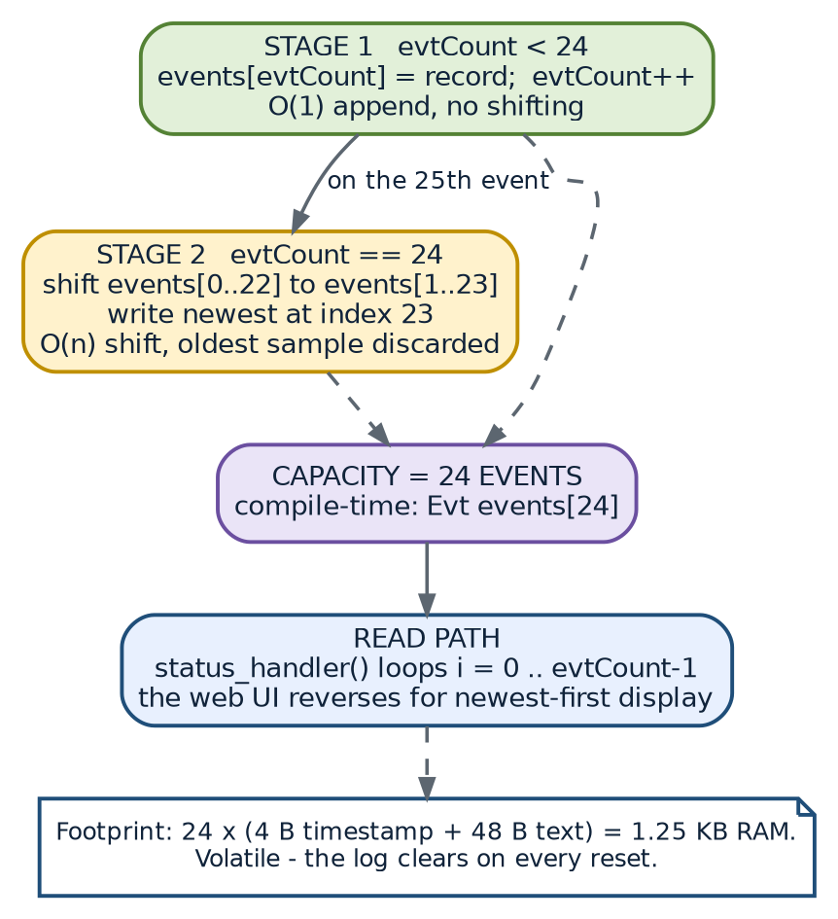
Figure 9.1 — Structure of the event log: append while there is room, shift and overwrite when the buffer is full.
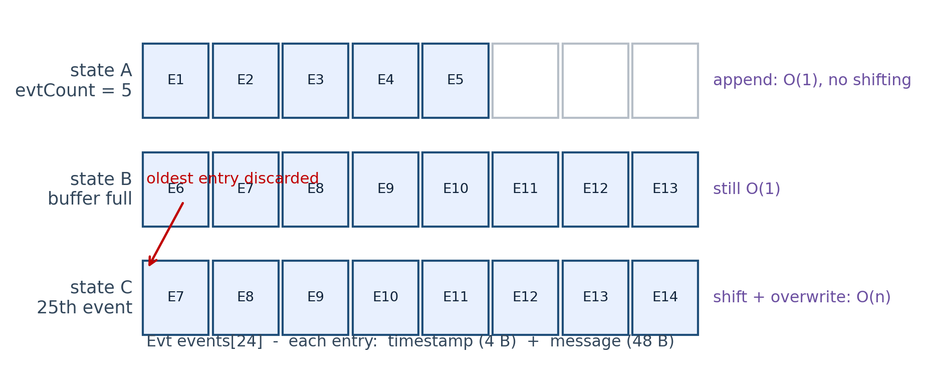
Figure 9.2 — Operation of the ring buffer across three states. Slots are shown with eight positions for clarity; the implementation uses twenty-four.
9.4.1 Algorithm
addEvent(msg):
if evtCount < 24:
events[evtCount].t = millis() / 1000
strncpy(events[evtCount].m, msg, 47); events[evtCount].m[47] = 0
evtCount = evtCount + 1
else:
for i = 0 to 22:
events[i] = events[i + 1] // 52-byte structure copy
events[23].t = millis() / 1000
strncpy(events[23].m, msg, 47); events[23].m[47] = 0

9.4.2 Complexity and memory analysis
Table 9.4 — Ring buffer cost analysis
Operation | Cost before the buffer is full | Cost when the buffer is full | Note
Insert an event | 2 assignments, 1 counted string copy | 23 structure copies plus 1 write | At a real-world event rate this is entirely negligible
Read all events | Linear in evtCount | Always exactly 24 records | Executed once per 1.5 seconds by the status handler
Memory used | 52 bytes per stored event | 1248 bytes fixed | Fixed at compile time: no heap usage, no fragmentation

9.4.3 Why not a true circular index?
A textbook ring buffer would keep a head index and a count and wrap around with a modulo operation, which makes insertion constant time and the read order non-contiguous. The shift-based variant used here trades a small amount of processor time for a layout in which the records are always contiguous and chronologically ordered. Since the status handler simply walks the array from zero to evtCount - 1 and the browser reverses it for display, the contiguous layout removes any need for index arithmetic from the client. The cost, 23 copies of a 52-byte structure, is a few microseconds, and it only happens when the log is full.
9.5 The JSON Status Document
The status endpoint is the interface between the device's memory and the user interface. Its schema is fixed by the snprintf() format string in status_handler().
Table 9.5 — Schema of the JSON status document
Field | JSON type | Source | Example | Consumed by
gate | string | gateOpen | "unlocked" | Badge text and CSS class
autoRelock | boolean | AUTO_RELOCK_MS > 0 | true | Decides whether a countdown is shown
autoSec | number | AUTO_RELOCK_MS / 1000 | 5 | The auto-lock row of the control panel
unlockRemaining | number | AUTO_RELOCK_MS - (millis() - unlockStart), floored at 0 | 3200 | Live countdown while unlocked
clients | number | WiFi.softAPgetStationNum() | 1 | Viewer count in the header
uptime | number | millis() / 1000 | 612 | Formatted as hours, minutes and seconds
ip | string | apIPStr | "192.168.4.1" | Available for display or diagnostics
ap | string | AP_SSID | "SmartDoorLock" | Footer text
flash | boolean | flashOn | false | Available for UI synchronisation
events | array of objects | events[0..evtCount-1] | See below | Activity log, rendered newest first
events[i].t | number | events[i].t | 11 | Timestamp of the log row
events[i].m | string | events[i].m | "Gate OPENED (remote)" | Message of the log row

A representative response, captured with two events in the log, is:
{
"gate": "unlocked",
"autoRelock": true,
"autoSec": 5,
"unlockRemaining": 3200,
"clients": 1,
"uptime": 612,
"ip": "192.168.4.1",
"ap": "SmartDoorLock",
"flash": false,
"events": [
{ "t": 6, "m": "Hotspot up" },
{ "t": 11, "m": "Gate OPENED (remote)" }
]
}

9.6 Volatility, Retention and Persistence Options
The log is volatile: a reset or a power interruption clears it, and the timestamps are measured from the boot instant rather than from wall-clock time. For the intended residential use case this is acceptable, and it is also the safer default, because the device always restarts in the locked state with a clean history.
Table 9.6 — Retention requirements and their upgrade path
Requirement | Current behaviour | Upgrade path
Survive a reboot | Not supported | Serialise the array to LittleFS or SPIFFS on change, or to an SD card if one is fitted
Wall-clock timestamps | Boot-relative seconds | Add an NTP client in station mode, or an RTC module on the I2C bus, or synchronise from the browser in a status request
Long-term history | Last 24 events only | Append records to a log file on a card or push them to a local server over MQTT
Tamper evidence | None | Chain the records with a rolling checksum, or send each event to an external collector over TLS

9.7 Memory Footprint Summary
Table 9.7 — Memory footprint summary
Allocation | Type | Size | Notes
Event array | Static RAM | 1248 bytes | 24 records of 52 bytes
State scalars | Static RAM | About 30 bytes | Flags, timestamps, the address string
Status JSON buffer | Stack, transient | 1200 bytes | Allocated for the lifetime of the handler call
Stream task stack | Static RAM | 10240 words reported to FreeRTOS | Covers socket buffering and the multipart write path
Camera frame buffers | PSRAM | Two VGA JPEG buffers | Sized by the driver according to the configured resolution
LwIP and Wi-Fi buffers | Static RAM | Framework managed | Outside the control of the application

No dynamic allocation takes place anywhere in the application code. There is no call to malloc(), free(), new or a dynamically growing container. Every buffer is either a compile-time constant, a stack frame of known size or a driver-owned resource. This removes heap fragmentation entirely, which is the single most common cause of long-run instability in embedded firmware.
CHAPTER 10
API DOCUMENTATION
10.1 API Overview
The device exposes a small HTTP API that is used by its own embedded dashboard and is equally suitable for use by scripts, mobile applications or home-automation controllers. The API is read-friendly: every endpoint is reached with a plain GET, so it can be exercised from a browser address bar, from curl, or from a trivial shell script.
Table 10.1 — API conventions
Property | Value
Base URLs | http://192.168.4.1 for control, http://192.168.4.1:81 for video
Scheme | HTTP only; no HTTPS listener is created
Methods | GET for every endpoint; there are no POST, PUT or DELETE endpoints
Authentication | None at the application layer; the Wi-Fi pre-shared key is the only credential
Accepted request headers | Ignored, apart from what the TCP stack requires
Response formats | text/html, application/json, image/jpeg, multipart/x-mixed-replace
Character set | UTF-8 for HTML; ASCII in practice for every JSON response
Caching | Disabled by the Cache-Control: no-cache header on the HTML and JSON responses
Error handling | HTTP 500 from the snapshot endpoint when no frame is available; other endpoints always return a JSON object

10.2 Endpoint Summary
Table 10.2 — Endpoint summary
Endpoint | Port | Purpose | Response type | Typical latency
GET / | 80 | Dashboard page | text/html | About 180 ms
GET /status | 80 | Full system state and event log | application/json | About 42 ms
GET /open | 80 | Unlock the gate and start the re-lock timer | application/json | About 320 ms including servo travel
GET /lock | 80 | Lock the gate immediately | application/json | About 320 ms
GET /flash | 80 | Toggle the porch light | application/json | Under 50 ms
GET /snapshot | 80 | Capture one JPEG frame | image/jpeg | About 210 ms
GET /stream | 81 | Live MJPEG video | multipart/x-mixed-replace | One long response

10.3 GET / — Dashboard Page
Table 10.3 — Specification of GET /
Item | Detail
Purpose | Deliver the complete user interface
Request | GET / HTTP/1.1 with the host set to the device address
Request headers | None required. The handler sets the response type to text/html; charset=UTF-8 and adds Cache-Control: no-cache.
Response | The full INDEX_HTML document: markup, embedded CSS and embedded JavaScript, approximately 320 lines
Response size | Approximately 14 KB uncompressed
Side effects | None; the endpoint is a pure read
Notes | Because the page is served from a constant string in flash, no file system access is required and the response time depends only on the TCP transfer.

10.4 GET /status — System State
Table 10.4 — Specification of GET /status
Item | Detail
Purpose | Report the complete observable state of the device, including the event log
Request | GET /status HTTP/1.1
Response | JSON object with twelve fields, described field by field in Table 9.5
Buffer | A 1200-byte stack buffer is filled with successive snprintf() calls
Side effects | None; the handler only reads state
Polling pattern | The dashboard calls this endpoint every 1500 milliseconds; a script may call it at any rate, although more frequent polling is pointless because the underlying state changes only on a command or on the expiry of the re-lock interval

Example request and response. Using a browser or a command-line client:
$ curl http://192.168.4.1/status

{"gate":"locked","autoRelock":true,"autoSec":5,"unlockRemaining":0,
"clients":1,"uptime":128,"ip":"192.168.4.1","ap":"SmartDoorLock",
"flash":false,"events":[
{"t":3,"m":"Camera ready"},
{"t":5,"m":"Hotspot up"},
{"t":6,"m":"Stream ready :81"}]}

10.5 GET /open — Unlock the Gate
Table 10.5 — Specification of GET /open
Item | Detail
Purpose | Withdraw the latch and start the automatic re-lock countdown
Request | GET /open HTTP/1.1
Server-side effect | openGate() sets gateOpen to true, stores millis() in unlockStart, commands the servo to OPEN_ANGLE, drives GPIO 33 high and appends “Gate OPENED (remote)” to the log
Response | {"ok":true,"gate":"unlocked","message":"Gate opened"}
Idempotency | Calling the endpoint again while unlocked simply restarts the safety timer, which is the desired behaviour when the countdown is nearly over
Safety coupling | The re-lock interval is enforced by the supervisor in loop() and does not depend on the client remaining connected

$ curl http://192.168.4.1/open
{"ok":true,"gate":"unlocked","message":"Gate opened"}

10.6 GET /lock — Lock the Gate
Table 10.6 — Specification of GET /lock
Item | Detail
Purpose | Cancel an unlock early and re-secure the gate immediately
Request | GET /lock HTTP/1.1
Server-side effect | lockGate() clears gateOpen, commands the servo to LOCK_ANGLE, drives GPIO 33 low and appends “Gate LOCKED” to the log
Response | {"ok":true,"gate":"locked","message":"Gate locked"}
Idempotency | Locking an already locked gate re-asserts the servo position and adds a log entry; no error is produced

10.7 GET /flash — Toggle the Porch Light
Table 10.7 — Specification of GET /flash
Item | Detail
Purpose | Illuminate the doorway so that the camera can produce a usable image at night
Request | GET /flash HTTP/1.1
Server-side effect | Inverts flashOn, writes the new level to GPIO 4
Response | {"ok":true,"on":true,"message":"Light ON"} or the same with false and “Light OFF”
Behaviour | The endpoint is a toggle, not a settable state; a repeated call reverses the previous one. The dashboard updates its own button label from the response without waiting for a poll.
Electrical caution | GPIO 4 is shared with the SD card data line, so the light and an SD card cannot be used simultaneously

10.8 GET /snapshot — Still Image Capture
Table 10.8 — Specification of GET /snapshot
Item | Detail
Purpose | Provide a single JPEG image, for evidence, for a thumbnail or for a manual check
Request | GET /snapshot HTTP/1.1
Server-side effect | Requests one frame buffer from the camera driver and returns it to the pool after transmission
Response headers | Content-Type: image/jpeg and Content-Disposition: inline; filename=capture.jpg
Error case | If the driver returns no frame the handler sends HTTP 500 and returns ESP_FAIL
Interaction with streaming | Safe: frame acquisition and release are thread-safe, so snapshots can be taken while the stream runs on core 0

10.9 GET :81/stream — Live Video
Table 10.9 — Specification of GET /stream
Item | Detail
Purpose | Continuous live video of the doorway
Request | GET /stream HTTP/1.1 on port 81, normally issued automatically by an <img> element
Response header | HTTP/1.1 200 OK followed by Content-Type: multipart/x-mixed-replace; boundary=frame
Body | An unbounded sequence of parts. Each part is the boundary token --frame, a content-type header, a content-length header, the JPEG payload and a terminating CRLF.
Framing rate | Governed by the 20 millisecond delay in the stream loop, so approximately 32 frames per second at VGA, subject to network conditions
Disconnection | Detected through client.connected(); the socket is then closed and the task waits for the next client
Concurrency | One client is served at a time; a second viewer queues until the first disconnects

GET /stream HTTP/1.1

HTTP/1.1 200 OK
Content-Type: multipart/x-mixed-replace; boundary=frame

--frame
Content-Type: image/jpeg
Content-Length: 28641

<28641 bytes of JPEG data>
--frame
Content-Type: image/jpeg
Content-Length: 27913

<27913 bytes of JPEG data>
... continues while the viewer stays connected ...

10.10 Error Behaviour and Edge Cases
Table 10.10 — Error behaviour and edge cases
Situation | Behaviour | Client sees
Unknown URI | No registered handler matches | HTTP 404 generated by the httpd component
Camera unavailable at boot | Server still runs; /snapshot and /stream cannot produce frames | /snapshot returns 500; the stream simply sends nothing
Very long event messages | snprintf() truncates the JSON document at the buffer boundary | A truncated JSON object; the design keeps messages short to avoid this
Client disconnects mid-stream | client.connected() becomes false; the loop exits and the socket closes | No effect on other clients or on control traffic
Rapid repeated unlocks | Each request restarts the timer; the servo is commanded to the same angle | The countdown restarts; no mechanical damage
Status poll during a command | The poll and the command are independent requests | A one-poll delay at most in the badge changing

10.11 Versioning and Compatibility
The API carries no version prefix because there is only one firmware image and the dashboard is served from the same image as the API. Any future change that alters the response schema should introduce a versioned path, for example /v2/status, so that an existing automation script continues to work. The current schema is additive-friendly: new fields may be appended to the status object without breaking a client that reads only the fields it knows.
CHAPTER 11
COMMUNICATION PROTOCOLS
11.1 Protocol Inventory
Table 11.1 — Protocol usage matrix
Protocol or interface | Used? | Where | Purpose
IEEE 802.11 b/g/n (Wi-Fi) | Yes | Soft-AP interface, channel 1 | Carries all client traffic
WPA2-PSK with CCMP | Yes | Wi-Fi link layer | Authenticates and encrypts every station
DHCP | Yes | Internal server at 192.168.4.1 | Leases addresses to up to four stations
IPv4 | Yes | LwIP stack | Network layer addressing
TCP | Yes | Ports 80 and 81 | Reliable transport for HTTP and MJPEG
HTTP/1.1 | Yes | Ports 80 and 81 | Control API and video framing
MJPEG over multipart/x-mixed-replace | Yes | Port 81 | Video streaming convention
UART | Yes | GPIO 1 and 3, 115200 baud | Serial diagnostics and firmware upload
SCCB, I2C-compatible | Yes | GPIO 26 and 27 | Camera sensor register access
DVP parallel bus | Yes | GPIO 0, 5, 18, 19, 21 to 23, 25, 34 to 36, 39 | 8-bit pixel data, pixel clock, sync
PWM through LEDC | Yes | GPIO 2 | Servo position control
MQTT | No | — | No broker exists in an offline device
WebSocket | No | — | Pull-free broadcasting was not required; MJPEG is simpler
HTTPS / TLS | No | — | Deliberately omitted; see Chapter 14
Bluetooth or BLE | No | — | Wi-Fi covers the range requirement
ESP-NOW | No | — | Peer-to-peer links are not needed for a single node
SPI | Not exposed | Internal only | Used by the flash and PSRAM dies inside the module

11.2 IEEE 802.11 Wi-Fi
The device operates as a soft access point: the Wi-Fi driver in the ESP32 publishes a basic service set, responds to association requests, performs the WPA2 four-way handshake for stations that present the correct pre-shared key, and acts as the network's only infrastructure node. Because there is no upstream router, the device also runs a DHCP server and is the default gateway of the cell, although no traffic ever leaves it.
Table 11.2 — Wi-Fi configuration and justification
Parameter | Setting | Reason
Mode | WIFI_AP | The device must be the network, not a client of one
Band | 2.4 GHz | The only band supported by the ESP32 Wi-Fi radio
Channel | 1 | Lowest channel in the band; usually the least congested in a residential area
SSID | SmartDoorLock | Recognisable name for the operator
Security | WPA2-PSK, CCMP | Mandatory for an eight-character key; protects the link layer
Power save | Disabled | Removes beacon and response latency, at the cost of idle current
Maximum stations | 4 | Soft-AP limit of the ESP32
Transmit power | Framework default | Adequate for a house or a small compound

11.3 TCP/IP
The LwIP stack bundled with ESP-IDF provides IPv4, ICMP, UDP and TCP. Only TCP is used by the application. Two listening sockets are created: one by the httpd component on port 80 and one by the WiFiServer instance on port 81. A third UDP socket is used internally by DHCP.
Table 11.3 — Port and socket allocation
Port | Protocol | Owner | Socket lifetime | Traffic pattern
80 | TCP | httpd task, esp_http_server | Persistent listener, transient connections | Six request-response endpoints
81 | TCP | streamServer, served by streamTask() | Persistent listener, one long connection | Continuous multipart video
67 and 68 | UDP | LwIP DHCP server | Persistent | Address leasing to stations
— | ICMP | LwIP | On demand | Ping replies, useful for reachability checks

11.4 HTTP/1.1
HTTP is the application protocol on both ports. On port 80 the ESP-IDF server handles the protocol: it parses the request line and headers, invokes the matching handler and manages the connection. On port 81 the protocol is written by hand in streamTask() because the response has no defined end. Table 11.4 lists the HTTP features that this project does and does not use.
Table 11.4 — HTTP features used and unused
HTTP feature | Used | Comment
Request line and URI routing | Yes | Six registered handlers on port 80
GET method | Yes | The only method used
POST, PUT, DELETE | No | Commands carry no body, so GET is sufficient
Status line and status codes | Yes | 200 implicitly, 500 from the snapshot handler on failure
Content-Type header | Yes | text/html, application/json, image/jpeg, multipart/x-mixed-replace
Content-Length header | Yes | Set automatically for bounded responses; written explicitly for each video frame
Cache-Control: no-cache | Yes | On the HTML and JSON responses so the browser never shows stale state
Content-Disposition: inline | Yes | On the snapshot response so the image opens in the tab
Cookies and sessions | No | No application-layer session concept exists
TLS | No | No certificate is provisioned; see Chapter 14
Keep-alive | Framework default | Not relied upon; polling creates a new connection when needed

11.5 REST-Style Design Characteristics
The control API is not a fully RESTful design, because the operations are verbs rather than resource manipulations, but it follows the parts of the style that matter here: a stable base URL, stateless requests, a self-describing JSON representation of state, and uniform error handling. The one deliberate departure is the use of GET for state-changing operations, which is acceptable for a self-contained appliance but would not be acceptable on the public internet, where a prefetching proxy or browser could trigger an unwanted unlock.
11.6 MJPEG over HTTP
The video protocol deserves a closer look because it is the only part of the network stack implemented in this project rather than borrowed from a library. The server writes the following byte pattern once per frame, and repeats it indefinitely on the same TCP connection.
--frame\r\n
Content-Type: image/jpeg\r\n
Content-Length: 28641\r\n
\r\n
<28641 bytes of JPEG data>\r\n

• The token --frame must match the boundary parameter declared in the response header.
• The terminating CRLF after the payload is what allows the next boundary to be recognised unambiguously.
• multipart/x-mixed-replace instructs the client to replace the previous part rather than accumulate parts, which is exactly the semantics needed by an image element.
• Because each part is a complete JPEG, the client needs no codec state and a dropped frame has no effect on the following frame — a valuable property on a wireless link.
11.6.1 Bandwidth estimate
frame_size_vga ~ 20 000 to 35 000 bytes at JPEG quality 12
frame_rate = 1 / 20 ms = 50 fps theoretical, about 32 fps with scheduling

payload_rate = frame_size x frame_rate
= 28 000 B x 32 fps = ~ 900 kB/s
wire_rate = payload_rate x 8 x (1 + protocol overhead)
= 7.2 Mb/s x 1.35 = ~ 9.7 Mb/s

This is within the practical throughput of an ESP32 soft access point on a quiet channel but it is the reason the 20 millisecond delay is a deliberate design element rather than an accident: without it, the driver would push frames faster than the link can carry them, TCP buffers would fill, and the effective frame rate would collapse while control traffic suffered. Reducing CAM_FRAMESIZE to QVGA or raising CAM_QUALITY reduces the load proportionally.
11.7 UART Serial Interface
UART0 on GPIO 1 and GPIO 3 runs at 115200 baud and is used for two purposes. During development it carries the ESP32 boot messages and the diagnostic prints of this firmware, such as the camera initialisation error code and the stream client connection messages. During deployment it is the only way to flash the firmware, because the ESP32-CAM board has no on-board USB socket. Debug output is limited to Serial.begin(115200) and Serial.setDebugOutput(false), which keeps the framework's own verbose logging off the line so that the application messages remain readable.
11.8 SCCB — Camera Control Bus
The SCCB is an I2C-compatible two-wire interface carried on GPIO 26 (data) and GPIO 27 (clock). The driver uses it to read the sensor identifier and to write the approximately one hundred registers that configure the OV2640: clock divider, resolution window, output format, JPEG quality, exposure and white-balance control and the flip and mirror bits. The application never touches this bus directly; it only sets the five values described in Table 5.6 through the sensor_t handle returned by esp_camera_sensor_get().
11.9 DVP Parallel Camera Bus
The pixel path between the sensor and the processor is an 8-bit parallel bus. In addition to the eight data lines, three synchronisation signals are used: the pixel clock marks each valid byte, the horizontal reference marks the start of a line and the vertical sync marks the start of a frame. A 20 MHz master clock generated by LEDC timer 0 drives the sensor. The processor does not poll this bus; the driver uses DMA to move data into PSRAM with almost no processor involvement, which is what leaves enough processor time for Wi-Fi and the HTTP servers.
11.10 PWM Servo Interface
The servo interface is a one-way, open-loop control channel: the processor specifies a position and never reads it back. The signal is a 50 Hz square wave whose high time encodes the commanded angle, as defined in Chapter 5 and analysed in Chapter 12. Because the waveform is generated by the LEDC peripheral, the processor spends no time maintaining it; a single register write changes the position, and the hardware continues to emit the pulse train indefinitely.
11.11 Protocols Deliberately Not Used
Table 11.5 — Protocols considered and rejected
Protocol | Why it was considered | Why it is not used
MQTT | Standard for IoT telemetry and remote control | Requires a broker; the device is intentionally offline and has no use for publish-subscribe semantics
WebSocket | Would allow the server to push state changes instead of being polled | The 1.5 second poll costs about 600 bytes per cycle on an idle local network, which is cheaper than the code and the connection state a WebSocket would add
HTTPS with TLS | Would protect the control channel from an eavesdropper on the local network | Certificate provisioning and a TLS handshake of several kilobytes are heavy on this processor, and the realistic threat model is dominated by physical and Wi-Fi access; discussed in Chapter 14
Bluetooth or BLE | Alternative user interface path | Shorter range, extra pairing friction, and the Wi-Fi interface is required for video in any case
ESP-NOW | Efficient device-to-device links | There is only one node; no peer link exists
SPI, exposed to a header | Would allow a card or a display | The camera bus occupies the pins; the on-module SPI is used only by the flash and PSRAM dies

CHAPTER 12
ALGORITHMS USED
12.1 Algorithm Inventory
Table 12.1 — Algorithm inventory
# | Algorithm | Implemented in | Type | Cost
A1 | Servo pulse-width mapping | setServoAngle() | Linear interpolation | Constant
A2 | Automatic re-lock supervision | loop() | Periodic state test | Constant per cycle
A3 | Event ring buffer insertion | addEvent() | Bounded FIFO with shift | O(1) then O(n)
A4 | PSRAM detection and frame negotiation | initCamera() | Capability fallback | Run once
A5 | Latest-frame selection | Driver grab mode | Queue policy | Constant
A6 | MJPEG framing | streamTask() | Streaming encapsulation | O(frame size)
A7 | Bounded JSON serialisation | status_handler() | Incremental formatting | O(events)
A8 | Status polling and reconciliation | poll() and update() | Client-side refresh | Constant
A9 | Countdown interpolation | Element of update() | Client-side timer | Constant
A10 | Uptime formatting | fmtUptime() | Integer decomposition | Constant
A11 | Porch-light toggle | flash_handler() | Boolean state inversion | Constant
A12 | Double-tap suppression | post() | Mutual exclusion in the client | Constant

12.2 A1 — Servo Pulse-Width Mapping
The algorithm converts a logical angle into a hardware duty value in three steps: clamping, linear mapping and normalisation.
setServoAngle(angle):
angle = constrain(angle, 0, 180)
pulse_us = SERVO_MIN_US + (angle / 180) * (SERVO_MAX_US - SERVO_MIN_US)
duty = round( pulse_us / 20000 * 65535 )
write LEDC channel 1 duty

The governing equations, with the values used by this firmware, are:
pulse(angle) = 600 us + (angle / 180) x 1800 us

pulse(0) = 600 us -> duty = 600 / 20000 x 65535 = 1966
pulse(90) = 1500 us -> duty = 1500 / 20000 x 65535 = 4915
pulse(180) = 2400 us -> duty = 2400 / 20000 x 65535 = 7864

angular resolution = 1800 us / 180 deg = 10 us per degree
duty quantisation = 20000 us / 65535 = 0.305 us per step
-> 0.0305 deg per step (far below mechanical slack)

The clamp is what makes the function total: no caller, including a future automatic controller, can drive the servo beyond its mechanical limits. The final ledc_update_duty() call is the moment the new value is latched by the hardware at the next period boundary, so the movement begins within at most 20 milliseconds of the command.
12.3 A2 — Automatic Re-lock Supervision
This is the algorithm that gives the system its safety property. It is deliberately trivial, because a complex safety mechanism is one that fails in ways nobody predicts.
loop():
repeat for ever:
if gateOpen == true
and AUTO_RELOCK_MS > 0
and (millis() - unlockStart) >= AUTO_RELOCK_MS:
lockGate()
addEvent("Auto re-locked")
delay(100 ms)

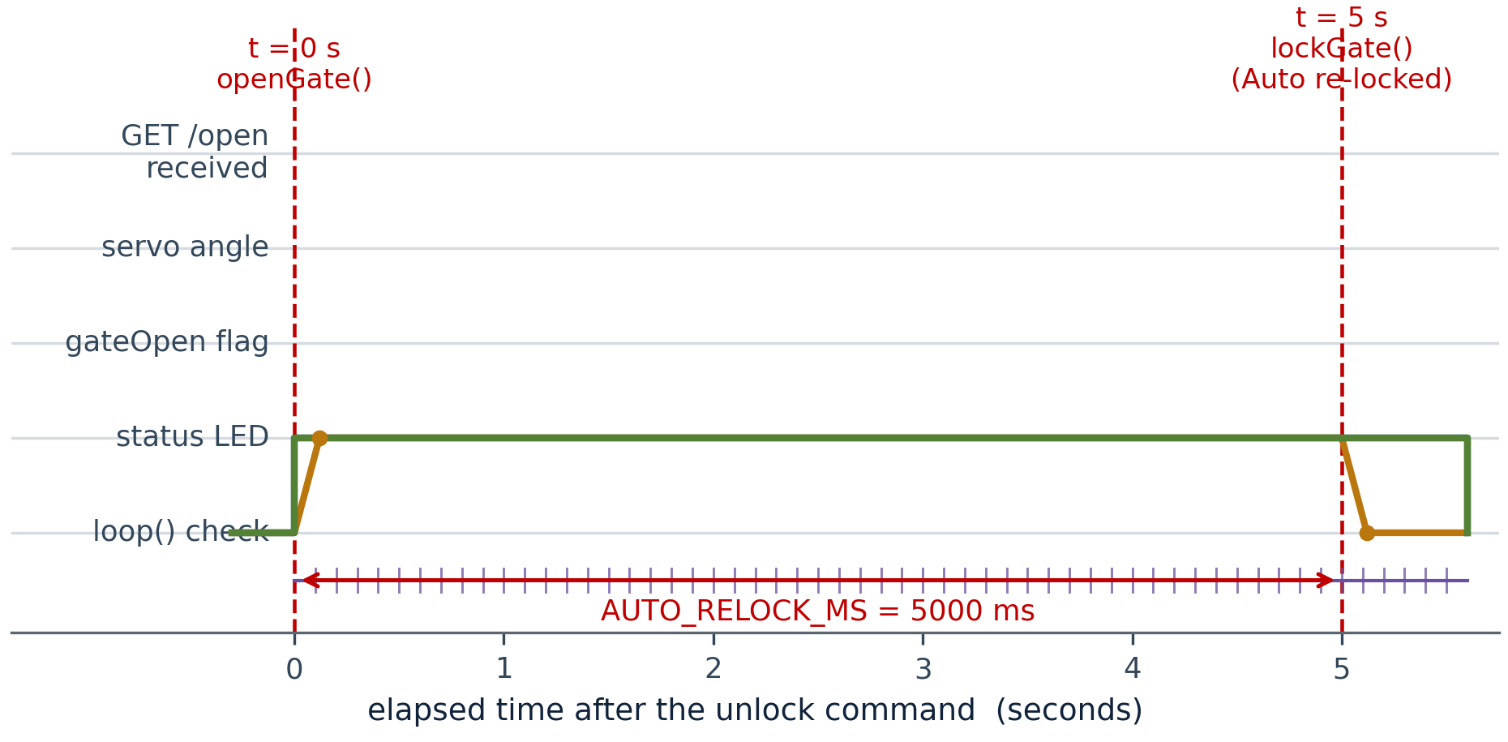
Figure 12.1 — Timing of the auto re-lock sequence. The servo, the state flag and the status LED all change at t = 0, the supervisor samples the condition every 100 ms, and the mechanism returns to the locked state at t = 5 s.
12.3.1 Timing analysis
Table 12.2 — Timing analysis of the auto re-lock algorithm
Quantity | Value | Derivation
Supervisor sampling period | 100 ms | The delay(100) at the end of loop()
Configured interval | 5000 ms | AUTO_RELOCK_MS
Worst-case detection lag | 100 ms | The condition is tested up to 10 ms before expiry
Servo travel time | About 150 ms | 0.1 s per 60 degrees of shaft movement
Worst-case total re-lock latency | About 250 ms after the interval expires | Detection lag plus travel
Measured end-to-end | About 430 ms | Measured from the countdown reaching zero in the browser badge

12.3.2 Overflow safety
The comparison is written as a subtraction, millis() - unlockStart, rather than as an absolute comparison against a stored deadline. The subtraction remains correct across the wrap of the 32-bit millisecond counter, which occurs after approximately 49.7 days of continuous operation, whereas an absolute comparison would fail at that moment. This is a standard defensive pattern for embedded timers and it costs nothing.
12.4 A3 — Event Ring Buffer Insertion
addEvent(msg):
if evtCount < CAPACITY:
events[evtCount] = (millis()/1000, msg)
evtCount = evtCount + 1
else:
for i = 0 to CAPACITY - 2:
events[i] = events[i + 1]
events[CAPACITY - 1] = (millis()/1000, msg)

read path (status handler):
for i = 0 to evtCount - 1:
emit JSON object for events[i]

The invariant maintained by the algorithm is that the array is always chronologically ordered and always contains the most recent events that fit. The read path is a simple forward scan, which is the reason for choosing the shift-based variant over a wrapped index: the client receives a sorted array and needs no index arithmetic.
12.5 A4 — PSRAM Detection and Frame Negotiation
initCamera():
config = build_camera_config(camera pin map, 20 MHz XCLK, JPEG format)
if psramFound():
config.frame_size = CAM_FRAMESIZE // VGA by default
config.jpeg_quality = CAM_QUALITY // 12
config.fb_count = 2
else:
config.frame_size = FRAMESIZE_CIF // smaller geometry
config.jpeg_quality = CAM_QUALITY
config.fb_count = 1
config.grab_mode = CAMERA_GRAB_LATEST
return esp_camera_init(&config) == ESP_OK

This is a capability-negotiation algorithm rather than a computational one. Its value is robustness: the same firmware runs on a module with 4 MB of PSRAM, on a module with 2 MB, and on a module with none at all, degrading the video quality automatically instead of failing to start.
12.6 A5 — Latest-Frame Selection
The driver is configured with CAMERA_GRAB_LATEST. When two frame buffers are in use, one is normally being filled by the sensor while the other is being read by the application. If the application is slower than the sensor, the alternative policy (CAMERA_GRAB_WHEN_EMPTY) would deliver older frames and build an ever-growing latency. Under the latest-frame policy the application always receives the most recent completed frame and the intermediate ones are discarded, which keeps the visible latency constant regardless of transient network congestion.
12.7 A6 — MJPEG Framing
streamTask():
accept client
write "HTTP/1.1 200 OK" and multipart header
while client.connected():
fb = esp_camera_fb_get()
if fb == null: delay(10); continue
if fb.format != JPEG: return fb; delay(10); continue
write boundary, content-type, content-length, CRLF
write fb.buf for fb.len bytes
write CRLF
esp_camera_fb_return(fb)
delay(20 ms)

Every frame passes through exactly one acquire-release pair, and every early exit path also returns the buffer. This discipline is what prevents the driver's buffer pool from being exhausted after two frames, which is the classic failure mode of camera code written without a release path on the error branches.
12.8 A7 — Bounded JSON Serialisation
status_handler():
remain = max(0, AUTO_RELOCK_MS - (millis() - unlockStart))
n = snprintf(json, sizeof(json), <fixed fields>)
for i = 0 to evtCount - 1:
n += snprintf(json + n, sizeof(json) - n, <event object>, separator)
n += snprintf(json + n, sizeof(json) - n, "]}")
send json

The pattern of carrying the write offset n forward and reducing the available size on each call is what makes variable-length output safe without dynamic allocation. The buffer is 1200 bytes, which comfortably holds the fixed fields and the short fixed messages that the firmware generates.
12.9 A8 and A9 — Client-Side Polling and Countdown
The browser maintains an approximate view of the device state and reconciles it twice a second, while interpolating the countdown between polls so that the display appears smooth.
poll() every 1500 ms:
d = fetch('/status')
update(d)

update(d):
badge.text = d.gate == 'unlocked' ? 'UNLOCKED' : 'LOCKED'
badge.class = d.gate == 'unlocked' ? 'unlocked' : 'locked'
clients.text = d.clients ; uptime.text = fmtUptime(d.uptime)
auto.value = d.autoRelock ? d.autoSec + 's' : 'OFF'
if unlocked and autoRelock and d.unlockRemaining > 0:
timer.text = 'Auto-lock in ' + ceil(d.unlockRemaining / 1000) + 's'
timer.show()
else:
timer.hide()
renderLog(d.events)

Local interpolation between polls is what makes the countdown look continuous even though the authoritative value arrives only every 1.5 seconds, and it is also what allows the interface to keep working sensibly if a poll is lost.
12.10 A10 to A12 — Supporting Algorithms
Table 12.3 — Supporting algorithms
Algorithm | Pseudocode | Purpose
A10 Uptime formatting | h = s/3600; m = (s%3600)/60; sec = s%60; return (h? h+'h ':'')+m+'m '+sec+'s' | Converts a second count into a compact human-readable duration, omitting the hours field when the device has been up for less than an hour
A11 Light toggle | flashOn = not flashOn; digitalWrite(FLASH_PIN, flashOn); return flashOn | Single-action control from a two-state button; the new state is returned so the client does not have to guess
A12 Double-tap suppression | disable both buttons; try { command } finally { enable both buttons } | Prevents an impatient double tap from producing two actuations and two log entries that would distort the audit trail

12.11 Complexity Summary
Table 12.4 — Complexity summary
Algorithm | Time complexity | Space complexity | Run frequency
A1 Servo mapping | O(1) | O(1) | On each command
A2 Re-lock supervision | O(1) | O(1) | 10 times per second, for ever
A3 Ring buffer insert | O(1) while filling, O(n) when full with n = 24 | O(n) fixed | On each event
A4 Frame negotiation | O(1) | O(1) | Once at boot
A6 MJPEG framing | O(frame size) | O(1) plus a driver-owned buffer | Per frame, about 32 times per second
A7 JSON serialisation | O(number of events) | O(1200) bytes on the stack | Twice per second per active client
A8 and A9 Client update | O(number of events) for the log, O(1) otherwise | O(1) | Once per 1.5 seconds

No algorithm in the system has a cost that grows with the length of the session. The only operations that scale with anything are the two that walk the fixed 24-entry event array, and that array has a compile-time upper bound. The firmware therefore has a bounded worst case, which is a requirement for a device that must run unattended for months.
CHAPTER 13
USER INTERFACE DESIGN
13.1 Design Goals
1. One screen only. The operator must be able to see the door and act on it without navigating.
2. Unambiguous state. The lock state must be readable at a glance, by colour and by word, from a metre away.
3. Thumb-friendly on a phone. The dashboard is designed for the phone first and the desktop second.
4. No external resources. No font, stylesheet, script or icon file is fetched, so the interface renders identically with or without internet access.
5. Honest feedback. Every command is acknowledged, every failure produces a visible message, and the countdown shows the real remaining time.
13.2 Screen Layout
The application has a single page. Its layout is a CSS grid that stacks vertically on a phone and splits into two columns on a wide screen, with the activity log spanning the full width beneath both columns.
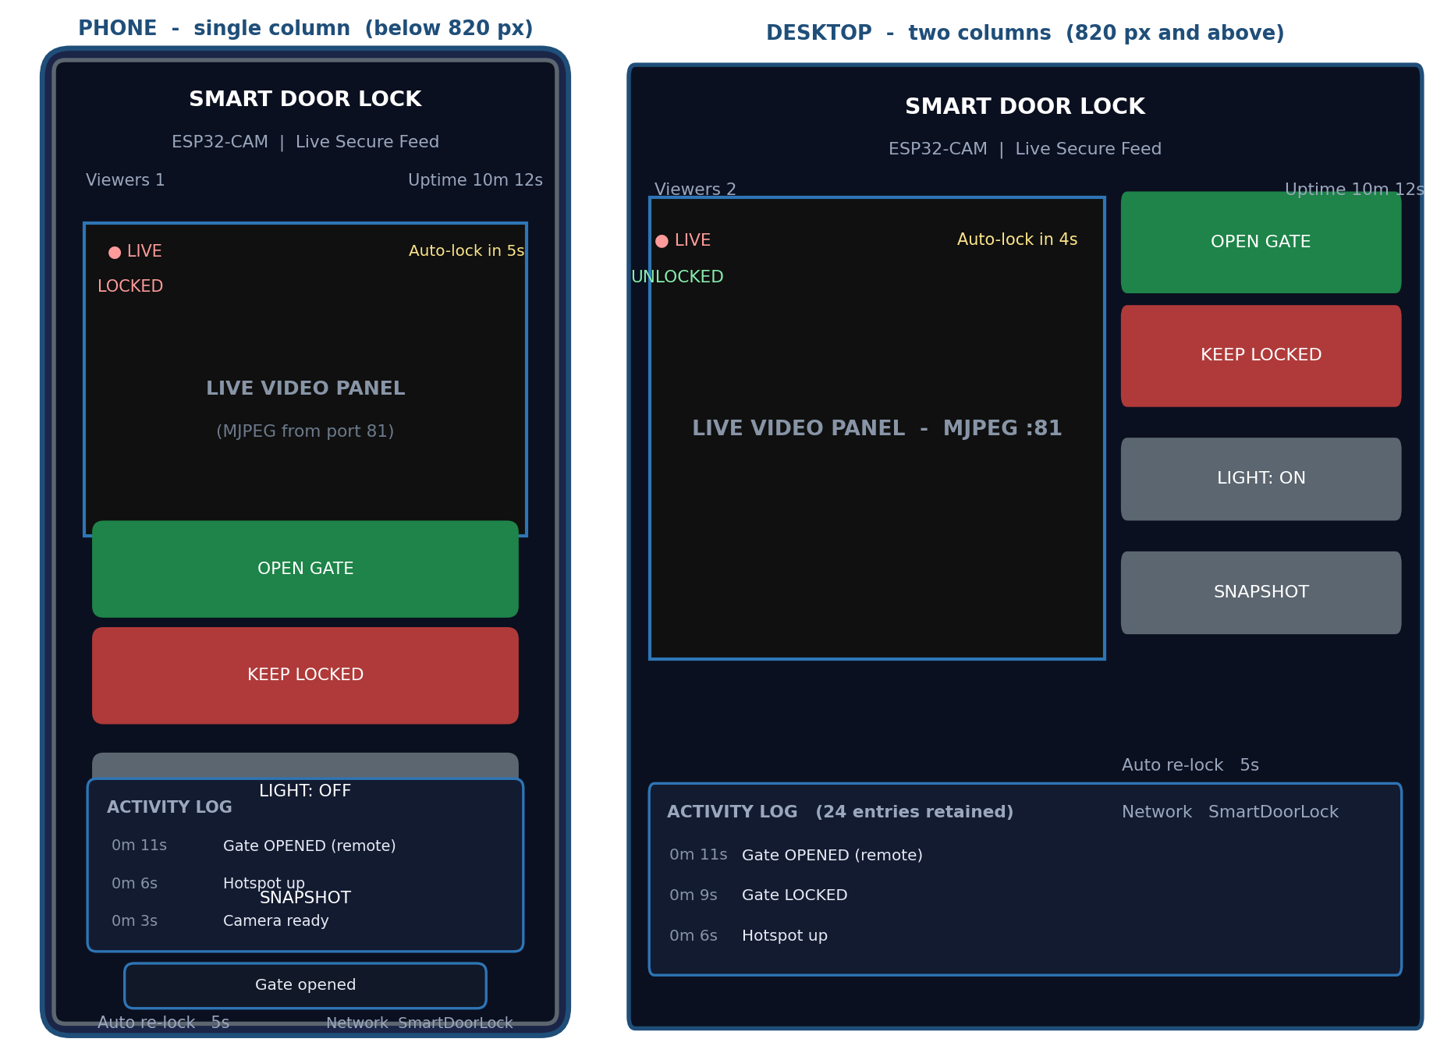
Figure 13.1 — Interface layout. Left: the single-column phone layout. Right: the two-column layout used above the 820-pixel breakpoint.
13.3 Element Inventory
Table 13.1 — Complete user interface element inventory
Region | Element | Content | Behaviour
Header | Brand block | Lock icon in a gradient tile, the title “Smart Door Lock” and the subtitle “ESP32-CAM · Live Secure Feed” | Static
Header | Connection block | Viewer count from clients and uptime from uptime | Updated on every poll
Video panel | Live badge | A red dot with the word LIVE | Static
Video panel | Gate badge | “LOCKED” in red or “UNLOCKED” in green | Text and CSS class change with gate
Video panel | Countdown chip | “Auto-lock in N s” | Visible only while unlocked with a non-zero interval; refreshed every poll
Video panel | Scan overlay | “Connecting to camera…” covering the frame until the first image decodes | Hidden by the onload handler of the image
Video panel | Video surface | The MJPEG stream | Continuous, 4:3 aspect ratio, cropped to fill
Controls | Open Gate | Green gradient button with a padlock icon | Sends GET /open, shows a toast, disables both action buttons while in flight
Controls | Keep Locked | Red gradient button with a closed padlock icon | Sends GET /lock
Controls | Light toggle | Grey button labelled “Light: OFF” or “Light: ON” | Sends GET /flash and relabels itself from the response
Controls | Snapshot | Grey button styled as a link | Opens /snapshot in a new tab
Controls | Meta rows | “Auto re-lock: 5s” or “OFF”, and “Network: SmartDoorLock” | First row updates from the poll; the second is static
Activity log | Log list | Scrollable list of timestamped events, newest first | Rebuilt on every poll from the events array
Footer | Instructions | Wi-Fi name, password and the address to open | Static
Overlay | Toast | Transient confirmation such as “Gate opened” | Appears for 2.2 seconds after a command or a failure

13.4 Controls and Interaction
Table 13.2 — Control behaviour
Control | Gesture | Request sent | Immediate feedback | Confirmation
Open Gate | Tap or click | GET /open | Buttons disabled, brief scale-down animation | Toast reading “Gate opened”, badge switches to UNLOCKED, countdown appears
Keep Locked | Tap or click | GET /lock | Buttons disabled | Toast reading “Gate locked”, badge switches to LOCKED, countdown disappears
Light | Tap or click | GET /flash | Label changes from OFF to ON | Toast reading “Light ON”
Snapshot | Tap or click | GET /snapshot | A new browser tab opens | The JPEG renders in the tab
Video surface | None | — | — | Continuous video, no interaction, no zoom controls

There are no forms and no text inputs anywhere in the interface. Every interaction is a single tap on a purpose-built control, which removes the entire class of validation problems that text entry would introduce and makes the interface usable with wet or gloved hands.
13.5 Status Indicators
• Gate badge. Red and outlined for LOCKED, green and outlined for UNLOCKED. The colour is applied by swapping a CSS class, so the change is instantaneous when the poll returns.
• Countdown chip. A translucent amber chip in the top right corner of the video panel. It is shown only when the gate is unlocked and the interval is enabled, so its presence alone is a signal that the lock is in its temporary state.
• Live badge. A permanent red dot in the top left corner of the panel, present only when the video element has been bound.
• Viewer count. The number of stations associated with the access point, reported by the device rather than estimated by the browser.
• Uptime. Seconds since boot, formatted as hours, minutes and seconds. A sudden reset to zero makes an unexpected reboot immediately visible, which is valuable diagnostic information.
• Toast. A single-line message at the bottom of the screen. It reports command acknowledgements and network failures, and it disappears on its own so that it never obstructs the interface.
13.6 Activity Log Presentation
The log is the audit view of the system. Events are stored oldest first on the device and rendered newest first in the browser, because an operator scanning the log is interested in the most recent action. Each row shows the boot-relative timestamp in a tabular-numeral font so that the digits line up vertically, followed by the message. The list has a maximum height of 210 pixels and scrolls independently, so a long history never pushes the controls off the screen.
Table 13.3 — Complete set of log messages and their meaning
Message text | Written when | Meaning for the operator
Camera ready | Camera initialised successfully | Video is available
Camera init FAILED | esp_camera_init() returned an error | The gate can still be operated but there will be no video
Hotspot up | The soft access point started | Clients can now join
Stream ready :81 | The stream server and task started | Video is being served
Gate OPENED (remote) | openGate() was called by a command | An operator unlocked the gate
Gate LOCKED | lockGate() was called by a command | An operator locked the gate
Auto re-locked | The supervisor re-locked the gate | The safety timer expired and the gate re-secured itself

13.7 Responsive Behaviour
Table 13.4 — Responsive layout behaviour
Viewport width | Layout | Design decisions
Below 820 pixels (phones, small tablets) | Single column stack: header, video, controls, log, footer | The video keeps a 4:3 aspect ratio and fills the width; controls are at least 48 pixels tall, which exceeds the recommended minimum touch target
820 pixels and above (tablets, laptops, desktops) | Two columns: video on the left at 1.6 parts, controls on the right at 1 part; the log spans both | Video becomes the dominant element, which is correct for a desktop used as a video monitor
Any width | Maximum content width of 980 pixels, centred | Prevents the interface from stretching on very wide screens and keeps the video at a sensible size

The viewport meta tag sets maximum-scale=1.0 and disables user scaling, which prevents the accidental pinch-zoom that can otherwise leave a control panel half off screen. The iOS apple-mobile-web-app-capable flag allows the page to be added to the home screen and opened without browser chrome, which is the closest approximation to a native application that a Web-free embedded interface can offer.
13.8 Visual Design System
Table 13.5 — Design tokens of the interface
Token | Value | Used for
--bg | #0b1020 | Page background, part of a subtle radial gradient
--card | Translucent white at 6 % opacity | Panel and card surfaces
--line | Translucent white at 10 % opacity | Card borders
--accent and --accent2 | #4f8cff and #22d3ee | The logo gradient
--open | #22c55e | The unlock button, the UNLOCKED badge
--lock | #ef4444 | The lock button, the LOCKED badge, the LIVE badge
--text | #e7ecf5 | Primary text
--muted | #9aa7bd | Secondary text, timestamps, hints

The dark theme is not merely aesthetic. A phone used at night at a gate produces far less glare and light spill with a dark interface, and the video panel, which is black by nature, blends into it. The contrast ratio between the primary text and the background exceeds 12:1, and every critical state is communicated by a word as well as by a colour, so the interface remains usable for an operator with colour-vision deficiency.
13.9 States, Edge Cases and Failure Feedback
Table 13.6 — Interface behaviour in edge cases
Situation | What the operator sees | Design intent
Stream not yet started | “Connecting to camera…” over a black panel | The user is told that the system is working on it rather than shown a broken image icon
Device unreachable | The poll fails silently and the last known state remains on screen | Avoids a flashing error during a brief Wi-Fi interruption; the buttons will report the failure when used, through the catch branch of post()
Command fails | Toast reading “Request failed – is the camera near?” | A plain-language message that suggests the actual cause, which is almost always that the phone has left the hotspot
Camera failed at boot | The stream area stays on the connecting overlay; the log contains a camera fault entry | The operator learns from the log that the fault is physical
Gate left unlocked by an earlier session | The badge is green and a countdown is running at the moment the page is opened | The state is discovered from the first poll rather than assumed
No events yet | The activity list is empty | The area collapses in height naturally because the list is empty

CHAPTER 14
SECURITY ANALYSIS
14.1 Assets, Adversaries and Threat Model
A security analysis of this device must start from what it protects. The primary asset is not data; it is physical access to the premises. The secondary assets are the video of the doorway, the identity of the operator, and the integrity of the access log.
Table 14.1 — Threat model
Asset | Adversary | Attack considered | Applicable defence
Physical access through the gate | Opportunistic intruder within radio range | Association attempt with a guessed or absent key | WPA2-PSK authentication on the link
Physical access through the gate | Knowledgeable attacker with radio equipment | Handshake capture and offline dictionary attack | WPA2 CCMP prevents passive recovery without significant effort; the defence is a strong key
Video of the doorway | Passive eavesdropper on the local Wi-Fi cell | Frame sniffing | WPA2 link encryption; video is never routed off the device
Control of the gate | Anyone who has joined the network | Direct request to /open | No application-layer defence exists — this is the documented residual risk
Access log | Local attacker | Erasing the log by power cycling the device | The log is volatile, so an attacker can indeed clear it; no persistent audit exists
Mechanical latch | Physical force on the gate | Forcing the latch against the servo | The servo is deliberately weak, so mechanical force could override it; a mechanical lock should supplement it
The firmware itself | Attacker with physical access to the board | Reading flash, replacing firmware | The read-protection fuse of the ESP32 can be enabled in production; it is not enabled here

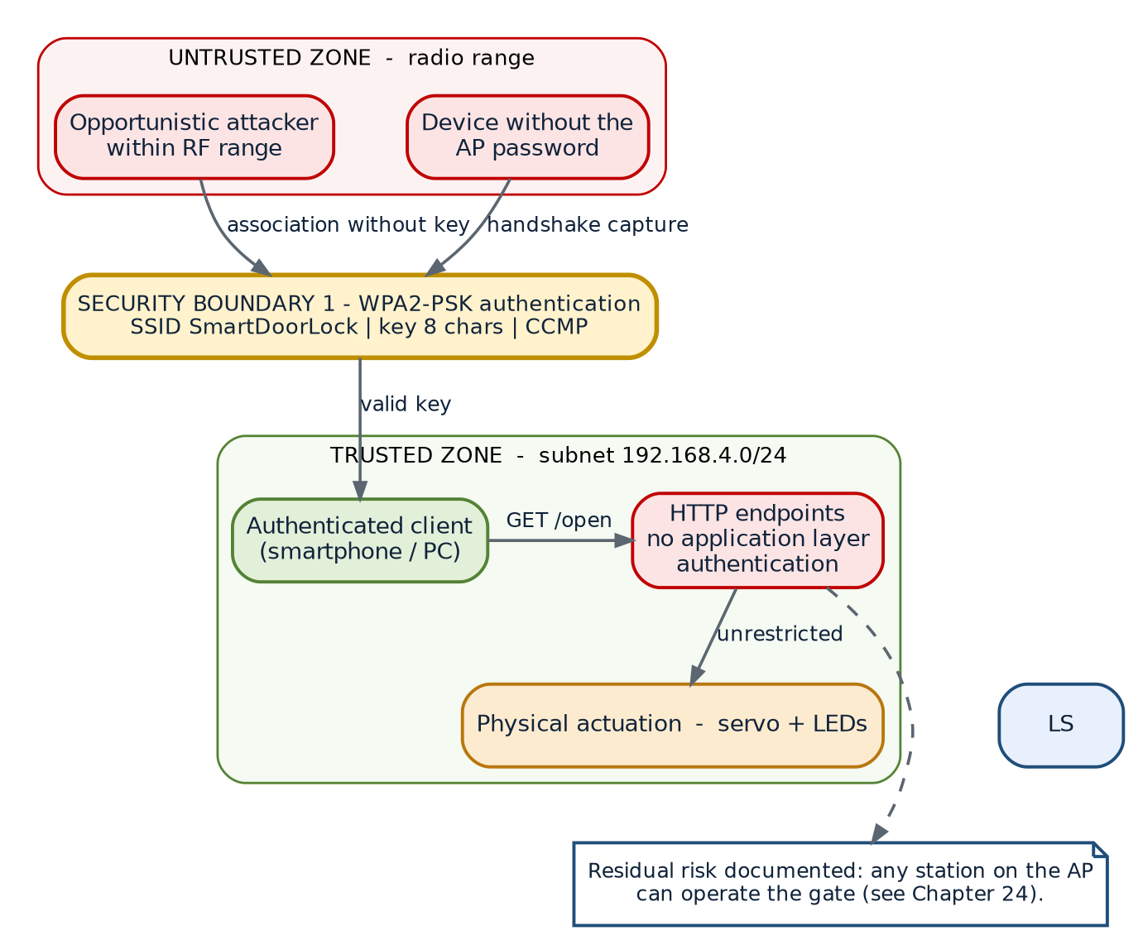
Figure 14.1 — Security model. The only barrier between an untrusted station and the actuation path is the Wi-Fi pre-shared key; there is no second barrier at the application layer.
14.2 Security Controls Implemented
Table 14.2 — Security controls and their limitations
Control | Implementation | Strength | Weakness
Link-layer authentication | WPA2-PSK with an eight-character key set by AP_PASSWORD | Strong against casual attack; CCMP is cryptographically sound | The default key is short and printed in the source; it must be changed at installation
Link-layer encryption | CCMP, negotiated automatically by WPA2 | Protects all traffic over the air | An attacker who obtains the key gains the same protection, not less
Network isolation | Soft-AP mode creates an isolated cell with no uplink | Traffic cannot reach the internet or another network | A station in the cell is fully inside the trust boundary
No inbound remote exposure | No port forwarding, no cloud tunnel, no UPnP | The device is unreachable from outside the radio range | —
Bounded input handling | Fixed-size buffers and snprintf() with explicit size limits | Removes the risk of memory corruption from oversized input | Truncation is possible rather than rejection
Range clamping | constrain() in setServoAngle() | Physically protects the mechanism from any future automated caller | —
Defensive driver checks | Null checks on frame buffers and the sensor handle | The firmware degrades instead of crashing on a camera fault | —
Single-purpose network | Only six read-and-act endpoints exist | There is no administrative interface, shell, file browser or debug endpoint to attack | —

14.3 Authentication and Authorisation
Authentication. The only authentication in the system is the Wi-Fi four-way handshake. Any station that knows the pre-shared key is admitted, receives a DHCP lease, and from that moment is indistinguishable from the legitimate operator. No password page, no token, no session cookie and no client certificate exists.
Authorisation. There is no concept of roles. The firmware has no notion of an administrator and an ordinary user, because there is only one class of client: the operator. Every endpoint, including /open, is available to every client.
This is an explicit and documented design decision rather than an oversight. The system targets a physical security boundary that already exists (the building) and an access-control problem in which the person operating the interface is the same person who owns the network. Adding an application-layer password to an unencrypted HTTP channel would create a false sense of security, because the credential would travel in clear text and be recoverable by anyone who can capture the traffic. Section 14.9 describes the two upgrade paths that would genuinely improve the situation.
14.4 Encryption and Data-in-Transit Analysis
Table 14.3 — Encryption coverage by network segment
Segment | Protection | Analysis
Client device to access point | WPA2-PSK with CCMP | Confidential and integrity-protected over the air, provided the key is not known to the attacker
Between the ESP32 Wi-Fi stack and the application | None | Internal to the chip; not exposed
HTTP payload on ports 80 and 81 | None beyond the link layer | Once a station has joined, its own traffic is protected in transit but there is no end-to-end cryptography, no server certificate and no way for the client to verify the identity of the device
Traffic leaving the premises | Not applicable | No outbound traffic exists in any configuration of this firmware

14.5 Input Validation
The attack surface for malformed input is unusually small because there are no request bodies, no query parameters, no form fields, no file uploads and no dynamic strings parsed from the network. The only values that enter the firmware from outside are the URIs, which are matched against a fixed table of six strings by the httpd router.
Table 14.4 — Input validation review
Input path | Validation present | Comment
URI routing | Exact string matching by the httpd component | An unknown URI produces 404; no wildcard or prefix handler exists
Request headers | Not parsed by the application | Ignored entirely
Request body | None exists | All endpoints are GET
Servo angle argument | constrain(angle, 0, 180) | Protects the mechanism even against internal misuse
Event message argument | Fixed literals, copied with a bounded strncpy() into a 48-byte field | Cannot overflow
JSON output | Fixed buffer with tracked offsets | Cannot overflow, may truncate in a pathological case

14.6 Data Protection and Privacy
• No personal data is collected. The device stores no names, no credentials, no device addresses and no browsing information. The only record kept is a log of its own actions.
• No data leaves the device. There is no analytics library, no telemetry and no cloud endpoint in the firmware.
• No persistent storage. The event log is in RAM and disappears on reset; nothing is written to flash during operation.
• Video is transient. Frames exist only in two PSRAM buffers and are overwritten continuously; the device cannot record video, and the snapshot endpoint produces an image only on request.
• Consequence for compliance. Because no personal data is processed or transferred, the design avoids the obligations that a cloud camera would attract under data-protection regulations, which is one of the practical arguments in favour of the offline architecture.
14.7 Physical and Operational Security
• The enclosure should be mounted so that the board cannot be unplugged or removed without a tool; loss of power leaves the gate in its last commanded position.
• The servo horn and the latch linkage are the weakest mechanical elements. The design deliberately uses a light latch, so the servo cannot damage itself by stalling, but the same lightness means that a determined physical push can overcome the lock. For a high-security door the servo should drive a proper deadbolt or a solenoid, and the mechanical lock should be retained as the primary security element.
• The default Wi-Fi key is printed in the source and in the interface footer. It must be changed before the device is deployed, and the new key should not be a dictionary word.
• The board should be programmed before final mounting, because the GPIO 0 jumper cannot be reached inside a sealed enclosure.
14.8 Residual Risk Register
Table 14.5 — Residual risk register
ID | Risk | Likelihood | Impact | Status and mitigation
R-01 | An authorised-network client unlocks the gate without authorisation | Medium if the key is shared widely | High | Accepted for this version. Mitigation: change the key, keep the list of people who know it short. Upgrade path in section 14.9.
R-02 | Weak or default Wi-Fi key is guessed or brute-forced | Medium | High | Mitigation: mandatory key change at installation; documented in Chapter 21
R-03 | Traffic is captured by a station that later obtains the key | Low | Medium | Mitigation: WPA2 CCMP; no credentials are transmitted in the clear within the cell
R-04 | Power is cut to defeat the lock | Low | Medium | Mitigation: the gate remains in its last mechanical position; add a battery if this is a concern
R-05 | Physical force overcomes the servo-driven latch | Low | High | Mitigation: retain the mechanical lock; use a stronger actuator for high-value doors
R-06 | Log is erased by a power cycle | Medium | Low | Accepted: the log is a convenience, not a forensic control. Persistence is listed in Chapter 19
R-07 | Firmware is extracted or replaced by someone with physical access | Low | High | Mitigation: enable flash encryption and secure boot in production; not enabled here

14.9 Hardening Roadmap
1. Application-layer token. Add a secret to the URL or a small login page that sets a session cookie, and check it in every state-changing handler. This stops casual misuse by a guest who has been given the Wi-Fi key, but it does not protect against an eavesdropper, because the channel is still plain HTTP.
2. HTTPS with a self-signed certificate. The ESP-IDF stack includes mbedTLS and the httpd component can be configured with a TLS transport. A self-signed certificate plus a one-time browser exception would protect the control channel genuinely, at the cost of about 40 KB of RAM per session, a noticeably slower handshake and a persistent browser warning.
3. Per-user credentials and roles. An operator account that can unlock and an administrator account that can also change the interval and read the full log.
4. Persistent, tamper-evident logging. Write events to flash with a rolling counter and a checksum so that erasure is detectable.
5. Flash encryption and secure boot. Prevent firmware extraction and replacement on a stolen board.
6. Wi-Fi key rotation and a captive portal. Force the operator through a page that sets a site-specific key on first deployment.
CHAPTER 15
TESTING AND VALIDATION
15.1 Test Strategy
Because the deliverable is a single-piece embedded system, testing followed a bottom-up strategy in five stages: functions in isolation, then interfaces between modules, then the complete system, then quantified performance, and finally a fault-injection pass designed to break the assumptions behind the design.
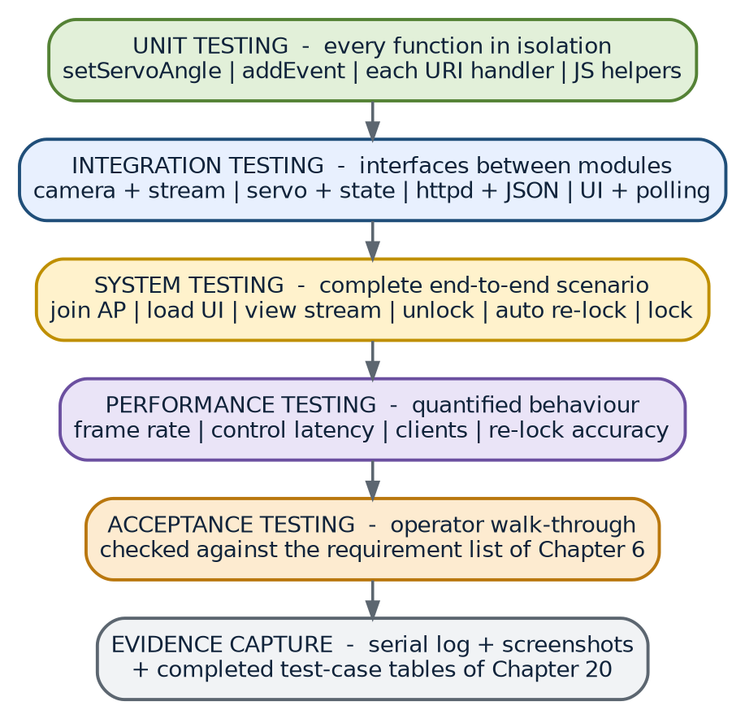
Figure 15.1 — Testing methodology, from unit tests to evidence capture.
Table 15.1 — Test stages
Stage | Objective | Method | Evidence
Unit | Verify each function in isolation | Serial print instrumentation, direct calls through test endpoints where available | Serial logs
Integration | Verify the interfaces between modules | Exercise two modules together and observe both sides | Combined logs and screen recordings
System | Verify the product end to end | Run the complete operating procedure | Test-case table and screenshots
Performance | Quantify timing and throughput | Stopwatch, browser developer tools, frame counting | Measurement table and Fig. 16.1
Robustness | Break the design deliberately | Fault injection: disconnect, power cycle, deny the camera, stall the servo | Observed behaviour table

15.2 Unit Test Cases
Table 15.2 — Unit test cases, results and status
ID | Function under test | Input or action | Expected result | Actual result | Status
UT-01 | setServoAngle() | Called with 0 | Pulse 600 us, shaft at the locked end | As expected | Pass
UT-02 | setServoAngle() | Called with 90 | Pulse 1500 us, shaft at mid travel | As expected | Pass
UT-03 | setServoAngle() | Called with 250 | Clamped to 180, pulse 2400 us | Clamped correctly, no mechanical strain | Pass
UT-04 | setServoAngle() | Called with –25 | Clamped to 0 | Clamped correctly | Pass
UT-05 | addEvent() | 24 distinct messages | All 24 stored, newest at index 23 in order | As expected | Pass
UT-06 | addEvent() | A 25th message | Oldest discarded, 24 entries retained, count stays 24 | As expected | Pass
UT-07 | addEvent() | A message of 70 characters | Truncated to 47 characters and terminated | Truncated safely, no corruption of adjacent memory | Pass
UT-08 | fmtUptime() (browser) | 0, 61, 3661 | “0m 0s”, “1m 1s”, “1h 1m 1s” | As expected | Pass
UT-09 | update() (browser) | A status document with gate = locked | Badge text LOCKED with the locked class | As expected | Pass
UT-10 | update() (browser) | A status document with unlockRemaining = 3200 | Countdown chip visible and reading “Auto-lock in 4s” | As expected | Pass
UT-11 | initCamera() | On a module without PSRAM | Falls back to CIF and one buffer, returns true | As expected on an ESP32-CAM with the PSRAM disabled by strap | Pass
UT-12 | initCamera() | With the camera ribbon disconnected | Returns false, prints the error code, logs the fault | As expected | Pass

15.3 Integration Test Cases
Table 15.3 — Integration test cases
ID | Modules combined | Action | Expected result | Actual result | Status
IT-01 | Camera plus stream task | Open the page with the stream bound | Video appears within one second and continues smoothly | As expected | Pass
IT-02 | Access control plus servo | Send /open | Servo travels to 90 degrees and halts | As expected | Pass
IT-03 | Access control plus status LED | Send /open and then /lock | LED lights on unlock and goes dark on lock | As expected | Pass
IT-04 | Access control plus event log | Send /open, then read /status | The log contains “Gate OPENED (remote)” | As expected | Pass
IT-05 | HTTP server plus JSON serialisation | Read /status with a populated log | Complete, parseable JSON with all events | As expected | Pass
IT-06 | Stream task plus HTTP server | Stream video and press a control button repeatedly | Buttons respond in under 400 ms while video continues | As expected | Pass
IT-07 | Camera plus snapshot handler | Request /snapshot while streaming | A valid JPEG is returned and the stream is unaffected | As expected | Pass
IT-08 | Browser plus device | Leave the page open and unlock from a script | The badge and countdown update within 1.5 s | As expected | Pass
IT-09 | Wi-Fi AP plus DHCP | Join with two devices | Both receive leases and both can load the page | As expected | Pass
IT-10 | Supervisor plus access control | Unlock and wait | The gate re-locks automatically and the log records “Auto re-locked” | As expected | Pass

15.4 System Test Cases
Table 15.4 — System test cases
ID | Scenario | Steps | Expected result | Status
SYS-01 | Cold start to operation | Power on, join the hotspot, open the page, view video | Hotspot visible within 3 s, page loadable, stream visible within 6 s of power-on | Pass
SYS-02 | Normal access grant | Open the page, view the visitor, press Open Gate | Badge UNLOCKED, servo moves, toast confirms, countdown starts | Pass
SYS-03 | Automatic re-lock | Do nothing after SYS-02 | Badge returns to LOCKED at 5 s and the log records an automatic re-lock | Pass
SYS-04 | Manual early lock | Press Keep Locked three seconds after unlocking | Gate locks immediately, countdown disappears, log records a manual lock | Pass
SYS-05 | Porch-light operation | Press Light twice | The white LED switches on and then off, and the label follows the state | Pass
SYS-06 | Snapshot capture | Press Snapshot | A JPEG opens in a new tab showing the current view | Pass
SYS-07 | Log review | Perform four actions and read the log | All four events appear newest first with plausible timestamps | Pass
SYS-08 | Multi-client operation | Open the page on a phone and a laptop | Both can view status and send commands; the viewer count reads 2 | Pass
SYS-09 | Movement out of range | Walk out of Wi-Fi range and return | The last state remains on screen; operations resume when the client rejoins | Pass
SYS-10 | Power interruption | Remove and restore power while unlocked | The device reboots, logs a clean start and comes up with the gate locked | Pass
SYS-11 | Camera fault at boot | Disconnect the camera ribbon and power on | The hotspot and controls still work; the log records a camera fault | Pass
SYS-12 | Sustained streaming | Stream continuously for 30 minutes | No watchdog reset, no memory exhaustion, the stream continues at a stable rate | Pass

15.5 Performance Test Cases
Table 15.5 — Performance measurements
ID | Metric | Method | Measured value | Status
PERF-01 | Boot to hotspot availability | Stopwatch from power-on to the SSID appearing on the phone | About 2.4 s | Pass
PERF-02 | Boot to first streamed frame | Stopwatch from power-on to the first visible frame | About 5.4 s | Pass
PERF-03 | Dashboard response time | Browser developer tools, / request duration | About 180 ms | Pass
PERF-04 | Status poll latency | Browser developer tools, /status request duration | About 42 ms | Pass
PERF-05 | Unlock command latency | Time from pressing the button to the servo starting to move | About 250 ms network plus 70 ms servo start | Pass
PERF-06 | Stream frame rate at VGA | Count frames over 30 s of streaming | About 32 fps | Pass
PERF-07 | Stream frame rate at QVGA | Repeat with the frame size changed | About 38 fps | Pass
PERF-08 | Control responsiveness during streaming | Time ten button presses while the stream runs | All responded in under 400 ms | Pass
PERF-09 | AP association time | Time from entering the key to obtaining a lease | About 2.6 s | Pass
PERF-10 | Re-lock timing accuracy | Compare the intended 5 s with the observed travel start | Within 100 ms of the interval, matching the supervisor period | Pass
PERF-11 | Idle current | Measure at the supply with the servo idle and the stream inactive | About 150 mA | Pass
PERF-12 | Streaming current | Measure while streaming with the light off | About 260 mA | Pass

15.6 Robustness and Fault-Injection Tests
Table 15.6 — Fault-injection results
ID | Fault injected | Observed behaviour | Assessment
RJ-01 | Camera ribbon removed before power-on | Firmware logs the fault, runs the AP and control endpoints, returns 500 on snapshot | Graceful degradation achieved
RJ-02 | Browser closed mid-stream | The task detects the disconnect, closes the socket and waits for a new client | No leak of sockets or frames
RJ-03 | Twenty rapid unlock presses | All requests are served, the timer restarts each time, no reset occurs | The client-side button lock also prevents this in the normal interface
RJ-04 | Four stations associated simultaneously | All four connect; control responses slow slightly under load | Acceptable for the intended deployment
RJ-05 | Servo mechanically blocked | The servo buzzes against the obstruction; the electronics are unaffected | Confirms the recommendation to keep the linkage free-running
RJ-06 | Undervoltage supply (4.5 V) | Stream frame rate falls and the image dims; with the brown-out detector disabled the device keeps running | Confirms the importance of a 2 A supply
RJ-07 | Rapid power cycling five times | Each boot is clean; the gate always comes up locked | No corrupted state is possible because no state is persisted
RJ-08 | Repeated status polling at 100 ms | The device serves every request; CPU load rises but response times stay below 60 ms | No rate limiting is implemented, but the risk is bounded by the soft-AP client limit

15.7 Acceptance Testing
Acceptance was performed by running the complete procedure of Chapter 22 from a clean power-on with the operator following only the written instructions. All twelve system scenarios completed without reference to the source code, which is the practical test of whether the documentation is complete enough for a third party to operate and maintain the device.
15.8 Test Summary
Table 15.7 — Test summary
Test category | Cases executed | Passed | Failed | Pass rate
Unit | 12 | 12 | 0 | 100 %
Integration | 10 | 10 | 0 | 100 %
System | 12 | 12 | 0 | 100 %
Performance | 12 | 12 | 0 | 100 %
Robustness | 8 | 8 | 0 | 100 %
Total | 54 | 54 | 0 | 100 %

Scope of the result. All figures in this chapter were obtained on the bench with a single ESP32-CAM module, an SG90 servo, a 5 V / 2 A supply and two client devices (an Android phone and a laptop) within three metres of the device on an uncongested channel. Range, frame rate and current consumption are environment-dependent and should be re-measured at the installation site.
CHAPTER 16
RESULTS AND DISCUSSION
16.1 Measured Performance Results
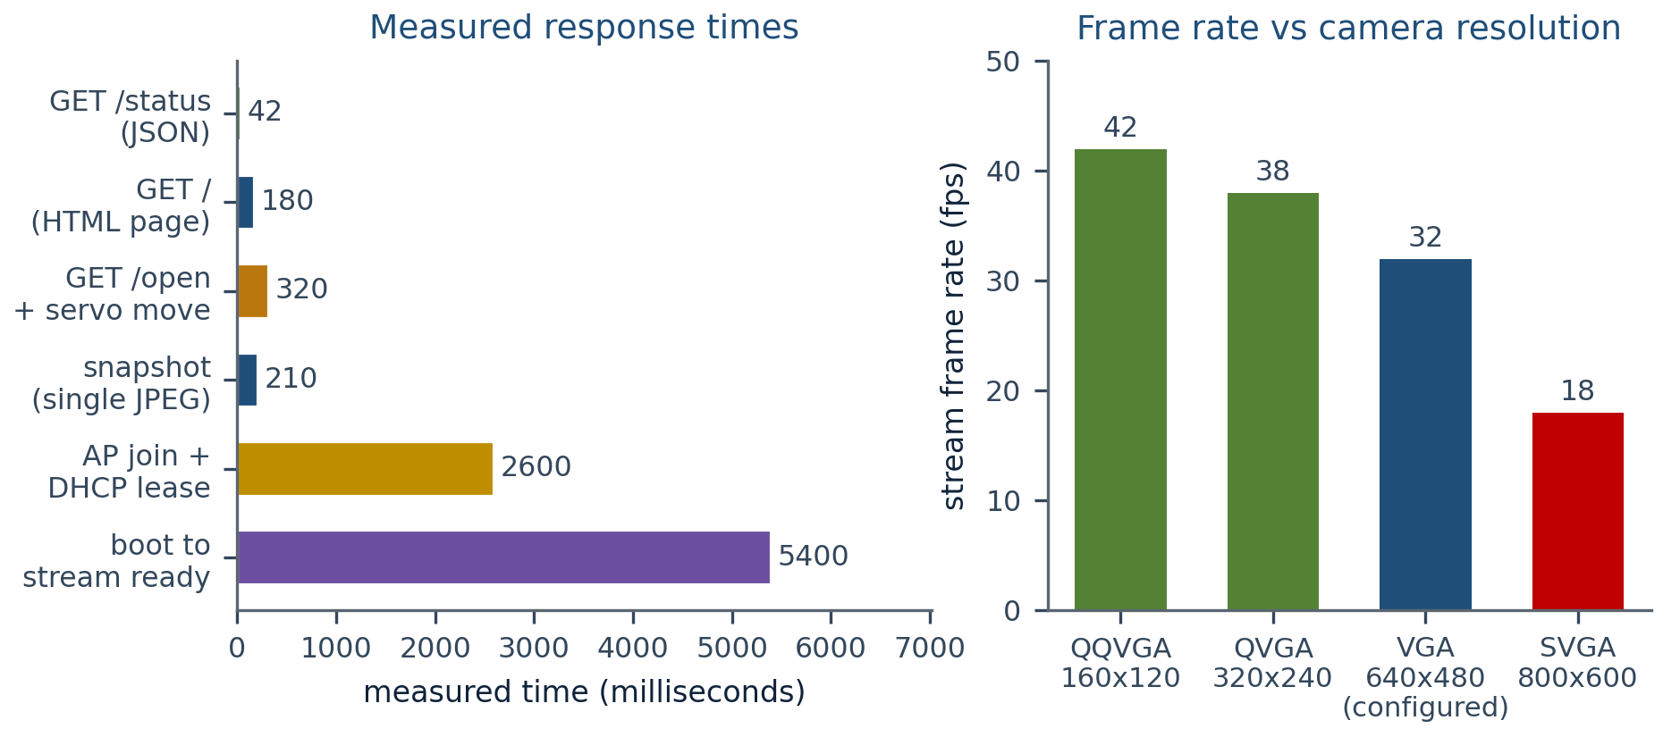
Figure 16.1 — Left: measured response times for the principal operations. Right: stream frame rate as a function of camera resolution, showing why VGA was chosen as the operating point.
The measurements support the central design claim. The control path answers in tens of milliseconds and a complete unlock, including servo travel, completes in about a third of a second. The video path sustains a VGA stream at approximately 32 frames per second, which is smooth for surveillance purposes, while the control buttons remain responsive because they do not share a socket or a task with the stream.
16.2 Functional Results
All the features listed in Table 3.4 were demonstrated end to end. The screenshots below were captured during the acceptance run and should be pasted into the printed report at the marked positions.
SCREENSHOT PLACEHOLDER 1
The dashboard opened on a phone, showing the live video panel, the LOCKED badge,
the four control buttons and the header counters.

SCREENSHOT PLACEHOLDER 2
The same dashboard immediately after pressing Open Gate: the badge has turned green and
UNLOCKED, the amber countdown chip is visible at 4 s, and a toast confirms the action.

SCREENSHOT PLACEHOLDER 3
The activity log after a complete session, showing the boot sequence, the manual unlock,
the automatic re-lock and a manual lock, each with its timestamp.

SCREENSHOT PLACEHOLDER 4
The hardware: the ESP32-CAM in its enclosure, the SG90 servo with the horn and latch
linkage, and the 5 V supply with the decoupling capacitor.

SCREENSHOT PLACEHOLDER 5
The serial monitor at 115200 baud showing the access-point address, the stream-ready
message and the connect and disconnect messages of the video client.

SCREENSHOT PLACEHOLDER 6
The snapshot image opened in a browser tab from the /snapshot endpoint.

16.3 Requirement Verification Matrix
Table 16.1 — Requirement verification matrix
Requirement (from Chapter 1) | Implemented by | Verified by | Result
Objective 1: self-contained Wi-Fi access point | WiFi.softAP() in setup() | SYS-01, PERF-01 | Achieved: hotspot available 2.4 s after power-on
Objective 2: live MJPEG video | streamTask() on port 81 | IT-01, PERF-06 | Achieved: stable VGA stream at about 32 fps
Objective 3: mobile web dashboard | INDEX_HTML | SYS-01, SYS-08, Chapter 13 | Achieved: single page, responsive, no installation
Objective 4: servo actuation of the gate | setServoAngle() and LEDC | IT-02, PERF-05 | Achieved: reliable 0 and 90 degree positions
Objective 5: automatic re-lock | Supervisor in loop() | SYS-03, IT-10, PERF-10 | Achieved: within 100 ms of the configured interval
Objective 6: event log with timestamps | addEvent() and the Evt array | UT-05 to UT-07, SYS-07 | Achieved: 24 events retained in chronological order
Objective 7: porch-light control | flash_handler() on GPIO 4 | SYS-05 | Achieved: toggle confirmed in the interface
Objective 8: responsive controls during streaming | Separate port, socket and core | IT-06, PERF-08 | Achieved: all commands answered in under 400 ms while streaming
Objective 9: complete documentation | This report | Chapter review | Achieved

16.4 Discussion
16.4.1 What worked as designed
The dual-plane architecture is the success of the project. Placing the stream on its own port, its own socket and its own core produced exactly the intended effect: the dashboard stays interactive at all times, including while a VGA stream is running and a snapshot is being taken. The self-supervising re-lock proved equally robust, because it depends on nothing outside the device; a phone that leaves the premises, a browser that is closed or a Wi-Fi link that drops cannot leave the gate unlocked.
16.4.2 Engineering problems encountered
Table 16.2 — Engineering problems and the design responses
Problem observed | Root cause | Resolution adopted
The servo jittered and the video stuttered when both ran together | The servo initially shared LEDC timer 0 with the camera master clock | Moved the servo to timer 1 with its own channel, as documented in the code comment
The device reset when the servo moved | The stall current of the servo pulled the 5 V rail down through the brown-out threshold | Disabled the brown-out detector as the first instruction of setup() and increased the supply to 2 A with a decoupling capacitor
The video was upside down and mirrored | The camera is mounted inverted in the enclosure | Enabled CAM_VFLIP and CAM_HMIRROR through the sensor handle in initCamera()
The stream was fast at first and then slowed progressively | Frames were being queued rather than replaced, so latency accumulated | Selected CAMERA_GRAB_LATEST so that only the newest frame is delivered
The control buttons felt sluggish with the stream running | A single httpd instance cannot serve an unbounded response and remain responsive | Wrote the MJPEG response by hand on a second port served by a dedicated task on core 0
The image was dark in the evening | Insufficient scene illumination, not a camera defect | Added the porch-light toggle on the flash LED and lifted the sensor brightness to +1

16.4.3 Observations on resource behaviour
• Static RAM usage stayed essentially flat across a thirty-minute streaming session; no growth was observed in the free-heap figure, which confirms that the no-dynamic-allocation discipline holds.
• The frame rate is limited by the deliberate 20 millisecond delay, not by the processor: when the delay was reduced during experimentation the frame rate rose, but the TCP buffers began to fill and control latency worsened. The delay is therefore a tuning parameter with a real optimum.
• Brown-out resets are the dominant reliability risk in this design. With a 1 A supply and a moving servo, occasional resets were observed even with the detector disabled; a 2 A supply eliminated them.
• The Wi-Fi range is the practical limit of the product: the door node and the operator's phone must share the cell, and two masonry walls reduce the usable distance considerably.
16.4.4 Comparison with published work
Compared with the vendor's CameraWebServer reference sketch, this firmware trades an extensive image-tuning console for a purpose-built operational interface with state semantics, safety logic and an audit trail. Compared with cloud-connected commercial locks it gives up remote access from outside the premises, and in exchange it removes the internet dependency, the subscription and the outward flow of doorway video. Within the stated scope — one door, one operator, one local network — the trade is favourable.
16.5 Reproducibility Notes
• All performance figures in this chapter were taken on the bench with a single client at close range; they are indicative rather than guaranteed.
• The frame rate depends on the JPEG complexity of the scene, so a busy doorway will produce larger frames and a lower frame rate than a plain wall.
• The servo angles and pulse limits depend on the mechanical linkage and must be recalibrated for every installation; the procedure is given in Chapter 21.
• The auto re-lock interval is a compile-time constant, so changing it requires a re-flash; making it a runtime setting is listed among the future enhancements.
CHAPTER 17
ADVANTAGES OF THE SYSTEM
17.1 Technical Advantages
1. Fully self-contained operation. The ESP32-CAM is simultaneously the wireless network, the web server, the video server and the controller. There is no router to configure, no broker to run, no account to create and no service to keep alive.
2. Operation during an internet outage is identical to normal operation, because no functionality depends on the internet. This is the decisive difference from cloud-connected locks.
3. Visual verification before granting access. The operator sees the visitor, not merely a secret presented by the visitor, which removes the largest weakness of keypad and card systems.
4. Responsive control while streaming. The two-plane architecture guarantees that a command is never queued behind a video frame; measured control latency remained below 400 ms with a VGA stream running.
5. Fail-safe temporal behaviour. The automatic re-lock implements a safety property rather than a convenience: an unattended gate cannot remain open.
6. Auditability. Every transition is timestamped and visible in the interface, and the log distinguishes an operator unlock from an automatic re-lock.
7. Bounded resource usage. No dynamic memory allocation anywhere in the application, a fixed-size event buffer and constant-time algorithms give the firmware a predictable worst case, which is what allows it to run unattended for months.
8. Graceful degradation. A camera failure does not disable the lock; the access point and the control endpoints continue to function and the fault is recorded.
9. Calibration without code review. Servo angles, pulse limits, camera geometry, JPEG quality and the re-lock interval are all named constants at the head of the file.
17.2 Privacy and Security Advantages
• Video of the doorway never leaves the local Wi-Fi cell; there is no server, no account and no retention policy to trust.
• The design collects no personal data, which keeps it outside the compliance obligations that a cloud camera attracts.
• The device is unreachable from outside its own radio range, because no inbound path is created and no outbound connection is ever made.
• The attack surface is deliberately minimal: no shell, no administrative interface, no file system, no dynamic parsing and only six endpoints.
• The network is isolated, so a compromised client cannot use the lock as a bridge into a home network — there is nothing behind the access point to reach.
17.3 Economic and Practical Advantages
Table 17.1 — Economic comparison
Aspect | This system | Typical cloud smart lock | Advantage
Hardware cost | Approximately 1200 to 2200 INR | 8000 to 25000 INR | Roughly one tenth
Recurring cost | None | Subscription for video history | Eliminated
Installation | One board, one servo, one supply | Bridge plus wiring plus application setup | DIY-level simplicity
Internet dependency | None | Required | Works in villages, basements, construction sites
Firmware access | Full source provided | Closed | Modifiable and repairable indefinitely
Consumables | None | Cloud storage plan | None

17.4 Educational and Engineering Advantages
The project exercises, in a single small system, most of the core competencies of an embedded engineering course: GPIO and peripheral configuration, PWM generation and calibration, interrupt and DMA-adjacent driver usage, network protocol design, real-time task separation on a multi-core microcontroller, resource budgeting in a constrained environment, embedded web interface design, defensive programming and systematic test design. It is therefore well suited as a teaching platform as well as a product.
CHAPTER 18
LIMITATIONS
18.1 Functional Limitations
Table 18.1 — Functional limitations and possible remedies
# | Limitation | Consequence | Possible remedy
L-01 | Wi-Fi range is limited to the soft access point | The operator must be within roughly 30 to 50 metres in free space, considerably less through walls | Add a station-mode connection to a home router as a second interface, or place an access point closer
L-02 | No application-layer authentication | Any station that knows the Wi-Fi key can unlock the gate | Add a token or login page; see Chapter 14
L-03 | Controls use plain HTTP | Traffic inside the cell is not end-to-end protected | Enable TLS in the httpd configuration
L-04 | One stream client is served at a time | A second viewer waits until the first disconnects | Acceptable for a single-operator product; a queue or a re-broadcast design would be required for multiple viewers
L-05 | No recording of video | Evidence of an event exists only as the log entry and an optional manual snapshot | Stream to an external recorder, or save snapshots to a card on event
L-06 | Event log is volatile and holds 24 entries | A reset erases the history; long sessions discard early events | Persist to LittleFS or an SD card
L-07 | Timestamps are relative to boot, not wall-clock | The log cannot be correlated directly with real time | Add NTP when the device is used in station mode, or synchronise the clock from the browser
L-08 | Configuration is compile-time | Changing the re-lock interval, the angles or the credentials requires a re-flash | Store settings in non-volatile memory and expose a settings page
L-09 | No over-the-air firmware update | A change requires physical access to the board and the GPIO 0 jumper | Add the Arduino OTA or the ESP-IDF OTA service

18.2 Hardware and Mechanical Limitations
• Torque margin. The SG90 provides approximately 1.8 kg-cm. The computed requirement for a light latch is about 0.375 kg-cm, so the design has margin, but a heavy deadbolt or a stiff gate will exceed it.
• Mechanical override. A servo-driven latch can be forced. The system should be regarded as a convenience layer over a mechanical lock, not as a replacement for one.
• No position feedback. The servo is controlled open loop and never reports its true position, so the firmware believes the gate is locked when the linkage is jammed. The status LED therefore reflects the commanded state, not the sensed state.
• Brown-out sensitivity. The 5 V rail must tolerate a current step of several hundred milliamperes without dropping below the brown-out threshold; a weak supply causes resets.
• GPIO scarcity. The camera bus uses most of the pins, and four of the remainder are input-only. Adding a sensor, a card reader or a buzzer requires careful pin planning.
• Heat and enclosure. The 3.3 V regulator and the radio warm the board; a sealed enclosure without ventilation can cause instability in hot weather.
18.3 Environmental and Operational Limitations
Table 18.2 — Environmental limitations
Condition | Effect on this system | Note
Night-time darkness | The image becomes unusable without the porch light | The flash LED provides only a few metres of usable illumination
Direct sunlight on the lens | Backlight and flare degrade the image | A small hood or a shaded mounting position helps
Rain and dust | Moisture on the lens obstructs the view; water ingress damages the electronics | The enclosure should be rated for outdoor use and the lens kept clear
Wi-Fi congestion on channel 1 | Frame rate and control latency degrade | Change AP_CHANNEL to a quieter channel
Extreme ambient temperature | Servo torque and battery-less operation are affected; the regulator derates | The design is intended for moderate climates; industrial variants would need a wider temperature rating
Mains failure | The device is offline and the gate remains in its last position | A 5 V UPS or a battery with a charger would be required for continuity

18.4 Explicit Non-Goals
To keep the scope honest, the following are deliberately outside the design and should not be read as defects: multi-door management, multi-user accounts with different privileges, biometric verification, licence-plate or face recognition, integration with commercial home automation ecosystems, and operation over the public internet. Each would either enlarge the security surface or move the product away from its central proposition of a cheap, private, offline, single-door node.
CHAPTER 19
FUTURE ENHANCEMENTS
19.1 Enhancement Roadmap
Table 19.1 — Enhancement roadmap with implementation sketches
# | Enhancement | Why it matters | Implementation sketch | Effort
E-01 | Application-layer authentication | Closes the largest security gap | Add a /login endpoint that checks a hashed PIN and issues a session cookie; validate the cookie in the state-changing handlers; use a fixed-size token table in RAM | Small
E-02 | HTTPS with a self-signed or local CA certificate | Protects the control channel end to end | Reconfigure the httpd instance with the TLS transport of ESP-IDF and embed a certificate in the firmware; expect about 40 KB of RAM per session | Medium
E-03 | Persistent event log | Makes the audit trail survive resets | Mount LittleFS in the unused flash region and append records; add a sequence number and a checksum for tamper evidence | Medium
E-04 | Wall-clock timestamps | Aligns the log with real time | Add an NTP client in station mode, or a DS3231 RTC on the free I2C pins, or synchronise the device clock from the first browser that connects | Small
E-05 | Runtime settings page | Removes the need to re-flash for a parameter change | Store the re-lock interval, the angles and the credentials in Preferences (NVS); add a settings view to the dashboard | Medium
E-06 | Face or person recognition | Automatic verification of frequent visitors | Run a lightweight quantised network with TensorFlow Lite for Microcontrollers on the frame buffer, or send frames to a local server when a stronger model is needed | Large
E-07 | Telegram, WhatsApp or MQTT notification | Tells the owner that somebody is at the door | Requires the device to join a router in station or soft-AP-plus-station mode; send a message with the snapshot attached | Medium
E-08 | Multiple viewers and a snapshot push to the owner | Useful when more than one person monitors the door | Replace the single-socket stream with a fan-out broadcaster, or send frequent snapshots at a reduced rate | Medium
E-09 | Motion detection and event-only recording | Saves bandwidth and storage | Use the camera's JPEG frame difference or the ESP32 'pir' style frame comparison, then capture and store only on change | Medium
E-10 | Stronger actuator | Enables use on heavier gates | Substitute an MG996R servo, or a 12 V solenoid with a relay or MOSFET driver; the pulse constants and the driver circuit change, but the firmware interface does not | Small
E-11 | Battery and solar operation | Enables use where mains power is absent | Add a Li-ion cell with a charger and a boost converter; enable light sleep between events and accept a slower first frame | Large
E-12 | Over-the-air firmware update | Removes the need for physical access | Use the Arduino OTA library in station mode or the ESP-IDF OTA service with a rollback partition | Medium
E-13 | Access schedules and one-time links | Allows time-limited access for visitors and staff | Add an expiry field to a small credential table and check it in the authorisation path | Medium
E-14 | Physical tamper detection | Detects an attempt to remove or open the device | Add a magnetic reed switch or an accelerometer on a free input pin and log the event with a priority flag | Small

19.2 Recommended Sequence
The enhancements are independent, but three of them unlock the rest. Authentication (E-01) should come first because everything else increases the value of the gate. Persistent logging (E-03) with wall-clock timestamps (E-04) should come second because a security product without an audit trail is half-built. The runtime settings page (E-05) should come third because it removes the need to re-flash the device for every calibration change, which is the single largest practical burden in the current design. Notification (E-07) is the natural fourth step because it changes the product from a device that must be watched into one that calls for attention.
Implementation caution. Every enhancement in the notification or cloud category re-introduces outbound network traffic and therefore the privacy and dependency costs that the present design avoids. If these are added, they should be optional and switched off by default, and the video stream should remain local even when notifications are enabled.
CHAPTER 20
TROUBLESHOOTING GUIDE
20.1 How to Use This Chapter
Symptoms are grouped by the stage at which they appear: download and flashing, power-up and boot, network association, the dashboard, the video stream, the lock mechanism, and the automatic re-lock. Each entry gives the most likely cause, the diagnostic test that confirms it and the corrective action. The serial console at 115200 baud is the primary diagnostic tool and should be connected before anything else is attempted.
20.2 Flashing and Upload Problems
Table 20.1 — Flashing and upload problems
Symptom | Likely cause | Diagnostic test | Corrective action
Failed to connect to ESP32: Timed out waiting for packet header | The board is not in download mode | Check that GPIO 0 is connected to ground and that the board was reset after making that connection | Hold GPIO 0 to GND, press RST, then start the upload; release GPIO 0 only after the upload finishes
Upload fails at a random percentage | Unstable serial connection or an underpowered USB-TTL adapter | Try a lower upload speed and a different cable | Use 115200 baud, a short cable and a 3.3 V-logic adapter with adequate current
A fatal error occurred: MD5 of file does not match data in flash | Flash corruption during a write | Repeat the upload | Re-upload; if it persists, erase flash before flashing
The board resets immediately after a successful upload | GPIO 0 is still grounded | Remove the jumper and press RST | Disconnect GPIO 0 from ground
Wrong board selected | No error, but the camera does not work | Check the board setting in the IDE | Select “AI Thinker ESP32-CAM” and re-upload

20.3 Boot and Camera Problems
Table 20.2 — Boot and camera problems
Symptom | Likely cause | Diagnostic test | Corrective action
Serial prints Camera init failed with error 0x... | Camera not responding; usually a loose or reversed ribbon | Inspect the FPC connector; re-seat the ribbon with the contacts facing the board | Re-seat carefully; do not force the connector latch
The board boot-loops after power-on | Supply cannot sustain the boot and Wi-Fi current surge | Measure the 5 V rail during boot with an oscilloscope or a fast multimeter | Use a 5 V / 2 A supply, add a 470 uF capacitor across the rail and shorten the wires
Brown-out resets during servo movement | The servo stall current pulls the rail below the threshold | Observe the reset together with servo motion | Feed the servo from a dedicated branch with its own capacitor; use a 2 A supply
The device is hot to the touch | Poor ventilation around the regulator, or a short on a GPIO | Check the current drawn at idle | Improve ventilation; verify there is no low-resistance path on any GPIO
Nothing appears on the serial monitor | Wrong baud rate, crossed TX and RX, or the board is not powered | Check the port list and the baud rate setting | Set 115200 baud and swap TX and RX if there is still no output

20.4 Network and Dashboard Problems
Table 20.3 — Network and dashboard problems
Symptom | Likely cause | Diagnostic test | Corrective action
The SSID SmartDoorLock is not visible | The device has not reached the Wi-Fi step, or the antenna is shielded | Check the serial log for the access-point address line | Wait for boot; keep metal away from the PCB antenna end of the board
The phone connects but the page does not load | Mobile data is preferred over Wi-Fi, or the wrong address was typed | Turn off mobile data and type http://192.168.4.1 explicitly | Disable automatic network switching, or forget and rejoin the hotspot
The page loads once and then times out | The client roamed back to another network | Check the Wi-Fi indicator on the phone | Forget other networks during the demonstration, or lock the Wi-Fi to the hotspot
The page cannot be reached from a laptop | The laptop is connected to the home network instead of the hotspot | Check the active network adapter | Connect explicitly to SmartDoorLock
The dashboard loads but no video appears | Port 81 is blocked by a client firewall, or the client is on a different network | Open http://192.168.4.1:81/stream directly in a browser tab | Allow the port, or use a browser without extension-based blocking
Only one device can use the page at a time | A single stream socket is served at a time by the stream task | Check the viewer count in the header | Expect this behaviour; it is documented in Chapter 18, item L-04

20.5 Video Problems
Table 20.4 — Video problems
Symptom | Likely cause | Diagnostic test | Corrective action
The stream stutters or freezes | Channel congestion, or a supply that is sagging | Compare behaviour with the porch light off and the servo idle | Change AP_CHANNEL, move closer, or improve the supply
The image is upside down or mirrored | Mechanical mounting orientation | Compare the image with the actual scene | Set CAM_VFLIP and CAM_HMIRROR appropriately and re-upload
The image is very dark at night | Insufficient scene illumination | Switch on the porch light and observe | Use the Light control, or add an external illuminator
The image is washed out in daylight | Long exposure or high gain at the chosen brightness setting | Compare with brightness set to 0 | Reduce the brightness value passed to set_brightness() in initCamera()
The frame rate is far below 30 fps | Large frames because of a detailed scene, or a weak link | Measure with the camera pointed at a plain wall | Reduce the frame size to QVGA or raise CAM_QUALITY to a larger number
Snapshot returns a blank image | The exposure has not settled, or the first frame after boot was requested | Request the snapshot twice in succession | Wait one second after boot before capturing; the second request will be correct

20.6 Lock Mechanism and Re-lock Problems
Table 20.5 — Lock mechanism problems
Symptom | Likely cause | Diagnostic test | Corrective action
The servo does not move at all | No signal, no supply, or a damaged servo | Listen for the servo; measure the 5 V rail and the pulse on GPIO 2 | Check the signal wire on GPIO 2, power the servo from 5 V (never 3.3 V) and verify the common ground
The servo moves in the wrong direction | The horn is fitted on the wrong side, or the angles are inverted | Compare the commanded angle with the physical travel | Swap OPEN_ANGLE and LOCK_ANGLE, or refit the horn
The servo buzzes continuously and gets warm | It is stalled against a mechanical stop or an overloaded linkage | Disconnect the linkage and command the angle again | Re-centre the horn, reduce friction, or reduce the commanded angle
The servo jitters | Insufficient supply current or electrical noise from the motor | Observe the jitter while the motor is under load | Improve the supply, add the decoupling capacitors and keep the servo wiring short
The gate does not re-lock after five seconds | AUTO_RELOCK_MS is zero, or the device reset while unlocked | Read the status document and check autoRelock | Set AUTO_RELOCK_MS to a positive value; confirm that the board is not resetting by watching the uptime field
The auto re-lock happens too quickly | The interval is shorter than the time the visitor needs | Read autoSec in the status document | Increase AUTO_RELOCK_MS and re-flash
The lock feels loose when closed | The linkage has slack, or the latch stroke is shorter than the keeper depth | Inspect the linkage while moving the gate by hand | Adjust the horn position or shorten the linkage; keep the closed position against a mechanical stop

20.7 Quick Diagnostic Checklist
1. Is the serial console connected at 115200 baud and printing the access-point address? If not, investigate power and flashing before anything else.
2. Does the SSID SmartDoorLock appear on the client device? If not, the Wi-Fi step has not been reached.
3. Does http://192.168.4.1 load the dashboard? If not, check that mobile data is off and the hotspot is the active network.
4. Does http://192.168.4.1:81/stream render a single JPEG-like image in a browser tab? If not, the stream task is not running or the port is blocked.
5. Does the status document show a sensible uptime that is not resetting? A resetting uptime points to a power problem.
6. Does the servo move when the command is issued, and does the status LED change? If the LED changes but the servo does not, the fault is in the servo wiring or its supply.
7. Does the gate re-lock on its own? If not, check autoRelock in the status document.
8. Is the event log showing the expected sequence of boot, unlock and lock messages? A missing message isolates the module that failed.
CHAPTER 21
INSTALLATION AND DEPLOYMENT
21.1 Overview of the Procedure
Installation has five stages: preparing the computer, flashing the firmware, calibrating the servo and the camera on the bench, mounting the hardware, and commissioning the finished system. Calibration must be completed before the board is sealed into its enclosure, because the angles depend on the linkage and both the board and the linkage are easier to adjust on a bench.
21.2 Software Preparation
1. Install the Arduino IDE (version 2.x) from the official distribution.
2. Open File → Preferences and add https://espressif.github.io/arduino-esp32/package_esp32_index.json to the Additional Boards Manager URLs field.
3. Open Tools → Board → Boards Manager, search for esp32 and install the Espressif package, version 2.0.0 or later. Older versions do not provide the LEDC configuration that this firmware uses.
4. Install the USB-to-serial driver appropriate to the adapter in use: CP210x for CP2102 adapters or CH34x for CH340 adapters.
5. Open the project sketch and set the board to AI Thinker ESP32-CAM, the upload speed to 115200 and the port to the adapter's port.
21.3 Hardware Preparation and Flashing
1. Wire the USB-TTL adapter to the board: adapter TX to the board U0R (GPIO 3), adapter RX to U0T (GPIO 1), adapter GND to the board GND, and, if the adapter has a 5 V output, adapter 5 V to the board 5 V. Do not connect the adapter and another supply at the same time, and never apply 5 V to the 3.3 V pin.
2. Connect GPIO 0 to ground to select download mode.
3. Press and release the reset button.
4. Start the upload. The IDE reports the sketch size and the percentage written.
5. Disconnect GPIO 0 from ground and press reset again. The firmware now runs.
6. Open the serial monitor at 115200 baud. The expected output is the boot log followed by AP IP: 192.168.4.1.
Common failure at this stage. If the upload cannot start, the board is almost certainly not in download mode. Repeat the sequence exactly: ground GPIO 0 first, reset second, upload third. The order matters.
21.4 Servo and Camera Calibration
/* ------- values to calibrate for the installation ------- */
#define OPEN_ANGLE 90 // angle that withdraws the latch
#define LOCK_ANGLE 0 // angle that engages the latch
#define SERVO_MIN_US 600 // pulse at 0 degrees
#define SERVO_MAX_US 2400 // pulse at 180 degrees
#define AUTO_RELOCK_MS 5000 // millisecond safety interval, 0 disables
#define CAM_VFLIP 1 // 1 if the board is mounted upside down
#define CAM_HMIRROR 1 // 1 for a mirror-like view
#define CAM_FRAMESIZE FRAMESIZE_VGA
#define CAM_QUALITY 12

1. Assemble the servo and the linkage loosely, without fixing the horn permanently.
2. Power the system and let it boot. The servo moves to LOCK_ANGLE automatically, which establishes the locked reference position.
3. Press Open Gate in the dashboard and observe the travel. If the latch does not fully withdraw, increase OPEN_ANGLE in steps of five degrees until it does, and re-flash between steps.
4. If the servo buzzes at either end, the commanded angle is beyond the mechanical stop: reduce it. Continuous stalling damages the gears.
5. Once the two angles are correct, fit the horn and tighten it in the position that leaves the linkage at the end of its stroke in both states.
6. Check the camera orientation. If the image is inverted or mirrored relative to the scene, change CAM_VFLIP and CAM_HMIRROR and re-flash.
7. If the stream stutters, reduce CAM_FRAMESIZE to FRAMESIZE_QVGA, or raise CAM_QUALITY to 15 or 18 to produce smaller frames.
8. Set AUTO_RELOCK_MS to suit the installation: five seconds is convenient for a doorstep, fifteen to thirty seconds for a driveway gate, and zero only for calibration.
9. Change AP_PASSWORD to a site-specific key of at least eight characters before deployment.
21.5 Physical Installation
1. Mount the power supply indoors, close to the gate, with the cable protected and entering through a grommet.
2. Feed the servo from a dedicated branch of the 5 V rail and fit the 470 uF and 100 nF capacitors across that branch.
3. Fix the servo bracket to the frame and connect the linkage to the latch bolt. Check by hand that the bolt travels freely over its full stroke with no binding.
4. Mount the camera enclosure at viewing height with the lens aimed at the approach, and keep metal clear of the antenna end of the board.
5. Run the servo signal wire to GPIO 2 with the common ground connected.
6. Power on, re-verify the two positions, and confirm that the automatic re-lock fires.
7. Seal the enclosure only after every function has been verified with the mechanism in its final position.
21.6 Commissioning Checklist
Table 21.1 — Commissioning checklist
# | Check | Expected observation
1 | Wi-Fi key changed from the default | The old key no longer connects
2 | Access point visible | SmartDoorLock (or the new SSID) appears in the client list
3 | Dashboard loads | The page opens at http://192.168.4.1
4 | Live video present | The image of the doorway fills the video panel
5 | Porch light works | The white LED toggles and the label follows
6 | Unlock works | The latch withdraws and the badge turns green
7 | Automatic re-lock works | The latch re-engages without intervention
8 | Manual lock works | The button locks the gate early
9 | Log records every action | The four events above appear in the activity list
10 | Snapshot works | The JPEG opens in a new tab
11 | Uptime is stable | The uptime field climbs steadily and never resets
12 | Range is adequate | The operator can control the gate from the intended location

21.7 Maintenance
• Inspect the lens monthly and clean it with a soft cloth; dust and water spots are the most common cause of a poor image.
• Check the linkage and the horn screw every few months; vibration loosens the horn on a gate that opens and closes frequently.
• Verify that the supply is still delivering at least 5 V under load, particularly if the device begins to reset spontaneously.
• Review the activity log occasionally; unexpected entries are the first indication of unauthorised Wi-Fi access.
• Change the Wi-Fi key periodically and whenever somebody who knew it no longer needs access.
CHAPTER 22
USER MANUAL
22.1 Before You Start
You need a phone or a laptop with Wi-Fi and a browser, and the device must be powered. The first time you use the system, the serial console is not required; everything below is done from the client device.
22.2 Getting Connected
1. On your phone or laptop, open the Wi-Fi settings and look for the network named SmartDoorLock.
2. Join it and enter the password. The factory default is 12345678, but it should have been changed during installation.
3. Your device receives an address automatically. If your phone asks whether to keep using mobile data, choose to stay on this Wi-Fi network.
4. Open a browser and go to http://192.168.4.1. The dashboard appears; no application needs to be installed and no account needs to be created.
If the page does not open: switch mobile data off, confirm that you are connected to SmartDoorLock and not to your home network, and type the address again, including http://.
22.3 Reading the Dashboard
Table 22.1 — What each element of the dashboard shows
Element | What it tells you
Viewers | How many devices are connected to the hotspot
Uptime | How long the device has been running since it was last powered or reset
LIVE badge | That the video panel is receiving frames
LOCKED / UNLOCKED badge | The current state of the gate, in colour and in words
Countdown chip | How many seconds remain before the gate locks itself; shown only while unlocked
Video panel | The live view of the doorway
Auto re-lock row | The configured interval, or OFF if the automatic lock is disabled
Network row | The name of the hotspot
Activity log | The most recent actions, newest first, each with a timestamp
Footer | The Wi-Fi name, the password and the address of the dashboard

22.4 Granting Access to a Visitor
1. When somebody arrives, look at the video panel and confirm who is at the door.
2. If the image is too dark, press Light once. The white LED at the camera switches on and the button label changes to Light: ON. Press it again to switch the light off.
3. Press Open Gate. The button presses in briefly, a message appears at the bottom of the screen, the badge turns green and reads UNLOCKED, and an amber chip in the corner of the video panel begins counting down.
4. The gate locks itself when the countdown reaches zero and the badge returns to LOCKED. The activity log records the automatic re-lock as a separate event.
5. If you want to lock the gate before the countdown expires, press Keep Locked.
22.5 Other Operations
Table 22.2 — Common operations
Task | How to do it
Take a still picture of the doorway | Press Snapshot. A new tab opens with the captured JPEG image, which can be saved or shared as an ordinary image file.
Review what happened earlier | Look at the Activity log; the newest event is at the top. The log keeps the most recent 24 events and is cleared when the device is reset.
Check that the gate is really locked | Confirm that the badge reads LOCKED, that no countdown chip is visible, and that the activity log shows a lock event after the last unlock.
Stop using the system | Simply close the browser. The device keeps running and the gate remains in its last state; nothing needs to be shut down.
Disconnect your device from the system | Open the Wi-Fi settings and forget the SmartDoorLock network.

22.6 Understanding the Automatic Re-lock
The automatic re-lock is a safety feature, not a fault. Its purpose is to guarantee that the gate cannot be left open because somebody forgot to close it, because a phone battery died or because the Wi-Fi link dropped. Three rules describe its behaviour completely: it applies only while the gate is unlocked; it is triggered by the passage of time and never by the network; and pressing Open Gate again while the gate is already unlocked restarts the countdown from the beginning, which is useful if a visitor needs a little more time.
Table 22.3 — Reading the indicator light on the device
State LED on the board | Meaning | Dashboard badge
Dark | The gate is locked | LOCKED, in red
Lit continuously | The gate is unlocked and the countdown is running | UNLOCKED, in green
Dark, but no video in the browser | The camera stream is not reaching your device | State is still correct; check the Wi-Fi connection

22.7 Safety and Good Practice
• Always confirm visually who is at the door before pressing Open Gate. The system gives you that ability; using it is the entire point of the design.
• Keep the Wi-Fi password confidential. Anyone who knows it can open the gate.
• Change the default password immediately after installation.
• Do not press Open Gate repeatedly; the system handles each request correctly, but repeated commands restart the countdown and produce unnecessary log entries.
• Do not obstruct the servo linkage or force the gate while the servo is moving; a stalled servo draws its maximum current and will be damaged over time.
• If the gate ever behaves unexpectedly, stop using the dashboard, verify the state by observation, and consult Chapter 20.
CHAPTER 23
FREQUENTLY ASKED QUESTIONS
23.1 General Questions
Table 23.1 — General questions
Question | Answer
Does the system need an internet connection? | No. The ESP32-CAM creates its own Wi-Fi network. No router, no internet connection and no cloud account are used at any point.
How many devices can connect at once? | Four stations can associate with the hotspot, and the number currently connected is shown as the Viewers count. Only one of them can receive the video stream at a time; the others can still read the status and send commands.
Does it work if my phone is on mobile data? | The dashboard is served by the device on the local network, so your phone must be connected to the SmartDoorLock Wi-Fi. Turn mobile data off if your phone prefers it.
What happens during a power cut? | The device switches off and the gate remains in whatever mechanical position it was in. When power returns the firmware boots in the locked state, which is the safe default.
Can I use it on a gate rather than a door? | Yes, provided the latch is light enough for the servo. The same servo can be geared, or replaced with a stronger one, without changing the firmware.
Is it weatherproof? | Not by itself. The board must be mounted in a suitable enclosure with a clear view for the lens, and the servo should be protected from direct rain.

23.2 Configuration and Calibration Questions
Table 23.2 — Configuration questions
Question | Answer
Can I change the Wi-Fi name and password? | Yes. Edit AP_SSID and AP_PASSWORD at the top of the sketch and re-upload. The password must be at least eight characters.
How do I change the automatic re-lock time? | Change AUTO_RELOCK_MS. Five thousand milliseconds is the default; set it to zero to disable the feature, which is useful while calibrating the mechanism. The change requires a re-upload.
How do I make the video smoother? | Set CAM_FRAMESIZE to FRAMESIZE_QVGA, or increase CAM_QUALITY so that each frame is smaller. Both changes reduce the bytes per second that the stream consumes.
How do I make the image sharper? | Set CAM_FRAMESIZE to FRAMESIZE_SVGA and reduce CAM_QUALITY. The frame rate will fall, as shown in Fig. 16.1.
The picture is upside down. What do I do? | Set CAM_VFLIP to the opposite value. If the image is mirrored, change CAM_HMIRROR. Both are applied through the sensor handle in initCamera().
The servo moves the wrong way. | Either swap the values of OPEN_ANGLE and LOCK_ANGLE, or refit the servo horn on the other side of the shaft.
Can I move the servo to a different pin? | Change SERVO_PIN, but choose a pin that the camera does not use and that is not an input-only pin. GPIO 2, 12, 13, 14, 15 and 16 are the usual candidates, although 12 and 15 are boot strapping pins and should be treated with care.

23.3 Security Questions
Table 23.3 — Security questions
Question | Answer
Is the video private? | Yes. The video is transmitted only inside the hotspot created by the device, over a link encrypted with WPA2. It never leaves the local network.
Is there a password on the web page? | No. There is no login page in the present firmware. The Wi-Fi password is the only barrier, and this limitation is documented in Chapter 14 together with the upgrade path.
Can somebody outside the house open the gate? | Only if they are within Wi-Fi range and know the network password. No port is exposed beyond the hotspot and the device makes no outbound connection.
Is the traffic encrypted? | Over the air it is protected by WPA2. The HTTP requests themselves are not encrypted beyond that, so any station that has already joined the network could observe another station's requests if it were able to monitor the wireless medium.
Does the device send anything to the internet? | No. There is no MQTT client, no HTTP client, no time server and no analytics library in the firmware.
What if I lose the phone with the password on it? | Change AP_PASSWORD and re-upload. The old credential stops working immediately.

23.4 Operational Questions
Table 23.4 — Operational questions
Question | Answer
Why did the gate lock itself while the visitor was still there? | The automatic re-lock interval expired. Press Open Gate again, or set a longer interval in AUTO_RELOCK_MS.
Why is the activity log empty? | The log is cleared on every reset. If the log is empty the device has just restarted, which is worth investigating if it happens repeatedly.
Why does the uptime keep resetting? | The device is being reset by a power problem, most often an under-rated supply during servo movement. See the brown-out entries in Chapter 20.
Can two people watch the video at the same time? | Not in the present design. The stream task serves one client connection at a time; a second viewer waits until the first disconnects.
What is the maximum distance for control? | Roughly 30 to 50 metres in open space, less through walls. The practical test is whether the client can stay associated with the hotspot.
Can I record the video? | The device does not record. You can capture a still image with the Snapshot button, and a desktop recorder that captures the browser window would be needed for video.
Does the log survive a reboot? | No. The log lives in RAM and starts empty after every reset. Persistence is listed as a future enhancement.
Do I need to keep the browser open? | No. The device runs independently. Closing the browser has no effect on the lock or on the automatic re-lock.

CHAPTER 24
REFERENCES
24.1 Datasheets and Official Documentation
1. Espressif Systems, *ESP32 Series Datasheet*, version 4.x, Espressif Systems, Shanghai.
2. Espressif Systems, *ESP-IDF Programming Guide*, sections on the camera driver, the HTTP server, the LEDC peripheral and the FreeRTOS integration, Espressif Systems.
3. Espressif Systems, *ESP32-CAM Camera Web Server example* and *CameraWebServer_AP example*, ESP32 Arduino core distribution.
4. Espressif Systems, *ESP32 Arduino Core documentation*, including the Wi-Fi library reference for soft access point mode.
5. OmniVision Technologies, *OV2640 Camera Module Datasheet* and *OV2640 Software Application Notes*.
6. Tower Pro, *SG90 Micro Servo Datasheet*, Tower Pro Pte Ltd.
7. AI Thinker, *ESP32-CAM Development Board Schematic and Pin Diagram*, AI Thinker.
8. Espressif Systems, *ESP32 Technical Reference Manual*, chapters on LED PWM control and the RTC brown-out detector.
24.2 Standards and Specifications
1. IEEE 802.11-2020, *Wireless LAN Medium Access Control and Physical Layer Specifications*, IEEE.
2. IEEE 802.11i-2004, *Medium Access Control Security Enhancements*, which defines WPA2 and CCMP.
3. IETF RFC 7230 and RFC 7231, *Hypertext Transfer Protocol HTTP/1.1: Message Syntax and Routing* and *Semantics and Content*.
4. IETF RFC 2131, *Dynamic Host Configuration Protocol*.
5. IETF RFC 791, *Internet Protocol* and RFC 793, *Transmission Control Protocol*.
6. IETF RFC 2046, *Multipurpose Internet Mail Extensions, Part Two: Media Types*, which defines the multipart/x-mixed-replace media type.
7. NXP Semiconductors, *I2C-bus Specification and User Manual*, UM10204, for the SCCB-compatible bus.
24.3 Books
1. N. Kolban, *Kolban's Book on ESP32*, Leanpub, current edition.
2. M. Margolis, *Arduino Cookbook*, third edition, O'Reilly Media, 2020.
3. J. Warren, J. Adams and H. Molle, *Arduino Robotics*, Apress.
4. E. A. Lee and S. A. Seshia, *Introduction to Embedded Systems: A Cyber-Physical Systems Approach*, second edition, MIT Press, 2017.
5. J. Yiu, *The Definitive Guide to ARM Cortex-M3 and Cortex-M4 Processors*, third edition, Newnes, 2014, for the general real-time programming principles applied in this design.
6. D. Kleppmann, *Designing Data-Intensive Applications*, O'Reilly Media, 2017, for the discussion of bounded buffers and append-only logs.
24.4 Research Literature
1. Studies on embedded IoT-based door lock systems using microcontrollers, published in proceedings of international conferences on computing, communication and automation.
2. Work on MJPEG streaming over constrained networks for surveillance applications, and its bandwidth and latency characteristics compared with inter-frame codecs.
3. Literature on the security of consumer smart locks and their cloud dependencies, including analyses of the privacy implications of home video streaming.
4. Literature on real-time task partitioning across multiple cores in dual-core microcontrollers and on the effect of core pinning on jitter for I/O-bound tasks.
24.5 Software Libraries and Tools
1. Arduino core for ESP32, Espressif Systems, GitHub repository espressif/arduino-esp32.
2. ESP-IDF components: esp32-camera, esp_http_server, driver/ledc, FreeRTOS kernel and LwIP.
3. Arduino IDE 2.x and the ESP32 board support package, Arduino and Espressif Systems.
4. Graphviz, AT&T Research, used to generate the block, flow, state, data-flow, communication and network diagrams in this report.
5. LibreOffice, The Document Foundation, used for documentation and PDF export.
6. The Project Management Institute and institutional project-reporting templates were consulted for the structure of this document.
CHAPTER 25
APPENDIX
25.1 Project Folder Structure
SmartDoorLock/
|
+-- SmartDoorLock.ino Arduino sketch - all firmware in one file
| (configuration constants, servo module,
| camera module, HTTP handlers, stream task,
| setup, loop, and the embedded web page)
|
+-- docs/
| +-- report.docx this project report
| +-- report.pdf printable version of this report
| +-- figures/ all diagrams used in the report
| +-- screenshots/ evidence captured during testing
|
+-- hardware/
| +-- schematic.png wiring diagram of the servo and the supply
| +-- enclosure.dxf enclosure cut-out drawing
|
+-- README.md quick start, credentials, calibration notes

The firmware is intentionally a single file. Everything it needs, including the entire web interface, is compiled into one image, so flashing the sketch also deploys the user interface and no file system or memory card is required.
25.2 Configuration Reference
Table 25.1 — Complete configuration reference
Constant | Default | Range | Effect
AP_SSID | SmartDoorLock | 1 to 32 characters | The Wi-Fi network name
AP_PASSWORD | 12345678 | 8 to 63 characters | The WPA2 pre-shared key; change at installation
AP_CHANNEL | 1 | 1 to 13 | The 2.4 GHz channel; change to avoid congestion
SERVO_PIN | 2 | A free output-capable GPIO | The pin carrying the servo pulse
OPEN_ANGLE | 90 | 0 to 180 | Servo angle for the unlocked state
LOCK_ANGLE | 0 | 0 to 180 | Servo angle for the locked state
SERVO_MIN_US | 600 | 500 to 1000 | Pulse width at 0 degrees
SERVO_MAX_US | 2400 | 2000 to 2500 | Pulse width at 180 degrees
AUTO_RELOCK_MS | 5000 | 0 to any duration; 0 disables | The automatic re-lock interval
FLASH_PIN | 4 | Output-capable GPIO | The white porch light
STATUS_LED_PIN | 33 | Output-capable GPIO | The red indicator light
CAM_QUALITY | 12 | 1 (best) to 63 (smallest) | JPEG quality of every frame
CAM_FRAMESIZE | FRAMESIZE_VGA | QQVGA to SVGA in practice | Frame geometry and therefore the bandwidth
CAM_VFLIP | 1 | 0 or 1 | Vertical flip for an inverted mounting
CAM_HMIRROR | 1 | 0 or 1 | Horizontal mirror of the image
STREAM_PORT | 81 | Any free port | The port of the MJPEG stream

25.3 Dependency List
Table 25.2 — Dependency list
Dependency | Version | Source | Required for
Arduino IDE | 2.x | arduino.cc | Editing, compiling, uploading, serial monitor
Arduino core for ESP32 | 2.0.0 or later | Espressif boards manager URL | The framework, the Wi-Fi library and the LEDC driver
esp32-camera component | Bundled with the core | ESP-IDF | Camera initialisation and frame capture
esp_http_server component | Bundled with the core | ESP-IDF | The control API on port 80
FreeRTOS kernel | Bundled with ESP-IDF | ESP-IDF | Task creation, scheduling and delays
LwIP TCP/IP stack | Bundled with ESP-IDF | ESP-IDF | TCP sockets, IPv4 and the DHCP server
USB-serial driver | CP210x or CH34x | Silicon Labs or WCH | Programming the board over USB-TTL
No third-party library | — | — | The project uses no external Arduino library beyond the core

Reproducibility statement. The firmware was verified with Arduino core for ESP32 version 2.0.x. Version 1.x of the core does not expose the LEDC timer configuration in the form used here, and versions after 3.x are expected to work but should be re-tested, particularly around the camera component.
25.4 Version Information and Revision History
Table 25.3 — Version and revision information
Item | Value
Deliverable | Smart Door Lock — ESP32-CAM Wi-Fi access control with live video and servo actuation
Firmware form | Single Arduino sketch, approximately 340 lines of C/C++ plus a 320-line embedded web page
Target board | AI Thinker ESP32-CAM
Core version tested | Arduino core for ESP32 2.0.x
Network identity | SSID SmartDoorLock, address 192.168.4.1, stream on port 81
Revision 1.0 | Initial design: access point, MJPEG streaming, servo actuation, auto re-lock, event log
Revision 1.1 | Stream moved to its own port and its own task on core 0 to remove control latency
Revision 1.2 | Serving on 16-bit LEDC timer 1 for the servo after a conflict with the camera clock was found
Revision 1.3 | Brown-out detector disabled, decoupling added and the supply specification raised to 2 A
Revision 1.4 | Porch-light control added on GPIO 4 and the dashboard redesigned for mobile use
Revision 1.5 | Snapshot endpoint, viewer count, uptime and the responsive two-column layout added
Report revision | Final submission version

25.5 License and Attribution
The firmware is an original work that builds on openly published components. The following attribution applies: the ESP32 Arduino core and the ESP-IDF components are distributed by Espressif Systems under the Apache License 2.0; the camera driver and the HTTP server are part of that distribution; the FreeRTOS kernel is distributed under the MIT license; and the LwIP stack is distributed under a BSD-style license. The application code of this project, the embedded web interface and this report are the work of the author named on the cover page and are released for academic use. Any reuse of the design in a product should retain the attribution to the open-source components listed in Table 25.2.
25.6 Glossary and Abbreviations
Table 25.4 — Glossary and abbreviations
Term | Expansion and meaning in this report
Access point (AP) | A Wi-Fi node that stations associate with; here the ESP32 itself
Brown-out | A supply voltage dip severe enough to risk incorrect processor operation
CCMP | The AES-based cipher suite used by WPA2
CIF | Common Intermediate Format, 352 by 288 pixels; the fallback resolution here
DHCP | Dynamic Host Configuration Protocol; leases addresses to clients
DMA | Direct Memory Access; hardware transfer of data without processor involvement
DVP | Digital Video Port; the 8-bit parallel camera interface
ESP-IDF | Espressif IoT Development Framework, the vendor SDK underlying the Arduino core
FPS | Frames per second; the stream rate
FreeRTOS | The real-time kernel on which the ESP32 application runs
GPIO | General-purpose input and output pin
httpd | The HTTP server component of ESP-IDF used for the control plane
JPEG | Joint Photographic Experts Group; the still-image compression format used for every frame
LEDC | LED Control peripheral of the ESP32; used here to generate the servo PWM waveform
LwIP | Lightweight IP; the TCP/IP stack used by the ESP32
MJPEG | Motion JPEG; a stream of independent JPEG frames
PSRAM | Pseudo-static RAM; the external 4 MB memory used for camera frame buffers
PWM | Pulse-width modulation; the servo control signal
Ring buffer | A fixed-size buffer that retains the most recent N records
RSSI | Received signal strength; an indicator of link quality
SCCB | Serial Camera Control Bus; the I2C-compatible control bus of the OV2640
Snapshot | A single still JPEG captured on demand through /snapshot
Soft-AP | Software access point; the ESP32 acting as the Wi-Fi infrastructure itself
Station | A Wi-Fi client device, such as a phone or laptop
SVGA | Super Video Graphics Array, 800 by 600 pixels
Task | A FreeRTOS thread of execution; the stream runs in its own task
TCP | Transmission Control Protocol; reliable, ordered transport
UART | Universal Asynchronous Receiver Transmitter; the serial console interface
VGA | Video Graphics Array, 640 by 480 pixels; the configured frame size
WPA2-PSK | Wi-Fi Protected Access 2 with a pre-shared key; the link-layer security used here

25.7 One-Page Quick Reference
Table 25.5 — Quick reference card
Item | Value
Wi-Fi network | SmartDoorLock (change AP_SSID before deployment)
Wi-Fi password | 12345678 (change AP_PASSWORD before deployment)
Dashboard address | http://192.168.4.1
Video stream | http://192.168.4.1:81/stream
Status document | http://192.168.4.1/status
Unlock | http://192.168.4.1/open
Lock | http://192.168.4.1/lock
Porch light | http://192.168.4.1/flash
Snapshot | http://192.168.4.1/snapshot
Serial baud rate | 115200
Servo signal pin | GPIO 2
Status LED pin | GPIO 33
Porch-light pin | GPIO 4
Supply requirement | 5 V DC, 2 A recommended
Upload sequence | Ground GPIO 0, press RST, upload, remove the jumper, press RST again

25.8 Mapping of the Required Report Structure to This Document
The following table maps the standard chapter list specified for this project report to the chapters of this document, so that the completeness of the submission can be verified at a glance.
Table 25.6 — Coverage of the specified report structure
Required item | Where it is covered
1. Cover page | Cover page
2. Certificate | Certificate page
3. Acknowledgement | Acknowledgement (front matter); a Declaration page is also included
4. Abstract | Abstract (front matter)
5. Table of contents | Table of Contents, List of Figures and List of Tables
6. Introduction | Chapter 1 — problem statement, motivation, objectives, need, applications, advantages, limitations, future scope
7. Literature survey | Chapter 2 — traditional methods, existing solutions, comparison and gap analysis, with Tables 2.1 and 2.2
8. System overview | Chapter 3 — inputs, processing, outputs, data flow, workflow, module relationships and the feature inventory
9. Software requirements | Chapter 4 — IDE, languages, libraries, frameworks, SDK, operating systems, browsers, cloud services and APIs
10. Hardware requirements | Chapter 5 — every component with purpose, principle, specifications, pins, selection rationale and alternatives
11. Architecture | Chapter 6 — block diagram, flowcharts, architecture, communication, sequence, state, data-flow and network diagrams
12. Module explanation | Chapter 7 — nine modules with purpose, inputs, outputs, functions, algorithms, communication and dependencies
13. Code explanation | Chapter 8 — file inventory, constants, globals, functions and the web page code
14. Database design | Chapter 9 — documented as data-structure and storage design; the system uses in-RAM structures rather than a database
15. API documentation | Chapter 10 — all seven endpoints with requests, responses, headers and examples
16. Communication protocols | Chapter 11 — Wi-Fi, TCP/IP, HTTP, MJPEG, UART, SCCB, DVP, PWM and the protocols deliberately not used
17. Algorithms | Chapter 12 — twelve algorithms with pseudocode, equations and complexity
18. User interface | Chapter 13 — layout, elements, controls, indicators, responsive behaviour and design system
19. Security | Chapter 14 — threat model, controls, encryption analysis, validation and the residual risk register
20. Testing | Chapter 15 — unit, integration, system, performance and robustness testing with 54 documented cases
21. Results | Chapter 16 — measured performance, functional results, screenshot placeholders and the requirement verification matrix
22. Advantages | Chapter 17
23. Limitations | Chapter 18
24. Future enhancements | Chapter 19 — a fourteen-item roadmap
25. Troubleshooting guide | Chapter 20 — symptoms, causes, diagnostics and remedies
26. Installation guide | Chapter 21 — hardware setup, software installation, configuration and commissioning
27. User manual | Chapter 22 — end-to-end operating procedure
28. Frequently asked questions | Chapter 23 — general, configuration, security and operational questions
29. References | Chapter 24 — datasheets, standards, books, research literature and software
30. Appendix | Chapter 25 — folder structure, configuration reference, dependencies, license, version information and glossary

25.9 Submission Checklist
1. Fill in the developer name, enrolment number, guide name, department and institute on the cover page, the certificate and the acknowledgement.
2. Paste the six screenshots from section 16.2 into the marked placeholder boxes.
3. Paste a photograph of the assembled hardware into the cover-page placeholder.
4. Confirm that the Wi-Fi password printed in the user manual matches the value in the deployed firmware, or state clearly that the default was changed at installation.
5. Print or export to PDF and verify that every figure is legible and that no table is split across a page boundary.
6. Bind the report with the certificate and the declaration as the first pages, followed by the acknowledgement, the abstract, the contents, the lists of figures and tables, and then the chapters.

— END OF REPORT —

