E-Commerce Sales Analysis Report
Prepared by: Surya Prakash
Tools Used: Power BI, Power Query, Microsoft Excel

1. Problem Statement
The objective of this project is to analyze e-commerce sales performance, identify top-performing products, loss-making categories, and regional sales trends. The dashboard provides actionable insights to support business decision-making.

2. Dataset Description
Dataset: Sample Superstore
Rows: 9,978
Columns: 15
The dataset contains information on product categories, sub-categories, sales, profit, quantity, region, segment and product names.

3. Approach / Methodology
• Imported the dataset into Power BI.
• Cleaned the data using Power Query.
• Removed duplicate records.
• Checked for missing values.
• Verified data types.
• Created DAX measures for Total Sales, Total Profit, Total Quantity and Profit Margin.
• Built an interactive dashboard.

4. Data Cleaning Steps
• Removed duplicate rows.
• Checked and handled missing values.
• Verified correct data types.
• Loaded the cleaned data into Power BI.

5. Analysis
KPIs: Total Sales, Total Profit, Total Quantity, Profit Margin.
Visual analysis included Sales by Category, Profit by Category, Sales by Region, Sales by Sub-Category, Top 10 Products and Loss-Making Sub-Categories.

6. Key Insights
1. Technology generated the highest sales (0.84M).
2. Technology produced the highest profit (145K).
3. Furniture generated strong sales but relatively low profit (18K).
4. Tables, Bookcases, Supplies and Fasteners were identified as loss-making sub-categories.
5. Phones and Chairs were the top-selling products.
6. The dashboard supports filtering by Region, Category and Segment.

7. Dashboard Screenshot
The final Power BI dashboard is shown below.
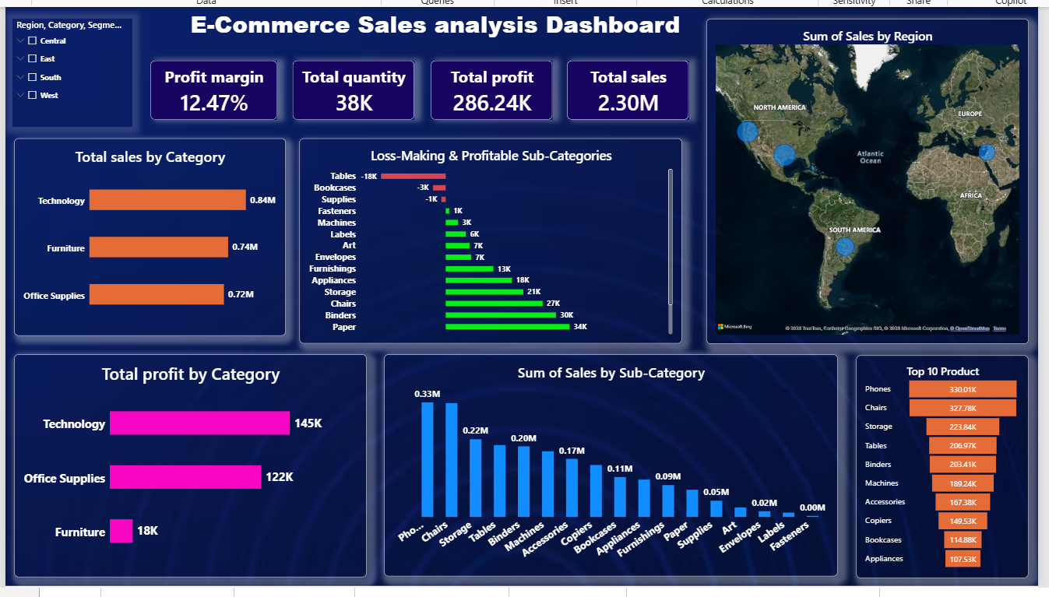
Figure 1. Final E-Commerce Sales Analysis Dashboard

8. Conclusion
The dashboard provides a comprehensive view of sales and profitability, helping identify high-performing products, loss-making areas and regional performance.

9. Recommendations
• Increase focus on Technology products.
• Review pricing and discounts for Furniture.
• Investigate loss-making sub-categories.
• Promote top-selling products such as Phones and Chairs.
• Use regional insights for better resource allocation.

