**ASSIGNMENT-1**

**LOKSABHA VISUALIZATION**

**TEAM:**

1. **SURYANARAYAN N PES1201700094**
2. **HARIKRISHNAN V PES1201700155**
3. **UNNATI CHATURVEDI PES1201700225**
4. **KRUTHIK JT PES1201701509**

1.Visualisation on Lok Sabha Dataset:

We have done various visualizations on the dataset like bar graph calculated all the unique party names participating in the election. The inference from the bar graph is that contestants from BJP have won more elections than other parties. The number of contestants participating from BJP and Congress in elections is way higher than other parties. The number of votes casted in various formats is also calculated. Votes casted through EVM is highest among all.

**VISUALIZATIONS:**

**CALCULATING NUMBER OF CONTESTANTS:**

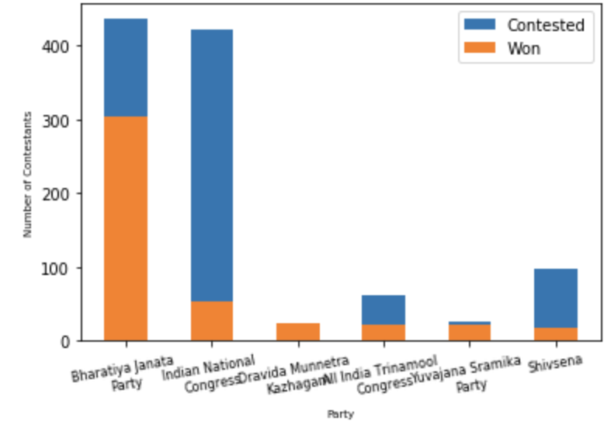

**CRIMINAL CASE vs. AGE:**

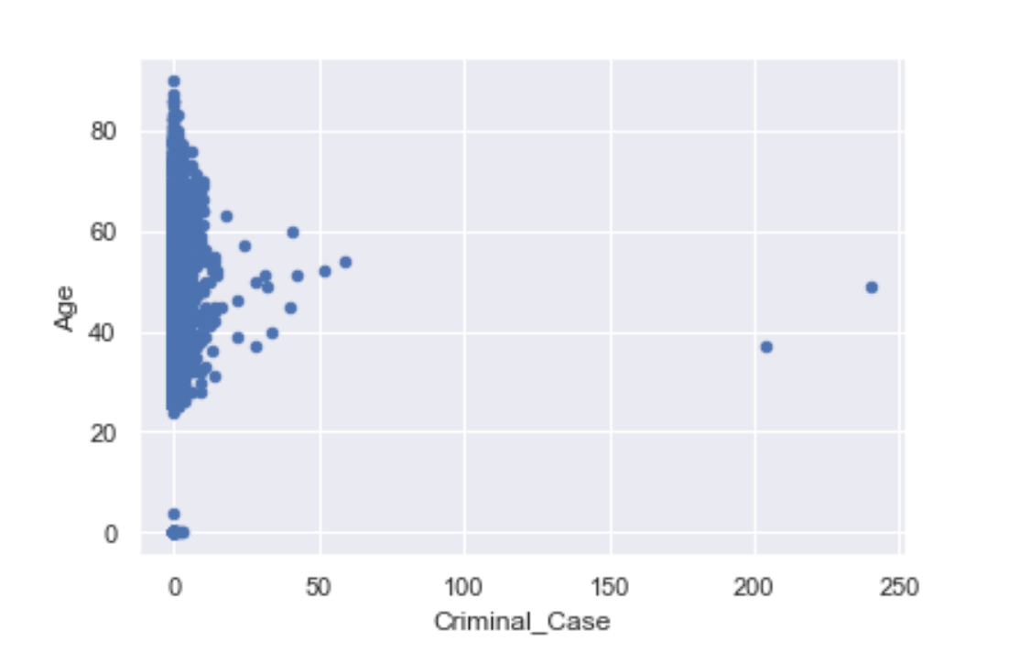

**AGE FREQUENCY DISTRIBUTION:**

